**Tips**

If input array is sorted then

- Binary search

- Two pointers

If asked for all permutations/subsets then

- Backtracking

- Subset

If given a tree then

- DFS

- BFS

If given a graph then

- DFS

- BFS

If given a linked list then

- Two pointers

If recursion is banned then

- Stack

If must solve in-place then

- Swap corresponding values

- Store one or more different values in the same pointer

If asked for maximum/minimum subarray/subset/options then

- Dynamic programming

If asked for top/least K items then

- Heap

- QuickSelect

If asked for common strings then

- Map

- Trie

Else

- Map/Set for O(1) time & O(n) space

- Sort input for O(nlogn) time and O(1) space

If we are dealing with top/maximum/minimum/closest ‘K' elements among 'N' elements, we will be using a Heap.  
  
♦️ If the given input is a sorted array or a list, we will either be using Binray Search or the Two Pointers.  
  
♦️ If we need to try all combinations (or permutations) of the input, we can either use Backtracking or Breadth First Search.  
  
♦️ Most of the questions related to Trees or Graphs can be solved either through Breadth First Search or Depth First Search.  
  
♦️ Every recursive solution can be converted to an iterative solution using a Stack.  
  
♦️ For a problem involving arrays, if there exists a solution in O(n^2)time and O(1) space, there must exist two other solutions: 1) Using a HashMap or a Set for O(n) time and O(n) space, 2) Using sorting for O(n log n) time and O(1) space.  
  
♦️ If a problem is asking for optimization (e.g., maximization or minimization), we will be using Dynamic Programming.  
  
♦️ If we need to find some common substring among a set of strings, we will be using a HashMap or a Trie.  
  
♦️ If we need to search/manipulate a bunch of strings, Trie will be the best data structure.  
  
  
♦️ If the problem is related to a LinkedList and we can't use extra space, then use the Fast & Slow Pointer approach.

7 Leetcode articles I wish I’d read sooner.

This would have saved me from solving 1500+ problems:  
  
Dynamic Programming Patterns: <https://lnkd.in/gbpRU46g>

Substring Problem Patterns: <https://lnkd.in/gdGtE72g>

Backtracking Problem Patterns: <https://lnkd.in/gVkQX5vA>

Two Pointers Patterns: <https://lnkd.in/gBfWgHYe>

Binary Search Patterns: <https://lnkd.in/gKEm_qUK>

Sliding Window Patterns: <https://lnkd.in/gjatQ5pK>

Graph Patterns: <https://lnkd.in/gKE6w7Jb>

Learning these patterns will help you tackle large variety of problems in less time.

# WarmUp

## Contains Duplicate

### Problem Statement

Given an integer array nums, return true if any value appears at least twice in the array, and return false if every element is distinct.

Example 1:

Input: nums= [1, 2, 3, 4]

Output: false

Explanation: There are no duplicates in the given array.

Example 2:

Input: nums= [1, 2, 3, 1]

Output: true

Explanation: '1' is repeating.

### Solution

### Approach 1: Brute Force

We can use a brute force approach and compare each element with all other elements in the array. If any two elements are the same, we'll return true. If we've gone through the entire array and haven't found any duplicates, we'll return false.

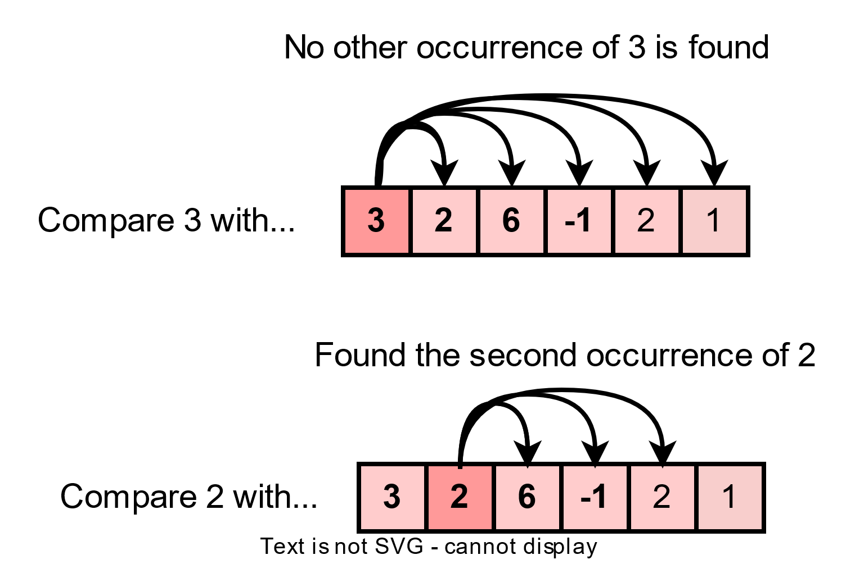

Brute force approach to solve Contains Duplicate

Code

Here is the code for this algorithm:

|  |
| --- |
| class Solution {  public boolean containsDuplicate(int[] nums) {  for (int i = 0; i < nums.length; i++) {  for (int j = i + 1; j < nums.length; j++) {  if (nums[i] == nums[j]) { // if any two elements are the same, return true  return true;  }  }  }  return false; // if no duplicates are found, return false  }  public static void main(String[] args) {  Solution solution = new Solution();  int[] nums1 = {1, 2, 3, 4};  System.out.println(solution.containsDuplicate(nums1)); // Expected output: false  int[] nums2 = {1, 2, 3, 1};  System.out.println(solution.containsDuplicate(nums2)); // Expected output: true  int[] nums3 = {};  System.out.println(solution.containsDuplicate(nums3)); // Expected output: false  int[] nums4 = {1, 1, 1, 1};  System.out.println(solution.containsDuplicate(nums4)); // Expected output: true  }  } |

**Time Complexity** The algorithm takes O(N^2) where N is the number of elements in the input array. This is because we need to compare each element with all other elements, which takes O(N^2) time.

**Space Complexity** The algorithm takes o(1) , because we only need a few variables to store the indices, which takes constant space.

### Approach 2: Using Hash Set

We can use the set data structure to check for duplicates in an array.

Since a set can only hold unique elements, we can check if the elements in the given array are present more than once by adding them to a set. This way, we can determine if there are any duplicates in the array.

This approach works as follows:

1. A set named unique_set is created to store unique elements.
2. The algorithm then iterates through the input array nums.
3. For each element "x" in the array, the algorithm checks if "x" is already in the unique_set.
   * If "x" is in the unique_set, then the algorithm returns True, indicating that a duplicate has been found.
   * If "x" is not in the unique_set, then the algorithm adds "x" to the unique_set.
4. The iteration continues until all elements in the array have been processed.
5. If no duplicates are found, the algorithm returns False.

This approach utilizes the property of sets to store only unique elements, making it an efficient solution for finding duplicates in an array.

### Code

Here is the code for this algorithm:

|  |
| --- |
| import java.util.HashSet;  import java.util.Set;  public class Solution {  public boolean containsDuplicate(int[] nums) {  Set<Integer> set = new HashSet<>(); // Use HashSet to store unique elements  for (int x : nums) {  if (!set.add(x)) // If the set already contains the current element, return true  return true;  }  return false; // Return false if no duplicates found  }  public static void main(String[] args) {  Solution solution = new Solution();  int[] nums1 = {1, 2, 3, 4};  System.out.println(solution.containsDuplicate(nums1)); // Expected output: false  int[] nums2 = {1, 2, 3, 1};  System.out.println(solution.containsDuplicate(nums2)); // Expected output: true  int[] nums3 = {};  System.out.println(solution.containsDuplicate(nums3)); // Expected output: false  int[] nums4 = {1, 1, 1, 1};  System.out.println(solution.containsDuplicate(nums4)); // Expected output: true  }  } |

**Time Complexity** The algorithm takes  O(N) where N  is the number of elements in the input array. This is because we iterate the array only once.

**Space Complexity** The algorithm takes O(N), as it stores the numbers in a set.

### Approach 3: Sorting

Another approach is to sort the array first and then check for duplicates.

We'll sort the array and then iterate through it, comparing each element with the next one.

If any two elements are the same, we'll return true. If we've gone through the entire array and haven't found any duplicates, we'll return false.

### Code

Here is the code for this algorithm:

|  |
| --- |
| import java.util.Arrays;  class Solution {  public boolean containsDuplicate(int[] nums) {  Arrays.sort(nums); // sort the array  // use a loop to compare each element with its next element  for (int i = 0; i < nums.length - 1; i++) {  // if any two elements are the same, return true  if (nums[i] == nums[i + 1]) {  return true;  }  }  return false; // if no duplicates are found, return false  }  public static void main(String[] args) {  Solution solution = new Solution();  int[] nums1 = {1, 2, 3, 4};  System.out.println(solution.containsDuplicate(nums1)); // Expected output: false  int[] nums2 = {1, 2, 3, 1};  System.out.println(solution.containsDuplicate(nums2)); // Expected output: true  int[] nums3 = {};  System.out.println(solution.containsDuplicate(nums3)); // Expected output: false  int[] nums4 = {1, 1, 1, 1};  System.out.println(solution.containsDuplicate(nums4)); // Expected output: true  }  } |

**Time Complexity:** O(N*logN), where N  is the number of elements in the array nums. This is because sorting the array takes O(N*logN), time.

**Space Complexity**:  O(1) or O(N) , depending on the sorting algorithm used. If an in-place sorting algorithm is used, the space complexity will be O(1) . If a sorting algorithm that creates a new array is used, the space complexity will be O(N) , where N is the number of elements in the array nums.

## Pangram

### Problem Statement

Given a string sentence containing English letters (lower- or upper-case), return true if sentence is a Pangram, or false otherwise.

A Pangram is a sentence where every letter of the English alphabet appears at least once.

Note: The given sentence might contain other characters like digits or spaces, your solution should handle these too.

Example 1:

Input: sentence = "TheQuickBrownFoxJumpsOverTheLazyDog"

Output: true

Explanation: The sentence contains at least one occurrence of every letter of the English alphabet either in lower or upper case.

Example 2:

Input: sentence = "This is not a pangram"

Output: false

Explanation: The sentence doesn't contain at least one occurrence of every letter of the English alphabet.

### Solution

We can use a HashSet to check if the given sentence is a pangram or not. The HashSet will be used to store all the unique characters in the sentence. The algorithm works as follows:

1. Converts the sentence to lowercase.
2. Iterate over each character of the sentence using a loop.
3. Add each character to the HashSet.
4. After looping through all characters, compare the size of the HashSet with 26 (total number of alphabets). If the size of the HashSet is equal to 26, it means the sentence contains all the alphabets and is a pangram, so the function will return true. Otherwise, it will return false.

### Code

Here is the code for this algorithm:

|  |
| --- |
| import java.util.HashSet;  import java.util.Set;  class Solution {  // Function to check if given sentence is pangram  public boolean checkIfPangram(String sentence) {  // Create a set to store unique characters  Set<Character> seen = new HashSet<>();  // Convert sentence to lowercase and iterate over each character  for (char currChar : sentence.toLowerCase().toCharArray()) {  if (Character.isLetter(currChar)) {  // Add the character to set  seen.add(currChar);  }  }  // Return true if set size is 26 (total number of alphabets)  return seen.size() == 26;  }  public static void main(String[] args) {  Solution sol = new Solution();  // Test case 1: "TheQuickBrownFoxJumpsOverTheLazyDog"  // Expected output: true  System.out.println(sol.checkIfPangram("TheQuickBrownFoxJumpsOverTheLazyDog"));  // Test case 2: "This is not a pangram"  // Expected output: false  System.out.println(sol.checkIfPangram("This is not a pangram"));  // Test case 3: "abcdef ghijkl mnopqr stuvwxyz"  // Expected output: true  System.out.println(sol.checkIfPangram("abcdef ghijkl mnopqr stuvwxyz"));  // Test case 4: ""  // Expected output: false  System.out.println(sol.checkIfPangram(""));  // Test case 5: "abcdefghijklmnopqrstuvwxyzABCDEFGHIJKLMNOPQRSTUVWXYZ"  // Expected output: true  System.out.println(sol.checkIfPangram("abcdefghijklmnopqrstuvwxyzABCDEFGHIJKLMNOPQRSTUVWXYZ"));  }  } |

**Time Complexity**  
The time complexity of this algorithm is O(N), where N  is the number of characters in the sentence because it iterates over each character once.

**Space Complexity**  
The space complexity is  O(1) because the HashSet can store at most 26 characters.

## Sqrt

### Problem Statement

Given a non-negative integer x, return the square root of x rounded down to the nearest integer. The returned integer should be non-negative as well.

You must not use any built-in exponent function or operator.

For example, do not use pow(x, 0.5) in c++ or x ** 0.5 in python.

Example 1:

Input: x = 8

Output: 2

Explanation: The square root of 8 is 2.8284, and since we need to return the floor of the square root (integer), hence we returned 2.

Example 2:

Input: x = 4

Output: 2

Explanation: The square root of 4 is 2.

Example 3:

Input: x = 2

Output: 1

Explanation: The square root of 2 is 1.414, and since we need to return the floor of the square root (integer), hence we returned 1.

### Solution

We can follow the Binary Search approach to solve this problem.

The algorithm will start with two pointers "left" and "right", pointing to the lower and upper bounds of the range in which the square root of the input number is expected to be.

The algorithm then finds the pivot point in this range, calculates the square of pivot, and checks if the result is equal to, greater than, or less than the input number.

If the result is greater than the input number, the algorithm narrows down the range by moving the right pointer to the pivot point minus 1. If the result is less than the input number, the algorithm expands the range by moving the left pointer to the pivot point plus 1.

The algorithm repeats these steps until the result is equal to the input number, or the range has become so small that left pointer is greater than the right pointer. In this case, the algorithm returns the right pointer, which will be the floor of the square root of the input number.

### Code

Here is the code for this algorithm:

|  |
| --- |
| class Solution {  public int mySqrt(int x) {  if (x < 2)  return x; // return x if it is 0 or 1  int left = 2, right = x / 2; // initialize left and right pointers  int pivot;  long num; // use long to store result of pivot * pivot to prevent overflow  while (left <= right) { // binary search for the square root  pivot = left + (right - left) / 2; // find the middle element  num = (long) pivot * pivot;  if (num > x)  right = pivot - 1; // if pivot * pivot is greater than x, set right to pivot - 1  else if (num < x)  left = pivot + 1; // if pivot * pivot is less than x, set left to pivot + 1  else  return pivot; // if pivot * pivot is equal to x, return pivot  }  return right; // return right after the loop  }  public static void main(String[] args) {  Solution solution = new Solution();  int input1 = 4;  int expectedOutput1 = 2;  int result1 = solution.mySqrt(input1);  System.out.println(result1 == expectedOutput1); // Expected output: true    int input2 = 8;  int expectedOutput2 = 2;  int result2 = solution.mySqrt(input2);  System.out.println(result2 == expectedOutput2); // Expected output: true    int input4 = 2;  int expectedOutput4 = 1;  int result4 = solution.mySqrt(input4);  System.out.println(result4 == expectedOutput4); // Expected output: true    int input5 = 3;  int expectedOutput5 = 1;  int result5 = solution.mySqrt(input5);  System.out.println(result5 == expectedOutput5); // Expected output: true  int input6 = 15;  int expectedOutput6 = 3;  int result6 = solution.mySqrt(input6);  System.out.println(result6 == expectedOutput6); // Expected output: true  }  } |

**Time Complexity**  
The time complexity of the algorithm is  O(logN) where N is the input number  because it uses binary search to find the square root.

**Space Complexity**  
The space complexity is O(1)  because it only uses a few variables to store the pointers (left, right, pivot, and num), and the size of these variables does not grow with the input size.

## Reverse Vowels

### Problem Statement

Given a string s, reverse only all the vowels in the string and return it.

The vowels are 'a', 'e', 'i', 'o', and 'u', and they can appear in both lower and upper cases, more than once.

Example 1:

Input: s= "hello"

Output: "holle"

Example 2:

Input: s= "AEIOU"

Output: "UOIEA"

Example 3:

Input: s= "DesignGUrus"

Output: "DusUgnGires"

### Solution

We can follow a two-pointer approach to reverse vowels in a string.

The algorithm will start by initializing two pointers, "first" and "last" to the start and end of the string, respectively. The algorithm then uses these two pointers to traverse the string and skip over any non-vowel characters. When two vowels are found, the algorithm swaps them and updates the pointers. The process continues until the two pointers cross over each other.

### Code

Here is the code for this algorithm:

|  |
| --- |
| public class Solution {  static final String vowels = "aeiouAEIOU";  public String reverseVowels(String s) {  int first = 0, last = s.length() - 1; // Initialize the two pointers  char[] array = s.toCharArray();  while (first < last) {  while (first < last && vowels.indexOf(array[first]) == -1) {  first++; // Skip non-vowel characters from the start  }  while (first < last && vowels.indexOf(array[last]) == -1) {  last--; // Skip non-vowel characters from the end  }  char temp = array[first]; // Swap the vowels found at first and last  array[first] = array[last];  array[last] = temp;  first++;  last--;  }  return new String(array); // Return the reversed string  }  public static void main(String[] args) {  Solution solution = new Solution();  // Test Case 1  String s1 = "hello";  String expectedOutput1 = "holle";  String actualOutput1 = solution.reverseVowels(s1);  System.out.println("Test Case 1: " + (expectedOutput1.equals(actualOutput1)));  // Test Case 2  String s2 = "DesignGUrus";  String expectedOutput2 = "DusUgnGires";  String actualOutput2 = solution.reverseVowels(s2);  System.out.println("Test Case 2: " + (expectedOutput2.equals(actualOutput2)));  // Test Case 3  String s3 = "AEIOU";  String expectedOutput3 = "UOIEA";  String actualOutput3 = solution.reverseVowels(s3);  System.out.println("Test Case 3: " + (expectedOutput3.equals(actualOutput3)));  // Test Case 4  String s4 = "aA";  String expectedOutput4 = "Aa";  String actualOutput4 = solution.reverseVowels(s4);  System.out.println("Test Case 4: " + (expectedOutput4.equals(actualOutput4)));  // Test Case 5  String s5 = "";  String expectedOutput5 = "";  String actualOutput5 = solution.reverseVowels(s5);  System.out.println("Test Case 5: " + (expectedOutput5.equals(actualOutput5)));  }  } |

**Time Complexity**  
The time complexity of the above algorithm is O(N), where N  is the length of the input string. This is because the algorithm uses two pointers to traverse the string and swap elements, and the worst-case scenario is that one of the pointers travels through the entire length of the string. The number of swaps is limited to half of the length of the string, so the time complexity is .

**Space Complexity**  
The space complexity of the algorithm is O(N). This is because the algorithm uses an array to store a list of characters, which is equivalent to the length of the input string. This means that the space complexity is directly proportional to the length of the input string.

## Valid Palindrome

### Problem Statement

A phrase is a palindrome if, after converting all uppercase letters into lowercase letters and removing all non-alphanumeric characters, it reads the same forward and backward. Alphanumeric characters include letters and numbers.

Given a string s, return true if it is a palindrome, or false otherwise.

Example 1:

Input: sentence = "A man, a plan, a canal, Panama!"

Output: true

Explanation: "amanaplanacanalpanama" is a palindrome.

Example 2:

Input: sentence = "Was it a car or a cat I saw?"

Output: true

Explanation: Explanation: "wasitacaroracatisaw" is a palindrome.

### Solution

We can use two pointers to solve this problem.

One pointer will start from the beginning of the string and the other from the end of the string. The pointers move towards each other, skipping non-alphanumeric characters, until they meet in the middle or one of the pointers points to an non-alphanumeric character that is different from its counterpart at the other end. If all characters are the same and both pointers meet in the middle, the string is a palindrome.

### Code

Here is the code for this algorithm:

|  |
| --- |
| class Solution {  public boolean isPalindrome(String s) {  int i = 0, j = s.length() - 1; // initialize two pointers, one at the start and one at the end of the string  while (i < j) { // continue until the two pointers cross over  while (i < j && !Character.isLetterOrDigit(s.charAt(i))) { // move i forward until a letter or digit is found  i++;  }  while (i < j && !Character.isLetterOrDigit(s.charAt(j))) { // move j backward until a letter or digit is found  j--;  }    // compare the characters at i and j after converting them to lowercase  if (Character.toLowerCase(s.charAt(i)) != Character.toLowerCase(s.charAt(j)))  return false; // if they are not equal, the string is not a palindrome  i++; // move i forward  j--; // move j backwards  }    return true; // if the two pointers have crossed over, the string is a palindrome  }  public static void main(String[] args) {  Solution sol = new Solution();    // Test case 1: "A man, a plan, a canal, Panama!"  // Expected output: true  System.out.println(sol.isPalindrome("A man, a plan, a canal, Panama!"));    // Test case 2: "race a car"  // Expected output: false  System.out.println(sol.isPalindrome("race a car"));    // Test case 3: "Was it a car or a cat I saw?"  // Expected output: true  System.out.println(sol.isPalindrome("Was it a car or a cat I saw?"));    // Test case 4: "Madam, in Eden, I'm Adam."  // Expected output: true  System.out.println(sol.isPalindrome("Madam, in Eden, I'm Adam."));    // Test case 5: "empty string"  // Expected output: true  System.out.println(sol.isPalindrome(""));  }  } |

### Time Complexity

The time complexity of this algorithm is O(n) , where n is the number of characters in the sentence, because it iterates over each character once.

### Space Complexity

The space complexity is O(1) because our algorithm uses constant space to store a few variables, and the size of these variables does not grow with the input size.

## Valid Anagram

### Problem Statement

Given two strings s and t, return true if t is an anagram of s, and false otherwise.

An Anagram is a word or phrase formed by rearranging the letters of a different word or phrase, typically using all the original letters exactly once.

Example 1:

Input: s = "listen", t = "silent"

Output: true

Example 2:

Input: s = "rat", t = "car"

Output: false

Example 3:

Input: s = "hello", t = "world"

Output: false

### Solution

We can solve this problem by calculating how many times each character appears in both the strings. If the frequency of each character is the same in both the given strings, we can conclude that the strings are anagrams of each other.

We can use a hash map to store the frequency of each character in both strings.

For each character in the string, the frequency of that character in string s is incremented and the frequency of that character in string t is decremented. After iterating over all characters in the strings, we will check if the frequency of all characters is 0. If it is, the strings are anagrams of each other and the function returns true. Otherwise, it returns false.

### Code

Here is the code for this algorithm:

|  |
| --- |
| import java.util.HashMap;  class Solution {  public boolean isAnagram(String s, String t) {  // Check if the lengths of both strings are equal. If not, return false.  if (s.length() != t.length()) {  return false;  }  // Create a hash map to store the frequency of characters in both strings.  HashMap<Character, Integer> freqMap = new HashMap<>();  for (int i = 0; i < s.length(); i++) {  // Increment the frequency of the character in string s.  freqMap.put(s.charAt(i), freqMap.getOrDefault(s.charAt(i), 0) + 1);  // Decrement the frequency of the character in string t.  freqMap.put(t.charAt(i), freqMap.getOrDefault(t.charAt(i), 0) - 1);  }  // Check if the frequency of all characters is 0.  for (char chr : freqMap.keySet()) {  if (freqMap.get(chr) != 0) {  return false;  }  }  // If all characters have a frequency of 0, this means that 't' is an anagram of 's'.  return true;  }  public static void main(String[] args) {  Solution sol = new Solution();  // Test case 1  String s1 = "listen";  String t1 = "silent";  System.out.println(sol.isAnagram(s1, t1)); // Expected output: true  // Test case 2  String s2 = "hello";  String t2 = "world";  System.out.println(sol.isAnagram(s2, t2)); // Expected output: false  // Test case 3  String s3 = "anagram";  String t3 = "nagaram";  System.out.println(sol.isAnagram(s3, t3)); // Expected output: true  // Test case 4  String s4 = "rat";  String t4 = "car";  System.out.println(sol.isAnagram(s4, t4)); // Expected output: false  // Test case 5  String s5 = "";  String t5 = "";  System.out.println(sol.isAnagram(s5, t5)); // Expected output: true  }  } |

### Time Complexity

The time complexity of this algorithm is O(n), where n  is the length of the strings. This is because the algorithm iterates over each character in the strings once and performs a constant amount of work for each character.

### Space Complexity

The space complexity of this algorithm is O(1), as the size of the hash map is proportional to the number of unique characters in the strings. In the worst case, all characters in the strings are unique, so the size of the hash map would be 26 (the number of letters in the alphabet).

However, in most cases, the number of unique characters is much smaller than 26, so the space complexity is closer to O(k), where k  is the number of unique characters in the strings.

## Shortest Word Distance

### Problem Statement

Given an array of strings words and two different strings that already exist in the array word1 and word2, return the shortest distance between these two words in the list.

Example 1:

Input: words = ["the", "quick", "brown", "fox", "jumps", "over", "the", "lazy", "dog"], word1 = "fox", word2 = "dog"

Output: 5

Explanation: The distance between "fox" and "dog" is 5 words.

Example 2:

Input: words = ["a", "c", "d", "b", "a"], word1 = "a", word2 = "b"

Output: 1

Explanation: The shortest distance between "a" and "b" is 1 word. Please note that "a" appeared twice.

Example 3:

Input: words = ["a", "b", "c", "d", "e"], word1 = "a", word2 = "e"

Output: 4

Explanation: The distance between "a" and "e" is 4 words.

### Solution

We can use two pointers approach to find the shortest distance between the two words in a list of words.

Here's how the algorithm will work:

1. Initialize two variables position1 and position2 to store the positions of word1 and word2 in the words list, respectively. Initialize these variables to -1 which means that the words haven't been found yet.
2. Initialize a variable shortestDistance with the length of the words list as the initial value. This value will be updated later in the loop as the shortest distance is found.
3. Loop through the words list and for each word, check if it is word1 or word2. If it is word1, update position1 with the current index. If it is word2, update position2 with the current index.
4. If both position1 and position2 have been updated, that means both word1 and word2 have been found in the words list. In this case, update the shortestDistance with the absolute difference of the positions of word1 and word2.
5. Repeat steps 3 and 4 until the end of the words list is reached.
6. Return the final value of shortestDistance as the result.

### Code

Here is the code for this algorithm:

|  |
| --- |
| class Solution {  public int shortestDistance(String[] words, String word1, String word2) {  // Initialize the shortest distance with the length of the words list  int shortestDistance = words.length;  int position1 = -1, position2 = -1; // Initialize the positions of word1 and word2 with -1  for (int i = 0; i < words.length; i++) {  String word = words[i];  if (word.equals(word1)) { // If the current word is word1, update the position1  position1 = i;  } else if (word.equals(word2)) { // If the current word is word2, update the position2  position2 = i;  }  // If both the positions are updated, update the shortest distance  if (position1 != -1 && position2 != -1) {  shortestDistance = Math.min(shortestDistance, Math.abs(position1 - position2));  }  }  return shortestDistance;  }  public static void main(String[] args) {  Solution solution = new Solution();  // Test case 1  String[] words1 = { "the", "quick", "brown", "fox", "jumps", "over", "the", "lazy", "dog" };  String word11 = "fox";  String word21 = "dog";  int expectedOutput1 = 5;  int actualOutput1 = solution.shortestDistance(words1, word11, word21);  System.out.println("Test case 1: " + (expectedOutput1 == actualOutput1));  // Test case 2  String[] words2 = { "a", "b", "c", "d", "a", "b" };  String word12 = "a";  String word22 = "b";  int expectedOutput2 = 1;  int actualOutput2 = solution.shortestDistance(words2, word12, word22);  System.out.println("Test case 2: " + (expectedOutput2 == actualOutput2));  // Test case 3  String[] words3 = { "a", "c", "d", "b", "a" };  String word13 = "a";  String word23 = "b";  int expectedOutput3 = 1;  int actualOutput3 = solution.shortestDistance(words3, word13, word23);  System.out.println("Test case 3: " + (expectedOutput3 == actualOutput3));  // Test case 4  String[] words4 = { "a", "b", "c", "d", "e" };  String word14 = "a";  String word24 = "e";  int expectedOutput4 = 4;  int actualOutput4 = solution.shortestDistance(words4, word14, word24);  System.out.println("Test case 4: " + (expectedOutput4 == actualOutput4));  }  } |

### Time Complexity

The time complexity of this algorithm is O(n), where n  is the length of the words list. This is because the algorithm loops through the words list once.

### Space Complexity

The space complexity of this algorithm is O(1).

## Number of Good Pairs

### Problem Statement

Given an array of integers nums, return the number of good pairs in it.

A pair (i, j) is called good if nums[i] == nums[j] and i < j.

Example 1:

Input: nums = [1,2,3,1,1,3]

Output: 4

Explanation: There are 4 good pairs, here are the indices: (0,3), (0,4), (3,4), (2,5).

Example 2:

Input: nums = [1,1,1,1]

Output: 6

Explanation: Each pair in the array is a 'good pair'.

Example 3:

Input: words = nums = [1,2,3]

Output: 0

Explanation: No number is repeating.

### Solution

We can use a HashMap to store the frequency of each number in the input array nums.

While iterating through the input array, for each number n in the array, we will increment the count of n in the HashMap.

Whenever we find a new occurrence of a number, we have found a new pair.

Every new occurrence of a number can be paired with every previous occurrence of the same number. This means if a number has already appeared p times, we will have p-1 new pairs.

Hence, whenever we find a new occurrence of a number (that is, its count is more than 1), we will add p-1 to pairCount, which keeps track of the total number of good pairs.

### Code

Here is the code for this algorithm:

|  |
| --- |
| import java.util.*;  class Solution {  public int numGoodPairs(int[] nums) {  int pairCount = 0;  Map<Integer, Integer> map = new HashMap<>();  for (int n : nums) {  map.put(n, map.getOrDefault(n, 0) + 1); // increment the count of 'n' in the map  // every new occurrence of a number can be paired with every previous occurrence  // so if a number has already appeared 'p' times, we will have 'p-1' new pairs  pairCount += map.get(n) - 1;  }  return pairCount;  }  public static void main(String[] args) {  Solution sol = new Solution();  int[] nums1 = { 1, 2, 3, 1, 1, 3 };  int result1 = sol.numGoodPairs(nums1);  System.out.println("Result 1: " + result1 + " (Expected: 4)");  int[] nums2 = { 1, 1, 1, 1 };  int result2 = sol.numGoodPairs(nums2);  System.out.println("Result 2: " + result2 + " (Expected: 6)");  int[] nums3 = { 1, 2, 3 };  int result3 = sol.numGoodPairs(nums3);  System.out.println("Result 3: " + result3 + " (Expected: 0)");  }  } |

### Time Complexity

The time complexity of the algorithm is O(n), where n is the length of the input array nums. The reason for this is that the algorithm only needs to loop through each element of the array once, and the operations performed inside the loop (putting elements into the map, getting their values, and incrementing pairCount) all have constant time complexity.

### Space Complexity

The space complexity of the algorithm is O(n), where n is the length of the input array nums. This is because the algorithm uses a HashMap to store the frequency of each number in the input array, which can take up to  O(n) space in the worst case scenario if all the elements in the array are unique.

# Pattern 1: Sliding Window

In many problems dealing with an array (or a **LinkedList**), we are asked to find or calculate something among all the contiguous subarrays (or sublists) of a given size. For example, take a look at this problem:

## Find Averages of Sub Arrays

<https://leetcode.com/problems/maximum-average-subarray-i/>

### Problem Statement

Given an array, find the average of all contiguous subarrays of size K in it.

Lets understand this problem with a real input:

Array: [1, 3, 2, 6, -1, 4, 1, 8, 2], K=5

### Solution

Here, we are asked to find the average of all subarrays of '5' contiguous elements in the given array. Let's solve this:

1. For the first 5 numbers (subarray from index 0-4), the average is: (1+3+2+6-10)/5=2.2
2. The average of next 5 numbers (subarray from index 1-5) is: 2.8
3. For the next 5 numbers (subarray from index 2-6), the average is: 2.4  
   ...

Here is the final output containing the averages of all subarrays of size 5:

Output: [2.2, 2.8, 2.4, 3.6, 2.8]

A brute-force algorithm will calculate the sum of every 5-element subarray of the given array and divide the sum by '5' to find the average. This is what the algorithm will look like:

### Code

|  |
| --- |
| import java.util.Arrays;  class Solution {  public static double[] findAverages(int K, int[] arr) {  double[] result = new double[arr.length - K + 1];  for (int i = 0; i <= arr.length - K; i++) {  // find sum of next 'K' elements  double sum = 0;  for (int j = i; j < i + K; j++)  sum += arr[j];  result[i] = sum / K; // calculate average  }  return result;  }  public static void main(String[] args) {  double[] result = Solution.findAverages(5,  new int[] { 1, 3, 2, 6, -1, 4, 1, 8, 2 });  System.out.println("Averages of subarrays of size K: " + Arrays.toString(result));  }  } |

**Time complexity:**Since for every element of the input array, we are calculating the sum of its next K elements, the time complexity of the above algorithm will be O(N*K) where N is the number of elements in the input array.

### Can we find a better solution? Do you see any inefficiency in the above approach?

The inefficiency is that for any two consecutive subarrays of size 5, the overlapping part (which will contain four elements) will be evaluated twice.

For example, take the above-mentioned input:

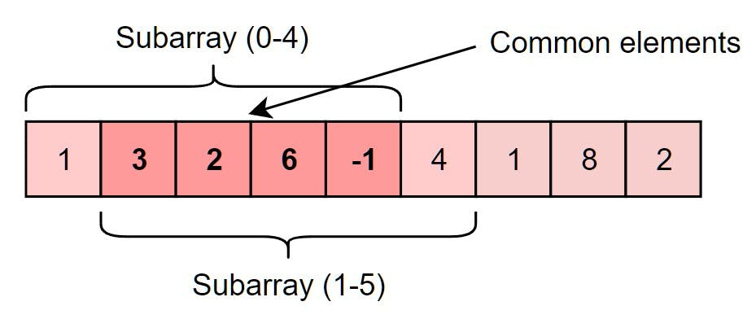

As you can see, there are four overlapping elements between the subarray (indexed from 0-4) and the subarray (indexed from 1-5). Can we somehow reuse the sum we have calculated for the overlapping elements?

The efficient way to solve this problem would be to visualize each contiguous subarray as a *sliding window* of 5 elements. This means that we will slide the window by one element when we move on to the next subarray. To reuse the sum from the previous subarray, we will subtract the element going out of the window and add the element now being included in the *sliding window*. This will save us from going through the whole subarray to find the sum and, as a result, the algorithm complexity will reduce to O(N).

Here is the algorithm for the **Sliding Window** approach:

### Sliding Window Approach

|  |
| --- |
| import java.util.Arrays;  class Solution {  public static double[] findAverages(int K, int[] arr) {  double[] result = new double[arr.length - K + 1];  double windowSum = 0;  int windowStart = 0;  for (int windowEnd = 0; windowEnd < arr.length; windowEnd++) {  windowSum += arr[windowEnd]; // add the next element  // slide the window, we don't need to slide if we've not hit the required  // window size of 'k'  if (windowEnd >= K - 1) {  result[windowStart] = windowSum / K; // calculate the average  windowSum -= arr[windowStart]; // subtract the element going out  windowStart++; // slide the window ahead  }  }  return result;  }  public static void main(String[] args) {  double[] result = Solution.findAverages(5,  new int[] { 1, 3, 2, 6, -1, 4, 1, 8, 2 });  System.out.println("Averages of subarrays of size K: " + Arrays.toString(result));  }  } |

In the following chapters, we will apply the **Sliding Window** approach to solve a few problems.

In some problems, the size of the sliding window is not fixed. We have to expand or shrink the window based on the problem constraints. We will see a few examples of such problems in the next chapters.

Let's jump onto our first problem and apply the **Sliding Window** pattern.

## Maximum Sum Subarray of Size K (easy)

<https://leetcode.com/problems/largest-subarray-length-k/>

Given an array of positive numbers and a positive number K, find the maximum sum of any contiguous subarray of size K.

**Example 1:**

Input: [2, 1, 5, 1, 3, 2], k=3

Output: 9

Explanation: Subarray with maximum sum is [5, 1, 3].

**Example 2:**

Input: [2, 3, 4, 1, 5], k=2

Output: 7

Explanation: Subarray with maximum sum is [3, 4].

**Brute Force**

A basic brute force solution will be to calculate the sum of all K sized subarrays of the given array to find the subarray with the highest sum. We can start from every index of the given array and add the next K elements to find the subarrays sum.

Following is the visual representation of this algorithm for Example-1:

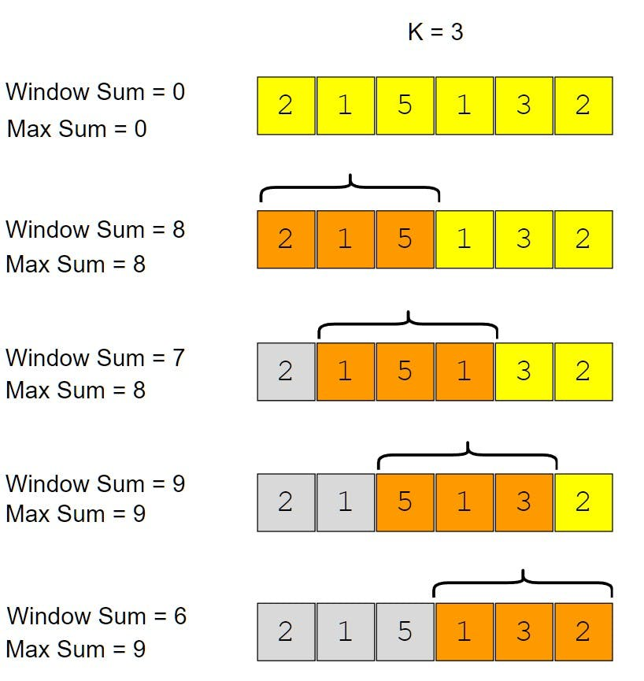

|  |
| --- |
| class Solution {  public static int findMaxSumSubArray(int k, int[] arr) {  int maxSum = 0, windowSum;  for (int i = 0; i <= arr.length - k; i++) {  windowSum = 0;  for (int j = i; j < i + k; j++) {  windowSum += arr[j];  }  maxSum = Math.max(maxSum, windowSum);  }  return maxSum;  }  public static void main(String[] args) {  System.out.println("Maximum sum of a subarray of size K: "  + Solution.findMaxSumSubArray(3, new int[] { 2, 1, 5, 1, 3, 2 }));  System.out.println("Maximum sum of a subarray of size K: "  + Solution.findMaxSumSubArray(2, new int[] { 2, 3, 4, 1, 5 }));  }  } |

* Time complexity will be O(N*K), where N is the total number of elements in the given array

**Sliding Window Approach**

If you observe closely, you will realize that to calculate the sum of a contiguous subarray, we can utilize the sum of the previous subarray. For this, consider each subarray as a **Sliding Window** of size K. To calculate the sum of the next subarray, we need to slide the window ahead by one element. So to slide the window forward and calculate the sum of the new position of the *sliding window*, we need to do two things:

1. Subtract the element going out of the *sliding window*, i.e., subtract the first element of the window.
2. Add the new element getting included in the *sliding window*, i.e., the element coming right after the end of the window.

This approach will save us from re-calculating the sum of the overlapping part of the *sliding window*.

|  |
| --- |
| class Solution {  public static int findMaxSumSubArray(int k, int[] arr) {  int windowSum = 0, maxSum = 0;  int windowStart = 0;  for (int windowEnd = 0; windowEnd < arr.length; windowEnd++) {  windowSum += arr[windowEnd]; // add the next element  // slide the window, no need to slide if we've not hit the window size of 'k'  if (windowEnd >= k - 1) {  maxSum = Math.max(maxSum, windowSum);  windowSum -= arr[windowStart]; // subtract the element going out  windowStart++; // slide the window ahead  }  }  return maxSum;  }  public static void main(String[] args) {  System.out.println("Maximum sum of a subarray of size K: "  + Solution.findMaxSumSubArray(3, new int[] { 2, 1, 5, 1, 3, 2 }));  System.out.println("Maximum sum of a subarray of size K: "  + Solution.findMaxSumSubArray(2, new int[] { 2, 3, 4, 1, 5 }));  }  } |

* The time complexity of the above algorithm will be O(N)
* The space complexity of the above algorithm will be O(1)

## Smallest Subarray with a given sum (easy)

<https://leetcode.com/problems/minimum-size-subarray-sum/>

### Problem Statement

Given an array of positive numbers and a positive number S, find the length of the **smallest contiguous subarray whose sum is greater than or equal to S**.

Return 0 if no such subarray exists.

**Example 1:**

Input: [2, 1, 5, 2, 3, 2], S=7

Output: 2

Explanation: The smallest subarray with a sum greater than or equal to '7' is [5, 2].

**Example 2:**

Input: [2, 1, 5, 2, 8], S=7

Output: 1

Explanation: The smallest subarray with a sum greater than or equal to '7' is [8].

**Example 3:**

Input: [3, 4, 1, 1, 6], S=8

Output: 3

Explanation: Smallest subarrays with a sum greater than or equal to '8' are [3, 4, 1] or [1, 1, 6].

### Solution

This problem follows the **Sliding Window pattern**, and we can use a similar strategy as discussed in [**Maximum Sum Subarray of Size K**](https://github.com/maazshaikh007/DSA_Patterns/blob/main/%E2%9C%85%20%20Pattern%2001%20:%20Sliding%20Window.md#maximum-sum-subarray-of-size-k-easy). There is one difference though: in this problem, the *sliding window* size is not fixed. Here is how we will solve this problem:

1. First, we will add-up elements from the beginning of the array until their sum becomes greater than or equal to S.
2. These elements will constitute our *sliding window*. We are asked to find the smallest such window having a sum greater than or equal to S. We will remember the length of this window as the smallest window so far.
3. After this, we will keep adding one element in the *sliding window* (i.e., slide the window ahead) in a stepwise fashion.
4. In each step, we will also try to shrink the window from the beginning. We will shrink the window until the windows sum is smaller than S again. This is needed as we intend to find the smallest window. This shrinking will also happen in multiple steps; in each step, we will do two things:

* Check if the current window length is the smallest so far, and if so, remember its length.
* Subtract the first element of the window from the running sum to shrink the sliding window.

Here is the visual representation of this algorithm for the Example-1:

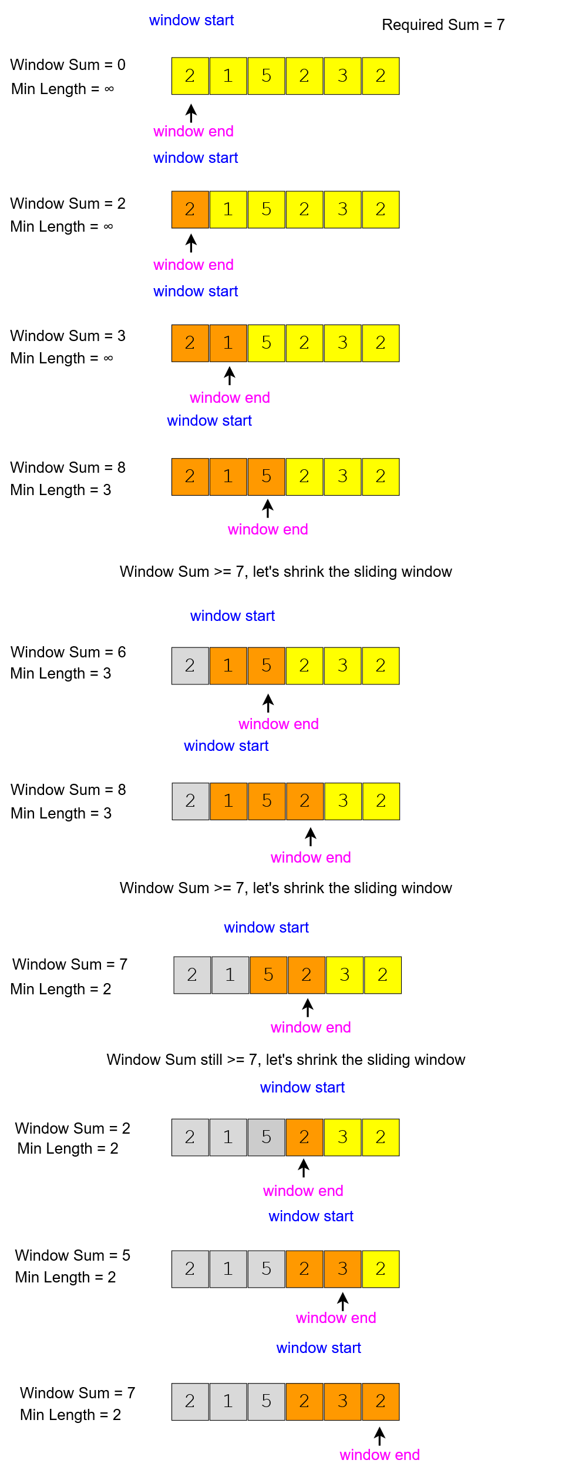

|  |
| --- |
| public class Solution {  public static int findMinSubArray(int S, int[] arr) {  int windowSum = 0, minLength = Integer.MAX_VALUE;  int windowStart = 0;  for (int windowEnd = 0; windowEnd < arr.length; windowEnd++) {  windowSum += arr[windowEnd]; // add the next element  // shrink the window as small as possible until the 'windowSum' is smaller than 'S'  while (windowSum >= S) {  minLength = Math.min(minLength, windowEnd - windowStart + 1);  windowSum -= arr[windowStart]; // subtract the element going out  windowStart++; // slide the window ahead  }  }  return minLength == Integer.MAX_VALUE ? 0 : minLength;  }  public static void main(String[] args) {  int result = Solution.findMinSubArray(7, new int[] { 2, 1, 5, 2, 3, 2 });  System.out.println("Smallest subarray length: " + result);  result = Solution.findMinSubArray(7, new int[] { 2, 1, 5, 2, 8 });  System.out.println("Smallest subarray length: " + result);  result = Solution.findMinSubArray(8, new int[] { 3, 4, 1, 1, 6 });  System.out.println("Smallest subarray length: " + result);  }  } |

* The time complexity of the above algorithm will be O(N). The outer for loop runs for all elements, and the inner while loop processes each element only once; therefore, the time complexity of the algorithm will be O(N+N)), which is asymptotically equivalent to O(N).
* The algorithm runs in constant space O(1).

**Longest Substring with K Distinct Characters (medium)**

<https://leetcode.com/problems/longest-substring-with-at-most-k-distinct-characters/>

Given a string, find the length of the **longest substring** in it with **no more than K distinct characters**.

You can assume that K is less than or equal to the length of the given string.

**Example 1:**

Input: String="araaci", K=2

Output: 4

Explanation: The longest substring with no more than '2' distinct characters is "araa".

**Example 2:**

Input: String="araaci", K=1

Output: 2

Explanation: The longest substring with no more than '1' distinct characters is "aa".

**Example 3:**

Input: String="cbbebi", K=3

Output: 5

Explanation: The longest substrings with no more than '3' distinct characters are "cbbeb" & "bbebi".

### **Solution**

This problem follows the **Sliding Window pattern**, and we can use a similar dynamic *sliding window* strategy as discussed in [**Smallest Subarray with a given sum**](https://github.com/maazshaikh007/DSA_Patterns/blob/main/%E2%9C%85%20%20Pattern%2001%20:%20Sliding%20Window.md#smallest-subarray-with-a-given-sum-easy). We can use a **HashMap** to remember the frequency of each character we have processed. Here is how we will solve this problem:

1. First, we will insert characters from the beginning of the string until we have K distinct characters in the **HashMap**.
2. These characters will constitute our *sliding window*. We are asked to find the longest such window having no more than K distinct characters. We will remember the length of this window as the longest window so far.
3. After this, we will keep adding one character in the *sliding window* (i.e., slide the window ahead) in a stepwise fashion.
4. In each step, we will try to shrink the window from the beginning if the count of distinct characters in the **HashMap** is larger than K. We will shrink the window until we have no more than K distinct characters in the **HashMap**. This is needed as we intend to find the longest window.
5. While shrinking, well decrement the characters frequency going out of the window and remove it from the **HashMap** if its frequency becomes zero.
6. At the end of each step, well check if the current window length is the longest so far, and if so, remember its length.

Here is the visual representation of this algorithm for the Example-1:

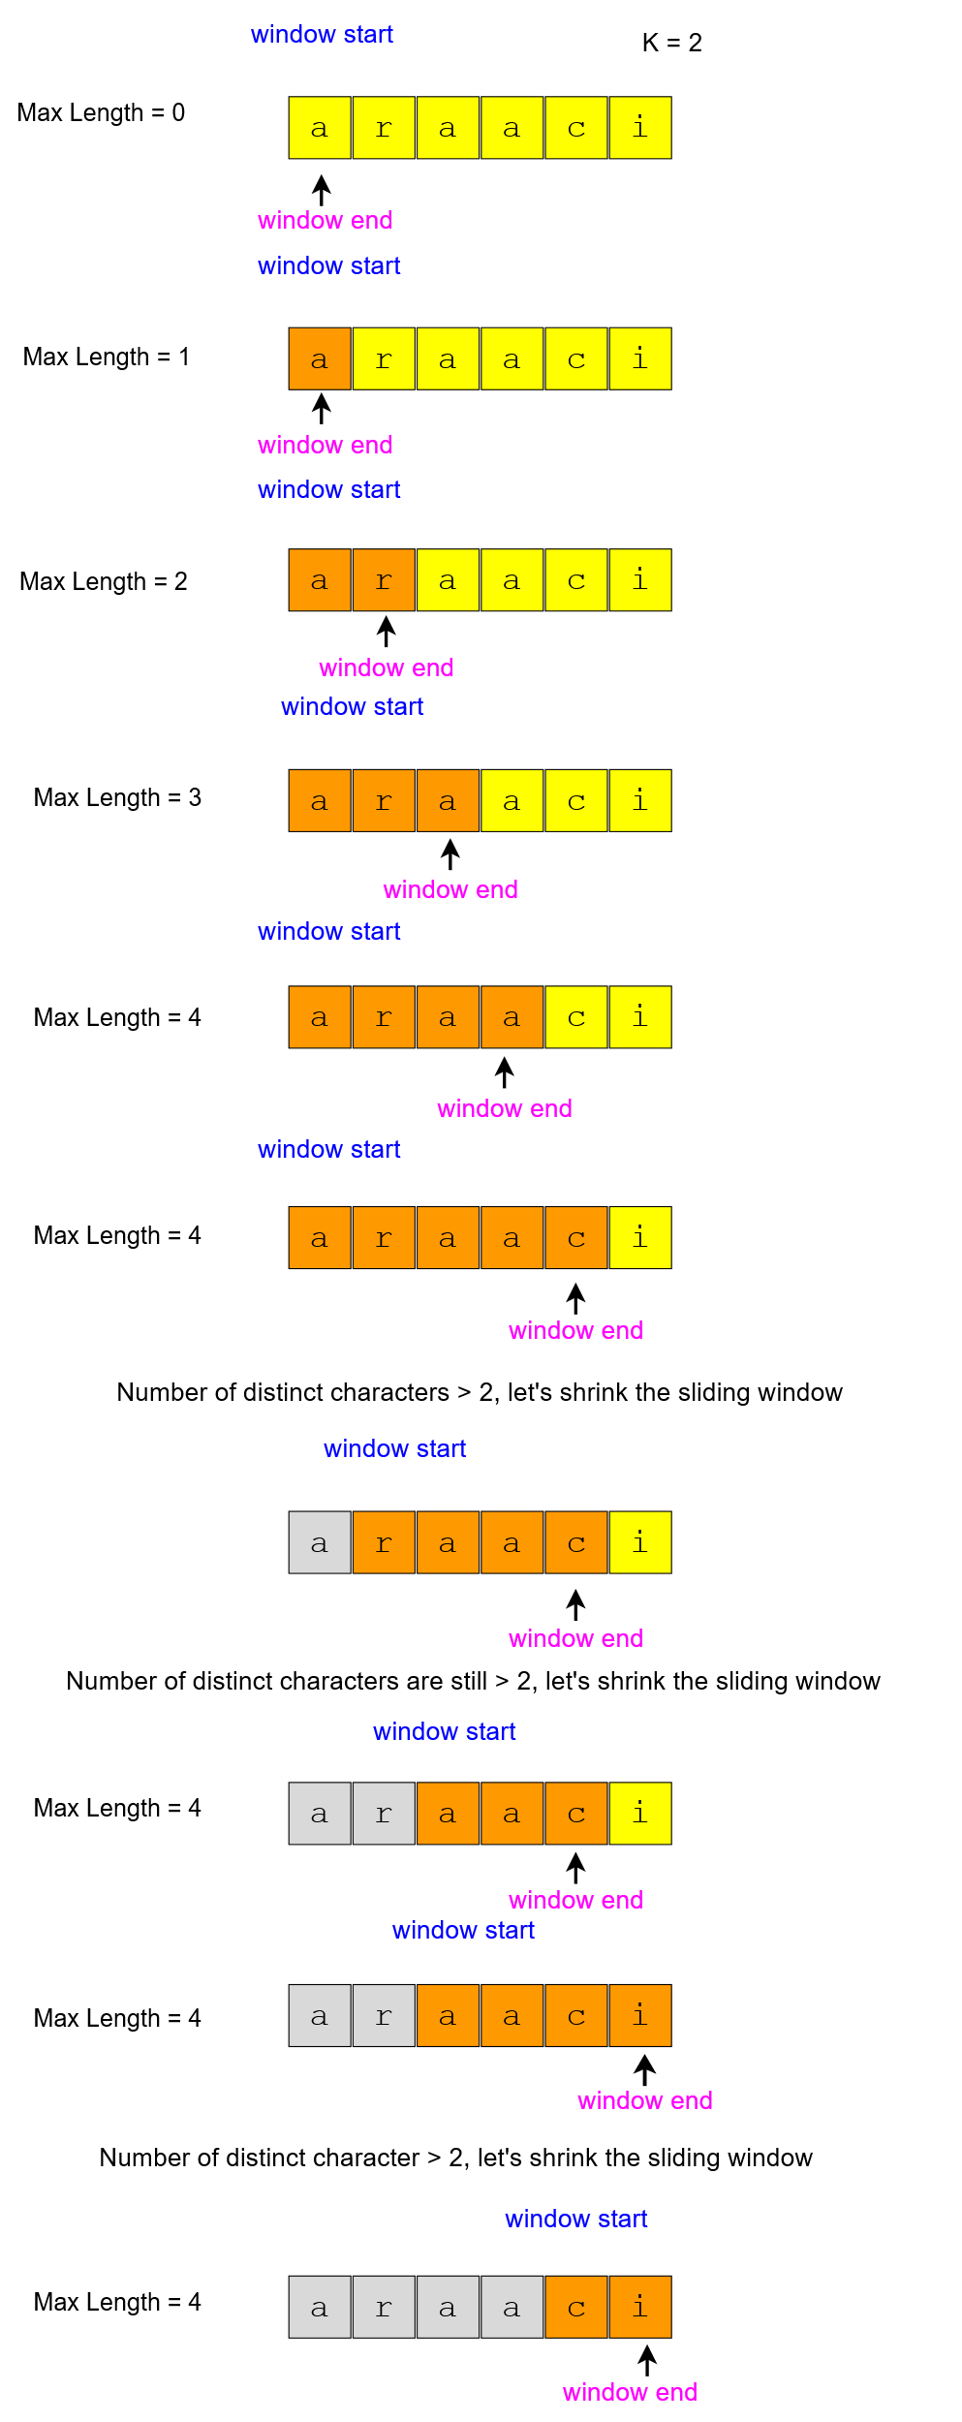

### Code

|  |
| --- |
| import java.util.*;  class Solution {  public static int findLength(String str, int k) {  if (str == null || str.length() == 0 || str.length() < k)  throw new IllegalArgumentException();  int windowStart = 0, maxLength = 0;  Map<Character, Integer> charFrequencyMap = new HashMap<>();  // in the following loop we'll try to extend the range [windowStart, windowEnd]  for (int windowEnd = 0; windowEnd < str.length(); windowEnd++) {  char rightChar = str.charAt(windowEnd);  charFrequencyMap.put(rightChar, charFrequencyMap.getOrDefault(rightChar, 0) + 1);  // shrink the sliding window, until we are left with 'k' distinct characters in  // the frequency map  while (charFrequencyMap.size() > k) {  char leftChar = str.charAt(windowStart);  charFrequencyMap.put(leftChar, charFrequencyMap.get(leftChar) - 1);  if (charFrequencyMap.get(leftChar) == 0) {  charFrequencyMap.remove(leftChar);  }  windowStart++; // shrink the window  }  // remember the maximum length so far  maxLength = Math.max(maxLength, windowEnd - windowStart + 1);  }  return maxLength;  }  public static void main(String[] args) {  System.out.println("Length of the longest substring: "  + Solution.findLength("araaci", 2));  System.out.println("Length of the longest substring: "  + Solution.findLength("araaci", 1));  System.out.println("Length of the longest substring: "  + Solution.findLength("cbbebi", 3));  }  } |

* The above algorithms time complexity will be O(N), where N is the number of characters in the input string. The outer for loop runs for all characters, and the inner while loop processes each character only once; therefore, the time complexity of the algorithm will be O(N+N), which is asymptotically equivalent to O(N)
* The algorithms space complexity is O(K), as we will be storing a maximum of K+1 characters in the **HashMap**.

## 🔎 Fruits into Baskets (medium)

<https://leetcode.com/problems/fruit-into-baskets/>

### Problem Statement

You are visiting a farm to collect fruits. The farm has a single row of fruit trees. You will be given two baskets, and your goal is to pick as many fruits as possible to be placed in the given baskets.

You will be given an array of characters where each character represents a fruit tree. The farm has following restrictions:

1. Each basket can have only one type of fruit. There is no limit to how many fruit a basket can hold.
2. You can start with any tree, but you can’t skip a tree once you have started.
3. You will pick exactly one fruit from every tree until you cannot, i.e., you will stop when you have to pick from a third fruit type.

Write a function to return the maximum number of fruits in both baskets.

Example 1:

Input: Fruit=['A', 'B', 'C', 'A', 'C']

Output: 3

Explanation: We can put 2 'C' in one basket and one 'A' in the other from the subarray ['C', 'A', 'C']

Example 2:

Input: Fruit = ['A', 'B', 'C', 'B', 'B', 'C']

Output: 5

Explanation: We can put 3 'B' in one basket and two 'C' in the other basket. This can be done if we start with the second letter: ['B', 'C', 'B', 'B', 'C']

Given an array of characters where each character represents a fruit tree, you are given **two baskets**, and your goal is to put the **maximum number of fruits in each basket**. The only restriction is that **each basket can have only one type of fruit**.

You can start with any tree, but you cant skip a tree once you have started. You will pick one fruit from each tree until you cannot, i.e., you will stop when you have to pick from a third fruit type.

Write a function to return the maximum number of fruits in both baskets.

### **Solution**

This problem follows the **Sliding Window pattern** and is quite similar to [**Longest Substring with K Distinct Characters**](https://github.com/maazshaikh007/DSA_Patterns/blob/main/%E2%9C%85%20%20Pattern%2001%20:%20Sliding%20Window.md#longest-substring-with-k-distinct-characters-medium).

In this problem, we need to find the length of the longest subarray with no more than two distinct characters (or fruit types!).

This transforms the current problem into Longest Substring with **K Distinct Characters** where K=2.

### **Code**

Here is what our algorithm will look like:

|  |
| --- |
| import java.util.*;  class Solution {  public static int findLength(char[] arr) {  int windowStart = 0, maxLength = 0;  Map<Character, Integer> fruitFrequencyMap = new HashMap<>();  // try to extend the range [windowStart, windowEnd]  for (int windowEnd = 0; windowEnd < arr.length; windowEnd++) {  fruitFrequencyMap.put(arr[windowEnd],  fruitFrequencyMap.getOrDefault(arr[windowEnd], 0) + 1);  // shrink the sliding window, until we're left with '2' fruits in the frequency  // map  while (fruitFrequencyMap.size() > 2) {  fruitFrequencyMap.put(arr[windowStart],  fruitFrequencyMap.get(arr[windowStart]) - 1);  if (fruitFrequencyMap.get(arr[windowStart]) == 0) {  fruitFrequencyMap.remove(arr[windowStart]);  }  windowStart++; // shrink the window  }  maxLength = Math.max(maxLength, windowEnd - windowStart + 1);  }  return maxLength;  }  public static void main(String[] args) {  System.out.println("Maximum number of fruits: " +  Solution.findLength(new char[] { 'A', 'B', 'C', 'A', 'C' }));  System.out.println("Maximum number of fruits: " +  Solution.findLength(new char[] { 'A', 'B', 'C', 'B', 'B', 'C' }));  }  } |

* The above algorithms time complexity will be O(N), where N is the number of characters in the input array. The outer for loop runs for all characters, and the inner while loop processes each character only once; therefore, the time complexity of the algorithm will be O(N+N), which is asymptotically equivalent to O(N).
* The algorithm runs in constant space O(1) as there can be a maximum of three types of fruits stored in the frequency map.

## Longest Substring with at most 2 distinct characters

<https://leetcode.com/problems/longest-substring-with-at-most-two-distinct-characters/>

Given a string, find the length of the longest substring in it with at most two distinct characters.

**Solution:** This problem is exactly similar to our parent problem.

**No-repeat Substring (hard)**

<https://leetcode.com/problems/longest-substring-without-repeating-characters/>

Given a string, find the **length of the longest substring**, which has **no repeating characters**.

Given a string **str**, find the length of the longest substring without repeating characters.

**Example:**

*For “ABDEFGABEF”, the longest substring are “BDEFGA” and “DEFGAB”, with length 6.*

*For “BBBB” the longest substring is “B”, with length 1.*

*For “GEEKSFORGEEKS”, there are two longest substrings shown in the below diagrams, with length 7*

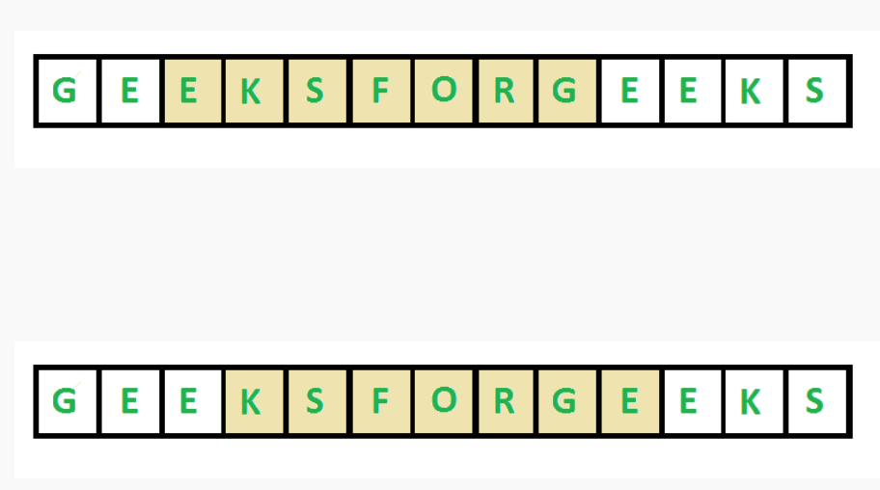

This problem follows the **Sliding Window pattern**, and we can use a similar dynamic *sliding window* strategy as discussed in **Longest Substring with K Distinct Characters**. We can use a **HashMap** to remember the last index of each character we have processed. Whenever we get a repeating character, we will shrink our *sliding window* to ensure that we always have distinct characters in the *sliding window*.

|  |
| --- |
| package patterns.slidingwindow1;  import java.util.HashMap;  import java.util.Map;  public class NoRepeatSubstring {  public static int nonRepeatSubstring(String word) {  // sliding window with hashmap  int windowStart = 0;  int maxLength = 0;  Map<Character, Integer> charIndexMap = new HashMap<>();  //try to extend the range [windowStart, windowEnd]  for(int windowEnd = 0; windowEnd < word.length(); windowEnd++) {  char endChar = word.charAt(windowEnd);  //if the map already contains the endChar,  //shrink the window from the beginning  //so that we only have on occurrence of endChar  if(charIndexMap.containsKey(endChar)) {  //this is tricky; in the current window,  //we will not have any endChar after  //it's previous index. and if windowStart  //is already ahead of the last index of  //endChar, we'll keep windowStart  windowStart = Math.max(windowStart, charIndexMap.get(endChar) + 1);  }  //insert the endChar into the map  charIndexMap.put(endChar, windowEnd);  //remember the maximum length so far  maxLength = Math.max(maxLength, windowEnd - windowStart + 1);  }  return maxLength;  }  public static void main(String[] args) {  System.out.println(NoRepeatSubstring.nonRepeatSubstring("aabccbb"));//3  System.out.println(NoRepeatSubstring.nonRepeatSubstring("abbbb"));//2  System.out.println(NoRepeatSubstring.nonRepeatSubstring("abccde"));//3  System.out.println(NoRepeatSubstring.nonRepeatSubstring("geeksforgeeks"));//7  }  } |

* The above algorithms time complexity will be O(N), where N is the number of characters in the input string.
* The algorithms space complexity will be O(K), where K is the number of distinct characters in the input string. This also means K<=N, because in the worst case, the whole string might not have any repeating character, so the entire string will be added to the **HashMap**. Having said that, since we can expect a fixed set of characters in the input string (e.g., 26 for English letters), we can say that the algorithm runs in fixed space O(1); in this case, we can use a fixed-size array instead of the **HashMap**.

## Longest Substring with Same Letters after Replacement (hard)

<https://leetcode.com/problems/longest-repeating-character-replacement/>

### **Problem Statement**

Given a string with lowercase letters only, if you are allowed to **replace no more than K letters** with any letter, find the **length of the longest substring having the same letters** after replacement.

**Example 1:**

Input: String="aabccbb", k=2

Output: 5

Explanation: Replace the two 'c' with 'b' to have a longest repeating substring "bbbbb".

**Example 2:**

Input: String="abbcb", k=1

Output: 4

Explanation: Replace the 'c' with 'b' to have a longest repeating substring "bbbb".

**Example 3:**

Input: String="abccde", k=1

Output: 3

Explanation: Replace the 'b' or 'd' with 'c' to have the longest repeating substring "ccc".

### **Solution**

This problem follows the **Sliding Window pattern**, and we can use a similar dynamic *sliding window* strategy as discussed in **Longest Substring with Distinct Characters**. We can use a **HashMap** to count the frequency of each letter.

* We will iterate through the string to add one letter at a time in the window.
* We will also keep track of the count of the maximum repeating letter in any window (lets call it maxRepeatLetterCount).
* So, at any time, we know that we do have a window with one letter repeating maxRepeatLetterCount times; this means we should try to replace the remaining letters.
  + If the remaining letters are less than or equal to K, we can replace them all.
  + If we have more than K remaining letters, we should shrink the window as we cannot replace more than K letters.

While shrinking the window, we dont need to update maxRepeatLetterCount (hence, it represents the maximum repeating count of ANY letter for ANY window). Why dont we need to update this count when we shrink the window? Since we have to replace all the remaining letters to get the longest substring having the same letter in any window, we cant get a better answer from any other window even though all occurrences of the letter with frequency maxRepeatLetterCount is not in the current window.

While shrinking the window, we don’t need to update maxRepeatLetterCount. Since we are only interested in the longest valid substring, our sliding windows do not have to shrink, even if a window may cover an invalid substring. Either we expand the window by appending a character to the right or we shift the entire window to the right by one. We only expand the window when the frequency of the newly added character exceeds the historical maximum frequency (from a previous window that included a valid substring). In other words, we do not need to know the exact maximum count of the current window. The only thing we need to know is whether the maximum count exceeds the historical maximum count, and that can only happen because of the newly added char.

### Code

|  |
| --- |
| import java.util.*;  class Solution {  public static int findLength(String str, int k) {  int windowStart = 0, maxLength = 0, maxRepeatLetterCount = 0;  Map<Character, Integer> letterFrequencyMap = new HashMap<>();  // try to extend the range [windowStart, windowEnd]  for (int windowEnd = 0; windowEnd < str.length(); windowEnd++) {  char rightChar = str.charAt(windowEnd);  letterFrequencyMap.put(rightChar,  letterFrequencyMap.getOrDefault(rightChar, 0) + 1);  // we don't need to place the maxRepeatLetterCount under the below 'if', see the  // explanation in the 'Solution' section above.  maxRepeatLetterCount =  Math.max(maxRepeatLetterCount, letterFrequencyMap.get(rightChar));  // current window size is from windowStart to windowEnd, overall we have a letter  // which is repeating 'maxRepeatLetterCount' times, this means we can have a window  // which has one letter repeating 'maxRepeatLetterCount' times and the remaining  // letters we should replace. If the remaining letters are more than 'k', it is the  // time to shrink the window as we are not allowed to replace more than 'k' letters  if (windowEnd - windowStart + 1 - maxRepeatLetterCount > k) {  char leftChar = str.charAt(windowStart);  letterFrequencyMap.put(leftChar, letterFrequencyMap.get(leftChar) - 1);  windowStart++;  }  maxLength = Math.max(maxLength, windowEnd - windowStart + 1);  }  return maxLength;  }  public static void main(String[] args) {  System.out.println(Solution.findLength("aabccbb", 2));  System.out.println(Solution.findLength("abbcb", 1));  System.out.println(Solution.findLength("abccde", 1));  }  } |

* The above algorithms time complexity will be O(N), where N is the number of letters in the input string.
* As we expect only the lower case letters in the input string, we can conclude that the space complexity will be O(26) to store each letters frequency in the **HashMap**, which is asymptotically equal to O(1).

## Longest Subarray with Ones after Replacement (hard)

<https://leetcode.com/problems/max-consecutive-ones-iii/>

### **Problem Statement**

Given an array containing 0's and 1's, if you are allowed to **replace no more than K 0's with 1's**, find the length of the **longest contiguous subarray having all 1's**.

Example 1:

Input: Array=[0, 1, 1, 0, 0, 0, 1, 1, 0, 1, 1], k=2

Output: 6

Explanation: Replace the '0' at index 5 and 8 to have the longest contiguous subarray of 1s having length 6.

Example 2:

Input: Array=[0, 1, 0, 0, 1, 1, 0, 1, 1, 0, 0, 1, 1], k=3

Output: 9

Explanation: Replace the '0' at index 6, 9, and 10 to have the longest contiguous subarray of 1s having length 9.

### **Solution**

This problem follows the **Sliding Window pattern** and is quite similar to **Longest Substring with same Letters after Replacement**. The only difference is that, in the problem, we only have two characters (1's and 0's) in the input arrays.

Following a similar approach, well iterate through the array to add one number at a time in the window. Well also keep track of the maximum number of repeating 1's in the current window (lets call it maxOnesCount). So at any time, we know that we can have a window with 1's repeating maxOnesCount time, so we should try to replace the remaining 0's. If we have more than K remaining 0's, we should shrink the window as we are not allowed to replace more than K 0's.

### **Code**

Here is what our algorithm will look like:

|  |
| --- |
| class Solution {  public static int findLength(int[] arr, int k) {  int windowStart = 0, maxLength = 0, maxOnesCount = 0;  // try to extend the range [windowStart, windowEnd]  for (int windowEnd = 0; windowEnd < arr.length; windowEnd++) {  if (arr[windowEnd] == 1)  maxOnesCount++;  // current window size is from windowStart to windowEnd, overall we have a maximum  // of 1s repeating a maximum of 'maxOnesCount' times, this means that we can have a  // window with 'maxOnesCount' 1s and the remaining are 0s which should replace  // with 1s. Now, if the remaining 0s are more than 'k', it is the time to shrink  // the window as we are not allowed to replace more than 'k' Os.  if (windowEnd - windowStart + 1 - maxOnesCount > k) {  if (arr[windowStart] == 1)  maxOnesCount--;  windowStart++;  }  maxLength = Math.max(maxLength, windowEnd - windowStart + 1);  }  return maxLength;  }  public static void main(String[] args) {  System.out.println(  Solution.findLength(new int[] { 0, 1, 1, 0, 0, 0, 1, 1, 0, 1, 1 }, 2));  System.out.println(  Solution.findLength(new int[] { 0, 1, 0, 0, 1, 1, 0, 1, 1, 0, 0, 1, 1 }, 3));  }  } |

* The above algorithms time complexity will be O(N), where N is the count of numbers in the input array.
* The algorithm runs in constant space O(1).

## 🌟 Permutation in a String (hard)

<https://leetcode.com/problems/permutation-in-string/>

### Problem Statement

Given a string and a pattern, find out if the **string contains any permutation of the pattern**.

**Permutation** is defined as the re-arranging of the characters of the string. For example, “abc” has the following six permutations:

* abc
* acb
* bac
* bca
* cab
* cba

If a string has n distinct characters, it will have n! permutations.

Example 1:

Input: String="oidbcaf", Pattern="ABC"

Output: true

Explanation: The string contains "bca" which is a permutation of the given pattern.

Example 2:

Input: String="odicf", Pattern="dc"

Output: false

Explanation: No permutation of the pattern is present in the given string as a substring.

Example 3:

Input: String="bcdxabcdy", Pattern="bcdyabcdx"

Output: true

Explanation: Both the string and the pattern are a permutation of each other.

Example 4:

Input: String="aaacb", Pattern="abc"

Output: true

Explanation: The string contains "acb" which is a permutation of the given pattern.

### **Solution**

This problem follows the **Sliding Window pattern**, and we can use a similar *sliding window* strategy as discussed in [**Longest Substring with K Distinct Characters**](https://github.com/maazshaikh007/DSA_Patterns/blob/main/%E2%9C%85%20%20Pattern%2001%20:%20Sliding%20Window.md#longest-substring-with-k-distinct-characters-medium). We can use a **HashMap** to remember the frequencies of all characters in the given pattern. Our goal will be to match all the characters from this **HashMap** with a*sliding window*in the given string. Here are the steps of our algorithm:

* Create a **HashMap** to calculate the frequencies of all characters in the pattern.
* Iterate through the string, adding one character at a time in the *sliding window*.
* If the character being added matches a character in the **HashMap**, decrement its frequency in the map. If the character frequency becomes zero, we got a complete match.
* If at any time, the number of characters matched is equal to the number of distinct characters in the pattern (i.e., total characters in the **HashMap**), we have gotten our required permutation.
* If the window size is greater than the length of the pattern, shrink the window to make it equal to the patterns size. At the same time, if the character going out was part of the pattern, put it back in the frequency **HashMap**.

### Code

|  |
| --- |
| import java.util.*;  class Solution {  public static boolean findPermutation(String str, String pattern) {  int windowStart = 0, matched = 0;  Map<Character, Integer> charFrequencyMap = new HashMap<>();  for (char chr : pattern.toCharArray())  charFrequencyMap.put(chr, charFrequencyMap.getOrDefault(chr, 0) + 1);  // our goal is to match all the characters from the 'charFrequencyMap' with the  // current window try to extend the range [windowStart, windowEnd]  for (int windowEnd = 0; windowEnd < str.length(); windowEnd++) {  char rightChar = str.charAt(windowEnd);  if (charFrequencyMap.containsKey(rightChar)) {  // decrement the frequency of the matched character  charFrequencyMap.put(rightChar, charFrequencyMap.get(rightChar) - 1);  if (charFrequencyMap.get(rightChar) == 0) // character is completely matched  matched++;  }  if (matched == charFrequencyMap.size())  return true;  if (windowEnd >= pattern.length() - 1) { // shrink the window by one character  char leftChar = str.charAt(windowStart++);  if (charFrequencyMap.containsKey(leftChar)) {  if (charFrequencyMap.get(leftChar) == 0)  matched--; // before putting the char back, decrement the matched count  // put the character back for matching  charFrequencyMap.put(leftChar, charFrequencyMap.get(leftChar) + 1);  }  }  }  return false;  }  public static void main(String[] args) {  System.out.println("Permutation exist: "  + Solution.findPermutation("oidbcaf", "abc"));  System.out.println("Permutation exist: "  + Solution.findPermutation("odicf", "dc"));  System.out.println("Permutation exist: "  + Solution.findPermutation("bcdxabcdy", "bcdyabcdx"));  System.out.println("Permutation exist: "  + Solution.findPermutation("aaacb", "abc"));  }  } |

* The above algorithms time complexity will be O(N + M), where N and M are the number of characters in the input string and the pattern, respectively.
* The algorithms space complexity is O(M) since, in the worst case, the whole pattern can have distinct characters that will go into the **HashMap**.

**🌟 String Anagrams (hard)**

<https://leetcode.com/problems/find-all-anagrams-in-a-string/>

### Problem Statement

Given a string and a pattern, **find all anagrams of the pattern in the given string**.

Every **anagram** is a **permutation** of a string.

As we know, when we are not allowed to repeat characters while finding permutations of a string, we get N! permutations (or anagrams) of a string having N characters. For example, here are the six anagrams of the string “abc”:

* abc
* acb
* bac
* bca
* cab
* cba

Write a function to return a list of starting indices of the anagrams of the pattern in the given string.

Example 1:

Input: String="ppqp", Pattern="pq"

Output: [1, 2]

Explanation: The two anagrams of the pattern in the given string are "pq" and "qp".

Example 2:

Input: String="abbcabc", Pattern="abc"

Output: [2, 3, 4]

Explanation: The three anagrams of the pattern in the given string are "bca", "cab", and "abc".

### **Solution**

This problem follows the **Sliding Window pattern** and is very similar to **Permutation in a String**. In this problem, we need to find every occurrence of any permutation of the pattern in the string. We will use a list to store the starting indices of the anagrams of the pattern in the string.

### **Code**

Here is what our algorithm will look like:

|  |
| --- |
| import java.util.*;  class Solution {  public static List<Integer> findStringAnagrams(String str, String pattern) {  int windowStart = 0, matched = 0;  Map<Character, Integer> charFrequencyMap = new HashMap<>();  for (char chr : pattern.toCharArray())  charFrequencyMap.put(chr, charFrequencyMap.getOrDefault(chr, 0) + 1);  List<Integer> resultIndices = new ArrayList<Integer>();  // our goal is to match all the characters from the map with the current window  for (int windowEnd = 0; windowEnd < str.length(); windowEnd++) {  char rightChar = str.charAt(windowEnd);  // decrement the frequency of the matched character  if (charFrequencyMap.containsKey(rightChar)) {  charFrequencyMap.put(rightChar, charFrequencyMap.get(rightChar) - 1);  if (charFrequencyMap.get(rightChar) == 0)  matched++;  }  if (matched == charFrequencyMap.size()) // have we found an anagram?  resultIndices.add(windowStart);  if (windowEnd >= pattern.length() - 1) { // shrink the window  char leftChar = str.charAt(windowStart++);  if (charFrequencyMap.containsKey(leftChar)) {  if (charFrequencyMap.get(leftChar) == 0)  matched--; // before putting the character back, decrement the matched count  // put the character back  charFrequencyMap.put(leftChar, charFrequencyMap.get(leftChar) + 1);  }  }  }  return resultIndices;  }  public static void main(String[] args) {  System.out.println(Solution.findStringAnagrams("ppqp", "pq"));  System.out.println(Solution.findStringAnagrams("abbcabc", "abc"));  }  } |

* The time complexity of the above algorithm will be O(N + M) where N and M are the number of characters in the input string and the pattern respectively.
* The space complexity of the algorithm is O(M) since in the worst case, the whole pattern can have distinct characters which will go into the **HashMap**. In the worst case, we also need O(N) space for the result list, this will happen when the pattern has only one character and the string contains only that character.

## 🌟 Smallest Window containing Substring (hard)

<https://leetcode.com/problems/minimum-window-substring/>

### **Problem Statement**

Given a string and a pattern, find the **smallest substring** in the given string which has **all the characters of the given pattern**.

Example 1:

Input: String="aabdec", Pattern="abc"

Output: "abdec"

Explanation: The smallest substring having all characters of the pattern is "abdec"

Example 2:

Input: String="aabdec", Pattern="abac"

Output: "aabdec"

Explanation: The smallest substring having all characters occurrences of the pattern is "aabdec"

Example 3:

Input: String="abdbca", Pattern="abc"

Output: "bca"

Explanation: The smallest substring having all characters of the pattern is "bca".

Example 4:

Input: String="adcad", Pattern="abc"

Output: ""

Explanation: No substring in the given string has all characters of the pattern

### Solution

This problem follows the **Sliding Window pattern** and has a lot of similarities with **Permutation in a String** with one difference. In this problem, we need to find a substring having all characters of the pattern which means that the required substring can have some additional characters and doesnt need to be a permutation of the pattern. Here is how we will manage these differences:

1. We will keep a running count of every matching instance of a character.
2. Whenever we have matched all the characters, we will try to shrink the window from the beginning, keeping track of the smallest substring that has all the matching characters.
3. We will stop the shrinking process as soon as we remove a matched character from the *sliding window*. One thing to note here is that we could have redundant matching characters, e.g., we might have two ‘a’ in the *sliding window* when we only need one ‘a’. In that case, when we encounter the first ‘a’, we will simply shrink the window without decrementing the matched count. We will decrement the matched count when the second ‘a’ goes out of the window.

### Code

Here is what our algorithm will look:

|  |
| --- |
| import java.util.*;  class Solution {  public static String findSubstring(String str, String pattern) {  int windowStart = 0, matched = 0, minLength = str.length() + 1, subStrStart = 0;  Map<Character, Integer> charFrequencyMap = new HashMap<>();  for (char chr : pattern.toCharArray())  charFrequencyMap.put(chr, charFrequencyMap.getOrDefault(chr, 0) + 1);  // try to extend the range [windowStart, windowEnd]  for (int windowEnd = 0; windowEnd < str.length(); windowEnd++) {  char rightChar = str.charAt(windowEnd);  if (charFrequencyMap.containsKey(rightChar)) {  charFrequencyMap.put(rightChar, charFrequencyMap.get(rightChar) - 1);  if (charFrequencyMap.get(rightChar) >= 0) // count every matching of a character  matched++;  }  // shrink the window if we can, finish as soon as we remove a matched character  while (matched == pattern.length()) {  if (minLength > windowEnd - windowStart + 1) {  minLength = windowEnd - windowStart + 1;  subStrStart = windowStart;  }  char leftChar = str.charAt(windowStart++);  if (charFrequencyMap.containsKey(leftChar)) {  // note that we could have redundant matching characters, therefore we'll  // decrement the matched count only when a useful occurrence of a matched  // character is going out of the window  if (charFrequencyMap.get(leftChar) == 0)  matched--;  charFrequencyMap.put(leftChar, charFrequencyMap.get(leftChar) + 1);  }  }  }  return  minLength > str.length() ? "" : str.substring(subStrStart, subStrStart + minLength);  }  public static void main(String[] args) {  System.out.println(Solution.findSubstring("aabdec", "abc"));  System.out.println(Solution.findSubstring("aabdec", "abac"));  System.out.println(Solution.findSubstring("abdbca", "abc"));  System.out.println(Solution.findSubstring("adcad", "abc"));  }  } |

* The time complexity of the above algorithm will be O(N + M) where N and M are the number of characters in the input string and the pattern respectively.
* The space complexity of the algorithm is O(M) since in the worst case, the whole pattern can have distinct characters which will go into the **HashMap**. In the worst case, we also need O(N) space for the resulting substring, which will happen when the input string is a permutation of the pattern.

## 🌟 Words Concatenation (hard)

<https://leetcode.com/problems/substring-with-concatenation-of-all-words/>

### **Problem Statement**

Given a string and a list of words, find all the starting indices of substrings in the given string that are a **concatenation of all the given words** exactly once without any **overlapping of words**. It is given that all words are of the same length.

Example 1:

Input: String="catfoxcat", Words=["cat", "fox"]

Output: [0, 3]

Explanation: The two substring containing both the words are "catfox" & "foxcat".

Example 2:

Input: String="catcatfoxfox", Words=["cat", "fox"]

Output: [3]

Explanation: The only substring containing both the words is "catfox".

### **Solution**

This problem follows the **Sliding Window pattern** and has a lot of similarities with [**Maximum Sum Subarray of Size K**](https://github.com/maazshaikh007/DSA_Patterns/blob/main/%E2%9C%85%20%20Pattern%2001%20:%20Sliding%20Window.md#maximum-sum-subarray-of-size-k-easy). We will keep track of all the words in a **HashMap** and try to match them in the given string. Here are the set of steps for our algorithm:

1. Keep the frequency of every word in a **HashMap**.
2. Starting from every index in the string, try to match all the words.
3. In each iteration, keep track of all the words that we have already seen in another **HashMap**.
4. If a word is not found or has a higher frequency than required, we can move on to the next character in the string.
5. Store the index if we have found all the words.

### Code

|  |
| --- |
| import java.util.*;  class Solution {  public static List<Integer> findWordConcatenation(String str, String[] words) {  Map<String, Integer> wordFrequencyMap = new HashMap<>();  for (String word : words)  wordFrequencyMap.put(word, wordFrequencyMap.getOrDefault(word, 0) + 1);  List<Integer> resultIndices = new ArrayList<Integer>();  int wordsCount = words.length, wordLength = words[0].length();  for (int i = 0; i <= str.length() - wordsCount * wordLength; i++) {  Map<String, Integer> wordsSeen = new HashMap<>();  for (int j = 0; j < wordsCount; j++) {  int nextWordIndex = i + j * wordLength;  // get the next word from the string  String word = str.substring(nextWordIndex, nextWordIndex + wordLength);  if (!wordFrequencyMap.containsKey(word)) // break if we don't need this word  break;  // add the word to the 'wordsSeen' map  wordsSeen.put(word, wordsSeen.getOrDefault(word, 0) + 1);  // no need to process further if the word has higher frequency than required  if (wordsSeen.get(word) > wordFrequencyMap.getOrDefault(word, 0))  break;  if (j + 1 == wordsCount) // store index if we have found all the words  resultIndices.add(i);  }  }  return resultIndices;  }  public static void main(String[] args) {  List<Integer> result = Solution.findWordConcatenation(  "catfoxcat", new String[] { "cat", "fox" });  System.out.println(result);  result = Solution.findWordConcatenation(  "catcatfoxfox", new String[] { "cat", "fox" });  System.out.println(result);  }  } |

* The time complexity of the above algorithm will be O(N * M * Len) where N is the number of characters in the given string, M is the total number of words, and Len is the length of a word.
* The space complexity of the algorithm is O(M) since at most, we will be storing all the words in the two **HashMaps**. In the worst case, we also need O(N) space for the resulting list. So, the overall space complexity of the algorithm will be O(M+N).

**Pattern 2: Two Pointers**

In problems where we deal with sorted arrays (or **LinkedList**s) and need to find a set of elements that fulfill certain constraints, the **two pointers** approach becomes quite useful. The set of elements could be a pair, a triplet or even a subarray. For example, take a look at the following problem:

Given an array of sorted numbers and a target sum, find a pair in the array whose sum is equal to the given target.

To solve this problem, we can consider each element one by one (pointed out by the first pointer) and iterate through the remaining elements (pointed out by the second pointer) to find a pair with the given sum. The **time complexity** of this algorithm will be O(N^2) where N is the number of elements in the input array.

Given that the input array is sorted, an efficient way would be to start with one pointer in the beginning and another pointer at the end. At every step, we will see if the numbers pointed by the **two pointers** add up to the target sum. If they do not, we will do one of two things:

1. If the sum of the two numbers pointed by the **two pointers** is greater than the target sum, this means that we need a pair with a smaller sum. So, to try more pairs, we can decrement the end-pointer.
2. If the sum of the two numbers pointed by the **two pointers** is smaller than the target sum, this means that we need a pair with a larger sum. So, to try more pairs, we can increment the start-pointer.

Here is the visual representation of this algorithm:

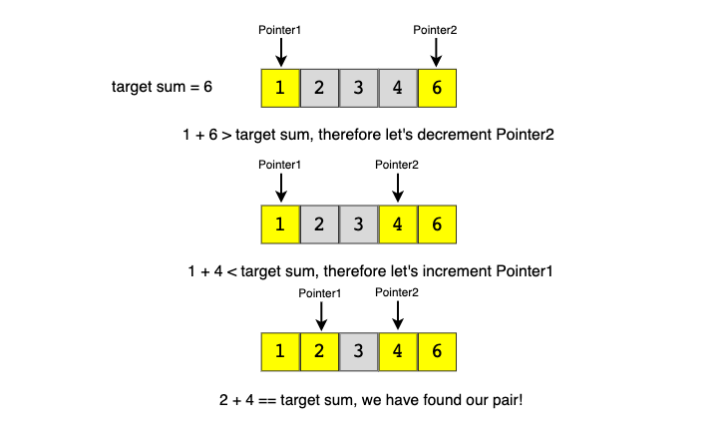

The time complexity of the above algorithm will be O(N).

In the following chapters, we will apply the **Two Pointers** approach to solve a few problems.

**🌴 Pair with Target Sum aka "Two Sum" (easy)**

<https://leetcode.com/problems/two-sum/>

### Problem Statement

Given an array of sorted numbers and a target sum, find a pair in the array whose sum is equal to the given target.

Write a function to return the indices of the two numbers (i.e. the pair) such that they add up to the given target.

Example 1:

Input: [1, 2, 3, 4, 6], target=6

Output: [1, 3]

Explanation: The numbers at index 1 and 3 add up to 6: 2+4=6

Example 2:

Input: [2, 5, 9, 11], target=11

Output: [0, 2]

Explanation: The numbers at index 0 and 2 add up to 11: 2+9=11

### Solution

Since the given array is sorted, a brute-force solution could be to iterate through the array, taking one number at a time and searching for the second number through **Binary Search**. The **time complexity** of this algorithm will be O(N*logN). Can we do better than this?

We can follow the **Two Pointers** approach. We will start with one pointer pointing to the beginning of the array and another pointing at the end. At every step, we will see if the numbers pointed by the **two pointers** add up to the target sum. If they do, we have found our pair; otherwise, we will do one of two things:

1. If the sum of the two numbers pointed by the **two pointers** is greater than the target sum, this means that we need a pair with a smaller sum. So, to try more pairs, we can decrement the end-pointer.
2. If the sum of the two numbers pointed by the **two pointers** is smaller than the target sum, this means that we need a pair with a larger sum. So, to try more pairs, we can increment the start-pointer.

Here is the visual representation of this algorithm for Example-1:

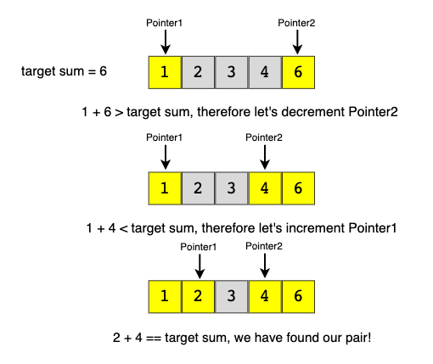

**Brute Force Solution**

function pairWithTargetSum(nums, target) {

for (let i = 0; i < nums.length; i++) {

for(let j = 1; j < nums.length; j++) {

if((nums[i] + nums[j]) === target) {

//they cannot be at the same index

if(i !== j) {

return [i, j]

}

}

}

}

}

**Two pointer Solution**

Assume the input is sorted

|  |
| --- |
| class Solution {  public static int[] search(int[] arr, int targetSum) {  int left = 0, right = arr.length - 1;  while (left < right) {  int currentSum = arr[left] + arr[right];  if (currentSum == targetSum)  return new int[] { left, right }; // found the pair  if (targetSum > currentSum)  left++; // we need a pair with a bigger sum  else  right--; // we need a pair with a smaller sum  }  return new int[] { -1, -1 };  }  public static void main(String[] args) {  int[] result = Solution.search(new int[] { 1, 2, 3, 4, 6 }, 6);  System.out.println("Pair with target sum: [" + result[0] + ", " + result[1] + "]");  result = Solution.search(new int[] { 2, 5, 9, 11 }, 11);  System.out.println("Pair with target sum: [" + result[0] + ", " + result[1] + "]");  }  } |

* The **time complexity** of the above algorithm will be O(N), where N is the total number of elements in the given array.
* The algorithm runs in constant space O(1).

**❗ Hash Table Solution**

Instead of using a two-pointer or a binary search approach, we can utilize a **HashTable** to search for the required pair. We can iterate through the array one number at a time. Let’s say during our iteration we are at number X, so we need to find Y such that “X + Y == Target”. We will do two things here:

1. Search for Y (which is equivalent to “Target - X”) in the HashTable. If it is there, we have found the required pair.
2. Otherwise, insert “X” in the HashTable, so that we can search it for the later numbers.

|  |
| --- |
| import java.util.HashMap;  class Solution {  public static int[] search(int[] arr, int targetSum) {  HashMap<Integer, Integer> nums = new HashMap<>(); // to store numbers and indices  for (int i = 0; i < arr.length; i++) {  if (nums.containsKey(targetSum - arr[i]))  return new int[] { nums.get(targetSum - arr[i]), i };  else  nums.put(arr[i], i); // put the number and its index in the map  }  return new int[] { -1, -1 }; // pair not found  }  public static void main(String[] args) {  int[] result = Solution.search(new int[] { 1, 2, 3, 4, 6 }, 6);  System.out.println("Pair with target sum: [" + result[0] + ", " + result[1] + "]");  result = Solution.search(new int[] { 2, 5, 9, 11 }, 11);  System.out.println("Pair with target sum: [" + result[0] + ", " + result[1] + "]");  }  } |

* The **time complexity** of the above algorithm will be O(N), where N is the total number of elements in the given array.
* The **space complexity** will also be O(N), as, in the worst case, we will be pushing N numbers in the HashTable.

#### Java Solution

|  |
| --- |
| public int[] twoSum(int[] nums, int target) {  Map<Integer, Integer> map = new HashMap<>();  for(int i = 0; i < nums.length; i++){  int complement = target - nums[i];  if(map.containsKey(complement)){  return new int[]{map.get(complement), i};  }  map.put(nums[i],i);  }  return null;  } |

**Remove Duplicates (easy)**

<https://leetcode.com/problems/remove-duplicates-from-sorted-array/>

### Problem Statement

Given an array of sorted numbers, **remove all duplicates** from it. You should **not use any extra space**; after removing the duplicates in-place return the length of the subarray that has no duplicate in it.

Example 1:

Input: [2, 3, 3, 3, 6, 9, 9]

Output: 4

Explanation: The first four elements after removing the duplicates will be [2, 3, 6, 9].

Example 2:

Input: [2, 2, 2, 11]

Output: 2

Explanation: The first two elements after removing the duplicates will be [2, 11].

### Solution

In this problem, we need to remove the duplicates in-place such that the resultant length of the array remains sorted. As the input array is sorted, therefore, one way to do this is to shift the elements left whenever we encounter duplicates. In other words, we will keep one pointer for iterating the array and one pointer for placing the next non-duplicate number. So our algorithm will be to iterate the array and whenever we see a non-duplicate number we move it next to the last non-duplicate number we’ve seen.

Here is the visual representation of this algorithm for Example-1:

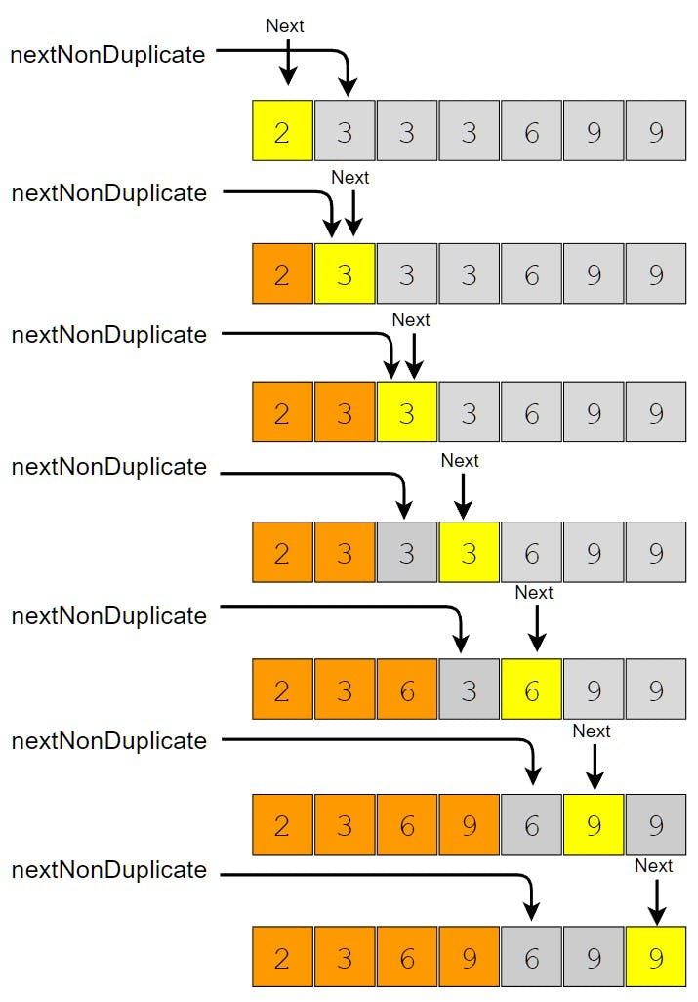

**Assume the input is sorted**

|  |
| --- |
| class Solution {  public static int remove(int[] arr) {  int nextNonDuplicate = 1; // index of the next non-duplicate element  for (int i = 0; i < arr.length; i++) {  if (arr[nextNonDuplicate - 1] != arr[i]) {  arr[nextNonDuplicate] = arr[i];  nextNonDuplicate++;  }  }  return nextNonDuplicate;  }  public static void main(String[] args) {  int[] arr = new int[] { 2, 3, 3, 3, 6, 9, 9 };  System.out.println(Solution.remove(arr));  arr = new int[] { 2, 2, 2, 11 };  System.out.println(Solution.remove(arr));  }  } |

* The **time complexity** of the above algorithm will be O(N), where N is the total number of elements in the given array.
* The algorithm runs in constant space O(1).

### Java Solution

|  |
| --- |
| public int removeDuplicates(int[] nums) {  int j=1;  for(int i= 1; i< nums.length; i++){  if(nums[i] != nums[i-1]){  nums[j++] = nums[i];  }  }  return j;  } |

## Remove Element

<https://leetcode.com/problems/remove-element/>

Given an unsorted array of numbers and a target key, remove all instances of key in-place and return the new length of the array.

Example 1:

Input: [3, 2, 3, 6, 3, 10, 9, 3], Key=3

Output: 4

Explanation: The first four elements after removing every 'Key' will be [2, 6, 10, 9].

Example 2:

Input: [2, 11, 2, 2, 1], Key=2

Output: 2

Explanation: The first two elements after removing every 'Key' will be [11, 1].

|  |
| --- |
| class Solution {  public static int remove(int[] arr, int key) {  int nextElement = 0; // index of the next element which is not 'key'  for (int i = 0; i < arr.length; i++) {  if (arr[i] != key) {  arr[nextElement] = arr[i];  nextElement++;  }  }  return nextElement;  }  public static void main(String[] args) {  int[] arr = new int[] { 3, 2, 3, 6, 3, 10, 9, 3 };  System.out.println(Solution.remove(arr, 3));  arr = new int[] { 2, 11, 2, 2, 1 };  System.out.println(Solution.remove(arr, 2));  }  } |

* The **time complexity** of the above algorithm will be O(N), where N is the total number of elements in the given array.
* The algorithm runs in constant space O(1).

|  |
| --- |
| public int removeElement(int[] nums, int val) {  int nextElement = 0;  for(int num : nums){  if(num != val){  nums[nextElement++] = num;  }  }  return nextElement;  } |

**Squaring a Sorted Array (easy)**

<https://leetcode.com/problems/squares-of-a-sorted-array/>

### Problem Statement

Given a sorted array, create a new array containing squares of all the numbers of the input array in the sorted order.

Example 1:

Input: [-2, -1, 0, 2, 3]

Output: [0, 1, 4, 4, 9]

Example 2:

Input: [-3, -1, 0, 1, 2]

Output: [0, 1, 1, 4, 9]

### Solution

We can use a brute-force approach to iterate the input array and calculate the square of each number. We can store these squares in a new array and then sort the resulting array using any sorting algorithm like Quicksort or Mergesort. Because of the sorting, this approach has a time complexity of , where is the length of the input array. Here is a Python solution for this approach:

def sorted_squares(nums): return sorted([num**2 for num in nums])

Can we do better than this? Can we avoid sorting? Is it possible to generate the output in sorted order?

This is a straightforward question. The only trick is that we can have negative numbers in the input array, which will make it a bit difficult to generate the output array with squares in sorted order.

An easier approach could be to first find the index of the first non-negative number in the array. After that, we can use **Two Pointers** to iterate the array. One pointer will move forward to iterate the non-negative numbers, and the other pointer will move backward to iterate the negative numbers. At any step, whichever number gives us a bigger square will be added to the output array.

For the above-mentioned Example-1, we will do something like this:

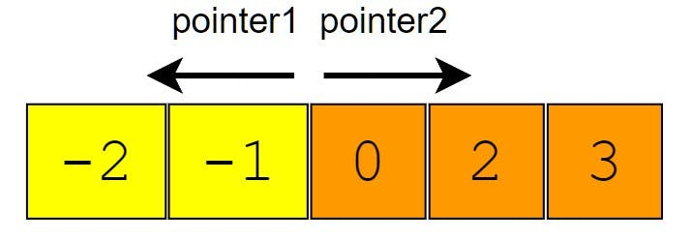

Since the numbers at both ends can give us the largest square, an alternate approach could be to use **two pointers** starting at both ends of the input array. At any step, whichever pointer gives us the bigger square, we add it to the result array and move to the next/previous number according to the number. Please note that we will be appending the bigger square (as opposed to the previous approach) because the two pointers are moving from larger squares to smaller squares. For that, we will be inserting the squares at the end of the output array.

For the above-mentioned Example-1, we will do something like this:

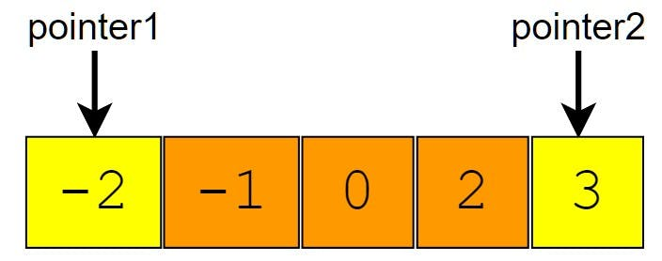

### Code

Here is the code for the second approach discussed above:

|  |
| --- |
| class Solution {  public static int[] makeSquares(int[] arr) {  int n = arr.length;  int[] squares = new int[n];  int highestSquareIdx = n - 1;  int left = 0, right = arr.length - 1;  while (left <= right) {  int leftSquare = arr[left] * arr[left];  int rightSquare = arr[right] * arr[right];  if (leftSquare > rightSquare) {  squares[highestSquareIdx--] = leftSquare;  left++;  } else {  squares[highestSquareIdx--] = rightSquare;  right--;  }  }  return squares;  }  public static void main(String[] args) {  int[] result = Solution.makeSquares(new int[] { -2, -1, 0, 2, 3 });  for (int num : result)  System.out.print(num + " ");  System.out.println();  result = Solution.makeSquares(new int[] { -3, -1, 0, 1, 2 });  for (int num : result)  System.out.print(num + " ");  System.out.println();  }  } |

* The above algorithm’s **time complexity** will be O(N) as we are iterating the input array only once.
* The above algorithm’s **space complexity** will also be O(N); this space will be used for the output array.

### Java Solution

|  |
| --- |
| public int[] sortedSquares(int[] nums) {  int n = nums.length;  int start = 0;  int end = n-1;  int highestSquare = n-1;  int[] res = new int[n];  while(start<=end){  int startSquare = nums[start] * nums[start];  int endSquare = nums[end] * nums[end];    if(startSquare>endSquare){  res[highestSquare--] = startSquare;  start++;  }else{  res[highestSquare--] = endSquare;  end--;  }  }  return res;  } |

**🌟 Triplet Sum to Zero (medium)**

<https://leetcode.com/problems/3sum/>

### Problem Statement

Given an array of unsorted numbers, find all unique triplets in it that add up to zero.

Example 1:

Input: [-3, 0, 1, 2, -1, 1, -2]

Output: [[-3, 1, 2], [-2, 0, 2], [-2, 1, 1], [-1, 0, 1]]

Explanation: There are four unique triplets whose sum is equal to zero. smallest sum.'

Example 2:

Input: [-5, 2, -1, -2, 3]

Output: [[-5, 2, 3], [-2, -1, 3]]

Explanation: There are two unique triplets whose sum is equal to zero.

### Solution

This problem follows the **Two Pointers** pattern and shares similarities with [Pair with Target Sum](https://github.com/maazshaikh007/DSA_Patterns/blob/main/%E2%9C%85%20%20Pattern%2002:%20Two%20Pointers.md#%F0%9F%8C%B4-pair-with-target-sum-aka-%22two-sum%22-easy). A couple of differences are that the input array is not sorted and instead of a pair we need to find triplets with a target sum of zero.

To follow a similar approach, first, we will sort the array and then iterate through it taking one number at a time. Let’s say during our iteration we are at number X, so we need to find Y and Z such that X + Y + Z == 0. At this stage, our problem translates into finding a pair whose sum is equal to -X (as from the above equation Y + Z == -X).

Another difference from [**Pair with Target Sum**](https://github.com/maazshaikh007/DSA_Patterns/blob/main/%E2%9C%85%20%20Pattern%2002:%20Two%20Pointers.md#%F0%9F%8C%B4-pair-with-target-sum-aka-%22two-sum%22-easy) is that we need to find all the unique triplets. To handle this, we have to skip any duplicate number. Since we will be sorting the array, so all the duplicate numbers will be next to each other and are easier to skip.

### Code

Here is what our algorithm will look like:

|  |
| --- |
| import java.util.*;  class Solution {  public static List<List<Integer>> searchTriplets(int[] arr) {  Arrays.sort(arr);  List<List<Integer>> triplets = new ArrayList<>();  for (int i = 0; i < arr.length - 2; i++) {  if (i > 0 && arr[i] == arr[i - 1]) // skip same element to avoid duplicate triplets  continue;  searchPair(arr, -arr[i], i + 1, triplets);  }  return triplets;  }  private static void searchPair(int[] arr, int targetSum,  int left, List<List<Integer>> triplets) {  int right = arr.length - 1;  while (left < right) {  int currentSum = arr[left] + arr[right];  if (currentSum == targetSum) { // found the triplet  triplets.add(Arrays.asList(-targetSum, arr[left], arr[right]));  left++;  right--;  while (left < right && arr[left] == arr[left - 1])  left++; // skip same element to avoid duplicate triplets  while (left < right && arr[right] == arr[right + 1])  right--; // skip same element to avoid duplicate triplets  } else if (targetSum > currentSum)  left++; // we need a pair with a bigger sum  else  right--; // we need a pair with a smaller sum  }  }  public static void main(String[] args) {  System.out.println(Solution.searchTriplets(  new int[] { -3, 0, 1, 2, -1, 1, -2 }));  System.out.println(Solution.searchTriplets(new int[] { -5, 2, -1, -2, 3 }));  }  } |

* Sorting the array will take O(N * logN). The searchPair() function will take O(N). As we are calling searchPair() for every number in the input array, this means that overall searchTriplets() will take O(N * logN + N^2), which is asymptotically equivalent to O(N^2).
* Ignoring the space required for the output array, the **space complexity** of the above algorithm will be O(N) which is required for sorting.

**Triplet Sum Close to Target (medium)**

<https://leetcode.com/problems/3sum-closest/>

### Problem Statement

Given an array of unsorted numbers and a targetSum, find a **triplet in the array whose sum is as close to the targetSum as possible**, return the sum of the triplet. If there are more than one such triplet, return the sum of the triplet with the smallest sum.

Example 1:

Input: [-1, 0, 2, 3], target=3

Output: 2

Explanation: There are two triplets whose sum is less than the target: [-1, 0, 3], [-1, 0, 2]

Example 2:

Input: [-3, -1, 1, 2], target=1

Output: 0

Explanation: The triplet [-3, 1, 2] has the closest sum to the target.

Example 3:

Input: [1, 0, 1, 1], target=100

Output: 3

Explanation: The triplet [1, 1, 1] has the closest sum to the target.

Example 4:

Input: [0, 0, 1, 1, 2, 6], target=5

Output: 4

Explanation: There are two triplets with distance '1' from target: [1, 1, 2] & [0,0, 6]. Between these two triplets, the correct answer will be [1, 1, 2] as it has a sum '4' which is less than the sum of the other triplet which is '6'. This is because of the following requirement: 'If there are more than one such triplet, return the sum of the triplet with the smallest sum.'

### Solution

This problem follows the **Two Pointers** pattern and is quite similar to [**Triplet Sum to Zero**](https://github.com/maazshaikh007/DSA_Patterns/blob/main/%E2%9C%85%20%20Pattern%2002:%20Two%20Pointers.md#%F0%9F%8C%9F-triplet-sum-to-zero-medium).

We can follow a similar approach to iterate through the array, taking one number at a time. At every step, we will save the difference between the triplet and the targetSum, so that in the end, we can return the triplet with the closest sum.

### Code

|  |
| --- |
| import java.util.*;  class Solution {  public static int searchTriplet(int[] arr, int targetSum) {  if (arr == null || arr.length < 3)  throw new IllegalArgumentException();  Arrays.sort(arr);  int smallestDifference = Integer.MAX_VALUE;  for (int i = 0; i < arr.length - 2; i++) {  int left = i + 1, right = arr.length - 1;  while (left < right) {  // comparing the sum of three numbers to the 'targetSum' can cause overflow  // so, we will try to find a target difference  int targetDiff = targetSum - arr[i] - arr[left] - arr[right];  if (targetDiff == 0) // we've found a triplet with an exact sum  return targetSum; // return sum of all the numbers  // the second part of the above 'if' is to handle the smallest sum when we have  // more than one solution  if (Math.abs(targetDiff) < Math.abs(smallestDifference)  || (Math.abs(targetDiff) == Math.abs(smallestDifference)  && targetDiff > smallestDifference))  smallestDifference = targetDiff; // save the closest and the biggest difference  if (targetDiff > 0)  left++; // we need a triplet with a bigger sum  else  right--; // we need a triplet with a smaller sum  }  }  return targetSum - smallestDifference;  }  public static void main(String[] args) {  System.out.println(  Solution.searchTriplet(new int[] { -2, 0, 1, 2 }, 2));  System.out.println(  Solution.searchTriplet(new int[] { -3, -1, 1, 2 }, 1));  System.out.println(  Solution.searchTriplet(new int[] { 1, 0, 1, 1 }, 100));  System.out.println(  Solution.searchTriplet(new int[] { 0, 0, 1, 1, 2, 6 }, 5));  }  } |

* Sorting the array will take O(N* logN). Overall, the function will take O(N * logN + N^2), which is asymptotically equivalent to O(N^2)
* The above algorithm’s **space complexity** will be O(N), which is required for sorting.

**Triplets with Smaller Sum (medium)**

<https://leetcode.com/problems/3sum-smaller/>

### Problem Statement

Given an array arr of unsorted numbers and a target sum, count all triplets in it such that arr[i] + arr[j] + arr[k] < target where i, j, and k are three different indices. Write a function to return the count of such triplets.

Example 1:

Input: [-1, 0, 2, 3], target=3

Output: 2

Explanation: There are two triplets whose sum is less than the target: [-1, 0, 3], [-1, 0, 2]

Example 2:

Input: [-1, 4, 2, 1, 3], target=5

Output: 4

Explanation: There are four triplets whose sum is less than the target:

[-1, 1, 4], [-1, 1, 3], [-1, 1, 2], [-1, 2, 3]

### Solution

This problem follows the **Two Pointers pattern** and shares similarities with **Triplet Sum to Zero**. The only difference is that, in this problem, we need to find the triplets whose sum is less than the given target. To meet the condition i != j != k we need to make sure that each number is not used more than once.

Following a similar approach, first, we can sort the array and then iterate through it, taking one number at a time. Let’s say during our iteration we are at number X, so we need to find Y and Z such that X + Y + Z < target. At this stage, our problem translates into finding a pair whose sum is less than “target - X” (as from the above equation Y + Z == target - X). We can use a similar approach as discussed in **Triplet Sum to Zero**.

### Code

|  |
| --- |
| import java.util.*;  class Solution {  public static int searchTriplets(int[] arr, int target) {  Arrays.sort(arr);  int count = 0;  for (int i = 0; i < arr.length - 2; i++) {  count += searchPair(arr, target - arr[i], i);  }  return count;  }  private static int searchPair(int[] arr, int targetSum, int first) {  int count = 0;  int left = first + 1, right = arr.length - 1;  while (left < right) {  if (arr[left] + arr[right] < targetSum) { // found the triplet  // since arr[right] >= arr[left], therefore, we can replace arr[right] by any  // number between left and right to get a sum less than the target sum  count += right - left;  left++;  } else {  right--; // we need a pair with a smaller sum  }  }  return count;  }  public static void main(String[] args) {  System.out.println(  Solution.searchTriplets(new int[] { -1, 0, 2, 3 }, 3));  System.out.println(  Solution.searchTriplets(new int[] { -1, 4, 2, 1, 3 }, 5));  }  } |

* Sorting the array will take O(N * logN). The searchPair() will take O(N). So, overall searchTriplets() will take O(N * logN + N^2), which is asymptotically equivalent to O(N^2).
* The **space complexity** of the above algorithm will be O(N) which is required for sorting if we are not using an in-place sorting algorithm.

### Java Solution

|  |
| --- |
| public int threeSumCount(int[] nums, int target){  Arrays.*sort*(nums);  int count = 0;  for(int i = 0; i< nums.length - 2; i++){  count += allTwoSumCount(nums, i, target-nums[i]);  }  return count; } public int allTwoSumCount(int[] nums, int first, int target){  int count = 0;  int end = nums.length - 1;  int start = first + 1;  while(start < end){  if(nums[start] + nums[end] < target){  //we found the a triplet  //since arr[end] >= arr[start], therefore, we can replace arr[end]  //by any number between start and end to get a sum less than the targetSum  count += end - start;  start++;  }else{  end--;  }  }  return count; } |

Write a function to return the list of all such triplets instead of the count. How will the **time complexity** change in this case?

|  |
| --- |
| import java.util.*;  class Solution {  public static List<List<Integer>> searchTriplets(int[] arr, int target) {  Arrays.sort(arr);  List<List<Integer>> triplets = new ArrayList<>();  for (int i = 0; i < arr.length - 2; i++) {  searchPair(arr, target - arr[i], i, triplets);  }  return triplets;  }  private static void searchPair(int[] arr, int targetSum, int first, List<List<Integer>> triplets) {  int left = first + 1, right = arr.length - 1;  while (left < right) {  if (arr[left] + arr[right] < targetSum) { // found the triplet  // since arr[right] >= arr[left], therefore, we can replace arr[right] by any  // number between left and right to get a sum less than the target sum  for (int i = right; i > left; i--)  triplets.add(Arrays.asList(arr[first], arr[left], arr[i]));  left++;  } else {  right--; // we need a pair with a smaller sum  }  }  }  public static void main(String[] args) {  System.out.println(  Solution.searchTriplets(new int[] { -1, 0, 2, 3 }, 3));  System.out.println(  Solution.searchTriplets(new int[] { -1, 4, 2, 1, 3 }, 5));  }  } |

* Sorting the array will take O(N * logN). The searchPair(), in this case, will take O(N^2); the main while loop will run in O(N) but the nested for loop can also take O(N) - this will happen when the target sum is bigger than every triplet in the array. So, overall searchTriplets() will take O(N * logN + N^3), which is asymptotically equivalent to O(N^3).
* Ignoring the space required for the output array, the **space complexity** of the above algorithm will be O(N) which is required for sorting.

### Java Solution

|  |
| --- |
| public int threeSumCount(int[] nums, int target){  Arrays.*sort*(nums);  int count = 0;  for(int i = 0; i< nums.length - 2; i++){  count += allTwoSumCount(nums, i, target-nums[i]);  }  return count; } public int allTwoSumCount(int[] nums, int first, int target){  int count = 0;  int end = nums.length - 1;  int start = first + 1;  while(start < end){  if(nums[start] + nums[end] < target){  //we found the a triplet  //since arr[end] >= arr[start], therefore, we can replace arr[end]  //by any number between start and end to get a sum less than the targetSum  count += end - start;  start++;  }else{  end--;  }  }  return count; } |

**🌟 Subarrays with Product Less than a Target (medium)**

<https://leetcode.com/problems/subarray-product-less-than-k/>

### Problem Statement

Given an array with positive numbers and a targetSum, find all of its contiguous subarrays whose **product is less than the targetSum**.

Example 1:

Input: [2, 5, 3, 10], target=30

Output: [2], [5], [2, 5], [3], [5, 3], [10]

Explanation: There are six contiguous subarrays whose product is less than the target.

Example 2:

Input: [8, 2, 6, 5], target=50

Output: [8], [2], [8, 2], [6], [2, 6], [5], [6, 5]

Explanation: There are seven contiguous subarrays whose product is less than the target.

### Solution

This problem follows the **Sliding Window** and the **Two Pointers** pattern and shares similarities with [**Triplets with Smaller Sum**](https://github.com/maazshaikh007/DSA_Patterns/blob/main/%E2%9C%85%20%20Pattern%2002:%20Two%20Pointers.md#triplets-with-smaller-sum-medium) with two differences:

1. In this problem, the input array is not sorted.
2. Instead of finding triplets with sum less than a target, we need to find all subarrays having a product less than the target. The implementation will be quite similar to [**Triplets with Smaller Sum**](https://github.com/maazshaikh007/DSA_Patterns/blob/main/%E2%9C%85%20%20Pattern%2002:%20Two%20Pointers.md#triplets-with-smaller-sum-medium).

### Code

|  |
| --- |
| import java.util.*;  class Solution {  public static List<List<Integer>> findSubarrays(int[] arr, int target) {  List<List<Integer>> result = new ArrayList<>();  double product = 1;  int left = 0;  for (int right = 0; right < arr.length; right++) {  product *= arr[right];  while (product >= target && left < arr.length)  product /= arr[left++];  // since the product of all numbers from left to right is less than the target  // therefore, all subarrays from left to right will have a product less than the  // target too; to avoid duplicates, we will start with a subarray containing only  // arr[right] and then extend it  List<Integer> tempList = new LinkedList<>();  for (int i = right; i >= left; i--) {  tempList.add(0, arr[i]);  result.add(new ArrayList<>(tempList));  }  }  return result;  }  public static void main(String[] args) {  System.out.println(  Solution.findSubarrays(new int[] { 2, 5, 3, 10 }, 30));  System.out.println(  Solution.findSubarrays(new int[] { 8, 2, 6, 5 }, 50));  }  } |

* The main for-loop managing the sliding window takes O(N) but creating subarrays can take up to O(N^2) in the worst case. Therefore overall, our algorithm will take O(N^3).
* Ignoring the space required for the output list, the algorithm runs in O(N) space which is used for the temp list.

Space Complexity

Ignoring the space required for the output list, the algorithm runs in space which is used for the temp list.

Can you try estimating how much space will be required for the output list?

n + (n-1) + (n-2) + ... 3 + 2 + 1

The worst-case will happen when every subarray has a product less than the target!

So the question will be, how many contiguous subarrays an array can have?

It is definitely not all Permutations of the given array; is it all Combinations of the given array?

It is not all the Combinations of all elements of the array!

For an array with distinct elements, finding all of its contiguous subarrays is like finding the number of ways to choose two indices, i and j, in the array such that i <= j.

If there are a total of n elements in the array, here is how we can count all the contiguous subarrays:

When i = 0, j can have any value from 0 to n-1, giving a total of n choices.

When i = 1, j can have any value from 1 to n-1, giving a total of n-1 choices.

Similarly, when i = 2, j can have n-2 choices. … …

When i = n-1, j can only have only 1 choice.

Let’s combine all the choices:

Which gives us a total of:n*(N+1)/2 .

So, at most, we need space for O(n^2) output lists. At worst, each subarray can take O(n) space, so overall, our algorithm’s space complexity will be O(n^3).

### Java Solution

|  |
| --- |
| public int numSubarrayProductLessThanK(int[] nums, int k){  if(k <= 1) return 0;  int res = 0;  int product = 1;  int left = 0;  for(int right = 0; right < nums.length; right++){  product *= nums[right];  while(product >= k){  product /= nums[left++];  }  res += right - left + 1;  }  return res; }  public List<List<Integer>> subarrayProductLessThanK(int[] nums, int k){  List<List<Integer>> res = new ArrayList<>();  if (nums.length <= 1 || k < 0) {  return res;  }  int product = 1;  int left = 0;  for(int right = 0; right < nums.length; right++){  product *= nums[right];  while(product >= k && left < nums.length){  product /= nums[left++];  }  ArrayList<Integer> subList = new ArrayList<>();  for (int i = right; i > left - 1; i--) {  subList.add(0, nums[i]);  res.add(new ArrayList<>(subList));  }  }  return res; }  public static void main(String[] args) {  SubarraysWithProductLessThanTarget subarraysWithProductLessThanTarget = new SubarraysWithProductLessThanTarget();  int[] nums = new int[]{10,5,2,6};  System.*out*.println(subarraysWithProductLessThanTarget.numSubarrayProductLessThanK(nums, 100));  System.*out*.println(subarraysWithProductLessThanTarget.subarrayProductLessThanK(nums, 100)); } |

**Dutch National Flag Problem (medium)**

<https://leetcode.com/problems/sort-colors/>

### Problem Statement

Given an array containing 0s, 1s and 2s, sort the array in-place. You should treat numbers of the array as objects, hence, we can’t count 0s, 1s, and 2s to recreate the array.

The flag of the Netherlands consists of three colors: red, white and blue; and since our input array also consists of three different numbers that is why it is called **Dutch National Flag problem**.

Example 1:

Input: [1, 0, 2, 1, 0]

Output: [0 0 1 1 2]

Example 2:

Input: [2, 2, 0, 1, 2, 0]

Output: [0 0 1 2 2 2 ]

### Solution

The brute force solution will be to use an *in-place* sorting algorithm like *Heapsort* which will take O(N*logN). Can we do better than this? Is it possible to sort the array in one iteration?

We can use a **Two Pointers** approach while iterating through the array. Let’s say the **two pointers** are called low and high which are pointing to the first and the last element of the array respectively. So while iterating, we will move all 0s before low and all 2s after high so that in the end, all 1s will be between low and high.

### Code

|  |
| --- |
| class Solution {  public static void sort(int[] arr) {  // all elements < low are 0 and all elements > high are 2  // all elements from >= low < i are 1  int low = 0, high = arr.length - 1;  for (int i = 0; i <= high;) {  if (arr[i] == 0) {  swap(arr, i, low);  // increment 'i' and 'low'  i++;  low++;  } else if (arr[i] == 1) {  i++;  } else { // the case for arr[i] == 2  swap(arr, i, high);  // decrement 'high' only, after the swap the number at index 'i' could be 0, 1,  // or 2  high--;  }  }  }  private static void swap(int[] arr, int i, int j) {  int temp = arr[i];  arr[i] = arr[j];  arr[j] = temp;  }  public static void main(String[] args) {  int[] arr = new int[] { 1, 0, 2, 1, 0 };  Solution.sort(arr);  for (int num : arr)  System.out.print(num + " ");  System.out.println();  arr = new int[] { 2, 2, 0, 1, 2, 0 };  Solution.sort(arr);  for (int num : arr)  System.out.print(num + " ");  }  } |

* The **time complexity** of the above algorithm will be O(N) as we are iterating the input array only once.
* The algorithm runs in constant space O(1).

### Java Solution

|  |
| --- |
| public class SortColors {   public int[] sortColors(int[] nums){   int i = 0;  int low = 0;  int high = nums.length - 1;   while(i < high){  if(nums[i] == 0){  swap(nums, i, low);  i++;  low++;  }else if(nums[i] == 1){  i++;  }else{  swap(nums, i, high);  high--;  }  }   return nums;  }   public void swap(int[] nums, int i, int j){  int temp = nums[i];  nums[i] = nums[j];  nums[j] = temp;  }  public static void main(String[] args) {  SortColors sortColors = new SortColors();  int[] nums = {2,0,2,1,1,0};  Arrays.*stream*(sortColors.sortColors(nums)).forEach(System.*out*::print);  } } |

**🌟 Quadruple Sum to Target (medium)**

<https://leetcode.com/problems/4sum/>

### Problem Statement

Given an array of unsorted numbers and a targetSum, find all **unique quadruplets** in it, whose **sum is equal to the targetSum**.

Example 1:

Input: [4, 1, 2, -1, 1, -3], target=1

Output: [-3, -1, 1, 4], [-3, 1, 1, 2]

Explanation: Both the quadruplets add up to the target.

Example 2:

Input: [2, 0, -1, 1, -2, 2], target=2

Output: [-2, 0, 2, 2], [-1, 0, 1, 2]

Explanation: Both the quadruplets add up to the target.

### Solution

This problem follows the **Two Pointers** pattern and shares similarities with [**Triplet Sum to Zero**](https://github.com/maazshaikh007/DSA_Patterns/blob/main/%E2%9C%85%20%20Pattern%2002:%20Two%20Pointers.md#%F0%9F%8C%9F-triplet-sum-to-zero-medium).

We can follow a similar approach to iterate through the array, taking one number at a time. At every step during the iteration, we will search for the quadruplets similar to **Triplet Sum to Zero** whose sum is equal to the given target.

### Code

|  |
| --- |
| import java.util.*;  class Solution {  public static List<List<Integer>> searchQuadruplets(int[] arr, int target) {  Arrays.sort(arr);  List<List<Integer>> quadruplets = new ArrayList<>();  for (int i = 0; i < arr.length - 3; i++) {  // skip same element to avoid duplicate quadruplets  if (i > 0 && arr[i] == arr[i - 1])  continue;  for (int j = i + 1; j < arr.length - 2; j++) {  // skip same element to avoid duplicate quadruplets  if (j > i + 1 && arr[j] == arr[j - 1])  continue;  searchPairs(arr, target, i, j, quadruplets);  }  }  return quadruplets;  }  private static void searchPairs(int[] arr, int targetSum, int first,  int second, List<List<Integer>> quadruplets) {  int left = second + 1;  int right = arr.length - 1;  while (left < right) {  int sum = arr[first] + arr[second] + arr[left] + arr[right];  if (sum == targetSum) { // found the quadruplet  quadruplets.add(Arrays.asList(arr[first], arr[second], arr[left], arr[right]));  left++;  right--;  while (left < right && arr[left] == arr[left - 1])  left++; // skip same element to avoid duplicate quadruplets  while (left < right && arr[right] == arr[right + 1])  right--; // skip same element to avoid duplicate quadruplets  } else if (sum < targetSum)  left++; // we need a pair with a bigger sum  else  right--; // we need a pair with a smaller sum  }  }  public static void main(String[] args) {  System.out.println(  Solution.searchQuadruplets(new int[] { 4, 1, 2, -1, 1, -3 }, 1));  System.out.println(  Solution.searchQuadruplets(new int[] { 2, 0, -1, 1, -2, 2 }, 2));  }  } |

* Sorting the array will take O(N*logN). Overall searchQuads() will take O(N * logN + N³), which is asymptotically equivalent to O(N³).
* The **space complexity** of the above algorithm will be O(N) which is required for sorting.

### Java Solution

|  |
| --- |
| public class FourSum {   public List<List<Integer>> fourSum(int[] nums, int target) {  Arrays.*sort*(nums);  List<List<Integer>> res = new ArrayList<>();  for(int i = 0; i < nums.length - 3; i++){  if(i > 0 && nums[i] == nums[i-1]){  continue;  }  for(int j = i+1; j < nums.length - 2; j++){  if(j > i+1 && nums[j] == nums[j-1]){  continue;  }  twoSum(nums, i, j, target, res);  }  }  return res; }  public void twoSum(int[] nums, int first, int second, int target, List<List<Integer>> res){  int left = second + 1;  int right = nums.length - 1;   while(left < right) {  long sum = (long)nums[first] + (long)nums[second] + (long)nums[left] + (long)nums[right];  if(sum == target){  List<Integer> list = List.*of*(nums[first], nums[second], nums[left], nums[right]);  res.add(list);  while(left < right && nums[left] == list.get(2)){  left++;  }  while ((left < right && nums[right] == list.get(3))){  right--;  }  }else if(sum < target){  left++;  }else{  right--;  }  } }  public static void main(String[] args) {   FourSum fourSum = new FourSum();  int[] nums = {1,0,-1,0,-2,2};  System.*out*.println(fourSum.fourSum(nums, 0));  } } |

**🌟 Comparing Strings containing Backspaces (medium)**

<https://leetcode.com/problems/backspace-string-compare/>

### Problem statement

Given two strings containing backspaces (identified by the character #), check if the two strings are equal.

Example 1:

Input: str1="xy#z", str2="xzz#"

Output: true

Explanation: After applying backspaces the strings become "xz" and "xz" respectively.

Example 2:

Input: str1="xy#z", str2="xyz#"

Output: false

Explanation: After applying backspaces the strings become "xz" and "xy" respectively.

Example 3:

Input: str1="xp#", str2="xyz##"

Output: true

Explanation: After applying backspaces the strings become "x" and "x" respectively.

In "xyz##", the first '#' removes the character 'z' and the second '#' removes the character 'y'.

Example 4:

Input: str1="xywrrmp", str2="xywrrmu#p"

Output: true

Explanation: After applying backspaces the strings become "xywrrmp" and "xywrrmp" respectively.

### Solution

To compare the given strings, first, we need to apply the backspaces. An efficient way to do this would be from the end of both the strings. We can have separate pointers, pointing to the last element of the given strings. We can start comparing the characters pointed out by both the pointers to see if the strings are equal. If, at any stage, the character pointed out by any of the pointers is a backspace (#), we will skip and apply the backspace until we have a valid character available for comparison.

### Code

|  |
| --- |
| class Solution {  public static boolean compare(String str1, String str2) {  // use two pointer approach to compare the strings  int index1 = str1.length() - 1, index2 = str2.length() - 1;  while (index1 >= 0 || index2 >= 0) {  int i1 = getNextValidCharIndex(str1, index1);  int i2 = getNextValidCharIndex(str2, index2);  if (i1 < 0 && i2 < 0) // reached the end of both the strings  return true;  if (i1 < 0 || i2 < 0) // reached the end of one of the strings  return false;  if (str1.charAt(i1) != str2.charAt(i2)) // check if the characters are equal  return false;  index1 = i1 - 1;  index2 = i2 - 1;  }  return true;  }  private static int getNextValidCharIndex(String str, int index) {  int backspaceCount = 0;  while (index >= 0) {  if (str.charAt(index) == '#') // found a backspace character  backspaceCount++;  else if (backspaceCount > 0) // a non-backspace character  backspaceCount--;  else  break;  index--; // skip a backspace or a valid character  }  return index;  }  public static void main(String[] args) {  System.out.println(Solution.compare("xy#z", "xzz#"));  System.out.println(Solution.compare("xy#z", "xyz#"));  System.out.println(Solution.compare("xp#", "xyz##"));  System.out.println(Solution.compare("xywrrmp", "xywrrmu#p"));  }  } |

* The **time complexity** of the above algorithm will be O(M+N) where M and N are the lengths of the two input strings respectively.
* The algorithm runs in constant space O(1).

### Java Solution

|  |
| --- |
| public class BackspaceStringCompare {  public boolean backspaceCompare(String str1, String str2) {  //use two pointer approach to compare the strings  int pointerOne = str1.length() -1;  int pointerTwo = str2.length() -1;   while(pointerOne >= 0 || pointerTwo >= 0){  int i = getNextChar(str1, pointerOne);  int j = getNextChar(str2, pointerTwo);   if(i < 0 && j < 0){  //reached the end of both strings  return true;  }  if(i < 0 || j < 0){  //reached the end of both strings  return false;  }  if(str1.charAt(i) != str2.charAt(j)){  //check if the characters are equal  return false;  }  pointerOne = i - 1;  pointerTwo = j -1;  }  return true;  }    public int getNextChar(String str, Integer index) {  int backspaceCount = 0;  while(index >= 0) {  if(str.charAt(index) == '#'){  //found a backspace character  backspaceCount++;  } else if(backspaceCount > 0) {  //a non-backspace character  backspaceCount--;  } else {  break;  }  //skip a backspace or valid character  index--;  }  return index;  }   public static void main(String[] args) {  BackspaceStringCompare backspaceStringCompare = new BackspaceStringCompare();  System.*out*.println(backspaceStringCompare.backspaceCompare("ab#c", "ad#c"));  System.*out*.println(backspaceStringCompare.backspaceCompare("a#c", "d"));  } } |

**🌟 Minimum Window Sort (medium)**

<https://leetcode.com/problems/shortest-subarray-to-be-removed-to-make-array-sorted/>

### Problem Statement

Given an array, find the length of the smallest subarray in it which when sorted will sort the whole array.

Example 1:

Input: [1, 2, 5, 3, 7, 10, 9, 12]

Output: 5

Explanation: We need to sort only the subarray [5, 3, 7, 10, 9] to make the whole array sorted

Example 2:

Input: [1, 3, 2, 0, -1, 7, 10]

Output: 5

Explanation: We need to sort only the subarray [1, 3, 2, 0, -1] to make the whole array sorted

Example 3:

Input: [1, 2, 3]

Output: 0

Explanation: The array is already sorted

Example 4:

Input: [3, 2, 1]

Output: 3

Explanation: The whole array needs to be sorted.

### Solution

As we know, once an array is sorted (in ascending order), the smallest number is at the beginning and the largest number is at the end of the array. So if we start from the beginning of the array to find the first element which is out of sorting order i.e., which is smaller than its previous element, and similarly from the end of array to find the first element which is bigger than its previous element, will sorting the subarray between these two numbers result in the whole array being sorted?

Let’s try to understand this with the Example mentioned above. In the following array, what are the first numbers out of sorting order from the beginning and the end of the array:

[1, 3, 2, 0, -1, 7, 10]

Starting from the beginning of the array the first number out of the sorting order is 2 as it is smaller than its previous element which is 3. Starting from the end of the array the first number out of the sorting order is 0 as it is bigger than its previous element which is -1

As you can see, sorting the numbers between 3 and -1 will not sort the whole array. To see this, the following will be our original array after the sorted subarray:

[1, -1, 0, 2, 3, 7, 10]

The problem here is that the smallest number of our subarray is -1 which dictates that we need to include more numbers from the beginning of the array to make the whole array sorted. We will have a similar problem if the maximum of the subarray is bigger than some elements at the end of the array. To sort the whole array we need to include all such elements that are smaller than the biggest element of the subarray. So our final algorithm will look like:

1. From the beginning and end of the array, find the first elements that are out of the sorting order. The two elements will be our candidate subarray.
2. Find the maximum and minimum of this subarray.
3. Extend the subarray from beginning to include any number which is bigger than the minimum of the subarray.
4. Similarly, extend the subarray from the end to include any number which is smaller than the maximum of the subarray.

### Code

|  |
| --- |
| class Solution {  public static int sort(int[] arr) {  int low = 0, high = arr.length - 1;  // find the first number out of sorting order from the beginning  while (low < arr.length - 1 && arr[low] <= arr[low + 1])  low++;  if (low == arr.length - 1) // if the array is sorted  return 0;  // find the first number out of sorting order from the end  while (high > 0 && arr[high] >= arr[high - 1])  high--;  // find the maximum and minimum of the subarray  int subarrayMax = Integer.MIN_VALUE, subarrayMin = Integer.MAX_VALUE;  for (int k = low; k <= high; k++) {  subarrayMax = Math.max(subarrayMax, arr[k]);  subarrayMin = Math.min(subarrayMin, arr[k]);  }  // extend the subarray to include any number which is bigger than the minimum of  // the subarray  while (low > 0 && arr[low - 1] > subarrayMin)  low--;  // extend the subarray to include any number which is smaller than the maximum of  // the subarray  while (high < arr.length - 1 && arr[high + 1] < subarrayMax)  high++;  return high - low + 1;  }  public static void main(String[] args) {  System.out.println(Solution.sort(new int[] { 1, 2, 5, 3, 7, 10, 9, 12 }));  System.out.println(Solution.sort(new int[] { 1, 3, 2, 0, -1, 7, 10 }));  System.out.println(Solution.sort(new int[] { 1, 2, 3 }));  System.out.println(Solution.sort(new int[] { 3, 2, 1 }));  }  } |

* The **time complexity** of the above algorithm will be O(N).
* The algorithm runs in constant space O(1).

**Pattern 3: Fast & Slow pointers**

The **Fast & Slow** pointer approach, also known as the **Hare & Tortoise algorithm**, is a pointer algorithm that uses two pointers which move through the array (or sequence/**LinkedList**) at different speeds. This approach is quite useful when dealing with cyclic **LinkedLists** or arrays.

By moving at different speeds (say, in a cyclic **LinkedList**), the algorithm proves that the two pointers are bound to meet. The *fast pointer* should catch the *slow pointer* once both the pointers are in a cyclic loop.

One of the famous problems solved using this technique was **Finding a *cycle* in a LinkedList**. Let’s jump onto this problem to understand the **Fast & Slow** pattern.

**LinkedList Cycle (easy)**

<https://leetcode.com/problems/linked-list-cycle/>

### Problem Statement

Given the head of a **Singly LinkedList**, write a function to determine if the **LinkedList** has a cycle in it or not.

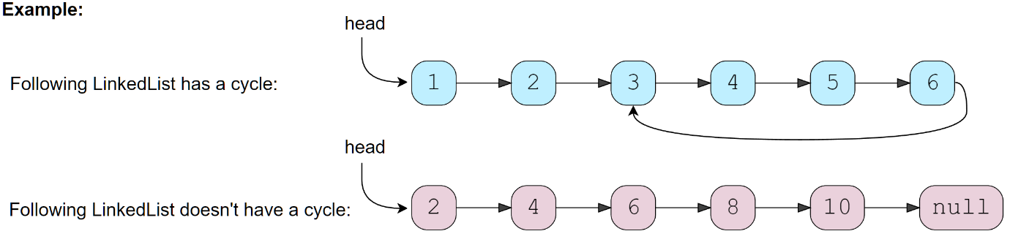

### Solution

Imagine two racers running in a circular racing track. If one racer is faster than the other, the faster racer is bound to catch up and cross the slower racer from behind. We can use this fact to devise an algorithm to determine if a **LinkedList** has a *cycle* in it or not.

Imagine we have a slow and a *fast pointer* to traverse the **LinkedList**. In each iteration, the *slow pointer* moves one step and the *fast pointer* moves two steps. This gives us two conclusions:

1. If the **LinkedList** doesn’t have a *cycle* in it, the *fast pointer* will reach the end of the **LinkedList** before the *slow pointer* to reveal that there is no *cycle* in the **LinkedList**.
2. The *slow pointer* will never be able to catch up to the *fast pointer* if there is no *cycle* in the **LinkedList**.

If the **LinkedList** has a cycle, the *fast pointer* enters the *cycle* first, followed by the *slow pointer*. After this, both pointers will keep moving in the *cycle* infinitely. If at any stage both of these pointers meet, we can conclude that the **LinkedList** has a *cycle* in it. Let’s analyze if it is possible for the two pointers to meet. When the *fast pointer* is approaching the *slow pointer* from behind we have two possibilities:

1. The *fast pointer* is one step behind the *slow pointer*.
2. The *fast pointer* is two steps behind the *slow pointer*.

All other distances between the fast and *slow pointers* will reduce to one of these two possibilities. Let’s analyze these scenarios, considering the *fast pointer* always moves first:

1. **If the *fast pointer* is one step behind the *slow pointer***: The *fast pointer* moves two steps and the *slow pointer* moves one step, and they both meet.
2. **If the *fast pointer* is two steps behind the *slow pointer***: The *fast pointer* moves two steps and the *slow pointer* moves one step. After the moves, the *fast pointer* will be one step behind the *slow pointer*, which reduces this scenario to the first scenario. This means that the two pointers will meet in the next iteration.

This concludes that the two pointers will definitely meet if the **LinkedList** has a cycle.

A similar analysis can be done where the slow pointer moves first. Here is a visual representation of the above discussion:

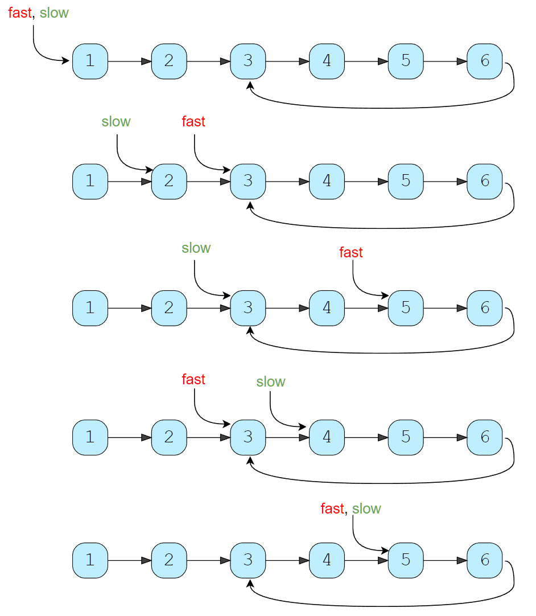

### Code

|  |
| --- |
| class ListNode {  int value = 0;  ListNode next;  ListNode(int value) {  this.value = value;  }  }  class Solution {  public static boolean hasCycle(ListNode head) {  ListNode slow = head;  ListNode fast = head;  while (fast != null && fast.next != null) {  fast = fast.next.next;  slow = slow.next;  if (slow == fast)  return true; // found the cycle  }  return false;  }  public static void main(String[] args) {  ListNode head = new ListNode(1);  head.next = new ListNode(2);  head.next.next = new ListNode(3);  head.next.next.next = new ListNode(4);  head.next.next.next.next = new ListNode(5);  head.next.next.next.next.next = new ListNode(6);  System.out.println("LinkedList has cycle: " + Solution.hasCycle(head));  head.next.next.next.next.next.next = head.next.next;  System.out.println("LinkedList has cycle: " + Solution.hasCycle(head));  head.next.next.next.next.next.next = head.next.next.next;  System.out.println("LinkedList has cycle: " + Solution.hasCycle(head));  }  } |

* Once the *slow pointer* enters the cycle, the *fast pointer* will meet the *slow pointer* in the same loop. Therefore, the time complexity of our algorithm will be O(N) where N is the total number of nodes in the **LinkedList**.
* The algorithm runs in constant space O(1).

### Java Solution

|  |
| --- |
| package patterns.fastandslowpointer;  public class FindCycle {   public boolean findCycle(ListNode node){  ListNode slow = node;  ListNode fast = node;  while(fast != null && fast.next != null){  slow = slow.next;  fast = fast.next.next;   if(slow == fast){  return true;  }  }  return false;  }  public int findCycleLength(ListNode node){  ListNode slow = node;  ListNode fast = node;  while(fast != null && fast.next != null){  slow = slow.next;  fast = fast.next.next;   if(slow == fast){  return calculateCycleLength(slow);  }  }  return 0;  }  public int calculateCycleLength(ListNode node){  int cycleLength = 1;  ListNode curNode = node.next;   while(curNode != node){  cycleLength++;  curNode = curNode.next;  }   return cycleLength;  }   public static void main(String[] args) {   ListNode head = new ListNode(20);  head.next = new ListNode(4);  head.next.next = new ListNode(15);  head.next.next.next = new ListNode(10);  // head.next.next.next.next = head.next.next;   FindCycle cycle = new FindCycle();  System.*out*.println(cycle.findCycle(head));  head.next.next.next.next = head.next;  System.*out*.println(cycle.findCycle(head));   System.*out*.println(cycle.findCycleLength(head));  } }  package patterns.fastandslowpointer;  public class ListNode {  int value;  ListNode next;  ListNode(int value){  this.value = value;  this.next = null;  } } |

### Similar Problems

**Problem:** Given the head of a LinkedList with a cycle, find the length of the cycle.

**Solution:** Once the fast and *slow pointers* meet, we can save the *slow pointer* and iterate the whole *cycle* with another pointer until we see the *slow pointer* again to find the length of the cycle.

**Code**

|  |
| --- |
| class ListNode {  int value = 0;  ListNode next;  ListNode(int value) {  this.value = value;  }  }  class Solution {  public static int findCycleLength(ListNode head) {  ListNode slow = head;  ListNode fast = head;  while (fast != null && fast.next != null) {  fast = fast.next.next;  slow = slow.next;  if (slow == fast) // found the cycle  return calculateLength(slow);  }  return 0;  }  private static int calculateLength(ListNode slow) {  ListNode current = slow;  int cycleLength = 0;  do {  current = current.next;  cycleLength++;  } while (current != slow);  return cycleLength;  }  public static void main(String[] args) {  ListNode head = new ListNode(1);  head.next = new ListNode(2);  head.next.next = new ListNode(3);  head.next.next.next = new ListNode(4);  head.next.next.next.next = new ListNode(5);  head.next.next.next.next.next = new ListNode(6);  head.next.next.next.next.next.next = head.next.next;  System.out.println("LinkedList cycle length: "  + Solution.findCycleLength(head));  head.next.next.next.next.next.next = head.next.next.next;  System.out.println("LinkedList cycle length: "  + Solution.findCycleLength(head));  }  } |

* The above algorithm runs in O(N) time complexity and O(1) space complexity.

**Start of LinkedList Cycle (medium)**

<https://leetcode.com/problems/linked-list-cycle-ii/>

Given the head of a **Singly LinkedList** that contains a cycle, write a function to find the **starting node of the cycle**.

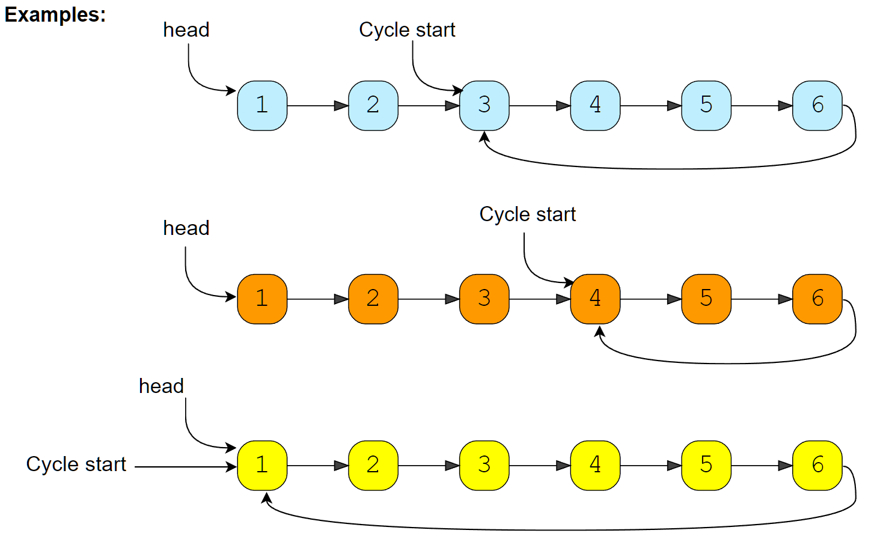

### Solution

If we know the length of the **LinkedList** cycle, we can find the start of the *cycle* through the following steps:

1. Take two pointers. Let’s call them pointer1 and pointer2.
2. Initialize both pointers to point to the start of the **LinkedList**.
3. We can find the length of the **LinkedList** *cycle* using the approach discussed in **LinkedList Cycle**. Let’s assume that the length of the *cycle* is K nodes.
4. Move pointer2 ahead by K nodes.
5. Now, keep incrementing pointer1 and pointer2 until they both meet.
6. As pointer2 is K nodes ahead of pointer1, which means, pointer2 must have completed one loop in the *cycle* when both pointers meet. Their meeting point will be the start of the cycle.

Let’s visually see this with the above-mentioned Example-1:

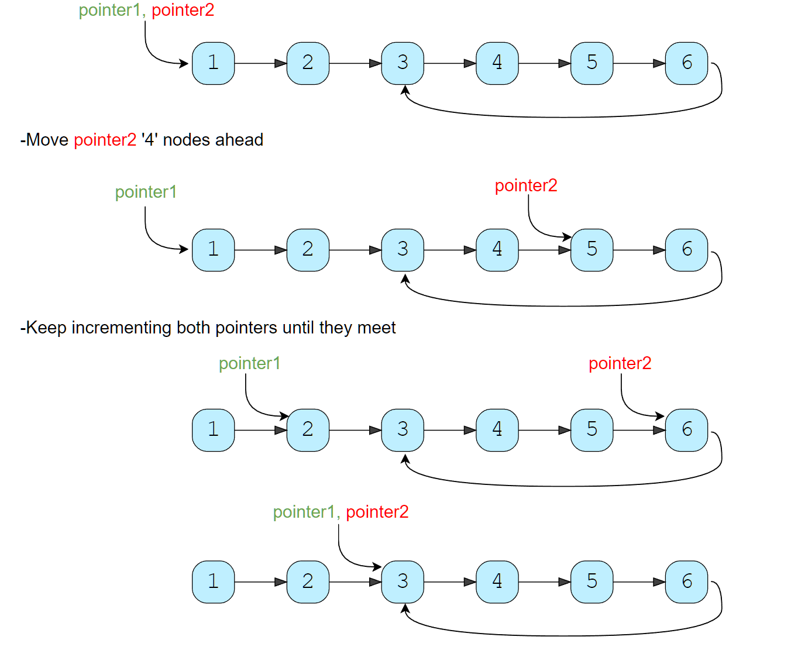

### Code

|  |
| --- |
| class ListNode {  int value = 0;  ListNode next;  ListNode(int value) {  this.value = value;  }  }  class Solution {  public static ListNode findCycleStart(ListNode head) {  int cycleLength = 0;  // find the LinkedList cycle  ListNode slow = head;  ListNode fast = head;  while (fast != null && fast.next != null) {  fast = fast.next.next;  slow = slow.next;  if (slow == fast) { // found the cycle  cycleLength = calculateCycleLength(slow);  break;  }  }  return findStart(head, cycleLength);  }  private static int calculateCycleLength(ListNode slow) {  ListNode current = slow;  int cycleLength = 0;  do {  current = current.next;  cycleLength++;  } while (current != slow);    return cycleLength;  }  private static ListNode findStart(ListNode head, int cycleLength) {  ListNode pointer1 = head, pointer2 = head;  // move pointer2 ahead 'cycleLength' nodes  while (cycleLength > 0) {  pointer2 = pointer2.next;  cycleLength--;  }  // increment both pointers until they meet at the start of the cycle  while (pointer1 != pointer2) {  pointer1 = pointer1.next;  pointer2 = pointer2.next;  }  return pointer1;  }  public static void main(String[] args) {  ListNode head = new ListNode(1);  head.next = new ListNode(2);  head.next.next = new ListNode(3);  head.next.next.next = new ListNode(4);  head.next.next.next.next = new ListNode(5);  head.next.next.next.next.next = new ListNode(6);  head.next.next.next.next.next.next = head.next.next;  System.out.println("LinkedList cycle start: " +  Solution.findCycleStart(head).value);  head.next.next.next.next.next.next = head.next.next.next;  System.out.println("LinkedList cycle start: " +  Solution.findCycleStart(head).value);  head.next.next.next.next.next.next = head;  System.out.println("LinkedList cycle start: " +  Solution.findCycleStart(head).value);  }  } |

* As we know, finding the *cycle* in a **LinkedList** with N nodes and also finding the length of the *cycle* requires O(N). Also, as we saw in the above algorithm, we will need O(N) to find the start of the cycle. Therefore, the overall time complexity of our algorithm will be O(N).
* The algorithm runs in constant space O(1).

### Java Solution

|  |
| --- |
| public ListNode detectCycle(ListNode head) {  ListNode slow = head;  ListNode fast = head;  int cycleLength = 0;  while(fast != null && fast.next != null){  slow = slow.next;  fast = fast.next.next;   if(slow == fast){  cycleLength = calculateCycleLength(slow);  break;  }  }  if(cycleLength == 0) return null;  return findStart(head, cycleLength); }  private ListNode findStart(ListNode head, int cycleLength) {  ListNode pointer1 = head;  ListNode pointer2 = head;   while(cycleLength > 0){  pointer2 = pointer2.next;  cycleLength--;  }   while(pointer1 != pointer2){  pointer1 = pointer1.next;  pointer2 = pointer2.next;  }  return pointer1; }  public int calculateCycleLength(ListNode node){  int cycleLength = 1;  ListNode curNode = node.next;   while(curNode != node){  cycleLength++;  curNode = curNode.next;  }   return cycleLength; }  public static void main(String[] args) {   ListNode head = new ListNode(20);  head.next = new ListNode(4);  head.next.next = new ListNode(15);  head.next.next.next = new ListNode(10);  // head.next.next.next.next = head.next.next;   FindCycle cycle = new FindCycle(); System.*out*.println(cycle.detectCycle(head).value);   head.next.next.next.next = head.next; System.*out*.println(cycle.detectCycle(head).value); } |

**Happy Number (medium)**

<https://leetcode.com/problems/happy-number/>

### Problem Statement

Any number will be called a **happy number** if, after repeatedly replacing it with a number equal to the **sum of the square of all of its digits, leads us to number 1**. All other **(not-happy)** numbers will never reach 1. Instead, they will be stuck in a *cycle* of numbers which does not include 1.

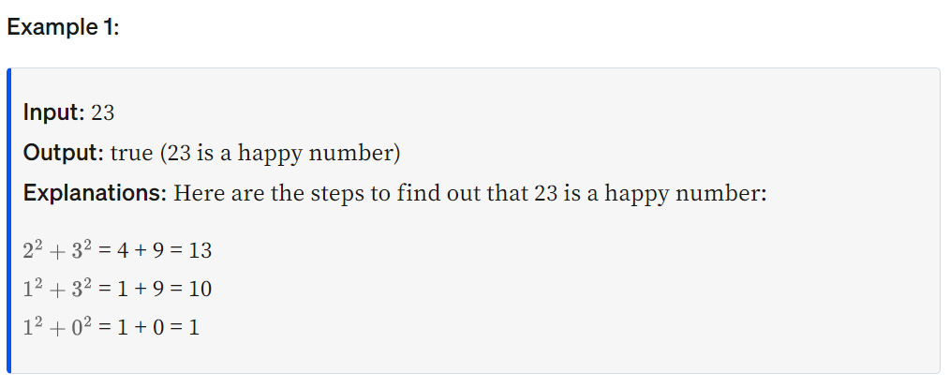

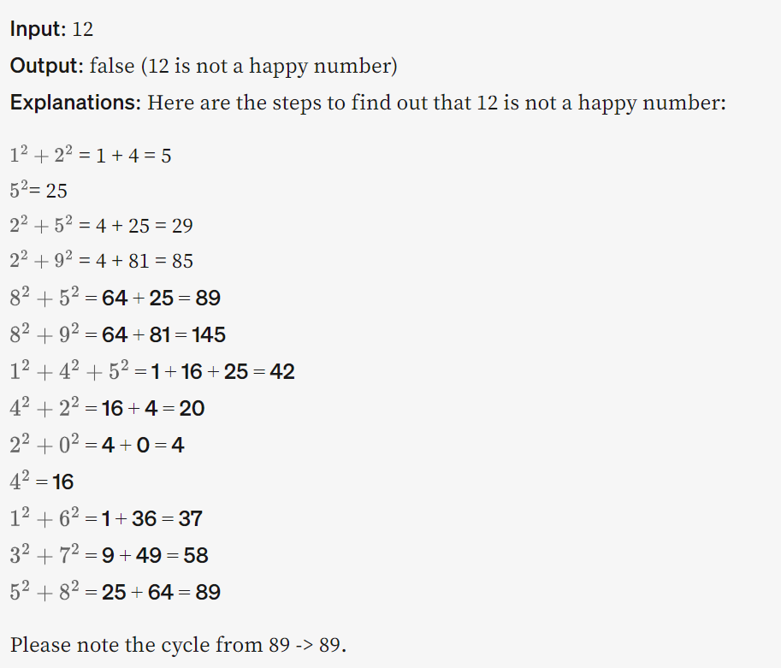

### Solution

The process, defined above, to find out if a number is a **happy number** or not, always ends in a cycle. If the number is a **happy number**, the process will be stuck in a *cycle* on number 1, and if the number is not a **happy number** then the process will be stuck in a *cycle* with a set of numbers. As we saw in Example-2 while determining if 12 is a **happy number** or not, our process will get stuck in a *cycle* with the following numbers: 89 -> 145 -> 42 -> 20 -> 4 -> 16 -> 37 -> 58 -> 89

We saw in the **LinkedList Cycle** problem that we can use the **Fast & Slow** pointers method to find a *cycle* among a set of elements. As we have described above, each number will definitely have a cycle. Therefore, we will use the same *fast* & *slow pointer* strategy to find the *cycle* and once the *cycle* is found, we will see if the *cycle* is stuck on number 1 to find out if the number is happy or not.

### Code

|  |
| --- |
| class Solution {  public static boolean find(int num) {  int slow = num, fast = num;  do {  slow = findSquareSum(slow); // move one step  fast = findSquareSum(findSquareSum(fast)); // move two steps  } while (slow != fast); // found the cycle  return slow == 1; // see if the cycle is stuck on the number '1'  }  private static int findSquareSum(int num) {  int sum = 0, digit;  while (num > 0) {  digit = num % 10;  sum += digit * digit;  num /= 10;  }  return sum;  }  public static void main(String[] args) {  System.out.println(Solution.find(23));  System.out.println(Solution.find(12));  }  } |

23 is a **happy number**, Here are the steps to find out that 23 is a **happy number**:

1. 2² + 3² = 4 + 9 = 13
2. 1² + 3² = 1 + 9 = 10
3. 1² + 0² = 1 + 0 = 1

findHappyNumber(12)//false

12 is not a **happy number**, Here are the steps to find out that 12 is not a **happy number**:

1. 1²+2²= 1 + 4 = 5
2. 5² = 25
3. 2² + 5² = 4 + 25 = 29
4. 2² + 9² = 4 + 81 = 85
5. 8² + 5² = 64 + 25 = 89
6. 8² + 9² = 64 + 81 = 145
7. 1² + 4² + 5²= 1 + 16 + 25 = 42
8. 4² + 2² = 16 + 4 = 20
9. 2² + 0² = 4 + 0 = 4
10. 4²= 16
11. 1² + 6² = 1 + 36 = 37
12. 3² + 7² = 9 + 49 = 58
13. 5² + 8²= 25 + 64 = 89 Step 13 leads us back to step 5 as the number becomes equal to 89’, this means that we can never reach 1, therefore, 12` is not a **happy number**.

findHappyNumber(19)//true

19 is a **happy number**, Here are the steps to find out that 19 is a **happy number**:

1. 1² + 9² = 82
2. 8² + 2² = 68
3. 6² + 8² = 100
4. 1² + 0² + 0² = 1

findHappyNumber(2)//false

2 is not a **happy number**

* The time complexity of the algorithm is difficult to determine. However we know the fact that all **unhappy number**s eventually get stuck in the cycle: 4 -> 16 -> 37 -> 58 -> 89 -> 145 -> 42 -> 20 -> 4

This sequence behavior tells us two things:

1. If the number N is less than or equal to 1000, then we reach the *cycle* or 1 in at most 1001 steps.
2. For N > 1000, suppose the number has M digits and the next number is N1. From the above Wikipedia link, we know that the sum of the squares of the digits of N is at most 9²M, or 81M(this will happen when all digits of N are 9).

This means:

1. N1 < 81M
2. As we know M = log(N+1)
3. Therefore: N1 < 81 * log(N+1) => N1 = O(logN)

* This concludes that the above algorithm will have a time complexity of O(logN).
* The algorithm runs in constant space O(1).

**Middle of the LinkedList (easy)**

<https://leetcode.com/problems/middle-of-the-linked-list/>

### Problem Statement

Given the head of a **Singly LinkedList**, write a method to return the **middle node** of the **LinkedList**.

If the total number of nodes in the **LinkedList** is even, return the second middle node.

Example 1:

Input: 1 -> 2 -> 3 -> 4 -> 5 -> null

Output: 3

Example 2:

Input: 1 -> 2 -> 3 -> 4 -> 5 -> 6 -> null

Output: 4

Example 3:

Input: 1 -> 2 -> 3 -> 4 -> 5 -> 6 -> 7 -> null

Output: 4

### Solution

One brute force strategy could be to first count the number of nodes in the **LinkedList** and then find the middle node in the second iteration. Can we do this in one iteration?

We can use the **Fast & Slow** pointers method such that the *fast pointer* is always twice the nodes ahead of the *slow pointer*. This way, when the *fast pointer* reaches the end of the **LinkedList**, the *slow pointer* will be pointing at the middle node.

### Code

|  |
| --- |
| class ListNode {  int value = 0;  ListNode next;  ListNode(int value) {  this.value = value;  }  }  public class Solution {  public static ListNode findMiddle(ListNode head) {  ListNode slow = head;  ListNode fast = head;  while (fast != null && fast.next != null) {  slow = slow.next;  fast = fast.next.next;  }  return slow;  }  public static void main(String[] args) {  ListNode head = new ListNode(1);  head.next = new ListNode(2);  head.next.next = new ListNode(3);  head.next.next.next = new ListNode(4);  head.next.next.next.next = new ListNode(5);  System.out.println("Middle Node: " + Solution.findMiddle(head).value);  head.next.next.next.next.next = new ListNode(6);  System.out.println("Middle Node: " + Solution.findMiddle(head).value);  head.next.next.next.next.next.next = new ListNode(7);  System.out.println("Middle Node: " + Solution.findMiddle(head).value);  }  } |

* The above algorithm will have a time complexity of O(N) where N is the number of nodes in the **LinkedList**.
* The algorithm runs in constant space O(1).

### Java Solution

|  |
| --- |
| public ListNode findMiddleOfLinkedList(ListNode node){  ListNode slow = node;  ListNode fast = node;  while(fast != null && fast.next != null){  slow = slow.next;  fast = fast.next.next;  }  return slow; } |

**🌟 Palindrome LinkedList (medium)**

<https://leetcode.com/problems/palindrome-linked-list/>

### Problem Statement

Given the head of a **Singly LinkedList**, write a method to check if the **LinkedList is a palindrome** or not.

Your algorithm should use **constant space** and the input **LinkedList** should be in the original form once the algorithm is finished. The algorithm should have O(N) time complexity where N is the number of nodes in the **LinkedList**.

**Example 1:**

Input: 2 -> 4 -> 6 -> 4 -> 2 -> null

Output: true

**Example 2:**

Input: 2 -> 4 -> 6 -> 4 -> 2 -> 2 -> null

Output: false

### Solution

As we know, a palindrome **LinkedList** will have nodes values that read the same backward or forward. This means that if we divide the **LinkedList** into two halves, the node values of the first half in the forward direction should be similar to the node values of the second half in the backward direction. As we have been given a Singly **LinkedList**, we can’t move in the backward direction. To handle this, we will perform the following steps:

1. We can use the **Fast & Slow pointers** method similar to **Middle of the LinkedList** to find the middle node of the **LinkedList**.
2. Once we have the middle of the **LinkedList**, we will reverse the second half.
3. Then, we will compare the first half with the reversed second half to see if the **LinkedList** represents a palindrome.
4. Finally, we will reverse the second half of the **LinkedList** again to revert and bring the **LinkedList** back to its original form.

### Code

|  |
| --- |
| class ListNode {  int value = 0;  ListNode next;  ListNode(int value) {  this.value = value;  }  }  class Solution {  public static boolean isPalindrome(ListNode head) {  if (head == null || head.next == null)  return true;  // find middle of the LinkedList  ListNode slow = head;  ListNode fast = head;  while (fast != null && fast.next != null) {  slow = slow.next;  fast = fast.next.next;  }  ListNode headSecondHalf = reverse(slow); // reverse the second half  // store the head of reversed part to revert back later  ListNode copyHeadSecondHalf = headSecondHalf;  // compare the first and the second half  while (head != null && headSecondHalf != null) {  if (head.value != headSecondHalf.value) {  break; // not a palindrome  }  head = head.next;  headSecondHalf = headSecondHalf.next;  }  reverse(copyHeadSecondHalf); // revert the reverse of the second half  if (head == null || headSecondHalf == null) // if both halves match  return true;  return false;  }  private static ListNode reverse(ListNode head) {  ListNode prev = null;  while (head != null) {  ListNode next = head.next;  head.next = prev;  prev = head;  head = next;  }  return prev;  }  public static void main(String[] args) {  ListNode head = new ListNode(2);  head.next = new ListNode(4);  head.next.next = new ListNode(6);  head.next.next.next = new ListNode(4);  head.next.next.next.next = new ListNode(2);  System.out.println("Is palindrome: " + Solution.isPalindrome(head));  head.next.next.next.next.next = new ListNode(2);  System.out.println("Is palindrome: " + Solution.isPalindrome(head));  }  } |

* The above algorithm will have a time complexity of O(N) where N is the number of nodes in the **LinkedList**.
* The algorithm runs in constant space O(1).

**🌟 Rearrange a LinkedList (medium)**

<https://leetcode.com/problems/reorder-list/>

### Problem Statement

Given the head of a Singly **LinkedList**, write a method to modify the **LinkedList** such that the **nodes from the second half of the LinkedList are inserted alternately to the nodes from the first half in reverse order**. So if the **LinkedList** has nodes 1 -> 2 -> 3 -> 4 -> 5 -> 6 -> null, your method should return 1 -> 6 -> 2 -> 5 -> 3 -> 4 -> null.

Your algorithm should not use any extra space and the input **LinkedList** should be modified in-place.

**Example 1:**

Input: 2 -> 4 -> 6 -> 8 -> 10 -> 12 -> null

Output: 2 -> 12 -> 4 -> 10 -> 6 -> 8 -> null

**Example 2:**

Input: 2 -> 4 -> 6 -> 8 -> 10 -> null

Output: 2 -> 10 -> 4 -> 8 -> 6 -> null

### Solution

This problem shares similarities with **Palindrome LinkedList**. To rearrange the given **LinkedList** we will follow the following steps:

1. We can use the **Fast & Slow pointers** method similar to **Middle of the LinkedList** to find the middle node of the **LinkedList**.
2. Once we have the middle of the **LinkedList**, we will reverse the second half of the **LinkedList**.
3. Finally, we’ll iterate through the first half and the reversed second half to produce a **LinkedList** in the required order.

### Code

|  |
| --- |
| class ListNode {  int value = 0;  ListNode next;  ListNode(int value) {  this.value = value;  }  }  class Solution {  public static void reorder(ListNode head) {  if (head == null || head.next == null)  return;  // find the middle of the LinkedList  ListNode slow = head, fast = head;  while (fast != null && fast.next != null) {  slow = slow.next;  fast = fast.next.next;  }  // slow is now pointing to the middle node  ListNode headSecondHalf = reverse(slow); // reverse the second half  ListNode headFirstHalf = head;  // rearrange to produce the LinkedList in the required order  while (headFirstHalf != null && headSecondHalf != null) {  ListNode temp = headFirstHalf.next;  headFirstHalf.next = headSecondHalf;  headFirstHalf = temp;  temp = headSecondHalf.next;  headSecondHalf.next = headFirstHalf;  headSecondHalf = temp;  }  // set the next of the last node to 'null'  if (headFirstHalf != null)  headFirstHalf.next = null;  }  private static ListNode reverse(ListNode head) {  ListNode prev = null;  while (head != null) {  ListNode next = head.next;  head.next = prev;  prev = head;  head = next;  }  return prev;  }  public static void main(String[] args) {  ListNode head = new ListNode(2);  head.next = new ListNode(4);  head.next.next = new ListNode(6);  head.next.next.next = new ListNode(8);  head.next.next.next.next = new ListNode(10);  head.next.next.next.next.next = new ListNode(12);  Solution.reorder(head);  while (head != null) {  System.out.print(head.value + " ");  head = head.next;  }  }  } |

* The above algorithm will have a time complexity of O(N) where N is the number of nodes in the **LinkedList**.
* The algorithm runs in constant space O(1).

**🌟 Cycle in a Circular Array (hard)**

<https://leetcode.com/problems/circular-array-loop/>

### Problem Statement

We are given an array containing positive and negative numbers. Suppose the array contains a number M at a particular index. Now, if M is positive we will move forward M indices and if M is negative move backwards M indices. You should assume that the **array is circular** which means two things:

1. If, while moving forward, we reach the end of the array, we will jump to the first element to continue the movement.
2. If, while moving backward, we reach the beginning of the array, we will jump to the last element to continue the movement. Write a method to determine **if the array has a cycle**. The *cycle* should have more than one element and should follow one direction which means the *cycle* should not contain both forward and backward movements.

**Example 1:**

Input: [1, 2, -1, 2, 2]

Output: true

Explanation: The array has a cycle among indices: 0 -> 1 -> 3 -> 0

**Example 2:**

Input: [2, 2, -1, 2]

Output: true

Explanation: The array has a cycle among indices: 1 -> 3 -> 1

**Example 3:**

Input: [2, 1, -1, -2]

Output: false

Explanation: The array does not have any cycle.

### Solution

This problem involves finding a *cycle* in the array and, as we know, the **Fast & Slow pointer** method is an efficient way to do that. We can start from each index of the array to find the cycle. If a number does not have a *cycle* we will move forward to the next element. There are a couple of additional things we need to take care of:

1. As mentioned in the problem, the *cycle* should have more than one element. This means that when we move a pointer forward, if the pointer points to the same element after the move, we have a one-element cycle. Therefore, we can finish our *cycle* search for the current element.
2. The other requirement mentioned in the problem is that the *cycle* should not contain both forward and backward movements. We will handle this by remembering the direction of each element while searching for the cycle. If the number is positive, the direction will be forward and if the number is negative, the direction will be backward. So whenever we move a pointer forward, if there is a change in the direction, we will finish our *cycle* search right there for the current element.

### Code

|  |
| --- |
| class Solution {  public static boolean loopExists(int[] arr) {  for (int i = 0; i < arr.length; i++) {  boolean isForward = arr[i] >= 0; // if we are moving forward or not  int slow = i, fast = i;  // if slow or fast becomes '-1' this means we can't find cycle for this number  do {  slow = findNextIndex(arr, isForward, slow); // move one step for slow pointer  fast = findNextIndex(arr, isForward, fast); // move one step for fast pointer  if (fast != -1)  fast = findNextIndex(arr, isForward, fast); // move another step for fast ptr  } while (slow != -1 && fast != -1 && slow != fast);  if (slow != -1 && slow == fast)  return true;  }  return false;  }  private static int findNextIndex(int[] arr, boolean isForward, int currentIndex) {  boolean direction = arr[currentIndex] >= 0;  if (isForward != direction)  return -1; // change in direction, return -1  int nextIndex = (currentIndex + arr[currentIndex]) % arr.length;  if (nextIndex < 0)  nextIndex += arr.length; // wrap around for negative numbers  // one element cycle, return -1  if (nextIndex == currentIndex)  nextIndex = -1;  return nextIndex;  }  public static void main(String[] args) {  System.out.println(Solution.loopExists(new int[] { 1, 2, -1, 2, 2 }));  System.out.println(Solution.loopExists(new int[] { 2, 2, -1, 2 }));  System.out.println(Solution.loopExists(new int[] { 2, 1, -1, -2 }));  }  } |

* The above algorithm will have a time complexity of O(N²) where N is the number of elements in the array. This complexity is due to the fact that we are iterating all elements of the array and trying to find a *cycle* for each element.
* The algorithm runs in constant space O(1).

**An Alternate Approach**

In our algorithm, we don’t keep a record of all the numbers that have been evaluated for *cycle* . We know that all such numbers will not produce a *cycle* for any other instance as well. If we can remember all the numbers that have been visited, our algorithm will improve to O(N) as, then, each number will be evaluated for *cycle* only once. We can keep track of this by creating a separate array, however, in this case, the space complexity of our algorithm will increase to O(N).

**Pattern 4 : Merge Intervals**

This pattern describes an efficient technique to deal with overlapping intervals. In a lot of problems involving intervals, we either need to find overlapping intervals or merge intervals if they overlap.

Given two intervals (a and b), there will be six different ways the two intervals can relate to each other:

1. a and b do not overlap
2. a and b overlap, b ends after a
3. a completely overlaps b
4. a and b overlap, a ends after b
5. b completly overlaps a
6. a and b do not overlap

Understanding the above six cases will help us in solving all intervals related problems. [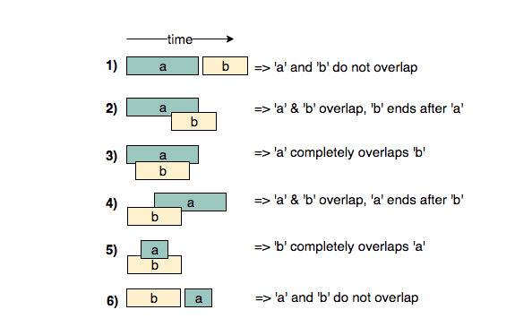](https://github.com/maazshaikh007/DSA_Patterns/blob/main/images/mergeintervals.png)

**Merge Intervals (medium)**

<https://leetcode.com/problems/merge-intervals/>

### Problem Statement

Given a list of intervals, **merge all the overlapping intervals** to produce a list that has only mutually exclusive intervals.

Example 1:

Intervals: [[1,4], [2,5], [7,9]]

Output: [[1,5], [7,9]]

Explanation: Since the first two intervals [1,4] and [2,5] overlap, we merged them into

one [1,5].

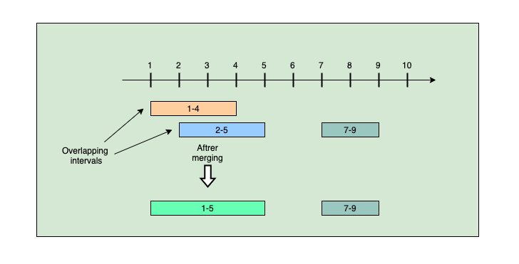

Example 2:

Intervals: [[6,7], [2,4], [5,9]]

Output: [[2,4], [5,9]]

Explanation: Since the intervals [6,7] and [5,9] overlap, we merged them into one [5,9].

Example 3:

Intervals: [[1,4], [2,6], [3,5]]

Output: [[1,6]]

Explanation: Since all the given intervals overlap, we merged them into one.

### Solution

Let’s take the example of two intervals (‘a’ and ‘b’) such that a.start <= b.start. There are four possible scenarios:

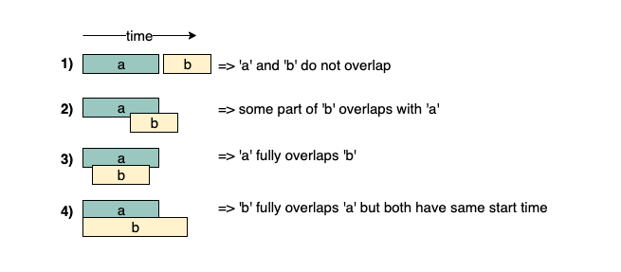

Our goal is to merge the intervals whenever they overlap. For the above-mentioned three overlapping scenarios (2, 3, and 4), this is how we will merge them:

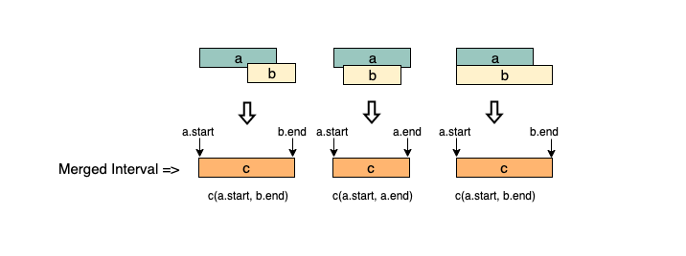

The diagram above clearly shows a merging approach. Our algorithm will look like this:

1. Sort the intervals on the startTime to ensure a.start <= b.start
2. If a overlaps b (i.e. b.start <= a.end), we need to merge them into a new interval c such that:

**c.start = a.start**

**c.end = max(a.end, b.end)**

We will keep repeating the above two steps to merge c with the next interval if it overlaps with c.

### Code

|  |
| --- |
| import java.util.*;  class Interval {  int start;  int end;  public Interval(int start, int end) {  this.start = start;  this.end = end;  }  };  class Solution {  public static List<Interval> merge(List<Interval> intervals) {  if (intervals.size() < 2)  return intervals;  // sort the intervals by start time  Collections.sort(intervals, (a, b) -> Integer.compare(a.start, b.start));  List<Interval> mergedIntervals = new LinkedList<Interval>();  Iterator<Interval> intervalItr = intervals.iterator();  Interval interval = intervalItr.next();  int start = interval.start;  int end = interval.end;  while (intervalItr.hasNext()) {  interval = intervalItr.next();  if (interval.start <= end) { // overlapping intervals, adjust the 'end'  end = Math.max(interval.end, end);  } else { // non-overlapping interval, add the previous interval and reset  mergedIntervals.add(new Interval(start, end));  start = interval.start;  end = interval.end;  }  }  // add the last interval  mergedIntervals.add(new Interval(start, end));  return mergedIntervals;  }  public static void main(String[] args) {  List<Interval> input = new ArrayList<Interval>();  input.add(new Interval(1, 4));  input.add(new Interval(2, 5));  input.add(new Interval(7, 9));  System.out.print("Merged intervals: ");  for (Interval interval : Solution.merge(input))  System.out.print("[" + interval.start + "," + interval.end + "] ");  System.out.println();  input = new ArrayList<Interval>();  input.add(new Interval(6, 7));  input.add(new Interval(2, 4));  input.add(new Interval(5, 9));  System.out.print("Merged intervals: ");  for (Interval interval : Solution.merge(input))  System.out.print("[" + interval.start + "," + interval.end + "] ");  System.out.println();  input = new ArrayList<Interval>();  input.add(new Interval(1, 4));  input.add(new Interval(2, 6));  input.add(new Interval(3, 5));  System.out.print("Merged intervals: ");  for (Interval interval : Solution.merge(input))  System.out.print("[" + interval.start + "," + interval.end + "] ");  System.out.println();  }  } |

* The time complexity of the above algorithm is O(N * logN), where N is the total number of intervals. We are iterating the intervals only once which will take O(N), in the beginning though, since we need to sort the intervals, our algorithm will take O(N * logN).
* The space complexity of the above algorithm will be O(N) as we need to return a list containing all the merged intervals. We will also need O(N) space for sorting

Given a set of intervals, find out if any two intervals overlap.

Intervals: [[1,4], [2,5], [7,9]]

Output: true

Explanation: Intervals [1,4] and [2,5] overlap

We can follow the same approach as discussed above to find if any two intervals overlap.

### Code

|  |
| --- |
| private static boolean anyInterval(List<Interval> intervals){  if (Objects.nonNull(intervals) && intervals.size() < 2) {  return false;  }  Collections.sort(intervals, Comparator.comparingInt(Interval::getStart));  for(int i = 1; i< intervals.size(); i++){  Interval current = intervals.get(i);  Interval previous = intervals.get(i-1);  if(previous.getEnd() >= current.getStart()){  return true;  }  }  return false; |

**Insert Interval (medium)**

<https://leetcode.com/problems/insert-interval/>

### Problem Statement

Given a list of non-overlapping intervals sorted by their startTime, **insert a given interval at the correct position** and merge all necessary intervals to produce a list that has only mutually exclusive intervals.

Example 1:

Input: Intervals=[[1,3], [5,7], [8,12]], New Interval=[4,6]

Output: [[1,3], [4,7], [8,12]]

Explanation: After insertion, since [4,6] overlaps with [5,7], we merged them into one [4,7].

Example 2:

Input: Intervals=[[1,3], [5,7], [8,12]], New Interval=[4,10]

Output: [[1,3], [4,12]]

Explanation: After insertion, since [4,10] overlaps with [5,7] & [8,12], we merged them into [4,12].

Example 3:

Input: Intervals=[[2,3],[5,7]], New Interval=[1,4]

Output: [[1,4], [5,7]]

Explanation: After insertion, since [1,4] overlaps with [2,3], we merged them into one [1,4].

### Solution

If the given list was not sorted, we could have simply appended the new interval to it and used the merge() function from **Merge Intervals**. But since the given list is sorted, we should try to come up with a solution better than O(N * logN)

When inserting a new interval in a sorted list, we need to first find the correct index where the new interval can be placed. In other words, we need to skip all the intervals which end before the start of the new interval. So we can iterate through the given sorted listed of intervals and skip all the intervals with the following condition: **intervals[i].end < newInterval.start**

Once we have found the correct place, we can follow an approach similar to **Merge Intervals** to insert and/or merge the new interval. Let’s call the new interval a and the first interval with the above condition b. There are five possibilities:

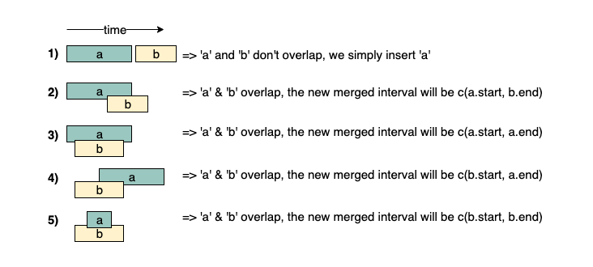

The diagram above clearly shows the merging approach. To handle all four merging scenarios, we need to do something like this:

c.start = min(a.start, b.start)

c.end = max(a.end, b.end)

Our overall algorithm will look like this:

1. Skip all intervals which end before the start of the new interval, i.e., skip all intervals with the following condition:

intervals[i].end < newInterval.start

1. Let’s call the last interval b that does not satisfy the above condition. If b overlaps with the new interval a (i.e. b.start <= a.end), we need to merge them into a new interval c:

c.start = min(a.start, b.start)

c.end = max(a.end, b.end)

1. We will repeat the above two steps to merge c with the next overlapping interval.

### Code

|  |
| --- |
| import java.util.*;  class Interval {  int start;  int end;  public Interval(int start, int end) {  this.start = start;  this.end = end;  }  };  class Solution {  public static List<Interval> insert(List<Interval> intervals, Interval newInterval) {  if (intervals == null || intervals.isEmpty())  return Arrays.asList(newInterval);  List<Interval> mergedIntervals = new ArrayList<>();  int i = 0;  // skip (and add to output) all intervals that come before the 'newInterval'  while (i < intervals.size() && intervals.get(i).end < newInterval.start)  mergedIntervals.add(intervals.get(i++));  // merge all intervals that overlap with 'newInterval'  while (i < intervals.size() && intervals.get(i).start <= newInterval.end) {  newInterval.start = Math.min(intervals.get(i).start, newInterval.start);  newInterval.end = Math.max(intervals.get(i).end, newInterval.end);  i++;  }  // insert the newInterval  mergedIntervals.add(newInterval);  // add all the remaining intervals to the output  while (i < intervals.size())  mergedIntervals.add(intervals.get(i++));  return mergedIntervals;  }  public static void main(String[] args) {  List<Interval> input = new ArrayList<Interval>();  input.add(new Interval(1, 3));  input.add(new Interval(5, 7));  input.add(new Interval(8, 12));  System.out.print("Intervals after inserting the new interval: ");  for (Interval interval : Solution.insert(input, new Interval(4, 6)))  System.out.print("[" + interval.start + "," + interval.end + "] ");  System.out.println();  input = new ArrayList<Interval>();  input.add(new Interval(1, 3));  input.add(new Interval(5, 7));  input.add(new Interval(8, 12));  System.out.print("Intervals after inserting the new interval: ");  for (Interval interval : Solution.insert(input, new Interval(4, 10)))  System.out.print("[" + interval.start + "," + interval.end + "] ");  System.out.println();  input = new ArrayList<Interval>();  input.add(new Interval(2, 3));  input.add(new Interval(5, 7));  System.out.print("Intervals after inserting the new interval: ");  for (Interval interval : Solution.insert(input, new Interval(1, 4)))  System.out.print("[" + interval.start + "," + interval.end + "] ");  System.out.println();  }  } |

* As we are iterating through all the intervals only once, the time complexity of the above algorithm is O(N), where N is the total number of intervals.
* The space complexity of the above algorithm will be O(N) as we need to return a list containing all the merged intervals.

**Intervals Intersection (medium)**

<https://leetcode.com/problems/interval-list-intersections/>

### Problem Statement

Given two lists of intervals, find the **intersection of these two lists**. Each list consists of **disjoint intervals sorted on their startTime**.

Example 1:

Input: arr1=[[1, 3], [5, 6], [7, 9]], arr2=[[2, 3], [5, 7]]

Output: [2, 3], [5, 6], [7, 7]

Explanation: The output list contains the common intervals between the two lists.

Example 2:

Input: arr1=[[1, 3], [5, 7], [9, 12]], arr2=[[5, 10]]

Output: [5, 7], [9, 10]

Explanation: The output list contains the common intervals between the two lists.

### Solution

This problem follows the [Merge Intervals pattern](https://github.com/maazshaikh007/DSA_Patterns/blob/main/%E2%9C%85%20%20Pattern%2004%20:%20Merge%20Intervals.md#pattern-4--merge-intervals). As we have discussed under **Insert Interval**, there are five overlapping possibilities between two intervals a and b. A close observation will tell us that whenever the two intervals overlap, one of the interval’s startTime lies within the other interval. This rule can help us identify if any two intervals overlap or not.

[](https://github.com/maazshaikh007/DSA_Patterns/blob/main/images/mergeintervals.png)

Now, if we have found that the two intervals overlap, how can we find the overlapped part?

Again from the above diagram, the overlapping interval will be equal to:

**start = max(a.start, b.start)**

**end = min(a.end, b.end)**

That is, the highest startTime and the lowest endTime will be the overlapping interval.

So our algorithm will be to iterate through both the lists together to see if any two intervals overlap. If two intervals overlap, we will insert the overlapped part into a result list and move on to the next interval which is finishing early.

### Code

|  |
| --- |
| import java.util.*;  class Interval {  int start;  int end;  public Interval(int start, int end) {  this.start = start;  this.end = end;  }  };  class Solution {  public static Interval[] merge(Interval[] arr1, Interval[] arr2) {  List<Interval> result = new ArrayList<Interval>();  int i = 0, j = 0;  while (i < arr1.length && j < arr2.length) {  // check if the interval arr[i] intersects with arr2[j]  // check if one of the interval's start time lies within the other interval  if ((arr1[i].start >= arr2[j].start && arr1[i].start <= arr2[j].end)  || (arr2[j].start >= arr1[i].start && arr2[j].start <= arr1[i].end)) {  // store the intersection part  result.add(new Interval(Math.max(arr1[i].start, arr2[j].start),  Math.min(arr1[i].end, arr2[j].end)));  }  // move next from the interval which is finishing first  if (arr1[i].end < arr2[j].end)  i++;  else  j++;  }  return result.toArray(new Interval[result.size()]);  }  public static void main(String[] args) {  Interval[] input1 = new Interval[] { new Interval(1, 3), new Interval(5, 6),  new Interval(7, 9) };  Interval[] input2 = new Interval[] { new Interval(2, 3), new Interval(5, 7) };  Interval[] result = Solution.merge(input1, input2);  System.out.print("Intervals Intersection: ");  for (Interval interval : result)  System.out.print("[" + interval.start + "," + interval.end + "] ");  System.out.println();  input1 = new Interval[] { new Interval(1, 3), new Interval(5, 7),  new Interval(9, 12) };  input2 = new Interval[] { new Interval(5, 10) };  result = Solution.merge(input1, input2);  System.out.print("Intervals Intersection: ");  for (Interval interval : result)  System.out.print("[" + interval.start + "," + interval.end + "] ");  }  } |

* As we are iterating through both the lists once, the time complexity of the above algorithm is O(N + M), where N and M are the total number of intervals in the input arrays respectively.
* Ignoring the space needed for the result list, the algorithm runs in constant space O(1).

**Conflicting Appointments (medium)**

<https://leetcode.com/problems/meeting-rooms/>

### Problem Statement

Given an array of intervals representing N appointments, find out if a person can **attend all the appointments**

Example 1:

Appointments: [[1,4], [2,5], [7,9]]

Output: false

Explanation: Since [1,4] and [2,5] overlap, a person cannot attend both of these appointments.

Example 2:

Appointments: [[6,7], [2,4], [8,12]]

Output: true

Explanation: None of the appointments overlap, therefore a person can attend all of them.

Example 3:

Appointments: [[4,5], [2,3], [3,6]]

Output: false

Explanation: Since [4,5] and [3,6] overlap, a person cannot attend both of these appointments.

### Solution.

The problem follows the [Merge Intervals pattern](https://github.com/maazshaikh007/DSA_Patterns/blob/main/%E2%9C%85%20%20Pattern%2004%20:%20Merge%20Intervals.md#pattern-4--merge-intervals). We can sort all the intervals by startTime and then check if any two intervals overlap. A person will not be able to attend all appointments if any two appointments overlap.

### Code

|  |
| --- |
| import java.util.*;  class Interval {  int start;  int end;  public Interval(int start, int end) {  this.start = start;  this.end = end;  }  };  class Solution {  public static boolean canAttendAllAppointments(Interval[] intervals) {  // sort the intervals by start time  Arrays.sort(intervals, (a, b) -> Integer.compare(a.start, b.start));  // find any overlapping appointment  for (int i = 1; i < intervals.length; i++) {  if (intervals[i].start < intervals[i - 1].end) {  // please note the comparison above, it is "<" and not "<="  // while merging we needed "<=" comparison, as we will be merging the two  // intervals having condition "intervals[i].start == intervals[i - 1].end" but  // such intervals don't represent conflicting appointments as one starts right  // after the other  return false;  }  }  return true;  }  public static void main(String[] args) {  Interval[] intervals = { new Interval(1, 4), new Interval(2, 5),  new Interval(7, 9) };  boolean result = Solution.canAttendAllAppointments(intervals);  System.out.println("Can attend all appointments: " + result);  Interval[] intervals1 = { new Interval(6, 7), new Interval(2, 4),  new Interval(8, 12) };  result = Solution.canAttendAllAppointments(intervals1);  System.out.println("Can attend all appointments: " + result);  Interval[] intervals2 = { new Interval(4, 5), new Interval(2, 3),  new Interval(3, 6) };  result = Solution.canAttendAllAppointments(intervals2);  System.out.println("Can attend all appointments: " + result);  }  } |

* The time complexity of the above algorithm is O(N*logN), where N is the total number of appointments. Though we are iterating the intervals only once, our algorithm will take O(N * logN) since we need to sort them in the beginning.
* The space complexity of the above algorithm will be O(N), which we need for sorting.

### Similar Problems

🌟 Given a list of appointments, find all the conflicting appointments.

Appointments: [[4,5], [2,3], [3,6], [5,7], [7,8]]

Output:

[4,5] and [3,6] conflict.

[3,6] and [5,7] conflict.

### Code

|  |
| --- |
| private static List<List<Interval>> whatAreTheConflicts(List<Interval> intervals){  intervals.sort(Comparator.comparingInt(Interval::getStart));  List<List<Interval>> results = new ArrayList<>();  for(int i = 0; i < intervals.size() - 1; i++){  for(int j = i+1; j < intervals.size(); j++){  if(intervals.get(i).getEnd() > intervals.get(j).getStart()){  results.add(List.of(intervals.get(i), intervals.get(j)));  }  }  }  return results;  } |

**🌟 Minimum Meeting Rooms (hard)**

<https://leetcode.com/problems/meeting-rooms-ii/>

### Problem Statement

Given a list of intervals representing the start and endTime of N meetings, find the **minimum number of rooms** required to **hold all the meetings**.

Example 1:

Meetings: [[1,4], [2,5], [7,9]]

Output: 2

Explanation: Since [1,4] and [2,5] overlap, we need two rooms to hold these two meetings. [7,9] can

occur in any of the two rooms later.

Example 2:

Meetings: [[6,7], [2,4], [8,12]]

Output: 1

Explanation: None of the meetings overlap, therefore we only need one room to hold all meetings.

Example 3:

Meetings: [[1,4], [2,3], [3,6]]

Output:2

Explanation: Since [1,4] overlaps with the other two meetings [2,3] and [3,6], we need two rooms to

hold all the meetings.

Example 4:

Meetings: [[4,5], [2,3], [2,4], [3,5]]

Output: 2

Explanation: We will need one room for [2,3] and [3,5], and another room for [2,4] and [4,5].

Here is a visual representation of Example 4:

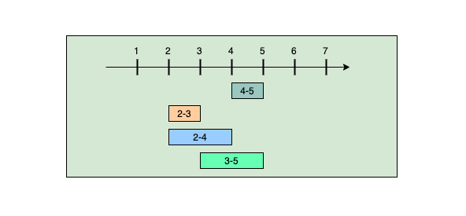

### Solution

Let’s take the above-mentioned example (4) and try to follow our Merge Intervals approach:

**Meetings: [[4,5], [2,3], [2,4], [3,5]]**

**approach**:

1. Sorting these meetings on their startTime will give us: [[2,3], [2,4], [3,5], [4,5]]
2. Merging overlapping meetings:

* [2,3] overlaps with [2,4], so after merging we’ll have => [[2,4], [3,5], [4,5]]
* [2,4] overlaps with [3,5], so after merging we’ll have => [[2,5], [4,5]]
* [2,5] overlaps [4,5], so after merging we’ll have => [2,5]

Since all the given meetings have merged into one big meeting ([2,5]), does this mean that they all are overlapping and we need a minimum of four rooms to hold these meetings? You might have already guessed that the answer is NO! As we can clearly see, some meetings are mutually exclusive. For example, [2,3] and [3,5] do not overlap and can happen in one room. So, to correctly solve our problem, we need to keep track of the mutual exclusiveness of the overlapping meetings.

Here is what our strategy will look like:

1. We will sort the meetings based on startTime.
2. We will schedule the first meeting (let’s call it m1) in one room (let’s call it r1).
3. If the next meeting m2 is not overlapping with m1, we can safely schedule it in the same room r1.
4. If the next meeting m3 is overlapping with m2 we can’t use r1, so we will schedule it in another room (let’s call it r2).
5. Now if the next meeting m4 is overlapping with m3, we need to see if the room r1 has become free. For this, we need to keep track of the endTime of the meeting happening in it. If the endTime of m2 is before the startTime of m4, we can use that room r1, otherwise, we need to schedule m4 in another room r3.

We can conclude that we need to **keep track of the ending time of all the meetings currently happening** so that when we try to schedule a new meeting, we can see what meetings have already ended. We need to put this information in a data structure that can easily give us the smallest ending time. A ***Min-Heap*** would fit our requirements best.

So our algorithm will look like this:

1. Sort all the meetings on their startTime.
2. Create a *min-heap* to store all the active meetings. This *min-heap* will also be used to find the active meeting with the smallest endTime.
3. Iterate through all the meetings one by one to add them in the *min-heap*. Let’s say we are trying to schedule the meeting m1.
4. Since the *min-heap* contains all the active meetings, so before scheduling m1 we can remove all meetings from the heap that have ended before m1, i.e., remove all meetings from the heap that have an endTime smaller than or equal to the startTime of m1.
5. Now add m1 to the heap.
6. The heap will always have all the overlapping meetings, so we will need rooms for all of them. Keep a counter to remember the maximum size of the heap at any time which will be the minimum number of rooms needed.

### Code

|  |
| --- |
| import java.util.*;  class Meeting {  int start;  int end;  public Meeting(int start, int end) {  this.start = start;  this.end = end;  }  };  class Solution {  public static int findMinimumMeetingRooms(List<Meeting> meetings) {  if (meetings == null || meetings.size() == 0)  return 0;  // sort the meetings by start time  Collections.sort(meetings, (a, b) -> Integer.compare(a.start, b.start));  int minRooms = 0;  PriorityQueue<Meeting> minHeap =  new PriorityQueue<>(meetings.size(), (a, b) -> Integer.compare(a.end, b.end));  for (Meeting meeting : meetings) {  // remove all meetings that have ended  while (!minHeap.isEmpty() && meeting.start >= minHeap.peek().end)  minHeap.poll();  // add the current meeting into the minHeap  minHeap.offer(meeting);  // all active meeting are in the minHeap, so we need rooms for all of them.  minRooms = Math.max(minRooms, minHeap.size());  }  return minRooms;  }  public static void main(String[] args) {  List<Meeting> input = new ArrayList<Meeting>() {  {  add(new Meeting(1, 4));  add(new Meeting(2, 5));  add(new Meeting(7, 9));  }  };  int result = Solution.findMinimumMeetingRooms(input);  System.out.println("Minimum meeting rooms required: " + result);  input = new ArrayList<Meeting>() {  {  add(new Meeting(6, 7));  add(new Meeting(2, 4));  add(new Meeting(8, 12));  }  };  result = Solution.findMinimumMeetingRooms(input);  System.out.println("Minimum meeting rooms required: " + result);  input = new ArrayList<Meeting>() {  {  add(new Meeting(1, 4));  add(new Meeting(2, 3));  add(new Meeting(3, 6));  }  };  result = Solution.findMinimumMeetingRooms(input);  System.out.println("Minimum meeting rooms required: " + result);  input = new ArrayList<Meeting>() {  {  add(new Meeting(4, 5));  add(new Meeting(2, 3));  add(new Meeting(2, 4));  add(new Meeting(3, 5));  }  };  result = Solution.findMinimumMeetingRooms(input);  System.out.println("Minimum meeting rooms required: " + result);  }  } |

* The time complexity of the above algorithm is O(N*logN), where N is the total number of meetings. This is due to the sorting that we did in the beginning. Also, while iterating the meetings we might need to poll/offer meeting to the priority queue. Each of these operations can take O(logN). Overall our algorithm will take O(NlogN).
* The space complexity of the above algorithm will be O(N) which is required for sorting. Also, in the worst case scenario, we’ll have to insert all the meetings into the Min Heap (when all meetings overlap) which will also take O(N) space. The overall space complexity of our algorithm is O(N).

**Similar Problems**

Given a list of intervals, find the point where the maximum number of intervals overlap.

Given a list of intervals representing the arrival and departure times of trains to a train station, our goal is to find the minimum number of platforms required for the train station so that no train has to wait.

Both of these problems can be solved using the approach discussed above.

**🌟 Maximum CPU Load (hard)**

<https://leetcode.com/problems/car-pooling/>

### Problem Statement

We are given a list of jobs. Each job has a startTime, an endTime, and a CPU load when it is running. Our goal is to find the **Maximum CPU Load** at any time if all the jobs are **running on the same machine**.

**Example 1:**

Jobs: [[1,4,3], [2,5,4], [7,9,6]]

Output: 7

Explanation: Since [1,4,3] and [2,5,4] overlap, their maximum CPU load (3+4=7) will be when both the

jobs are running at the same time i.e., during the time interval (2,4).

**Example 2:**

Jobs: [[6,7,10], [2,4,11], [8,12,15]]

Output: 15

Explanation: None of the jobs overlap, therefore we will take the maximum load of any job which is 15.

**Example 3:**

Jobs: [[1,4,2], [2,4,1], [3,6,5]]

Output: 8

Explanation: Maximum CPU load will be 8 as all jobs overlap during the time interval [3,4].

### Solution

The problem follows the [Merge Intervals pattern](https://github.com/maazshaikh007/DSA_Patterns/blob/main/%E2%9C%85%20%20Pattern%2004%20:%20Merge%20Intervals.md#pattern-4--merge-intervals) and can easily be converted to [**Minimum Meeting Rooms**](https://github.com/maazshaikh007/DSA_Patterns/blob/main/%E2%9C%85%20%20Pattern%2004%20:%20Merge%20Intervals.md#%F0%9F%8C%9F-minimum-meeting-rooms-hard). Similar to [Minimum Meeting Rooms](https://github.com/maazshaikh007/DSA_Patterns/blob/main/%E2%9C%85%20%20Pattern%2004%20:%20Merge%20Intervals.md#%F0%9F%8C%9F-minimum-meeting-rooms-hard) where we were trying to find the maximum number of meetings happening at any time, for **Maximum CPU Load** we need to find the maximum number of jobs running at any time. We will need to keep a running count of the maximum **CPU Load** at any time to find the overall maximum load.

### Code

|  |
| --- |
| import java.util.*;  class Job {  int start;  int end;  int cpuLoad;  public Job(int start, int end, int cpuLoad) {  this.start = start;  this.end = end;  this.cpuLoad = cpuLoad;  }  };  class Solution {  public static int findMaxCPULoad(List<Job> jobs) {  // sort the jobs by start time  Collections.sort(jobs, (a, b) -> Integer.compare(a.start, b.start));  int maxCPULoad = 0;  int currentCPULoad = 0;  PriorityQueue<Job> minHeap = new PriorityQueue<>(jobs.size(),  (a, b) -> Integer.compare(a.end, b.end));  for (Job job : jobs) {  // remove all jobs that have ended  while (!minHeap.isEmpty() && job.start > minHeap.peek().end)  currentCPULoad -= minHeap.poll().cpuLoad;  // add the current job into the minHeap  minHeap.offer(job);  currentCPULoad += job.cpuLoad;  maxCPULoad = Math.max(maxCPULoad, currentCPULoad);  }  return maxCPULoad;  }  public static void main(String[] args) {  List<Job> input = new ArrayList<Job>(Arrays.asList(new Job(1, 4, 3),  new Job(2, 5, 4), new Job(7, 9, 6)));  System.out.println("Maximum CPU load at any time: " +  Solution.findMaxCPULoad(input));  input = new ArrayList<Job>(Arrays.asList(new Job(6, 7, 10), new Job(2, 4, 11),  new Job(8, 12, 15)));  System.out.println("Maximum CPU load at any time: " +  Solution.findMaxCPULoad(input));  input = new ArrayList<Job>(Arrays.asList(new Job(1, 4, 2), new Job(2, 4, 1),  new Job(3, 6, 5)));  System.out.println("Maximum CPU load at any time: " +  Solution.findMaxCPULoad(input));  }  } |

* The time complexity of the above algorithm is O(N*logN), where N is the total number of jobs. This is due to the sorting that we did in the beginning. Also, while iterating the jobs, we might need to poll/offer jobs to the priority queue. Each of these operations can take O(logN). Overall our algorithm will take O(NlogN).
* The space complexity of the above algorithm will be O(N), which is required for sorting. Also, in the worst case, we have to insert all the jobs into the priority queue (when all jobs overlap) which will also take O(N) space. The overall space complexity of our algorithm is O(N).

**🌟 Employee Free Time (hard)**

<https://leetcode.com/problems/employee-free-time/>

### Problem Statement

For K employees, we are given a list of intervals representing the working hours of each employee. Our goal is to find out if there is a **free interval that is common to all employees**. You can assume that each list of employee working hours is sorted on the startTime.

Example 1:

Input: Employee Working Hours=[[[1,3], [5,6]], [[2,3], [6,8]]]

Output: [3,5]

Explanation: All the employees are free between [3,5].

Example 2:

Input: Employee Working Hours=[[[1,3], [9,12]], [[2,4]], [[6,8]]]

Output: [4,6], [8,9]

Explanation: All employees are free between [4,6] and [8,9].

Example 3:

Input: Employee Working Hours=[[[1,3]], [[2,4]], [[3,5], [7,9]]]

Output: [5,7]

Explanation: All employees are free between [5,7].

### Solution

This problem follows the [Merge Intervals pattern](https://github.com/maazshaikh007/DSA_Patterns/blob/main/%E2%9C%85%20%20Pattern%2004%20:%20Merge%20Intervals.md#pattern-4--merge-intervals). Let’s take the an example:

Input: Employee Working Hours=[[[1,3], [9,12]], [[2,4]], [[6,8]]]

Output: [4,6], [8,9]

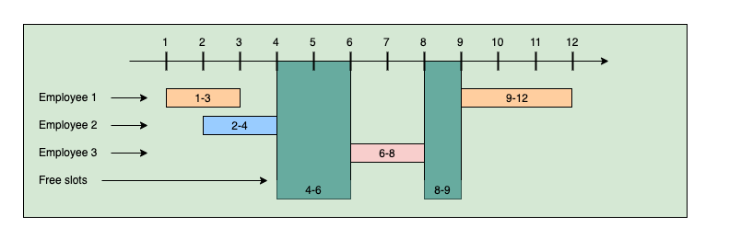

One simple solution can be to put all employees' working hours in a list and sort them on the startTime. Then we can iterate through the list to find the gaps. Let’s dig deeper. Sorting the intervals of the above example will give us:

[1,3], [2,4], [6,8], [9,12]

We can now iterate through these intervals, and whenever we find non-overlapping intervals (e.g., [2,4] and [6,8]), we can calculate a free interval (e.g., [4,6]).

function findEmployeeFreeTime (schedules) {

let freeTime = [];

//combine all schedules

let allTime = []

for(let i = 0; i < schedules.length; i++) {

for(let j = 0; j < schedules[i].length; j++) {

allTime.push(schedules[i][j])

}

}

allTime.sort((a,b) => a[0]-b[0])

//merge overlap

for(let i = 1; i < allTime.length; i++) {

let current = allTime[i]

let previous = allTime[i-1]

if(current[0] <= previous[1]) {

allTime[i] = [previous[0], current[1]]

allTime.splice(i-1, 1)

i--

}

}

//whatever is not accounted for is free time

for(let i = 1; i < allTime.length; i++) {

freeTime.push([allTime[i-1][1], allTime[i][0]])

}

return freeTime;

};

findEmployeeFreeTime ([[[1,3], [5,6]], [[2,3], [6,8]]])//[3,5], Both the employees are free between [3,5].

findEmployeeFreeTime ([[[1,3], [9,12]], [[2,4]], [[6,8]]])//[4,6], [8,9], All employees are free between [4,6] and [8,9].

findEmployeeFreeTime ([[[1,3]], [[2,4]], [[3,5], [7,9]]])//[5,7], ll employees are free between [5,7].

* This algorithm will take O(N * logN) time, where N is the total number of intervals. This time is needed because we need to sort all the intervals.
* The space complexity will be O(N), which is needed for sorting.

**Can we find a better solution?**

One fact that we are not utilizing is that each employee list is individually sorted!

How about we take the first interval of each employee and insert it in a *Min-Heap*. This *Min-Heap* can always give us the interval with the smallest startTime. Once we have the smallest start-time interval, we can then compare it with the next smallest start-time interval (again from the *Heap* to find the gap. This interval comparison is similar to what we suggested in the previous approach.

Whenever we take an interval out of the *Min-Heap*, we can insert the same employee’s next interval. This also means that we need to know which interval belongs to which employee.

### Code

|  |
| --- |
| import java.util.*;  class Interval {  int start;  int end;  public Interval(int start, int end) {  this.start = start;  this.end = end;  }  };  class EmployeeInterval {  Interval interval; // interval representing employee's working hours  int employeeIndex; // index of the list containing working hours of this employee  int intervalIndex; // index of the interval in the employee list  public EmployeeInterval(Interval interval, int employeeIndex, int intervalIndex) {  this.interval = interval;  this.employeeIndex = employeeIndex;  this.intervalIndex = intervalIndex;  }  };  class Solution {  public static List<Interval> findEmployeeFreeTime(List<List<Interval>> schedule) {  List<Interval> result = new ArrayList<>();  // PriorityQueue to store one interval from each employee  PriorityQueue<EmployeeInterval> minHeap = new PriorityQueue<>(  (a, b) -> Integer.compare(a.interval.start, b.interval.start));  // insert the first interval of each employee to the queue  for (int i = 0; i < schedule.size(); i++)  minHeap.offer(new EmployeeInterval(schedule.get(i).get(0), i, 0));  Interval previousInterval = minHeap.peek().interval;  while (!minHeap.isEmpty()) {  EmployeeInterval queueTop = minHeap.poll();  // if previousInterval is not overlapping with the next interval, insert a free  // interval  if (previousInterval.end < queueTop.interval.start) {  result.add(new Interval(previousInterval.end, queueTop.interval.start));  previousInterval = queueTop.interval;  } else { // overlapping intervals, update the previousInterval if needed  if (previousInterval.end < queueTop.interval.end)  previousInterval = queueTop.interval;  }  // if there are more intervals available for the same employee, add their next  // interval  List<Interval> employeeSchedule = schedule.get(queueTop.employeeIndex);  if (employeeSchedule.size() > queueTop.intervalIndex + 1) {  minHeap.offer(new EmployeeInterval(  employeeSchedule.get(queueTop.intervalIndex + 1), queueTop.employeeIndex,  queueTop.intervalIndex + 1));  }  }  return result;  }  public static void main(String[] args) {  List<List<Interval>> input = new ArrayList<>();  input.add(new ArrayList<Interval>(Arrays.asList(new Interval(1, 3),  new Interval(5, 6))));  input.add(new ArrayList<Interval>(Arrays.asList(new Interval(2, 3),  new Interval(6, 8))));  List<Interval> result = Solution.findEmployeeFreeTime(input);  System.out.print("Free intervals: ");  for (Interval interval : result)  System.out.print("[" + interval.start + ", " + interval.end + "] ");  System.out.println();  input = new ArrayList<>();  input.add(new ArrayList<Interval>(Arrays.asList(new Interval(1, 3),  new Interval(9, 12))));  input.add(new ArrayList<Interval>(Arrays.asList(new Interval(2, 4))));  input.add(new ArrayList<Interval>(Arrays.asList(new Interval(6, 8))));  result = Solution.findEmployeeFreeTime(input);  System.out.print("Free intervals: ");  for (Interval interval : result)  System.out.print("[" + interval.start + ", " + interval.end + "] ");  System.out.println();  input = new ArrayList<>();  input.add(new ArrayList<Interval>(Arrays.asList(new Interval(1, 3))));  input.add(new ArrayList<Interval>(Arrays.asList(new Interval(2, 4))));  input.add(new ArrayList<Interval>(Arrays.asList(new Interval(3, 5),  new Interval(7, 9))));  result = Solution.findEmployeeFreeTime(input);  System.out.print("Free intervals: ");  for (Interval interval : result)  System.out.print("[" + interval.start + ", " + interval.end + "] ");  }  } |

* The above algorithm’s time complexity is O(N*logK), where N is the total number of intervals, and K is the total number of employees. This is because we are iterating through the intervals only once (which will take O(N)), and every time we process an interval, we remove (and can insert) one interval in the *Min-Heap*, (which will take O(logK). At any time, the heap will not have more than K elements.
* The space complexity of the above algorithm will be O(K) as at any time, the heap will not have more than K elements.

# Pattern 5: Cyclic Sort

This pattern describes an interesting approach to deal with problems involving arrays containing numbers in a given range.

**For example, take the following problem:**

**You are given an unsorted array containing numbers taken from the range 1 to n The array can have duplicates, which means that some numbers will be missing. Find all the missing numbers.**

To efficiently solve this problem, we can use the fact that the input array contains numbers in the range of 1 to n. For example, to efficiently sort the array, we can try placing each number in its correct place, i.e., placing 1 at index 0, placing 2 at index 1, and so on. Once we are done with the sorting, we can iterate the array to find all indices that are missing the correct numbers. These will be our required numbers.

## Cyclic Sort (easy)

### Problem Statement

We are given an array containing n objects. Each object, when created, was assigned a unique number from 1 to n based on their creation sequence. This means that the object with sequence number 3 was created just before the object with sequence number 4.

Write a function to sort the objects *in-place* on their creation sequence number in O(n) and without any extra space.

For simplicity, let’s assume we are passed an integer array containing only the sequence numbers, though each number is actually an object.

Example 1:

Input: [3, 1, 5, 4, 2]

Output: [1, 2, 3, 4, 5]

Example 2:

Input: [2, 6, 4, 3, 1, 5]

Output: [1, 2, 3, 4, 5, 6]

Example 3:

Input: [1, 5, 6, 4, 3, 2]

Output: [1, 2, 3, 4, 5, 6]

### Solution

As we know, the input array contains numbers in the range of 1 to n. We can use this fact to devise an efficient way to sort the numbers. Since all numbers are unique, we can try placing each number at its correct place, i.e., placing 1 at index 0, placing 2 at index 1, and so on.

To place a number (or an object in general) at its correct index, we first need to find that number. If we first find a number and then place it at its correct place, it will take us O(N²), which is not acceptable.

Instead, what if we iterate the array one number at a time, and if the current number we are iterating is not at the correct index, we swap it with the number at its correct index. This way we will go through all numbers and place them in their correct indices, hence, sorting the whole array.

[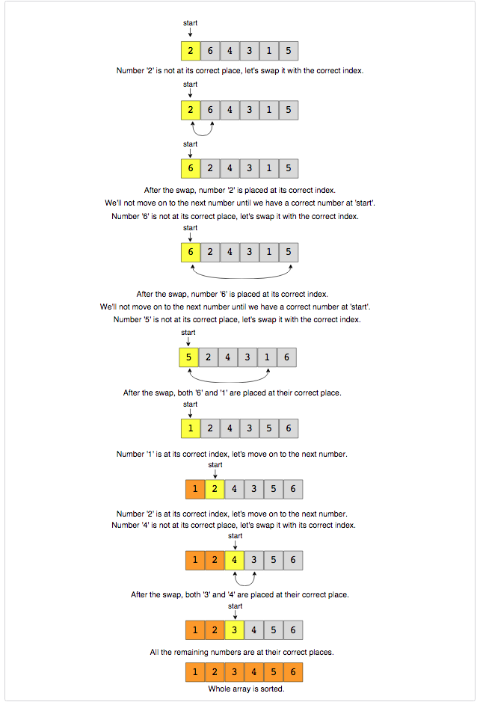](https://github.com/maazshaikh007/DSA_Patterns/blob/main/images/cyclicsort.png)

### Code

|  |
| --- |
| public class Solution {  public static void sort(int[] nums) {  int i = 0;  while (i < nums.length) {  int j = nums[i] - 1;  if (nums[i] != nums[j])  swap(nums, i, j);  else  i++;  }  }  private static void swap(int[] arr, int i, int j) {  int temp = arr[i];  arr[i] = arr[j];  arr[j] = temp;  }  public static void main(String[] args) {  int[] arr = new int[] { 3, 1, 5, 4, 2 };  Solution.sort(arr);  for (int num : arr)  System.out.print(num + " ");  System.out.println();  arr = new int[] { 2, 6, 4, 3, 1, 5 };  Solution.sort(arr);  for (int num : arr)  System.out.print(num + " ");  System.out.println();  arr = new int[] { 1, 5, 6, 4, 3, 2 };  Solution.sort(arr);  for (int num : arr)  System.out.print(num + " ");  System.out.println();  }  } |

* The time complexity of the above algorithm is O(n). Although we are not incrementing the index i when swapping the numbers, this will result in more than n iterations of the loop, but in the worst-case scenario, the while loop will swap a total of n-1 numbers and once a number is at its correct index, we will move on to the next number by incrementing i. So overall, our algorithm will take O(n) + O(n-1) which is asymptotically equivalent to O(n).
* The algorithm runs in constant space O(1).

**Find the Missing Number (easy)**

<https://leetcode.com/problems/missing-number/>

### Problem Statement

We are given an array containing n distinct numbers taken from the range 0 to n. Since the array has only n numbers out of the total n+1 numbers, find the missing number.

Example 1:

Input: [4, 0, 3, 1]

Output: 2

Example 2:

Input: [8, 3, 5, 2, 4, 6, 0, 1]

Output: 7

### Solution

This problem follows the [**Cyclic Sort pattern**](https://github.com/maazshaikh007/DSA_Patterns/blob/main/%E2%9C%85%20%20Pattern%2005:%20Cyclic%20Sort.md#pattern-5-cyclic-sort). Since the input array contains unique numbers from the range 0 to n, we can use a similar strategy as discussed in [**Cyclic Sort pattern**](https://github.com/maazshaikh007/DSA_Patterns/blob/main/%E2%9C%85%20%20Pattern%2005:%20Cyclic%20Sort.md#pattern-5-cyclic-sort) to place the numbers on their correct index. Once we have every number in its correct place, we can iterate the array to find the index which does not have the correct number, and that index will be our missing number.

However, there are two differences with [**Cyclic Sort**](https://github.com/maazshaikh007/DSA_Patterns/blob/main/%E2%9C%85%20%20Pattern%2005:%20Cyclic%20Sort.md#pattern-5-cyclic-sort):

1. In this problem, the numbers are ranged from 0 to n, compared to 1 to n in the [**Cyclic Sort**](https://github.com/maazshaikh007/DSA_Patterns/blob/main/%E2%9C%85%20%20Pattern%2005:%20Cyclic%20Sort.md#pattern-5-cyclic-sort). This will make two changes in our algorithm:
   * In this problem, each number should be equal to its index, compared to index - 1 in the [**Cyclic Sort**](https://github.com/maazshaikh007/DSA_Patterns/blob/main/%E2%9C%85%20%20Pattern%2005:%20Cyclic%20Sort.md#pattern-5-cyclic-sort). Therefore => nums[i] == nums[nums[i]]
   * Since the array will have n numbers, which means array indices will range from 0 to n-1. Therefore, we will ignore the number n as we can’t place it in the array, so => nums[i] < nums.length
2. Say we are at index i. If we swap the number at index i to place it at the correct index, we can still have the wrong number at index i. This was true in [**Cyclic Sort**](https://github.com/maazshaikh007/DSA_Patterns/blob/main/%E2%9C%85%20%20Pattern%2005:%20Cyclic%20Sort.md#pattern-5-cyclic-sort) too. It didn’t cause any problems in [**Cyclic Sort**](https://github.com/maazshaikh007/DSA_Patterns/blob/main/%E2%9C%85%20%20Pattern%2005:%20Cyclic%20Sort.md#pattern-5-cyclic-sort) as over there, we made sure to place one number at its correct place in each step, but that wouldn’t be enough in this problem as we have one extra number due to the larger range. Therefore, we will not move to the next number after the swap until we have a correct number at the index i.

### Code

|  |
| --- |
| class Solution {  public static int findMissingNumber(int[] nums) {  int i = 0;  while (i < nums.length) {  if (nums[i] < nums.length && nums[i] != nums[nums[i]])  swap(nums, i, nums[i]);  else  i++;  }  // find the first number missing from its index, that will be our required number  for (i = 0; i < nums.length; i++)  if (nums[i] != i)  return i;  return nums.length;  }  private static void swap(int[] arr, int i, int j) {  int temp = arr[i];  arr[i] = arr[j];  arr[j] = temp;  }  public static void main(String[] args) {  System.out.println(Solution.findMissingNumber(new int[] { 4, 0, 3, 1 }));  System.out.println(Solution.findMissingNumber(  new int[] { 8, 3, 5, 2, 4, 6, 0, 1 }));  } |

* The time complexity of the above algorithm is O(n). In the while loop, although we are not incrementing the index i when swapping the numbers, this will result in more than n iterations of the loop, but in the worst-case scenario, the while loop will swap a total of n-1 numbers and once a number is at its correct index, we will move on to the next number by incrementing i. In the end, we iterate the input array again to find the first number missing from its index, so overall, our algorithm will take O(n) + O(n-1) + O(n) which is asymptotically equivalent to O(n).
* The algorithm runs in constant space O(1).

**Find all Missing Numbers (easy)**

<https://leetcode.com/problems/find-all-numbers-disappeared-in-an-array/>

### Problem Statement

We are given an unsorted array containing numbers taken from the range 1 to n. The array can have duplicates, which means some numbers will be missing. Find all those missing numbers.

Example 1:

Input: [2, 3, 1, 8, 2, 3, 5, 1]

Output: 4, 6, 7

Explanation: The array should have all numbers from 1 to 8, due to duplicates 4, 6, and 7 are missing.

Example 2:

Input: [2, 4, 1, 2]

Output: 3

Example 3:

Input: [2, 3, 2, 1]

Output: 4

### Solution

This problem follows the [**Cyclic Sort pattern**](https://github.com/maazshaikh007/DSA_Patterns/blob/main/%E2%9C%85%20%20Pattern%2005:%20Cyclic%20Sort.md#pattern-5-cyclic-sort) and shares similarities with [**Find the Missing Number**](https://github.com/maazshaikh007/DSA_Patterns/blob/main/%E2%9C%85%20%20Pattern%2005:%20Cyclic%20Sort.md#find-the-missing-number-easy) with one difference. In this problem, there can be many duplicates whereas in [**Find the Missing Number**](https://github.com/maazshaikh007/DSA_Patterns/blob/main/%E2%9C%85%20%20Pattern%2005:%20Cyclic%20Sort.md#find-the-missing-number-easy) there were no duplicates and the range was greater than the length of the array.

However, we will follow a similar approach though as discussed in [**Find the Missing Number**](https://github.com/maazshaikh007/DSA_Patterns/blob/main/%E2%9C%85%20%20Pattern%2005:%20Cyclic%20Sort.md#find-the-missing-number-easy) to place the numbers on their correct indices. Once we are done with the **Cyclic Sort** we will iterate the array to find all indices that are missing the correct numbers.

### Code

|  |
| --- |
| import java.util.*;  class Solution {  public static List<Integer> findNumbers(int[] nums) {  int i = 0;  while (i < nums.length) {  if (nums[i] != nums[nums[i] - 1])  swap(nums, i, nums[i] - 1);  else  i++;  }  List<Integer> missingNumbers = new ArrayList<>();  for (i = 0; i < nums.length; i++)  if (nums[i] != i + 1)  missingNumbers.add(i + 1);  return missingNumbers;  }  private static void swap(int[] arr, int i, int j) {  int temp = arr[i];  arr[i] = arr[j];  arr[j] = temp;  }  public static void main(String[] args) {  List<Integer> missing = Solution.findNumbers(  new int[] { 2, 3, 1, 8, 2, 3, 5, 1 });  System.out.println("Missing numbers: " + missing);  missing = Solution.findNumbers(new int[] { 2, 4, 1, 2 });  System.out.println("Missing numbers: " + missing);  missing = Solution.findNumbers(new int[] { 2, 3, 2, 1 });  System.out.println("Missing numbers: " + missing);  }  } |

* The time complexity of the above algorithm is O(n).
* Ignoring the space required for the output array, the algorithm runs in constant space O(1).

**Find the Duplicate Number (easy)**

<https://leetcode.com/problems/find-the-duplicate-number/>

### Problem Statement

We are given an unsorted array containing n+1 numbers taken from the range 1ton The array has only one duplicate but it can be repeated multiple times. **Find that duplicate number without using any extra space**. You are, however, allowed to modify the input array.

Example 1:

Input: [1, 4, 4, 3, 2]

Output: 4

Example 2:

Input: [2, 1, 3, 3, 5, 4]

Output: 3

Example 3:

Input: [2, 4, 1, 4, 4]

Output: 4

### Solution

This problem follows the [**Cyclic Sort pattern**](https://github.com/maazshaikh007/DSA_Patterns/blob/main/%E2%9C%85%20%20Pattern%2005:%20Cyclic%20Sort.md#pattern-5-cyclic-sort) and shares similarities with [**Find the Missing Number**](https://github.com/maazshaikh007/DSA_Patterns/blob/main/%E2%9C%85%20%20Pattern%2005:%20Cyclic%20Sort.md#find-the-missing-number-easy). Following a similar approach, we will try to place each number on its correct index. Since there is only one duplicate, if while swapping the number with its index both the numbers being swapped are same, we have found our duplicate!

### Code

|  |
| --- |
| class Solution {  public static int findNumber(int[] nums) {  int i = 0;  while (i < nums.length) {  if (nums[i] != i + 1) {  if (nums[i] != nums[nums[i] - 1])  swap(nums, i, nums[i] - 1);  else // we have found the duplicate  return nums[i];  } else {  i++;  }  }  return -1;  }  private static void swap(int[] arr, int i, int j) {  int temp = arr[i];  arr[i] = arr[j];  arr[j] = temp;  }  public static void main(String[] args) {  System.out.println(Solution.findNumber(new int[] { 1, 4, 4, 3, 2 }));  System.out.println(Solution.findNumber(new int[] { 2, 1, 3, 3, 5, 4 }));  System.out.println(Solution.findNumber(new int[] { 2, 4, 1, 4, 4 }));  }  } |

* The time complexity of the above algorithm is O(n).
* The algorithm runs in constant space O(1) but modifies the input array.

Can we solve the above problem in O(1) space and without modifying the input array?

While doing the **Cyclic Sort**, we realized that the array will have a cycle due to the duplicate number and that the start of the cycle will always point to the duplicate number. This means that we can use the **fast & the slow** pointer method to find the duplicate number or the start of the cycle similar to [**Start of LinkedList Cycle**](https://github.com/Chanda-Abdul/Several-Coding-Patterns-for-Solving-Data-Structures-and-Algorithms-Problems-during-Interviews/blob/main/%E2%9C%85%20%20Pattern%2003:%20Fast%20%26%20Slow%20pointers.md#start-of-linkedlist-cycle-medium).

### Code

|  |
| --- |
| class Solution {  public static int findDuplicate(int[] arr) {  int slow = 0, fast = 0;  do {  slow = arr[slow];  fast = arr[arr[fast]];  } while (slow != fast);  // find cycle length  int current = arr[slow];  int cycleLength = 0;  do {  current = arr[current];  cycleLength++;  } while (current != arr[slow]);  return findStart(arr, cycleLength);  }  private static int findStart(int[] arr, int cycleLength) {  int pointer1 = arr[0], pointer2 = arr[0];  // move pointer2 ahead 'cycleLength' steps  while (cycleLength > 0) {  pointer2 = arr[pointer2];  cycleLength--;  }  // increment both pointers until they meet at the start of the cycle  while (pointer1 != pointer2) {  pointer1 = arr[pointer1];  pointer2 = arr[pointer2];  }  return pointer1;  }  public static void main(String[] args) {  System.out.println(Solution.findDuplicate(new int[] { 1, 4, 4, 3, 2 }));  System.out.println(Solution.findDuplicate(new int[] { 2, 1, 3, 3, 5, 4 }));  System.out.println(Solution.findDuplicate(new int[] { 2, 4, 1, 4, 4 }));  }  } |

* The time complexity of the above algorithm is O(n) and the space complexity is O(1).

**Find all Duplicate Numbers (easy)**

<https://leetcode.com/problems/find-all-duplicates-in-an-array/>

### Problem Statement

We are given an unsorted array containing n numbers taken from the range 1 to n. The array has some numbers appearing twice, **find all these duplicate numbers without using any extra space**.

Example 1:

Input: [3, 4, 4, 5, 5]

Output: [4, 5]

Example 2:

Input: [5, 4, 7, 2, 3, 5, 3]

Output: [3, 5]

### Solution

This problem follows the [**Cyclic Sort pattern**](https://github.com/maazshaikh007/DSA_Patterns/blob/main/%E2%9C%85%20%20Pattern%2005:%20Cyclic%20Sort.md#pattern-5-cyclic-sort) and shares similarities with [**Find the Duplicate Number**](https://github.com/maazshaikh007/DSA_Patterns/blob/main/%E2%9C%85%20%20Pattern%2005:%20Cyclic%20Sort.md#find-all-duplicate-numbers-easy). Following a similar approach, we will place each number at its correct index. After that, we will iterate through the array to find all numbers that are not at the correct indices. All these numbers are duplicates.

### Code

|  |
| --- |
| import java.util.*;  class Solution {  public static List<Integer> findNumbers(int[] nums) {  int i = 0;  while (i < nums.length) {  if (nums[i] != nums[nums[i] - 1])  swap(nums, i, nums[i] - 1);  else  i++;  }  List<Integer> duplicateNumbers = new ArrayList<>();  for (i = 0; i < nums.length; i++) {  if (nums[i] != i + 1)  duplicateNumbers.add(nums[i]);  }  return duplicateNumbers;  }  private static void swap(int[] arr, int i, int j) {  int temp = arr[i];  arr[i] = arr[j];  arr[j] = temp;  }  public static void main(String[] args) {  List<Integer> duplicates = Solution.findNumbers(new int[] { 3, 4, 4, 5, 5 });  System.out.println("Duplicates are: " + duplicates);  duplicates = Solution.findNumbers(new int[] { 5, 4, 7, 2, 3, 5, 3 });  System.out.println("Duplicates are: " + duplicates);  }  } |

* The time complexity of the above algorithm is O(n).
* Ignoring the space required for storing the duplicates, the algorithm runs in constant space O(1).

**🌟 Find the Corrupt Pair (easy)**

### Problem Statement

We are given an unsorted array containing n numbers taken from the range 1 to n. The array originally contained all the numbers from 1 to n, but due to a data error, one of the numbers got duplicated which also resulted in one number going missing. Find both these numbers.

Example 1:

Input: [3, 1, 2, 5, 2]

Output: [2, 4]

Explanation: '2' is duplicated and '4' is missing.

Example 2:

Input: [3, 1, 2, 3, 6, 4]

Output: [3, 5]

Explanation: '3' is duplicated and '5' is missing.

### Solution

This problem follows the Cyclic Sort pattern and shares similarities with Find all Duplicate Numbers. Following a similar approach, we will place each number at its correct index. Once we are done with the cyclic sort, we will iterate through the array to find the number that is not at the correct index. Since only one number got corrupted, the number at the wrong index is the duplicated number and the index itself represents the missing number.

### Code

|  |
| --- |
| class Solution {  public static int[] findNumbers(int[] nums) {  int i = 0;  while (i < nums.length) {  if (nums[i] != nums[nums[i] - 1])  swap(nums, i, nums[i] - 1);  else  i++;  }  for (i = 0; i < nums.length; i++)  if (nums[i] != i + 1)  return new int[] { nums[i], i + 1 };  return new int[] { -1, -1 };  }  private static void swap(int[] arr, int i, int j) {  int temp = arr[i];  arr[i] = arr[j];  arr[j] = temp;  }  public static void main(String[] args) {  int[] nums = Solution.findNumbers(new int[] { 3, 1, 2, 5, 2 });  System.out.println(nums[0] + ", " + nums[1]);  nums = Solution.findNumbers(new int[] { 3, 1, 2, 3, 6, 4 });  System.out.println(nums[0] + ", " + nums[1]);  }  } |

* The time complexity of the above algorithm is O(n).
* The algorithm runs in constant space O(1).

**🌟 Find the Smallest Missing Positive Number (medium)**

<https://leetcode.com/problems/first-missing-positive/>

### Problem Statement

Given an unsorted array containing numbers, find the **smallest missing positive number** in it.

Note: Positive numbers start from '1'.

Example 1:

Input: [-3, 1, 5, 4, 2]

Output: 3

Explanation: The smallest missing positive number is '3'

Example 2:

Input: [3, -2, 0, 1, 2]

Output: 4

Example 3:

Input: [3, 2, 5, 1]

Output: 4

Example 4:

Input: [33, 37, 5]

Output: 1

### Solution

This problem follows the [**Cyclic Sort pattern**](https://github.com/maazshaikh007/DSA_Patterns/blob/main/%E2%9C%85%20%20Pattern%2005:%20Cyclic%20Sort.md#pattern-5-cyclic-sort) and shares similarities with [**Find the Missing Number**](https://github.com/maazshaikh007/DSA_Patterns/blob/main/%E2%9C%85%20%20Pattern%2005:%20Cyclic%20Sort.md#find-the-missing-number-easy) with one big difference. In this problem, the numbers are not bound by any range so we can have any number in the input array.

However, we will follow a similar approach though as discussed in [**Find the Missing Number**](https://github.com/maazshaikh007/DSA_Patterns/blob/main/%E2%9C%85%20%20Pattern%2005:%20Cyclic%20Sort.md#find-the-missing-number-easy) to place the numbers on their correct indices and ignore all numbers that are out of the range of the array (i.e., all negative numbers and all numbers greater than or equal to the length of the array). Once we are done with the **Cyclic Sort** we will iterate the array and the first index that does not have the correct number will be the smallest missing positive number!

### Code

|  |
| --- |
| class Solution {  public static int findNumber(int[] nums) {  int i = 0;  while (i < nums.length) {  if (nums[i] > 0 && nums[i] <= nums.length && nums[i] != nums[nums[i] - 1])  swap(nums, i, nums[i] - 1);  else  i++;  }    for (i = 0; i < nums.length; i++)  if (nums[i] != i + 1)  return i + 1;  return nums.length + 1;  }  private static void swap(int[] arr, int i, int j) {  int temp = arr[i];  arr[i] = arr[j];  arr[j] = temp;  }  public static void main(String[] args) {  System.out.println(  Solution.findNumber(new int[] { -3, 1, 5, 4, 2 }));  System.out.println(  Solution.findNumber(new int[] { 3, -2, 0, 1, 2 }));  System.out.println(  Solution.findNumber(new int[] { 3, 2, 5, 1 }));  }  } |

* The time complexity of the above algorithm is O(n).
* The algorithm runs in constant space O(1).

**🌟 Find the First K Missing Positive Numbers (hard)**

<https://leetcode.com/problems/kth-missing-positive-number/>

### Problem Statement

Given an unsorted array containing numbers and a number K, find the first K missing positive numbers in the array.

Example 1:

Input: [3, -1, 4, 5, 5], k=3

Output: [1, 2, 6]

Explanation: The smallest missing positive numbers are 1, 2 and 6.

Example 2:

Input: [2, 3, 4], k=3

Output: [1, 5, 6]

Explanation: The smallest missing positive numbers are 1, 5 and 6.

Example 3:

Input: [-2, -3, 4], k=2

Output: [1, 2]

Explanation: The smallest missing positive numbers are 1 and 2.

### Solution

This problem follows the [**Cyclic Sort pattern**](https://github.com/maazshaikh007/DSA_Patterns/blob/main/%E2%9C%85%20%20Pattern%2005:%20Cyclic%20Sort.md#pattern-5-cyclic-sort) and shares similarities with [**Find the Smallest Missing Positive Number**](https://github.com/maazshaikh007/DSA_Patterns/blob/main/%E2%9C%85%20%20Pattern%2005:%20Cyclic%20Sort.md#%F0%9F%8C%9F-find-the-smallest-missing-positive-number-medium). The only difference is that, in this problem, we need to find the first K missing numbers compared to only the first missing number.

We will follow a similar approach as discussed in [**Find the Smallest Missing Positive Number**](https://github.com/maazshaikh007/DSA_Patterns/blob/main/%E2%9C%85%20%20Pattern%2005:%20Cyclic%20Sort.md#%F0%9F%8C%9F-find-the-smallest-missing-positive-number-medium) to place the numbers on their correct indices and ignore all numbers that are out of the range of the array. Once we are done with the **Cyclic Sort** we will iterate through the array to find indices that do not have the correct numbers.

If we are not able to find K missing numbers from the array, we need to add additional numbers to the output array.

To find these additional numbers we will use the length of the array. For example, if the length of the array is 4, the next missing numbers will be 4, 5, 6 and so on.

One tricky aspect is that any of these additional numbers could be part of the array. Remember, while sorting, we ignored all numbers that are greater than or equal to the length of the array.

So all indices that have the missing numbers could possibly have these additional numbers.

To handle this, we must keep track of all numbers from those indices that have missing numbers.

Let’s understand this with an example:

**nums: [2, 1, 3, 6, 5], k =2**

After the **Cyclic Sort** our array will look like:

**nums: [1, 2, 3, 6, 5]**

From the sorted array we can see that the first missing number is 4 (as we have 6 on the fourth index) but to find the second missing number we need to remember that the array does contain 6. Hence, the next missing number is 7.

### Code

|  |
| --- |
| import java.util.*;  class Solution {  public static List<Integer> findNumbers(int[] nums, int k) {  int i = 0;  while (i < nums.length) {  if (nums[i] > 0 && nums[i] <= nums.length && nums[i] != nums[nums[i] - 1])  swap(nums, i, nums[i] - 1);  else  i++;  }  List<Integer> missingNumbers = new ArrayList<>();  Set<Integer> extraNumbers = new HashSet<>();  for (i = 0; i < nums.length && missingNumbers.size() < k; i++)  if (nums[i] != i + 1) {  missingNumbers.add(i + 1);  extraNumbers.add(nums[i]);  }  // add the remaining missing numbers  for (i = 1; missingNumbers.size() < k; i++) {  int candidateNumber = i + nums.length;  // ignore if the array contains the candidate number  if (!extraNumbers.contains(candidateNumber))  missingNumbers.add(candidateNumber);  }  return missingNumbers;  }  private static void swap(int[] arr, int i, int j) {  int temp = arr[i];  arr[i] = arr[j];  arr[j] = temp;  }  public static void main(String[] args) {  List<Integer> missingNumbers = Solution.findNumbers(  new int[] { 3, -1, 4, 5, 5 }, 3);  System.out.println("Missing numbers: " + missingNumbers);  missingNumbers = Solution.findNumbers(new int[] { 2, 3, 4 }, 3);  System.out.println("Missing numbers: " + missingNumbers);  missingNumbers = Solution.findNumbers(new int[] { -2, -3, 4 }, 2);  System.out.println("Missing numbers: " + missingNumbers);  }  } |

* The time complexity of the above algorithm is O(n + k), as the last two for loops will run for O(n) and O(k) times respectively.
* The algorithm needs O(k) space to store the extraNumbers.

# Pattern 6: In-place Reversal of a LinkedList

In a lot of problems, we are asked to reverse the links between a set of nodes of a **LinkedList**. Often, the constraint is that we need to do this in-place, i.e., using the existing node objects and without using extra memory.

**in-place Reversal of a LinkedList pattern** describes an efficient way to solve the above problem.

## Reverse a LinkedList (easy)

<https://leetcode.com/problems/reverse-linked-list/>

### Problem Statement

Given the head of a Singly **LinkedList**, reverse the **LinkedList**. Write a function to return the new head of the reversed **LinkedList**.

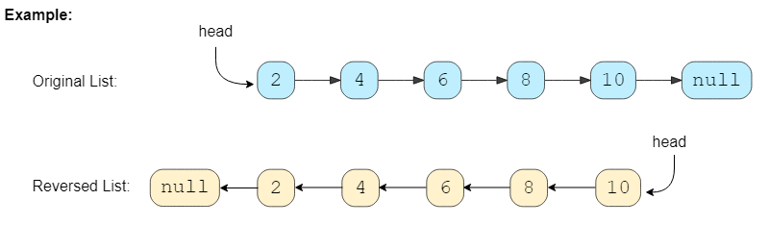

### Solution

To reverse a **LinkedList**, we need to reverse one node at a time. We will start with a variable current which will initially point to the head of the **LinkedList** and a variable previous which will point to the previous node that we have processed; initially previous will point to null.

In a stepwise manner, we will reverse the current node by pointing it to the previous before moving on to the next node. Also, we will update the previous to always point to the previous node that we have processed.

Here is the visual representation of our algorithm:

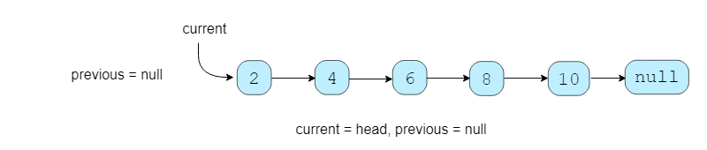

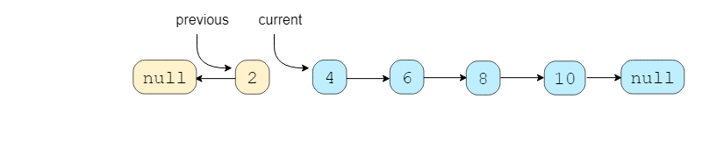

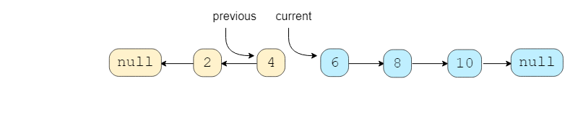

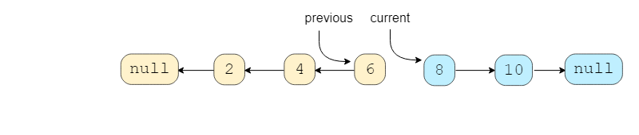

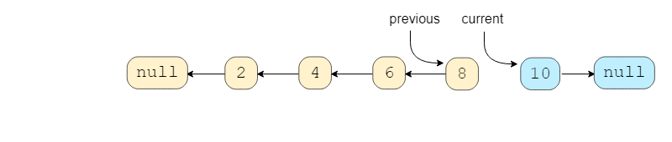

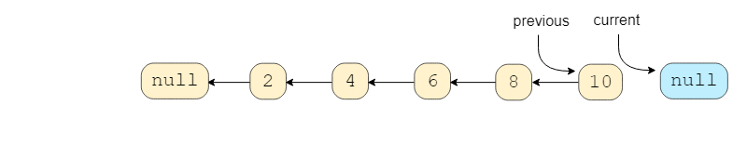

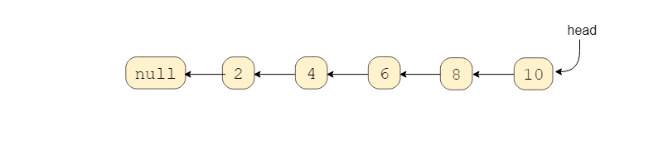

### Code

|  |
| --- |
| class ListNode {  int value = 0;  ListNode next;  ListNode(int value) {  this.value = value;  }  }  class Solution {  public static ListNode reverse(ListNode head) {  ListNode current = head; // current node that we will be processing  ListNode previous = null; // previous node that we have processed  ListNode next = null; // will be used to temporarily store the next node  while (current != null) {  next = current.next; // temporarily store the next node  current.next = previous; // reverse the current node  // before we move to the next node, point previous to the current node  previous = current;  current = next; // move on the next node  }  // after the loop current will be pointing to 'null' and 'previous' will be the  // new head  return previous;  }  public static void main(String[] args) {  ListNode head = new ListNode(2);  head.next = new ListNode(4);  head.next.next = new ListNode(6);  head.next.next.next = new ListNode(8);  head.next.next.next.next = new ListNode(10);  ListNode result = Solution.reverse(head);  System.out.print("Nodes of the reversed LinkedList are: ");  while (result != null) {  System.out.print(result.value + " ");  result = result.next;  }  }  } |

* The time complexity of our algorithm will be O(N) where N’ is the total number of nodes in the **LinkedList**.
* We only used constant space, therefore, the space complexity of our algorithm is O(1).

**Reverse a Sub-list (medium)**

<https://leetcode.com/problems/reverse-linked-list-ii/>

### Problem Statement

Given the head of a **LinkedList** and two positions p and q, reverse the **LinkedList** from position p to q.

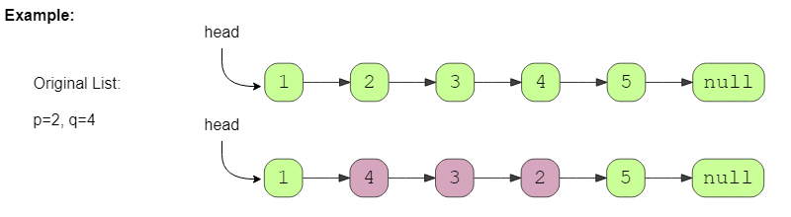

### Solution

The problem follows the **in-place Reversal** of a **LinkedList** pattern. We can use a similar approach as discussed in **Reverse a LinkedList**. Here are the steps we need to follow:

1. Skip the first p-1 nodes, to reach the node at position p.
2. Remember the node at position p-1 to be used later to connect with the reversed sub-list.
3. Next, reverse the nodes from p to q using the same approach discussed in **Reverse a LinkedList**.
4. Connect the p-1 and q+1 nodes to the reversed sub-list.

### Code

|  |
| --- |
| import java.util.*;  class ListNode {  int value = 0;  ListNode next;  ListNode(int value) {  this.value = value;  }  }  class Solution {  public static ListNode reverse(ListNode head, int p, int q) {  if (p == q)  return head;  // after skipping 'p-1' nodes, current will point to 'p'th node  ListNode current = head, previous = null;  for (int i = 0; current != null && i < p - 1; ++i) {  previous = current;  current = current.next;  }  // we are interested in three parts of the LinkedList, part before index 'p', part  // between 'p' and 'q', and the part after index 'q'  ListNode lastNodeOfFirstPart = previous; // points to the node at index 'p-1'  // after reversing the LinkedList 'current' will become the last node of the sub-list  ListNode lastNodeOfSubList = current;  ListNode next = null; // will be used to temporarily store the next node  // reverse nodes between 'p' and 'q'  for (int i = 0; current != null && i < q - p + 1; i++) {  next = current.next;  current.next = previous;  previous = current;  current = next;  }  // connect with the first part  if (lastNodeOfFirstPart != null)  // 'previous' is now the first node of the sub-list  lastNodeOfFirstPart.next = previous;  else  // this means p == 1 i.e., we are changing the first node (head) of the LinkedList  head = previous;  // connect with the last part  lastNodeOfSubList.next = current;  return head;  }  public static void main(String[] args) {  ListNode head = new ListNode(1);  head.next = new ListNode(2);  head.next.next = new ListNode(3);  head.next.next.next = new ListNode(4);  head.next.next.next.next = new ListNode(5);  ListNode result = Solution.reverse(head, 2, 4);  System.out.print("Nodes of the reversed LinkedList are: ");  while (result != null) {  System.out.print(result.value + " ");  result = result.next;  }  }  } |

* The time complexity of our algorithm will be O(N) where N is the total number of nodes in the **LinkedList**.
* We only used constant space, therefore, the space complexity of our algorithm is O(1).

### Similar problems

### 🌟 Reverse the first k elements of a given LinkedList.

This problem can be easily converted to our parent problem; to reverse the first k nodes of the list, we need to pass p=1 and q=k.

### 🌟 Given a LinkedList with n nodes, reverse it based on its size in the following way:

1. If n is even, reverse the list in a group of n/2 nodes.
2. If n is odd, keep the middle node as it is, reverse the first n/2 nodes and reverse the last n/2 nodes.

When n is even we can perform the following steps:

1. Reverse first n/2 nodes: head = reverse(head, 1, n/2)
2. Reverse last n/2 nodes: head = reverse(head, n/2 + 1, n)

When n is odd, our algorithm will look like:

1. head = reverse(head, 1, n/2)
2. head = reverse(head, n/2 + 2, n) Please note the function call in the second step. We’re skipping two elements as we will be skipping the middle element.

**Reverse every K-element Sub-list (medium)**

<https://leetcode.com/problems/reverse-nodes-in-k-group/>

### Problem Statement

Given the head of a **LinkedList** and a number ‘k’, **reverse every ‘k’ sized sub-list** starting from the head. If, in the end, you are left with a sub-list with less than ‘k’ elements, reverse it too.

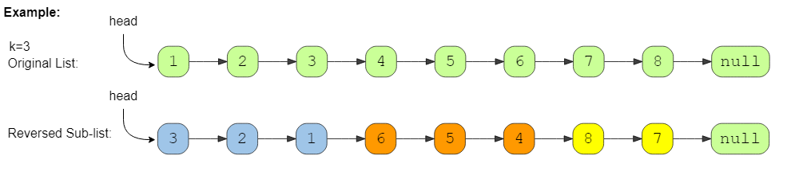

### Solution

The problem follows the **in-place Reversal of a LinkedList** pattern and is quite similar to **Reverse a Sub-list**. The only difference is that we have to reverse all the sub-lists. We can use the same approach, starting with the first sub-list (i.e. p=1, q=k) and keep reversing all the sublists of size ‘k’.

### Code

|  |
| --- |
| import java.util.*;  class ListNode {  int value = 0;  ListNode next;  ListNode(int value) {  this.value = value;  }  }  class Solution {  public static ListNode reverse(ListNode head, int k) {  if (k <= 1 || head == null)  return head;  ListNode current = head, previous = null;  while (true) {  ListNode lastNodeOfPreviousPart = previous;  // after reversing the LList 'current' will become the last node of the sub-list  ListNode lastNodeOfSubList = current;  ListNode next = null; // will be used to temporarily store the next node  // reverse 'k' nodes  for (int i = 0; current != null && i < k; i++) {  next = current.next;  current.next = previous;  previous = current;  current = next;  }  // connect with the previous part  if (lastNodeOfPreviousPart != null)  // 'previous' is now the first node of the sub-list  lastNodeOfPreviousPart.next = previous;  else // this means we are changing the first node (head) of the LinkedList  head = previous;  // connect with the next part  lastNodeOfSubList.next = current;  if (current == null) // break, if we've reached the end of the LinkedList  break;  // prepare for the next sub-list  previous = lastNodeOfSubList;  }  return head;  }  public static void main(String[] args) {  ListNode head = new ListNode(1);  head.next = new ListNode(2);  head.next.next = new ListNode(3);  head.next.next.next = new ListNode(4);  head.next.next.next.next = new ListNode(5);  head.next.next.next.next.next = new ListNode(6);  head.next.next.next.next.next.next = new ListNode(7);  head.next.next.next.next.next.next.next = new ListNode(8);  ListNode result = Solution.reverse(head, 3);  System.out.print("Nodes of the reversed LinkedList are: ");  while (result != null) {  System.out.print(result.value + " ");  result = result.next;  }  }  } |

* The time complexity of our algorithm will be O(N) where N is the total number of nodes in the **LinkedList**.
* We only used constant space, therefore, the space complexity of our algorithm is O(1).

**🌟 Reverse alternating K-element Sub-list (medium)**

### Problem Statement

Given the head of a **LinkedList** and a number K, **reverse every alternating K sized sub-list** starting from the head.

If, in the end, you are left with a sub-list with less than K elements, reverse it too.

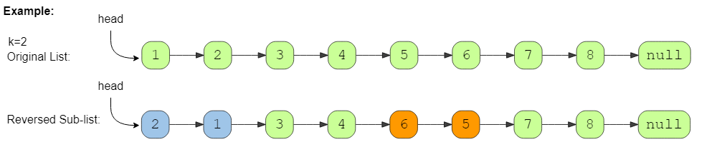

### Solution

The problem follows the **in-place Reversal of a LinkedList** pattern and is quite similar to **Reverse every K-element Sub-list**. The only difference is that we have to skip K alternating elements. We can follow a similar approach, and in each iteration after reversing K elements, we will skip the next K elements.

### Code

|  |
| --- |
| import java.util.*;  class ListNode {  int value = 0;  ListNode next;  ListNode(int value) {  this.value = value;  }  }  class Solution {  public static ListNode reverse(ListNode head, int k) {  if (k <= 1 || head == null)  return head;  ListNode current = head, previous = null;  while (current != null) { // break if we've reached the end of the list  ListNode lastNodeOfPreviousPart = previous;  // after reversing the LList 'current' will become the last node of the sub-list  ListNode lastNodeOfSubList = current;  ListNode next = null; // will be used to temporarily store the next node  // reverse 'k' nodes  for (int i = 0; current != null && i < k; i++) {  next = current.next;  current.next = previous;  previous = current;  current = next;  }  // connect with the previous part  if (lastNodeOfPreviousPart != null)  // 'previous' is now the first node of the sub-list  lastNodeOfPreviousPart.next = previous;  else // this means we are changing the first node (head) of the LinkedList  head = previous;  // connect with the next part  lastNodeOfSubList.next = current;  // skip 'k' nodes  for (int i = 0; current != null && i < k; ++i) {  previous = current;  current = current.next;  }  }  return head;  }  public static void main(String[] args) {  ListNode head = new ListNode(1);  head.next = new ListNode(2);  head.next.next = new ListNode(3);  head.next.next.next = new ListNode(4);  head.next.next.next.next = new ListNode(5);  head.next.next.next.next.next = new ListNode(6);  head.next.next.next.next.next.next = new ListNode(7);  head.next.next.next.next.next.next.next = new ListNode(8);  ListNode result = Solution.reverse(head, 2);  System.out.print("Nodes of the reversed LinkedList are: ");  while (result != null) {  System.out.print(result.value + " ");  result = result.next;  }  }  } |

The time complexity of our algorithm will be O(N)where N’ is the total number of nodes in the **LinkedList**.

* We only used constant space, therefore, the space complexity of our algorithm is O(1).

**🌟 Rotate a LinkedList (medium)**

<https://leetcode.com/problems/rotate-list/>

### Problem Statement

Given the head of a Singly **LinkedList** and a number K, rotate the **LinkedList** to the right by K nodes.

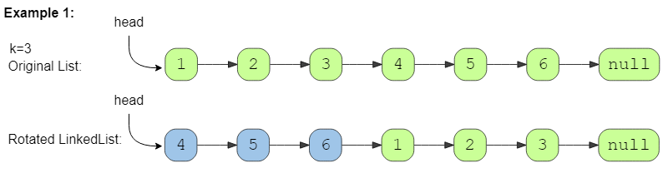

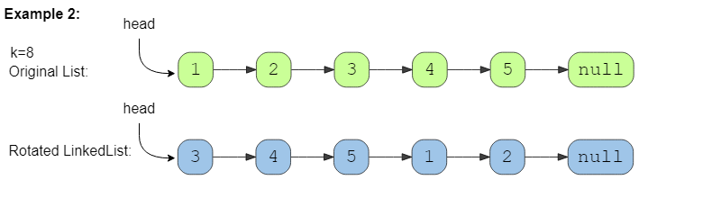

### Solution

Another way of defining the rotation is to take the sub-list of K ending nodes of the **LinkedList** and connect them to the beginning. Other than that we have to do three more things:

1. Connect the last node of the **LinkedList** to the head, because the list will have a different tail after the rotation.
2. The new head of the **LinkedList** will be the node at the beginning of the sublist.
3. The node right before the start of sub-list will be the new tail of the rotated **LinkedList**.

### Code

|  |
| --- |
| import java.util.*;  class ListNode {  int value = 0;  ListNode next;  ListNode(int value) {  this.value = value;  }  }  class Solution {  public static ListNode rotate(ListNode head, int rotations) {  if (head == null || head.next == null || rotations <= 0)  return head;  // find the length and the last node of the list  ListNode lastNode = head;  int listLength = 1;  while (lastNode.next != null) {  lastNode = lastNode.next;  listLength++;  }  lastNode.next = head; // connect the last node with the head to a circular list  rotations %= listLength; // no need to do rotations more than the length of the list  int skipLength = listLength - rotations;  ListNode lastNodeOfRotatedList = head;  for (int i = 0; i < skipLength - 1; i++)  lastNodeOfRotatedList = lastNodeOfRotatedList.next;  // 'lastNodeOfRotatedList.next' is pointing to the sub-list of 'k' ending nodes  head = lastNodeOfRotatedList.next;  lastNodeOfRotatedList.next = null;  return head;  }  public static void main(String[] args) {  ListNode head = new ListNode(1);  head.next = new ListNode(2);  head.next.next = new ListNode(3);  head.next.next.next = new ListNode(4);  head.next.next.next.next = new ListNode(5);  head.next.next.next.next.next = new ListNode(6);  ListNode result = Solution.rotate(head, 3);  System.out.print("Nodes of the reversed LinkedList are: ");  while (result != null) {  System.out.print(result.value + " ");  result = result.next;  }  }  } |

* The time complexity of our algorithm will be O(N) where N’ is the total number of nodes in the **LinkedList**.
* We only used constant space, therefore, the space complexity of our algorithm is O(1).

**Pattern 7: Tree Breadth First Search**

This pattern is based on the **Breadth First Search (BFS)** technique to traverse a tree.

Any problem involving the traversal of a tree in a level-by-level order can be efficiently solved using this approach. We will use a **Queue** to keep track of all the nodes of a level before we jump onto the next level. This also means that the space complexity of the algorithm will be O(W), where W is the maximum number of nodes on any level.

Given the root of a binary tree, return *the level order traversal of its nodes' values*. (i.e., from left to right, level by level).

**Example 1:**

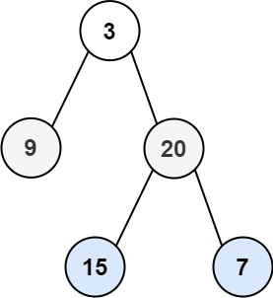

**Input:** root = [3,9,20,null,null,15,7]

**Output:** [[3],[9,20],[15,7]]

**Example 2:**

**Input:** root = [1]

**Output:** [[1]]

**Example 3:**

**Input:** root = []

**Output:** []

**Constraints:**

* The number of nodes in the tree is in the range [0, 2000].
* -1000 <= Node.val <= 1000

## Binary Tree Level Order Traversal (easy)

<https://leetcode.com/problems/binary-tree-level-order-traversal/>

### Problem Statement

Given a binary tree, populate an array to represent its level-by-level traversal. You should populate the values of all nodes of each level from left to right in separate sub-arrays.

Example 1:

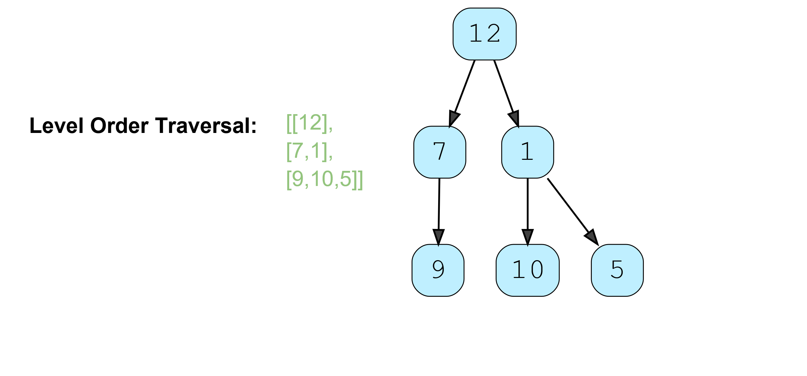

Example 2:

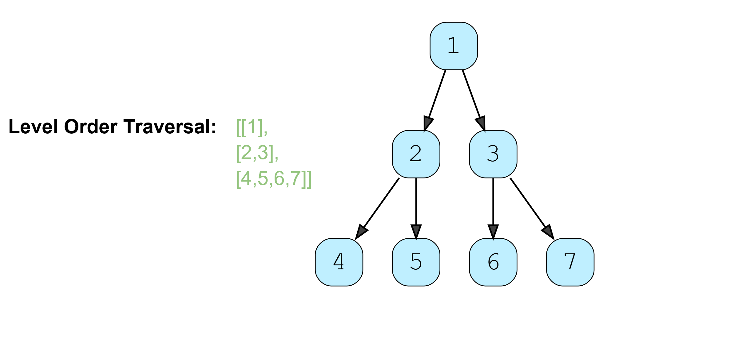

Given a binary tree, populate an array to represent its level-by-level traversal. You should populate the values of all **nodes of each level from left to right** in separate sub-arrays.

### Solution

Since we need to traverse all nodes of each level before moving onto the next level, we can use the **Breadth First Search (BFS)** technique to solve this problem.

We can use a **Queue** to efficiently traverse in **BFS** fashion. Here are the steps of our algorithm:

1. Start by pushing the root node to the queue.
2. Keep iterating until the **queue** is empty.
3. In each iteration, first count the elements in the **queue** (let’s call it levelSize). We will have these many nodes in the current level.
4. Next, remove levelSize nodes from the **queue** and push their value in an array to represent the current level.
5. After removing each node from the queue, insert both of its children into the queue.
6. If the **queue** is not empty, repeat from *step 3* for the next level.

Let’s take the example-2 mentioned above to visually represent our algorithm:

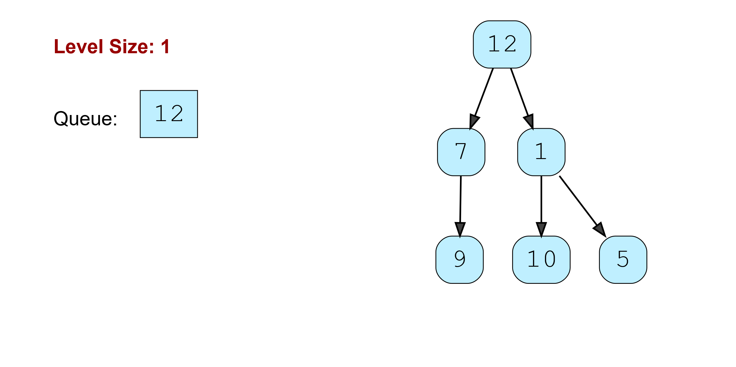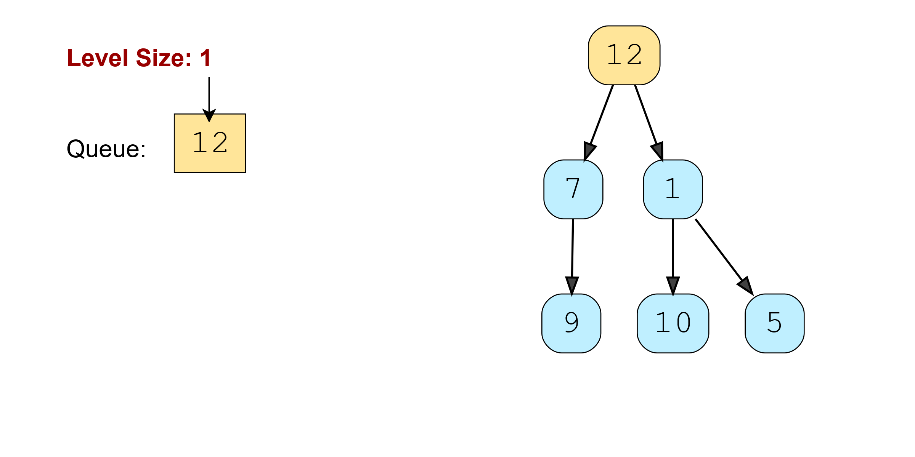

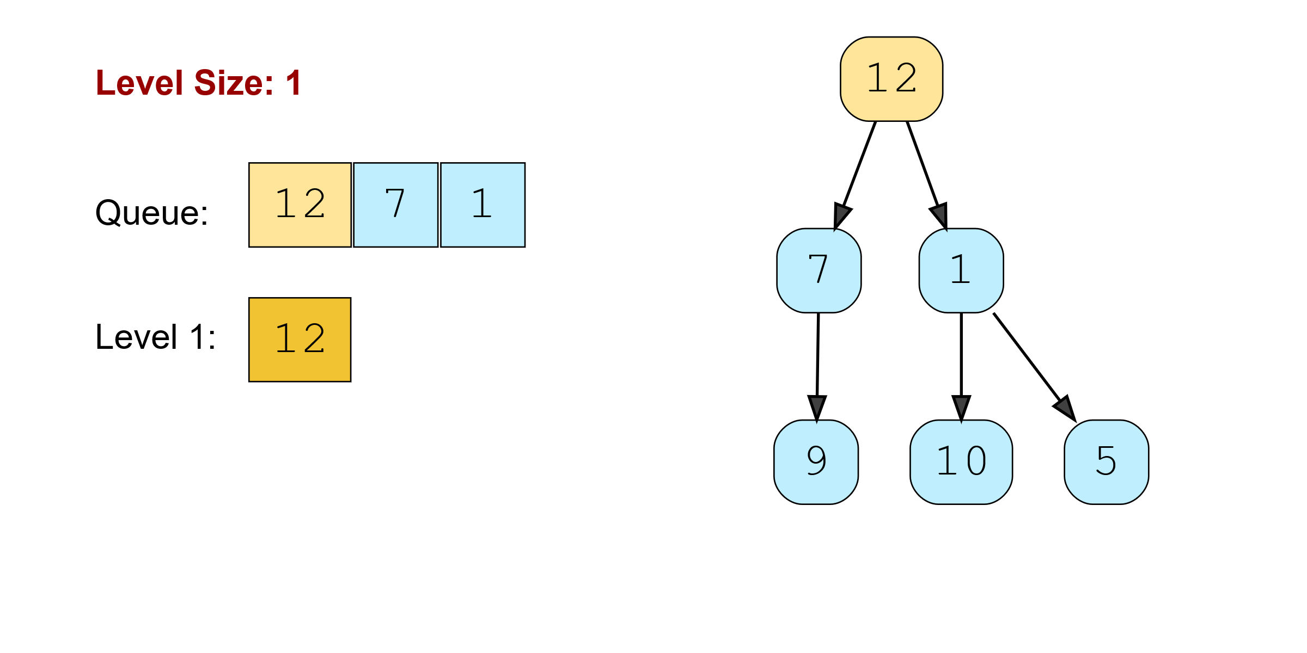

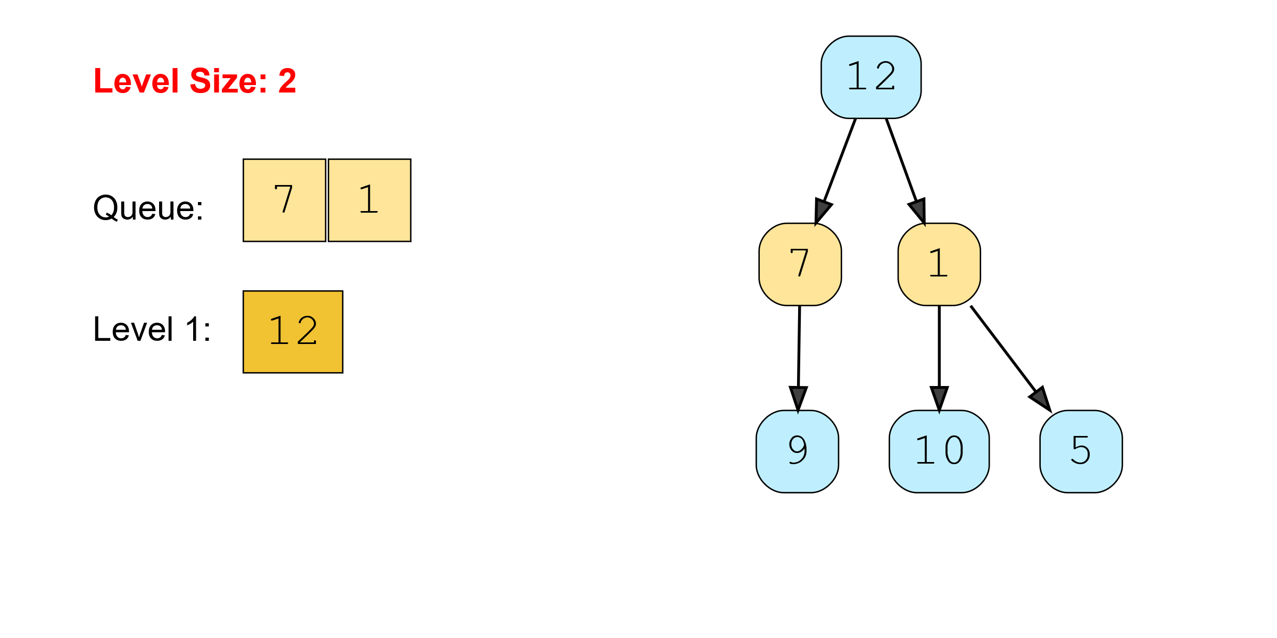

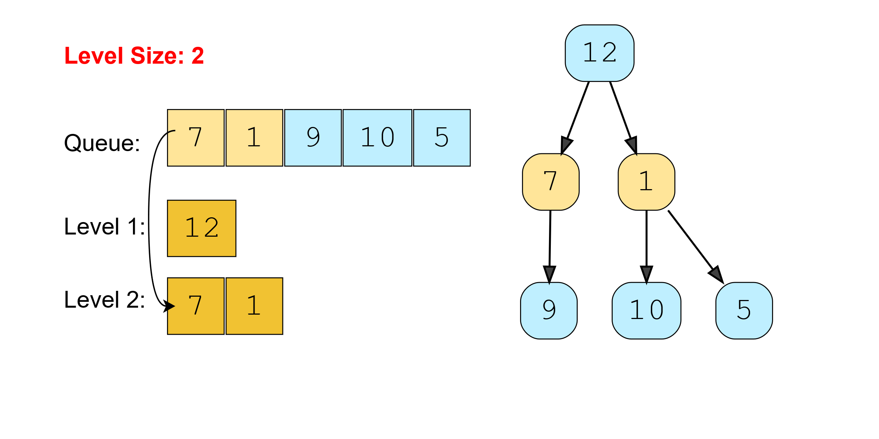

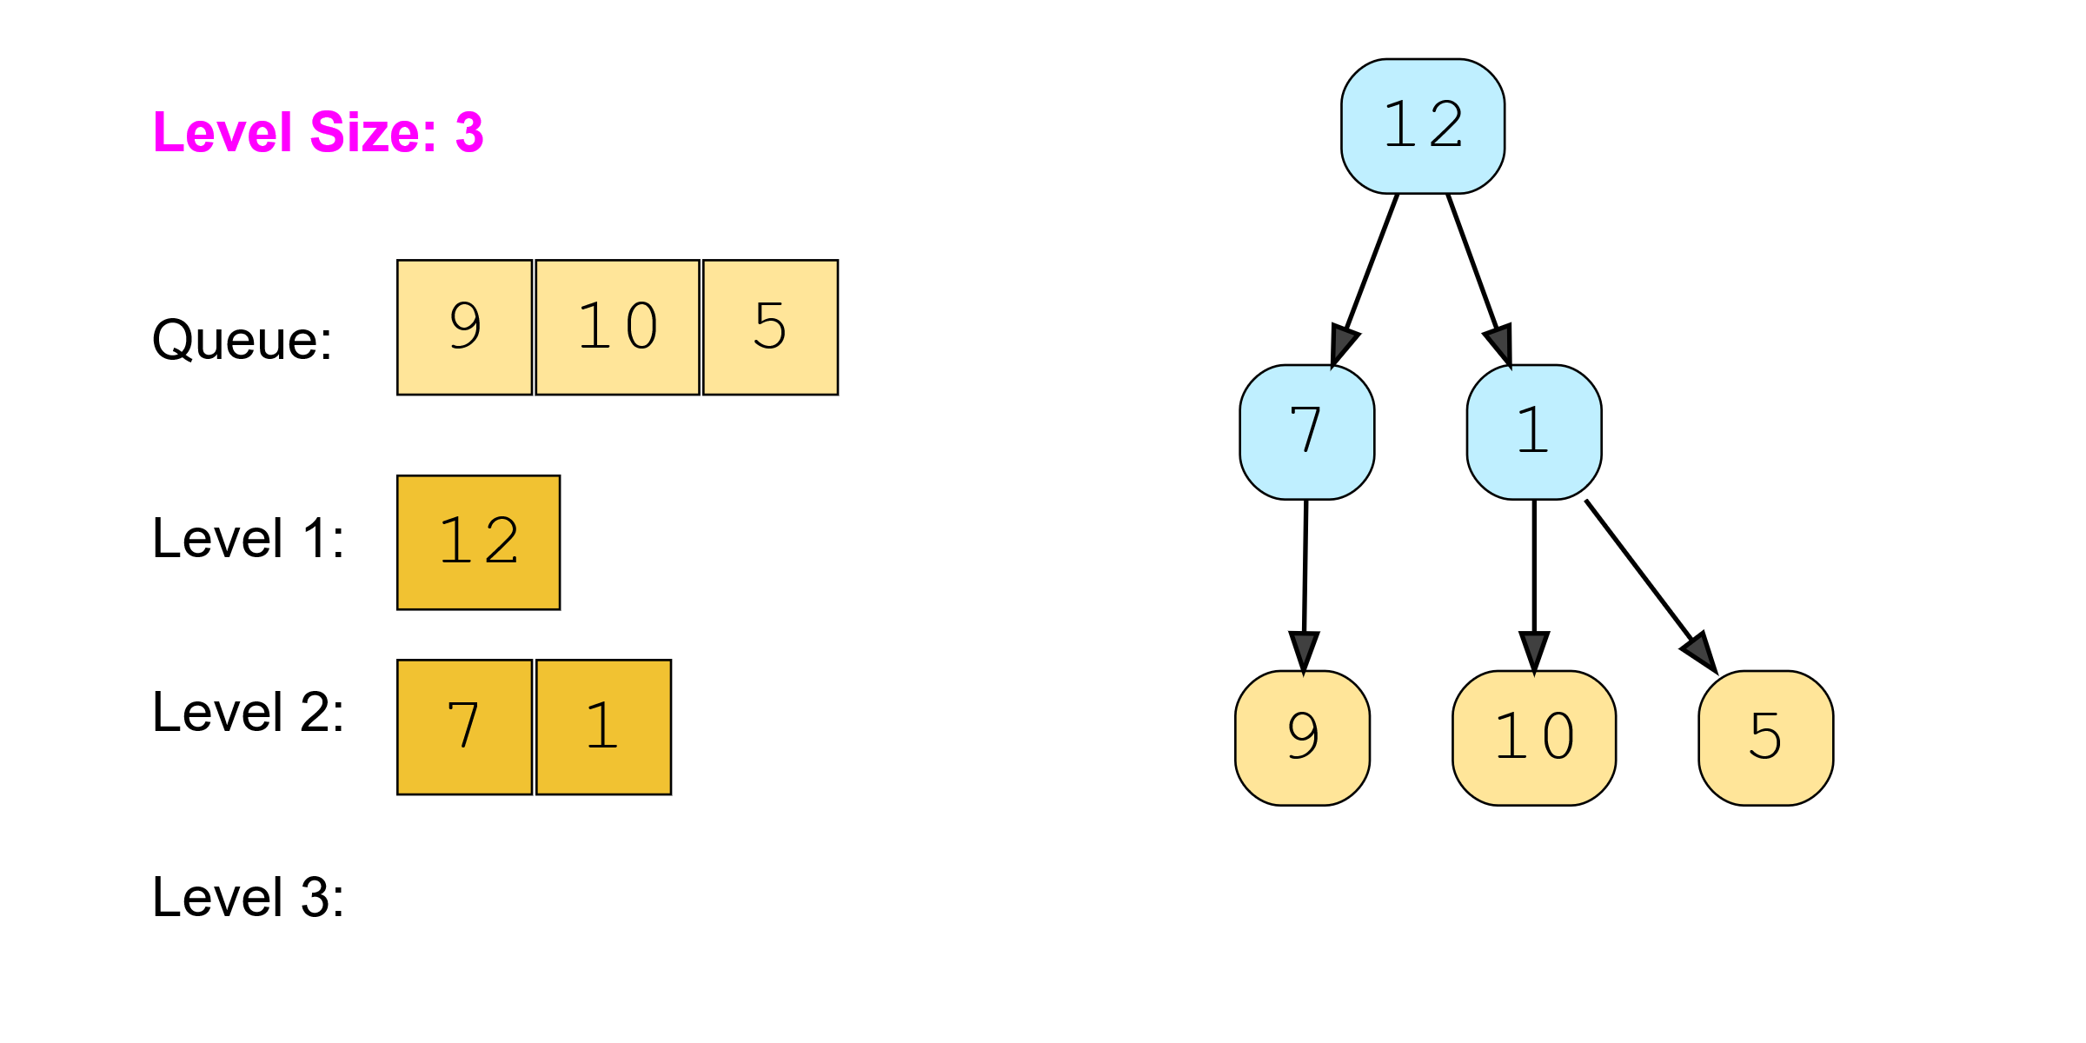

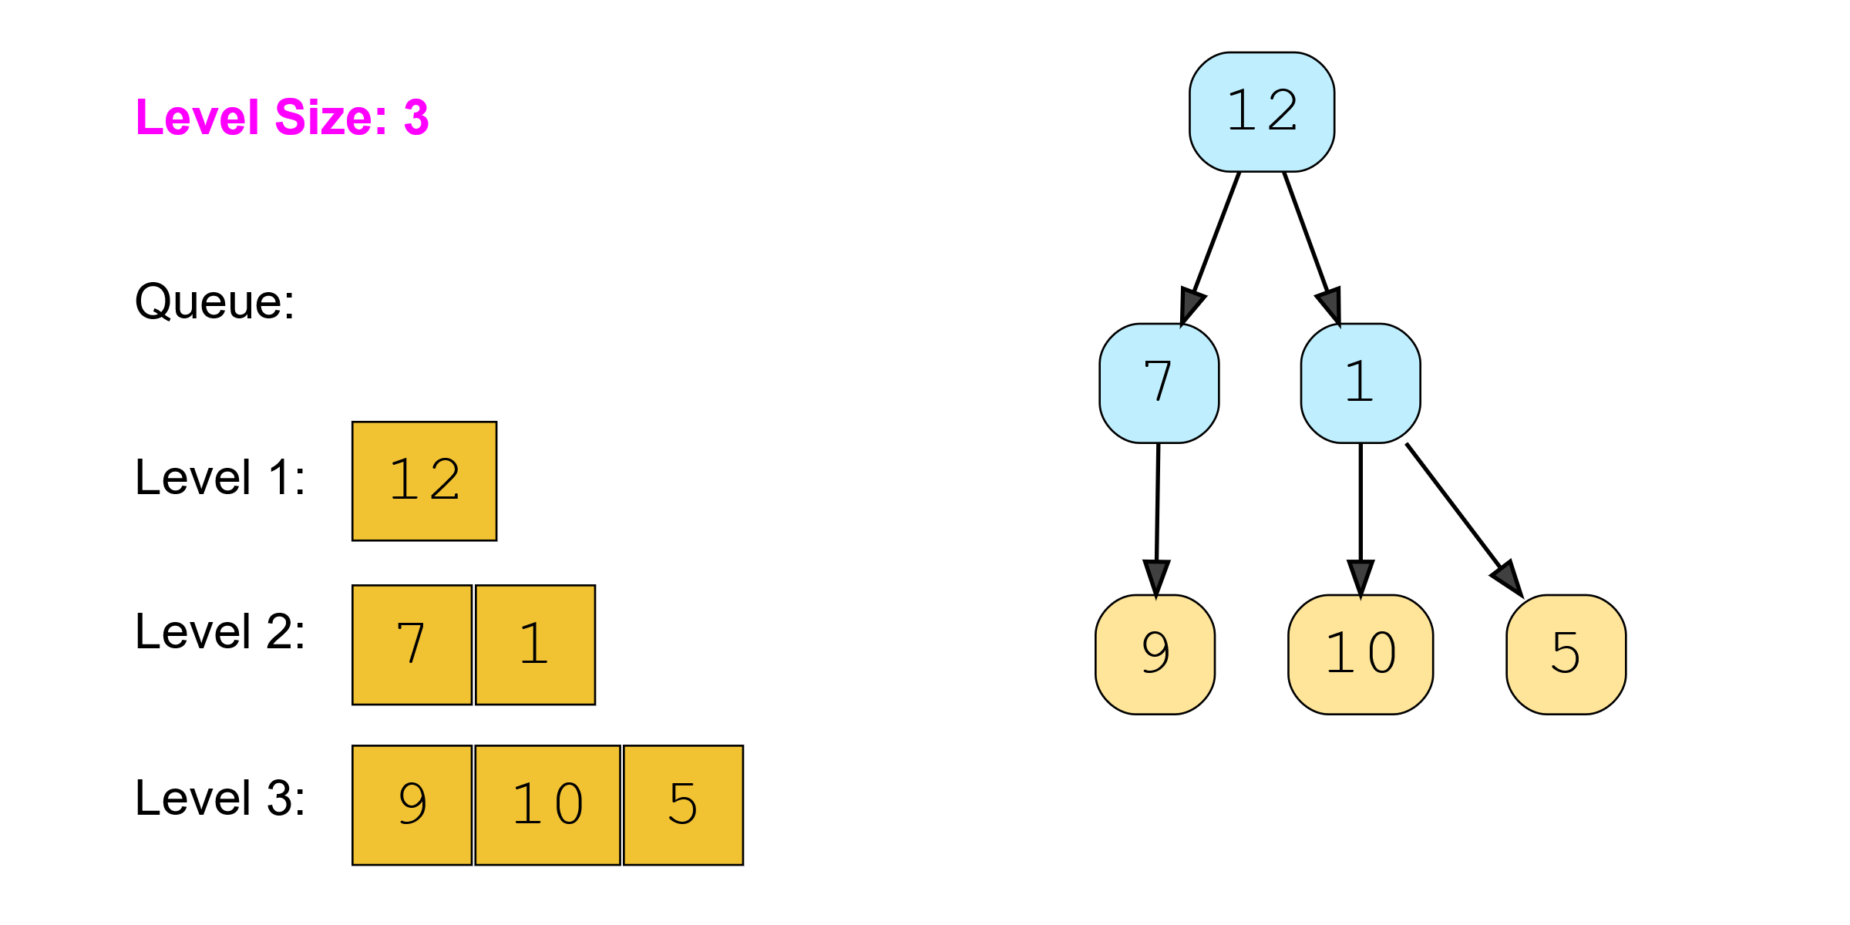

### Code

|  |
| --- |
| import java.util.*;  class TreeNode {  int val;  TreeNode left;  TreeNode right;  TreeNode(int x) {  val = x;  }  };  class Solution {  public static List<List<Integer>> traverse(TreeNode root) {  List<List<Integer>> result = new ArrayList<List<Integer>>();  if (root == null)  return result;  Queue<TreeNode> queue = new LinkedList<>();  queue.offer(root);  while (!queue.isEmpty()) {  int levelSize = queue.size();  List<Integer> currentLevel = new ArrayList<>(levelSize);  for (int i = 0; i < levelSize; i++) {  TreeNode currentNode = queue.poll();  // add the node to the current level  currentLevel.add(currentNode.val);  // insert the children of current node in the queue  if (currentNode.left != null)  queue.offer(currentNode.left);  if (currentNode.right != null)  queue.offer(currentNode.right);  }  result.add(currentLevel);  }  return result;  }  public static void main(String[] args) {  TreeNode root = new TreeNode(12);  root.left = new TreeNode(7);  root.right = new TreeNode(1);  root.left.left = new TreeNode(9);  root.right.left = new TreeNode(10);  root.right.right = new TreeNode(5);  List<List<Integer>> result = Solution.traverse(root);  System.out.println("Level order traversal: " + result);  }  } |

* The time complexity of the above algorithm is O(N), where N is the total number of nodes in the tree. This is due to the fact that we traverse each node once.
* The space complexity of the above algorithm will be O(N) as we need to return a list containing the level order traversal. We will also need O(N) space for the queue. Since we can have a maximum of N/2 nodes at any level (this could happen only at the lowest level), therefore we will need O(N) space to store them in the queue.

### Java Solution

|  |
| --- |
| public class BinaryTreeLevelOrderTraversal {  public static void main(String[] args) {  TreeNode node = new TreeNode(3);  node.left = new TreeNode(9);  node.right = new TreeNode(20);  node.right.left = new TreeNode(15);  node.right.right = new TreeNode(7);  System.*out*.println(*levelOrder*(node));  TreeNode root = new TreeNode(1);  TreeNode root1 = new TreeNode();  System.*out*.println(*levelOrder*(root));  System.*out*.println(*levelOrder*(root1));  }  private static List<List<Integer>> levelOrder(TreeNode root){  if(root == null) return new ArrayList<>();  List<List<Integer>> result = new ArrayList<>();  Queue<TreeNode> queue = new LinkedList<>();  queue.add(root);   while(!queue.isEmpty()){  List<Integer> list = new ArrayList<>();  int size = queue.size();  for(int i= 0; i< size;i++){  TreeNode node = queue.poll();  if(node.left != null) queue.add(node.left);  if(node.right != null) queue.add(node.right);  list.add(node.value);  }  result.add(list);  }  return result;  } } |

## Reverse Level Order Traversal (easy)

<https://leetcode.com/problems/binary-tree-level-order-traversal-ii/>

### Problem Statement

Given a binary tree, populate an array to represent its level-by-level traversal in reverse order, i.e., **the lowest level comes first**. You should populate the values of all nodes in each level from left to right in separate sub-arrays.

Example 1:

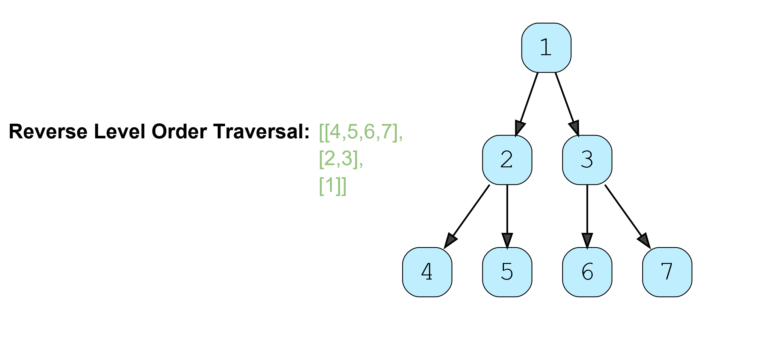

Example 2:

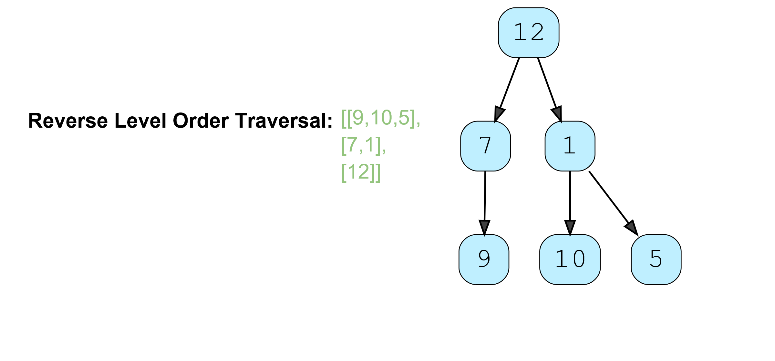

### Solution

This problem follows the **Binary Tree Level Order Traversal** pattern. We can follow the same **BFS** approach. The only difference will be that instead of appending the current level at the end, we will append the current level at the beginning of the result list.

### Code

Here is what our algorithm will look like. Please note that, for Java, we will use a LinkedList instead of an ArrayList for our result list. As in the case of ArrayList, appending an element at the beginning means shifting all the existing elements. Since we need to append the level array at the beginning of the result list, a LinkedList will be better, as this shifting of elements is not required in a LinkedList. Similarly, we will use a double-ended queue (deque) for Python, C++, and JavaScript.

|  |
| --- |
| import java.util.*;  class TreeNode {  int val;  TreeNode left;  TreeNode right;  TreeNode(int x) {  val = x;  }  };  class Solution {  public static List<List<Integer>> traverse(TreeNode root) {  List<List<Integer>> result = new LinkedList<List<Integer>>();  if (root == null)  return result;  Queue<TreeNode> queue = new LinkedList<>();  queue.offer(root);  while (!queue.isEmpty()) {  int levelSize = queue.size();  List<Integer> currentLevel = new ArrayList<>(levelSize);  for (int i = 0; i < levelSize; i++) {  TreeNode currentNode = queue.poll();  // add the node to the current level  currentLevel.add(currentNode.val);  // insert the children of current node to the queue  if (currentNode.left != null)  queue.offer(currentNode.left);  if (currentNode.right != null)  queue.offer(currentNode.right);  }  // append the current level at the beginning  result.add(0, currentLevel);  }  return result;  }  public static void main(String[] args) {  TreeNode root = new TreeNode(12);  root.left = new TreeNode(7);  root.right = new TreeNode(1);  root.left.left = new TreeNode(9);  root.right.left = new TreeNode(10);  root.right.right = new TreeNode(5);  List<List<Integer>> result = Solution.traverse(root);  System.out.println("Reverse level order traversal: " + result);  }  } |

* The time complexity of the above algorithm is O(N), where N is the total number of nodes in the tree. This is due to the fact that we traverse each node once.
* The space complexity of the above algorithm will be O(N) as we need to return a list containing the level order traversal. We will also need O(N) space for the queue. Since we can have a maximum of N/2 nodes at any level (this could happen only at the lowest level), therefore we will need O(N) space to store them in the queue.

### Java Solution

The difference is **add the list to first index always instead of adding at end**.

|  |
| --- |
| private static List<List<Integer>> levelOrderReversal(TreeNode root){  if(root == null) return new ArrayList<>();  List<List<Integer>> result = new ArrayList<>();  Queue<TreeNode> queue = new LinkedList<>();  queue.add(root);   while(!queue.isEmpty()){  List<Integer> list = new ArrayList<>();  int size = queue.size();  for(int i= 0; i< size;i++){  TreeNode node = queue.poll();  if(node.left != null) queue.add(node.left);  if(node.right != null) queue.add(node.right);  list.add(node.value);  }  **result.add(0, list);**  }  return result; } |

## 🌴 Zigzag Traversal (medium)

<https://leetcode.com/problems/binary-tree-zigzag-level-order-traversal/>

Given a binary tree, populate an array to represent its zigzag level order traversal. You should populate the values of all **nodes of the first level from left to right**, then **right to left for the next level** and keep alternating in the same manner for the following levels.

### Problem Statement

Given a binary tree, populate an array to represent its zigzag level order traversal. You should populate the values of all nodes of the first level from left to right, then right to left for the next level and keep alternating in the same manner for the following levels.

Example 1:

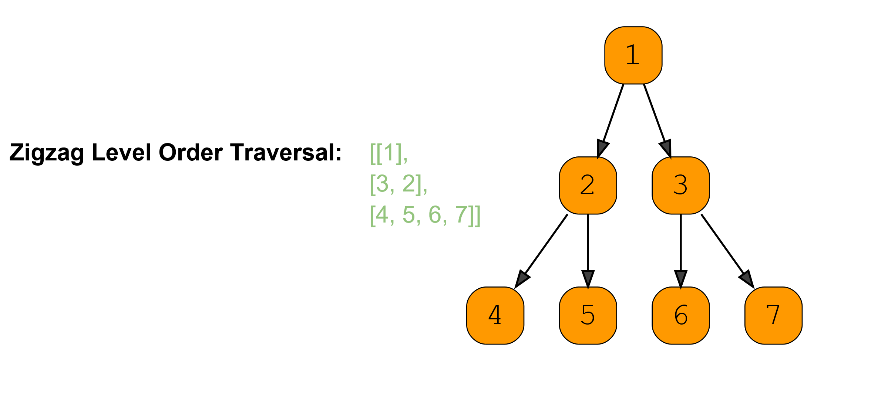

Example 2:

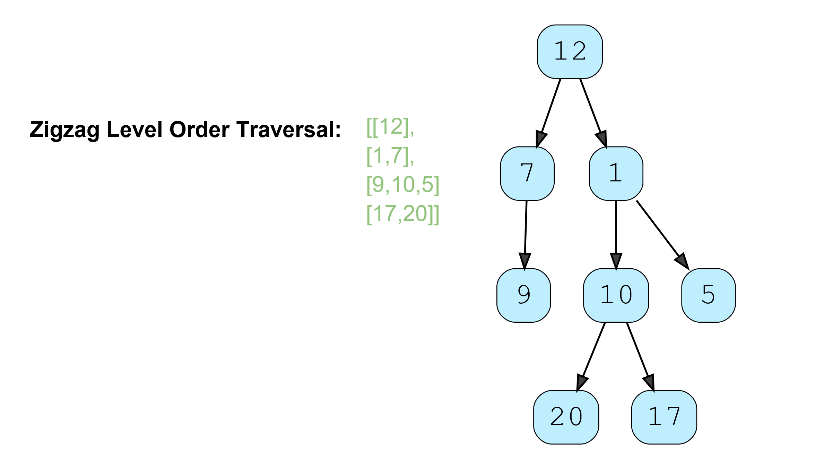

### Solution

This problem follows the **Binary Tree Level Order Traversal** pattern. We can follow the same **BFS** approach. The only additional step we have to keep in mind is to alternate the level order traversal, which means that for every other level, we will traverse similar to [**Reverse Level Order Traversal**](https://github.com/maazshaikh007/DSA_Patterns/blob/main/%E2%9C%85%20%20Pattern%2007:%20Tree%20Breadth%20First%20Search.md#reverse-level-order-traversal-easy).

### Code

|  |
| --- |
| import java.util.*;  class TreeNode {  int val;  TreeNode left;  TreeNode right;  TreeNode(int x) {  val = x;  }  };  class Solution {  public static List<List<Integer>> traverse(TreeNode root) {  List<List<Integer>> result = new ArrayList<List<Integer>>();  if (root == null)  return result;  Queue<TreeNode> queue = new LinkedList<>();  queue.offer(root);  boolean leftToRight = true;  while (!queue.isEmpty()) {  int levelSize = queue.size();  List<Integer> currentLevel = new LinkedList<>();  for (int i = 0; i < levelSize; i++) {  TreeNode currentNode = queue.poll();  // add the node to the current level based on the traverse direction  if (leftToRight)  currentLevel.add(currentNode.val);  else  currentLevel.add(0, currentNode.val);  // insert the children of current node in the queue  if (currentNode.left != null)  queue.offer(currentNode.left);  if (currentNode.right != null)  queue.offer(currentNode.right);  }  result.add(currentLevel);  // reverse the traversal direction  leftToRight = !leftToRight;  }  return result;  }  public static void main(String[] args) {  TreeNode root = new TreeNode(12);  root.left = new TreeNode(7);  root.right = new TreeNode(1);  root.left.left = new TreeNode(9);  root.right.left = new TreeNode(10);  root.right.right = new TreeNode(5);  root.right.left.left = new TreeNode(20);  root.right.left.right = new TreeNode(17);  List<List<Integer>> result = Solution.traverse(root);  System.out.println("Zigzag traversal: " + result);  }  } |

* The time complexity of the above algorithm is O(N), where N is the total number of nodes in the tree. This is due to the fact that we traverse each node once.
* The space complexity of the above algorithm will be O(N) as we need to return a list containing the level order traversal. We will also need O(N) space for the queue. Since we can have a maximum of N/2 nodes at any level (this could happen only at the lowest level), therefore we will need O(N) space to store them in the queue.

### Java Solution

Eaither use linkedlist (addFirst and addLast) method or Arraylist(add with index method).LinkedList will be better because it adds in O(1) time complexity

|  |
| --- |
| private static List<List<Integer>> zigzagLevelOrder(TreeNode root){  if(root == null) return new LinkedList<>();  List<List<Integer>> result = new LinkedList<>();  Queue<TreeNode> queue = new LinkedList<>();  queue.add(root);  boolean leftToRight = true;  while(!queue.isEmpty()){  LinkedList<Integer> list = new LinkedList<>();  int size = queue.size();  for(int i= 0; i< size;i++){  TreeNode node = queue.poll();  if(node.left != null) queue.add(node.left);  if(node.right != null) queue.add(node.right);  if(leftToRight)  list.addLast(node.value);  else  list.addFirst(node.value);  }  result.add(list);  leftToRight = !leftToRight;  }  return result; } |

## Level Averages in a Binary Tree (easy)

<https://leetcode.com/problems/average-of-levels-in-binary-tree/>

Given the root of a binary tree, return *the average value of the nodes on each level in the form of an array*. Answers within 10-5 of the actual answer will be accepted.

**Example 1:**

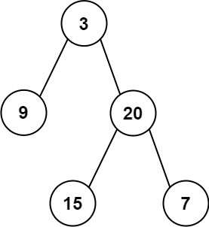

**Input:** root = [3,9,20,null,null,15,7]

**Output:** [3.00000,14.50000,11.00000]

Explanation: The average value of nodes on level 0 is 3, on level 1 is 14.5, and on level 2 is 11.

Hence return [3, 14.5, 11].

**Example 2:**

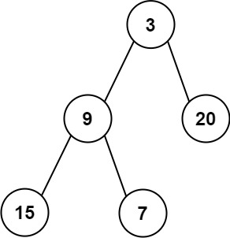

**Input:** root = [3,9,20,15,7]

**Output:** [3.00000,14.50000,11.00000]

* **Constraints:**
* The number of nodes in the tree is in the range [1, 104].
* -231 <= Node.val <= 231 - 1

### Problem Statement

Given a binary tree, populate an array to represent the **averages of all of its levels**

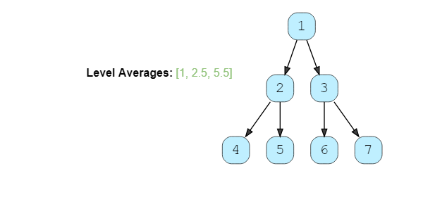

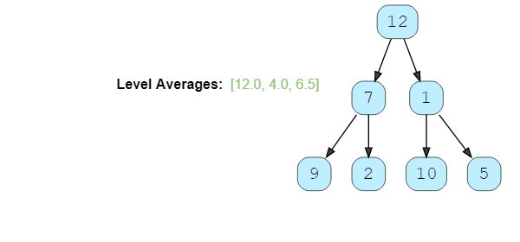

### Solution

This problem follows the **Binary Tree Level Order Traversal** pattern. We can follow the same **BFS** approach. The only difference will be that instead of keeping track of all nodes of a level, we will only track the running sum of the values of all nodes in each level. In the end, we will append the average of the current level to the result array.

|  |
| --- |
| import java.util.*;  class TreeNode {  int val;  TreeNode left;  TreeNode right;  TreeNode(int x) {  val = x;  }  };  class Solution {  public static List<Double> findLevelAverages(TreeNode root) {  List<Double> result = new ArrayList<>();  if (root == null)  return result;  Queue<TreeNode> queue = new LinkedList<>();  queue.offer(root);  while (!queue.isEmpty()) {  int levelSize = queue.size();  double levelSum = 0;  for (int i = 0; i < levelSize; i++) {  TreeNode currentNode = queue.poll();  // add the node's value to the running sum  levelSum += currentNode.val;  // insert the children of current node to the queue  if (currentNode.left != null)  queue.offer(currentNode.left);  if (currentNode.right != null)  queue.offer(currentNode.right);  }  // append the current level's average to the result array  result.add(levelSum / levelSize);  }  return result;  }  public static void main(String[] args) {  TreeNode root = new TreeNode(12);  root.left = new TreeNode(7);  root.right = new TreeNode(1);  root.left.left = new TreeNode(9);  root.left.right = new TreeNode(2);  root.right.left = new TreeNode(10);  root.right.right = new TreeNode(5);  List<Double> result = Solution.findLevelAverages(root);  System.out.print("Level averages are: " + result);  }  } |

* The time complexity of the above algorithm is O(N), where N is the total number of nodes in the tree. This is due to the fact that we traverse each node once.
* The space complexity of the above algorithm will be O(N) which is required for the queue. Since we can have a maximum of N/2 nodes at any level (this could happen only at the lowest level), therefore we will need O(N) space to store them in the queue

### Java Solution

|  |
| --- |
| private static List<Double> levelAverage(TreeNode root){  if(root == null) return new LinkedList<>();  List<Double> result = new LinkedList<>();  Queue<TreeNode> queue = new LinkedList<>();  queue.add(root);  while(!queue.isEmpty()){  int size = queue.size();  double sum = 0;  for(int i= 0; i< size;i++){  TreeNode node = queue.poll();  if(node.left != null) queue.add(node.left);  if(node.right != null) queue.add(node.right);  sum+=node.value;  }  result.add(sum/size);  }  return result;  } |

## Level Having Maximum Sum in a Binary Tree

<https://leetcode.com/problems/maximum-level-sum-of-a-binary-tree/>

Given the root of a binary tree, the level of its root is 1, the level of its children is 2, and so on.

Return the smallest level x such that the sum of all the values of nodes at level x is maximal.

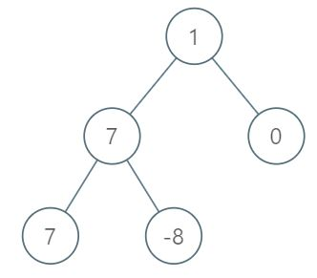

**Input:** root = [1,7,0,7,-8,null,null]

**Output:** 2

**Explanation:**

Level 1 sum = 1.

Level 2 sum = 7 + 0 = 7.

Level 3 sum = 7 + -8 = -1.

So we return the level with the maximum sum which is level 2.

### Java Solution

|  |
| --- |
| private static int levelHavingMaximumSum(TreeNode root){  if(root == null) return -1;  Queue<TreeNode> queue = new LinkedList<>();  queue.add(root);  int result = -1;  int max = Integer.*MIN_VALUE*;  int level = 1;  while(!queue.isEmpty()){  int size = queue.size();  int sum = 0;  for(int i= 0; i< size;i++){  TreeNode node = queue.poll();  if(node.left != null) queue.add(node.left);  if(node.right != null) queue.add(node.right);  sum+=node.value;  }  if(sum > max){  max = sum;  result = level;  }  level++;  }  return result; } |

## Level Maximum in a Binary Tree

<https://leetcode.com/problems/maximum-level-sum-of-a-binary-tree/>

🌟 Find the largest value on each level of a binary tree.

We will follow a similar approach, but instead of having a running sum we will track the maximum value of each level.

**maxValue = Math.max(maxValue, currentNode.val)**

class TreeNode {

constructor(value, left = null, right = null) {

this.value = value;

this.left = left;

this.right = right;

}

}

function largestValue(root) {

//If root is null return an empty array

if (!root) return [];

//declare output array

let result = [];

//initialize the queue with root

const queue = [root];

while (queue.length > 0) {

let levelSize = queue.length;

let maxValue = 0;

for (let i = 0; i < levelSize; i++) {

//get next node

const currNode = queue.shift();

maxValue = Math.max(maxValue, currNode.value);

//insert the children of current node in the queue

if (currNode.left !== null) {

queue.push(currNode.left);

}

if (currNode.right !== null) {

queue.push(currNode.right);

}

}

//append the current level's average to the result array

result.push(maxValue);

maxValue = 0;

}

return result;

}

let root = new TreeNode(12);

root.left = new TreeNode(7);

root.right = new TreeNode(1);

root.left.left = new TreeNode(9);

root.left.right = new TreeNode(2);

root.right.left = new TreeNode(10);

root.right.right = new TreeNode(5);

console.log(`Max value's for each level are: ${largestValue(root)}`);

// [[12], [7], [10]];

## Minimum Depth of a Binary Tree (easy)

<https://leetcode.com/problems/minimum-depth-of-binary-tree/>

### Problem Statement

Find the minimum depth of a binary tree. The minimum depth is the number of nodes along the **shortest path from the root node to the nearest leaf node**.

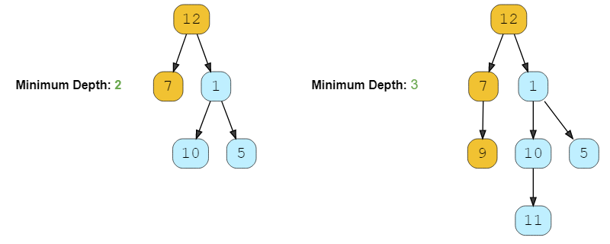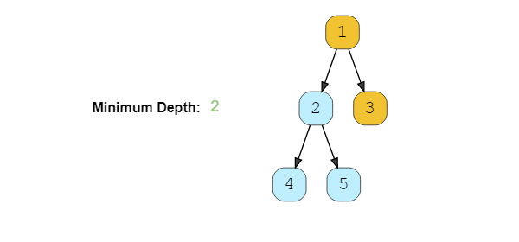

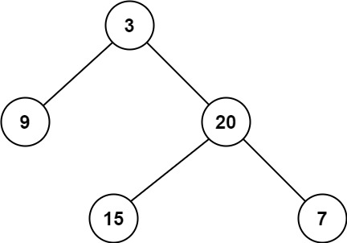

**Input:** root = [3,9,20,null,null,15,7]

**Output:** 2

### Solution

This problem follows the **Binary Tree Level Order Traversal** pattern. We can follow the same **BFS** approach. The only difference will be, instead of keeping track of all the nodes in a level, we will only track the depth of the tree. As soon as we find our first leaf node, that level will represent the minimum depth of the tree.

### Code

|  |
| --- |
| import java.util.*;  class TreeNode {  int val;  TreeNode left;  TreeNode right;  TreeNode(int x) {  val = x;  }  };  class Solution {  public static int findDepth(TreeNode root) {  if (root == null)  return 0;  Queue<TreeNode> queue = new LinkedList<>();  queue.add(root);  int minimumTreeDepth = 0;  while (!queue.isEmpty()) {  minimumTreeDepth++;  int levelSize = queue.size();  for (int i = 0; i < levelSize; i++) {  TreeNode currentNode = queue.poll();  // check if this is a leaf node  if (currentNode.left == null && currentNode.right == null)  return minimumTreeDepth;  // insert the children of current node in the queue  if (currentNode.left != null)  queue.add(currentNode.left);  if (currentNode.right != null)  queue.add(currentNode.right);  }  }  return minimumTreeDepth;  }  public static void main(String[] args) {  TreeNode root = new TreeNode(12);  root.left = new TreeNode(7);  root.right = new TreeNode(1);  root.right.left = new TreeNode(10);  root.right.right = new TreeNode(5);  System.out.println("Tree Minimum Depth: " + Solution.findDepth(root));  root.left.left = new TreeNode(9);  root.right.left.left = new TreeNode(11);  System.out.println("Tree Minimum Depth: " + Solution.findDepth(root));  }  } |

* The time complexity of the above algorithm is O(N), where N is the total number of nodes in the tree. This is due to the fact that we traverse each node once.
* The space complexity of the above algorithm will be O(N) which is required for the queue. Since we can have a maximum of N/2 nodes at any level (this could happen only at the lowest level), therefore we will need O(N) space to store them in the queue.

### Java Solution

|  |
| --- |
| private static int findMinimumDepth(TreeNode root){  if(root == null) return 0;  Queue<TreeNode> queue = new LinkedList<>();  queue.add(root);  int minimumDepth = 0;  while(!queue.isEmpty()){  minimumDepth++;  int size = queue.size();  for(int i= 0; i< size;i++){  TreeNode node = queue.poll();  if(node.left == null && node.right == null) return minimumDepth;  if(node.left != null) queue.add(node.left);  if(node.right != null) queue.add(node.right);  }  }  return minimumDepth; } |

## Maximum Depth of a Binary Tree

<https://leetcode.com/problems/maximum-depth-of-binary-tree/>

### Problem 1

Given a binary tree, find its maximum depth (or height).

### ****Solution****

We will follow a similar approach. Instead of returning as soon as we find a leaf node, we will keep traversing for all the levels, incrementing maximumDepth each time we complete a level.

### Code

|  |
| --- |
| import java.util.*;  class TreeNode {  int val;  TreeNode left;  TreeNode right;  TreeNode(int x) {  val = x;  }  };  class Solution {  public static int findDepth(TreeNode root) {  if (root == null)  return 0;  Queue<TreeNode> queue = new LinkedList<>();  queue.add(root);  int maximumTreeDepth = 0;  while (!queue.isEmpty()) {  maximumTreeDepth++;  int levelSize = queue.size();  for (int i = 0; i < levelSize; i++) {  TreeNode currentNode = queue.poll();  // insert the children of current node in the queue  if (currentNode.left != null)  queue.add(currentNode.left);  if (currentNode.right != null)  queue.add(currentNode.right);  }  }  return maximumTreeDepth;  }  public static void main(String[] args) {  TreeNode root = new TreeNode(12);  root.left = new TreeNode(7);  root.right = new TreeNode(1);  root.right.left = new TreeNode(10);  root.right.right = new TreeNode(5);  System.out.println("Tree Maximum Depth: " + Solution.findDepth(root));  root.left.left = new TreeNode(9);  root.right.left.left = new TreeNode(11);  System.out.println("Tree Maximum Depth: " + Solution.findDepth(root));  }  } |

### Java Solution 1: Level Order Traversal(BFS)

|  |
| --- |
| private static int findMaximumDepth(TreeNode root){  if(root == null) return 0;  Queue<TreeNode> queue = new LinkedList<>();  queue.add(root);  int maximumDepth = 0;  while(!queue.isEmpty()){  maximumDepth++;  int size = queue.size();  for(int i= 0; i< size;i++){  TreeNode node = queue.poll();  if(node.left != null) queue.add(node.left);  if(node.right != null) queue.add(node.right);  }  }  return maximumDepth;  } |

### Java Solution 2: Post Order Traversal(DFS)

|  |
| --- |
| private static int maxDepth(TreeNode root) {  if(root == null) return 0;  return 1 + Math.max(maxDepth(root.left), maxDepth(root.right));  } |

## Level Order Successor (easy)

### Problem Statement

Given a binary tree and a node, find the level order successor of the given node in the tree. The level order successor is the node that appears right after the given node in the level order traversal.

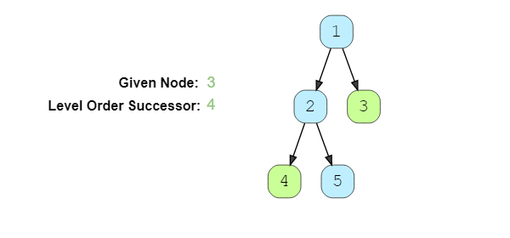

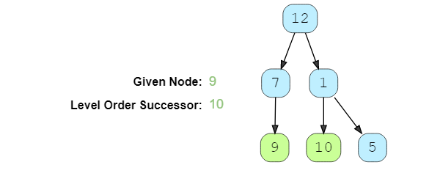

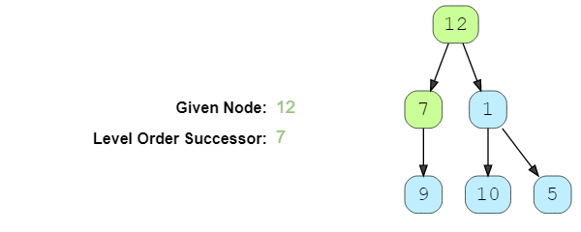

### Solution

This problem follows the **Binary Tree Level Order Traversal** pattern. We can follow the same **BFS** approach. The only difference will be that we will not keep track of all the levels. Instead we will keep inserting child nodes to the queue. As soon as we find the given node, we will return the next node from the **queue** as the level order successor.

### Code

|  |
| --- |
| import java.util.*;  class TreeNode {  int val;  TreeNode left;  TreeNode right;  TreeNode(int x) {  val = x;  }  };  class Solution {  public static TreeNode findSuccessor(TreeNode root, int key) {  if (root == null)  return null;  Queue<TreeNode> queue = new LinkedList<>();  queue.offer(root);  while (!queue.isEmpty()) {  TreeNode currentNode = queue.poll();  // insert the children of current node in the queue  if (currentNode.left != null)  queue.offer(currentNode.left);  if (currentNode.right != null)  queue.offer(currentNode.right);  // break if we have found the key  if (currentNode.val == key)  break;  }  return queue.peek();  }  public static void main(String[] args) {  TreeNode root = new TreeNode(1);  root.left = new TreeNode(2);  root.right = new TreeNode(3);  root.left.left = new TreeNode(4);  root.left.right = new TreeNode(5);    TreeNode result = Solution.findSuccessor(root, 3);  if (result != null)  System.out.println(result.val + " ");  root = new TreeNode(12);  root.left = new TreeNode(7);  root.right = new TreeNode(1);  root.left.left = new TreeNode(9);  root.right.left = new TreeNode(10);  root.right.right = new TreeNode(5);  result = Solution.findSuccessor(root, 9);  if (result != null)  System.out.println(result.val + " ");  result = Solution.findSuccessor(root, 12);  if (result != null)  System.out.println(result.val + " ");  }  } |

* The time complexity of the above algorithm is O(N), where N is the total number of nodes in the tree. This is due to the fact that we traverse each node once.
* The space complexity of the above algorithm will be O(N) which is required for the queue. Since we can have a maximum of N/2 nodes at any level (this could happen only at the lowest level), therefore we will need O(N) space to store them in the queue.

### Java Solution

|  |
| --- |
| private static TreeNode findSuccessor(TreeNode root, int key){  if(root == null) return null;  Queue<TreeNode> queue = new LinkedList<>();  queue.add(root);  while(!queue.isEmpty()){  TreeNode node = queue.poll();  if(node.left != null) queue.add(node.left);  if(node.right != null) queue.add(node.right);  if(node.value == key) break;  }  if(queue.size() > 0) return queue.poll();  return null;  } |

## 😕 Connect Level Order Siblings (medium)

<https://leetcode.com/problems/populating-next-right-pointers-in-each-node/>

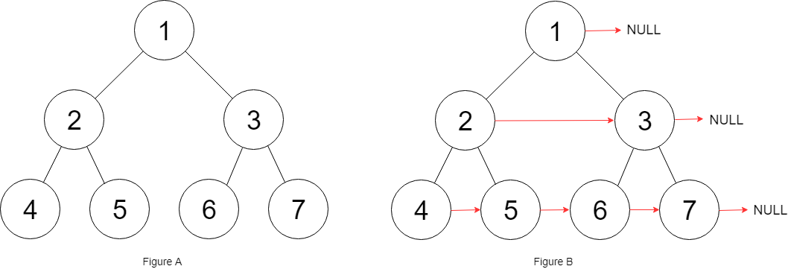

**Input:** root = [1,2,3,4,5,6,7]

**Output:** [1,#,2,3,#,4,5,6,7,#]

**Explanation:** Given the above perfect binary tree (Figure A), your function should populate each next pointer to point to its next right node, just like in Figure B. The serialized output is in level order as connected by the next pointers, with '#' signifying the end of each level.

### Problem Statement

Given a binary tree, connect each node with its level order successor. The last node of each level should point to a null node.

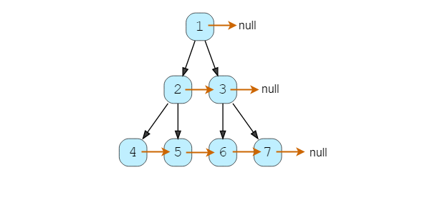

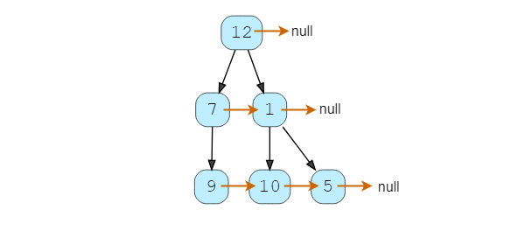

### Solution

This problem follows the **Binary Tree Level Order Traversal** pattern. We can follow the same **BFS** approach. The only difference is that while traversing a level we will **remember the previous node to connect it with the current node**.

### Code

|  |
| --- |
| import java.util.*;  class TreeNode {  int val;  TreeNode left;  TreeNode right;  TreeNode next;  TreeNode(int x) {  val = x;  left = right = next = null;  }  // level order traversal using 'next' pointer  public void printLevelOrder() {  TreeNode nextLevelRoot = this;  while (nextLevelRoot != null) {  TreeNode current = nextLevelRoot;  nextLevelRoot = null;  while (current != null) {  System.out.print(current.val + " ");  if (nextLevelRoot == null) {  if (current.left != null)  nextLevelRoot = current.left;  else if (current.right != null)  nextLevelRoot = current.right;  }  current = current.next;  }  System.out.println();  }  }  };  class Solution {  public static void connect(TreeNode root) {  if (root == null)  return;  Queue<TreeNode> queue = new LinkedList<>();  queue.offer(root);  while (!queue.isEmpty()) {  TreeNode previousNode = null;  int levelSize = queue.size();  // connect all nodes of this level  for (int i = 0; i < levelSize; i++) {  TreeNode currentNode = queue.poll();  if (previousNode != null)  previousNode.next = currentNode;  previousNode = currentNode;  // insert the children of current node in the queue  if (currentNode.left != null)  queue.offer(currentNode.left);  if (currentNode.right != null)  queue.offer(currentNode.right);  }  }  }  public static void main(String[] args) {  TreeNode root = new TreeNode(12);  root.left = new TreeNode(7);  root.right = new TreeNode(1);  root.left.left = new TreeNode(9);  root.right.left = new TreeNode(10);  root.right.right = new TreeNode(5);  Solution.connect(root);  System.out.println("Level order traversal using 'next' pointer: ");  root.printLevelOrder();  }  } |

* The time complexity of the above algorithm is O(N), where N is the total number of nodes in the tree. This is due to the fact that we traverse each node once.
* The space complexity of the above algorithm will be O(N), which is required for the queue. Since we can have a maximum of N/2nodes at any level (this could happen only at the lowest level), therefore we will need O(N) space to store them in the queue.

### Java Solution

|  |
| --- |
| private static Node connect(Node root){  if(root == null) return null;  Queue<Node> queue = new LinkedList<>();  queue.add(root);  queue.add(null);  while(!queue.isEmpty()){  Node curNode = queue.poll();  if(curNode ==null && queue.isEmpty()){  return root;  }  if(curNode == null){  queue.add(null);  }  else {  curNode.next = queue.peek();  if (curNode.left != null) queue.add(curNode.left);  if (curNode.right != null) queue.add(curNode.right);  }  }  return root;  }  public static Node connectOptimized(Node root) {  Node answ = root;  Node tmpLeft;  while (root != null) {  tmpLeft = root.left;  while (root != null && root.left != null) {  root.left.next = root.right;  if (root.next != null)  root.right.next = root.next.left;  root = root.next;  }  root = tmpLeft;  }  return answ;  }  public Node connectOptimized2(Node root) {  if(root == null) return null;  if(root.left != null) root.left.next = root.right;  if(root.right != null && root.next != null) root.right.next = root.next.left;  connect(root.left);  connect(root.right);  return root;  } |

## 🌟 Connect All Level Order Siblings (medium)

### Problem Statement

Given a binary tree, connect each node with its level order successor. The last node of each level should point to the first node of the next level.

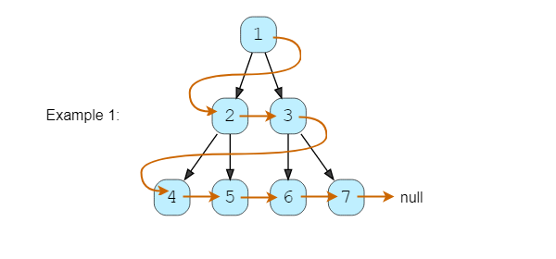

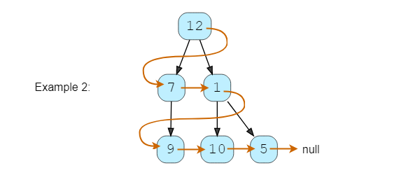

### Solution

This problem follows the **Binary Tree Level Order Traversal** pattern. We can follow the same **BFS** approach. The only difference will be that while traversing we will remember (irrespective of the level) the previous node to connect it with the current node.

### Code

|  |
| --- |
| import java.util.*;  class TreeNode {  int val;  TreeNode left;  TreeNode right;  TreeNode next;  TreeNode(int x) {  val = x;  left = right = next = null;  }  // tree traversal using 'next' pointer  public void printTree() {  TreeNode current = this;  System.out.print("Traversal using 'next' pointer: ");  while (current != null) {  System.out.print(current.val + " ");  current = current.next;  }  }  };  class Solution {  public static void connect(TreeNode root) {  if (root == null)  return;  Queue<TreeNode> queue = new LinkedList<>();  queue.offer(root);  TreeNode currentNode = null, previousNode = null;  while (!queue.isEmpty()) {  currentNode = queue.poll();  if (previousNode != null)  previousNode.next = currentNode;  previousNode = currentNode;  // insert the children of current node in the queue  if (currentNode.left != null)  queue.offer(currentNode.left);  if (currentNode.right != null)  queue.offer(currentNode.right);  }  }  public static void main(String[] args) {  TreeNode root = new TreeNode(12);  root.left = new TreeNode(7);  root.right = new TreeNode(1);  root.left.left = new TreeNode(9);  root.right.left = new TreeNode(10);  root.right.right = new TreeNode(5);  Solution.connect(root);  root.printTree();  }  } |

* The time complexity of the above algorithm is O(N), where N is the total number of nodes in the tree. This is due to the fact that we traverse each node once.
* The space complexity of the above algorithm will be O(N) which is required for the queue. Since we can have a maximum of N/2 nodes at any level (this could happen only at the lowest level), therefore we will need O(N) space to store them in the queue.

### Java Solution

|  |
| --- |
| private static Node connectAllSibling(Node root){  if(root == null) return null;  Queue<Node> queue = new LinkedList<>();  queue.add(root);  Node previousNode = null;  Node currentNode;  while(!queue.isEmpty()){  currentNode = queue.poll();  if(previousNode != null){  previousNode.next = currentNode;  }  previousNode = currentNode;  if(currentNode.left != null) queue.add(currentNode.left);  if(currentNode.right != null) queue.add(currentNode.right);  }  return root;  } |

**🌟 Right View of a Binary Tree (easy)**

<https://leetcode.com/problems/binary-tree-right-side-view/>

Given a binary tree, return an array containing nodes in its right view. The right view of a binary tree is the set of **nodes visible when the tree is seen from the right side**.

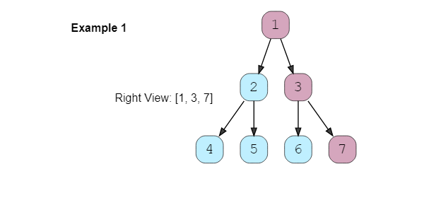

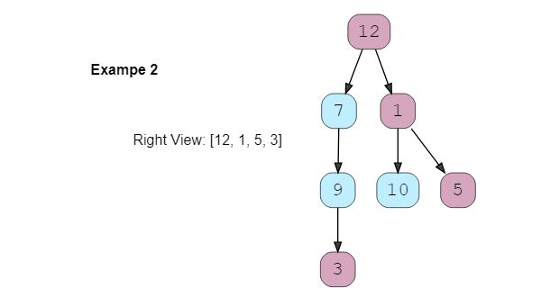

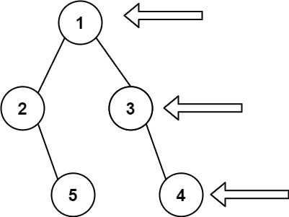

Input: root = [1,2,3,null,5,null,4]

Output: [1,3,4]

Input: root = [1,null,3]

Output: [1,3]

### Solution

This problem follows the **Binary Tree Level Order Traversal pattern**. We can follow the same BFS approach. The only additional thing we will be doing is to **append the last node of each level to the result array**.

|  |
| --- |
| import java.util.*;  class TreeNode {  int val;  TreeNode left;  TreeNode right;  TreeNode(int x) {  val = x;  }  };  class Solution {  public static List<TreeNode> traverse(TreeNode root) {  List<TreeNode> result = new ArrayList<>();  if (root == null)  return result;  Queue<TreeNode> queue = new LinkedList<>();  queue.offer(root);  while (!queue.isEmpty()) {  int levelSize = queue.size();  for (int i = 0; i < levelSize; i++) {  TreeNode currentNode = queue.poll();  // if it is the last node of this level, add it to the result  if (i == levelSize - 1)  result.add(currentNode);  // insert the children of current node in the queue  if (currentNode.left != null)  queue.offer(currentNode.left);  if (currentNode.right != null)  queue.offer(currentNode.right);  }  }  return result;  }  public static void main(String[] args) {  TreeNode root = new TreeNode(12);  root.left = new TreeNode(7);  root.right = new TreeNode(1);  root.left.left = new TreeNode(9);  root.right.left = new TreeNode(10);  root.right.right = new TreeNode(5);  root.left.left.left = new TreeNode(3);  List<TreeNode> result = Solution.traverse(root);  for (TreeNode node : result) {  System.out.print(node.val + " ");  }  }  } |

* The time complexity of the above algorithm is O(N), where N is the total number of nodes in the tree. This is due to the fact that we traverse each node once
* The space complexity of the above algorithm will be O(N) as we need to return a list containing the level order traversal. We will also need O(N) space for the queue. Since we can have a maximum of N/2 nodes at any level (this could happen only at the lowest level), therefore we will need O(N) space to store them in the queue.

### Java Solution

|  |
| --- |
| private static List<Integer> rightSideView(TreeNode root) {  List<Integer> result = new ArrayList<>();  if(root == null) return result;  Queue<TreeNode> queue = new LinkedList<>();  queue.add(root);  while(!queue.isEmpty()){  int levelSize = queue.size();  for(int i = 0; i< levelSize; i++){  TreeNode currentNode = queue.poll();  if(i +1 == levelSize){  result.add(currentNode.value);  }  if(currentNode.left != null) queue.add(currentNode.left);  if(currentNode.right != null) queue.add(currentNode.right);  }  }  return result;  }  public static List<Integer> rightSideViewOptimized(TreeNode root) {  List<Integer> result = new ArrayList<Integer>();  rightView(root, result, 0);  return result;  }  public static void rightView(TreeNode curr, List<Integer> result, int currDepth){  if(curr == null){  return;  }  if(currDepth == result.size()){  result.add(curr.value);  }  rightView(curr.right, result, currDepth + 1);  rightView(curr.left, result, currDepth + 1);  } |

**Similar Questions**

#### Problem 1:

Given a binary tree, return an array containing nodes in its left view. The left view of a binary tree is the set of nodes visible when the tree is seen from the left side.

#### Solution:

We will be following a similar approach, but instead of appending the last element of each level, we will be appending the first element of each level to the output array.

class TreeNode {

constructor(value) {

this.value = value

this.left = null

this.right = null

}

}

function treeRightView(root) {

let result = [];

if(root === null) {

return result

}

const queue = [root]

while(queue.length > 0) {

let levelSize = queue.length

for(let i = 0; i < levelSize; i++) {

let currentNode = queue.shift()

//if it is the first node of this level,

//add it to the result

if(i === 0){

result.push(currentNode.value)

}

//insert the children of current node in the queue

if(currentNode.left !== null) {

queue.push(currentNode.left)

}

if(currentNode.right !== null) {

queue.push(currentNode.right)

}

}

}

return result;

};

const root = new TreeNode(12);

root.left = new TreeNode(7);

root.right = new TreeNode(1);

root.left.left = new TreeNode(9);

root.right.left = new TreeNode(10);

root.right.right = new TreeNode(5);

root.left.left.left = new TreeNode(3);

console.log("Tree right view: " + treeRightView(root))

### Java Solution

|  |
| --- |
| private static List<Integer> leftSideView(TreeNode root) {  List<Integer> result = new ArrayList<>();  if(root == null) return result;  Queue<TreeNode> queue = new LinkedList<>();  queue.add(root);  while(!queue.isEmpty()){  int levelSize = queue.size();  for(int i = 0; i< levelSize; i++){  TreeNode currentNode = queue.poll();  if(i == 0){  result.add(currentNode.value);  }  if(currentNode.left != null) queue.add(currentNode.left);  if(currentNode.right != null) queue.add(currentNode.right);  }  }  return result;  }  public static List<Integer> leftSideViewOptimized(TreeNode root) {  List<Integer> result = new ArrayList<Integer>();  leftView(root, result, 0);  return result;  }  public static void leftView(TreeNode curr, List<Integer> result, int currDepth){  if(curr == null){  return;  }  if(currDepth == result.size()){  result.add(curr.value);  }  leftView(curr.left, result, currDepth + 1);  leftView(curr.right, result, currDepth + 1);  } |

**Pattern 8: Tree Depth First Search (DFS)**

This pattern is based on the **Depth First Search (DFS)** technique to traverse a tree.

We will be using **recursion** (or we can also use a stack for the iterative approach) to keep track of all the previous (parent) nodes while traversing. This also means that the space complexity of the algorithm will be O(H), where H is the maximum height of the tree.

## Binary Tree Path Sum (easy)

<https://leetcode.com/problems/path-sum/>

### Problem Statement

Given a binary tree and a number S, find if the tree has a path from root-to-leaf such that the sum of all the node values of that path equals S.

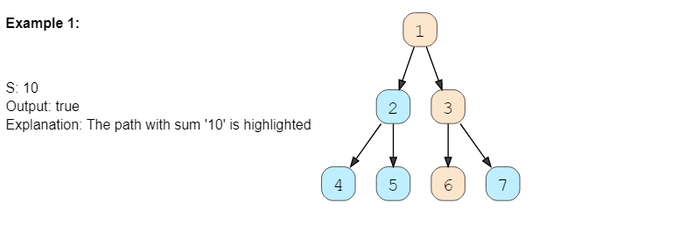

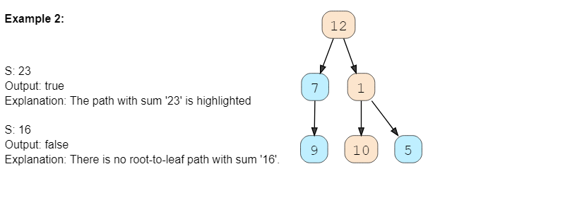

### Solution

As we are trying to search for a *root-to-leaf path* , we can use the **Depth First Search (DFS)** technique to solve this problem.

To recursively traverse a binary tree in a **DFS** fashion, we can start from the root and at every step, make two recursive calls one for the left and one for the right child.

Here are the steps for our [Binary Tree Path Sum](https://github.com/maazshaikh007/DSA_Patterns/blob/main/%E2%9C%85%20%20Pattern%2008:Tree%20Depth%20First%20Search.md#binary-tree-path-sum-easy) problem:

1. Start **DFS** with the root of the tree.
2. If the current node is not a leaf node, do two things:
   * Subtract the value of the current node from the given number to get a new *sum* => S = S - node.value
   * Make two recursive calls for both the children of the current node with the new number calculated in the previous step.
3. At every step, see if the current node being visited is a leaf node and if its value is equal to the given number S. If both these conditions are true, we have found the required *root-to-leaf path* , therefore return true.
4. If the current node is a leaf but its value is not equal to the given number S, return false.

Let’s take the example-2 mentioned above to visually see our algorithm:

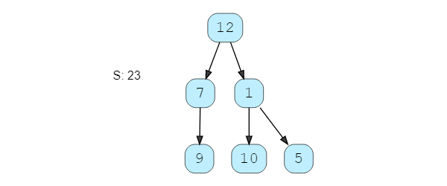

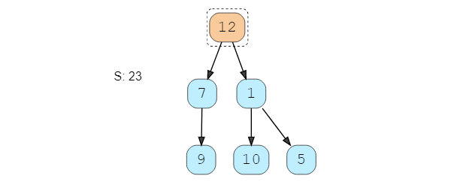

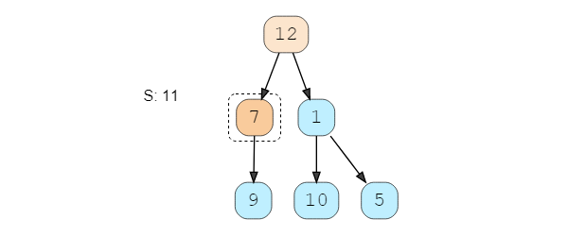

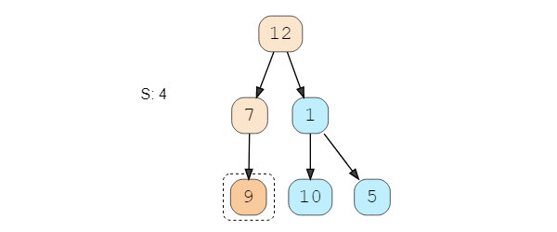

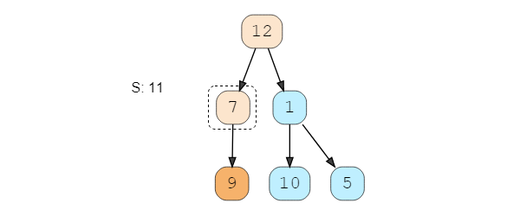

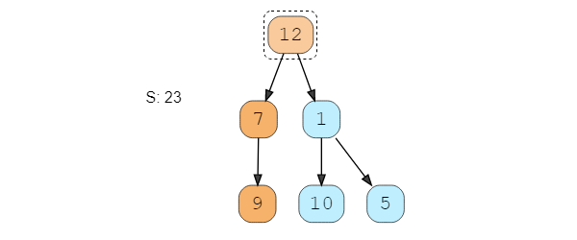

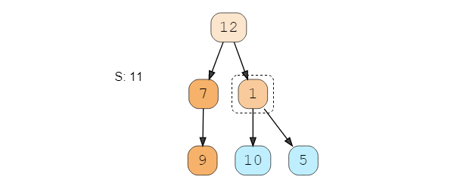

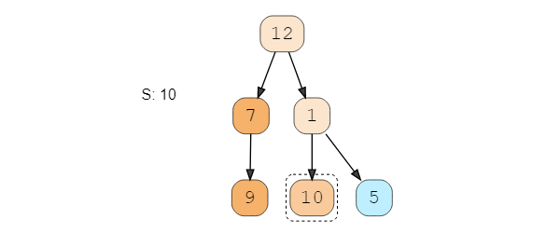

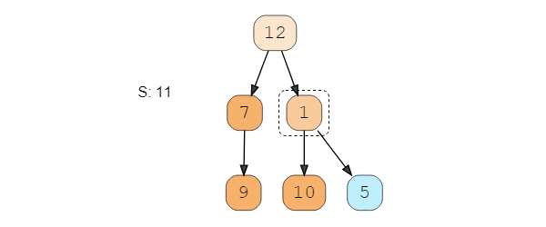

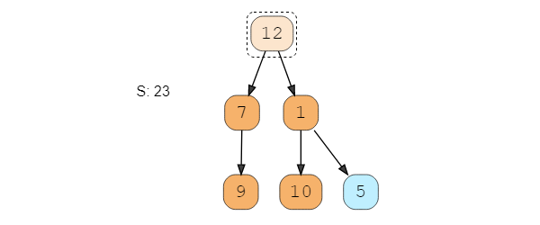

### Code

|  |
| --- |
| class TreeNode {  int val;  TreeNode left;  TreeNode right;  TreeNode(int x) {  val = x;  }  };  class Solution {  public static boolean hasPath(TreeNode root, int sum) {  if (root == null)  return false;  // if the current node is leaf and its value is equal to the sum, we've found a path  if (root.val == sum && root.left == null && root.right == null)  return true;  // recursively call to traverse the left and right sub-tree  // return true if any of the two recursive call return true  return hasPath(root.left, sum - root.val) || hasPath(root.right, sum - root.val);  }  public static void main(String[] args) {  TreeNode root = new TreeNode(12);  root.left = new TreeNode(7);  root.right = new TreeNode(1);  root.left.left = new TreeNode(9);  root.right.left = new TreeNode(10);  root.right.right = new TreeNode(5);  System.out.println("Tree has path: " + Solution.hasPath(root, 23));  System.out.println("Tree has path: " + Solution.hasPath(root, 16));  }  } |

* The time complexity of the above algorithm is O(N), where N is the total number of nodes in the tree. This is due to the fact that we traverse each node once.
* The space complexity of the above algorithm will be O(N) in the worst case. This space will be used to store the **recursion** stack. The worst case will happen when the given tree is a *linked list* (i.e., every node has only one child).

### Java Solution

|  |
| --- |
| private static boolean hasPath(TreeNode root, int sum){  if(root == null) return false;  if(root.value == sum && root.left == null && root.right == null) return true;  return hasPath(root.left, sum - root.value) || hasPath(root.right, sum - root.value);  } |

## All Paths for a Sum (medium)

<https://leetcode.com/problems/path-sum-ii/>

### Problem Statement

Given a binary tree and a number S, find all paths from root-to-leaf such that the sum of all the node values of each path equals S.

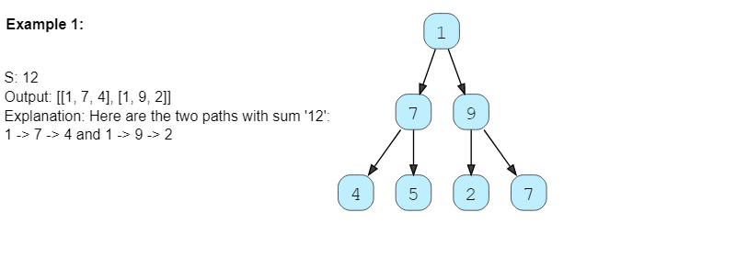

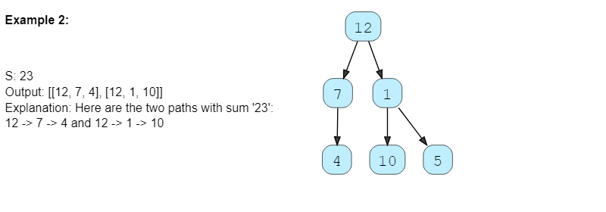

### Solution

This problem follows the [**Binary Tree Path Sum**](https://github.com/maazshaikh007/DSA_Patterns/blob/main/%E2%9C%85%20%20Pattern%2008:Tree%20Depth%20First%20Search.md#binary-tree-path-sum-easy) pattern. We can follow the same **DFS** approach. There will be two differences:

1. Every time we find a *root-to-leaf path* , we will store it in a list.
2. We will traverse all paths and will not stop processing after finding the first path.

### Code

|  |
| --- |
| import java.util.*;  class TreeNode {  int val;  TreeNode left;  TreeNode right;  TreeNode(int x) {  val = x;  }  };  class Solution {  public static List<List<Integer>> findPaths(TreeNode root, int sum) {  List<List<Integer>> allPaths = new ArrayList<>();  List<Integer> currentPath = new ArrayList<Integer>();  findPathsRecursive(root, sum, currentPath, allPaths);  return allPaths;  }  private static void findPathsRecursive(TreeNode currentNode, int sum,  List<Integer> currentPath, List<List<Integer>> allPaths) {  if (currentNode == null)  return;  // add the current node to the path  currentPath.add(currentNode.val);  // if the current node is a leaf and its value is equal to sum, save the current path  if (currentNode.val == sum && currentNode.left == null  && currentNode.right == null) {  allPaths.add(new ArrayList<Integer>(currentPath));  } else {  // traverse the left sub-tree  findPathsRecursive(currentNode.left, sum - currentNode.val, currentPath, allPaths);  // traverse the right sub-tree  findPathsRecursive(currentNode.right, sum - currentNode.val,  currentPath, allPaths);  }  // remove the current node from the path to backtrack,  // we need to remove the current node while we are going up the recursive call stack.  currentPath.remove(currentPath.size() - 1);  }  public static void main(String[] args) {  TreeNode root = new TreeNode(12);  root.left = new TreeNode(7);  root.right = new TreeNode(1);  root.left.left = new TreeNode(4);  root.right.left = new TreeNode(10);  root.right.right = new TreeNode(5);  int sum = 23;  List<List<Integer>> result = Solution.findPaths(root, sum);  System.out.println("Tree paths with sum " + sum + ": " + result);  }  } |

* The time complexity of the above algorithm is O(N^2), where N is the total number of nodes in the tree. This is due to the fact that we traverse each node once (which will take O(N)), and for every leaf node, we might have to store its path (by making a copy of the current path) which will take O(N).
  + We can calculate a tighter time complexity of O(NlogN) from the space complexity discussion below.
* If we ignore the space required for the allPaths list, the space complexity of the above algorithm will be O(N) in the worst case. This space will be used to store the **recursion** stack. The worst-case will happen when the given tree is a *linked list* (i.e., every node has only one child).
* How can we estimate the space used for the allPaths array? Take the example of the following balanced tree:

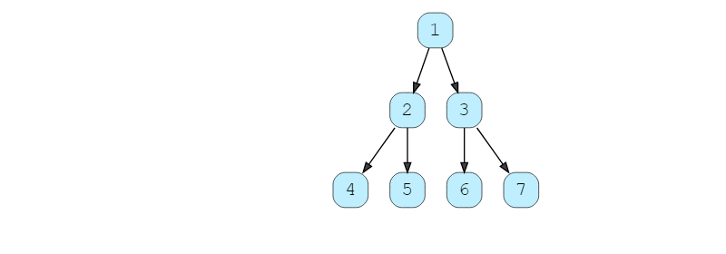

Here we have seven nodes (i.e., N = 7). Since, for binary trees, there exists only one path to reach any leaf node, we can easily say that total root-to-leaf paths in a binary tree can’t be more than the number of leaves. As we know that there can’t be more than (N+1)/2 leaves in a binary tree, therefore the maximum number of elements in allPaths will be O((N+1)/2) = O(N) . Now, each of these paths can have many nodes in them. For a balanced binary tree (like above), each leaf node will be at maximum depth. As we know that the depth (or height) of a balanced binary tree is O(logN) we can say that, at the most, each path can have logN nodes in it. This means that the total size of the allPaths list will be O(N*logN). If the tree is not balanced, we will still have the same worst-case space complexity.

From the above discussion, we can conclude that our algorithm’s overall space complexity is O(N*logN).

Also, from the above discussion, since for each leaf node, in the worst case, we have to copy log(N) nodes to store its path; therefore, the time complexity of our algorithm will also be O(N*logN).

### Java Solution

|  |
| --- |
| public List<List<Integer>> pathSum(TreeNode root, int targetSum) {  List<Integer> currentPath = new ArrayList<>();  List<List<Integer>> allPath = new ArrayList<>();  dfs(root, currentPath, allPath, targetSum);  return allPath;  }  public void dfs(TreeNode root, List<Integer> currentPath, List<List<Integer>> allPath, int sum){  if(root == null) return;  currentPath.add(root.value);  if(root.value == sum && root.left == null && root.right == null) allPath.add(new ArrayList<>(currentPath));  else{  dfs(root.left, currentPath, allPath, sum-root.value);  dfs(root.right, currentPath, allPath, sum-root.value);  }  currentPath.remove(currentPath.size() - 1);  } |

### Similar Problems

### 🌟 Given a binary tree, return all *root-to-leaf* paths.

<https://leetcode.com/problems/binary-tree-paths/>

We can follow a similar approach. We just need to remove the “check for the path sum.”

class TreeNode {

constructor(value, left = null, right = null) {

this.value = value;

this.left = left;

this.right = right;

}

};

function findPaths(root) {

let allPaths = []

findAPath(root, [], allPaths)

return allPaths

};

function findAPath(currentNode, currentPath, allPaths) {

if(currentNode === null) {

return

}

//add the current node to the path

currentPath.push(currentNode.value)

//if the current node is not a leaf, save the current path

if(currentNode.left === null && currentNode.right === null) {

allPaths.push([...currentPath])

} else {

//traverse the left sub-tree

findAPath(currentNode.left, currentPath, allPaths)

//traverse the right sub-tree

findAPath(currentNode.right, currentPath, allPaths)

}

//remove the current node from the path to backtrack,

//we need to remove the currentNode while we are going

//up the recursive call stack

currentPath.pop()

}

const root = new TreeNode(12)

root.left = new TreeNode(7)

root.right = new TreeNode(1)

root.left.left = new TreeNode(4)

root.right.left = new TreeNode(10)

root.right.right = new TreeNode(5)

findPaths(root);

#### Java Solution 1

|  |
| --- |
| public static List<List<Integer>> allRootToLeafPath(TreeNode root) {  List<Integer> currentPath = new ArrayList<>();  List<List<Integer>> allPath = new ArrayList<>();  dfs(root, currentPath, allPath);  return allPath;  }  public static void dfs(TreeNode root, List<Integer> currentPath, List<List<Integer>> allPath){  if(root == null) return;  currentPath.add(root.value);  if(root.left == null && root.right == null) allPath.add(new ArrayList<>(currentPath));  else{  dfs(root.left, currentPath, allPath);  dfs(root.right, currentPath, allPath);  }  currentPath.remove(currentPath.size() - 1);  } |

#### Java Solution 2

|  |
| --- |
| public static List<String> allRootToLeafPathLeetCode(TreeNode root) {  List<String> allPath = new ArrayList<>();  dfsLeetCode(root, "", allPath);  return allPath;  }  public static void dfsLeetCode(TreeNode root, String currentPath, List<String> allPath){  if(root == null) return;  currentPath+=root.value;  if(root.left == null && root.right == null) allPath.add(currentPath);  else{  dfsLeetCode(root.left, currentPath+"-->", allPath);  dfsLeetCode(root.right, currentPath+"-->", allPath);  }  } |

### 🌟 Given a binary tree, find the *root-to-leaf* path with the maximum sum.

We need to find the path with the maximum sum. As we traverse all paths, we can keep track of the path with the maximum sum.

class TreeNode {

constructor(value, left = null, right = null) {

this.value = value;

this.left = left;

this.right = right;

}

};

function maxPathSum(root) {

let maxSum = -Infinity

function findAPath(currentNode, currentPath) {

if(currentNode === null) {

return

}

//add the current node to the path

currentPath.push(currentNode.value)

let pathMax = 0

//if the current node is not a leaf, save the current path

if(currentNode.left === null && currentNode.right === null) {

for(let i = 0; i < currentPath.length; i++) {

pathMax += currentPath[i]

}

maxSum = Math.max(maxSum, pathMax)

} else {

//traverse the left sub-tree

findAPath(currentNode.left, currentPath)

//traverse the right sub-tree

findAPath(currentNode.right, currentPath)

}

//remove the current node from the path to backtrack,

//we need to remove the currentNode while we are going

//up the recursive call stack

currentPath.pop()

}

findAPath(root, [], maxSum)

return maxSum

};

const root = new TreeNode(12)

root.left = new TreeNode(7)

root.right = new TreeNode(1)

root.left.left = new TreeNode(4)

root.right.left = new TreeNode(10)

root.right.right = new TreeNode(5)

maxPathSum(root);

#### Java Solution

|  |
| --- |
| static int max = Integer.MIN_VALUE;  public static int maximumPathSum(TreeNode root) {  List<Integer> currentPath = new ArrayList<>();  maximumPathSum(root, currentPath);  return max;  }  public static void maximumPathSum(TreeNode root, List<Integer> currentPath){  if(root == null) return;  currentPath.add(root.value);  int sum = 0;  if(root.left == null && root.right == null) {  for(Integer path: currentPath){  sum += path;  }  max = Math.max(sum, max);  }  else{  maximumPathSum(root.left, currentPath);  maximumPathSum(root.right, currentPath);  }  currentPath.remove(currentPath.size() - 1);  } |

## Sum of Path Numbers (medium)

<https://leetcode.com/problems/sum-root-to-leaf-numbers/>

### Problem Statement

Given a binary tree where each node can only have a digit (0-9) value, each *root-to-leaf path* will represent a number. Find the total sum of all the numbers represented by all paths.

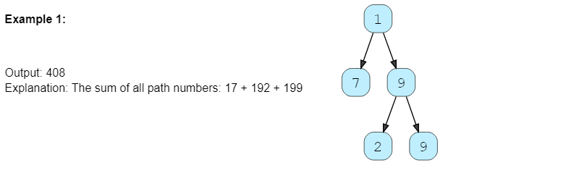

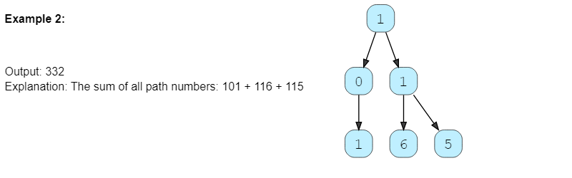

For example, the root-to-leaf path 1 -> 2 -> 3 represents the number 123.

Return the total sum of all root-to-leaf numbers. Test cases are generated so that the answer will fit in a 32-bit integer.

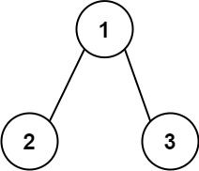

**Input:** root = [1,2,3]

**Output:** 25

**Explanation:**

The root-to-leaf path 1->2 represents the number 12.

The root-to-leaf path 1->3 represents the number 13.

Therefore, sum = 12 + 13 = 25.

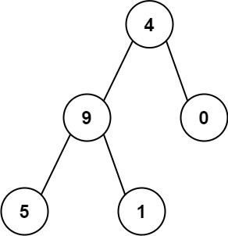

**Input:** root = [4,9,0,5,1]

**Output:** 1026

**Explanation:**

The root-to-leaf path 4->9->5 represents the number 495.

The root-to-leaf path 4->9->1 represents the number 491.

The root-to-leaf path 4->0 represents the number 40.

Therefore, sum = 495 + 491 + 40 = 1026.

### Solution

This problem follows the [**Binary Tree Path Sum**](https://github.com/maazshaikh007/DSA_Patterns/blob/main/%E2%9C%85%20%20Pattern%2008:Tree%20Depth%20First%20Search.md#binary-tree-path-sum-easy) pattern. We can follow the same **DFS** approach. The additional thing we need to do is to keep track of the number representing the current path.

How do we calculate the path number for a node? Taking the first example mentioned above, say we are at node 7. As we know, the path number for this node is 17, which was calculated by: 1 * 10 + 7 => 17. We will follow the same approach to calculate the path number of each node.

### Code

|  |
| --- |
| class TreeNode {  int val;  TreeNode left;  TreeNode right;  TreeNode(int x) {  val = x;  }  };  class Solution {  public static int findSumOfPathNumbers(TreeNode root) {  return findRootToLeafPathNumbers(root, 0);  }  private static int findRootToLeafPathNumbers(TreeNode currentNode, int pathSum) {  if (currentNode == null)  return 0;  // calculate the path number of the current node  pathSum = 10 * pathSum + currentNode.val;  // if the current node is a leaf, return the current path sum.  if (currentNode.left == null && currentNode.right == null) {  return pathSum;  }  // traverse the left and the right sub-tree  return findRootToLeafPathNumbers(currentNode.left, pathSum) +  findRootToLeafPathNumbers(currentNode.right, pathSum);  }  public static void main(String[] args) {  TreeNode root = new TreeNode(1);  root.left = new TreeNode(0);  root.right = new TreeNode(1);  root.left.left = new TreeNode(1);  root.right.left = new TreeNode(6);  root.right.right = new TreeNode(5);  System.out.println("Total Sum of Path Numbers: " +  Solution.findSumOfPathNumbers(root));  }  } |

* The time complexity of the above algorithm is O(N), where N is the total number of nodes in the tree. This is due to the fact that we traverse each node once.
* The space complexity of the above algorithm will be O(N) in the worst case. This space will be used to store the **recursion** stack. The worst case will happen when the given tree is a *linked list* (i.e., every node has only one child).

### Java Solution

|  |
| --- |
| private static int findSumOfPathNumber(TreeNode root){  return findSumOfPathNumber(root, 0);  }  private static int findSumOfPathNumber(TreeNode root, int pathSum){  if(root == null) return 0;  pathSum = 10 * pathSum + root.value;  if(root.left == null && root.right == null) return pathSum;  return findSumOfPathNumber(root.left, pathSum)+findSumOfPathNumber(root.right, pathSum);  } |

**Path With Given Sequence (medium)**

Given a binary tree and a number sequence, find if the sequence is present as a *root-to-leaf path* in the given tree.

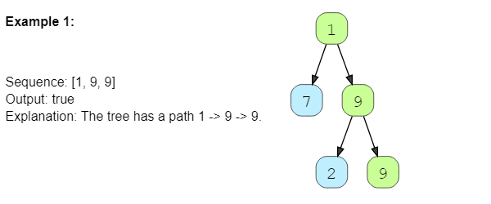

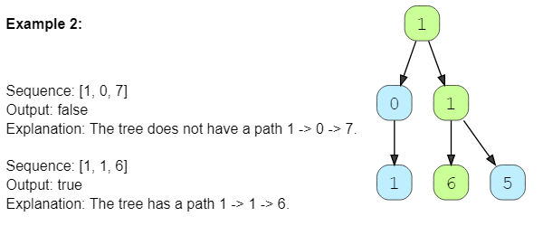

### Solution

This problem follows the [**Binary Tree Path Sum**](https://github.com/maazshaikh007/DSA_Patterns/blob/main/%E2%9C%85%20%20Pattern%2008:Tree%20Depth%20First%20Search.md#binary-tree-path-sum-easy) pattern. We can follow the same **DFS** approach and additionally, track the element of the given sequence that we should match with the current node. Also, we can return false as soon as we find a mismatch between the sequence and the node value.

### Code

|  |
| --- |
| import java.util.*;  class TreeNode {  int val;  TreeNode left;  TreeNode right;  TreeNode(int x) {  val = x;  }  };  class Solution {  public static boolean findPath(TreeNode root, int[] sequence) {  if (root == null)  return sequence.length == 0;  return findPathRecursive(root, sequence, 0);  }  private static boolean findPathRecursive(TreeNode currentNode, int[] sequence,  int sequenceIndex) {  if (currentNode == null)  return false;  if (sequenceIndex >= sequence.length || currentNode.val != sequence[sequenceIndex])  return false;  // if the current node is a leaf, add it is the end of the sequence, we have found  // a path!  if (currentNode.left == null && currentNode.right == null  && sequenceIndex == sequence.length - 1)  return true;  // recursively call to traverse the left and right sub-tree  // return true if any of the two recursive call return true  return findPathRecursive(currentNode.left, sequence, sequenceIndex + 1)  || findPathRecursive(currentNode.right, sequence, sequenceIndex + 1);  }  public static void main(String[] args) {  TreeNode root = new TreeNode(1);  root.left = new TreeNode(0);  root.right = new TreeNode(1);  root.left.left = new TreeNode(1);  root.right.left = new TreeNode(6);  root.right.right = new TreeNode(5);  System.out.println("Tree has path sequence: " +  Solution.findPath(root, new int[] { 1, 0, 7 }));  System.out.println("Tree has path sequence: " +  Solution.findPath(root, new int[] { 1, 1, 6 }));  }  } |

* The time complexity of the above algorithm is O(N), where N is the total number of nodes in the tree. This is due to the fact that we traverse each node once.
* The space complexity of the above algorithm will be O(N) in the worst case. This space will be used to store the **recursion** stack. The worst case will happen when the given tree is a *linked list* (i.e., every node has only one child).

### Java Solution

|  |
| --- |
| static boolean isPathExist(TreeNode root, int[] arr, int n, int index){  if(root == null){  return n==0;  }  return isPathExistUtil(root, arr, n, index);  }  private static boolean isPathExistUtil(TreeNode root, int[] arr, int n, int index) {  if(root == null || index == n) return false;  if(root.left == null && root.right == null){  if(root.value == arr[index] && index == n-1) return true;  return false;  }  return index < n && root.value == arr[index] && isPathExistUtil(root.left, arr, n, index+1) || isPathExistUtil(root.right, arr, n, index+1);  } |

## Count Paths for a Sum (medium)

<https://leetcode.com/problems/path-sum-iii/>

### Problem Statement

Given a binary tree and a number S, find all paths in the tree such that the sum of all the node values of each path equals S. Please note that the paths can start or end at any node but all paths must follow direction from parent to child (top to bottom).

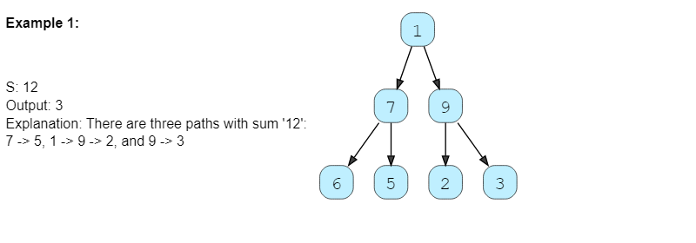

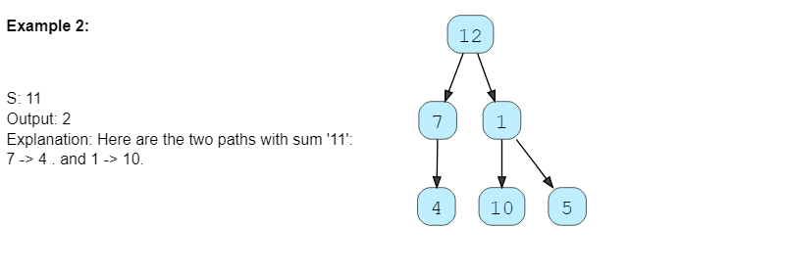

### Solution

This problem follows the [**Binary Tree Path Sum**](https://github.com/maazshaikh007/DSA_Patterns/blob/main/%E2%9C%85%20%20Pattern%2008:Tree%20Depth%20First%20Search.md#binary-tree-path-sum-easy) pattern. We can follow the same **DFS** approach. But there will be four differences:

1. We will keep track of the current path in a list which will be passed to every recursive call.
2. Whenever we traverse a node we will do two things:
   * Add the current node to the current path.
   * As we added a new node to the current path, we should find the sums of all sub-paths ending at the current node. If the sum of any sub-path is equal to S we will increment our path count.
3. We will traverse all paths and will not stop processing after finding the first path.
4. Remove the current node from the current path before returning from the function. This is needed to *backtrack* while we are going up the recursive call stack to process other paths.

### Code

|  |
| --- |
| import java.util.*;  class TreeNode {  int val;  TreeNode left;  TreeNode right;  TreeNode(int x) {  val = x;  }  };  class Solution {  public static int countPaths(TreeNode root, int S) {  List<Integer> currentPath = new LinkedList<>();  return countPathsRecursive(root, S, currentPath);  }  private static int countPathsRecursive(TreeNode currentNode, int S,  List<Integer> currentPath) {  if (currentNode == null)  return 0;  // add the current node to the path  currentPath.add(currentNode.val);  int pathCount = 0;  double pathSum = 0; // let's use a double to handle integer overflow for large sums  // find the sums of all sub-paths in the current path list  ListIterator<Integer> pathIterator = currentPath.listIterator(currentPath.size());  while (pathIterator.hasPrevious()) {  pathSum += pathIterator.previous();  // if the sum of any sub-path is equal to 'S' we increment our path count.  if (pathSum == S) {  pathCount++;  }  }  // traverse the left sub-tree  pathCount += countPathsRecursive(currentNode.left, S, currentPath);  // traverse the right sub-tree  pathCount += countPathsRecursive(currentNode.right, S, currentPath);  // remove the current node from the path to backtrack,  // we need to remove the current node while we are going up the recursive call stack.  currentPath.remove(currentPath.size() - 1);  return pathCount;  }  public static void main(String[] args) {  TreeNode root = new TreeNode(12);  root.left = new TreeNode(7);  root.right = new TreeNode(1);  root.left.left = new TreeNode(4);  root.right.left = new TreeNode(10);  root.right.right = new TreeNode(5);  System.out.println("Tree has path: " + Solution.countPaths(root, 11));  }  } |

### Java Solution

|  |
| --- |
| private static int countPaths(TreeNode root, int sum){  List<Integer> currentPath = new ArrayList<>();  return countPathsRecursive(root, sum, currentPath);  }  private static int countPathsRecursive(TreeNode currentNode, int sum, List<Integer> currentPath){  if(currentNode == null) return 0;  currentPath.add(currentNode.value);  int pathCount = 0;  int pathSum = 0;  for(int i = currentPath.size() - 1; i>=0; i--){  pathSum +=currentPath.get(i);  if(pathSum == sum) pathCount++;  }  pathCount += countPathsRecursive(currentNode.left, sum, currentPath);  pathCount += countPathsRecursive(currentNode.right, sum, currentPath);  currentPath.remove(currentPath.size() - 1);  return pathCount;  } |

* The time complexity of the above algorithm is O(N²) in the worst case, where N is the total number of nodes in the tree. This is due to the fact that we traverse each node once, but for every node, we iterate the current path. The current path, in the worst case, can be O(N) (in the case of a skewed tree). But, if the tree is balanced, then the current path will be equal to the height of the tree, i.e., O(logN). So the best case of our algorithm will be O(NlogN).
* The space complexity of the above algorithm will be O(N). This space will be used to store the **recursion** stack. The worst case will happen when the given tree is a *linked list* (i.e., every node has only one child). We also need O(N) space for storing the currentPath in the worst case. Overall space complexity of our algorithm is O(N).

### A more efficient solution

Can we further improve the solution?

One thing we are repeating for each node is traversing the current path and seeing if any sub-path that ends at the current node gives us the required sum.

Let’s see if we can improve this part.

We can use the Prefix Sum technique to efficiently manage the path sums.

Prefix Sum

Let’s first understand what Prefix Sum is. For a given array, its Prefix Sum is another array where each element is the commutative sum of the corresponding element in the given array and all its previous elements.

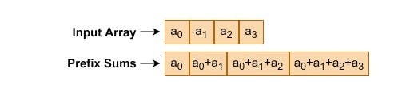

Here is an example:



Now, let’s say we want to find all subarrays of a given array with a target sum.

Let’s say our target sum is 7, and we want to find all the subarrays of the array mentioned above.

We can clearly see that there are two such subarrays: 1) [1, 6], and 2) [2, 5].

How can we utilize the Prefix Sum array to find these two subarrays efficiently?

There are two ways Prefix Sum can help us:

a) Since each element of the prefix sum array contains the cumulative sum of current and previous elements, therefore, whenever we see our target sum, we have found our targeted subarray. For example, since the second element of the prefix sum array is 7; therefore, our target subarray will be from the start of the array till the second element, i.e., [1, 6]

(b) Secondly, the prefix sum array can also help us find our target subarray that is not starting from the first index.

If we subtract the target sum from any element of the prefix sum array, the result will also give us our target subarray (if that result is present in the prefix sum array).

For example, take the 4th element of the prefix sum array and subtract the target sum from it: 14 – 7 => 7

Is this result (7) present in the prefix sum array? Yes, it is the second element. This means the sum from the 3rd element to the current element (i.e., the 4th) is also 7.

Hence, our target subarray will be from the 3rd element to the current element, i.e., [2, 5].

Now, let’s see how we can use prefix sum for binary trees. Take the following example:

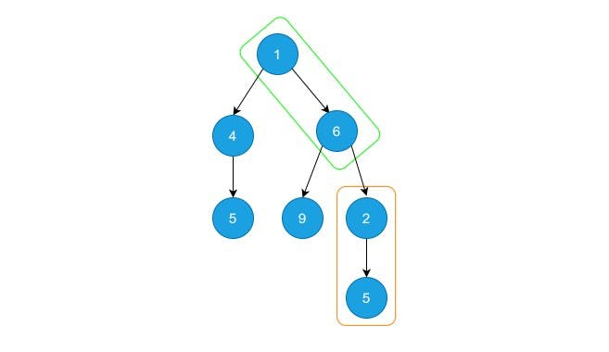

We can consider each path as an array and calculate its prefix sums to find any required sub-paths. In the above tree, the highlighted sub-paths are exactly the same as our previous array example.

Here is what our new algorithm will look like:

|  |
| --- |
| import java.util.*;  class TreeNode {  int val;  TreeNode left;  TreeNode right;  TreeNode(int val) {  this.val = val;  }  }  class Solution {  public static int countPaths(TreeNode root, int targetSum) {  // A map that stores the number of times a prefix sum has occurred so far.  Map<Integer, Integer> map = new HashMap<>();  return countPathsPrefixSum(root, targetSum, map, 0);  }  public static int countPathsPrefixSum(TreeNode node, int targetSum, Map<Integer, Integer> map,  Integer currentPathSum) {  if (node == null)  return 0;  // The number of paths that have the required sum.  int pathCount = 0;  // 'currentPathSum' is the prefix sum, i.e., sum of all node values from the root to  // the current node.  currentPathSum += node.val;  // This is the base case. If the current sum is equal to the target sum, we have  // found a path from root to the current node having the required sum. Hence, we  // increment the path count by 1.  if (targetSum == currentPathSum)  pathCount++;  // 'currentPathSum' is the path sum from root to the current node. If within  // this path, there is a valid solution, then there must be an 'oldPathSum' such that:  // => currentPathSum - oldPathSum = targetSum  // => currentPathSum - targetSum = oldPathSum  // Hence, we can search such an 'oldPathSum' in the map from the key  // 'currentPathSum - targetSum'.  pathCount += map.getOrDefault(currentPathSum - targetSum, 0);  // This is the key step in the algorithm. We are storing the number of times the  // prefix sum `currentPathSum` has occurred so far.  map.put(currentPathSum, map.getOrDefault(currentPathSum, 0) + 1);  // Counting the number of paths from the left and right subtrees.  pathCount += countPathsPrefixSum(node.left, targetSum, map, currentPathSum);  pathCount += countPathsPrefixSum(node.right, targetSum, map, currentPathSum);  // Removing the current path sum from the map for backtracking.  // 'currentPathSum' is the prefix sum up to the current node. When we go back  // (i.e., backtrack), then the current node is no more a part of the path, hence, w  // e should remove its prefix sum from the map.  map.put(currentPathSum, map.getOrDefault(currentPathSum, 1) - 1);  return pathCount;  }  public static void main(String[] args) {  TreeNode root = new TreeNode(12);  root.left = new TreeNode(7);  root.right = new TreeNode(1);  root.left.left = new TreeNode(4);  root.right.left = new TreeNode(10);  root.right.right = new TreeNode(5);  System.out.println("Tree has path: " + Solution.countPaths(root, 11));  }  } |

### Time Complexity

As we are not traversing the current path for each node, the time complexity of the above algorithm will be O(N) in the worst case, where ‘N’ is the total number of nodes in the tree.

### Space Complexity

The space complexity of the above algorithm will be O(N). This space will be used to store the recursion stack, as well as for the prefix sum.

## 🌟 Tree Diameter (medium)

<https://leetcode.com/problems/diameter-of-binary-tree/>

### Problem Statement

Given a binary tree, find the length of its diameter. The diameter of a tree is the number of nodes on the **longest path between any two leaf nodes**. The diameter of a tree may or may not pass through the root.

Note: You can always assume that there are at least two leaf nodes in the given tree.

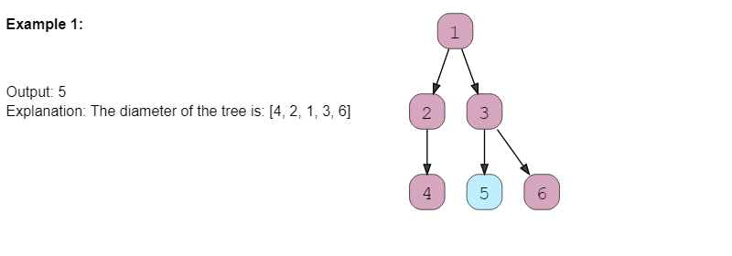

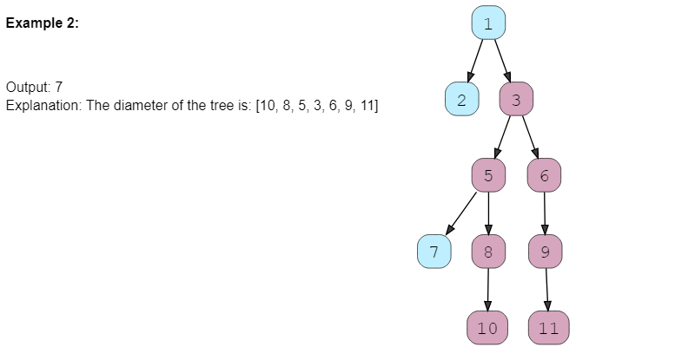

### Solution

This problem follows the **Binary Tree Path Sum** pattern. We can follow the same **DFS** approach. There will be a few differences:

1. At every step, we need to find the height of both children of the current node. For this, we will make two recursive calls similar to **DFS**.
2. The height of the current node will be equal to the maximum of the heights of its left or right children, plus 1 for the currentNode.
3. The tree diameter at the currentNode will be equal to the height of the left child plus the height of the right child plus 1 for the current node: diameter = leftTreeHeight + rightTreeHeight + 1. To find the overall tree diameter, we will use a class level variable. This variable will store the maximum diameter of all the nodes visited so far, hence, eventually, it will have the final tree diameter.

### Code

|  |
| --- |
| class TreeNode {  int val;  TreeNode left;  TreeNode right;  TreeNode(int x) {  val = x;  }  };  public class Solution {  private static int treeDiameter = 0;  public static int findDiameter(TreeNode root) {  calculateHeight(root);  return treeDiameter;  }  private static int calculateHeight(TreeNode currentNode) {  if (currentNode == null)  return 0;  int leftTreeHeight = calculateHeight(currentNode.left);  int rightTreeHeight = calculateHeight(currentNode.right);  // if the current node doesn't have a left or right subtree, we can't have  // a path passing through it, since we need a leaf node on each side  if (leftTreeHeight != 0 && rightTreeHeight != 0) {  // diameter at the current node will be equal to the height of left subtree +  // the height of right sub-trees + '1' for the current node  int diameter = leftTreeHeight + rightTreeHeight + 1;  // update the global tree diameter  treeDiameter = Math.max(treeDiameter, diameter);  }  // height of the current node will be equal to the maximum of the heights of  // left or right subtrees plus '1' for the current node  return Math.max(leftTreeHeight, rightTreeHeight) + 1;  }  public static void main(String[] args) {  TreeNode root = new TreeNode(1);  root.left = new TreeNode(2);  root.right = new TreeNode(3);  root.left.left = new TreeNode(4);  root.right.left = new TreeNode(5);  root.right.right = new TreeNode(6);  System.out.println("Tree Diameter: " + Solution.findDiameter(root));  root.left.left = null;  root.right.left.left = new TreeNode(7);  root.right.left.right = new TreeNode(8);  root.right.right.left = new TreeNode(9);  root.right.left.right.left = new TreeNode(10);  root.right.right.left.left = new TreeNode(11);  System.out.println("Tree Diameter: " + Solution.findDiameter(root));  }  } |

* The time complexity of the above algorithm is O(N), where N is the total number of nodes in the tree. This is due to the fact that we traverse each node once.
* The space complexity of the above algorithm will be O(N) in the worst case. This space will be used to store the **recursion** stack. The worst case will happen when the given tree is a *linked list* (i.e., every node has only one child).

### Java Solution

|  |
| --- |
| static int ans = 0;  public static int diameterOfBinaryTree(TreeNode root) {  height(root);  return ans-1;  }  public static int height(TreeNode root){  if(root == null) return 0;  int lh = height(root.left);  int rh = height(root.right);  ans = Math.max(ans, lh+rh+1);  return Math.max(lh,rh)+1;  } |

**🌟 Path with Maximum Sum (hard)**

<https://leetcode.com/problems/binary-tree-maximum-path-sum/>

Find the path with the maximum sum in a given binary tree. Write a function that returns the maximum sum.

A path can be defined as a **sequence of nodes between any two nodes** and doesn’t necessarily pass through the root. The path must contain at least one node.

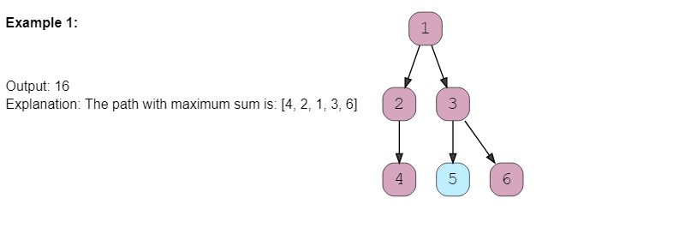

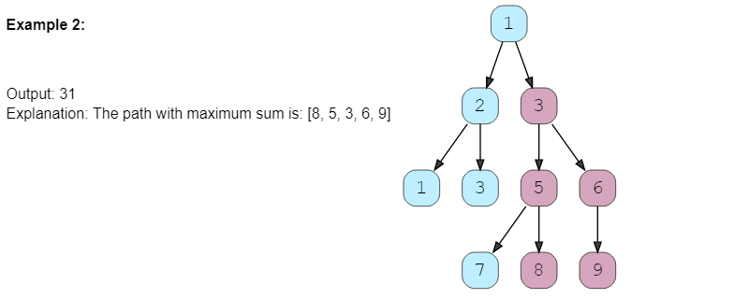

### Solution

This problem follows the **Binary Tree Path Sum** pattern and shares the algorithmic logic with **Tree Diameter**. We can follow the same **DFS** approach. The only difference will be to ignore the paths with negative sums. Since we need to find the overall maximum sum, we should ignore any path which has an overall negative sum.

### Code

|  |
| --- |
| class TreeNode {  int val;  TreeNode left;  TreeNode right;  TreeNode(int x) {  val = x;  }  };  class Solution {  private static int globalMaximumSum;  public static int findMaximumPathSum(TreeNode root) {  globalMaximumSum = Integer.MIN_VALUE;  findMaximumPathSumRecursive(root);  return globalMaximumSum;  }  private static int findMaximumPathSumRecursive(TreeNode currentNode) {  if (currentNode == null)  return 0;  int maxPathSumFromLeft = findMaximumPathSumRecursive(currentNode.left);  int maxPathSumFromRight = findMaximumPathSumRecursive(currentNode.right);  // ignore paths with negative sums, since we need to find the maximum sum we should  // ignore any path which has an overall negative sum.  maxPathSumFromLeft = Math.max(maxPathSumFromLeft, 0);  maxPathSumFromRight = Math.max(maxPathSumFromRight, 0);  // maximum path sum at the current node will be equal to the sum from the left  // subtree + the sum from right subtree + val of current node  int localMaximumSum = maxPathSumFromLeft + maxPathSumFromRight + currentNode.val;  // update the global maximum sum  globalMaximumSum = Math.max(globalMaximumSum, localMaximumSum);  // maximum sum of any path from the current node will be equal to the maximum of  // the sums from left or right subtrees plus the value of the current node  return Math.max(maxPathSumFromLeft, maxPathSumFromRight) + currentNode.val;  }  public static void main(String[] args) {  TreeNode root = new TreeNode(1);  root.left = new TreeNode(2);  root.right = new TreeNode(3);  System.out.println("Maximum Path Sum: " + Solution.findMaximumPathSum(root));    root.left.left = new TreeNode(1);  root.left.right = new TreeNode(3);  root.right.left = new TreeNode(5);  root.right.right = new TreeNode(6);  root.right.left.left = new TreeNode(7);  root.right.left.right = new TreeNode(8);  root.right.right.left = new TreeNode(9);  System.out.println("Maximum Path Sum: " + Solution.findMaximumPathSum(root));    root = new TreeNode(-1);  root.left = new TreeNode(-3);  System.out.println("Maximum Path Sum: " + Solution.findMaximumPathSum(root));  }  } |

* The time complexity of the above algorithm is O(N), where N is the total number of nodes in the tree. This is due to the fact that we traverse each node once.
* The space complexity of the above algorithm will be O(N) in the worst case. This space will be used to store the **recursion** stack. The worst case will happen when the given tree is a *linked list* (i.e., every node has only one child).

### Java Solution

|  |
| --- |
| public static int maxPathSum(TreeNode root) {  if(root == null) return 0;  maxPathSumRecursive(root);  return ans;  }  public static int maxPathSumRecursive(TreeNode root){  if(root == null) return 0;  int leftSum = Math.max(maxPathSumRecursive(root.left), 0);  int rightSum = Math.max(maxPathSumRecursive(root.right), 0);  ans = Math.max(ans, leftSum+rightSum+root.value);  return Math.max(leftSum, rightSum)+root.value;  } |

# Pattern 9: Two Heaps

In many problems, where we are given a set of elements such that we can divide them into two parts. To solve the problem, we are interested in knowing the smallest element in one part and the biggest element in the other part. This pattern is an efficient approach to solve such problems.

This pattern uses two **Heaps** to solve these problems; A **Min Heap** to find the smallest element and a **Max Heap** to find the biggest element.

Although this course uses **Heaps** to solve **Top 'K' Elements** problems, **JavaScript** does not have a built in method for **Heaps/Priority Queues**. It can be very time consuming to implement a **Heap class** from scratch, especially during an interview. After reviewing the *JavaScript* solutions on *Leetcode* the most effecient way to solve a **Top 'K' Elements** problem is usually with **[QuickSort](https://github.com/Chanda-Abdul/leetcode/blob/master/0%20%E2%9D%97Sort%20Algorithms.md" \l "-quick-sort)**, **[BinarySearch](https://github.com/Chanda-Abdul/leetcode/blob/master/0%20%E2%9D%97Sort%20Algorithms.md" \l "binary-search)**, **[BucketSort](https://initjs.org/bucket-sort-in-javascript-dc040b8f0058)**, [**Greedy Algorithms**](https://github.com/Chanda-Abdul/Grokking-Algorithm-Book-Notes/blob/main/8.%20Greedy%20Algoritms.md), or **[HashMaps](https://developer.mozilla.org/en-US/docs/Web/JavaScript/Reference/Global_Objects/Map)**.

## Find the Median of a Number Stream (medium)

<https://leetcode.com/problems/find-median-from-data-stream/>

### Problem Statement

Design a class to calculate the median of a number stream. The class should have the following two methods:

1. insertNum(int num): stores the number in the class
2. findMedian(): returns the median of all numbers inserted in the class.

If the count of numbers inserted in the class is even, the median will be the average of the middle two numbers.

Example 1:

1. insertNum(3)

2. insertNum(1)

3. findMedian() -> output: 2

4. insertNum(5)

5. findMedian() -> output: 3

6. insertNum(4)

7. findMedian() -> output: 3.5

### Solution

As we know, the median is the middle value in an ordered integer list. So a brute force solution could be to maintain a sorted list of all numbers inserted in the class so that we can efficiently return the median whenever required. Inserting a number in a sorted list will take O(N) time if there are N numbers in the list. This insertion will be similar to the **Insertion sort**. Can we do better than this? Can we utilize the fact that we don’t need the fully sorted list - we are only interested in finding the middle element?

Assume ‘x’ is the median of a list. This means that half of the numbers in the list will be smaller than (or equal to) ‘x’ and half will be greater than (or equal to) ‘x’. This leads us to an approach where we can divide the list into two halves: one half to store all the smaller numbers (let’s call it smallNumList) and one half to store the larger numbers (let’s call it largNumList). The median of all the numbers will either be the largest number in the smallNumList or the smallest number in the largNumList. If the total number of elements is even, the median will be the average of these two numbers.

The best data structure that comes to mind to find the smallest or largest number among a list of numbers is a **Heap**. Let’s see how we can use a heap to find a better algorithm.

1. We can store the first half of numbers (i.e., smallNumList) in a **Max Heap**. We should use a Max Heap as we are interested in knowing the largest number in the first half.
2. We can store the second half of numbers (i.e., largeNumList) in a **Min Heap**, as we are interested in knowing the smallest number in the second half.
3. Inserting a number in a heap will take O(logN), which is better than the brute force approach.
4. At any time, the median of the current list of numbers can be calculated from the top element of the two heaps.

Let’s take the Example-1 mentioned above to go through each step of our algorithm:

1. insertNum(3): We can insert a number in the **Max Heap** (i.e. first half) if the number is smaller than the top (largest) number of the heap. After every insertion, we will balance the number of elements in both heaps, so that they have an equal number of elements. If the count of numbers is odd, let’s decide to have more numbers in max-heap than the Min Heap.



1. insertNum(1): As ‘1’ is smaller than ‘3’, let’s insert it into the **Max Heap**.

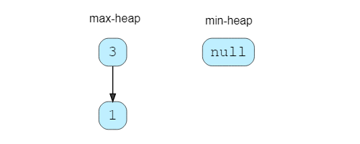

Now, we have two elements in the **Max Heap** and no elements in **Min Heap**. Let’s take the largest element from the Max Heap and insert it into the **Min Heap**, to balance the number of elements in both heaps.



1. findMedian(): As we have an even number of elements, the median will be the average of the top element of both the heaps ➡️ (1+3)/2 = 2.0(1+3)/2=2.0
2. insertNum(5): As ‘5’ is greater than the top element of the **Max Heap**, we can insert it into the **Min Heap**. After the insertion, the total count of elements will be odd. As we had decided to have more numbers in the **Max Heap** than the **Min Heap**, we can take the top (smallest) number from the **Min Heap** and insert it into the **Max Heap**.

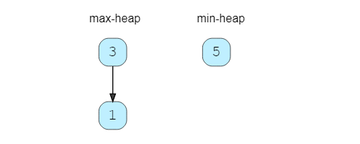

1. findMedian(): Since we have an odd number of elements, the median will be the top element of **Max Heap** ➡️ 3. An odd number of elements also means that the **Max Heap** will have one extra element than the **Min Heap**.
2. insertNum(4): Insert ‘4’ into **Min Heap**.
3. findMedian(): As we have an even number of elements, the median will be the average of the top element of both the heaps ➡️ (3+4)/2 = 3.5(3+4)/2=3.5

### Code

|  |
| --- |
| import java.util.*;  class Solution {  PriorityQueue<Integer> maxHeap; //containing first half of numbers  PriorityQueue<Integer> minHeap; //containing second half of numbers  public Solution() {  maxHeap = new PriorityQueue<>((a, b) -> b - a);  minHeap = new PriorityQueue<>((a, b) -> a - b);  }  public void insertNum(int num) {  if (maxHeap.isEmpty() || maxHeap.peek() >= num)  maxHeap.add(num);  else  minHeap.add(num);  // either both the heaps will have equal number of elements or max-heap will have one  // more element than the min-heap  if (maxHeap.size() > minHeap.size() + 1)  minHeap.add(maxHeap.poll());  else if (maxHeap.size() < minHeap.size())  maxHeap.add(minHeap.poll());  }  public double findMedian() {  if (maxHeap.size() == minHeap.size()) {  // we have even number of elements, take the average of middle two elements  return maxHeap.peek() / 2.0 + minHeap.peek() / 2.0;  }  // because max-heap will have one more element than the min-heap  return maxHeap.peek();  }  public static void main(String[] args) {  Solution medianOfAStream = new Solution();  medianOfAStream.insertNum(3);  medianOfAStream.insertNum(1);  System.out.println("The median is: " + medianOfAStream.findMedian());  medianOfAStream.insertNum(5);  System.out.println("The median is: " + medianOfAStream.findMedian());  medianOfAStream.insertNum(4);  System.out.println("The median is: " + medianOfAStream.findMedian());  }  } |

* The time complexity of the insertNum() will be O(logN) due to the insertion in the heap. The time complexity of the findMedian() will be O(1) as we can find the median from the top elements of the heaps.
* The space complexity will be O(N) because, as at any time, we will be storing all the numbers.

**😕 Sliding Window Median (hard)**

<https://leetcode.com/problems/sliding-window-median/>

Given an array of numbers and a number ‘k’, find the median of all the ‘k’ sized sub-arrays (or windows) of the array.

**Example 1:**

**Input:**

nums=[1, 2, -1, 3, 5], k = 2

**Output:**

[1.5, 0.5, 1.0, 4.0]

**Explanation:**

Lets consider all windows of size ‘2’:

[**1, 2**, -1, 3, 5] -> median is 1.5

[1, **2, -1**, 3, 5] -> median is 0.5

[1, 2, **-1, 3**, 5] -> median is 1.0

[1, 2, -1, **3, 5**] -> median is 4.0

**Example 2:**

**Input: nums=[1, 2, -1, 3, 5], k = 3**

**Output: [1.0, 2.0, 3.0]**

**Explanation:**

Lets consider all windows of size ‘3’:

[**1, 2, -1**, 3, 5] -> median is 1.0

[1, **2, -1, 3**, 5] -> median is 2.0

[1, 2, **-1, 3, 5**] -> median is 3.0

### Solution

This problem follows the **Two Heaps** pattern and share similarities with **Find the Median of a Number Stream**. We can follow a similar approach of maintaining a **max-heap** and a **min-heap** for the list of numbers to find their median.

The only difference is that we need to keep track of a sliding window of ‘k’ numbers. This means, in each iteration, when we insert a new number in the heaps, we need to remove one number from the heaps which is going out of the sliding window. After the removal, we need to rebalance the heaps in the same way that we did while inserting.

### Code

|  |
| --- |
| import java.util.*;  class Solution {  PriorityQueue<Integer> maxHeap = new PriorityQueue<>(Collections.reverseOrder());  PriorityQueue<Integer> minHeap = new PriorityQueue<>();  public double[] findSlidingWindowMedian(int[] nums, int k) {  double[] result = new double[nums.length - k + 1];  for (int i = 0; i < nums.length; i++) {  if (maxHeap.size() == 0 || maxHeap.peek() >= nums[i]) {  maxHeap.add(nums[i]);  } else {  minHeap.add(nums[i]);  }  rebalanceHeaps();  if (i - k + 1 >= 0) { // if we have at least 'k' elements in the sliding window  // add the median to the the result array  if (maxHeap.size() == minHeap.size()) {  // we have even number of elements, take the average of middle two elements  result[i - k + 1] = maxHeap.peek() / 2.0 + minHeap.peek() / 2.0;  } else { // because max-heap will have one more element than the min-heap  result[i - k + 1] = maxHeap.peek();  }  // remove the element going out of the sliding window  int elementToBeRemoved = nums[i - k + 1];  if (elementToBeRemoved <= maxHeap.peek()) {  maxHeap.remove(elementToBeRemoved);  } else {  minHeap.remove(elementToBeRemoved);  }  rebalanceHeaps();  }  }  return result;  }  private void rebalanceHeaps() {  // either both the heaps will have equal number of elements or max-heap will have  // one more element than the min-heap  if (maxHeap.size() > minHeap.size() + 1)  minHeap.add(maxHeap.poll());  else if (maxHeap.size() < minHeap.size())  maxHeap.add(minHeap.poll());  }  public static void main(String[] args) {  Solution Solution = new Solution();  double[] result = Solution.findSlidingWindowMedian(  new int[] { 1, 2, -1, 3, 5 }, 2);  System.out.print("Sliding window medians are: ");  for (double num : result)  System.out.print(num + " ");  System.out.println();  Solution = new Solution();  result = Solution.findSlidingWindowMedian(  new int[] { 1, 2, -1, 3, 5 }, 3);  System.out.print("Sliding window medians are: ");  for (double num : result)  System.out.print(num + " ");  }  } |

* The time complexity of our algorithm is O(N*K)where N is the total number of elements in the input array and K is the size of the sliding window. This is due to the fact that we are going through all the N numbers and, while doing so, we are doing two things:
  1. Inserting/removing numbers from heaps of size K. This will take O(logK).
  2. Removing the element going out of the sliding window. This will take O(K) as we will be searching this element in an array of size K (i.e., a heap).
* Ignoring the space needed for the output array, the space complexity will be O(K) because, at any time, we will be storing all the numbers within the sliding window.

### Java Solution

As removal from heap takes O(k) times. We will use a HashMap to store the element which needs to be removed and if they are in top(because top only used to calculate the median) of the heap then only we will remove.

|  |
| --- |
| PriorityQueue<Integer> maxHeap;  PriorityQueue<Integer> minHeap;  Map<Integer, Integer> invalid;  public double[] medianSlidingWindow(int[] nums, int k) {  maxHeap = new PriorityQueue<>(Collections.reverseOrder());  minHeap = new PriorityQueue<>();  invalid = new HashMap<>();  boolean isKEven = (k % 2 == 0);  for (int i = 0; i < k; i++) {  maxHeap.add(nums[i]);  }  for (int i = 0; i < k / 2; i++) {  minHeap.add(maxHeap.poll());  }  double[] res = new double[nums.length - k + 1];  res[0] = isKEven ? 0.5 * maxHeap.peek() + 0.5 * minHeap.peek() : maxHeap.peek();  for (int i = k; i < nums.length; i++) {  int inComing = nums[i];  int outGoing = nums[i - k];  balance(inComing, outGoing);  res[i - k + 1] = isKEven ? 0.5 * maxHeap.peek() + 0.5 * minHeap.peek() : maxHeap.peek();  }  return res;  }  private void balance(int in, int out) {  int balance = 0;  if (in <= maxHeap.peek()) {  balance += 1;  maxHeap.offer(in);  } else {  balance -= 1;  minHeap.offer(in);  }  if (out <= maxHeap.peek()) {  invalid.put(out, invalid.getOrDefault(out, 0) + 1);  balance -= 1;  } else {  invalid.put(out, invalid.getOrDefault(out, 0) + 1);  balance += 1;  }  while (balance > 0) {  minHeap.offer(maxHeap.poll());  balance -= 2;  }  while (balance < 0) {  maxHeap.offer(minHeap.poll());  balance += 2;  }  while (invalid.getOrDefault(maxHeap.peek(), 0) > 0) {  int cur = maxHeap.poll();  invalid.put(cur, invalid.get(cur) - 1);  }  while (invalid.getOrDefault(minHeap.peek(), 0) > 0) {  int cur = minHeap.poll();  invalid.put(cur, invalid.get(cur) - 1);  }  } |

**😕 Maximize Capital (hard)**

<https://leetcode.com/problems/ipo/>

### Problem Statement

Given a set of investment projects with their respective profits, we need to find the most profitable projects. We are given an initial capital and are allowed to invest only in a fixed number of projects. Our goal is to choose projects that give us the maximum profit. Write a function that returns the maximum total capital after selecting the most profitable projects.

We can start an investment project only when we have the required capital. Once a project is selected, we can assume that its profit has become our capital.

**Example 1**

Input:

Project Capitals=[0,1,2], Project Profits=[1,2,3], Initial Capital=1, Number of Projects=2

Output: 6

Explanation

With initial capital of ‘1’, we will start the second project which will give us profit of ‘2’.

Once we selected our first project, our total capital will become 3 (profit + initial capital).

With ‘3’ capital, we will select the third project, which will give us ‘3’ profit.

After the completion of the two projects, our total capital will be 6 (1+2+3).

**Example 2**

Input

Project Capitals=[0,1,2,3], Project Profits=[1,2,3,5], Initial Capital=0, Number of Projects=3

Output

8

Explanation

With ‘0’ capital, we can only select the first project, bringing out capital to 1.

Next, we will select the second project, which will bring our capital to 3.

Next, we will select the fourth project, giving us a profit of 5.

After selecting the three projects, our total capital will be 8 (1+2+5).

### Solution

While selecting projects we have two constraints:

1. We can select a project only when we have the required capital.
2. There is a maximum limit on how many projects we can select.

Since we don’t have any constraint on time, we should choose a project, among the projects for which we have enough capital, which gives us a maximum profit. Following this greedy approach will give us the best solution.

While selecting a project, we will do two things:

1. Find all the projects that we can choose with the available capital.
2. From the list of projects in the 1st step, choose the project that gives us a maximum profit.

We can follow the Two Heaps approach similar to Find the Median of a Number Stream. Here are the steps of our algorithm:

1. Add all project capitals to a min-heap, so that we can select a project with the smallest capital requirement.
2. Go through the top projects of the min-heap and filter the projects that can be completed within our available capital. Insert the profits of all these projects into a max-heap, so that we can choose a project with the maximum profit.
3. Finally, select the top project of the max-heap for investment.
4. Repeat the 2nd and 3rd steps for the required number of projects.

### Code

|  |
| --- |
| import java.util.*;  class Solution {  public static int findMaximumCapital(int[] capital, int[] profits,  int numberOfProjects, int initialCapital) {  int n = profits.length;  PriorityQueue<Integer> minCapitalHeap =  new PriorityQueue<>(n, (i1, i2) -> capital[i1] - capital[i2]);  PriorityQueue<Integer> maxProfitHeap =  new PriorityQueue<>(n, (i1, i2) -> profits[i2] - profits[i1]);  // insert all project capitals to a min-heap  for (int i = 0; i < n; i++)  minCapitalHeap.offer(i);  // let's try to find a total of 'numberOfProjects' best projects  int availableCapital = initialCapital;  for (int i = 0; i < numberOfProjects; i++) {  // find all projects that can be selected within the available capital and insert  // them in a max-heap  while (!minCapitalHeap.isEmpty()  && capital[minCapitalHeap.peek()] <= availableCapital)  maxProfitHeap.add(minCapitalHeap.poll());  // terminate if we are not able to find any project that can be completed within  // the available capital  if (maxProfitHeap.isEmpty())  break;  // select the project with the maximum profit  availableCapital += profits[maxProfitHeap.poll()];  }  return availableCapital;  }  public static void main(String[] args) {  int result = Solution.findMaximumCapital(new int[] { 0, 1, 2 },  new int[] { 1, 2, 3 }, 2, 1);  System.out.println("Maximum capital: " + result);  result = Solution.findMaximumCapital(new int[] { 0, 1, 2, 3 },  new int[] { 1, 2, 3, 5 }, 3, 0);  System.out.println("Maximum capital: " + result);  }  } |

* Since, at the most, all the projects will be pushed to both the heaps once, the time complexity of our algorithm is O(NlogN + KlogN), where N is the total number of projects and K is the number of projects we are selecting.
* The space complexity will be O(N) because we will be storing all the projects in the heaps.

### Java Solution

|  |
| --- |
| public static int findMaximizedCapitalOptimized(int k, int w, int[] profits, int[] capital) {  Queue<Pair> minHeap = new PriorityQueue<>(Comparator.comparingInt(a -> a.capital));  Queue<Pair> maxHeap = new PriorityQueue<>((a, b) -> b.profit - a.profit);  for (int i = 0; i < capital.length; ++i)  minHeap.offer(new Pair(profits[i], capital[i]));  while (k-- > 0) {  while (!minHeap.isEmpty() && minHeap.peek().capital <= w)  maxHeap.offer(minHeap.poll());  if (maxHeap.isEmpty())  break;  w += maxHeap.poll().profit;  }  return w;  }  static class Pair{  public int profit;  public int capital;  public Pair(int profit, int capital){  this.profit = profit;  this.capital = capital;  }  } |

## 🌟 😴 Next Interval (hard)

<https://leetcode.com/problems/find-right-interval/>

### Problem Statement

Given an array of intervals, find the next interval of each interval. In a list of intervals, for an interval ‘i’ its next interval ‘j’ will have the smallest ‘start’ greater than or equal to the ‘end’ of ‘i’.

Write a function to return an array containing indices of the next interval of each input interval. If there is no next interval of a given interval, return -1. It is given that none of the intervals have the same start point.

Example 1:

Input: Intervals [[2,3], [3,4], [5,6]] Output: [1, 2, -1] Explanation: The next interval of [2,3] is [3,4] having index ‘1’. Similarly, the next interval of [3,4] is [5,6] having index ‘2’. There is no next interval for [5,6] hence we have ‘-1’.

Example 2:

Input: Intervals [[3,4], [1,5], [4,6]] Output: [2, -1, -1] Explanation: The next interval of [3,4] is [4,6] which has index ‘2’. There is no next interval for [1,5] and [4,6].

### Solution

A brute force solution could be to take one interval at a time and go through all the other intervals to find the next interval. This algorithm will take O(N^2) where N is the total number of intervals. Can we do better than that?

We can utilize the Two Heaps approach. We can push all intervals into two heaps: one heap to sort the intervals on maximum start time (let’s call it maxStartHeap) and the other on maximum end time (let’s call it maxEndHeap). We can then iterate through all intervals of the maxEndHeap to find their next interval. Our algorithm will have the following steps:

1. Take out the top (having highest end) interval from the maxEndHeap1 to find its next interval. Let’s call this interval topEnd.
2. Find an interval in the maxStartHeap with the closest start greater than or equal to the start of topEnd. Since maxStartHeap is sorted by ‘start’ of intervals, it is easy to find the interval with the highest ‘start’. Let’s call this interval topStart.
3. Add the index of topStart in the result array as the next interval of topEnd. If we can’t find the next interval, add ‘-1’ in the result array.
4. Put the topStart back in the maxStartHeap, as it could be the next interval of other intervals.
5. Repeat the steps 1-4 until we have no intervals left in maxEndHeap. 😴(needs review)

### Code

|  |
| --- |
| import java.util.*;  class Interval {  int start = 0;  int end = 0;  Interval(int start, int end) {  this.start = start;  this.end = end;  }  }  class Solution {  public static int[] findNextInterval(Interval[] intervals) {  int n = intervals.length;  // heap for finding the maximum start  PriorityQueue<Integer> maxStartHeap =  new PriorityQueue<>(n, (i1, i2) -> intervals[i2].start - intervals[i1].start);  // heap for finding the minimum end  PriorityQueue<Integer> maxEndHeap =  new PriorityQueue<>(n, (i1, i2) -> intervals[i2].end - intervals[i1].end);  int[] result = new int[n];  for (int i = 0; i < intervals.length; i++) {  maxStartHeap.offer(i);  maxEndHeap.offer(i);  }  // go through all the intervals to find each interval's next interval  for (int i = 0; i < n; i++) {  // let's find the next interval of the interval which has the highest 'end'  int topEnd = maxEndHeap.poll();  result[topEnd] = -1; // defaults to -1  if (intervals[maxStartHeap.peek()].start >= intervals[topEnd].end) {  int topStart = maxStartHeap.poll();  // find the the interval that has the closest 'start'  while (!maxStartHeap.isEmpty()  && intervals[maxStartHeap.peek()].start >= intervals[topEnd].end) {  topStart = maxStartHeap.poll();  }  result[topEnd] = topStart;  // put the interval back as it could be the next interval of other intervals  maxStartHeap.add(topStart);  }  }  return result;  }  public static void main(String[] args) {  Interval[] intervals = new Interval[] { new Interval(2, 3), new Interval(3, 4),  new Interval(5, 6) };  int[] result = Solution.findNextInterval(intervals);  System.out.print("Next interval indices are: ");  for (int index : result)  System.out.print(index + " ");  System.out.println();  intervals = new Interval[] { new Interval(3, 4), new Interval(1, 5),  new Interval(4, 6) };  result = Solution.findNextInterval(intervals);  System.out.print("Next interval indices are: ");  for (int index : result)  System.out.print(index + " ");  }  } |

* The time complexity of our algorithm will be O(NlogN), where N is the total number of intervals.
* The space complexity will be O(N) because we will be storing all the intervals in the heaps.

### Java Solution

* Maintain a minHeapEnd of end indices and a minHeapStart of start indices.
* We can iterate through each end index in minHeapEnd and try to find the corresponding start index in the minHeapStart which is greater than equal to the current end element.
* Once found we update corresponding index (idx of the current end element) in the final result[] with the start index that we found.
* If minHeapStart is empty, then definitely rest all elements in the minHeapEnd can be mapped to -1 in the final result[].

|  |
| --- |
| public static int[] findRightInterval(int[][] intervals) {  PriorityQueue<int[]> startMinHeap = new PriorityQueue<>(Comparator.comparingInt(a -> a[0]));  PriorityQueue<int[]> endMinHeap = new PriorityQueue<>(Comparator.comparingInt(a -> a[0]));  for (int i = 0; i < intervals.length; i++) {  startMinHeap.add(new int[]{intervals[i][0], i});  endMinHeap.add(new int[]{intervals[i][1], i});  }  int[] results = new int[intervals.length];  for (int i = 0; i < results.length; i++) {  results[i] = -1;  }  while (!endMinHeap.isEmpty()) {  int[] curEnd = endMinHeap.poll();  int curEndVal = curEnd[0];  int curEndIndex = curEnd[1];  while (!startMinHeap.isEmpty() && curEndVal > startMinHeap.peek()[0])  startMinHeap.poll();  if (startMinHeap.isEmpty()) return results;  results[curEndIndex] = startMinHeap.peek()[1];  }  return results;  } |

**Pattern 10: Subsets**

A huge number of coding interview problems involve dealing with **Permutations** and **Combinations** of a given set of elements. This pattern describes an efficient **Breadth First Search (BFS)** approach to handle all these problems.

**Subsets (easy)**

<https://leetcode.com/problems/subsets/>

### Problem Statement

Given a set with distinct elements, find all of its distinct subsets.

Example 1:

Input: [1, 3]

Output: [], [1], [3], [1,3]

Example 2:

Input: [1, 5, 3]

Output: [], [1], [5], [3], [1,5], [1,3], [5,3], [1,5,3]

### Solution

To generate all subsets of the given set, we can use the **Breadth First Search (BFS)** approach. We can start with an empty set, iterate through all numbers one-by-one, and add them to existing sets to create new subsets.

Let’s take the example-2 mentioned above to go through each step of our algorithm:

Given set: [1, 5, 3]

1. Start with an empty set: [[]]
2. Add the first number 1 to all the existing subsets to create new subsets: [[],**[1]**];
3. Add the second number 5 to all the existing subsets: [[], [1], **[5], [1,5]**];
4. Add the third number 3 to all the existing subsets: [[], [1], [5], [1,5], **[3], [1,3], [5,3], [1,5,3]**].

Here is the visual representation of the above steps:

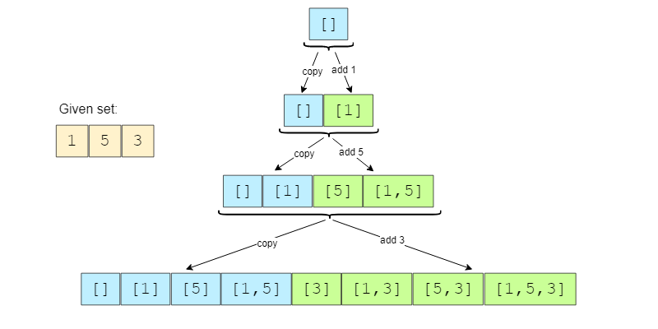

Since the input set has distinct elements, the above steps will ensure that we will not have any duplicate subsets.

### Code

|  |
| --- |
| import java.util.*;  class Solution {  public static List<List<Integer>> findSubsets(int[] nums) {  List<List<Integer>> subsets = new ArrayList<>();  // start by adding the empty subset  subsets.add(new ArrayList<>());  for (int currentNumber : nums) {  // we will take all existing subsets and insert the current number in them to  // create new subsets  int n = subsets.size();  for (int i = 0; i < n; i++) {  // create a new subset from the existing subset and insert the current  // element to it  List<Integer> set = new ArrayList<>(subsets.get(i));  set.add(currentNumber);  subsets.add(set);  }  }  return subsets;  }  public static void main(String[] args) {  List<List<Integer>> result = Solution.findSubsets(new int[] { 1, 3 });  System.out.println("Here is the list of subsets: " + result);  result = Solution.findSubsets(new int[] { 1, 5, 3 });  System.out.println("Here is the list of subsets: " + result);  }  } |

* Since, in each step, the number of subsets doubles as we add each element to all the existing subsets, therefore, we will have a total of O(2ᴺ) subsets, where N is the total number of elements in the input set. And since we construct a new subset from an existing set, therefore, the time complexity of the above algorithm will be O(N*2ᴺ).
* All the additional space used by our algorithm is for the output list. Since we will have a total of O(2ᴺ) subsets, and each subset can take up to O(N) space, therefore, the space complexity of our algorithm will be O(N*2ᴺ).

## Subsets With Duplicates (medium)

<https://leetcode.com/problems/subsets-ii/>

### Problem Statement

Given a set of numbers that might contain duplicates, find all of its distinct subsets.

Example 1:

Input: [1, 3, 3]

Output: [], [1], [3], [1,3], [3,3], [1,3,3]

Example 2:

Input: [1, 5, 3, 3]

Output: [], [1], [5], [3], [1,5], [1,3], [5,3], [1,5,3], [3,3], [1,3,3], [3,3,5], [1,5,3,3]

### Solution

This problem follows the **Subsets** pattern and we can follow a similar **Breadth First Search (BFS)** approach. The only additional thing we need to do is handle duplicates. Since the given set can have duplicate numbers, if we follow the same approach discussed in **Subsets**, we will end up with duplicate subsets, which is not acceptable. To handle this, we will do two extra things:

1. Sort all numbers of the given set. This will ensure that all duplicate numbers are next to each other.
2. Follow the same **BFS** approach but whenever we are about to process a duplicate (i.e., when the current and the previous numbers are same), instead of adding the current number (which is a duplicate) to all the existing subsets, only add it to the subsets which were created in the previous step.

Let’s take first Example mentioned below to go through each step of our algorithm:

Given set: [1, 5, 3, 3]

Sorted set: [1, 3, 3, 5]

1. Start with an empty set: [[]]
2. Add the first number 1 to all the existing subsets to create new subsets: [[], [1]];
3. Add the second number 3 to all the existing subsets: [[], [1], [3], [1,3]].
4. The next number 3 is a duplicate. If we add it to all existing subsets we will get:
5. [[], [1], [3], [1,3], [3], [1,3], [3,3], [1,3,3]]

We got two duplicate subsets: [3], [1,3]

Whereas we only needed the new subsets: [3,3], [1,3,3]

To handle this instead of adding 3 to all the existing subsets, we only add it to the new subsets which were created in the previous **3rd** step:

[[], [1], [3], [1,3], [3,3], [1,3,3]]

1. Finally, add the forth number 5 to all the existing subsets: [[], [1], [3], [1,3], [3,3], [1,3,3], [5], [1,5], [3,5], [1,3,5], [3,3,5], [1,3,3,5]]

Here is the visual representation of the above steps:

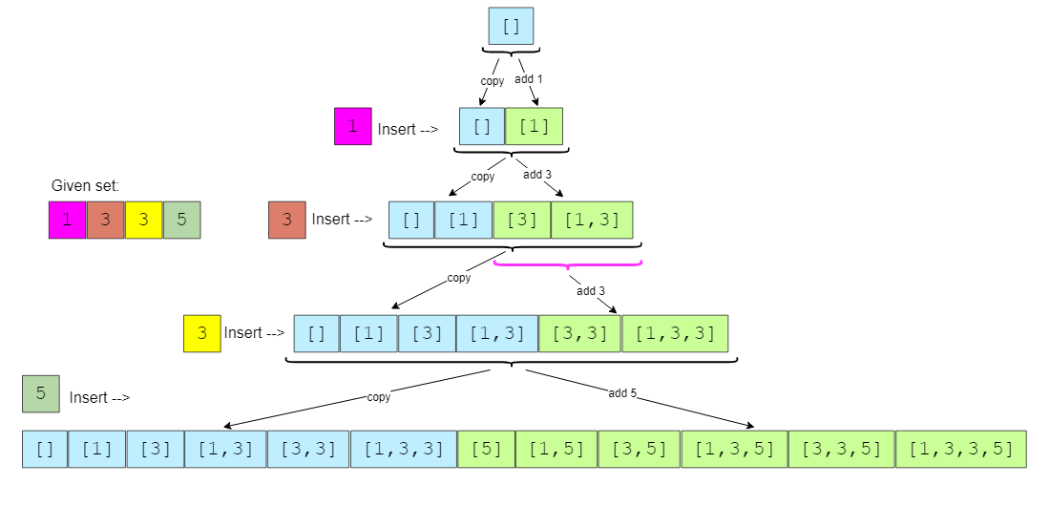

### Code

|  |
| --- |
| import java.util.*;  class Solution {  public static List<List<Integer>> findSubsets(int[] nums) {  // sort the numbers to handle duplicates  Arrays.sort(nums);  List<List<Integer>> subsets = new ArrayList<>();  subsets.add(new ArrayList<>());  int startIndex = 0, endIndex = 0;  for (int i = 0; i < nums.length; i++) {  startIndex = 0;  // if current and the previous elements are same, create new subsets only from the  // subsets added in the previous step  if (i > 0 && nums[i] == nums[i - 1])  startIndex = endIndex + 1;  endIndex = subsets.size() - 1;  for (int j = startIndex; j <= endIndex; j++) {  // create a new subset from the existing subset and add the current element to it  List<Integer> set = new ArrayList<>(subsets.get(j));  set.add(nums[i]);  subsets.add(set);  }  }  return subsets;  }  public static void main(String[] args) {  List<List<Integer>> result = Solution.findSubsets(new int[] { 1, 3, 3 });  System.out.println("Here is the list of subsets: " + result);  result = Solution.findSubsets(new int[] { 1, 5, 3, 3 });  System.out.println("Here is the list of subsets: " + result);  }  } |

* Since, in each step, the number of subsets doubles (if not duplicate) as we add each element to all the existing subsets, therefore, we will have a total of O(2ᴺ) subsets, where N is the total number of elements in the input set. And since we construct a new subset from an existing set, therefore, the time complexity of the above algorithm will be O(N*2ᴺ).
* All the additional space used by our algorithm is for the output list. Since, at most, we will have a total of O(2ᴺ) subsets, and each subset can take up to O(N) space, therefore, the space complexity of our algorithm will be O(N*2ᴺ).

**Permutations (medium)**

<https://leetcode.com/problems/permutations/>

### Problem Statement

Given a set of distinct numbers, find all of its permutations.

Permutation is defined as the re-arranging of the elements of the set. For example, {1, 2, 3} has the following six permutations:

1. {1, 2, 3}
2. {1, 3, 2}
3. {2, 1, 3}
4. {2, 3, 1}
5. {3, 1, 2}
6. {3, 2, 1}

Example 1:

Input: [1,3,5]

Output: [1,3,5], [1,5,3], [3,1,5], [3,5,1], [5,1,3], [5,3,1]

If a set has n distinct elements it will have n! permutations.

### Solution

This problem follows the **Subsets** pattern and we can follow a similar **Breadth First Search (BFS)** approach. However, unlike **Subsets**, every permutation must contain all the numbers.

Let’s take the example mentioned below to generate all the permutations. Following a **BFS** approach, we will consider one number at a time:

1. If the given set is empty then we have only an empty permutation set: []
2. Let’s add the first element 1, the permutations will be: [1]
3. Let’s add the second element 3, the permutations will be: [3,1], [1,3]
4. Let’s add the third element 5, the permutations will be: [5,3,1], [3,5,1], [3,1,5], [5,1,3], [1,5,3], [1,3,5]

Let’s analyze the permutations in the 3rd and 4th step. How can we generate permutations in the 4th step from the permutations of the 3rd step?

If we look closely, we will realize that when we add a new number 5, we take each permutation of the previous step and insert the new number in every position to generate the new permutations. For example, inserting 5 in different positions of [3,1] will give us the following permutations:

1. Inserting 5 before 3: [5,3,1]
2. Inserting 5 between 3 and 1: [3,5,1]
3. Inserting 5 after 1: [3,1,5]

Here is the visual representation of this algorithm:

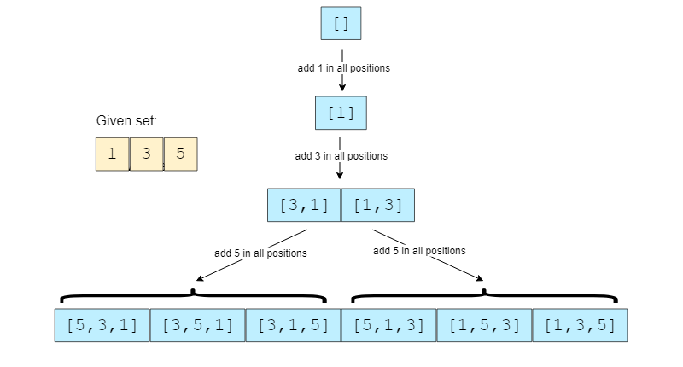

### Code

|  |
| --- |
| import java.util.*;  public class Solution {  public static List<List<Integer>> findPermutations(int[] nums) {  List<List<Integer>> result = new ArrayList<>();  Queue<List<Integer>> permutations = new LinkedList<>();  permutations.add(new ArrayList<>());  for (int currentNumber : nums) {  // we will take all existing permutations and add the current number to create  // new permutations  int n = permutations.size();  for (int i = 0; i < n; i++) {  List<Integer> oldPermutation = permutations.poll();  // create a new permutation by adding the current number at every position  for (int j = 0; j <= oldPermutation.size(); j++) {  List<Integer> newPermutation = new ArrayList<Integer>(oldPermutation);  newPermutation.add(j, currentNumber);  if (newPermutation.size() == nums.length)  result.add(newPermutation);  else  permutations.add(newPermutation);  }  }  }  return result;  }  public static void main(String[] args) {  List<List<Integer>> result = Solution.findPermutations(new int[] { 1, 3, 5 });  System.out.print("Here are all the permutations: " + result);  }  } |

We know that there are a total of N! permutations of a set with N numbers. In the algorithm above, we are iterating through all of these permutations with the help of the two ‘for’ loops. In each iteration, we go through all the current permutations to insert a new number in them. To insert a number into a permutation of size ‘N will take O(N), which makes the overall time complexity of our algorithm O(N*N!).

* All the additional space used by our algorithm is for the result list and the queue to store the intermediate permutations. If you see closely, at any time, we don’t have more than N! permutations between the result list and the queue. Therefore the overall space complexity to store N! permutations each containing N elements will be O(N*N!).

**Recursive Solution**

|  |
| --- |
| import java.util.*;  class Solution {  public static List<List<Integer>> generatePermutations(int[] nums) {  List<List<Integer>> result = new ArrayList<>();  generatePermutationsRecursive(nums, 0, new ArrayList<Integer>(), result);  return result;  }  private static void generatePermutationsRecursive(int[] nums, int index,  List<Integer> currentPermutation, List<List<Integer>> result) {  if (index == nums.length) {  result.add(currentPermutation);  } else {  // create a new permutation by adding the current number at every position  for (int i = 0; i <= currentPermutation.size(); i++) {  List<Integer> newPermutation = new ArrayList<Integer>(currentPermutation);  newPermutation.add(i, nums[index]);  generatePermutationsRecursive(nums, index + 1, newPermutation, result);  }  }  }  public static void main(String[] args) {  List<List<Integer>> result = Solution.generatePermutations(  new int[] { 1, 3, 5 });  System.out.print("Here are all the permutations: " + result);  }  } |

### Java Solution 1

|  |
| --- |
| public static List<List<Integer>> permute(int[] nums) {  List<List<Integer>> ans = new ArrayList();  List<Integer> subset = new ArrayList();  boolean map[] = new boolean[nums.length];  helper(nums,subset,ans,map);  return ans;  }  public static void helper(int nums[], List<Integer> subset, List<List<Integer>> ans, boolean map[]){  if(subset.size()==nums.length){  ans.add(new ArrayList(subset));  return;  }  for(int i=0; i<nums.length; i++){  if(!map[i]){  subset.add(nums[i]);  map[i]=true;  helper(nums,subset,ans,map);  subset.remove(subset.size()-1);  map[i]=false;  }  }  } |

### Java Solution 2

|  |
| --- |
| public static List<List<Integer>> permuteWithSwap(int[] nums) {  List<List<Integer>> ans = new ArrayList();  helperSwap(0, nums,ans);  return ans;  }  public static void helperSwap(int index, int nums[], List<List<Integer>> ans){  if(index==nums.length){  List<Integer> list = new ArrayList<>();  for(int i = 0; i< nums.length; i++){  list.add(nums[i]);  }  ans.add(list);  return;  }  for(int i=index; i<nums.length; i++){  swap(index, i, nums);  helperSwap(index+1, nums, ans);  swap(index, i , nums);  }  }  public static void swap(int i, int j, int[] nums){  int temp = nums[i];  nums[i] = nums[j];  nums[j] = temp;  } |

**String Permutations by changing case (medium)**

<https://leetcode.com/problems/letter-case-permutation/>

### Problem Statement

Given a string, find all of its permutations preserving the character sequence but changing case.

Example 1:

Input: "ad52"

Output: "ad52", "Ad52", "aD52", "AD52"

Example 2:

Input: "ab7c"

Output: "ab7c", "Ab7c", "aB7c", "AB7c", "ab7C", "Ab7C", "aB7C", "AB7C"

### Solution

This problem follows the **Subsets** pattern and can be mapped to **Permutations**.

Let’s take Example-2 mentioned above to generate all the permutations. Following a **BFS** approach, we will consider one character at a time. Since we need to preserve the character sequence, we can start with the actual string and process each character (i.e., make it upper-case or lower-case) one by one:

1. Starting with the actual string: "ab7c"
2. Processing the first character a, we will get two permutations: "ab7c", "Ab7c"
3. Processing the second character b, we will get four permutations: "ab7c", "Ab7c", "aB7c", "AB7c"
4. Since the third character is a digit, we can skip it.
5. Processing the fourth character c, we will get a total of eight permutations: "ab7c", "Ab7c", "aB7c", "AB7c", "ab7C", "Ab7C", "aB7C", "AB7C"

Let’s analyze the permutations in the 3rd and the 5th step. How can we generate the permutations in the 5th step from the permutations in the 3rd step?

If we look closely, we will realize that in the 5th step, when we processed the new character c, we took all the permutations of the previous step (3rd) and changed the case of the letter c in them to create four new permutations.

Here is the visual representation of this algorithm:

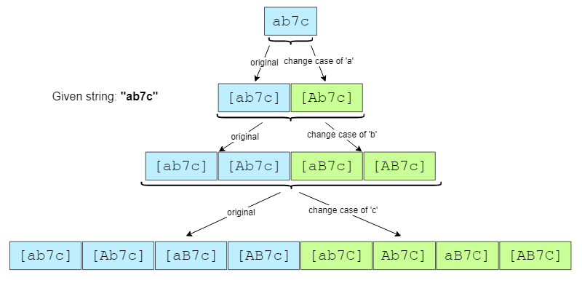

### Code

|  |
| --- |
| import java.util.*;  class Solution {  public static List<String> findLetterCaseStringPermutations(String str) {  List<String> permutations = new ArrayList<>();  if (str == null)  return permutations;  permutations.add(str);  // process every character of the string one by one  for (int i = 0; i < str.length(); i++) {  if (Character.isLetter(str.charAt(i))) { // only process characters, skip digits  // we'll take all existing permutations and change the letter case appropriately  int n = permutations.size();  for (int j = 0; j < n; j++) {  char[] chs = permutations.get(j).toCharArray();  // if the current char is in upper case change it to lower case or vice versa  if (Character.isUpperCase(chs[i]))  chs[i] = Character.toLowerCase(chs[i]);  else  chs[i] = Character.toUpperCase(chs[i]);  permutations.add(String.valueOf(chs));  }  }  }  return permutations;  }  public static void main(String[] args) {  List<String> result =  Solution.findLetterCaseStringPermutations("ad52");  System.out.println(" String permutations are: " + result);  result = Solution.findLetterCaseStringPermutations("ab7c");  System.out.println(" String permutations are: " + result);  }  } |

* Since we can have2ᴺ permutations at the most and while processing each permutation we convert it into a character array, the overall time complexity of the algorithm will be O(N*2ᴺ).
* All the additional space used by our algorithm is for the output list. Since we can have a total of O(2ᴺ) permutations, the space complexity of our algorithm is O(N*2ᴺ).

### Java Solution

|  |
| --- |
| public static List<String> letterCasePermutation(String s) {  List<String> ans = new ArrayList<>();  permutation(s.toCharArray(), 0, ans);  return ans;  }  public static void permutation(char[] nums, int index, List<String> ans){  if(index == nums.length){  ans.add(new String(nums));  return;  }  if(Character.isDigit(nums[index])){  permutation(nums, index+1, ans);  return;  }  nums[index] = Character.toLowerCase(nums[index]);  permutation(nums, index+1, ans);  nums[index] = Character.toUpperCase(nums[index]);  permutation(nums, index+1, ans);  } |

**Balanced Parentheses (hard)**

<https://leetcode.com/problems/generate-parentheses/>

### Problem Statement

For a given number N, write a function to generate all combination of N pairs of balanced parentheses.

Example 1:

Input: N=2

Output: (()), ()()

Example 2:

Input: N=3

Output: ((())), (()()), (())(), ()(()), ()()()

### Solution

This problem follows the **Subsets** pattern and can be mapped to **Permutations**. We can follow a similar **BFS** approach.

Let’s take Example-2 mentioned above to generate all the combinations of balanced parentheses. Following a **BFS** approach, we will keep adding open parentheses ( or close parentheses ). At each step we need to keep two things in mind:

* We can’t add more than N open parenthesis.
* To keep the parentheses balanced, we can add a close parenthesis ) only when we have already added enough open parenthesis (. For this, we can keep a count of open and close parenthesis with every combination.

Following this guideline, let’s generate parentheses for N=3:

1. Start with an empty combination: “”
2. At every step, let’s take all combinations of the previous step and add ( or ) keeping the above-mentioned two rules in mind.
3. For the empty combination, we can add ( since the count of open parenthesis will be less than N. We can’t add ) as we don’t have an equivalent open parenthesis, so our list of combinations will now be: (
4. For the next iteration, let’s take all combinations of the previous set. For ( we can add another ( to it since the count of open parenthesis will be less than N. We can also add ) as we do have an equivalent open parenthesis, so our list of combinations will be: ((, ()
5. In the next iteration, for the first combination ((, we can add another ( to it as the count of open parenthesis will be less than N, we can also add ) as we do have an equivalent open parenthesis. This gives us two new combinations: ((( and ((). For the second combination (), we can add another ( to it since the count of open parenthesis will be less than N. We can’t add ) as we don’t have an equivalent open parenthesis, so our list of combinations will be: (((, ((), ()(
6. Following the same approach, next we will get the following list of combinations: “((()”, “(()(”, “(())”, “()((”, “()()”
7. Next we will get: “((())”, “(()()”, “(())(”, “()(()”, “()()(”
8. Finally, we will have the following combinations of balanced parentheses: “((()))”, “(()())”, “(())()”, “()(())”, “()()()”
9. We can’t add more parentheses to any of the combinations, so we stop here.

Here is the visual representation of this algorithm:

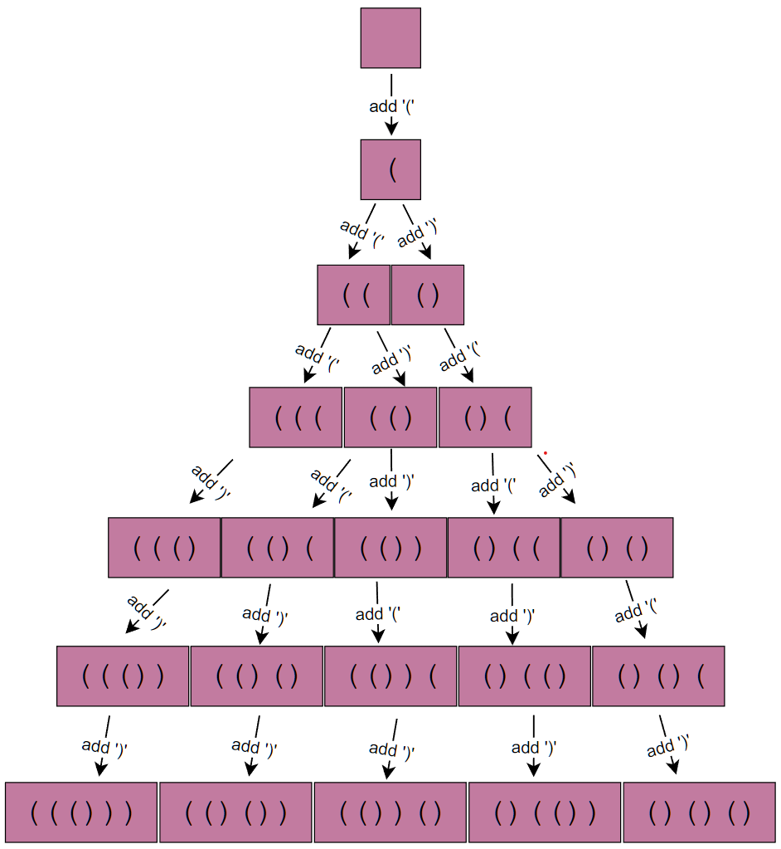

### Code

|  |
| --- |
| import java.util.*;  class ParenthesesString {  String str;  int openCount; // open parentheses count  int closeCount; // close parentheses count  public ParenthesesString(String s, int openCount, int closeCount) {  str = s;  this.openCount = openCount;  this.closeCount = closeCount;  }  }  class Solution {  public static List<String> generateValidParentheses(int num) {  List<String> result = new ArrayList<String>();  Queue<ParenthesesString> queue = new LinkedList<>();  queue.add(new ParenthesesString("", 0, 0));  while (!queue.isEmpty()) {  ParenthesesString ps = queue.poll();  // if we've reached the maximum number of open and close parentheses, add to result  if (ps.openCount == num && ps.closeCount == num) {  result.add(ps.str);  } else {  if (ps.openCount < num) // if we can add an open parentheses, add it  queue.add(new ParenthesesString(ps.str + "(",  ps.openCount + 1, ps.closeCount));  if (ps.openCount > ps.closeCount) // if we can add a close parentheses, add it  queue.add(new ParenthesesString(ps.str + ")",  ps.openCount, ps.closeCount + 1));  }  }  return result;  }  public static void main(String[] args) {  List<String> result = Solution.generateValidParentheses(2);  System.out.println("All combinations of balanced parentheses are: " + result);  result = Solution.generateValidParentheses(3);  System.out.println("All combinations of balanced parentheses are: " + result);  }  } |

* Let’s try to estimate how many combinations we can have for N pairs of balanced parentheses. If we don’t care for the ordering - that ) can only come after ( - then we have two options for every position, i.e., either put open parentheses or close parentheses. This means we can have a maximum of 2ᴺ combinations. Because of the ordering, the actual number will be less than 2ᴺ
* If you see the visual representation of Example-2 closely you will realize that, in the worst case, it is equivalent to a binary tree, where each node will have two children. This means that we will have 2ᴺ leaf nodes and 2ᴺ-1 intermediate nodes. So the total number of elements pushed to the queue will be 2ᴺ−1, which is asymptotically equivalent to O(2ᴺ). While processing each element, we do need to concatenate the current string with ( or ). This operation will take O(N), so the overall time complexity of our algorithm will be O(N*2ᴺ). *This is not completely accurate but reasonable enough to be presented in the interview.*
* All the additional space used by our algorithm is for the output list. Since we can’t have more than O(2ᴺ) combinations, the space complexity of our algorithm is O(N*2ᴺ).

### Java Solution

|  |
| --- |
| public static List<String> generateParenthesisQueue(int n) {  List<String> result = new ArrayList<>();  Queue<ParenthesisString> queue = new LinkedList();  queue.add(new ParenthesisString("(",1,0));  while(!queue.isEmpty()){  ParenthesisString ps = queue.poll();  if(ps.parenthesis.length() == 2*n){  result.add(ps.parenthesis);  }  if(ps.open < n){  queue.add(new ParenthesisString(ps.parenthesis+"(", ps.open+1, ps.close));  }  if(ps.close < ps.open){  queue.add(new ParenthesisString(ps.parenthesis+")", ps.open, ps.close+1));  }  }  return result;  } |

**Recursive Solution**

|  |
| --- |
| import java.util.*;  class Solution {  public static List<String> generateValidParentheses(int num) {  List<String> result = new ArrayList<String>();  char[] parenthesesString = new char[2 * num];  generateValidParenthesesRecursive(num, 0, 0, parenthesesString, 0, result);  return result;  }  private static void generateValidParenthesesRecursive(int num, int openCount,  int closeCount, char[] parenthesesString, int index, List<String> result) {  // if we've reached the maximum number of open and close parentheses, add to result  if (openCount == num && closeCount == num) {  result.add(new String(parenthesesString));  } else {  if (openCount < num) { // if we can add an open parentheses, add it  parenthesesString[index] = '(';  generateValidParenthesesRecursive(num, openCount + 1, closeCount,  parenthesesString, index + 1, result);  }  if (openCount > closeCount) { // if we can add a close parentheses, add it  parenthesesString[index] = ')';  generateValidParenthesesRecursive(num, openCount, closeCount + 1,  parenthesesString, index + 1, result);  }  }  }  public static void main(String[] args) {  List<String> result = Solution.generateValidParentheses(2);  System.out.println("All combinations of balanced parentheses are: " + result);  result = Solution.generateValidParentheses(3);  System.out.println("All combinations of balanced parentheses are: " + result);  }  } |

### Java Solution

|  |
| --- |
| public static List<String> generateParenthesis(int n) {  List<String> result = new ArrayList<>();  findAll("(", 1,0,n,result);  return result;  }  public static void findAll(String current, int open, int close, int n, List<String> result){  if(current.length() == 2*n){  result.add(current);  return;  }  if(open<n)  findAll(current+"(",open+1, close, n, result);  if(close<open)  findAll(current+")", open, close+1, n, result);  } |

## 😕 Unique Generalized Abbreviations (hard)

<https://leetcode.com/problems/generalized-abbreviation/>

### Problem Statement

Given a word, write a function to generate all of its unique generalized abbreviations.

A generalized abbreviation of a word can be generated by replacing each substring of the word with the count of characters in the substring. Take the example of “ab” which has four substrings: “”, “a”, “b”, and “ab”. After replacing these substrings in the actual word by the count of characters, we get all the generalized abbreviations: “ab”, “1b”, “a1”, and “2”.

**Note:** All contiguous characters should be considered one substring, e.g., we can’t take “a” and “b” as substrings to get “11”; since “a” and “b” are contiguous, we should consider them together as one substring to get an abbreviation “2”.

Example 1:

Input: "BAT"

Output: "BAT", "BA1", "B1T", "B2", "1AT", "1A1", "2T", "3"

Example 2:

Input: "code"

Output: "code", "cod1", "co1e", "co2", "c1de", "c1d1", "c2e", "c3", "1ode", "1od1", "1o1e", "1o2", "2de", "2d1", "3e", "4"

### Solution

This problem follows the Subsets pattern and can be mapped to Balanced Parentheses. We can follow a similar BFS approach.

Let’s take Example-1 mentioned above to generate all unique generalized abbreviations. Following a BFS approach, we will abbreviate one character at a time. At each step, we have two options:

* Abbreviate the current character, or
* Add the current character to the output and skip the abbreviation.

Following these two rules, let’s abbreviate BAT:

1. Start with an empty word: “”
2. At every step, we will take all the combinations from the previous step and apply the two abbreviation rules to the next character.
3. Take the empty word from the previous step and add the first character to it. We can either abbreviate the character or add it (by skipping abbreviation). This gives us two new words: _, B.
4. In the next iteration, let’s add the second character. Applying the two rules on _ will give us _ _ and 1A. Applying the above rules to the other combination B gives us B_ and BA.
5. The next iteration will give us: _ _ _, 2T, 1A_, 1AT, B _ _, B1T, BA_, BAT
6. The final iteration will give us:3, 2T, 1A1, 1AT, B2, B1T, BA1, BAT

Here is the visual representation of this algorithm:

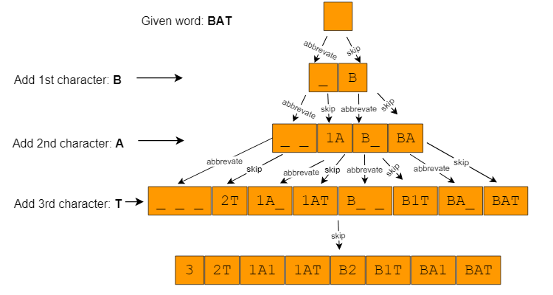

### Code

|  |
| --- |
| import java.util.*;  class AbbreviatedWord {  StringBuilder str;  int start;  int count;  public AbbreviatedWord(StringBuilder str, int start, int count) {  this.str = str;  this.start = start;  this.count = count;  }  }  class Solution {  public static List<String> generateGeneralizedAbbreviation(String word) {  int wordLen = word.length();  List<String> result = new ArrayList<String>();  Queue<AbbreviatedWord> queue = new LinkedList<>();  queue.add(new AbbreviatedWord(new StringBuilder(), 0, 0));  while (!queue.isEmpty()) {  AbbreviatedWord abWord = queue.poll();  if (abWord.start == wordLen) {  if (abWord.count != 0)  abWord.str.append(abWord.count);  result.add(abWord.str.toString());  } else {  // continue abbreviating by incrementing the current abbreviation count  queue.add(new AbbreviatedWord(new StringBuilder(abWord.str),  abWord.start + 1, abWord.count + 1));  // restart abbreviating, append the count and the current character to the string  if (abWord.count != 0)  abWord.str.append(abWord.count);  queue.add(  new AbbreviatedWord(new StringBuilder(  abWord.str).append(word.charAt(abWord.start)), abWord.start + 1, 0));  }  }  return result;  }  public static void main(String[] args) {  List<String> result = Solution.generateGeneralizedAbbreviation("BAT");  System.out.println("Generalized abbreviation are: " + result);  result = Solution.generateGeneralizedAbbreviation("code");  System.out.println("Generalized abbreviation are: " + result);  }  } |

* Since we had two options for each character, we will have a maximum of 2ᴺ combinations. If you see the visual representation of Example-1 closely, you will realize that it is equivalent to a binary tree, where each node has two children. This means that we will have 2ᴺ leaf nodes and 2ᴺ-1 intermediate nodes, so the total number of elements pushed to the queue will be 2ᴺ + 2ᴺ-1, which is asymptotically equivalent to O(2ᴺ). While processing each element, we do need to concatenate the current string with a character. This operation will take O(N), so the overall time complexity of our algorithm will be O(N*2ᴺ).
* All the additional space used by our algorithm is for the output list. Since we can’t have more than O(2ᴺ) combinations, the space complexity of our algorithm is O(N*2ᴺ).

### Recursive Solution

|  |
| --- |
| import java.util.*;  class Solution {  public static List<String> generateGeneralizedAbbreviation(String word) {  List<String> result = new ArrayList<String>();  generateAbbreviationRecursive(word, new StringBuilder(), 0, 0, result);  return result;  }  private static void generateAbbreviationRecursive(String word, StringBuilder abWord,  int start, int count, List<String> result) {  if (start == word.length()) {  if (count != 0)  abWord.append(count);  result.add(abWord.toString());  } else {  // continue abbreviating by incrementing the current abbreviation count  generateAbbreviationRecursive(word, new StringBuilder(abWord),  start + 1, count + 1, result);  // restart abbreviating, append the count and the current character to the string  if (count != 0)  abWord.append(count);  generateAbbreviationRecursive(word,  new StringBuilder(abWord).append(word.charAt(start)), start + 1, 0, result);  }  }  public static void main(String[] args) {  List<String> result =  Solution.generateGeneralizedAbbreviation("BAT");  System.out.println("Generalized abbreviation are: " + result);  result = Solution.generateGeneralizedAbbreviation("code");  System.out.println("Generalized abbreviation are: " + result);  }  } |

### Java Solution

|  |
| --- |
| public static List<String> abbreviations(String string){  List<String> answer = new ArrayList<>();  abbreviations("pep","", 0, 0, answer);  return answer;  }  public static void abbreviations(String string, String curAns, int count, int pos, List<String> answer){  if(pos == string.length()){  if(count == 0)  answer.add(curAns);  else  answer.add(curAns+count);  return;  }  if(count>0)  abbreviations(string, curAns+count+string.charAt(pos), 0, pos+1, answer);  else  abbreviations(string, curAns+string.charAt(pos), 0, pos+1, answer);  abbreviations(string, curAns, count+1, pos+1, answer);  } |

**🌟 Evaluate Expression (hard)**

<https://leetcode.com/problems/different-ways-to-add-parentheses/>

### Problem Statement

Given an expression containing digits and operations (+, -, *), find all possible ways in which the expression can be evaluated by grouping the numbers and operators using parentheses.

Example 1:

Input: "1+2*3"

Output: 7, 9

Explanation:

1+(2*3) => 7

(1+2)*3 => 9

Example 2:

Input: "2*3-4-5"

Output: 8, -12, 7, -7, -3

Explanation:

2*(3-(4-5)) => 8

2*(3-4-5) => -12

2*3-(4-5) => 7

2*(3-4)-5 => -7

(2*3)-4-5 => -3

### Solution

This problem follows the Subsets pattern and can be mapped to Balanced Parentheses. We can follow a similar BFS approach.

Let’s take the first example to generate different ways to evaluate the expression.

1. We can iterate through the expression character-by-character.
2. we can break the expression into two halves whenever we get an operator (+, -, *).
3. The two parts can be calculated by recursively calling the function.
4. Once we have the evaluation results from the left and right halves, we can combine them to produce all results.

### Code

|  |
| --- |
| import java.util.*;  class Solution {  public static List<Integer> diffWaysToEvaluateExpression(String input) {  List<Integer> result = new ArrayList<>();  // base case: if the input string is a number, parse and add it to output.  if (!input.contains("+") && !input.contains("-") && !input.contains("*")) {  result.add(Integer.parseInt(input));  } else {  for (int i = 0; i < input.length(); i++) {  char chr = input.charAt(i);  if (!Character.isDigit(chr)) {  // break the equation here into two parts and make recursively calls  List<Integer> leftParts = diffWaysToEvaluateExpression(input.substring(0, i));  List<Integer> rightParts = diffWaysToEvaluateExpression(input.substring(i + 1));  for (int part1 : leftParts) {  for (int part2 : rightParts) {  if (chr == '+')  result.add(part1 + part2);  else if (chr == '-')  result.add(part1 - part2);  else if (chr == '*')  result.add(part1 * part2);  }  }  }  }  }  return result;  }  public static void main(String[] args) {  List<Integer> result = Solution.diffWaysToEvaluateExpression("1+2*3");  System.out.println("Expression evaluations: " + result);  result = Solution.diffWaysToEvaluateExpression("2*3-4-5");  System.out.println("Expression evaluations: " + result);  }  } |

* The time complexity of this algorithm will be exponential and will be similar to Balanced Parentheses. Estimated time complexity will be O(N*2^N) but the actual time complexity ( O(4^n/\sqrt{n}) is bounded by the Catalan number and is beyond the scope of a coding interview.
* The space complexity of this algorithm will also be exponential, estimated at O(2^N) though the actual will be ( O(4^n/\sqrt{n}).

### Java Solution

|  |
| --- |
| public static List<Integer> differentWaysToCompute(String input){  List<Integer> ans = new ArrayList<>();  for(int i = 0; i<input.length(); i++){  char c = input.charAt(i);  if(c == '-' || c == '+' || c == '*'){  String left = input.substring(0,i);  String right = input.substring(i+1);  List<Integer> left1 = differentWaysToCompute(left);  List<Integer> right1 = differentWaysToCompute(right);  for(int x:left1){  for(int y : right1){  if(c =='-'){  ans.add(x-y);  }  if(c =='+'){  ans.add(x+y);  }  if(c =='*'){  ans.add(x*y);  }  }  }  }  }  if(ans.size() == 0) ans.add(Integer.valueOf(input));  return ans;  } |

**Memoized Solution**

The problem has overlapping subproblems, as our recursive calls can be evaluating the same sub-expression multiple times. To resolve this, we can use **memoization** and store the intermediate results in a **HashMap**. In each function call, we can check our map to see if we have already evaluated this sub-expression before

|  |
| --- |
| import java.util.*;  class Solution {  // memoization map  Map<String, List<Integer>> map = new HashMap<String, List<Integer>>();  public List<Integer> diffWaysToEvaluateExpression(String input) {  if (map.containsKey(input))  return map.get(input);  List<Integer> result = new ArrayList<>();  // base case: if the input string is a number, parse and return it.  if (!input.contains("+") && !input.contains("-") && !input.contains("*")) {  result.add(Integer.parseInt(input));  } else {  for (int i = 0; i < input.length(); i++) {  char chr = input.charAt(i);  if (!Character.isDigit(chr)) {  List<Integer> leftParts = diffWaysToEvaluateExpression(input.substring(0, i));  List<Integer> rightParts = diffWaysToEvaluateExpression(input.substring(i + 1));  for (int part1 : leftParts) {  for (int part2 : rightParts) {  if (chr == '+')  result.add(part1 + part2);  else if (chr == '-')  result.add(part1 - part2);  else if (chr == '*')  result.add(part1 * part2);  }  }  }  }  }  map.put(input, result);  return result;  }  public static void main(String[] args) {  Solution ee = new Solution();  List<Integer> result = ee.diffWaysToEvaluateExpression("1+2*3");  System.out.println("Expression evaluations: " + result);    ee = new Solution();  result = ee.diffWaysToEvaluateExpression("2*3-4-5");  System.out.println("Expression evaluations: " + result); }  } |

## 🌟 Structurally Unique Binary Search Trees (hard)

<https://leetcode.com/problems/unique-binary-search-trees-ii/>

### Problem Statement

Given a number n, write a function to return all structurally unique **Binary Search Trees (BST)** that can store values 1 to n?

Example 1:

Input: 2

Output: List containing root nodes of all structurally unique BSTs.

Explanation: Here are the 2 structurally unique BSTs storing all numbers from 1 to 2:

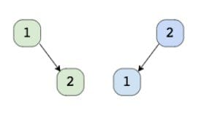

Example 2:

Input: 3

Output: List containing root nodes of all structurally unique BSTs.

Explanation: Here are the 5 structurally unique BSTs storing all numbers from 1 to 3:

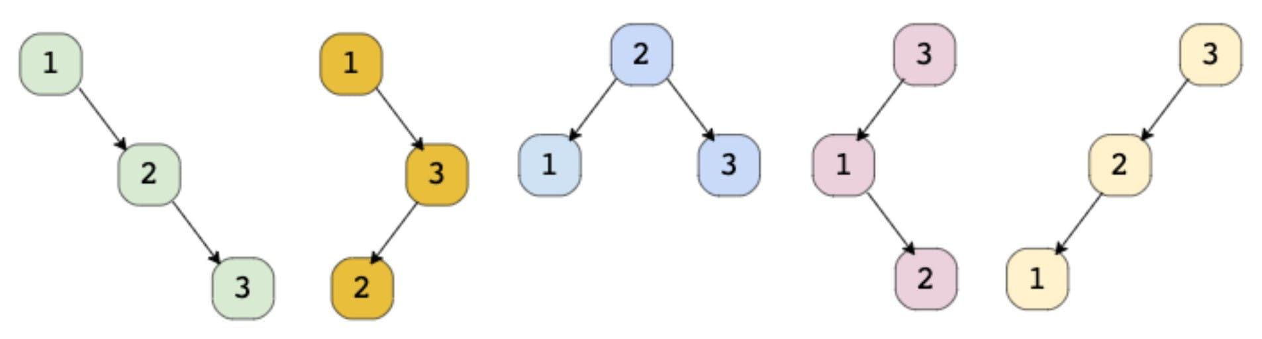

### Solution

This problem follows the **Subsets** pattern and is quite similar to **Evaluate Expression**. Following a similar approach, we can iterate from 1 to n and consider each number as the root of a tree. All smaller numbers will make up the left sub-tree and bigger numbers will make up the right sub-tree. We will make recursive calls for the left and right sub-trees

### Code

|  |
| --- |
| import java.util.*;  class TreeNode {  int val;  TreeNode left;  TreeNode right;  TreeNode(int x) {  val = x;  }  };  class Solution {  public static List<TreeNode> findUniqueTrees(int n) {  if (n <= 0)  return new ArrayList<TreeNode>();  return findUniqueTreesRecursive(1, n);  }  public static List<TreeNode> findUniqueTreesRecursive(int start, int end) {  List<TreeNode> result = new ArrayList<>();  // base condition, return 'null' for an empty sub-tree  // consider n=1, in this case we will have start=end=1, this means we should have  // only one tree we will have two recursive calls, findUniqueTreesRecursive(1, 0) &  // (2, 1) both of these should return 'null' for the left and the right child  if (start > end) {  result.add(null);  return result;  }  for (int i = start; i <= end; i++) {  // making 'i' root of the tree  List<TreeNode> leftSubtrees = findUniqueTreesRecursive(start, i - 1);  List<TreeNode> rightSubtrees = findUniqueTreesRecursive(i + 1, end);  for (TreeNode leftTree : leftSubtrees) {  for (TreeNode rightTree : rightSubtrees) {  TreeNode root = new TreeNode(i);  root.left = leftTree;  root.right = rightTree;  result.add(root);  }  }  }  return result;  }  public static void main(String[] args) {  List<TreeNode> result = Solution.findUniqueTrees(2);  System.out.print("Total trees: " + result.size());  }  } |

* The time complexity of this algorithm will be exponential and will be similar to Balanced Parentheses. Estimated time complexity will be O(n*2^n) but the actual time complexity ( O(4^n/\sqrt{n}) is bounded by the Catalan number and is beyond the scope of a coding interview.
* The space complexity of this algorithm will be exponential too, estimated at O(2^n), but the actual will be ( O(4^n/\sqrt{n}).

### Java Solution

|  |
| --- |
| public static List<TreeNode> generateTrees(int n) {  if(n == 0) return new ArrayList<>();  return generateTrees(1, n);  }  public static List<TreeNode> generateTrees(int start, int end){  List<TreeNode> res = new ArrayList<>();  if(start>end){  res.add(null);  return res;  }  for(int i=start; i<end+1;i++){  List<TreeNode> leftTree = generateTrees(start, i-1);  List<TreeNode> rightTree = generateTrees(i+1, end);  for(TreeNode left: leftTree){  for(TreeNode right: rightTree){  res.add(new TreeNode( i, left, right));  }  }  }  return res;  } |

**Memoized Solution**

Since our algorithm has overlapping subproblems, can we use memoization to improve it? We could, but every time we return the result of a subproblem from the cache, we have to clone the result list because these trees will be used as the left or right child of a tree. This cloning is equivalent to reconstructing the trees, therefore, the overall time complexity of the memoized algorithm will also be the same.

## 🌟 Count of Structurally Unique Binary Search Trees (hard)

<https://leetcode.com/problems/unique-binary-search-trees/>

### Problem Statement

Given a number n, write a function to return the count of structurally unique **Binary Search Trees (BST)** that can store values 1 to n.

Example 1:

Input: 2

Output: 2

Explanation: As we saw in the previous problem, there are 2 unique BSTs storing numbers from 1-2.

Example 2:

Input: 3

Output: 5

Explanation: There will be 5 unique BSTs that can store numbers from 1 to 3.

### Solution

This problem is similar to Structurally Unique Binary Search Trees. Following a similar approach, we can iterate from 1 to ‘n’ and consider each number as the root of a tree and make two recursive calls to count the number of left and right sub-trees.

### Code

|  |
| --- |
| class Solution {  public int countTrees(int n) {  if (n <= 1)  return 1;  int count = 0;  for (int i = 1; i <= n; i++) {  // making 'i' root of the tree  int countOfLeftSubtrees = countTrees(i - 1);  int countOfRightSubtrees = countTrees(n - i);  count += (countOfLeftSubtrees * countOfRightSubtrees);  }  return count;  }  public static void main(String[] args) {  Solution ct = new Solution();  int count = ct.countTrees(3);  System.out.print("Total trees: " + count);  }  } |

* The time complexity of this algorithm will be exponential and will be similar to Balanced Parentheses. Estimated time complexity will be O(n*2^n) but the actual time complexity ( O(4^n/\sqrt{n}) is bounded by the Catalan number and is beyond the scope of a coding interview.
* The space complexity of this algorithm will be exponential too, estimated O(2^n) but the actual will be ( O(4^n/\sqrt{n}).

### Java Solution

|  |
| --- |
| public static int countTrees(int n) {  if(n <= 1) return 1;  int count = 0;  for(int i = 1; i< n+1; i++){  int leftCount = countTrees(i-1);  int rightCount = countTrees(n-i);  count+=(leftCount* rightCount);  }  return count;  } |

### Dynamic Programming solution

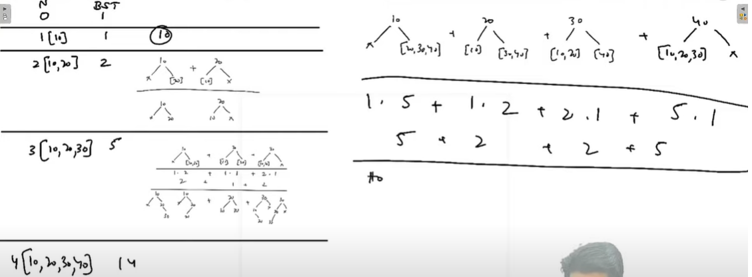

|  |
| --- |
| public static int countTreesDp(int n) {  int[] dp = new int[n+1];  dp[0] = 1;  dp[1] = 1;  for(int i = 2; i<= n; i++){  int leftCount = 0;  int rightCount = i-1;  while(leftCount <= i-1){  dp[i] += dp[leftCount] * dp[rightCount];  leftCount++;  rightCount--;  }  }  return dp[n];  } |

**Memoized version**

Our algorithm has overlapping subproblems as our recursive call will be evaluating the same sub-expression multiple times. To resolve this, we can use memoization and store the intermediate results in a **HashMap**. In each function call, we can check our map to see if we have already evaluated this sub-expression before.

|  |
| --- |
| import java.util.*;  class Solution {  Map<Integer, Integer> map = new HashMap<>();  public int countTrees(int n) {  if (map.containsKey(n))  return map.get(n);  if (n <= 1)  return 1;  int count = 0;  for (int i = 1; i <= n; i++) {  // making 'i' root of the tree  int countOfLeftSubtrees = countTrees(i - 1);  int countOfRightSubtrees = countTrees(n - i);  count += (countOfLeftSubtrees * countOfRightSubtrees);  }  map.put(n, count);  return count;  }  public static void main(String[] args) {  Solution ct = new Solution();  int count = ct.countTrees(3);  System.out.print("Total trees: " + count);  }  } |

* The time complexity of the memoized algorithm will be O(n^2), since we are iterating from 1 to n and ensuring that each sub-problem is evaluated only once.
* The space complexity will be O(n) for the memoization map.

### Java Solution

|  |
| --- |
| public static int countTreesMemorized(int n) {  Map<Integer, Integer> map = new HashMap<>();  return countTreesMemorized(n,map);  }  public static int countTreesMemorized(int n, Map<Integer, Integer> map) {  if(map.containsKey(n)){  return map.get(n);  }  if(n <= 1) return 1;  int count = 0;  for(int i = 1; i< n+1; i++){  int leftCount = countTreesMemorized(i-1, map);  int rightCount = countTreesMemorized(n-i, map);  count+=(leftCount* rightCount);  }  map.put(n, count);  return count;  } |

**Pattern 11: Modified Binary Search**

As we know, whenever we are given a sorted **Array** or **LinkedList** or **Matrix**, and we are asked to find a certain element, the best algorithm we can use is the **Binary Search**.

**Order-agnostic Binary Search (easy)**

<https://leetcode.com/problems/binary-search/>

### Problem Statement

Given a sorted array of numbers, find if a given number key is present in the array. Though we know that the array is sorted, we don’t know if it’s sorted in ascending or descending order. You should assume that the array can have duplicates.

Write a function to return the index of the key if it is present in the array, otherwise return -1.

Example 1:

Input: [4, 6, 10], key = 10

Output: 2

Example 2:

Input: [1, 2, 3, 4, 5, 6, 7], key = 5

Output: 4

Example 3:

Input: [10, 6, 4], key = 10

Output: 0

Example 4:

Input: [10, 6, 4], key = 4

Output: 2

### Solution

To make things simple, let’s first solve this problem assuming that the input array is sorted in ascending order. Here are the set of steps for **Binary Search**:

1. Let’s assume start is pointing to the first index and end is pointing to the last index of the input array (let’s call it arr). This means:

int start = 0;

int end = arr.length - 1;

1. First, we will find the middle of start and end. An easy way to find the middle would be: *middle=(start+end)/2*. For Java and C++, this equation will work for most cases, but when start or end is large, this equation will give us the wrong result due to integer overflow. Imagine that end is equal to the maximum range of an integer (e.g. for Java: int end = Integer.MAX_VALUE). Now adding any positive number to end will result in an integer overflow. Since we need to add both the numbers first to evaluate our equation, an overflow might occur. The safest way to find the middle of two numbers without getting an overflow is as follows:

middle = start + (end-start)/2

The above discussion is not relevant for Python, as we don’t have the integer overflow problem in pure Python.

1. Next, we will see if the key is equal to the number at index middle. If it is equal we return middle as the required index.
2. If key is not equal to number at index middle, we have to check two things:

* If key < arr[middle], then we can conclude that the key will be smaller than all the numbers after index middle as the array is sorted in the ascending order. Hence, we can reduce our search to end = mid - 1.
* If key > arr[middle], then we can conclude that the key will be greater than all numbers before index middle as the array is sorted in the ascending order. Hence, we can reduce our search to start = mid + 1.

1. We will repeat steps 2-4 with new ranges of start to end. If at any time start becomes greater than end, this means that we can’t find the key in the input array and we must return -1.

Here is the visual representation of Binary Search for the Example-2:

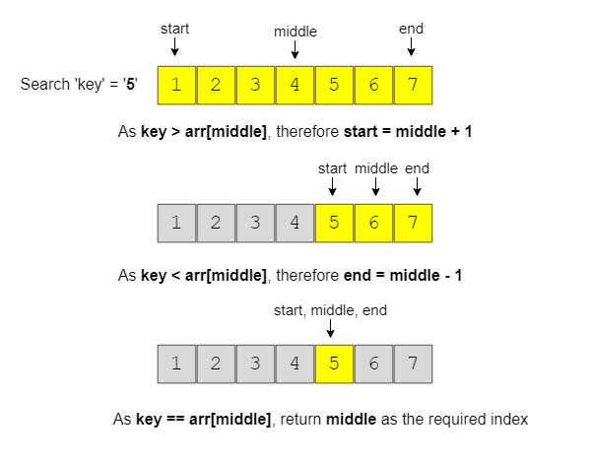

If the array is sorted in the descending order, we have to update the step 4 above as:

* If key > arr[middle], then we can conclude that the key will be greater than all numbers after index middle as the array is sorted in the descending order. Hence, we can reduce our search to end = mid - 1.
* If key < arr[middle], then we can conclude that the key will be smaller than all the numbers before index middle as the array is sorted in the descending order. Hence, we can reduce our search to start = mid + 1.
* Finally, how can we figure out the sort order of the input array? We can compare the numbers pointed out by start and end index to find the sort order. If arr[start] < arr[end], it means that the numbers are sorted in ascending order otherwise they are sorted in the descending order.

### Code

|  |
| --- |
| class Solution {  public static int search(int[] arr, int key) {  int start = 0, end = arr.length - 1;  boolean isAscending = arr[start] < arr[end];  while (start <= end) {  // calculate the middle of the current range  int mid = start + (end - start) / 2;  if (key == arr[mid])  return mid;  if (isAscending) { // ascending order  if (key < arr[mid]) {  end = mid - 1; // the 'key' can be in the first half  } else { // key > arr[mid]  start = mid + 1; // the 'key' can be in the second half  }  } else { // descending order  if (key > arr[mid]) {  end = mid - 1; // the 'key' can be in the first half  } else { // key < arr[mid]  start = mid + 1; // the 'key' can be in the second half  }  }  }  return -1; // element not found  }  public static void main(String[] args) {  System.out.println(Solution.search(new int[] { 4, 6, 10 }, 10));  System.out.println(Solution.search(new int[] { 1, 2, 3, 4, 5, 6, 7 }, 5));  System.out.println(Solution.search(new int[] { 10, 6, 4 }, 10));  System.out.println(Solution.search(new int[] { 10, 6, 4 }, 4));  }  } |

* Since, we are reducing the search range by half at every step, this means that the time complexity of our algorithm will be O(log N) where N is the total elements in the given array.
* The algorithm runs in constant space O(1).

**Ceiling of a Number (medium)**

### Problem Statement

Given an array of numbers sorted in an ascending order, find the ceiling of a given number key. The ceiling of the key will be the smallest element in the given array greater than or equal to the key.

Write a function to return the index of the ceiling of the key. If there isn’t any ceiling return -1.

Example 1:

Input: [4, 6, 10], key = 6

Output: 1

Explanation: The smallest number greater than or equal to '6' is '6' having index '1'.

Example 2:

Input: [1, 3, 8, 10, 15], key = 12

Output: 4

Explanation: The smallest number greater than or equal to '12' is '15' having index '4'.

Example 3:

Input: [4, 6, 10], key = 17

Output: -1

Explanation: There is no number greater than or equal to '17' in the given array.

Example 4:

Input: [4, 6, 10], key = -1

Output: 0

Explanation: The smallest number greater than or equal to '-1' is '4' having index '0'.

### Solution

This problem follows the **Binary Search** pattern. Since **Binary Search** helps us find a number in a sorted array efficiently, we can use a modified version of the **Binary Search** to find the ceiling of a number.

We can use a similar approach as discussed in **Order-agnostic Binary Search**. We will try to search for the key in the given array. If we find the key, we return its index as the ceiling. If we can’t find the key, the next big number will be pointed out by the index start.

Consider Example-2 mentioned above:

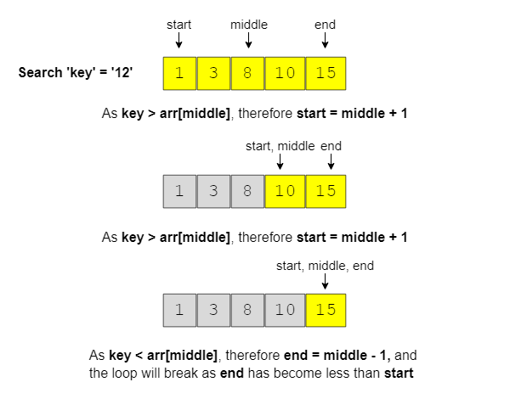

Since we are always adjusting our range to find the key, when we exit the loop, the start of our range will point to the smallest number greater than the key as shown in the above picture.

We can add a check in the beginning to see if the key is bigger than the biggest number in the input array. If so, we can return -1.

### Code

|  |
| --- |
| class Solution {  public static int searchCeilingOfANumber(int[] arr, int key) {  if (key > arr[arr.length - 1]) // if the 'key' is bigger than the biggest element  return -1;  int start = 0, end = arr.length - 1;  while (start <= end) {  int mid = start + (end - start) / 2;  if (key < arr[mid]) {  end = mid - 1;  } else if (key > arr[mid]) {  start = mid + 1;  } else { // found the key  return mid;  }  }  // since the loop is running until 'start <= end', so at the end of the while loop,  // 'start == end+1' we are not able to find the element in the given array, so the  // next big number will be arr[start]  return start;  }  public static void main(String[] args) {  System.out.println(Solution.searchCeilingOfANumber(  new int[] { 4, 6, 10 }, 6));  System.out.println(Solution.searchCeilingOfANumber(  new int[] { 1, 3, 8, 10, 15 }, 12));  System.out.println(Solution.searchCeilingOfANumber(  new int[] { 4, 6, 10 }, 17));  System.out.println(Solution.searchCeilingOfANumber(  new int[] { 4, 6, 10 }, -1));  }  } |

* Since, we are reducing the search range by half at every step, this means that the time complexity of our algorithm will be O(log N) where N is the total elements in the given array.
* The algorithm runs in constant space O(1).

**Similar Problem**

<https://leetcode.com/problems/search-insert-position/>

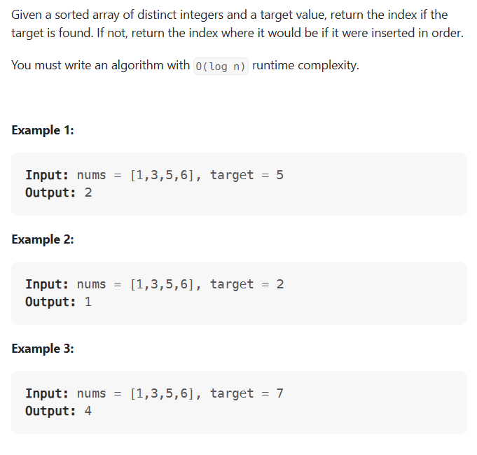

#### Problem 1

Given an array of numbers sorted in ascending order, find the floor of a given number ‘key’. The floor of the ‘key’ will be the biggest element in the given array smaller than or equal to the ‘key’

Write a function to return the index of the floor of the ‘key’. If there isn’t a floor, return -1.

Example 1:

Input: [4, 6, 10], key = 6

Output: 1

Explanation: The biggest number smaller than or equal to '6' is '6' having index '1'.

Example 2:

Input: [1, 3, 8, 10, 15], key = 12

Output: 3

Explanation: The biggest number smaller than or equal to '12' is '10' having index '3'.

Example 3:

Input: [4, 6, 10], key = 17

Output: 2

Explanation: The biggest number smaller than or equal to '17' is '10' having index '2'.

Example 4:

Input: [4, 6, 10], key = -1

Output: -1

Explanation: There is no number smaller than or equal to '-1' in the given array.

#### Code

|  |
| --- |
| class Solution {  public static int searchFloorOfANumber(int[] arr, int key) {  if (key < arr[0]) // if the 'key' is smaller than the smallest element  return -1;  int start = 0, end = arr.length - 1;  while (start <= end) {  int mid = start + (end - start) / 2;  if (key < arr[mid]) {  end = mid - 1;  } else if (key > arr[mid]) {  start = mid + 1;  } else { // found the key  return mid;  }  }  // since the loop is running until 'start <= end', so at the end of the while loop,  // 'start == end+1' we are not able to find the element in the given array, so the  // next smaller number will be arr[end]  return end;  }  public static void main(String[] args) {  System.out.println(Solution.searchFloorOfANumber(new int[] { 4, 6, 10 }, 6));  System.out.println(Solution.searchFloorOfANumber(  new int[] { 1, 3, 8, 10, 15 }, 12));  System.out.println(Solution.searchFloorOfANumber(new int[] { 4, 6, 10 }, 17));  System.out.println(Solution.searchFloorOfANumber(new int[] { 4, 6, 10 }, -1));  }  } |

* Since, we are reducing the search range by half at every step, this means that the time complexity of our algorithm will be O(log N) where N is the total elements in the given array.
* The algorithm runs in constant space O(1).

**Next Letter (medium)**

<https://leetcode.com/problems/find-smallest-letter-greater-than-target/>

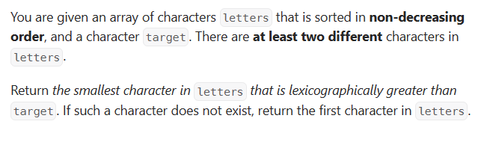

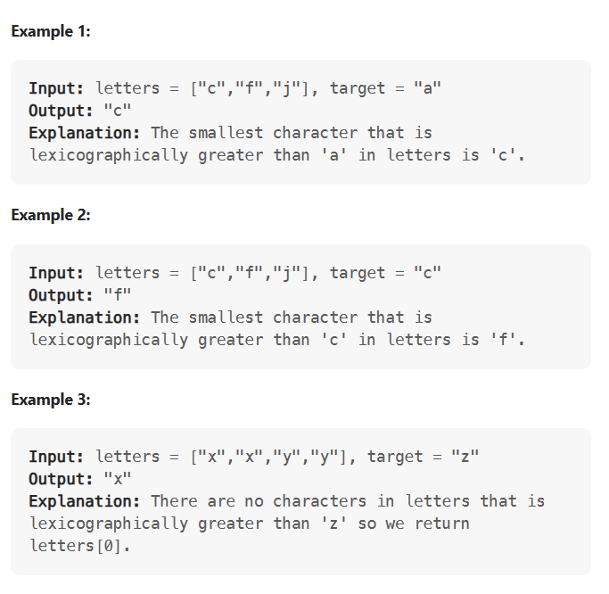

### Problem Statement

Given an array of lowercase letters sorted in ascending order, find the **smallest letter** in the given array **greater than a given key**.

Assume the given array is a **circular list**, which means that the last letter is assumed to be connected with the first letter. This also means that the smallest letter in the given array is greater than the last letter of the array and is also the first letter of the array.

Write a function to return the next letter of the given key.

Example 1:

Input: ['a', 'c', 'f', 'h'], key = 'f'

Output: 'h'

Explanation: The smallest letter greater than 'f' is 'h' in the given array.

Example 2:

Input: ['a', 'c', 'f', 'h'], key = 'b'

Output: 'c'

Explanation: The smallest letter greater than 'b' is 'c'.

Example 3:

Input: ['a', 'c', 'f', 'h'], key = 'm'

Output: 'a'

Explanation: As the array is assumed to be circular, the smallest letter greater than 'm' is 'a'.

### Solution

The problem follows the **Binary Search** pattern. Since **Binary Search** helps us find an element in a sorted array efficiently, we can use a modified version of it to find the next letter.

We can use a similar approach as discussed in **Ceiling of a Number**. There are a couple of differences though:

1. The array is considered circular, which means if the key is bigger than the last letter of the array or if it is smaller than the first letter of the array, the key’s next letter will be the first letter of the array.
2. The other difference is that we have to find the next biggest letter which can’t be equal to the key. This means that we will ignore the case where key == arr[middle]. To handle this case, we can update our start range to start = middle +1.

In the end, instead of returning the element pointed out by start, we have to return the letter pointed out by start % array.length. This is needed because of point 2 discussed above. Imagine that the last letter of the array is equal to the key. In that case, we have to return the first letter of the input array.

### Code

|  |
| --- |
| class Solution {  public static char searchNextLetter(char[] letters, char key) {  int n = letters.length;  int start = 0, end = n - 1;  while (start <= end) {  int mid = start + (end - start) / 2;  if (key < letters[mid]) {  end = mid - 1;  } else { //if (key >= letters[mid]) {  start = mid + 1;  }  }  // since the loop is running until 'start <= end', so at the end of the while loop,  // 'start == end+1'  return letters[start % n];  }  public static void main(String[] args) {  System.out.println(Solution.searchNextLetter(  new char[] { 'a', 'c', 'f', 'h' }, 'f'));  System.out.println(Solution.searchNextLetter(  new char[] { 'a', 'c', 'f', 'h' }, 'b'));  System.out.println(Solution.searchNextLetter(  new char[] { 'a', 'c', 'f', 'h' }, 'm'));  System.out.println(Solution.searchNextLetter(  new char[] { 'a', 'c', 'f', 'h' }, 'h'));  }  } |

* Since, we are reducing the search range by half at every step, this means that the time complexity of our algorithm will be O(log N) where N is the total elements in the given array.
* The algorithm runs in constant space O(1).

**Number Range (medium)**

<https://leetcode.com/problems/find-first-and-last-position-of-element-in-sorted-array/>

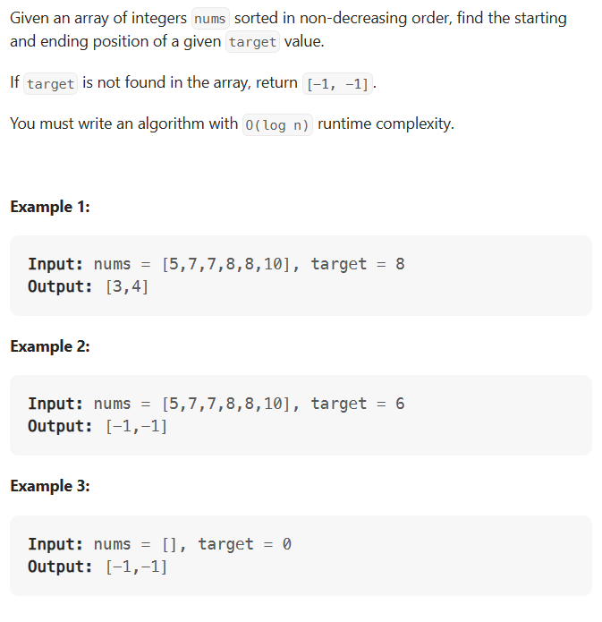

### Problem Statement

Given an array of numbers sorted in ascending order, find the range of a given number key. The range of the key will be the first and last position of the key in the array.

Write a function to return the range of the key. If the key is not present return [-1, -1].

Example 1:

Input: [4, 6, 6, 6, 9], key = 6

Output: [1, 3]

Example 2:

Input: [1, 3, 8, 10, 15], key = 10

Output: [3, 3]

Example 3:

Input: [1, 3, 8, 10, 15], key = 12

Output: [-1, -1]

### Solution

The problem follows the **Binary Search** pattern. Since **Binary Search** helps us find a number in a sorted array efficiently, we can use a modified version of the **Binary Search** to find the first and the last position of a number.

We can use a similar approach as discussed in **Order-agnostic Binary Search**. We will try to search for the key in the given array; if the key is found (i.e. key == arr[middle) we have two options:

1. When trying to find the first position of the key, we can update end = middle - 1 to see if the key is present before middle.
2. When trying to find the last position of the key, we can update start = middle + 1 to see if the key is present after middle.

In both cases, we will keep track of the last position where we found the key. These positions will be the required range.

### Code

|  |
| --- |
| class Solution {  public static int[] findRange(int[] arr, int key) {  int[] result = new int[] { -1, -1 };  result[0] = search(arr, key, false);  if (result[0] != -1) // no need to search, if 'key' is not present in the input array  result[1] = search(arr, key, true);  return result;  }  // modified Binary Search  private static int search(int[] arr, int key, boolean findMaxIndex) {  int keyIndex = -1;  int start = 0, end = arr.length - 1;  while (start <= end) {  int mid = start + (end - start) / 2;  if (key < arr[mid]) {  end = mid - 1;  } else if (key > arr[mid]) {  start = mid + 1;  } else { // key == arr[mid]  keyIndex = mid;  if (findMaxIndex)  start = mid + 1; // search ahead to find the last index of 'key'  else  end = mid - 1; // search behind to find the first index of 'key'  }  }  return keyIndex;  }  public static void main(String[] args) {  int[] result = Solution.findRange(new int[] { 4, 6, 6, 6, 9 }, 6);  System.out.println("Range: [" + result[0] + ", " + result[1] + "]");  result = Solution.findRange(new int[] { 1, 3, 8, 10, 15 }, 10);  System.out.println("Range: [" + result[0] + ", " + result[1] + "]");  result = Solution.findRange(new int[] { 1, 3, 8, 10, 15 }, 12);  System.out.println("Range: [" + result[0] + ", " + result[1] + "]");  }  } |

* Since, we are reducing the search range by half at every step, this means that the time complexity of our algorithm will be O(log N) where N is the total elements in the given array.
* The algorithm runs in constant space O(1).

### Java Solution

For readability I kept 2 methods but it can combined to 1 method by adding a flag in method signature.

|  |
| --- |
| public static int[] searchRange(int[] nums, int target) {  int[] result = new int[]{-1, -1};  if(nums == null || nums.length == 0) return result;  result[0] = findFirst(nums, target);  result[1] = findLast(nums, target);  return result;  }  private static int findFirst(int[] nums, int target){  int idx = -1;  int start = 0;  int end = nums.length - 1;  while(start <= end){  int mid = (start + end) / 2;  if(nums[mid] == target) {  idx = mid;  end = mid - 1;  } else if(nums[mid] > target){  end = mid - 1;  }else{  start = mid + 1;  }  }  return idx;  }  private static int findLast(int[] nums, int target){  int idx = -1;  int start = 0;  int end = nums.length - 1;  while(start <= end){  int mid = (start + end) / 2;  if(nums[mid] == target){  start = mid + 1;  idx = mid;  } else if(nums[mid] < target){  start = mid + 1;  }else{  end = mid - 1;  }  if(nums[mid] == target) idx = mid;  }  return idx;  } |

**Search in a Sorted Infinite Array (medium)**

<https://leetcode.com/problems/search-in-a-sorted-array-of-unknown-size/>

### Problem Statement

Given an infinite sorted array (or an array with unknown size), find if a given number key is present in the array. Write a function to return the index of the key if it is present in the array, otherwise return -1.

Since it is not possible to define an array with infinite (unknown) size, you will be provided with an interface ArrayReader to read elements of the array. ArrayReader.get(index) will return the number at index; if the array’s size is smaller than the index, it will return Integer.MAX_VALUE.

Example 1:

Input: [4, 6, 8, 10, 12, 14, 16, 18, 20, 22, 24, 26, 28, 30], key = 16

Output: 6

Explanation: The key is present at index '6' in the array.

Example 2:

Input: [4, 6, 8, 10, 12, 14, 16, 18, 20, 22, 24, 26, 28, 30], key = 11

Output: -1

Explanation: The key is not present in the array.

Example 3:

Input: [1, 3, 8, 10, 15], key = 15

Output: 4

Explanation: The key is present at index '4' in the array.

Example 4:

Input: [1, 3, 8, 10, 15], key = 200

Output: -1

Explanation: The key is not present in the array.

### Solution

The problem follows the **Binary Search** pattern. Since **Binary Search** helps us find a number in a sorted array efficiently, we can use a modified version of the **Binary Search** to find the key in an infinite sorted array.

The only issue with applying binary search in this problem is that we don’t know the bounds of the array. To handle this situation, we will first find the proper bounds of the array where we can perform a binary search.

An efficient way to find the proper bounds is to start at the beginning of the array with the bound’s size as 1 and exponentially increase the bound’s size (i.e., double it) until we find the bounds that can have the key.

Consider Example-1 mentioned above:

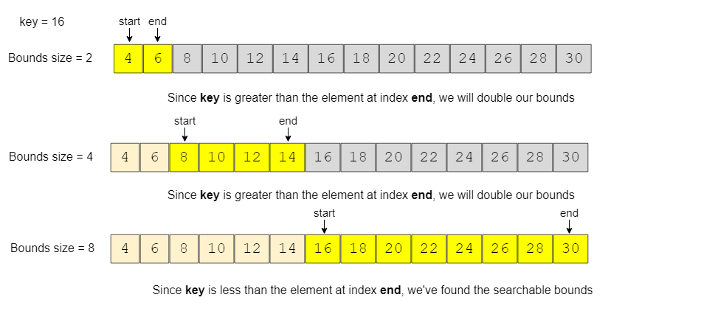

### Code

|  |
| --- |
| class ArrayReader {  int[] arr;  ArrayReader(int[] arr) {  this.arr = arr;  }  public int get(int index) {  if (index >= arr.length)  return Integer.MAX_VALUE;  return arr[index];  }  }  class Solution {  public static int search(ArrayReader reader, int key) {  // find the proper bounds first  int start = 0, end = 1;  while (reader.get(end) < key) {  int newStart = end + 1;  end += (end - start + 1) * 2; // increase to double the bounds size  start = newStart;  }  return binarySearch(reader, key, start, end);  }  private static int binarySearch(ArrayReader reader, int key, int start, int end) {  while (start <= end) {  int mid = start + (end - start) / 2;  if (key < reader.get(mid)) {  end = mid - 1;  } else if (key > reader.get(mid)) {  start = mid + 1;  } else { // found the key  return mid;  }  }  return -1;  }  public static void main(String[] args) {  ArrayReader reader = new ArrayReader(  new int[] { 4, 6, 8, 10, 12, 14, 16, 18, 20, 22, 24, 26, 28, 30 });  System.out.println(Solution.search(reader, 16));  System.out.println(Solution.search(reader, 11));  reader = new ArrayReader(new int[] { 1, 3, 8, 10, 15 });  System.out.println(Solution.search(reader, 15));  System.out.println(Solution.search(reader, 200));  }  } |

* There are two parts of the algorithm. In the first part, we keep increasing the bound’s size exponentially (double it every time) while searching for the proper bounds. Therefore, this step will take O(log N) assuming that the array will have maximum N numbers. In the second step, we perform the binary search which will take O(log N), so the overall time complexity of our algorithm will be O(log N + log N) which is asymptotically equivalent to O(log N).
* The algorithm runs in constant space O(1).

### Java Solution

|  |
| --- |
| public static int searchInfinite(ArrayReader reader, int key){  int start = 0;  int end = 1;  while(reader.getValue(end) < key){  start = end+1;  end = end *2 ;  }  return binarySearch(reader, key, start, end);  }  public static int binarySearch(ArrayReader reader, int key, int start, int end){  while(start <= end){  int mid = start+(end-start)/2;  if(reader.getValue(mid) == key) return mid;  if(reader.getValue(mid) < key) {  start = mid+1;  }else{  end = mid - 1;  }  }  return -1;  }  static class ArrayReader{  int[] arr;  public ArrayReader(int[] arr) {  this.arr = arr;  }  int getValue(int index){  if(index >= this.arr.length) return Integer.MAX_VALUE;  return this.arr[index];  }  } |

**Minimum Difference Element (medium)**

<https://leetcode.com/problems/minimum-absolute-difference/>

### Problem Statement

Given an array of numbers sorted in ascending order, find the element in the array that has the minimum difference with the given key.

Example 1:

Input: [4, 6, 10], key = 7

Output: 6

Explanation: The difference between the key '7' and '6' is minimum than any other number in the array

Example 2:

Input: [4, 6, 10], key = 4

Output: 4

Example 3:

Input: [1, 3, 8, 10, 15], key = 12

Output: 10

Example 4:

Input: [4, 6, 10], key = 17

Output: 10

### Solution

The problem follows the **Binary Search** pattern. Since **Binary Search** helps us find a number in a sorted array efficiently, we can use a modified version of the **Binary Search** to find the number that has the minimum difference with the given key.

We can use a similar approach as discussed in **Order-agnostic Binary Search**. We will try to search for the key in the given array. If we find the key we will return it as the minimum difference number. If we can’t find the key, (at the end of the loop) we can find the differences between the key and the numbers pointed out by indices start and end, as these two numbers will be closest to the key. The number that gives minimum difference will be our required number.

### Code

|  |
| --- |
| class Solution {  public static int searchMinDiffElement(int[] arr, int key) {  if (key < arr[0])  return arr[0];  if (key > arr[arr.length - 1])  return arr[arr.length - 1];  int start = 0, end = arr.length - 1;  while (start <= end) {  int mid = start + (end - start) / 2;  if (key < arr[mid]) {  end = mid - 1;  } else if (key > arr[mid]) {  start = mid + 1;  } else {  return arr[mid];  }  }  // at the end of the while loop, 'start == end+1'  // we are not able to find the element in the given array  // return the element which is closest to the 'key'  if ((arr[start] - key) < (key - arr[end]))  return arr[start];  return arr[end];  }  public static void main(String[] args) {  System.out.println(  Solution.searchMinDiffElement(new int[] { 4, 6, 10 }, 7));  System.out.println(  Solution.searchMinDiffElement(new int[] { 4, 6, 10 }, 4));  System.out.println(  Solution.searchMinDiffElement(new int[] { 1, 3, 8, 10, 15 }, 12));  System.out.println(  Solution.searchMinDiffElement(new int[] { 4, 6, 10 }, 17));  }  } |

* Since, we are reducing the search range by half at every step, this means the time complexity of our algorithm will be O(logN) where N is the total elements in the given array.
* The algorithm runs in constant space O(1).

### Part 2

<https://leetcode.com/problems/minimum-absolute-difference/>

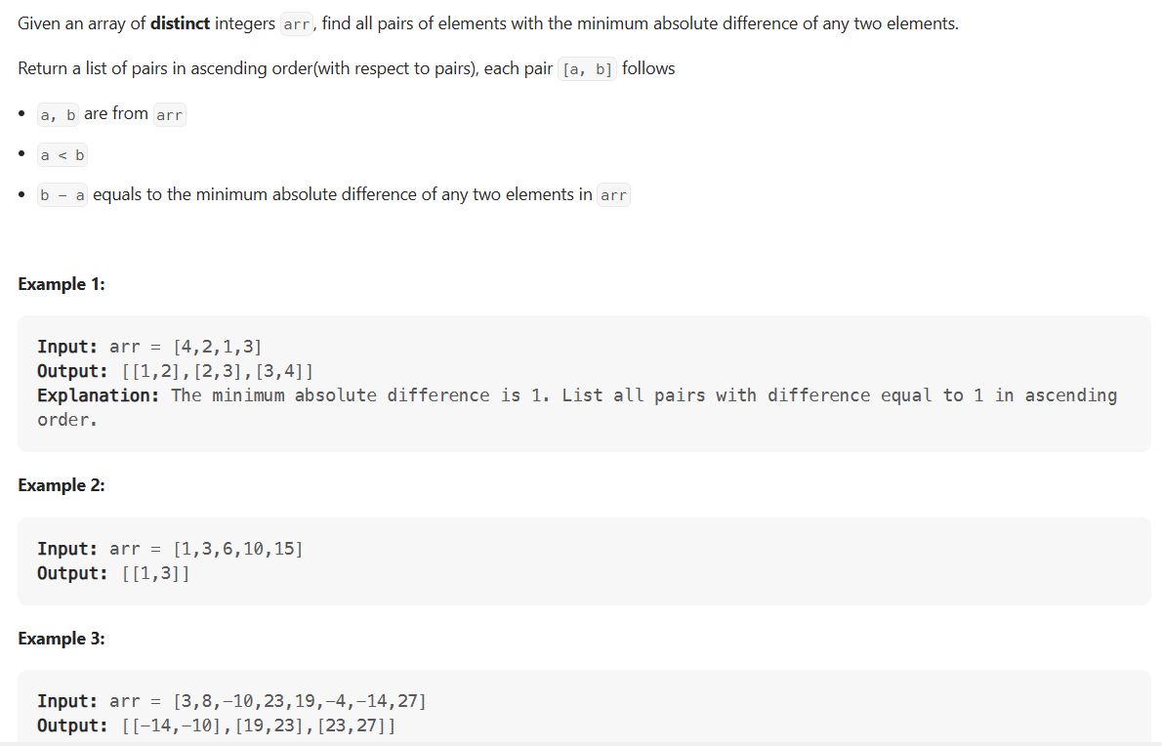

#### Java Solution

|  |
| --- |
| public List<List<Integer>> minimumAbsDifference(int[] arr) {          List<List<Integer>> res = new ArrayList();          //sort elements          Arrays.sort(arr);          //init our min difference value          int min = Integer.MAX_VALUE;          //start looping over array to find real min element. Each time we found smaller difference          //we reset resulting list and start building it from scratch. If we found pair with the same          //difference as min - add it to the resulting list          for (int i = 0; i < arr.length - 1; i++) {              int diff = arr[i + 1] - arr[i];              if (diff < min) {                  min = diff;                  res.clear();                  res.add(Arrays.asList(arr[i], arr[i + 1]));              } else if (diff == min) {                  res.add(Arrays.asList(arr[i], arr[i + 1]));              }          }          return res;      } |

#### Java Solution 2

|  |
| --- |
| public List<List<Integer>> minimumAbsDifference(int[] arr) {  Arrays.sort(arr);    int minD = IntStream.range(1, arr.length).map(t -> arr[t] - arr[t - 1]).  reduce(Integer::min).getAsInt();  return IntStream.range(1 , arr.length).  filter(t -> arr[t] - arr[t - 1] == minD).  mapToObj(t -> Arrays.asList(arr[t - 1], arr[t])).  collect(Collectors.toList());  } |

**Bitonic Array Maximum (easy)**

### Problem Statement

Find the maximum value in a given Bitonic array. An array is considered bitonic if it is monotonically increasing and then monotonically decreasing. Monotonically increasing or decreasing means that for any index i in the array arr[i] != arr[i+1].

Example 1:

Input: [1, 3, 8, 12, 4, 2]

Output: 12

Explanation: The maximum number in the input bitonic array is '12'.

Example 2:

Input: [3, 8, 3, 1]

Output: 8

Example 3:

Input: [1, 3, 8, 12]

Output: 12

Example 4:

Input: [10, 9, 8]

Output: 10

### Solution

A **bitonic array** is a sorted array; the only difference is that its first part is sorted in *ascending order* and the second part is sorted in *descending order*. We can use a similar approach as discussed in **Order-agnostic Binary Search**. Since no two consecutive numbers are same (as the array is monotonically increasing or decreasing), whenever we calculate the middle, we can compare the numbers pointed out by the index middle and middle+1 to find if we are in the ascending or the descending part. So:

1. If arr[middle] > arr[middle + 1], we are in the second (descending) part of the bitonic array. Therefore, our required number could either be pointed out by middle or will be before middle. This means we will be doing: end = middle.
2. If arr[middle] < arr[middle + 1], we are in the first (ascending) part of the bitonic array. Therefore, the required number will be after middle. This means we will be doing: start = middle + 1.

We can break when start == end. Due to the two points mentioned above, both start and end will be pointing at the maximum number of the bitonic array.

### Code

|  |
| --- |
| class Solution {  public static int findMax(int[] arr) {  int start = 0, end = arr.length - 1;  while (start < end) {  int mid = start + (end - start) / 2;  if (arr[mid] > arr[mid + 1]) {  end = mid;  } else {  start = mid + 1;  }  }  // at the end of the while loop, 'start == end'  return arr[start];  }  public static void main(String[] args) {  System.out.println(Solution.findMax(new int[] { 1, 3, 8, 12, 4, 2 }));  System.out.println(Solution.findMax(new int[] { 3, 8, 3, 1 }));  System.out.println(Solution.findMax(new int[] { 1, 3, 8, 12 }));  System.out.println(Solution.findMax(new int[] { 10, 9, 8 }));  }  } |

* Since, we are reducing the search range by half at every step, this means the time complexity of our algorithm will be O(logN) where N is the total elements in the given array.
* The algorithm runs in constant space O(1).

## 🌟 Search Bitonic Array (medium)

### Problem Statement

Given a Bitonic array, find if a given key is present in it. An array is considered bitonic if it is monotonically increasing and then monotonically decreasing. Monotonically increasing or decreasing means that for any index i in the array arr[i] != arr[i+1].

Write a function to return the index of the key. If the key is not present, return -1.

Example 1:

Input: [1, 3, 8, 4, 3], key=4

Output: 3

Example 2:

Input: [3, 8, 3, 1], key=8

Output: 1

Example 3:

Input: [1, 3, 8, 12], key=12

Output: 3

Example 4:

Input: [10, 9, 8], key=10

Output: 0

### Solution

The problem follows the **Binary Search** pattern. Since **Binary Search** helps us efficiently find a number in a sorted array we can use a modified version of the **Binary Search** to find the key in the bitonic array.

Here is how we can search in a **bitonic array**:

1. First, we can find the index of the maximum value of the **bitonic array**, similar to **Bitonic Array Maximum**. Let’s call the index of the maximum number maxIndex.
2. Now, we can break the array into two sub-arrays:
   * Array from index 0 to maxIndex, sorted in ascending order.
   * Array from index maxIndex+1 to array_length-1, sorted in descending order.
3. We can then call **Binary Search** separately in these two arrays to search the key. We can use the same **Order-agnostic Binary Search** for searching.

### Code

|  |
| --- |
| class Solution {  public static int search(int[] arr, int key) {  int maxIndex = findMax(arr);  int keyIndex = binarySearch(arr, key, 0, maxIndex);  if (keyIndex != -1)  return keyIndex;  return binarySearch(arr, key, maxIndex + 1, arr.length - 1);  }  // find index of the maximum value in a bitonic array  public static int findMax(int[] arr) {  int start = 0, end = arr.length - 1;  while (start < end) {  int mid = start + (end - start) / 2;  if (arr[mid] > arr[mid + 1]) {  end = mid;  } else {  start = mid + 1;  }  }  // at the end of the while loop, 'start == end'  return start;  }  // order-agnostic binary search  private static int binarySearch(int[] arr, int key, int start, int end) {  while (start <= end) {  int mid = start + (end - start) / 2;  if (key == arr[mid])  return mid;  if (arr[start] < arr[end]) { // ascending order  if (key < arr[mid]) {  end = mid - 1;  } else { // key > arr[mid]  start = mid + 1;  }  } else { // descending order  if (key > arr[mid]) {  end = mid - 1;  } else { // key < arr[mid]  start = mid + 1;  }  }  }  return -1; // element is not found  }  public static void main(String[] args) {  System.out.println(Solution.search(new int[] { 1, 3, 8, 4, 3 }, 4));  System.out.println(Solution.search(new int[] { 3, 8, 3, 1 }, 8));  System.out.println(Solution.search(new int[] { 1, 3, 8, 12 }, 12));  System.out.println(Solution.search(new int[] { 10, 9, 8 }, 10));  }  } |

* Since, we are reducing the search range by half at every step, this means the time complexity of our algorithm will be O(logN) where N is the total elements in the given array.
* The algorithm runs in constant space O(1).

**🌟 Search in Rotated Array (medium)**

<https://leetcode.com/problems/search-in-rotated-sorted-array/>

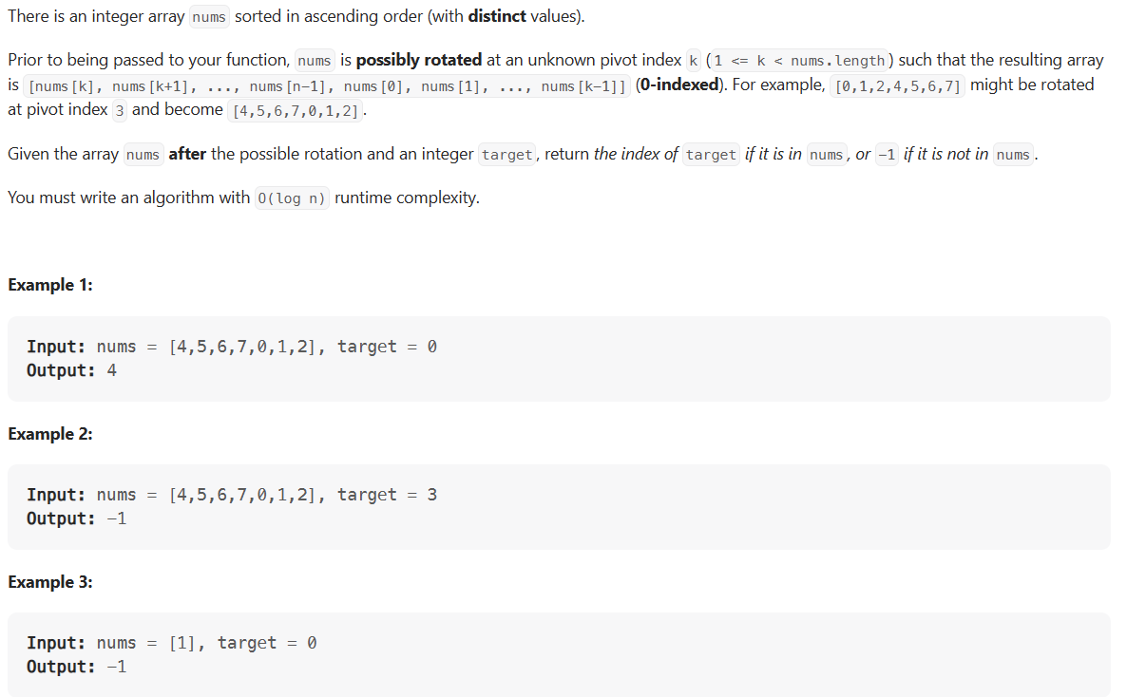

### Problem Statement

Given an array of numbers which is sorted in ascending order and also rotated by some arbitrary number, find if a given ‘key’ is present in it.

Write a function to return the index of the ‘key’ in the rotated array. If the ‘key’ is not present, return -1. You can assume that the given array does not have any duplicates.

Example 1:

Input: [10, 15, 1, 3, 8], key = 15

Output: 1

Explanation: '15' is present in the array at index '1'.



Example 2:

Input: [4, 5, 7, 9, 10, -1, 2], key = 10

Output: 4

Explanation: '10' is present in the array at index '4'.

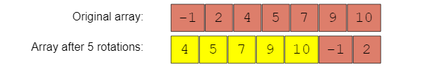

### Solution

The problem follows the **Binary Search** pattern. We can use a similar approach as discussed in **Order-agnostic Binary Search** and modify it similar to **Search Bitonic Array** to search for the key in the rotated array.

After calculating the middle, we can compare the numbers at indices start and middle. This will give us two options:

1. If arr[start] <= arr[middle], the numbers from start to middle are sorted in ascending order.
2. Else, the numbers from middle+1 to end are sorted in ascending order.

Once we know which part of the array is sorted, it is easy to adjust our ranges. For example, if option 1 is true, we have two choices:

1. By comparing the key with the numbers at index start and middle we can easily find out if the key lies between indices start and middle; if it does, we can skip the second part => end = middle -1.
2. Else, we can skip the first part => start = middle + 1.

Let’s visually see this with the above-mentioned Example-2:

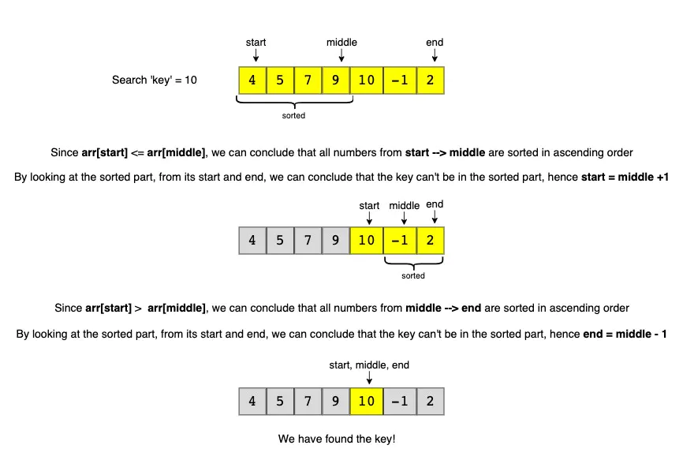

Since there are no duplicates in the given array, it is always easy to skip one part of the array in each iteration. However, if there are duplicates, it is not always possible to know which part is sorted. We will look into this case in the **Similar Problems** section.

### Code

|  |
| --- |
| class Solution {  public static int search(int[] arr, int key) {  int start = 0, end = arr.length - 1;  while (start <= end) {  int mid = start + (end - start) / 2;  if (arr[mid] == key)  return mid;  if (arr[start] <= arr[mid]) { // left side is sorted in ascending order  if (key >= arr[start] && key < arr[mid]) {  end = mid - 1;  } else { //key > arr[mid]  start = mid + 1;  }  } else { // right side is sorted in ascending order  if (key > arr[mid] && key <= arr[end]) {  start = mid + 1;  } else {  end = mid - 1;  }  }  }  // we are not able to find the element in the given array  return -1;  }  public static void main(String[] args) {  System.out.println(Solution.search(new int[] { 10, 15, 1, 3, 8 }, 15));  System.out.println(Solution.search(  new int[] { 4, 5, 7, 9, 10, -1, 2 }, 10));  }  } |

* Since, we are reducing the search range by half at every step, this means the time complexity of our algorithm will be O(logN) where N is the total elements in the given array.
* The algorithm runs in constant space O(1).

**Similar Problem**

<https://leetcode.com/problems/search-in-rotated-sorted-array-ii/>

How do we search in a sorted and rotated array that also has duplicates?

The code above will fail in the following example!

**Example 1**:

Input: [3, 7, 3, 3, 3], key = 7

Output: 1

Explanation: '7' is present in the array at index '1'.

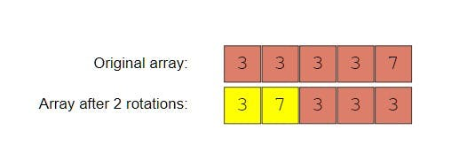

The only problematic scenario is when the numbers at indices start, middle, and end are the same **but start and end indices are different**, as in this case, we can’t decide which part of the array is sorted. In such a case, the best we can do is to skip one number from both ends: start = start + 1 & end = end - 1.

### Code

|  |
| --- |
| class Solution {  public static int search(int[] arr, int key) {  int start = 0, end = arr.length - 1;  while (start <= end) {  int mid = start + (end - start) / 2;  if (arr[mid] == key)  return mid;  // the only difference from the previous solution,  // if numbers at indexes start, mid, and end are same, we can't choose a side  // the best we can do, is to skip one number from both ends as key != arr[mid]  if ((arr[start] == arr[mid]) && (arr[end] == arr[mid])) {  ++start;  --end;  } else if (arr[start] <= arr[mid]) { // left side is sorted in ascending order  if (key >= arr[start] && key < arr[mid]) {  end = mid - 1;  } else { //key > arr[mid]  start = mid + 1;  }  } else { // right side is sorted in ascending order  if (key > arr[mid] && key <= arr[end]) {  start = mid + 1;  } else {  end = mid - 1;  }  }  }  // we are not able to find the element in the given array  return -1;  }  public static void main(String[] args) {  System.out.println(Solution.search(new int[] { 3, 7, 3, 3, 3 }, 7));  }  } |

* This algorithm will run most of the times in O(logN). However, since we only skip two numbers in case of duplicates instead of half of the numbers, the worst case time complexity will become O(N).
* The algorithm runs in constant space O(1).

**🌟 Rotation Count (medium)**

<https://leetcode.com/problems/find-minimum-in-rotated-sorted-array/>

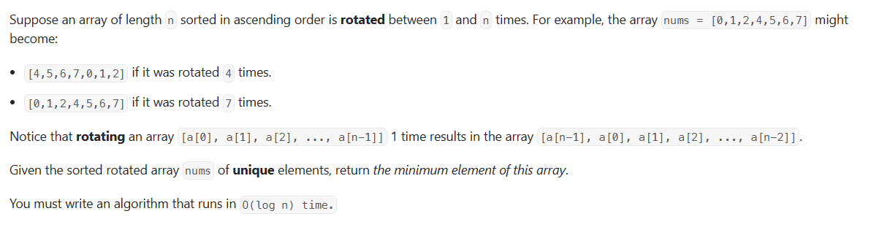

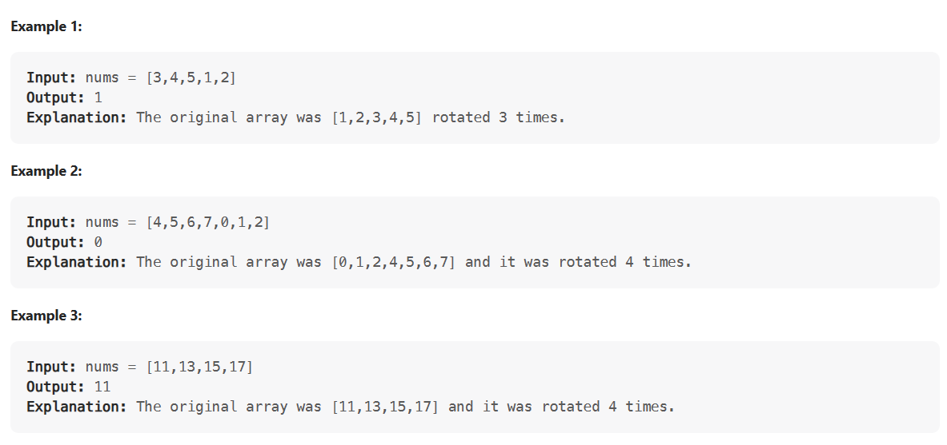

### Problem Statement

Given an array of numbers which is sorted in ascending order and is rotated ‘k’ times around a pivot, find ‘k’.

You can assume that the array does not have any duplicates.

Example 1:

Input: [10, 15, 1, 3, 8]

Output: 2

Explanation: The array has been rotated 2 times.



Example 2:

Input: [4, 5, 7, 9, 10, -1, 2]

Output: 5

Explanation: The array has been rotated 5 times.



Example 3:

Input: [1, 3, 8, 10]

Output: 0

Explanation: The array has not been rotated.

### Solution

This problem follows the **Binary Search** pattern. We can use a similar strategy as discussed in **Search in Rotated Array**.

In this problem, actually, we are asked to find the index of the minimum element. The number of times the minimum element is moved to the right will be equal to the number of rotations. An interesting fact about the minimum element is that it is the only element in the given array which is smaller than its previous element. Since the array is sorted in ascending order, all other elements are bigger than their previous element.

After calculating the middle, we can compare the number at index middle with its previous and next number. This will give us two options:

1. If arr[middle] > arr[middle + 1], then the element at middle + 1 is the smallest.
2. If arr[middle - 1] > arr[middle], then the element at middle is the smallest.

To adjust the ranges we can follow the same approach as discussed in **Search in Rotated Array**. Comparing the numbers at indices start and middle will give us two options:

1. If arr[start] < arr[middle], the numbers from start to middle are sorted.
2. Else, the numbers from middle + 1 to end are sorted.

### Code

|  |
| --- |
| class Solution {  public static int countRotations(int[] arr) {  int start = 0, end = arr.length - 1;  while (start < end) {  int mid = start + (end - start) / 2;  // if mid is greater than the next element  if (mid < end && arr[mid] > arr[mid + 1])  return mid + 1;    // if mid is smaller than the previous element  if (mid > start && arr[mid - 1] > arr[mid])  return mid;  if (arr[start] < arr[mid]) { // left side is sorted, so the pivot is on right side  start = mid + 1;  } else { // right side is sorted, so the pivot is on the left side  end = mid - 1;  }  }  return 0; // the array has not been rotated  }  public static void main(String[] args) {  System.out.println(Solution.countRotations(  new int[] { 10, 15, 1, 3, 8 }));  System.out.println(Solution.countRotations(  new int[] { 4, 5, 7, 9, 10, -1, 2 }));  System.out.println(Solution.countRotations(  new int[] { 1, 3, 8, 10 }));  }  } |

* Since, we are reducing the search range by half at every step, this means the time complexity of our algorithm will be O(logN) where N is the total elements in the given array.
* The algorithm runs in constant space O(1).

### Java Solution

|  |
| --- |
| public static int findMin1(int[] nums) {  int low = 0;  int high = nums.length - 1;  while(low < high){  int mid = low + ( high - low)/2;  if( mid > 0 && nums[mid] < nums[mid - 1]) return nums[mid];  if(mid < high && nums[mid] > nums[mid + 1]) return nums[mid+1];  if(nums[low] <= nums[mid] && nums[mid] > nums[high])  low = mid + 1;  else  high = mid - 1;  }  return nums[low];  } |

### Java Solution 2

|  |
| --- |
| public static int findMin(int[] nums) {  int start = 0;  int end = nums.length - 1;  while (start < end) {  final int mid = start+(end-start) / 2;  if (nums[mid] < nums[end])  end = mid;  else  start = mid + 1;  }  return nums[start];  } |

**Similar Problem**

<https://leetcode.com/problems/find-minimum-in-rotated-sorted-array-ii/>

How do we find the rotation count of a sorted and rotated array that has duplicates too?

The above code will fail on the following example!

Example 1:

Input: [3, 3, 7, 3]

Output: 3

Explanation: The array has been rotated 3 times.

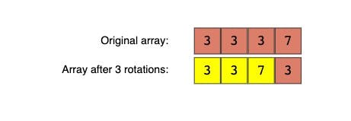

We can follow the same approach as discussed in **Search in Rotated Array**. The only difference is that before incrementing start or decrementing end, we will check if either of them is the smallest number.

### Code

|  |
| --- |
| class Solution {  public static int countRotations(int[] arr) {  if (arr == null || arr.length == 0)  throw new IllegalArgumentException();  int start = 0, end = arr.length - 1;  while (start < end) {  int mid = start + (end - start) / 2;  // if element at mid is greater than the next element  if (mid < end && arr[mid] > arr[mid + 1])  return mid + 1;    // if element at mid is smaller than the previous element  if (mid > start && arr[mid - 1] > arr[mid])  return mid;  // this is the only difference from the previous solution  // if numbers at indices start, mid, and end are same, we can't choose a side  // the best we can do is to skip one number from both ends if they are not the  // smallest number  if (arr[start] == arr[mid] && arr[end] == arr[mid]) {  if (arr[start] > arr[start + 1]) // if element at start+1 is not the smallest  return start + 1;  ++start;  if (arr[end - 1] > arr[end]) // if the element at end is not the smallest  return end;  --end;  // left side is sorted, so the pivot is on right side  } else if (arr[start] < arr[mid] || (arr[start] == arr[mid] &&  arr[mid] > arr[end])) {  start = mid + 1;  } else { // right side is sorted, so the pivot is on the left side  end = mid - 1;  }  }  return 0; // the array has not been rotated  }  public static void main(String[] args) {  System.out.println(  Solution.countRotations(new int[] { 3, 3, 7, 3 }));  }  } |

* This algorithm will run in O(logN) most of the times, but since we only skip two numbers in case of duplicates instead of the half of the numbers, therefore the worst case time complexity will become O(N).
* The algorithm runs in constant space O(1).

### Java Solution

|  |
| --- |
| public static int findMinWithDuplicate(int[] nums) {  int start = 0;  int end = nums.length - 1;  while (start < end) {  final int mid = start+(end-start) / 2;  if (nums[mid] > nums[end])  start = mid + 1;  else if(nums[mid] < nums[end])  end = mid;  else end--;  }  return nums[start];  } |

**Pattern 12: Bitwise XOR**

**XOR** is a logical bitwise operator that returns 0 (false) if both bits are the same and returns 1 (true) otherwise. In other words, it only returns 1 if exactly one bit is set to 1 out of the two bits in comparison.

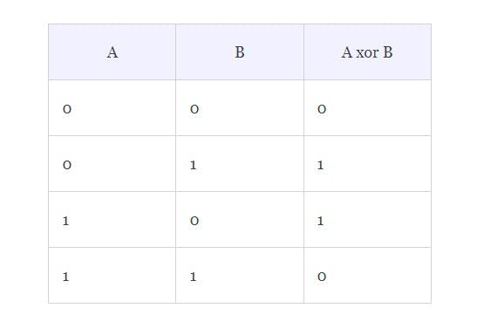

It is surprising to know the approaches that the XOR operator enables us to solve certain problems. For example, let’s take a look at the following problem:

## Missing Number

### Problem Statement

Given an array of n-1 integers in the range from 1 to n, find the one number that is missing from the array.

**Example**:

Input: 1, 5, 2, 6, 4

Answer: 3

A straight forward approach to solve this problem can be:

1. Find the sum of all integers from 1 to n; let’s call it s1.
2. Subtract all the numbers in the input array from s1; this will give us the missing number.

### Code

|  |
| --- |
| class Solution {  public static int findMissingNumber(int[] arr) {  int n = arr.length + 1;  // find sum of all numbers from 1 to n.  int s1 = 0;  for (int i = 1; i <= n; i++)  s1 += i;  // subtract all numbers in input from sum.  for (int num : arr)  s1 -= num;  // s1, now, is the missing number  return s1;  }  public static void main(String[] args) {  int[] arr = new int[] { 1, 5, 2, 6, 4 };  System.out.print("Missing number is: " + Solution.findMissingNumber(arr));  }  } |

* The time complexity of the above algorithm is O(n) and the space complexity is O(1).

**What could go wrong with the above algorithm?**

While finding the sum of numbers from 1 to n, we can **get integer overflow when n is large.**

How can we avoid this? Can XOR help us here?

Remember the important property of XOR that it returns 0 if both the bits in comparison are the same. In other words, XOR of a number with itself will always result in 0. This means that if we XOR all the numbers in the input array with all numbers from the range 1 to n then each number in the input is going to get zeroed out except the missing number. Following are the set of steps to find the missing number using XOR:

1. XOR all the numbers from 1 to n, let’s call it x1.
2. XOR all the numbers in the input array, let’s call it x2.
3. The missing number can be found by x1 XOR x2.

### Code

|  |
| --- |
| class Solution {  public static int findMissingNumber(int[] arr) {  int n = arr.length + 1;  // find sum of all numbers from 1 to n.  int x1 = 1;  for (int i = 2; i <= n; i++)  x1 = x1 ^ i;  // x2 represents XOR of all values in arr  int x2 = arr[0];  for (int i = 1; i < n-1; i++)  x2 = x2 ^ arr[i];  // missing number is the xor of x1 and x2  return x1 ^ x2;  }  public static void main(String[] args) {  int[] arr = new int[] { 1, 5, 2, 6, 4 };  System.out.print("Missing number is: " + Solution.findMissingNumber(arr));  }  } |

* The time complexity of the above algorithm is O(n) and the space complexity is O(1). The time and space complexities are the same as that of the previous solution but, in this algorithm, we will not have any **integer overflow problem**.

**Important properties of XOR to remember**

Following are some important properties of XOR to remember:

* Taking XOR of a number with itself returns 0, e.g.,
  + 1 ^ 1 = 0
  + 29 ^ 29 = 0
* Taking XOR of a number with 0 returns the same number, e.g.,
  + 1 ^ 0 = 1
  + 31 ^ 0 = 31
* XOR is Associative & Commutative, which means:
  + (a ^ b) ^ c = a ^ (b ^ c)
  + a ^ b = b ^ a

**Single Number (easy)**

<https://leetcode.com/problems/single-number/>

### Problem Statement

In a non-empty array of integers, every number appears twice except for one, find that single number.

**Example 1**:

Input: 1, 4, 2, 1, 3, 2, 3

Output: 4

**Example 2**:

Input: 7, 9, 7

Output: 9

One straight forward solution can be to use a **HashMap** kind of data structure and iterate through the input:

* If number is already present in **HashMap**, remove it.
* If number is not present in **HashMap**, add it.
* In the end, only number left in the **HashMap** is our required single number.

**using Map class**

function findSingleNumber(arr) {

const numberMap = new Map()

for(let i = 0; i < arr.length; i++) {

if(numberMap.has(arr[i])){

numberMap.delete(arr[i])

} else {

numberMap.set(arr[i], 0)

}

}

for(const k of numberMap.keys()){

return k

}

}

findSingleNumber([1, 4, 2, 1, 3, 2, 3])//4

findSingleNumber([7, 9, 7])//9

**using Map object**

function singleNumber(arr) {

//HashMap

let numberMap = {}

//if number is not in HashMap, add it

for(let i of arr) {

numberMap[i] = (numberMap[i] || 0) + 1

}

//if number is already in HashMap, remove it

//number left at the end is out rquired single number

return numberMap

}

findMissingNumber([1, 4, 2, 1, 3, 2, 3])//4

findMissingNumber([7, 9, 7])//9

Time and space complexity Time Complexity of the above solution will be O(n)and space complexity will also be O(n).

Can we do better than this using the **XOR** Pattern?

Recall the following two properties of XOR:

* It returns zero if we take XOR of two same numbers.
* It returns the same number if we XOR with zero. So we can XOR all the numbers in the input; duplicate numbers will zero out each other and we will be left with the single number.

### Code

|  |
| --- |
| class Solution {  public static int findSingleNumber(int[] arr) {  int num = 0;  for (int i=0; i < arr.length; i++) {  num = num ^ arr[i];  }  return num;  }  public static void main( String args[] ) {  System.out.println(findSingleNumber(new int[]{1, 4, 2, 1, 3, 2, 3}));  }  } |

* Time complexity of this solution is O(n) as we iterate through all numbers of the input once.
* The algorithm runs in constant space O(1).

## 😕 Two Single Numbers (medium)

<https://leetcode.com/problems/single-number-iii/>

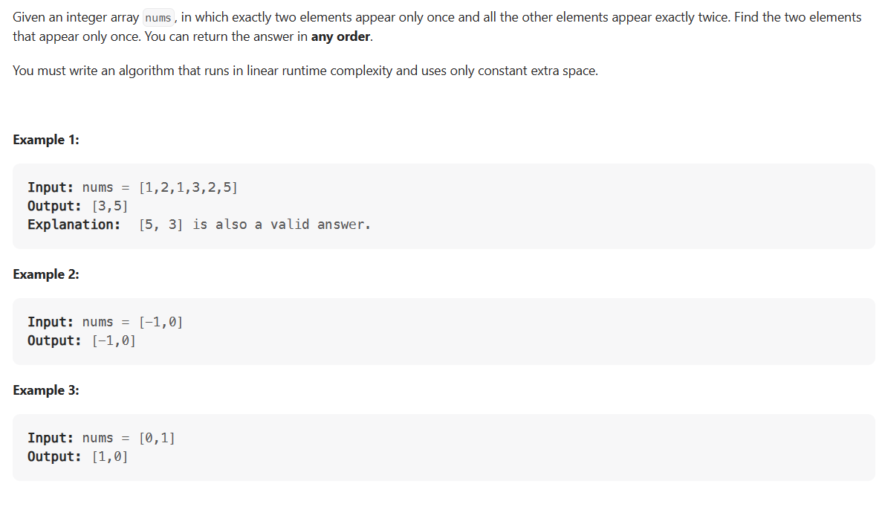

### Problem Statement

In a non-empty array of numbers, every number appears exactly twice except two numbers that appear only once. Find the two numbers that appear only once.

**Example 1**:

Input: [1, 4, 2, 1, 3, 5, 6, 2, 3, 5]

Output: [4, 6]

**Example 2**:

Input: [2, 1, 3, 2]

Output: [1, 3]

### Solution

This problem is quite similar to **Single Number**, the only difference is that, in this problem, we have two single numbers instead of one. Can we still use XOR to solve this problem?

Let’s assume num1 and num2 are the two single numbers. If we do XOR of all elements of the given array, we will be left with XOR of num1 and num2 as all other numbers will cancel each other because all of them appeared twice. Let’s call this XOR n1xn2. Now that we have XOR of num1 and num2, how can we find these two single numbers?

As we know that num1 and num2 are two different numbers, therefore, they should have at least one bit different between them. If a bit in n1xn2 is ‘1’, this means that num1 and num2 have different bits in that place, as we know that we can get ‘1’ only when we do XOR of two different bits, i.e.,

1 XOR 0 = 0 XOR 1 = 1

We can take any bit which is ‘1’ in n1xn2 and partition all numbers in the given array into two groups based on that bit. One group will have all those numbers with that bit set to ‘0’ and the other with the bit set to ‘1’. This will ensure that num1 will be in one group and num2 will be in the other. We can take XOR of all numbers in each group separately to get num1 and num2, as all other numbers in each group will cancel each other. Here are the steps of our algorithm:

1. Taking XOR of all numbers in the given array will give us XOR of num1 and num2, calling this XOR as n1xn2.
2. Find any bit which is set in n1xn2. We can take the rightmost bit which is ‘1’. Let’s call this rightmostSetBit.
3. Iterate through all numbers of the input array to partition them into two groups based on rightmostSetBit. Take XOR of all numbers in both the groups separately. Both these XORs are our required numbers.

### Code

|  |
| --- |
| class Solution {  public static int[] findSingleNumbers(int[] nums) {  // get the XOR of the all the numbers  int n1xn2 = 0;  for (int num : nums) {  n1xn2 ^= num;  }  // get the rightmost bit that is '1'  int rightmostSetBit = 1;  while ((rightmostSetBit & n1xn2) == 0) {  rightmostSetBit = rightmostSetBit << 1;  }  int num1 = 0, num2 = 0;  for (int num : nums) {  if ((num & rightmostSetBit) != 0) // the bit is set  num1 ^= num;  else // the bit is not set  num2 ^= num;  }  return new int[] { num1, num2 };  }  public static void main(String[] args) {  int[] arr = new int[] { 1, 4, 2, 1, 3, 5, 6, 2, 3, 5 };  int[] result = Solution.findSingleNumbers(arr);  System.out.println("Single numbers are: " + result[0] + ", " + result[1]);  arr = new int[] { 2, 1, 3, 2 };  result = Solution.findSingleNumbers(arr);  System.out.println("Single numbers are: " + result[0] + ", " + result[1]);  }  } |

* The time complexity of this solution is O(n) where n is the number of elements in the input array.
* The algorithm runs in constant space O(1).

### Java Solution

|  |
| --- |
| public static int[] singleNumber(int[] nums) {  int xxory = 0;  for(int num: nums){  xxory ^= num;  }  int rsbm = xxory & -xxory;  int x = 0;  int y = 0;  for(int num : nums){  if((num & rsbm) == 0){  x = x ^ num;  }else{  y = y ^ num;  }  }  return new int[]{x,y};  } |

**😕 Complement of Base 10 Number (medium)**

<https://leetcode.com/problems/complement-of-base-10-integer/>

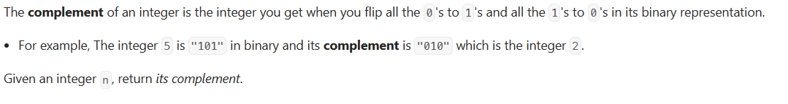

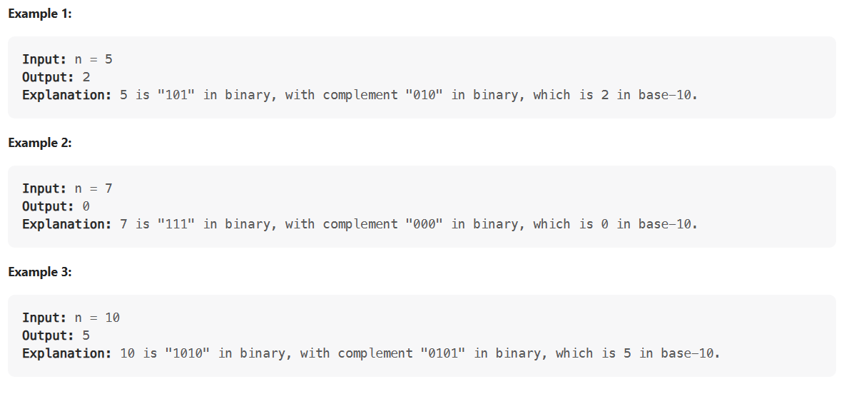

Every non-negative integer N has a binary representation, for example, 8 can be represented as “1000” in binary and 7 as “0111” in binary.

The complement of a binary representation is the number in binary that we get when we change every 1 to a 0 and every 0 to a 1. For example, the binary complement of “1010” is “0101”.

For a given positive number N in base-10, return the complement of its binary representation as a base-10 integer.

Example 1:

Input: 8

Output: 7

Explanation: 8 is 1000 in binary, its complement is 0111 in binary, which is 7 in base-10.

Example 2:

Input: 10

Output: 5

Explanation: 10 is 1010 in binary, its complement is 0101 in binary, which is 5 in base-10.

### Solution

Recall the following properties of XOR:

1. It will return 1 if we take XOR of two different bits i.e. 1^0 = 0^1 = 1.
2. It will return 0 if we take XOR of two same bits i.e. 0^0 = 1^1 = 0. In other words, XOR of two same numbers is 0.
3. It returns the same number if we XOR with 0.

From the above-mentioned first property, we can conclude that XOR of a number with its complement will result in a number that has all of its bits set to 1. For example, the binary complement of “101” is “010”; and if we take XOR of these two numbers, we will get a number with all bits set to 1, i.e., 101 ^ 010 = 111

We can write this fact in the following equation:

number ^ complement = all_bits_set

Let’s add ‘number’ on both sides:

number ^ number ^ complement = number ^ all_bits_set

From the above-mentioned second property:

0 ^ complement = number ^ all_bits_set

From the above-mentioned third property:

complement = number ^ all_bits_set

We can use the above fact to find the complement of any number.

**How do we calculate all_bits_set?** One way to calculate all_bits_set will be to first count the bits required to store the given number. We can then use the fact that for a number which is a complete power of ‘2’ i.e., it can be written as pow(2, n), if we subtract ‘1’ from such a number, we get a number which has ‘n’ least significant bits set to ‘1’. For example, ‘4’ which is a complete power of ‘2’, and ‘3’ (which is one less than 4) has a binary representation of ‘11’ i.e., it has ‘2’ least significant bits set to ‘1’.

### Code

|  |
| --- |
| import java.lang.Math;  class Solution {  public static int bitwiseComplement(int num) {  // count number of total bits in 'num'  int bitCount = 0;  int n = num;  while (n > 0) {  bitCount++;  n = n >> 1;  }  // for a number which is a complete power of '2' i.e., it can be written as  // pow(2, n), if we subtract '1' from such a number, we get a number which has 'n'  // least significant bits set to '1'. For example, '4' which is a complete power of  // '2', and '3' (which is one less than 4) has a binary representation of '11' i.e.,  // it has '2' least significant bits set to '1'  int all_bits_set = (int) Math.pow(2, bitCount) - 1;  // from the solution description: complement = number ^ all_bits_set  return num ^ all_bits_set;  }  public static void main(String[] args) {  System.out.println("Bitwise complement is: " +  Solution.bitwiseComplement(8));  System.out.println("Bitwise complement is: " +  Solution.bitwiseComplement(10));  }  } |

* Time complexity of this solution is O(b)where b is the number of bits required to store the given number.
* Space complexity of this solution is O(1).

### Java Solution 1

|  |
| --- |
| public static int bitwiseComplement(int n){  if(n == 0) return 1;  int result = 0;  int factor = 1;  while(n>0){  result += factor * (n % 2 == 0 ? 1 : 0);  factor *= 2;  n /= 2;  }  return result;  } |

### Java Solution 2

|  |
| --- |
| public static int bitwiseComplement1(int n){  return n == 0 ? 1 : (( 1 << Integer.toBinaryString(n).length()) -1) ^ n;  } |

### Java Solution 3

|  |
| --- |
| public static int bitwiseComplement2(int n){  if(n == 0) return 1;  int bitCount = 0;  int num = n;  while(num > 0){  bitCount++;  num >>= 1;  }  return n ^ ((int)Math.pow(2, bitCount) - 1);  } |

## 🌟 Flip Binary Matrix(hard)

<https://leetcode.com/problems/flipping-an-image/>

### Problem Statement

Given a binary matrix representing an image, we want to flip the image horizontally, then invert it.

To flip an image horizontally means that each row of the image is reversed. For example, flipping [0, 1, 1] horizontally results in [1, 1, 0].

To invert an image means that each 0 is replaced by 1, and each 1 is replaced by 0. For example, inverting [1, 1, 0] results in [0, 0, 1].

Example 1:

Input: [

[1,0,1],

[1,1,1],

[0,1,1]

]

Output: [

[0,1,0],

[0,0,0],

[0,0,1]

]

Explanation: First reverse each row: [[1,0,1],[1,1,1],[1,1,0]]. Then, invert the image: [[0,1,0],[0,0,0],[0,0,1]]

Example 2:

Input: [

[1,1,0,0],

[1,0,0,1],

[0,1,1,1],

[1,0,1,0]

]

Output: [

[1,1,0,0],

[0,1,1,0],

[0,0,0,1],

[1,0,1,0]

]

Explanation: First reverse each row: [[0,0,1,1],[1,0,0,1],[1,1,1,0],[0,1,0,1]]. Then invert the image: [[1,1,0,0],[0,1,1,0],[0,0,0,1],[1,0,1,0]]

### Solution

* **Flip:** We can flip the image in place by replacing *ith* element from left with the *ith* element from the right.
* **Invert:** We can take XOR of each element with 1. If it is 1 then it will become 0 and if it is 0 then it will become 1.

### Code

|  |
| --- |
| class Solution {  public static int[][] flipAndInvertImage(int[][] arr) {  int C = arr[0].length;  for (int[] row: arr) {  for (int i = 0; i < (C + 1) / 2; ++i) {  int tmp = row[i] ^ 1;  row[i] = row[C - 1 - i] ^ 1;  row[C - 1 - i] = tmp;  }  }  return arr;  }  public static void print(int[][] arr) {  for(int i=0; i < arr.length; i++) {  for (int j=0; j < arr[i].length; j++) {  System.out.print(arr[i][j] + " ");  }  System.out.println();  }  }  public static void main(String[] args) {  int[][] arr = {{1, 0, 1}, {1, 1, 1}, {0, 1, 1}};  print(flipAndInvertImage(arr));  System.out.println();  int[][]arr2 = {{1,1,0,0},{1,0,0,1},{0,1,1,1},{1,0,1,0}};  print(flipAndInvertImage(arr2));  }  } |

* The time complexity of this solution is O(n) as we iterate through all elements of the input.
* The space complexity of this solution is O(1).

### Java Solution 1

Do XOR with each element which will invert. And swap first and last element for flip

|  |
| --- |
| public static int[][] flipAndInvertImage1(int[][] image) {  if (image == null || image.length == 0 | image[0].length == 0) {  return image;  }  for (int[] row : image) {  int start = 0;  int end = row.length - 1;  while (start <= end) {  int temp = row[start] ^ 1;  row[start] = row[end] ^ 1;  row[end] = temp;  start++;  end--;  }  }  return image;  } |

### Java Solution 2

If the start and end elements are different no need to do anything because after flip and invert, they will be same. So XOR and assign to both start and end if they are same.

|  |
| --- |
| public static int[][] flipAndInvertImage(int[][] image) {  if(image == null || image.length == 0 | image[0].length == 0){  return image;  }  for(int[] row : image){  int start = 0;  int end = row.length - 1;  while(start <= end){  if(row[start] == row[end]){  row[start]^= 1;  row[end] = row[start];  }  start++;  end--;  }  }  return image;  } |

**Pattern 13: Top 'K' Elements**

Any problem that asks us to find the **top/smallest/frequent K** elements among a given set falls under this pattern.

The best data structure that comes to mind to keep track of ‘K’ elements is Heap. This pattern will make use of the Heap to solve multiple problems dealing with ‘K’ elements at a time from a set of given elements.

**Top 'K' Numbers (easy)**

Given an unsorted array of numbers, find the K largest numbers in it.

**Note:** For a detailed discussion about different approaches to solve this problem, take a look at [Kth Smallest Number](https://github.com/maazshaikh007/DSA_Patterns/blob/main/%E2%9C%85%20Pattern%2013:%20Top%20'K'%20Elements.md#kth-smallest-number-easy).

Example 1:

Input: [3, 1, 5, 12, 2, 11], K = 3

Output: [5, 12, 11]

Example 2:

Input: [5, 12, 11, -1, 12], K = 3

Output: [12, 11, 12]

### Solution

A brute force solution could be to sort the array and return the largest K numbers. The time complexity of such an algorithm will be O(N∗logN) as we need to use a sorting algorithm like Timsort if we use Java’s Collection.sort(). Can we do better than that?

The best data structure that comes to mind to keep track of top ‘K’ elements is Heap. Let’s see if we can use a heap to find a better algorithm.

If we iterate through the array one element at a time and keep ‘K’ largest numbers in a heap such that each time we find a larger number than the smallest number in the heap, we do two things:

1. Take out the smallest number from the heap, and
2. Insert the larger number into the heap.

This will ensure that we always have ‘K’ largest numbers in the heap. The most efficient way to repeatedly find the smallest number among a set of numbers will be to use a min-heap. As we know, we can find the smallest number in a min-heap in constant time O(1), since the smallest number is always at the root of the heap. Extracting the smallest number from a min-heap will take O(logN) (if the heap has ‘N’ elements) as the heap needs to readjust after the removal of an element.

Let’s take Example-1 to go through each step of our algorithm:

Given array: [3, 1, 5, 12, 2, 11], and K=3

1. First, let’s insert ‘K’ elements in the min-heap.
2. After the insertion, the heap will have three numbers [3, 1, 5] with ‘1’ being the root as it is the smallest element.
3. We’ll iterate through the remaining numbers and perform the above-mentioned two steps if we find a number larger than the root of the heap.
4. The 4th number is ‘12’ which is larger than the root (which is ‘1’), so let’s take out ‘1’ and insert ‘12’. Now the heap will have [3, 5, 12] with ‘3’ being the root as it is the smallest element.
5. The 5th number is ‘2’ which is not bigger than the root of the heap (‘3’), so we can skip this as we already have top three numbers in the heap.
6. The last number is ‘11’ which is bigger than the root (which is ‘3’), so let’s take out ‘3’ and insert ‘11’. Finally, the heap has the largest three numbers: [5, 12, 11]

As discussed above, it will take us O(logK) to extract the minimum number from the min-heap. So the overall time complexity of our algorithm will be is O(K * log K +(N - K) * logK) since, first, we insert ‘K’ numbers in the heap and then iterate through the remaining numbers and at every step, in the worst case, we need to extract the minimum number and insert a new number in the heap. This algorithm is better than O(N∗logN).

Here is the visual representation of our algorithm:

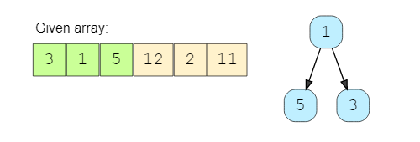

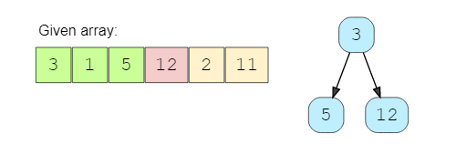

### Code

|  |
| --- |
| import java.util.*;  class Solution {  public static List<Integer> findKLargestNumbers(int[] nums, int k) {  PriorityQueue<Integer> minHeap = new PriorityQueue<Integer>((n1, n2) -> n1 - n2);  // put first 'K' numbers in the min heap  for (int i = 0; i < k; i++)  minHeap.add(nums[i]);  // go through the remaining numbers of the array, if the number from the array is  // bigger than the top (smallest) number of the min-heap, remove the top number from  // heap and add the number from array  for (int i = k; i < nums.length; i++) {  if (nums[i] > minHeap.peek()) {  minHeap.poll();  minHeap.add(nums[i]);  }  }  // the heap has the top 'K' numbers, return them in a list  return new ArrayList<>(minHeap);  }  public static void main(String[] args) {  List<Integer> result =  Solution.findKLargestNumbers(new int[] { 3, 1, 5, 12, 2, 11 }, 3);  System.out.println("Here are the top K numbers: " + result);  result = Solution.findKLargestNumbers(new int[] { 5, 12, 11, -1, 12 }, 3);  System.out.println("Here are the top K numbers: " + result);  }  } |

* As discussed above, the time complexity of this algorithm is O(K * log K +(N - K) * logK), which is asymptotically equal to O(N*logK).
* The space complexity will be O(K) since we need to store the top K numbers in an array.

### Java Solution

|  |
| --- |
| public static int[] topKElements(int[] nums, int k) {  PriorityQueue<Integer> minHeap = new PriorityQueue<>();  for(int num: nums){  minHeap.offer(num);  if(minHeap.size() > k){  minHeap.poll();  }  }  int[] res = new int[k];  int index = 0;  while(!minHeap.isEmpty()){  res[index++] = minHeap.poll();  }  return res; |

## Kth Largest Element

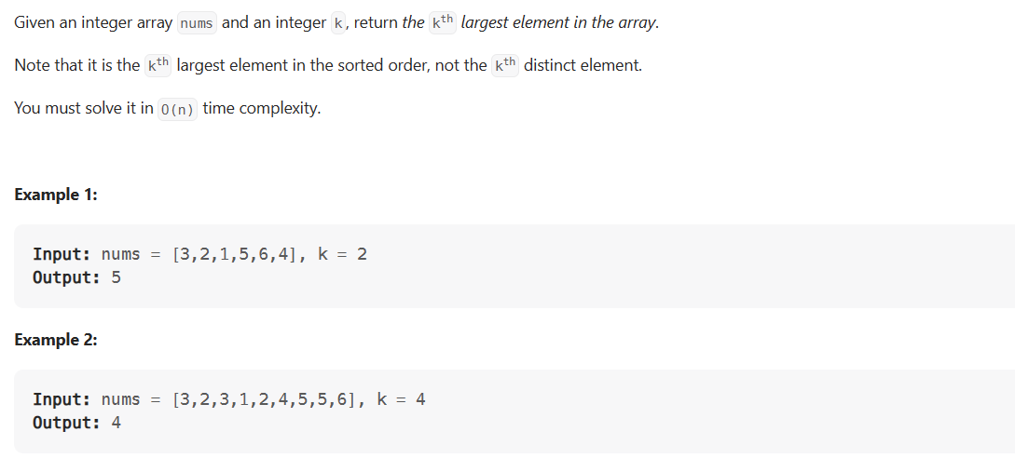

### Java Solution 1

|  |
| --- |
| public static int findKthLargest(int[] nums, int k) {  Arrays.sort(nums);  return nums[nums.length - k];  } |

### Java Solution 2

|  |
| --- |
| public static int findKthLargestMinHeap(int[] nums, int k) {  PriorityQueue<Integer> minHeap = new PriorityQueue<>();  for(int num: nums){  minHeap.offer(num);  if(minHeap.size() > k){  minHeap.poll();  }  }  return minHeap.peek();  } |

### Java Solution 3

|  |
| --- |
| public static int findKthLargestMaxHeap(int[] nums, int k) {  PriorityQueue<Integer> maxHeap = new PriorityQueue<>(Comparator.reverseOrder());  for(int num: nums){  maxHeap.offer(num);  }  int i = 0;  while(i< k-1){  maxHeap.poll();  i++;  }  return maxHeap.peek();  } |

### Java Solution 4

|  |
| --- |
| public static int findKthLargestQuickSelect(int[] nums, int k) {  return quickSelect(nums, 0, nums.length-1, nums.length-k);  }  private static int quickSelect(int[] nums, int left, int right, int k) {  if (left == right) return nums[left];  int pIndex = new Random().nextInt(right - left + 1) + left;  //int pIndex = right;  pIndex = partition(nums, left, right, pIndex);  if (pIndex == k) return nums[k];  else if (pIndex < k) return quickSelect(nums, pIndex+1, right, k);  return quickSelect(nums, left, pIndex-1, k);  }  private static int partition(int[] nums, int left, int right, int pIndex) {  int pivot = nums[pIndex];  swap(nums, pIndex, right);  pIndex = left;  for (int i=left; i<=right; i++)  if (nums[i] <= pivot)  swap(nums, i, pIndex++);  return pIndex - 1;  }  private static void swap(int[] nums, int x, int y) {  int temp = nums[x];  nums[x] = nums[y];  nums[y] = temp;  } |

## Kth Smallest Number (easy)

<https://leetcode.com/problems/kth-largest-element-in-an-array/>

### Problem Statement

Given an unsorted array of numbers, find Kth smallest number in it.

Please note that it is the Kth smallest number in the sorted order, not the Kth distinct element.

**Example 1**:

Input: [1, 5, 12, 2, 11, 5], K = 3

Output: 5

Explanation: The 3rd smallest number is '5', as the first two smaller numbers are [1, 2].

**Example 2**:

Input: [1, 5, 12, 2, 11, 5], K = 4

Output: 5

Explanation: The 4th smallest number is '5', as the first three small numbers are [1, 2, 5].

**Example 3**:

Input: [5, 12, 11, -1, 12], K = 3

Output: 11

Explanation: The 3rd smallest number is '11', as the first two small numbers are [5, -1].

### Solution

This problem follows the Top ‘K’ Numbers pattern but has two differences:

1. Here we need to find the Kth smallest number, whereas in Top ‘K’ Numbers we were dealing with ‘K’ largest numbers.
2. In this problem, we need to find only one number (Kth smallest) compared to finding all ‘K’ largest numbers.

We can follow the same approach as discussed in the ‘Top K Elements’ problem. To handle the first difference mentioned above, we can use a max-heap instead of a min-heap. As we know, the root is the biggest element in the max heap. So, since we want to keep track of the ‘K’ smallest numbers, we can compare every number with the root while iterating through all numbers, and if it is smaller than the root, we’ll take the root out and insert the smaller number.

### Code

|  |
| --- |
| import java.util.*;  class Solution {  public static int findKthSmallestNumber(int[] nums, int k) {  PriorityQueue<Integer> maxHeap = new PriorityQueue<Integer>((n1, n2) -> n2 - n1);  // put first k numbers in the max heap  for (int i = 0; i < k; i++)  maxHeap.add(nums[i]);  // go through the remaining numbers of the array, if the number from the array is  // smaller than the top (biggest) number of the heap, remove the top number from  // heap and add the number from array  for (int i = k; i < nums.length; i++) {  if (nums[i] < maxHeap.peek()) {  maxHeap.poll();  maxHeap.add(nums[i]);  }  }  // the root of the heap has the Kth smallest number  return maxHeap.peek();  }  public static void main(String[] args) {  int result =  Solution.findKthSmallestNumber(new int[] { 1, 5, 12, 2, 11, 5 }, 3);  System.out.println("Kth smallest number is: " + result);  // since there are two 5s in the input array, our 3rd and 4th smallest numbers  // should be a '5'  result =  Solution.findKthSmallestNumber(new int[] { 1, 5, 12, 2, 11, 5 }, 4);  System.out.println("Kth smallest number is: " + result);  result =  Solution.findKthSmallestNumber(new int[] { 5, 12, 11, -1, 12 }, 3);  System.out.println("Kth smallest number is: " + result); }  } |

* As discussed above, the time complexity of this algorithm is O(K * log K +(N - K) * logK), which is asymptotically equal to O(N*logK).
* The space complexity will be O(K) since we need to store the top K numbers in an array.

### An Alternate Approach

Alternatively, we can use a Min Heap to find the Kth smallest number. We can insert all the numbers in the min-heap and then extract the top ‘K’ numbers from the heap to find the Kth smallest number. Initializing the min-heap with all numbers will take O(N) and extracting ‘K’ numbers will take O(KlogN). Overall, the time complexity of this algorithm will be  and the space complexity will be O(N).

**'K' Closest Points to the Origin (easy)**

<https://leetcode.com/problems/k-closest-points-to-origin/>

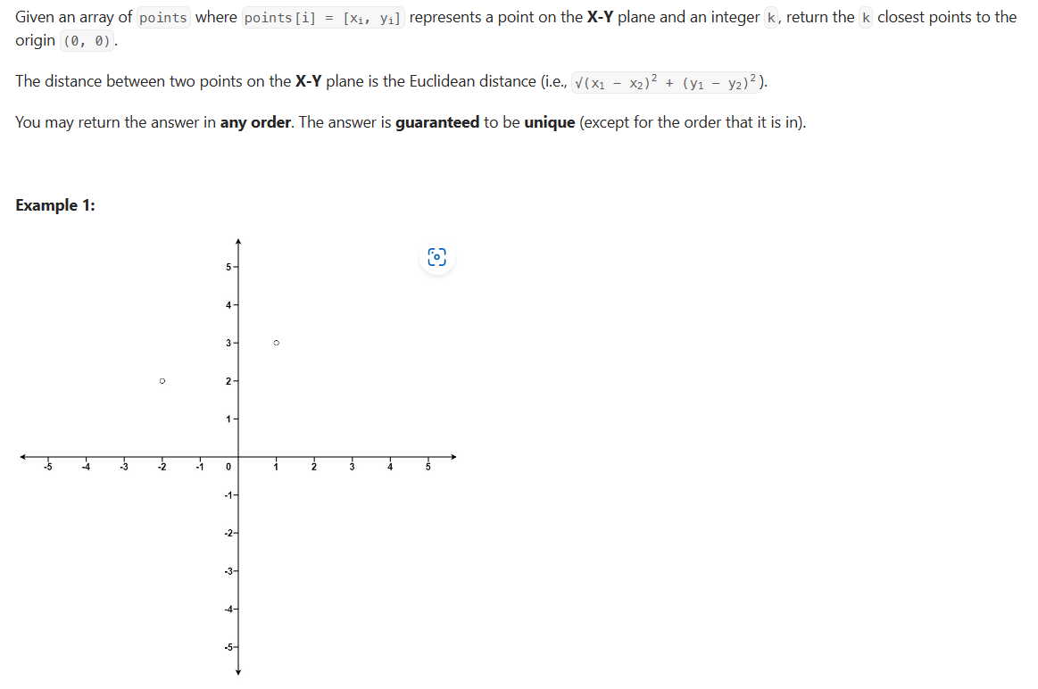

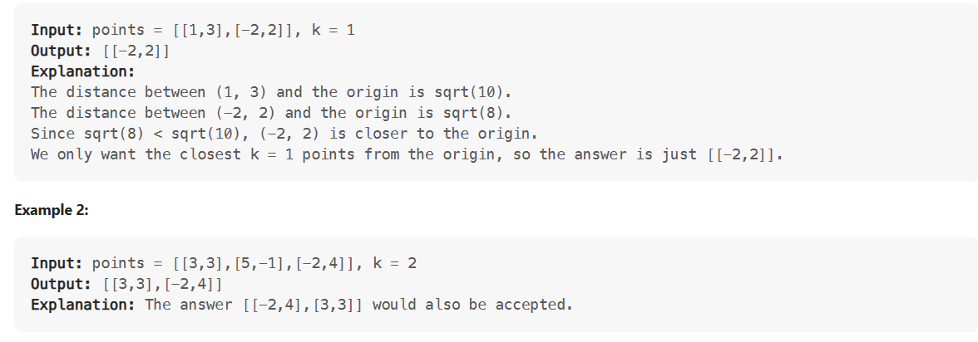

### Problem Statement

Given an array of points in a 2D plane, find K closest points to the origin.

**Example 1**:

Input: points = [[1,2],[1,3]], K = 1

Output: [[1,2]]

Explanation: The Euclidean distance between (1, 2) and the origin is sqrt(5).

The Euclidean distance between (1, 3) and the origin is sqrt(10).

Since sqrt(5) < sqrt(10), therefore (1, 2) is closer to the origin.

**Example 2**:

Input: point = [[1, 3], [3, 4], [2, -1]], K = 2

Output: [[1, 3], [2, -1]]

### Solution

The Euclidean distance of a point P(x,y) from the origin can be calculated through the following formula:

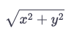

This problem follows the Top ‘K’ Numbers pattern. The only difference in this problem is that we need to find the closest point (to the origin) as compared to finding the largest numbers.

Following a similar approach, we can use a Max Heap to find ‘K’ points closest to the origin. While iterating through all points, if a point (say ‘P’) is closer to the origin than the top point of the max-heap, we will remove that top point from the heap and add ‘P’ to always keep the closest points in the heap.

### Code

|  |
| --- |
| import java.util.*;  class Point {  int x;  int y;  public Point(int x, int y) {  this.x = x;  this.y = y;  }  public int distFromOrigin() {  // ignoring sqrt  return (x * x) + (y * y);  }  }  class Solution {  public static List<Point> findClosestPoints(Point[] points, int k) {  PriorityQueue<Point> maxHeap =  new PriorityQueue<>((p1, p2) -> p2.distFromOrigin() - p1.distFromOrigin());  // put first 'k' points in the max heap  for (int i = 0; i < k; i++)  maxHeap.add(points[i]);  // go through the remaining points of the input array, if a point is closer to the  // origin than the top point of the max-heap, remove the top point from heap and add  // the point from the input array  for (int i = k; i < points.length; i++) {  if (points[i].distFromOrigin() < maxHeap.peek().distFromOrigin()) {  maxHeap.poll();  maxHeap.add(points[i]);  }  }  // the heap has 'k' points closest to the origin, return them in a list  return new ArrayList<>(maxHeap);  }  public static void main(String[] args) {  Point[] points = new Point[] { new Point(1, 3), new Point(3, 4), new Point(2, -1) };  List<Point> result = Solution.findClosestPoints(points, 2);  System.out.print("Here are the k points closest the origin: ");  for (Point p : result)  System.out.print("[" + p.x + " , " + p.y + "] ");  }  } |

### Time Complexity

The time complexity of this algorithm is  O(N*logK) as we iterating all points and pushing them into the heap.

### Space Complexity

The space complexity will be O(K)  because we need to store ‘K’ point in the heap.

### Java Solution 1

|  |
| --- |
| public static int[][] kClosest(int[][] p, int k) {  PriorityQueue<Node> minHeap = new PriorityQueue<>((a,b) -> b.distance - a.distance);  for(int[] point : p){  int distance = point[0]*point[0] + point[1] * point[1];  minHeap.add(new Node(distance, point[0], point[1]));  if(minHeap.size() >k){  minHeap.poll();  }  }  int[][] res = new int[k][2];  int index = 0;  while(!minHeap.isEmpty()){  Node node = minHeap.poll();  res[index][0] = node.x;  res[index][1] = node.y;  index++;  }  return res;  }  static class Node{  int distance;  int x;  int y;  public Node(int distance, int x, int y) {  this.distance = distance;  this.x = x;  this.y = y;  }  } |

### Java Solution 2: Quick Select

|  |
| --- |
| private final Random rand = new Random();  public int[][] kClosest(int[][] points, int k) {  quickSelect(points, 0, points.length - 1, k - 1);  return Arrays.copyOf(points, k);  }  private void quickSelect(int[][] points, int l, int r, int k) {  while (l < r) {  int p = partition(points, l, r);  if (p == k) return;  else if (p > k) r = p;  else l = p + 1;  }  }  private int partition(int[][] points, int l, int r) {  int pivot = getDist( points[ l + rand.nextInt(r - l + 1) ] );  int i = l - 1, j = r + 1;  while (true) {  while (getDist(points[--j]) > pivot);  while (getDist(points[++i]) < pivot);  if (i >= j) return j;  swap(points, i, j);  }  }  private void swap(int[][] points, int i, int j) {  int[] temp = points[i];  points[i] = points[j];  points[j] = temp;  }  private int getDist(int[] p) {  return p[0] * p[0] + p[1] * p[1];  } |

## Connect Ropes (easy)

<https://leetcode.com/problems/minimum-cost-to-connect-sticks/>

### Problem Statement

Given N ropes with different lengths, we need to connect these ropes into one big rope with minimum cost. The cost of connecting two ropes is equal to the sum of their lengths.

**Example 1**:

Input: [1, 3, 11, 5]

Output: 33

Explanation: First connect 1+3(=4), then 4+5(=9), and then 9+11(=20). So the total cost is 33 (4+9+20)

**Example 2**:

Input: [3, 4, 5, 6]

Output: 36

Explanation: First connect 3+4(=7), then 5+6(=11), 7+11(=18). Total cost is 36 (7+11+18)

**Example 3**:

Input: [1, 3, 11, 5, 2]

Output: 42

Explanation: First connect 1+2(=3), then 3+3(=6), 6+5(=11), 11+11(=22). Total cost is 42 (3+6+11+22)

### Solution

In this problem, following a greedy approach to connect the smallest ropes first will ensure the lowest cost. We can use a **Min Heap** to find the smallest ropes following a similar approach as discussed in **Kth Smallest Number**. Once we connect two ropes, we need to insert the resultant rope back in the **Min Heap** so that we can connect it with the remaining ropes.

### Code

|  |
| --- |
| import java.util.*;  class Solution {  public static int minimumCostToConnectRopes(int[] ropeLengths) {  PriorityQueue<Integer> minHeap = new PriorityQueue<Integer>((n1, n2) -> n1 - n2);  // add all ropes to the min heap  for (int i = 0; i < ropeLengths.length; i++)  minHeap.add(ropeLengths[i]);  // go through the values of the heap, in each step take top (lowest) rope lengths  // from the min heap connect them and push the result back to the min heap.  // keep doing this until the heap is left with only one rope  int result = 0, temp = 0;  while (minHeap.size() > 1) {  temp = minHeap.poll() + minHeap.poll();  result += temp;  minHeap.add(temp);  }  return result;  }  public static void main(String[] args) {  int result = Solution.minimumCostToConnectRopes(new int[] { 1, 3, 11, 5 });  System.out.println("Minimum cost to connect ropes: " + result);  result = Solution.minimumCostToConnectRopes(new int[] { 3, 4, 5, 6 });  System.out.println("Minimum cost to connect ropes: " + result);  result = Solution.minimumCostToConnectRopes(new int[] { 1, 3, 11, 5, 2 });  System.out.println("Minimum cost to connect ropes: " + result);  }  } |

### Time Complexity

Given ‘N’ ropes, we need O(N∗logN) to insert all the ropes in the heap. In each step, while processing the heap, we take out two elements from the heap and insert one. This means we will have a total of ‘N’ steps, having a total time complexity of O(N∗logN).

### Space Complexity

The space complexity will be O(N) because we need to store all the ropes in the heap.

## 👩🏽‍🦯 Top 'K' Frequent Numbers (medium)

<https://leetcode.com/problems/top-k-frequent-elements/>

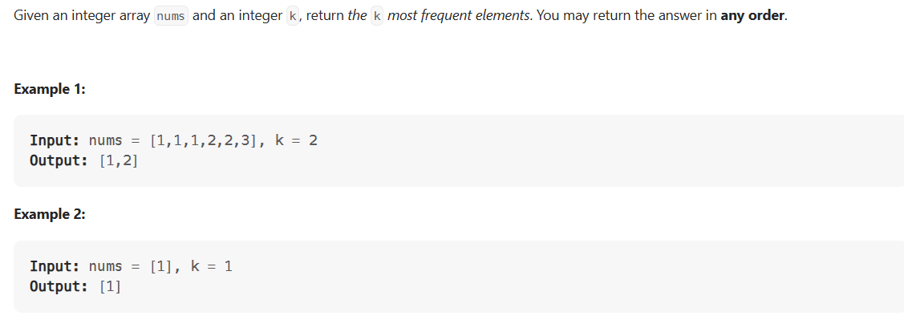

### Problem Statement

Given an unsorted array of numbers, find the top K frequently occurring numbers in it.

**Example 1**:

Input: [1, 3, 5, 12, 11, 12, 11], K = 2

Output: [12, 11]

Explanation: Both '11' and '12' appeared twice.

**Example 2**:

Input: [5, 12, 11, 3, 11], K = 2

Output: [11, 5] or [11, 12] or [11, 3]

Explanation: Only '11' appeared twice, all other numbers appeared once.

### Solution

This problem follows Top ‘K’ Numbers. The only difference is that in this problem, we need to find the most frequently occurring number compared to finding the largest numbers.

We can follow the same approach as discussed in the **Top K Elements** problem. However, in this problem, we first need to know the frequency of each number, for which we can use a **HashMap**. Once we have the frequency map, we can use a **Min Heap** to find the ‘K’ most frequently occurring number. In the **Min Heap**, instead of comparing numbers we will compare their frequencies in order to get frequently occurring numbers

### Code

|  |
| --- |
| import java.util.*;  class Solution {  public static List<Integer> findTopKFrequentNumbers(int[] nums, int k) {  // find the frequency of each number  Map<Integer, Integer> numFrequencyMap = new HashMap<>();  for (int n : nums)  numFrequencyMap.put(n, numFrequencyMap.getOrDefault(n, 0) + 1);  PriorityQueue<Map.Entry<Integer, Integer>> minHeap =  new PriorityQueue<Map.Entry<Integer, Integer>>(  (e1, e2) -> e1.getValue() - e2.getValue());  // go through all numbers of the numFrequencyMap and push them in the minHeap, which  // will have top k frequent numbers.  // If the heap size is more than k, we remove the smallest (top) number  for (Map.Entry<Integer, Integer> entry : numFrequencyMap.entrySet()) {  minHeap.add(entry);  if (minHeap.size() > k) {  minHeap.poll();  }  }  // create a list of top k numbers  List<Integer> topNumbers = new ArrayList<>(k);  while (!minHeap.isEmpty()) {  topNumbers.add(minHeap.poll().getKey());  }  return topNumbers;  }  public static void main(String[] args) {  List<Integer> result = Solution.findTopKFrequentNumbers(  new int[] { 1, 3, 5, 12, 11, 12, 11 }, 2);  System.out.println("Here are the K frequent numbers: " + result);  result =  Solution.findTopKFrequentNumbers(new int[] { 5, 12, 11, 3, 11 }, 2);  System.out.println("Here are the K frequent numbers: " + result);  }  } |

### Time Complexity

The time complexity of the above algorithm is O(N + N*logK).

### Space Complexity

The space complexity will be O(N). Even though we are storing only ‘K’ numbers in the heap. For the frequency map, however, we need to store all the ‘N’ numbers.

### Java Solution

|  |
| --- |
| public int[] topKFrequent(int[] nums, int k) {  List<Integer>[] bucket = new List[nums.length + 1];  HashMap<Integer, Integer> hm = new HashMap<>();  for (int i = 0; i < nums.length; i++)  hm.put(nums[i], hm.getOrDefault(nums[i], 0) + 1);  for (int key : hm.keySet()) {  int frequency = hm.get(key);  if (bucket[frequency] == null) {  bucket[frequency] = new ArrayList<>();  }  bucket[frequency].add(key);  }  int ans[] = new int[k];  int count = 0;  for (int i = bucket.length - 1; i >= 0; i--) {  if (bucket[i] != null) {  for (int j = 0; j < bucket[i].size(); j++)  ans[count++] = bucket[i].get(j);  }  if (count == k) break;  }  return ans;  } |

### Time Complexity

O(N)

**Frequency Sort (medium)**

<https://leetcode.com/problems/sort-characters-by-frequency/>

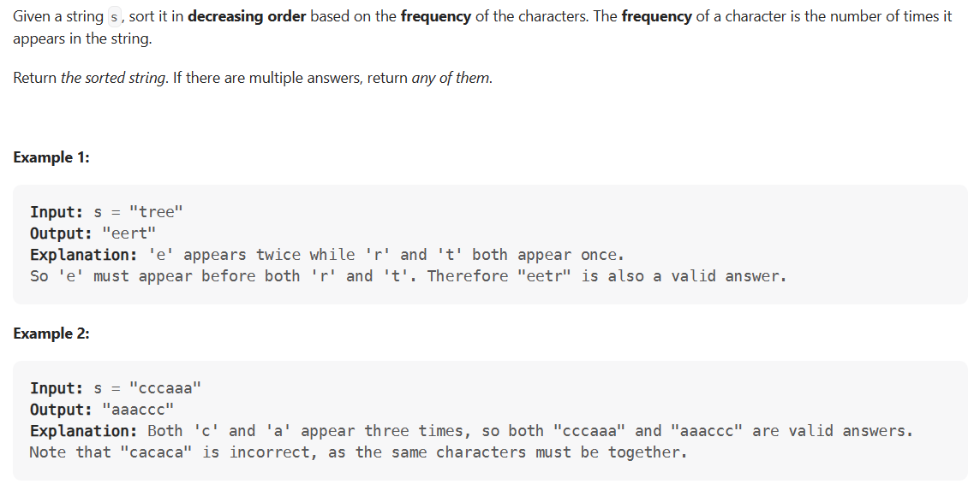

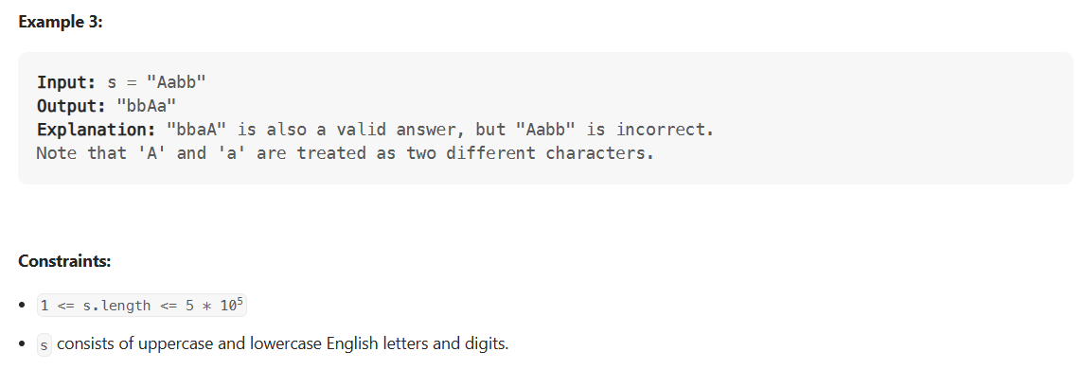

### Problem Statement

Given a string, sort it based on the decreasing frequency of its characters.

**Example 1**:

Input: "Programming"

Output: "rrggmmPiano"

Explanation: 'r', 'g', and 'm' appeared twice, so they need to appear before any other character.

**Example 2**:

Input: "abcbab"

Output: "bbbaac"

Explanation: 'b' appeared three times, 'a' appeared twice, and 'c' appeared only once.

### Solution

This problem follows the **Top ‘K’ Elements** pattern, and shares similarities with Top ‘K’ Frequent Numbers.

We can follow the same approach as discussed in the Top ‘K’ Frequent Numbers problem. First, we will find the frequencies of all characters, then use a max-heap to find the most occurring characters.

### Code

|  |
| --- |
| import java.util.*;  class Solution {  public static String sortCharacterByFrequency(String str) {  // find the frequency of each character  Map<Character, Integer> characterFrequencyMap = new HashMap<>();  for (char chr : str.toCharArray()) {  characterFrequencyMap.put(chr, characterFrequencyMap.getOrDefault(chr, 0) + 1);  }  PriorityQueue<Map.Entry<Character, Integer>> maxHeap =  new PriorityQueue<Map.Entry<Character, Integer>>(  (e1, e2) -> e2.getValue() - e1.getValue());  // add all characters to the max heap  maxHeap.addAll(characterFrequencyMap.entrySet());  // build a string, appending the most occurring characters first  StringBuilder sortedString = new StringBuilder(str.length());  while (!maxHeap.isEmpty()) {  Map.Entry<Character, Integer> entry = maxHeap.poll();  for (int i = 0; i < entry.getValue(); i++)  sortedString.append(entry.getKey());  }  return sortedString.toString();  }  public static void main(String[] args) {  String result = Solution.sortCharacterByFrequency("Programming");  System.out.println("Here is the given string after sorting characters by frequency: "  + result);  result = Solution.sortCharacterByFrequency("abcbab");  System.out.println("Here is the given string after sorting characters by frequency: "  + result);  }  } |

### Time Complexity

The time complexity of the above algorithm is O(D∗logD) where ‘D’ is the number of distinct characters in the input string. This means, in the worst case, when all characters are unique the time complexity of the algorithm will be O(N∗logN) where ‘N’ is the total number of characters in the string.

### Space Complexity

The space complexity will be O(N), as in the worst case, we need to store all the ‘N’ characters in the HashMap.

### Java Solution 1: Using MaxHeap

Time Complexity : NlogN

|  |
| --- |
| public static String frequencySortMaxHeap(String s) {  if(s == null || s.length() <= 1) return s;  PriorityQueue<CharFreq> maxHeap = new PriorityQueue<>((a,b) -> b.freq - a.freq);  Map<Character, Integer> charCount = new HashMap<>();  for(char c : s.toCharArray()){  charCount.put(c, charCount.getOrDefault(c, 0)+1);  }  for(char key : charCount.keySet()){  maxHeap.add(new CharFreq(key, charCount.get(key)));  }  StringBuffer res = new StringBuffer();  while(!maxHeap.isEmpty()){  CharFreq charFreq = maxHeap.poll();  int pointer = 0;  while(pointer < charFreq.freq){  res.append(charFreq.ch);  pointer++;  }  }  return res.toString();  }  static class CharFreq{  char ch;  int freq;  public CharFreq(char ch, int freq) {  this.ch = ch;  this.freq = freq;  }  } |

### Java Solution 2: Using Bucket

Time Complexity : O(n)

|  |
| --- |
| public static String frequencySort(String s) {  if(s == null || s.length() <= 1) return s;  List<Character>[] bucket = new List[s.length()+1];  Map<Character, Integer> charCount = new HashMap<>();  for(char c : s.toCharArray()){  charCount.put(c, charCount.getOrDefault(c, 0)+1);  }  for(char key : charCount.keySet()){  int count = charCount.get(key);  if(bucket[count] == null){  bucket[count]= new ArrayList<>();  }  bucket[count].add(key);  }  StringBuffer res = new StringBuffer();  for(int i = bucket.length -1; i >0;i--){  if(bucket[i] != null){  for(char ch : bucket[i]){  int freq = 0;  while(freq<i) {  res.append(ch);  freq++;  }  }  }  }  return res.toString();  } |

## Kth Largest Number in a Stream (medium)

<https://leetcode.com/problems/kth-largest-element-in-a-stream/>

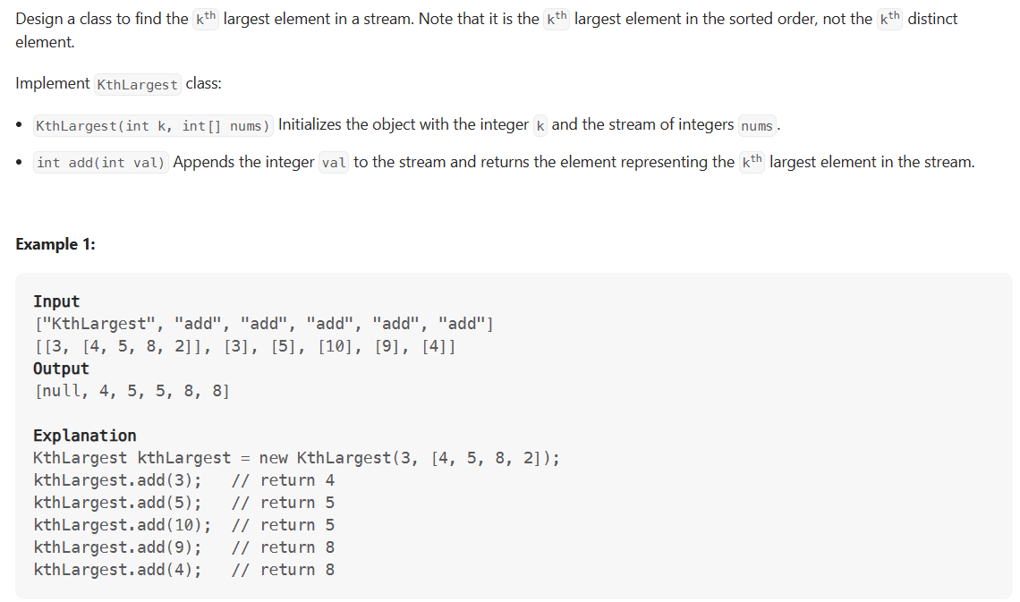

### Problem Statement

Design a class to efficiently find the Kth largest element in a stream of numbers.

The class should have the following two things:

1. The constructor of the class should accept an integer array containing initial numbers from the stream and an integer K.
2. The class should expose a function add(num) which will store the given number and return the **Kth largest** number.

**Example 1**:

Input: [3, 1, 5, 12, 2, 11], K = 4

1. Calling add(6) should return '5'.

2. Calling add(13) should return '6'.

2. Calling add(4) should still return '6'.

### Solution

This problem follows the Top ‘K’ Elements pattern and shares similarities with Kth Smallest number.

We can follow the same approach as discussed in the ‘Kth Smallest number’ problem. However, we will use a Min Heap (instead of a Max Heap) as we need to find the Kth largest number.

### Code

|  |
| --- |
| import java.util.*;  class Solution {  PriorityQueue<Integer> minHeap = new PriorityQueue<Integer>((n1, n2) -> n1 - n2);  final int k;  public Solution(int[] nums, int k) {  this.k = k;  // add the numbers in the min heap  for (int i = 0; i < nums.length; i++)  add(nums[i]);  }  public int add(int num) {  // add the new number in the min heap  minHeap.add(num);  // if heap has more than 'k' numbers, remove one number  if (minHeap.size() > this.k)  minHeap.poll();  // return the 'Kth largest number  return minHeap.peek();  }  public static void main(String[] args) {  int[] input = new int[] { 3, 1, 5, 12, 2, 11 };  Solution kthLargestNumber = new Solution(input, 4);  System.out.println("4th largest number is: " + kthLargestNumber.add(6));  System.out.println("4th largest number is: " + kthLargestNumber.add(13));  System.out.println("4th largest number is: " + kthLargestNumber.add(4));  }  } |

### Time Complexity

The time complexity of the add() function will be O(logK) since we are inserting the new number in the heap.

### Space Complexity

The space complexity will be O(K) for storing numbers in the heap.

### Java Solution

|  |
| --- |
| public class KthLargestElementInAStream {  public static void main(String[] args) {  KthLargestElementInAStream kthLargestElementInAStream = new KthLargestElementInAStream(3, new int[]{4,5,8,2});  System.out.println(kthLargestElementInAStream.add(3));  System.out.println(kthLargestElementInAStream.add(5));  System.out.println(kthLargestElementInAStream.add(10));  System.out.println(kthLargestElementInAStream.add(9));  System.out.println(kthLargestElementInAStream.add(4));  }  private PriorityQueue<Integer> minHeap;  private int k;  private int[] nums;  public KthLargestElementInAStream(int k, int[] nums) {  this.k = k;  this.nums = nums;  minHeap = new PriorityQueue<>();  for(int num : nums){  minHeap.add(num);  if(minHeap.size() > k){  minHeap.poll();  }  }  }  public int add(int val) {  if(minHeap.size() == k) {  int topElement = minHeap.peek();  if (val < topElement) return topElement;  }  minHeap.add(val);  if(minHeap.size() > k){  minHeap.poll();  }  return minHeap.peek();  }  } |

## 'K' Closest Numbers (medium)

<https://leetcode.com/problems/find-k-closest-elements/>

### Problem Statement

Given a sorted number array and two integers K and X, find K closest numbers to X in the array. Return the numbers in the sorted order. X is not necessarily present in the array.

**Example 1**:

Input: [5, 6, 7, 8, 9], K = 3, X = 7

Output: [6, 7, 8]

**Example 2**:

Input: [2, 4, 5, 6, 9], K = 3, X = 6

Output: [4, 5, 6]

**Example 3**:

Input: [2, 4, 5, 6, 9], K = 3, X = 10

Output: [5, 6, 9]

### Solution

This problem follows the [Top K Numbers](https://github.com/maazshaikh007/DSA_Patterns/blob/main/%E2%9C%85%20Pattern%2013:%20Top%20'K'%20Elements.md#top-k-numbers-easy) pattern. The biggest difference in this problem is that we need to find the closest (to X) numbers compared to finding the overall largest numbers. Another difference is that the given array is sorted.

Utilizing a similar approach, we can find the numbers closest to X through the following algorithm:

1. Since the array is sorted, we can first find the number closest to X through **Binary Search**. Let's say that number is Y.
2. The K closest numbers to Y will be adjacent to Y in the array. We can search in both directions of Y to find the closest numbers.
3. We can use a heap to efficiently search for the closest numbers. We will take K numbers in both directions of Y and push them in a **Min Heap** sorted by their absolute difference from X. This will ensure that the numbers with the smallest difference from X (i.e., closest to X) can be extracted easily **from Min Heap**.
4. Finally, we will extract the top K numbers from the **Min Heap** to find the required numbers.

### Code

|  |
| --- |
| import java.util.*;  class Entry {  int key;  int value;  public Entry(int key, int value) {  this.key = key;  this.value = value;  }  }  class Solution {  public static List<Integer> findClosestElements(int[] arr, int K, Integer X) {  int index = binarySearch(arr, X);  int low = index - K, high = index + K;  low = Math.max(low, 0); // 'low' should not be less than zero  // 'high' should not be greater the size of the array  high = Math.min(high, arr.length - 1);  PriorityQueue<Entry> minHeap = new PriorityQueue<>((n1, n2) -> n1.key - n2.key);  // add all candidate elements to the min heap, sorted by their absolute difference  // from 'X'  for (int i = low; i <= high; i++)  minHeap.add(new Entry(Math.abs(arr[i] - X), i));  // we need the top 'K' elements having smallest difference from 'X'  List<Integer> result = new ArrayList<>();  for (int i = 0; i < K; i++)  result.add(arr[minHeap.poll().value]);  Collections.sort(result);  return result;  }  private static int binarySearch(int[] arr, int target) {  int low = 0;  int high = arr.length - 1;  while (low <= high) {  int mid = low + (high - low) / 2;  if (arr[mid] == target)  return mid;  if (arr[mid] < target) {  low = mid + 1;  } else {  high = mid - 1;  }  }  if (low > 0) {  return low - 1;  }  return low;  }  public static void main(String[] args) {  List<Integer> result =  Solution.findClosestElements(new int[] { 5, 6, 7, 8, 9 }, 3, 7);  System.out.println("'K' closest numbers to 'X' are: " + result);  result = Solution.findClosestElements(new int[] { 2, 4, 5, 6, 9 }, 3, 6);  System.out.println("'K' closest numbers to 'X' are: " + result);  result = Solution.findClosestElements(new int[] { 2, 4, 5, 6, 9 }, 3, 10);  System.out.println("'K' closest numbers to 'X' are: " + result);  }  } |

### Time Complexity

The time complexity of the above algorithm is **O(logN+K∗logK)**. We need O(logN) for Binary Search and O(K∗logK) to insert the numbers in the **Min Heap**, as well as to sort the output array.

### Space Complexity

The space complexity will be O(K), as we need to put a maximum of 2K numbers in the heap.

### Alternate Solution using Two Pointers

After finding the number closest to X through **Binary Search**, we can use the [**Two Pointers**](https://github.com/Chanda-Abdul/Several-Coding-Patterns-for-Solving-Data-Structures-and-Algorithms-Problems-during-Interviews/blob/main/%E2%9C%85%20%20Pattern%2002:%20Two%20Pointers.md) approach to find the K closest numbers. Let’s say the closest number is Y. We can have a left pointer to move back from Y and a right pointer to move forward from Y. At any stage, whichever number pointed out by the left or the right pointer gives the smaller difference from X will be added to our result list.

To keep the resultant list sorted we can use a **Queue**. So whenever we take the number pointed out by the left pointer, we will append it at the beginning of the list and whenever we take the number pointed out by the right pointer we will append it at the end of the list.

Here is what our algorithm will look like:

### Code

|  |
| --- |
| import java.util.*;  class Solution {  public static List<Integer> findClosestElements(int[] arr, int K, Integer X) {  List<Integer> result = new LinkedList<>();  int index = binarySearch(arr, X);  int leftPointer = index;  int rightPointer = index + 1;  for (int i = 0; i < K; i++) {  if (leftPointer >= 0 && rightPointer < arr.length) {  int diff1 = Math.abs(X - arr[leftPointer]);  int diff2 = Math.abs(X - arr[rightPointer]);  if (diff1 <= diff2)  result.add(0, arr[leftPointer--]); // append in the beginning  else  result.add(arr[rightPointer++]); // append at the end  } else if (leftPointer >= 0) {  result.add(0, arr[leftPointer--]);  } else if (rightPointer < arr.length) {  result.add(arr[rightPointer++]);  }  }  return result;  }  private static int binarySearch(int[] arr, int target) {  int low = 0;  int high = arr.length - 1;  while (low <= high) {  int mid = low + (high - low) / 2;  if (arr[mid] == target)  return mid;  if (arr[mid] < target) {  low = mid + 1;  } else {  high = mid - 1;  }  }  if (low > 0) {  return low - 1;  }  return low;  }  public static void main(String[] args) {  List<Integer> result =  Solution.findClosestElements(new int[] { 5, 6, 7, 8, 9 }, 3, 7);  System.out.println("'K' closest numbers to 'X' are: " + result);  result =  Solution.findClosestElements(new int[] { 2, 4, 5, 6, 9 }, 3, 6);  System.out.println("'K' closest numbers to 'X' are: " + result);  result =  Solution.findClosestElements(new int[] { 2, 4, 5, 6, 9 }, 3, 10);  System.out.println("'K' closest numbers to 'X' are: " + result);  }  } |

* The time complexity of the above algorithm is O(logN + K). We need O(logN) for **Binary Search** and O(K)for finding the K closest numbers using the two pointers.
* If we ignoring the space required for the output list, the algorithm runs in constant space O(1).

### Java Solution 1 : Linear Search

|  |
| --- |
| public List<Integer> findClosestElementsLinearSearch(int[] arr, int k, int x) {  List<Integer> ans = new ArrayList<>();  int left = 0; int right = arr.length - 1;  while(right - left >= k){  if(x- arr[left] <= arr[right] - x){  right--;  }else{  left++;  }  }  for(int i = left; i<=right; i++){  ans.add(arr[i]);  }  return ans;  } |

### Java Solution 2: Binary Search

|  |
| --- |
| public List<Integer> findClosestElementsBinarySearch(int[] arr, int k, int x) {  int left = 0, right = arr.length - k;  while (left < right) {  int mid = left+(right-left) / 2;  if (x - arr[mid] <= arr[mid + k] - x)  right = mid;  else  left = mid + 1;  }  List<Integer> ans = new ArrayList<>();  for(int i = left; i<left+k; i++){  ans.add(arr[i]);  }  return ans;  //return Arrays.stream(arr, left, left + k).boxed().collect(Collectors.toList());  } |

**Maximum Distinct Elements (medium)**

### Problem Statement

Given an array of numbers and a number K, we need to remove K numbers from the array such that we are left with maximum distinct numbers.

**Example 1**:

Input: [7, 3, 5, 8, 5, 3, 3], and K=2

Output: 3

Explanation: We can remove two occurrences of 3 to be left with 3 distinct numbers [7, 3, 8], we have

to skip 5 because it is not distinct and occurred twice.

Another solution could be to remove one instance of '5' and '3' each to be left with three distinct numbers [7, 5, 8], in this case, we have to skip 3 because it occurred twice.

**Example 2**:

Input: [3, 5, 12, 11, 12], and K=3

Output: 2

Explanation: We can remove one occurrence of 12, after which all numbers will become distinct. Then we can delete any two numbers which will leave us 2 distinct numbers in the result.

**Example 3**:

Input: [1, 2, 3, 3, 3, 3, 4, 4, 5, 5, 5], and K=2

Output: 3

Explanation: We can remove one occurrence of '4' to get three distinct numbers.

### Solution

This problem follows the Top ‘K’ Numbers pattern, and shares similarities with Top ‘K’ Frequent Numbers.

We can follow a similar approach as discussed in Top ‘K’ Frequent Numbers problem:

1. First, we will find the frequencies of all the numbers.
2. Then, push all numbers that are not distinct (i.e., have a frequency higher than one) in a **Min Heap** based on their frequencies. At the same time, we will keep a running count of all the distinct numbers.
3. Following a greedy approach, in a stepwise fashion, we will remove the least frequent number from the heap (i.e., the top element of the min-heap), and try to make it distinct. We will see if we can remove all occurrences of a number except one. If we can, we will increment our running count of distinct numbers. We have to also keep a count of how many removals we have done.
4. If after removing elements from the heap, we are still left with some deletions, we have to remove some distinct elements.

### Code

|  |
| --- |
| import java.util.*;  class Solution {  public static int findMaximumDistinctElements(int[] nums, int k) {  int distinctElementsCount = 0;  if (nums.length <= k)  return distinctElementsCount;  // find the frequency of each number  Map<Integer, Integer> numFrequencyMap = new HashMap<>();  for (int i : nums)  numFrequencyMap.put(i, numFrequencyMap.getOrDefault(i, 0) + 1);  PriorityQueue<Map.Entry<Integer, Integer>> minHeap =  new PriorityQueue<Map.Entry<Integer, Integer>>(  (e1, e2) -> e1.getValue() - e2.getValue());  // insert all numbers with frequency greater than '1' into the min-heap  for (Map.Entry<Integer, Integer> entry : numFrequencyMap.entrySet()) {  if (entry.getValue() == 1)  distinctElementsCount++;  else  minHeap.add(entry);  }  // following a greedy approach, try removing the least frequent numbers first from  // the min-heap  while (k > 0 && !minHeap.isEmpty()) {  Map.Entry<Integer, Integer> entry = minHeap.poll();  // to make an element distinct, we need to remove all of its occurrences except one  k -= entry.getValue() - 1;  if (k >= 0)  distinctElementsCount++;  }  // if k > 0, this means we have to remove some distinct numbers  if (k > 0)  distinctElementsCount -= k;  return distinctElementsCount;  }  public static void main(String[] args) {  int result = Solution.findMaximumDistinctElements(  new int[] { 7, 3, 5, 8, 5, 3, 3 }, 2);  System.out.println("Maximum distinct numbers after removing K numbers: " + result);  result = Solution.findMaximumDistinctElements(  new int[] { 3, 5, 12, 11, 12 }, 3);  System.out.println("Maximum distinct numbers after removing K numbers: " + result);  result = Solution.findMaximumDistinctElements(  new int[] { 1, 2, 3, 3, 3, 3, 4, 4, 5, 5, 5 }, 2);  System.out.println("Maximum distinct numbers after removing K numbers: " + result);  }  } |

* Since we will insert all numbers in a **HashMap**, this will take O(N*logN) where N is the total input numbers. While extracting numbers from the map, in the worst case, we will need to take out K numbers. This will happen when we have at least K numbers with a frequency of two. Since the ~~heap~~ can have a maximum of N/2 numbers, therefore, extracting an element from the ~~heap~~ will take O(logN) and extracting K numbers will take O(KlogN). So overall, the time complexity of our algorithm will be O(N*logN + KlogN). We can optimize the above algorithm and only push K elements in the ~~heap~~, as in the worst case we will be extracting K elements from the ~~heap~~. This optimization will reduce the overall time complexity to O(N*logK + KlogK).
* The space complexity will be O(N) as, in the worst case, we need to store all the N characters in the **HashMap**.

## Least Number of Distinct Elements

<https://leetcode.com/problems/least-number-of-unique-integers-after-k-removals/>

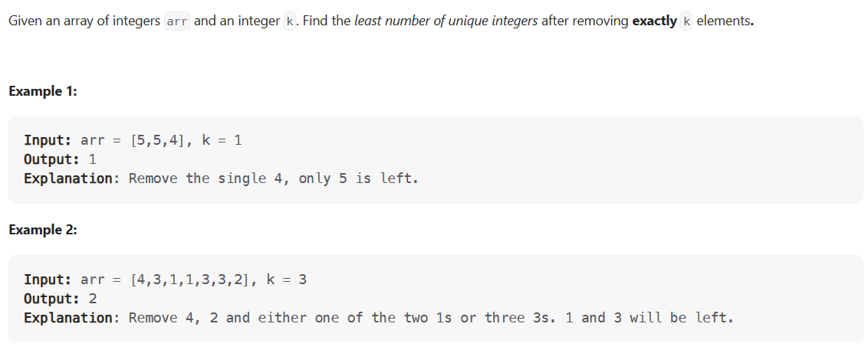

### Java Solution 1: HashMap and PriorityQueue

|  |
| --- |
| public static int findLeastNumOfUniqueIntsHeap(int[] arr, int k) {  Map<Integer, Integer> count = new HashMap<>();  for (int a : arr)  count.put(a, 1 + count.getOrDefault(a, 0));  PriorityQueue<Integer> pq = new PriorityQueue<>(count.values());  while (k > 0)  k -= pq.poll();  return k < 0 ? pq.size() + 1 : pq.size();  } |

Analysis:

new PriorityQueue<>(count.values()); and for loop both cost O(n) in worst case, the while loop cost O(klogn) time. Therefore,

Time: O(n + klogn), space: O(n).

### Java Solution 2: HashMap and Array

|  |
| --- |
| public static int findLeastNumOfUniqueInts(int[] arr, int k) {  Map<Integer, Integer> count = new HashMap<>();  for (int a : arr)  count.put(a, 1 + count.getOrDefault(a, 0));  int remaining = count.size(), occur = 1;  int[] occurrenceCount = new int[arr.length + 1];  for (int v : count.values())  ++occurrenceCount[v];  while (k > 0) {  if (k - occur * occurrenceCount[occur] >= 0) {  k -= occur * occurrenceCount[occur];  remaining -= occurrenceCount[occur++];  }else {  return remaining - k / occur;  }  }  return remaining;  } |

Analysis:

Time: O(n), space: O(n).

**Sum of Elements (medium)**

<https://www.geeksforgeeks.org/sum-elements-k1th-k2th-smallest-elements/>

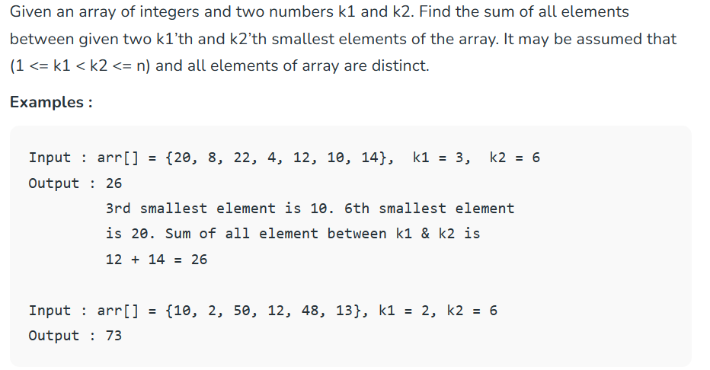

### Problem Statement

Given an array, find the sum of all numbers between the K1th and K2th smallest elements of that array.

**Example 1**:

Input: [1, 3, 12, 5, 15, 11], and K1=3, K2=6

Output: 23

Explanation: The 3rd smallest number is 5 and 6th smallest number 15. The sum of numbers coming

between 5 and 15 is 23 (11+12).

**Example 2**:

Input: [3, 5, 8, 7], and K1=1, K2=4

Output: 12

Explanation: The sum of the numbers between the 1st smallest number (3) and the 4th smallest

number (8) is 12 (5+7).

### Solution

This problem follows the Top ‘K’ Numbers pattern, and shares similarities with Kth Smallest Number.

We can find the sum of all numbers coming between the K1’th and K2’th smallest numbers in the following steps:

1. First, insert all numbers in a min-heap.
2. Remove the first K1 smallest numbers from the min-heap.
3. Now take the next K2-K1-1 numbers out of the heap and add them. This sum will be our required output.

### Code

|  |
| --- |
| import java.util.*;  class Solution {  public static int findSumOfElements(int[] nums, int k1, int k2) {  PriorityQueue<Integer> minHeap = new PriorityQueue<Integer>((n1, n2) -> n1 - n2);  // insert all numbers to the min heap  for (int i = 0; i < nums.length; i++)  minHeap.add(nums[i]);  // remove k1 small numbers from the min heap  for (int i = 0; i < k1; i++)  minHeap.poll();  int elementSum = 0;  // sum next k2-k1-1 numbers  for (int i = 0; i < k2 - k1 - 1; i++)  elementSum += minHeap.poll();  return elementSum;  }  public static void main(String[] args) {  int result =  Solution.findSumOfElements(new int[] { 1, 3, 12, 5, 15, 11 }, 3, 6);  System.out.println(  "Sum of all numbers between k1 and k2 smallest numbers: " + result);  result = Solution.findSumOfElements(new int[] { 3, 5, 8, 7 }, 1, 4);  System.out.println(  "Sum of all numbers between k1 and k2 smallest numbers: " + result);  }  } |

### Time Complexity

Since we need to put all the numbers in a min-heap, the time complexity of the above algorithm will be O(N*logN) where ‘N’ is the total input numbers.

### Space Complexity

The space complexity will be O(N), as we need to store all the ‘N’ numbers in the heap.

### Alternate Solution

We can iterate the array and use a max-heap to keep track of the top K2 numbers. We can, then, add the top K2-K1-1 numbers in the max-heap to find the sum of all numbers coming between the K1’th and K2’th smallest numbers. Here is what the algorithm will look like:

### Code 1

|  |
| --- |
| static long sumBetweenTwoKth(long arr[], long n, long k1, long k2) {  PriorityQueue<Long> maxHeap = new PriorityQueue<>(  Collections.reverseOrder());  for (int i = 0; i < n; i++) {  maxHeap.add(arr[i]);  if (maxHeap.size() >= k2) {  maxHeap.poll();  }  }  long ans = 0;  while (maxHeap.size() > k1) {  ans += maxHeap.poll();  }  return ans;  } |

Code 1 is better than Code2

### Code 2

|  |
| --- |
| import java.util.*;  class Solution {  public static int findSumOfElements(int[] nums, int k1, int k2) {  PriorityQueue<Integer> maxHeap = new PriorityQueue<Integer>((n1, n2) -> n2 - n1);  // keep smallest k2 numbers in the max heap  for (int i = 0; i < nums.length; i++) {  if (i < k2 - 1) {  maxHeap.add(nums[i]);  } else if (nums[i] < maxHeap.peek()) {  maxHeap.poll(); // as we are interested only in the smallest k2 numbers  maxHeap.add(nums[i]);  }  }  // get the sum of numbers between k1 and k2 indices  // these numbers will be at the top of the max heap  int elementSum = 0;  for (int i = 0; i < k2 - k1 - 1; i++)  elementSum += maxHeap.poll();  return elementSum;  }  public static void main(String[] args) {  int result =  Solution.findSumOfElements(new int[] { 1, 3, 12, 5, 15, 11 }, 3, 6);  System.out.println(  "Sum of all numbers between k1 and k2 smallest numbers: " + result);  result = Solution.findSumOfElements(new int[] { 3, 5, 8, 7 }, 1, 4);  System.out.println(  "Sum of all numbers between k1 and k2 smallest numbers: " + result);  }  } |

### Time Complexity

Since we need to put only the top K2 numbers in the max-heap at any time, the time complexity of the above algorithm will be O(N*logK2).

### Space Complexity

The space complexity will be O(K2), as we need to store the smallest ‘K2’ numbers in the heap.

## Rearrange String (hard)

<https://leetcode.com/problems/reorganize-string/>

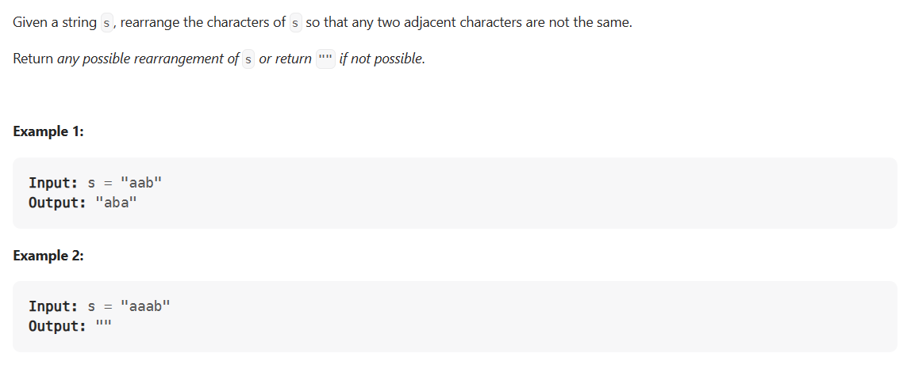

### Problem Statement

Given a string, find if its letters can be rearranged in such a way that no two same characters come next to each other.

**Example 1**:

Input: "aappp"

Output: "papap"

Explanation: In "papap", none of the repeating characters come next to each other.

**Example 2**:

Input: "Programming"

Output: "rgmrgmPiano" or "gmringmrPoa" or "gmrPagimnor", etc.

Explanation: None of the repeating characters come next to each other.

**Example 3**:

Input: "aapa"

Output: ""

Explanation: In all arrangements of "aapa", atleast two 'a' will come together e.g., "apaa", "paaa".

### Solution

This problem follows the Top ‘K’ Numbers pattern. We can follow a greedy approach to find an arrangement of the given string where no two same characters come next to each other.

We can work in a stepwise fashion to create a string with all characters from the input string. Following a greedy approach, we should first append the most frequent characters to the output strings, for which we can use a **Max Heap**. By appending the most frequent character first, we have the best chance to find a string where no two same characters come next to each other.

So in each step, we should append one occurrence of the highest frequency character to the output string. We will not put this character back in the heap to ensure that no two same characters are adjacent to each other. In the next step, we should process the next most frequent character from the heap in the same way and then, at the end of this step, insert the character from the previous step back to the heap after decrementing its frequency.

Following this algorithm, if we can append all the characters from the input string to the output string, we would have successfully found an arrangement of the given string where no two same characters appeared adjacent to each other.

### Code

|  |
| --- |
| import java.util.*;  class Solution {  public static String rearrangeString(String str) {  Map<Character, Integer> charFrequencyMap = new HashMap<>();  for (char chr : str.toCharArray())  charFrequencyMap.put(chr, charFrequencyMap.getOrDefault(chr, 0) + 1);  PriorityQueue<Map.Entry<Character, Integer>> maxHeap =  new PriorityQueue<Map.Entry<Character, Integer>>(  (e1, e2) -> e2.getValue() - e1.getValue());  // add all characters to the max heap  maxHeap.addAll(charFrequencyMap.entrySet());  Map.Entry<Character, Integer> previousEntry = null;  StringBuilder resultString = new StringBuilder(str.length());  while (!maxHeap.isEmpty()) {  Map.Entry<Character, Integer> currentEntry = maxHeap.poll();  // add the previous entry back in the heap if its frequency is greater than zero  if (previousEntry != null && previousEntry.getValue() > 0)  maxHeap.offer(previousEntry);  // append the current character to the result string and decrement its count  resultString.append(currentEntry.getKey());  currentEntry.setValue(currentEntry.getValue() - 1);  previousEntry = currentEntry;  }  // if we were successful in appending all the characters to the result string,  // return it  return resultString.length() == str.length() ? resultString.toString() : "";  }  public static void main(String[] args) {  System.out.println("Rearranged string: " +  Solution.rearrangeString("aappp"));  System.out.println("Rearranged string: " +  Solution.rearrangeString("Programming"));  System.out.println("Rearranged string: " +  Solution.rearrangeString("aapa"));  }  } |

### Time Complexity

The time complexity of the above algorithm is O(N*logN) where ‘N’ is the number of characters in the input string.

### Space Complexity

The space complexity will be O(N), as in the worst case, we need to store all the ‘N’ characters in the **HashMap**.

### Java Solution : PriorityQueue O(nlogn)

Time Complexity : O(nlogn)

|  |
| --- |
| public static String reorganizeString(String s) {  int[] charCount = new int[26];  for(char ch: s.toCharArray()){  charCount[ch - 'a']++;  }  PriorityQueue<Pair> maxHeap = new PriorityQueue<>((a,b) -> b.freq - a.freq);  for(int i = 0; i< charCount.length; i++){  if(charCount[i]>0) {  maxHeap.add(new Pair((char) ('a'+i), charCount[i]));  }  }  StringBuilder res = new StringBuilder();  Pair block = maxHeap.poll();  res.append(block.ch);  block.freq--;  while(!maxHeap.isEmpty()){  Pair temp = maxHeap.poll();  res.append(temp.ch);  temp.freq--;  if(block.freq > 0)  maxHeap.add(block);  block = temp;  }  if(block.freq>0) return "";  return res.toString();  }  static class Pair{  char ch;  int freq;  Pair(char ch, int freq){  this.ch = ch;  this.freq = freq;  }  } |

### Java Solution : Array O(n)

Time Complexity: On)

|  |
| --- |
| public static String reorganizeStringOptimised(String s) {  int[] charCount = new int[26];  char[] arr = s.toCharArray();  for(char ch: arr){  charCount[ch - 'a']++;  }  int max = 0, letter = 0;  for(int i = 0; i< charCount.length; i++){  if(charCount[i] > max){  max = charCount[i];  letter = i;  }  }  if(max> (s.length()+1)/2) return "";  int index = 0;  char[] res = new char[s.length()];  while(charCount[letter] >0){  res[index] = (char)(letter+'a');  index +=2;  charCount[letter]--;  }  for(int i = 0; i< 26; i++){  while(charCount[i] >0){  if(index >= s.length()) index = 1;  res[index] = (char)(i+'a');  index += 2;  charCount[i]--;  }  }  return String.valueOf(res);  } |

**🌟 Rearrange String K Distance Apart (hard)**

<https://leetcode.com/problems/rearrange-string-k-distance-apart/>

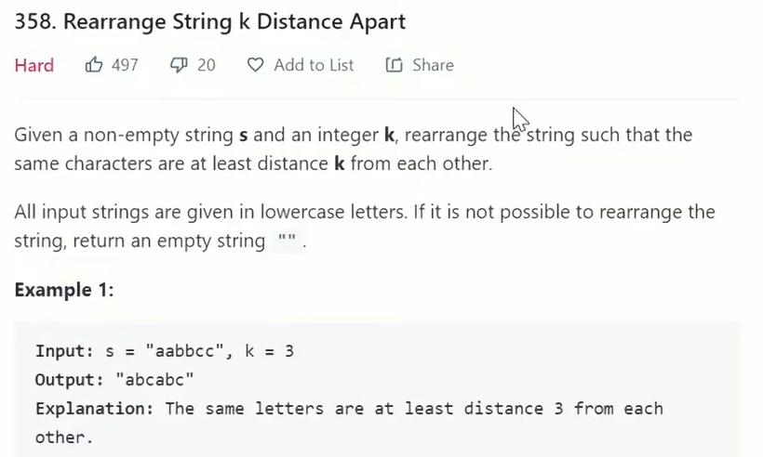

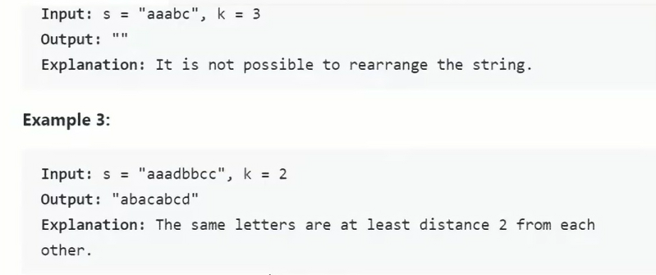

### Problem Statement

Given a string and a number K, find if the string can be rearranged such that the same characters are at least K distance apart from each other.

**Example 1**:

Input: "mmpp", K=2

Output: "mpmp" or "pmpm"

Explanation: All same characters are 2 distance apart.

**Example 2**:

Input: "Programming", K=3

Output: "rgmPrgmiano" or "gmringmrPoa" or "gmrPagimnor" and a few more

Explanation: All same characters are 3 distance apart.

**Example 3**:

Input: "aab", K=2

Output: "aba"

Explanation: All same characters are 2 distance apart.

**Example 4**:

Input: "aappa", K=3

Output: ""

Explanation: We cannot find an arrangement of the string where any two 'a' are 3 distance apart.

### Solution

This problem follows the Top ‘K’ Numbers pattern and is quite similar to Rearrange String. The only difference is that in the ‘Rearrange String’ the same characters need not be adjacent i.e., they should be at least ‘2’ distance apart (in other words, there should be at least one character between two same characters), while in the current problem, the same characters should be ‘K’ distance apart.

Following a similar approach, since we were inserting a character back in the heap in the next iteration, in this problem, we will re-insert the character after ‘K’ iterations. We can keep track of previous characters in a queue to insert them back in the heap after ‘K’ iterations.

### Code

|  |
| --- |
| import java.util.*;  class Solution {  public static String reorganizeString(String str, int k) {  if (k <= 1)  return str;  Map<Character, Integer> charFrequencyMap = new HashMap<>();  for (char chr : str.toCharArray())  charFrequencyMap.put(chr, charFrequencyMap.getOrDefault(chr, 0) + 1);  PriorityQueue<Map.Entry<Character, Integer>> maxHeap =  new PriorityQueue<Map.Entry<Character, Integer>>(  (e1, e2) -> e2.getValue() - e1.getValue());  // add all characters to the max heap  maxHeap.addAll(charFrequencyMap.entrySet());  Queue<Map.Entry<Character, Integer>> queue = new LinkedList<>();  StringBuilder resultString = new StringBuilder(str.length());  while (!maxHeap.isEmpty()) {  Map.Entry<Character, Integer> currentEntry = maxHeap.poll();  // append the current character to the result string and decrement its count  resultString.append(currentEntry.getKey());  currentEntry.setValue(currentEntry.getValue() - 1);  queue.offer(currentEntry);  if (queue.size() == k) {  Map.Entry<Character, Integer> entry = queue.poll();  if (entry.getValue() > 0)  maxHeap.add(entry);  }  }  // if we were successful in appending all the characters to the result string,  // return it  return resultString.length() == str.length() ? resultString.toString() : "";  }  public static void main(String[] args) {  System.out.println("Reorganized string: " +  Solution.reorganizeString("mmpp", 2));  System.out.println("Reorganized string: " +  Solution.reorganizeString("Programming", 3));  System.out.println("Reorganized string: " +  Solution.reorganizeString("aab", 2));  System.out.println("Reorganized string: " +  Solution.reorganizeString("aappa", 3));  }  } |

### Time Complexity

The time complexity of the above algorithm is O(N∗logN) where ‘N’ is the number of characters in the input string.

### Space Complexity

The space complexity will be O(N), as in the worst case, we need to store all the ‘N’ characters in the HashMap.

### Java Solution

|  |
| --- |
| public static String reorganizeString(String s, int k) {  int[] charCount = new int[26];  for(char ch: s.toCharArray()){  charCount[ch - 'a']++;  }  PriorityQueue<Pair> maxHeap = new PriorityQueue<>((a,b) -> (b.freq - a.freq == 0)?a.ch - b.ch : b.freq - a.freq);  for(int i = 0; i< charCount.length; i++){  if(charCount[i]>0) {  maxHeap.add(new Pair((char) ('a'+i), charCount[i]));  }  }  StringBuilder res = new StringBuilder();  while(maxHeap.size() >= k){  Pair[] pairs = new Pair[k];  for(int i = 0 ; i< k; i++){  pairs[i] = maxHeap.poll();  }  for(int i = 0; i < k; i++){  res.append(pairs[i].ch);  pairs[i].freq--;  if(pairs[i].freq > 0) maxHeap.add(pairs[i]);  }  }  while(!maxHeap.isEmpty()){  Pair pair = maxHeap.poll();  res.append(pair.ch);  pair.freq--;  if(pair.freq > 0) return "";  }  return res.toString();  }  static class Pair{  char ch;  int freq;  Pair(char ch, int freq){  this.ch = ch;  this.freq = freq;  }  } |

### Java Solution 2: Priority Queue based greedy search

In order to complete the rearrangement for the original string, we need to always consider about the character with the highest frequency first because this is our best bet to construct the result. Hence this is a greedy algorithm.

For the purpose to get the character with highest frequency easily, we can make use of a max heap sorted based on the frequency of the characters in s. Consider that there might exists two character with the same frequency, we need to add an extra comparison setp in the comparator, that is, when 2 characters have the same frequency, we sort them alphabetically. This way we can aoivd the undefinite behavior in Java's PriorityQueue when 2 values in it have the same rank.

Meanwhile, we have to also keep a FIFO queue to store all the characters that have been added but is frozen right now because of the k distance limitation. We can only add them back to the max heap when we have passed k steps, i.e. there are k entries in the wait queue.

Hence we have the following implementation.

**Time complexity: O(nlogn)** since we have to perform the poll and offer on the queue n times each given that there is n characters in s in total.

**Space complexity: O(26) = O(1)**

|  |
| --- |
| public static String rearrangeString(String s, int k) {  int len = s.length();  Map<Character, Integer> map = new HashMap<>();  for (int i = 0; i < len; i++) {  map.put(s.charAt(i), map.getOrDefault(s.charAt(i), 0) + 1);  }  // Initialize a max heap sorted based on the frequency of the characters  // For two characters with the same frequency, sort based on alphabetical order  Queue<Map.Entry<Character, Integer>> maxHeap = new PriorityQueue<>((a, b) -> a.getValue() == b.getValue() ? a.getKey() - b.getKey() : b.getValue() - a.getValue());  Queue<Map.Entry<Character, Integer>> waitQueue = new LinkedList<>();  maxHeap.addAll(map.entrySet());  StringBuilder sb = new StringBuilder();  while (!maxHeap.isEmpty()) {  Map.Entry<Character, Integer> entry = maxHeap.poll();  sb.append(entry.getKey());  entry.setValue(entry.getValue() - 1);  waitQueue.offer(entry);  // need to wait for distance k  if (waitQueue.size() < k) {  continue;  }  Map.Entry<Character, Integer> front = waitQueue.poll();  if (front.getValue() > 0) {  maxHeap.offer(front);  }  }  return sb.length() == s.length() ? sb.toString() : "";  } |

### Java Solution2: Two array for frequency and next valid position

Since this is a greedy question, for sure we need to consider placing the characters with higher frequencies first. Thus we first construct a map between characters and their corresponding frequencies. Meanwhile, since the same character must be at least distance k from each other, we keep another map between each character and their next valid position, say we have put 'a' at index i, then the next valid position of 'a' should be greater than or equal to i + k.

During the process we iterate through the input String, we first get the first character among 'a' to 'z' that satisfy:

1. It has the highest frequency among the remaining characters.
2. Current index we are considering is at least distance k from the previous position of this character, that is to say, the next valid position of this character should be less than or equal to current index.

If we cannot find a match, that means a result satisfies the question requirement is not possible, return "".

Otherwise, we reduce frequency of current character by 1 and update its next valid position.

**Time complexity: O(26*n) = O(n)** where n is the length of the input string.

**Space complexity: O(26) = O(1)**

|  |
| --- |
| public static String rearrangeStringOptimized(String s, int k) {  int len = s.length();  int[] count = new int[26];  int[] nextPosition = new int[26];  for (int i = 0; i < len; i++) {  count[s.charAt(i) - 'a']++;  }  StringBuilder sb = new StringBuilder();  for (int index = 0; index < len; index++) {  int candidate = findCandidate(count, nextPosition, index);  if (candidate == -1) return "";  count[candidate]--;  nextPosition[candidate] = index + k;  sb.append((char)('a' + candidate));  }  return sb.toString();  }  private static int findCandidate(int[] count, int[] nextPosition, int index) {  int max = Integer.MIN_VALUE;  int candidate = -1;  for (int i = 0; i < count.length; i++) {  if (count[i] > 0 && count[i] > max && index >= nextPosition[i]) {  max = count[i];  candidate = i;  }  }  return candidate;  } |

## 🌟 🔎 Scheduling Tasks (hard)

<https://leetcode.com/problems/task-scheduler/>

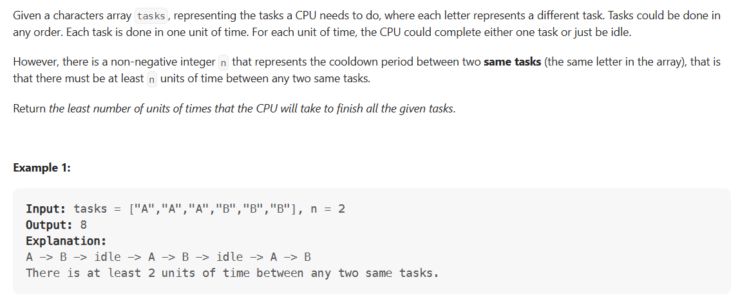

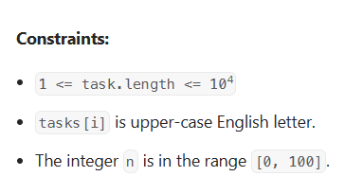

### Problem Statement

You are given a list of tasks that need to be run, in any order, on a server. Each task will take one CPU interval to execute but once a task has finished, it has a cooling period during which it cant be run again. If the cooling period for all tasks is K intervals, find the minimum number of CPU intervals that the server needs to finish all tasks.

If at any time the server can't execute any task then it must stay idle.

**Example 1**:

Input: [a, a, a, b, c, c], K=2

Output: 7

Explanation: a -> c -> b -> a -> c -> idle -> a

**Example 2**:

Input: [a, b, a], K=3

Output: 5

Explanation: a -> b -> idle -> idle -> a

### Solution

This problem follows the Top 'K' Numbers pattern and is quite similar to Rearrange String K Distance Apart. We need to rearrange tasks such that same tasks are ‘K’ distance apart.

Following a similar approach, we will use a **Max Heap** to execute the highest frequency task first. After executing a task we decrease its frequency and put it in a waiting list. In each iteration, we will try to execute as many as k+1 tasks. For the next iteration, we will put all the waiting tasks back in the **Max Heap**. If, for any iteration, we are not able to execute k+1 tasks, the CPU has to remain idle for the remaining time in the next iteration.

### Code

|  |
| --- |
| import java.util.*;  class Solution {  public static int scheduleTasks(char[] tasks, int k) {  int intervalCount = 0;  Map<Character, Integer> taskFrequencyMap = new HashMap<>();  for (char chr : tasks)  taskFrequencyMap.put(chr, taskFrequencyMap.getOrDefault(chr, 0) + 1);  PriorityQueue<Map.Entry<Character, Integer>> maxHeap =  new PriorityQueue<Map.Entry<Character, Integer>>(  (e1, e2) -> e2.getValue() - e1.getValue());  // add all tasks to the max heap  maxHeap.addAll(taskFrequencyMap.entrySet());  while (!maxHeap.isEmpty()) {  List<Map.Entry<Character, Integer>> waitList = new ArrayList<>();  int n = k + 1; // try to execute as many as 'k+1' tasks from the max-heap  for (; n > 0 && !maxHeap.isEmpty(); n--) {  intervalCount++;  Map.Entry<Character, Integer> currentEntry = maxHeap.poll();  if (currentEntry.getValue() > 1) {  currentEntry.setValue(currentEntry.getValue() - 1);  waitList.add(currentEntry);  }  }  maxHeap.addAll(waitList); // put all the waiting list back on the heap  if (!maxHeap.isEmpty())  intervalCount += n; // we'll be having 'n' idle intervals for the next iteration  }  return intervalCount;  }  public static void main(String[] args) {  char[] tasks = new char[] { 'a', 'a', 'a', 'b', 'c', 'c' };  System.out.println("Minimum intervals needed to execute all tasks: " +  Solution.scheduleTasks(tasks, 2));  tasks = new char[] { 'a', 'b', 'a' };  System.out.println("Minimum intervals needed to execute all tasks: " +  Solution.scheduleTasks(tasks, 3));  }  } |

### Time Complexity

The time complexity of the above algorithm is O(N∗logN) where ‘N’ is the number of tasks. Our while loop will iterate once for each occurrence of the task in the input (i.e. ‘N’) and in each iteration we will remove a task from the heap which will take O(logN) time. Hence the overall time complexity of our algorithm is O(N∗logN).

### Space Complexity

The space complexity will be O(N), as in the worst case, we need to store all the ‘N’ tasks in the HashMap.

Previous

Problem Challenge 2: Scheduling

**A mental model for solving this problem**

❗ Explaination referenced [here](https://leetcode.com/problems/task-scheduler/discuss/1874475/Easy-Solution-with-Writeup)

Consider the following input:

tasks = ["A", "A", "A", "B", "B", "B", "C", "C", "C", "D", "D", "E"]

n = 2

* First let's find the most frequently occuring task and lay it out like so (an underscore represents a cooldown period):

A _ _ A _ _ A

* Our goal is to insert all the other tasks into this sequence by filling the cooldown periods first.
* We know any other task can be scheduled into this sequence without creating additional cooldown slots because:

1. The number of occurrences of any task x is less than or equal to the number occurences of the most frequrntly occuring task A; and
2. We can always find a sequence of k different tasks to schedule between any pair of tasks x.

* Let's insert in the second most frequently occuring task B (we fill the two cooldown slots first and append the third task to the end):

A B _ A B _ A B

* Next let's insert in the third most frequently occuring task C (we fill in the two cooldown slots first and append the third task to the end):

A B C A B C A B C

* Next let's insert the fourth most frequently occuring task D. At this point we've used up all our cooldown slots so we can insert these tasks pretty much anywhere we like as long as there are at least k tasks between every pair of D tasks.

D A B D C A B C A B C

* Lastly, the least frequently occuring task E can be inserted literally anywhere we like. Because it only occurs once there is no cooldown period we need to respect.

D A B D C A B C A E B C

The sequence above is the shortest possible sequence these tasks can be scheduled in. **Note** that there are multiple possible sequences of this length.

The answer to the problem is the number of tasks + the number of cooldown periods.

**😕 Heap Solution**

Following a similar approach, we will use a **Max Heap** to execute the highest frequency task first. After executing a task we decrease its frequency and put it in a waiting list. In each iteration, we will try to execute as many as k+1 tasks. For the next iteration, we will put all the waiting tasks back in the **Max Heap** . If, for any iteration, we are not able to execute k+1 tasks, the CPU has to remain idle for the remaining time in the next iteration.

class Heap {

constructor(data = []) {

this.data = data;

this.comparator = (a, b) => a - b;

this.heapify();

}

heapify() {

//O(nlog(n))

if (this.size() < 2) return;

for (let i = 1; i < this.size(); i++) {

this.bubbleUp(i);

}

}

peek() {

// O(1)

if (this.size() === 0) return null;

return this.data[0];

}

offer(value) {

// O(log(n))

this.data.push(value);

this.bubbleUp(this.size() - 1);

}

poll() {

// O(log(n))

if (this.size() === 0) return null;

const result = this.data[0];

const last = this.data.pop();

if (this.size() !== 0) {

this.data[0] = last;

this.bubbleDown(0);

}

return result;

}

bubbleUp(index) {

// O(log(n))

while (index > 0) {

const parentIndex = (index - 1) >> 1;

if (this.comparator(this.data[index], this.data[parentIndex]) < 0) {

this.swap(index, parentIndex);

index = parentIndex;

} else {

break;

}

}

}

bubbleDown(index) {

// O(log(n))

const lastIndex = this.size() - 1;

while (true) {

const startIndex = index * 2 + 1;

const endIndex = index * 2 + 2;

let findIndex = ind;

if (

startIndex <= lastIndex &&

this.comparator(this.data[startIndex], this.data[findIndex]) < 0

) {

findIndex = starttIndex;

}

if (

endIndex <= lastIndex &&

this.comparator(this.data[endIndex], this.data[findIndex]) < 0

) {

findIndex = endIndex;

}

if (index !== findIndex) {

this.swap(index, findIndex);

index = findIndex;

} else {

break;

}

}

}

swap(index1, index2) {

// O(1)

[this.data[index1], this.data[index2]] = [

this.data[index2],

this.data[index1],

];

}

size() {

// O(1)

return this.data.length;

}

}

function scheduleTasks(tasks, k) {

let intervalCount = 0;

let taskFreqMap = new Map();

tasks.forEach((char) => {

taskFreqMap.set(char, taskFreqMap.get(char) + 1 || 1);

});

const maxHeap = new Heap();

//add all taks to the heap

Object.keys(taskFreqMap).forEach((char) => {

// 😕

maxHeap.offer([taskFrequencyMap[char], char]);

});

while (maxHeap.length > 0) {

const waitList = [];

let n = k + 1; // try to execute as many as 'k+1' tasks from the max-heap

while (n > 0 && maxHeap.length > 0) {

intervalCount++;

const [frequency, char] = maxHeap.pop();

if (frequency > 1) {

// decrement the frequency and add to the waitList

waitList.push([frequency - 1, char]);

}

n -= 1;

}

// put all the waiting list back on the heap

waitList.forEach((task) => maxHeap.offer(task));

if (maxHeap.length > 0) {

intervalCount += n; // we'll be having 'n' idle intervals for the next iteration

}

}

return intervalCount;

}

console.log(

`Minimum intervals needed to execute all tasks: ${scheduleTasks(

["a", "a", "a", "b", "c", "c"],

2

)}`

);

//7

//a -> c -> b -> a -> c -> idle -> a

console.log(

`Minimum intervals needed to execute all tasks: ${scheduleTasks(

["a", "b", "a"],

3

)}`

);

//5

//a -> b -> idle -> idle -> a

* The time complexity of the above algorithm is O(N∗logN) where N is the number of tasks. Our while loop will iterate once for each occurrence of the task in the input (i.e. N) and in each iteration we will remove a task from the **heap** which will take O(logN)time. Hence the overall time complexity of our algorithm is O(N*logN).
* The space complexity will be O(N), as in the worst case, we need to store all the N tasks in the **HashMap**.

**Greedy HashMap Solution**

function scheduleTasks(tasks, k) {

let taskFreqMap = new Map();

let intervalMax = 0;

let taskCountMax = 0;

tasks.forEach((char) => {

taskFreqMap.set(char, taskFreqMap.get(char) + 1 || 1);

//set intervalMax and taskCountMax only if we have a new max

if (taskFreqMap.get(char) > intervalMax) {

intervalMax = taskFreqMap.get(char);

taskCountMax = 1;

} else if (taskFreqMap.get(char) === intervalMax) {

//otherwise, increment taskCountMax

taskCountMax++;

}

});

return Math.max(tasks.length, (intervalMax - 1) * (k + 1) + taskCountMax);

}

console.log(

`Minimum intervals needed to execute all tasks: ${scheduleTasks(

["A", "A", "A", "B", "B", "B"],

2

)}`

);

// 8

// A -> B -> idle -> A -> B -> idle -> A -> B

// There is at least 2 units of time between any two same tasks.

console.log(

`Minimum intervals needed to execute all tasks: ${scheduleTasks(

["A", "A", "A", "B", "B", "B"],

0

)}`

);

// 6

// On this case any permutation of size 6 would work since n = 0.

// ["A","A","A","B","B","B"]

// ["A","B","A","B","A","B"]

// ["B","B","B","A","A","A"]

console.log(

`Minimum intervals needed to execute all tasks: ${scheduleTasks(

["A", "A", "A", "A", "A", "A", "B", "C", "D", "E", "F", "G"],

2

)}`

);

// 16

// One possible solution is

// A -> B -> C -> A -> D -> E -> A -> F -> G -> A

// -> idle -> idle -> A -> idle -> idle -> A

### Java Solution: Sorting

**Approach:**

1. Create a frequency array freq to count the number of occurrences of each task.
2. Sort the freq array in ascending order.
3. Calculate the maximum frequency maxFreq of any task.
4. Calculate the number of idle slots idleSlots required by the most frequent task, which is equal to (maxFreq - 1) * n.
5. Iterate over the remaining tasks in descending order of frequency and subtract the minimum of maxFreq and the frequency of the task from idleSlots.
6. If idleSlots is still positive, add it to the length of the input task list tasks. Otherwise, return tasks.size().

**Complexity:**

* Time complexity: The time complexity of the algorithm is O(26 log 26 + n), where 26 log 26 is the time complexity of sorting the frequency array, and n is the length of the input task list.
* Space complexity: The space complexity of the algorithm is O(26), which is the size of the frequency array.

|  |
| --- |
| public static int leastIntervalSorting(char[] tasks, int n) {  // Create a frequency array to keep track of the count of each task  int[] freq = new int[26];  for (char task : tasks) {  freq[task - 'A']++;  }  // Sort the frequency array in non-decreasing order  Arrays.sort(freq);  // Calculate the maximum frequency of any task  int maxFreq = freq[25] - 1;  // Calculate the number of idle slots that will be required  int idleSlots = maxFreq * n;  // Iterate over the frequency array from the second highest frequency to the lowest frequency  for (int i = 24; i >= 0 && freq[i] > 0; i--) {  // Subtract the minimum of the maximum frequency and the current frequency from the idle slots  idleSlots -= Math.min(maxFreq, freq[i]);  }  // If there are any idle slots left, add them to the total number of tasks  return idleSlots > 0 ? idleSlots + tasks.length : tasks.length;  } |

### Java Solution 2 : Using Formula

Time - Complexity : O(n)

Space - Complexity: O(26)

**Explanation:**

**max** = length of maximum occurring character  
**maxCount** = total number of character that are occurring for max times.

Let's take a example **AAABBBC** , **n=2**  
result: **7** => **ABCAB#AB**

first, we try to fill most frequent character and a empty gap of length n is created between these two characters

A _ _ A _ _ A

here places of most frequent character is fixed , and in empty spaces we have to fill remaining character, we can also notice that length of all part (excluding last character 'A') is equals to **(max - 1) * (n+1)** , i.e. **A _ _ A _ _**

**Reason** -> as we are excluding last 'A' total slots created is **(max-1)** and after including 'A' and empty spaces **(A _ _ )** , length of one slot is **(n+1)**  
so, length after excluding last 'A' = **(max-1)*(n+1)**

But, there can be a case where more than one character can appear for max times, so in this case we have to fill second character just after first,

**A B _ A B _ A B**

in this case, length of last part which was excluded earlier is equals to maxCount, A B _ A B _ **A B**  
so, totalLength = **((max-1) * (n+1)) + maxCount;**

**But, wait!,** what if we have given **n=0,** we don't have to bother about the order of occurrences, so it result will be equals to tasks.length.  
So,

result=Math.max(tasks.length, ((max-1) * (n+1)) + maxCount);

|  |
| --- |
| public static int leastInterval(char[] tasks, int n) {  if(n < 1) return tasks.length;  int[] count = new int[26];  int max = 0, maxCount = 0;  for(char ch : tasks){  count[ch-'A']++;  if(count[ch-'A']==max){  maxCount++;  }else if(count[ch-'A']>max){  max=count[ch-'A'];  maxCount=1;  }  }  return Math.max(tasks.length, (max-1)*(n+1) + maxCount);  } |

**🌟Frequency Stack (hard)**

<https://leetcode.com/problems/maximum-frequency-stack/>

### Problem Statement

Design a class that simulates a Stack data structure, implementing the following two operations:

* push(int num): Pushes the number num on the stack.
* pop(): Returns the most frequent number in the stack. If there is a tie, return the number which was pushed later.

**Example**:

After following push operations: push(1), push(2), push(3), push(2), push(1), push(2), push(5)

1. pop() should return 2, as it is the most frequent number

2. Next pop() should return 1

3. Next pop() should return 2

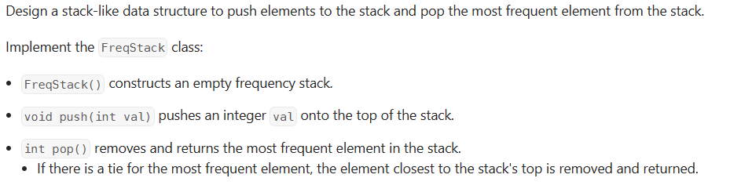

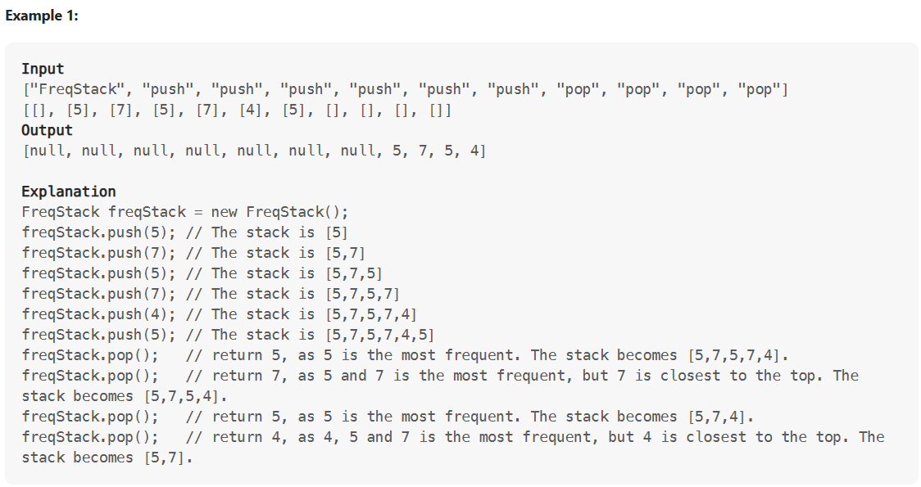

### Solution

This problem follows the Top ‘K’ Elements pattern, and shares similarities with Top ‘K’ Frequent Numbers.

We can use a Max Heap to store the numbers. Instead of comparing the numbers we will compare their frequencies so that the root of the heap is always the most frequently occurring number. There are two issues that need to be resolved though:

1. How can we keep track of the frequencies of numbers in the heap? When we are pushing a new number to the Max Heap, we don’t know how many times the number has already appeared in the Max Heap. To resolve this, we will maintain a HashMap to store the current frequency of each number. Thus whenever we push a new number in the heap, we will increment its frequency in the HashMap and when we pop, we will decrement its frequency.
2. If two numbers have the same frequency, we will need to return the number which was pushed later while popping. To resolve this, we need to attach a sequence number to every number to know which number came first.

In short, we will keep three things with every number that we push to the heap:

1. number // value of the number

2. frequency // frequency of the number when it was pushed to the heap

3. sequenceNumber // a sequence number, to know what number came first

### Code

|  |
| --- |
| import java.util.*;  class Element {  int number;  int frequency;  int sequenceNumber;  public Element(int number, int frequency, int sequenceNumber) {  this.number = number;  this.frequency = frequency;  this.sequenceNumber = sequenceNumber;  }  }  class ElementComparator implements Comparator<Element> {  public int compare(Element e1, Element e2) {  if (e1.frequency != e2.frequency)  return e2.frequency - e1.frequency;  // if both elements have same frequency, return the one that was pushed later  return e2.sequenceNumber - e1.sequenceNumber;  }  }  class Solution {  int sequenceNumber = 0;  PriorityQueue<Element> maxHeap = new PriorityQueue<Element>(new ElementComparator());  Map<Integer, Integer> frequencyMap = new HashMap<>();  public void push(int num) {  frequencyMap.put(num, frequencyMap.getOrDefault(num, 0) + 1);  maxHeap.offer(new Element(num, frequencyMap.get(num), sequenceNumber++));  }  public int pop() {  int num = maxHeap.poll().number;  // decrement the frequency or remove if this is the last number  if (frequencyMap.get(num) > 1)  frequencyMap.put(num, frequencyMap.get(num) - 1);  else  frequencyMap.remove(num);  return num;  }  public static void main(String[] args) {  Solution frequencyStack = new Solution();  frequencyStack.push(1);  frequencyStack.push(2);  frequencyStack.push(3);  frequencyStack.push(2);  frequencyStack.push(1);  frequencyStack.push(2);  frequencyStack.push(5);  System.out.println(frequencyStack.pop());  System.out.println(frequencyStack.pop());  System.out.println(frequencyStack.pop());  }  } |

### Time Complexity

The time complexity of push() and pop() is O(logN) where ‘N’ is the current number of elements in the heap.

### Space Complexity

We will need O(N) space for the heap and the map, so the overall space complexity of the algorithm is O(N).

**Frequency Map & Stack Solution**

❗ Explaination referenced [here](https://leetcode.com/problems/maximum-frequency-stack/discuss/1086543/JS-Python-Java-C%2B%2B-or-Frequency-Map-and-Stack-Solution-w-Explanation)

There are many ways to solve this problem, but the description gives us two clues as to the most efficient way to do so.

* First, any time the word *"frequency"* is used, we're most likely going to need to make a **frequency map**.
* Second, they use the word *"stack"* in the title, so we should look at the possibility of a **stack** solution.

In this instance, we should consider a **2D stack**, with frequency on one side and input order on the other. This **stack** will hold each individual instance of a value pushed separately by what the frequency was at the time of insertion.

freqStack will work here because it starts at **1** and will increment from there. If we remember to pop() off unused frequencies, then the top of the frequency dimension of our **stack** stack[stack.length-1] will always represent the most frequent element, while the top of the input order dimension will represent the most recently seen value.

Our frequency map freqMap() will be used to keep track of the current frequencies of seen elements, so we know where to enter new ones into our stack.

**Implementation:**

Since our frequencies are **1-indexed** and the **stack** is **0-indexed**, we have to insert a dummy **0-index** for all languages except *Javascript*, which lets you directly access even undefined array elements by index.

class FreqStack {

constructor() {

this.freqMap = new Map();

this.freqStack = [];

}

push(value) {

let freq = this.freqMap.get(value) + 1 || 0;

this.freqMap.set(value, freq);

if (!this.freqStack[freq]) {

this.freqStack[freq] = [value];

} else {

this.freqStack[freq].push(value);

}

console.log(this.freqStack);

}

pop() {

let top = this.freqStack[this.freqStack.length - 1];

let value = top.pop();

if (!top.length) this.freqStack.pop();

this.freqMap.set(value, this.freqMap.get(value) - 1);

return value;

}

}

// Input

// ["FreqStack", "push", "push", "push", "push", "push", "push", "pop", "pop", "pop", "pop"]

// [[], [5], [7], [5], [7], [4], [5], [], [], [], []]

// Output

// [null, null, null, null, null, null, null, 5, 7, 5, 4]

// Explanation

let freqStack = new FreqStack();

freqStack.push(5); // The stack is [5]

freqStack.push(7); // The stack is [5,7]

freqStack.push(5); // The stack is [5,7,5]

freqStack.push(7); // The stack is [5,7,5,7]

freqStack.push(4); // The stack is [5,7,5,7,4]

freqStack.push(5); // The stack is [5,7,5,7,4,5]

freqStack.pop();

// return 5, as 5 is the most frequent. The stack becomes [5,7,5,7,4].

freqStack.pop();

// return 7, as 5 and 7 is the most frequent, but 7 is closest to the top.

//The stack becomes [5,7,5,4].

freqStack.pop();

// return 5, as 5 is the most frequent. The stack becomes [5,7,4].

freqStack.pop();

// return 4, as 4, 5 and 7 is the most frequent, but 4 is closest to the top. The stack becomes [5,7].

let frequencyStack = new FreqStack();

frequencyStack.push(1);

frequencyStack.push(2);

frequencyStack.push(3);

frequencyStack.push(2);

frequencyStack.push(1);

frequencyStack.push(2);

frequencyStack.push(5);

frequencyStack.pop();

// return 2, as it is the most frequent number

frequencyStack.pop();

// should return 1

frequencyStack.pop();

// should return 2

* **Time Complexity** of O(1) for both push() and pop() operations.
* **Space Complexity** of O(N), where N is the number of elements in the FreqStack().

### Java Solution 1 : Use list size as maxFreq

|  |
| --- |
| public class FreqStack3 {  Map<Integer, Integer> map;  List<Stack<Integer>> stkList;  public FreqStack3() {  map = new HashMap<>();  stkList = new ArrayList<>();  }  public void push(int val) {  map.put(val, map.getOrDefault(val, 0) + 1);  int freq = map.get(val);  if (freq - 1 >= stkList.size()) {  stkList.add(new Stack<Integer>());  }  stkList.get(freq - 1).push(val);  }  public int pop() {  int size = stkList.size();  int x = stkList.get(size - 1).pop();  if (stkList.get(size - 1).isEmpty()) {  stkList.remove(size - 1);  }  map.put(x, map.get(x) - 1);  if (map.get(x) == 0) {  map.remove(x);  }  return x;  }  } |

### Java Solution 2: With maxFreq variable

|  |
| --- |
| public class FreqStack {  Map<Integer, Integer> map;  List<Stack<Integer>> stkList;  int maxFreq;  public FreqStack() {  map = new HashMap<>();  stkList = new ArrayList<>();  this.maxFreq = 0;  }  public void push(int val) {  int freq = map.getOrDefault(val, 0) + 1;  map.put(val, freq);  maxFreq = Math.max(maxFreq, freq);  if (freq - 1 >= stkList.size()) {  stkList.add(new Stack<Integer>());  }  stkList.get(freq - 1).push(val);  }  public int pop() {  Stack<Integer> stack = stkList.get(maxFreq - 1);  int x = stack.pop();  if (stack.isEmpty()) {  maxFreq--;  }  map.put(x, map.get(x) - 1);  return x;  } |

## Kth Smallest Number

### Problem Statement

Given an unsorted array of numbers, find Kth smallest number in it.

Please note that it is the Kth smallest number in the sorted order, not the Kth distinct element.

Example 1:

Input: [1, 5, 12, 2, 11, 5], K = 3

Output: 5

Explanation: The 3rd smallest number is '5', as the first two smaller numbers are [1, 2].

Example 2:

Input: [1, 5, 12, 2, 11, 5], K = 4

Output: 5

Explanation: The 4th smallest number is '5', as the first three smaller numbers are

[1, 2, 5].

Example 3:

Input: [5, 12, 11, -1, 12], K = 3

Output: 11

Explanation: The 3rd smallest number is '11', as the first two small numbers are [5, -1].

### Solution

This is a well-known problem and there are multiple solutions available to solve this. A few other similar problems are:

1. Find the Kth largest number in an unsorted array.
2. Find the median of an unsorted array.
3. Find the ‘K’ smallest or largest numbers in an unsorted array.

Let’s discuss different algorithms to solve this problem and understand their time and space complexity. Similar solutions can be devised for the above-mentioned three problems.

### Brute-force

The simplest brute-force algorithm will be to find the Kth smallest number in a step by step fashion. This means that, first, we will find the smallest element, then 2nd smallest, then 3rd smallest and so on, until we have found the Kth smallest element. Here is what the algorithm will look like:

|  |
| --- |
| class Solution {  public static int findKthSmallestNumber(int[] nums, int k) {  int previousSmallestNum = Integer.MIN_VALUE;  int previousSmallestIndex = -1;  int currentSmallestNum = Integer.MAX_VALUE;  int currentSmallestIndex = -1;  for (int i = 0; i < k; i++) {  for (int j = 0; j < nums.length; j++) {  if (nums[j] > previousSmallestNum && nums[j] < currentSmallestNum) {  // found the next smallest number  currentSmallestNum = nums[j];  currentSmallestIndex = j;  } else if (nums[j] == previousSmallestNum && j > previousSmallestIndex) {  // found a number which is equal to the previous smallest number; since numbers  // can repeat, we will consider 'nums[j]' only if it has a different index  // than previous smallest  currentSmallestNum = nums[j];  currentSmallestIndex = j;  break; // break here as we have found our definitive next smallest number  }  }  // current smallest number becomes previous smallest number for the next iteration  previousSmallestNum = currentSmallestNum;  previousSmallestIndex = currentSmallestIndex;  currentSmallestNum = Integer.MAX_VALUE;  }  return previousSmallestNum;  }  public static void main(String[] args) {  int result =  Solution.findKthSmallestNumber(new int[] { 1, 5, 12, 2, 11, 5 }, 3);  System.out.println("Kth smallest number is: " + result);  // since there are two 5s in the input array, our 3rd and 4th smallest numbers  // should be a '5'  result =  Solution.findKthSmallestNumber(new int[] { 1, 5, 12, 2, 11, 5 }, 4);  System.out.println("Kth smallest number is: " + result);  result = Solution.findKthSmallestNumber(new int[] { 5, 12, 11, -1, 12 }, 3);  System.out.println("Kth smallest number is: " + result);  }  } |

**Time and Space Complexity**

The time complexity of the above algorithm will be O(N*K). The algorithm runs in constant space O(1).

### 2. Brute-force using Sorting

We can use an in-place sort like a **HeapSort** to sort the input array to get the Kth smallest number. Following is the code for this solution:

|  |
| --- |
| import java.util.*;  class Solution {  public static int findKthSmallestNumber(int[] nums, int k) {  Arrays.sort(nums);  return nums[k - 1];  }  public static void main(String[] args) {  int result =  Solution.findKthSmallestNumber(new int[] { 1, 5, 12, 2, 11, 5 }, 3);  System.out.println("Kth smallest number is: " + result);  // as there're two 5s in input array, our 3rd and 4th smallest numbers should be '5'  result = Solution.findKthSmallestNumber(new int[] { 1, 5, 12, 2, 11, 5 }, 4);  System.out.println("Kth smallest number is: " + result);  result = Solution.findKthSmallestNumber(new int[] { 5, 12, 11, -1, 12 }, 3);  System.out.println("Kth smallest number is: " + result);  }  } |

**Time and Space Complexity**

Sorting will take  O(N*logN)and if we are not using an in-place sorting algorithm, we will need O(N) space.

### 4. Using Max-Heap

As discussed in Kth Smallest Number, we can iterate the array and use a **Max Heap** to keep track of ‘K’ smallest number. In the end, the root of the heap will have the Kth smallest number.

Here is what this algorithm will look like:

|  |
| --- |
| import java.util.*;  class Solution {  public static int findKthSmallestNumber(int[] nums, int k) {  PriorityQueue<Integer> maxHeap = new PriorityQueue<Integer>((n1, n2) -> n2 - n1);  // put first k numbers in the max heap  for (int i = 0; i < k; i++)  maxHeap.add(nums[i]);  // go through the remaining numbers of the array, if the number from the array is  // smaller than the top (biggest) number of the heap, remove the top number from  // heap and add the number from array  for (int i = k; i < nums.length; i++) {  if (nums[i] < maxHeap.peek()) {  maxHeap.poll();  maxHeap.add(nums[i]);  }  }  // the root of the heap has the Kth smallest number  return maxHeap.peek();  }  public static void main(String[] args) {  int result =  Solution.findKthSmallestNumber(new int[] { 1, 5, 12, 2, 11, 5 }, 3);  System.out.println("Kth smallest number is: " + result);  // as there're two 5s in input array, our 3rd and 4th smallest numbers should be '5'  result = Solution.findKthSmallestNumber(new int[] { 1, 5, 12, 2, 11, 5 }, 4);  System.out.println("Kth smallest number is: " + result);  result = Solution.findKthSmallestNumber(new int[] { 5, 12, 11, -1, 12 }, 3);  System.out.println("Kth smallest number is: " + result); }  } |

ime and Space Complexity

The time complexity of the above algorithm is  O(K*logK+(N-K)*logK) which is asymptotically equal to O(N*logK). The space complexity will be  O(K) because we need to store K smallest numbers in the heap.

### 4. Using Min-Heap

Also discussed in Kth Smallest Number, we can use a Min Heap to find the Kth smallest number. We can insert all the numbers in the min-heap and then extract the top ‘K’ numbers from the heap to find the Kth smallest number.

Time and Space Complexity

Building a heap with N elements will take O(N) and extracting K  numbers will take O(K*logN) . Overall, the time complexity of this algorithm will be O(N+K*logN), and the space complexity will be O(N).

### 5. Using the Partition Scheme of Quicksort

Quicksort picks a number called pivot and partition the input array around it. After partitioning, all numbers smaller than the pivot are to the left of the pivot, and all numbers greater than or equal to the pivot are to the right of the pivot. This ensures that the pivot has reached its correct sorted position.

We can use this partitioning scheme to find the Kth smallest number. We will recursively partition the input array and if, after partitioning, our pivot is at the K-1 index we have found our required number; if not, we will choose one the following option:

1. If pivot’s position is larger than K-1, we will recursively partition the array on numbers lower than the pivot.
2. If pivot’s position is smaller than K-1, we will recursively partition the array on numbers greater than the pivot.

Here is what our algorithm will look like:

|  |
| --- |
| import java.util.*;  class Solution {  public static int findKthSmallestNumber(int[] nums, int k) {  return findKthSmallestNumberRec(nums, k, 0, nums.length - 1);  }  public static int findKthSmallestNumberRec(int[] nums, int k, int start, int end) {  int p = partition(nums, start, end);  if (p == k - 1)  return nums[p];  if (p > k - 1) // search lower part  return findKthSmallestNumberRec(nums, k, start, p - 1);  // search higher part  return findKthSmallestNumberRec(nums, k, p + 1, end);  }  private static int partition(int[] nums, int low, int high) {  if (low == high)  return low;  int pivot = nums[high];  for (int i = low; i < high; i++) {  // all elements less than 'pivot' will be before the index 'low'  if (nums[i] < pivot)  swap(nums, low++, i);  }  // put the pivot in its correct place  swap(nums, low, high);  return low;  }  private static void swap(int[] nums, int i, int j) {  int temp = nums[i];  nums[i] = nums[j];  nums[j] = temp;  }  public static void main(String[] args) {  int result =  Solution.findKthSmallestNumber(new int[] { 1, 5, 12, 2, 11, 5 }, 3);  System.out.println("Kth smallest number is: " + result);  // as there're two 5s in input array, our 3rd and 4th smallest numbers should be '5'  result =  Solution.findKthSmallestNumber(new int[] { 1, 5, 12, 2, 11, 5 }, 4);  System.out.println("Kth smallest number is: " + result);  result = Solution.findKthSmallestNumber(new int[] { 5, 12, 11, -1, 12 }, 3);  System.out.println("Kth smallest number is: " + result);  }  } |

**Time and Space Complexity**

The above algorithm is known as QuickSelect and has a Worst case time complexity of O(N^2). The best and average case is O(N), which is better than the best and average case of QuickSort. Overall, QuickSelect uses the same approach as QuickSort i.e., partitioning the data into two parts based on a pivot. However, contrary to QuickSort, instead of recursing into both sides QuickSelect only recurses into one side – the side with the element it is searching for. This reduces the average and best case time complexity from O(N*logN) to O(N).

The worst-case occurs when, at every step, the partition procedure splits the N-length array into arrays of size ‘11’ and ‘N−1’. This can only happen when the input array is sorted or if all of its elements are the same. This “unlucky” selection of pivot elements requires O(N) recursive calls, leading to an O(N^2) worst-case.

Worst-case space complexity will be O(N) used for the recursion stack. See details under Quicksort.

### 6. Using Quicksort's Randomized Partitioning Scheme

As mentioned above, the worst case for Quicksort occurs when the partition procedure splits the N-length array into arrays of size ‘11’ and ‘N−1’. To mitigate this, instead of always picking a fixed index for pivot (e.g., in the above algorithm we always pick nums[high] as the pivot), we can randomly select an element as pivot. After randomly choosing the pivot element, we expect the split of the input array to be reasonably well balanced on average.

Here is what our algorithm will look like:

|  |
| --- |
| import java.util.*;  import java.util.Random;  class KthSmallestNumber {  public static int findKthSmallestNumber(int[] nums, int k) {  return findKthSmallestNumberRec(nums, k, 0, nums.length - 1);  }  public static int findKthSmallestNumberRec(int[] nums, int k, int start, int end) {  int p = partition(nums, start, end);  if (p == k - 1)  return nums[p];  if (p > k - 1) // search lower part  return findKthSmallestNumberRec(nums, k, start, p - 1);  // search higher part  return findKthSmallestNumberRec(nums, k, p + 1, end);  }  private static int partition(int[] nums, int low, int high) {  if (low == high)  return low;  Random randomNum = new Random();  int pivotIndex = low + randomNum.nextInt(high - low);  swap(nums, pivotIndex, high);  int pivot = nums[high];  for (int i = low; i < high; i++) {  // all elements less than 'pivot' will be before the index 'low'  if (nums[i] < pivot)  swap(nums, low++, i);  }  // put the pivot in its correct place  swap(nums, low, high);  return low;  }  private static void swap(int[] nums, int i, int j) {  int temp = nums[i];  nums[i] = nums[j];  nums[j] = temp;  }  public static void main(String[] args) {  int result =  KthSmallestNumber.findKthSmallestNumber(new int[] { 1, 5, 12, 2, 11, 5 }, 3);  System.out.println("Kth smallest number is: " + result);  // as there're two 5s in input array, our 3rd and 4th smallest numbers should be '5'  result = KthSmallestNumber.findKthSmallestNumber(new int[] { 1, 5, 12, 2, 11, 5 }, 4);  System.out.println("Kth smallest number is: " + result);  result = KthSmallestNumber.findKthSmallestNumber(new int[] { 5, 12, 11, -1, 12 }, 3);  System.out.println("Kth smallest number is: " + result);  }  } |

Time and Space Complexity

The above algorithm has the same worst and average case time complexities as mentioned for the previous algorithm. But choosing the pivot randomly has the effect of rendering the worst-case very unlikely, particularly for large arrays. Therefore, the expected time complexity of the above algorithm will be O(N), but the absolute worst case is still O(N^2. Practically, this algorithm is a lot faster than the non-randomized version.

### 7. Using the Median of Medians

We can use the Median of Medians algorithm to choose a good pivot for the partitioning algorithm of the Quicksort. This algorithm finds an approximate median of an array in linear time O(N). When this approximate median is used as the pivot, the worst-case complexity of the partitioning procedure reduces to linear O(N), which is also the asymptotically optimal worst-case complexity of any sorting/selection algorithm. This algorithm was originally developed by Blum, Floyd, Pratt, Rivest, and Tarjan and was describe in their 1973 paper.

This is how the partitioning algorithm works:

1. If we have 5 or less than 5 elements in the input array, we simply take its first element as the pivot. If not then we divide the input array into subarrays of five elements (for simplicity we can ignore any subarray having less than five elements).
2. Sort each subarray to determine its median. Sorting a small and fixed numbered array takes constant time. At the end of this step, we have an array containing medians of all the subarray.
3. Recursively call the partitioning algorithm on the array containing medians until we get our pivot.
4. Every time the partition procedure needs to find a pivot, it will follow the above three steps.

Here is what this algorithm will look like:

|  |
| --- |
| import java.util.*;  class Solution {  public static int findKthSmallestNumber(int[] nums, int k) {  return findKthSmallestNumberRec(nums, k, 0, nums.length - 1);  }  public static int findKthSmallestNumberRec(int[] nums, int k, int start, int end) {  int p = partition(nums, start, end);  if (p == k - 1)  return nums[p];  if (p > k - 1) // search the lower part  return findKthSmallestNumberRec(nums, k, start, p - 1);  // search the higher part  return findKthSmallestNumberRec(nums, k, p + 1, end);  }  private static int partition(int[] nums, int low, int high) {  if (low == high)  return low;  int median = medianOfMedians(nums, low, high);  // find median in the array and swap it with 'nums[high]' which will become our pivot  for (int i = low; i < high; i++) {  if (nums[i] == median) {  swap(nums, i, high);  break;  }  }  int pivot = nums[high];  for (int i = low; i < high; i++) {  // all elements less than 'pivot' will be before the index 'low'  if (nums[i] < pivot)  swap(nums, low++, i);  }  // put the pivot in its correct place, remember nums[high] is our pivot  swap(nums, low, high);  return low;  }  private static void swap(int[] nums, int i, int j) {  int temp = nums[i];  nums[i] = nums[j];  nums[j] = temp;  }  private static int medianOfMedians(int[] nums, int low, int high) {  int n = high - low + 1;  // if we have less than 5 elements, ignore the partitioning algorithm  if (n < 5)  return nums[low];  // for simplicity, lets ignore any partition with less than 5 elements  int numOfPartitions = n / 5; // represents total number of 5 elements partitions  int[] medians = new int[numOfPartitions];  for (int i = 0; i < numOfPartitions; i++) {  int partitionStart = low + i * 5; // starting index of the current partition  Arrays.sort(nums, partitionStart, partitionStart + 5); // sort the 5 elements array  medians[i] = nums[partitionStart + 2]; // get the middle element (or the median)  }  return partition(medians, 0, numOfPartitions - 1);  }  public static void main(String[] args) {  int result =  Solution.findKthSmallestNumber(new int[] { 1, 5, 12, 2, 11, 5 }, 3);  System.out.println("Kth smallest number is: " + result);  // as there're two 5s in input array, our 3rd and 4th smallest numbers should be '5'  result =  Solution.findKthSmallestNumber(new int[] { 1, 5, 12, 2, 11, 5 }, 4);  System.out.println("Kth smallest number is: " + result);  result = Solution.findKthSmallestNumber(new int[] { 5, 12, 11, -1, 12 }, 3);  System.out.println("Kth smallest number is: " + result);  }  } |

**Time and Space Complexity**

The above algorithm has a guaranteed O(N) worst-case time. Please see the proof of its running time [here](https://en.wikipedia.org/wiki/Median_of_medians) and under ["Selection-based pivoting”](https://en.wikipedia.org/wiki/Quicksort#Selection-based_pivoting). The worst-case space complexity is O(N)  .

### Conclusion

Theoretically, the Median of Medians algorithm gives the best time complexity of O(N)  , but practically both the Median of Medians and the Randomized Partitioning algorithms nearly perform equally.

In the context of **Quicksort**, given an  selection algorithm using the Median of Medians, one can use it to find the ideal pivot (the median) at every step of quicksort and thus produce a sorting algorithm with  O(N*logN) running time in the worst-case. Though practical implementations of this variant are considerably slower on average, they are of theoretical interest because they show that an optimal selection algorithm can yield an optimal sorting algorithm.

# Pattern 14: K-way merge

This pattern helps us solve problems that involve a list of sorted arrays.

Whenever we are given K sorted arrays, we can use a **Heap** to efficiently perform a sorted traversal of all the elements of all arrays. We can push the smallest (first) element of each sorted array in a **Min Heap** to get the overall minimum. While inserting elements to the **Min Heap** we keep track of which array the element came from. We can, then, remove the top element from the **heap** to get the smallest element and push the next element from the same array, to which this smallest element belonged, to the **heap**. We can repeat this process to make a sorted traversal of all elements.

## 👩🏽‍🦯 🌴 😐📖 Merge K Sorted Lists (medium)

<https://leetcode.com/problems/merge-k-sorted-lists/>

### Problem Statement

Given an array of K sorted **LinkedLists**, merge them into one sorted list.

**Example 1**:

Input: L1=[2, 6, 8], L2=[3, 6, 7], L3=[1, 3, 4]

Output: [1, 2, 3, 3, 4, 6, 6, 7, 8]

**Example 2**:

Input: L1=[5, 8, 9], L2=[1, 7]

Output: [1, 5, 7, 8, 9]

### Solution

A brute force solution could be to add all elements of the given ‘K’ lists to one list and sort it. If there are a total of ‘N’ elements in all the input lists, then the brute force solution will have a time complexity of O(N*logN) as we will need to sort the merged list. Can we do better than this? How can we utilize the fact that the input lists are individually sorted?

If we have to find the smallest element of all the input lists, we have to compare only the smallest (i.e. the first) element of all the lists. Once we have the smallest element, we can put it in the merged list. Following a similar pattern, we can then find the next smallest element of all the lists to add it to the merged list.

The best data structure that comes to mind to find the smallest number among a set of ‘K’ numbers is a Heap. Let’s see how can we use a heap to find a better algorithm.

1. We can insert the first element of each array in a Min Heap.
2. After this, we can take out the smallest (top) element from the heap and add it to the merged list.
3. After removing the smallest element from the heap, we can insert the next element of the same list into the heap.
4. We can repeat steps 2 and 3 to populate the merged list in sorted order.

Let’s take the Example-1 mentioned above to go through each step of our algorithm:

Given lists: L1=[2, 6, 8], L2=[3, 6, 7], L3=[1, 3, 4]

1. After inserting the 1st element of each list, the heap will have the following elements:

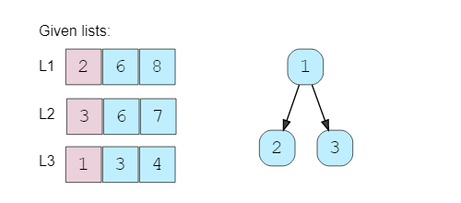

1. We’ll take the top number from the heap, insert it into the merged list and add the next number in the heap.

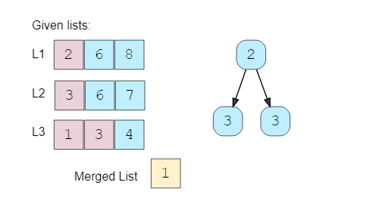

1. Again, we’ll take the top element of the heap, insert it into the merged list and add the next number to the heap.

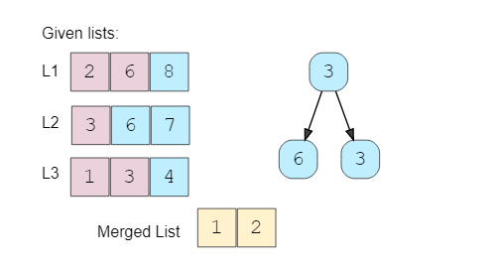

1. Repeating the above step, take the top element of the heap, insert it into the merged list and add the next number to the heap. As there are two 3s in the heap, we can pick anyone but we need to take the next element from the corresponding list to insert in the heap.

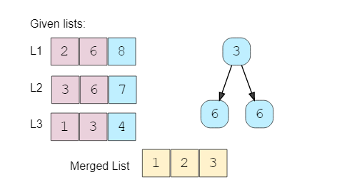

We’ll repeat the above step to populate our merged array.

### Code

|  |
| --- |
| import java.util.*;  class ListNode {  int value;  ListNode next;  ListNode(int value) {  this.value = value;  }  }  class Solution {  public static ListNode merge(ListNode[] lists) {  PriorityQueue<ListNode> minHeap =  new PriorityQueue<ListNode>((n1, n2) -> n1.value - n2.value);  // put the root of each list in the min heap  for (ListNode root : lists)  if (root != null)  minHeap.add(root);  // take the smallest (top) element form the min-heap and add it to the result;  // if the top element has a next element add it to the heap  ListNode resultHead = null, resultTail = null;  while (!minHeap.isEmpty()) {  ListNode node = minHeap.poll();  if (resultHead == null) {  resultHead = resultTail = node;  } else {  resultTail.next = node;  resultTail = resultTail.next;  }  if (node.next != null)  minHeap.add(node.next);  }  return resultHead;  }  public static void main(String[] args) {  ListNode l1 = new ListNode(2);  l1.next = new ListNode(6);  l1.next.next = new ListNode(8);  ListNode l2 = new ListNode(3);  l2.next = new ListNode(6);  l2.next.next = new ListNode(7);  ListNode l3 = new ListNode(1);  l3.next = new ListNode(3);  l3.next.next = new ListNode(4);  ListNode result = Solution.merge(new ListNode[] { l1, l2, l3 });  System.out.print("Here are the elements form the merged list: ");  while (result != null) {  System.out.print(result.value + " ");  result = result.next;  }  }  } |

### Time Complexity

Since we’ll be going through all the elements of all lists and will be removing/adding one element to the heap in each step, the time complexity of the above algorithm will be O(N∗logK), where ‘N’ is the total number of elements in all the ‘K’ input lists.

### Space Complexity

The space complexity will be O(K) because, at any time, our min-heap will be storing one number from all the ‘K’ input lists.

**Array Sort**

class ListNode {

constructor(value, next = null) {

this.value = value;

this.next = next;

}

}

function mergeLists(lists) {

//push to list

if (!lists || !lists.length) return null;

let mergeArr = [];

let resultList = new ListNode(-1);

lists.forEach((list) => {

let curr = list;

while (curr) {

mergeArr.push(curr.value);

curr = curr.next;

}

});

let curr = resultList;

//sort list

mergeArr

.sort((a, b) => a - b)

.forEach((n) => {

let temp = new ListNode(n);

curr.next = temp;

curr = curr.next;

});

return resultList.next;

}

let l1 = new ListNode(2);

l1.next = new ListNode(6);

l1.next.next = new ListNode(8);

let l2 = new ListNode(3);

l2.next = new ListNode(6);

l2.next.next = new ListNode(7);

l1.next = new ListNode(6);

let l3 = new ListNode(1);

l3.next = new ListNode(3);

l3.next.next = new ListNode(4);

l2.next = new ListNode(6);

result = mergeLists([l1, l2, l3]);

let output = "Here are the elements form the merged list: ";

while (result != null) {

output += result.value + " ";

result = result.next;

}

console.log(output);

**Compare Each Node One by One**

function mergeLists(lists) {

//compare one by one

if (!lists || !lists.length) return null;

function findMinNode(lists) {

let index = -1;

let min = Infinity;

for (let i = 0; i < lists.length; i++) {

if (!lists[i]) continue;

if (lists[i].value <= min) {

min = lists[i].value;

index = i;

}

}

let resultNode = null;

if (index !== -1) {

resultNode = lists[index];

lists[index] = lists[index].next;

}

return resultNode;

}

let resultList = new ListNode(-1);

let curr = resultList;

let temp = findMinNode(lists);

while (temp) {

curr.next = temp;

curr = curr.next;

temp = findMinNode(lists);

}

return resultList.next;

}

### Approach 1

|  |
| --- |
| public ListNode mergeKLists(ListNode[] lists) {  List<Integer> l = new ArrayList<Integer>();    for (ListNode ln : lists) {  while (ln != null) {  l.add(ln.val);  ln = ln.next;  }  }    Collections.sort(l);    ListNode head = new ListNode(0);  ListNode h = head;  for (int i : l) {  ListNode t = new ListNode(i);  h.next = t;  h = h.next;  }  h.next = null;  return head.next;  } |

* Time complexity : O(NlogN) where N is the total number of nodes.
  + Collecting all the values costs O(N) time.
  + A stable sorting algorithm costs O(NlogN) time.
  + Iterating for creating the linked list costs O(N) time.
* Space complexity : O(N)
  + Sorting cost O(N) space (depends on the algorithm you choose).
  + Creating a new linked list costs O(N) space.

### Approach 2: Compare one by one O(n) space.

|  |
| --- |
| public ListNode mergeKLists(ListNode[] lists) {  int min_index = 0;  ListNode head = new ListNode(0);  ListNode h = head;  while (true) {  boolean isBreak = true;  int min = Integer.MAX_VALUE;  for (int i = 0; i < lists.length; i++) {  if (lists[i] != null) {  if (lists[i].val < min) {  min_index = i;  min = lists[i].val;  }  isBreak = false;  }  }  if (isBreak) {  break;  }  ListNode a = new ListNode(lists[min_index].val);  h.next = a;  h = h.next;  lists[min_index] = lists[min_index].next;  }  h.next = null;  return head.next;  } |

* Time complexity : O(kN) where k is the number of linked lists.
  + Almost every selection of node in final linked costs O(k) (k-1 times comparison).
  + There are N nodes in the final linked list.
* Space complexity :
  + O(n) Creating a new linked list costs O(n) space.
  + O(1) It's not hard to apply in-place method - connect selected nodes instead of creating new nodes to fill the new linked list.

|  |
| --- |
| public ListNode mergeKLists(ListNode[] lists) {  int min_index = 0;  ListNode head = new ListNode(0);  ListNode h = head;  while (true) {  boolean isBreak = true;  int min = Integer.MAX_VALUE;  for (int i = 0; i < lists.length; i++) {  if (lists[i] != null) {  if (lists[i].val < min) {  min_index = i;  min = lists[i].val;  }  isBreak = false;  }  }  if (isBreak) {  break;  }  h.next = lists[min_index];  h = h.next;  lists[min_index] = lists[min_index].next;  }  h.next = null;  return head.next;  } |

### Approach 3: Optimize Approach 2 by Priority Queue

|  |
| --- |
| public ListNode mergeKLists(ListNode[] lists) {  Queue<ListNode> q = new PriorityQueue<ListNode>((a, b) -> a.value - b.value);  for(ListNode l : lists){  if(l!=null){  q.add(l);  }  }  ListNode head = new ListNode(0);  ListNode point = head;  while(!q.isEmpty()){  point.next = q.poll();  point = point.next;  ListNode next = point.next;  if(next!=null){  q.add(next);  }  }  return head.next;  } |

* Time complexity : O(Nlogk) where k is the number of linked lists.
  + The comparison cost will be reduced to O(logk) for every pop and insertion to priority queue. But finding the node with the smallest value just costs O(1) time.
  + There are NN*N* nodes in the final linked list.
* Space complexity :
  + O(n) Creating a new linked list costs O(n) space.
  + O(k) The code above present applies in-place method which cost O(1) space. And the priority queue (often implemented with heaps) costs O(k) space (it's far less than N in most situations).

### Approach 4: Merge lists one by one

|  |
| --- |
| public ListNode mergeTwoLists(ListNode l1, ListNode l2) {  ListNode h = new ListNode(0);  ListNode ans=h;  while (l1 != null && l2 != null) {  if (l1.val < l2.val) {  h.next = l1;  h = h.next;  l1 = l1.next;  } else {  h.next = l2;  h = h.next;  l2 = l2.next;  }  }  if(l1==null){  h.next=l2;  }  if(l2==null){  h.next=l1;  }  return ans.next;  }  public ListNode mergeKLists(ListNode[] lists) {  if(lists.length==1){  return lists[0];  }  if(lists.length==0){  return null;  }  ListNode head = mergeTwoLists(lists[0],lists[1]);  for (int i = 2; i < lists.length; i++) {  head = mergeTwoLists(head,lists[i]);  }  return head;  } |

* Time complexity : O(kN) where k is the number of linked lists.
  + We can merge two sorted linked list in O(n) time where n is the total number of nodes in two lists.
  + Sum up the merge process and we can get:  *O*(∑*i*=1*k*−1​(*i*∗(*kN*​)+*kN*​))=*O*(*kN*).
* Space complexity : O(1)
  + We can merge two sorted linked list in O(1) space.

### Approach 5: Merge with Divide And Conquer

|  |
| --- |
| public ListNode mergeTwoLists(ListNode l1, ListNode l2) {  ListNode h = new ListNode(0);  ListNode ans=h;  while (l1 != null && l2 != null) {  if (l1.val < l2.val) {  h.next = l1;  h = h.next;  l1 = l1.next;  } else {  h.next = l2;  h = h.next;  l2 = l2.next;  }  }  if(l1==null){  h.next=l2;  }  if(l2==null){  h.next=l1;  }  return ans.next;  }  public ListNode mergeKLists(ListNode[] lists) {  if(lists.length==0){  return null;  }  int interval = 1;  while(interval<lists.length){  System.out.println(lists.length);  for (int i = 0; i + interval< lists.length; i=i+interval*2) {  lists[i]=mergeTwoLists(lists[i],lists[i+interval]);  }  interval*=2;  }  return lists[0];  } |

* Time complexity : O(Nlogk) where k is the number of linked lists.
  + We can merge two sorted linked list in O(n) time where n is the total number of nodes in two lists.
  + Sum up the merge process and we can get: O*O*(∑*i*=1*log*2​*k*​*N*)=*O*(*N*log*k*)
* Space complexity : O(1)O(1)*O*(1)
  + We can merge two sorted linked lists in O(1)O(1)*O*(1) space.

## 🔎 Kth Smallest Number in M Sorted Lists (Medium)

### Problem Statement

Given M sorted arrays, find the Kth smallest number among all the arrays.

**Example 1**:

Input: L1=[2, 6, 8], L2=[3, 6, 7], L3=[1, 3, 4], K=5

Output: 4

Explanation: The 5th smallest number among all the arrays is 4, this can be verified from

the merged list of all the arrays: [1, 2, 3, 3, 4, 6, 6, 7, 8]

**Example 2**:

Input: L1=[5, 8, 9], L2=[1, 7], K=3

Output: 7

Explanation: The 3rd smallest number among all the arrays is 7.

### Examples:

Input: m = 5

arr[][] = { {1, 3},

{2, 4, 6},

{0, 9, 10, 11}} ;

Output: 4

Explanation The merged array would

be {0 1 2 3 4 6 9 10 11}. The 5-th

smallest element in this merged

array is 4.

Input: m = 2

arr[][] = { {1, 3, 20},

{2, 4, 6}} ;

Explanation The merged array would

be {1 2 3 4 6 20}. The 2nd smallest element would be 2.

Output: 2

### Solution

This problem follows the **K-way merge pattern** and we can follow a similar approach as discussed in Merge K Sorted Lists.

We can start merging all the arrays, but instead of inserting numbers into a merged list, we will keep count to see how many elements have been inserted in the merged list. Once that count is equal to ‘K’, we have found our required number.

A big difference from Merge K Sorted Lists is that in this problem, the input is a list of arrays compared to LinkedLists. This means that when we want to push the next number in the heap we need to know what the index of the current number in the current array was. To handle this, we will need to keep track of the array and the element indices.

### Code

|  |
| --- |
| import java.util.*;  class Node {  int elementIndex;  int arrayIndex;  Node(int elementIndex, int arrayIndex) {  this.elementIndex = elementIndex;  this.arrayIndex = arrayIndex;  }  }  class Solution {  public static int findKthSmallest(List<Integer[]> lists, int k) {  PriorityQueue<Node> minHeap = new PriorityQueue<Node>(  (n1, n2) -> lists.get(n1.arrayIndex)[n1.elementIndex]  - lists.get(n2.arrayIndex)[n2.elementIndex]);  // put the 1st element of each array in the min heap  for (int i = 0; i < lists.size(); i++)  if (lists.get(i) != null)  minHeap.add(new Node(0, i));  // take the smallest (top) element form the min heap, if the running count is equal  // to k return the number if the array of the top element has more elements, add the  // next element to the heap  int numberCount = 0, result = 0;  while (!minHeap.isEmpty()) {  Node node = minHeap.poll();  result = lists.get(node.arrayIndex)[node.elementIndex];  if (++numberCount == k)  break;  node.elementIndex++;  if (lists.get(node.arrayIndex).length > node.elementIndex)  minHeap.add(node);  }  return result;  }  public static void main(String[] args) {  Integer[] l1 = new Integer[] { 2, 6, 8 };  Integer[] l2 = new Integer[] { 3, 6, 7 };  Integer[] l3 = new Integer[] { 1, 3, 4 };  List<Integer[]> lists = new ArrayList<Integer[]>();  lists.add(l1);  lists.add(l2);  lists.add(l3);  int result = Solution.findKthSmallest(lists, 5);  System.out.print("Kth smallest number is: " + result);  }  } |

### Time Complexity

Since we’ll be going through at most ‘K’ elements among all the arrays, and we will remove/add one element in the heap in each step, the time complexity of the above algorithm will be O(K∗logM) where ‘M’ is the total number of input arrays.

### Space Complexity

The space complexity will be O(M) because, at any time, our min-heap will be storing one number from all the ‘M’ input arrays.

**Similar Problems**

**🔎 🌴 Median of Two Sorted Arrays**

<https://leetcode.com/problems/median-of-two-sorted-arrays/>

Given M sorted arrays, find the median number among all arrays.

**Solution:** This problem is similar to our parent problem with K=Median. So if there are N total numbers in all the arrays we need to find the Kth minimum number where K=N/2.

### Java Solution

Time Complexity : O(m+n)

As the 2 arrays sorted we can simply we can simply do it iterating both array and adding the minimum one to result array and returning the median from result array.

|  |
| --- |
| public static double findMedianSortedArrays(int[] nums1, int[] nums2) {  int i = 0, i1 = 0, i2 = 0;  int n1 = nums1.length;  int n2 = nums2.length;  int n = n1+n2;  int[] res = new int[n/2+1];  while(i < res.length){  if(i1 < n1 & i2 < n2){  res[i++] = nums1[i1] > nums2[i2] ? nums2[i2++] : nums1[i1++];  }  else if(i1 < n1){  res[i++] = nums1[i1++];  }  else if(i2 < n2){  res[i++] = nums2[i2++];  }  }  if(n%2 == 1) return res[res.length - 1];  else  return (res[res.length - 2] + res[res.length - 1]) / 2.00;  } |

If there are more than 2 Arrays either we can use Priority queue o solve it or merge 2 array and merge the third with result array and so on.

**👩🏽‍🦯 🌴 Merge K Sorted Arrays**

<https://leetcode.com/problems/merge-k-sorted-lists/>

Given a list of K sorted arrays, merge them into one sorted list.

**Solution:** This problem is similar to [Merge K Sorted Lists](https://github.com/maazshaikh007/DSA_Patterns/blob/main/%E2%9C%85%20Pattern%2014%3A%20K-way%20merge.md#%F0%9F%94%8E-median-of-two-sorted-arrays) except that the input is a list of arrays compared to LinkedLists. To handle this, we can use a similar approach as discussed in our parent problem by keeping a track of the array and the element indices.

## 🔎 🌴 Kth Smallest Number in a Sorted Matrix (Hard)

<https://leetcode.com/problems/kth-smallest-element-in-a-sorted-matrix/>

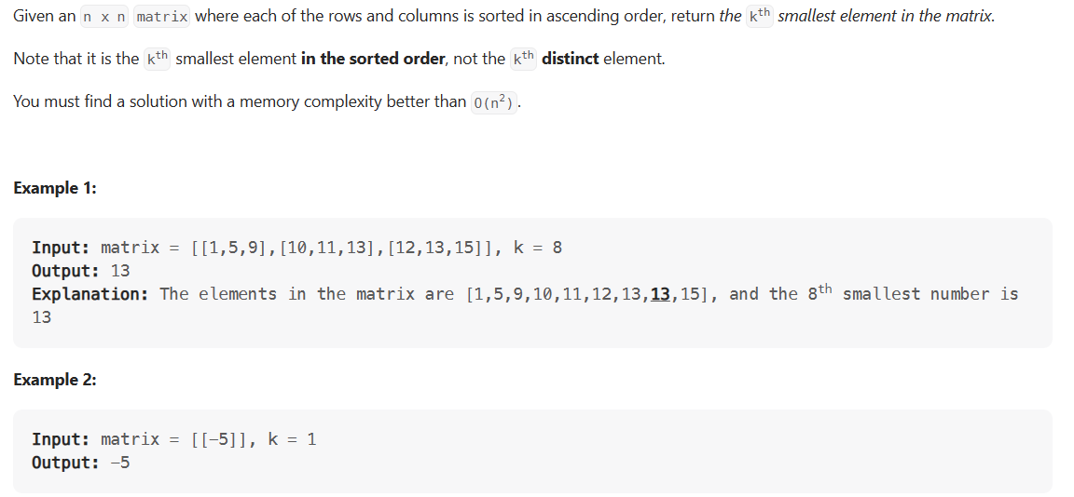

### Problem Statement

Given an N * N matrix where each row and column is sorted in ascending order, find the Kth smallest element in the matrix.

**Example 1**:

Input: Matrix=[

[2, 6, 8],

[3, 7, 10],

[5, 8, 11]

],

K=5

Output: 7

Explanation: The 5th smallest number in the matrix is 7

### Solution

This problem follows the [K-way merge pattern](https://github.com/maazshaikh007/DSA_Patterns/blob/main/%E2%9C%85%20Pattern%2014%3A%20K-way%20merge.md#pattern-14-k-way-merge) and can be easily converted to [Kth Smallest Number in M Sorted Lists](https://github.com/maazshaikh007/DSA_Patterns/blob/main/%E2%9C%85%20Pattern%2014%3A%20K-way%20merge.md#%F0%9F%94%8E-kth-smallest-number-in-m-sorted-lists-medium). As each row (or column) of the given matrix can be seen as a sorted list, we essentially need to find the Kth smallest number in N sorted lists.

### Code

|  |
| --- |
| import java.util.*;  class Node {  int row;  int col;  Node(int row, int col) {  this.row = row;  this.col = col;  }  }  class Solution {  public static int findKthSmallest(int[][] matrix, int k) {  PriorityQueue<Node> minHeap = new PriorityQueue<Node>(  (n1, n2) -> matrix[n1.row][n1.col] - matrix[n2.row][n2.col]);  // put the 1st element of each row in the min heap  // we don't need to push more than 'k' elements in the heap  for (int i = 0; i < matrix.length && i < k; i++)  minHeap.add(new Node(i, 0));  // take the smallest (top) element form the min heap, if the running count is equal  // to k return the number. if the row of the top element has more elements, add the  // next element to the heap  int numberCount = 0, result = 0;  while (!minHeap.isEmpty()) {  Node node = minHeap.poll();  result = matrix[node.row][node.col];  if (++numberCount == k)  break;  node.col++;  if (matrix[0].length > node.col)  minHeap.add(node);  }  return result;  }  public static void main(String[] args) {  int matrix[][] = { { 2, 6, 8 }, { 3, 7, 10 }, { 5, 8, 11 } };  int result = Solution.findKthSmallest(matrix, 5);  System.out.print("Kth smallest number is: " + result);  }  } |

### Time Complexity

First, we inserted at most ‘K’ or one element from each of the ‘N’ rows, which will take O(min(K,N)). Then we went through at most ‘K’ elements in the matrix and remove/add one element in the heap in each step. As we can’t have more than ‘N’ elements in the heap in any condition, therefore, the overall time complexity of the above algorithm will be O(min(K, N) + K*logN).

### Space Complexity

The space complexity will be O(N) because, in the worst case, our min-heap will be storing one number from each of the ‘N’ rows.

### An Alternate Approach

Since each row and column of the matrix is sorted, is it possible to use **Binary Search** to find the Kthsmallest number?

The biggest problem to use **Binary Search**, in this case, is that we don’t have a straightforward sorted array, instead, we have a matrix. As we remember, in **Binary Search**, we calculate the middle index of the search space *(‘1’ to ‘N’)* and see if our required number is pointed out by the middle index; if not we either search in the lower half or the upper half. In a sorted matrix, we can’t really find a middle. Even if we do consider some index as middle, it is not straightforward to find the search space containing numbers bigger or smaller than the number pointed out by the middle index.

An alternative could be to apply the **Binary Search** on the *“number range”* instead of the *“index range”*. As we know that the smallest number of our matrix is at the top left corner and the biggest number is at the bottom right corner. These two numbers can represent the *“range”* i.e., the start and the end for the **Binary Search**. Here is how our algorithm will work:

1. Start the **Binary Search** with start = matrix[0][0] and end = matrix[n-1][n-1].
2. Find middle of the start and the end. This middle number is NOT necessarily an element in the matrix.
3. Count all the numbers smaller than or equal to middle in the matrix. As the matrix is sorted, we can do this in O(N).
4. While counting, we can keep track of the *“smallest number greater than the middle”* (let’s call it n1) and at the same time the *“biggest number less than or equal to the middle”*(let’s call it n2). These two numbers will be used to adjust the *“number range”* for the **Binary Search** in the next iteration.
5. If the count is equal to **K**, n2 will be our required number as it is the *“biggest number less than or equal to the middle”*, and is definitely present in the matrix. If the count is less than **K**, we can update start = n2 to search in the higher part of the matrix and if the count is greater than **K**, we can update end = n1 to search in the lower part of the matrix in the next iteration.

[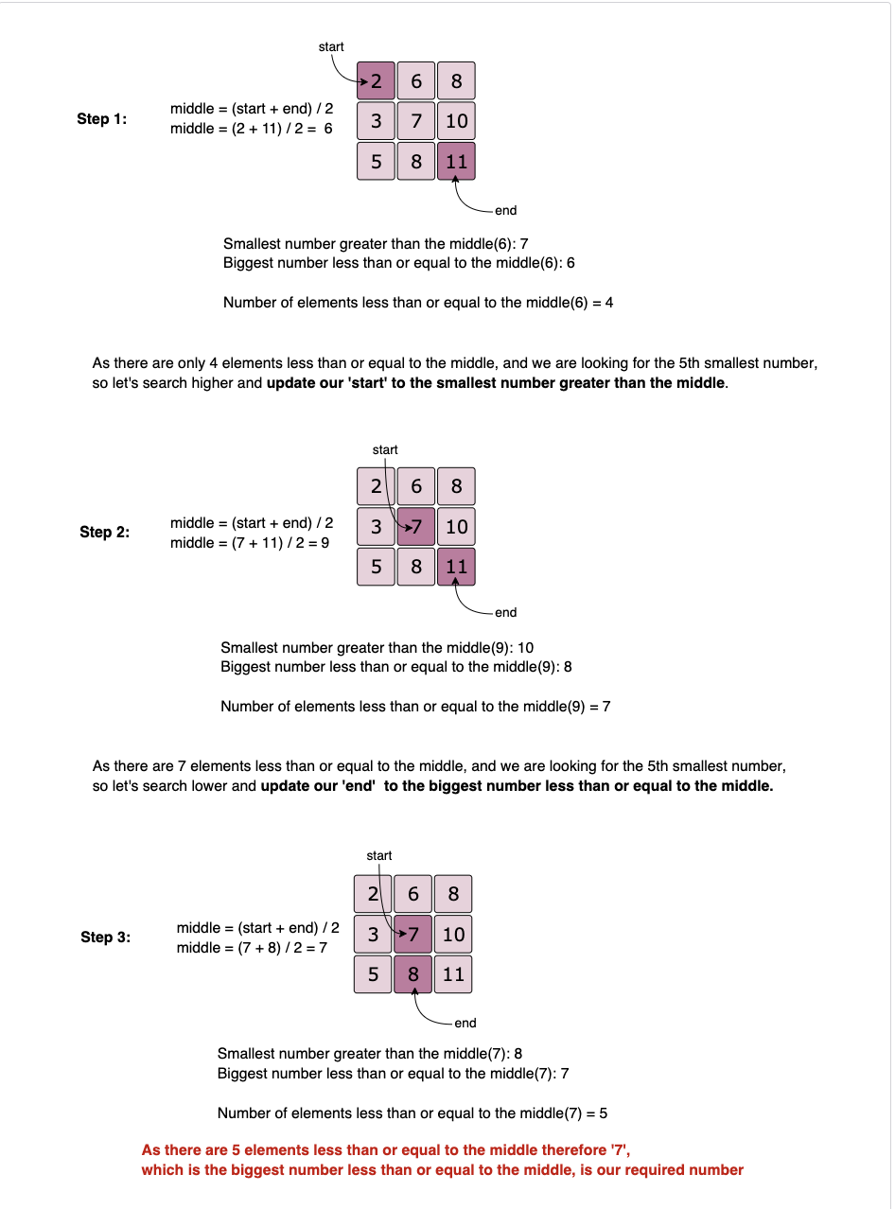](https://github.com/maazshaikh007/DSA_Patterns/blob/main/images/kwaymatrix.png)

### Code

|  |
| --- |
| class Solution {  public static int findKthSmallest(int[][] matrix, int k) {  int n = matrix.length;  int start = matrix[0][0], end = matrix[n - 1][n - 1];  while (start < end) {  int mid = start + (end - start) / 2;  // first number is the smallest and the second number is the largest  int[] smallLargePair = { matrix[0][0], matrix[n - 1][n - 1] };  int count = countLessEqual(matrix, mid, smallLargePair);  if (count == k)  return smallLargePair[0];  if (count < k)  start = smallLargePair[1]; // search higher  else  end = smallLargePair[0]; // search lower  }  return start;  }  private static int countLessEqual(int[][] matrix, int mid, int[] smallLargePair) {  int count = 0;  int n = matrix.length, row = n - 1, col = 0;  while (row >= 0 && col < n) {  if (matrix[row][col] > mid) {  // as matrix[row][col] is bigger than the mid, let's keep track of the  // smallest number greater than the mid  smallLargePair[1] = Math.min(smallLargePair[1], matrix[row][col]);  row--;  } else {  // as matrix[row][col] is less than or equal to the mid, let's keep track of the  // biggest number less than or equal to the mid  smallLargePair[0] = Math.max(smallLargePair[0], matrix[row][col]);  count += row + 1;  col++;  }  }  return count;  }  public static void main(String[] args) {  int matrix[][] = { { 1, 4 }, { 2, 5 } };  int result = Solution.findKthSmallest(matrix, 2);  System.out.println("Kth smallest number is: " + result);  int matrix1[][] = { { -5 } };  result = Solution.findKthSmallest(matrix1, 1);  System.out.println("Kth smallest number is: " + result);  int matrix2[][] = { { 2, 6, 8 }, { 3, 7, 10 }, { 5, 8, 11 } };  result = Solution.findKthSmallest(matrix2, 5);  System.out.println("Kth smallest number is: " + result);  int matrix3[][] = { { 1, 5, 9 }, { 10, 11, 13 }, { 12, 13, 15 } };  result = Solution.findKthSmallest(matrix3, 8);  System.out.println("Kth smallest number is: " + result);  }  } |

* The **Binary Search** could take O(log(max-min )) iterations where max is the largest and min is the smallest element in the matrix and in each iteration we take O(N) for counting, therefore, the overall time complexity of the algorithm will be O(N*log(max-min)).
* The algorithm runs in constant space O(1).

### Java Solution

|  |
| --- |
| public static int kthSmallestOptimised(int[][] matrix, int k) {  int m = matrix.length;  int n = matrix[0].length; // For general, the matrix need not be a square  int left = matrix[0][0], right = matrix[m-1][n-1], ans = -1;  while (left <= right) {  int mid = (left + right) >> 1;  if (countLessOrEqual(matrix, mid, m , n) >= k) {  ans = mid;  right = mid - 1; // try to looking for a smaller value in the left side  } else left = mid + 1; // try to looking for a bigger value in the right side  }  return ans;  }  static int countLessOrEqual(int[][] matrix, int x, int m, int n) {  int count = 0, col = n - 1; // start with the rightmost column  for (int row = 0; row < m; ++row) {  while (col >= 0 && matrix[row][col] > x) --col; // decrease column until matrix[r][col] <= x  count += (col + 1);  }  return count;  } |

**📍 Smallest Number Range (Hard)**

<https://leetcode.com/problems/smallest-range-covering-elements-from-k-lists/>

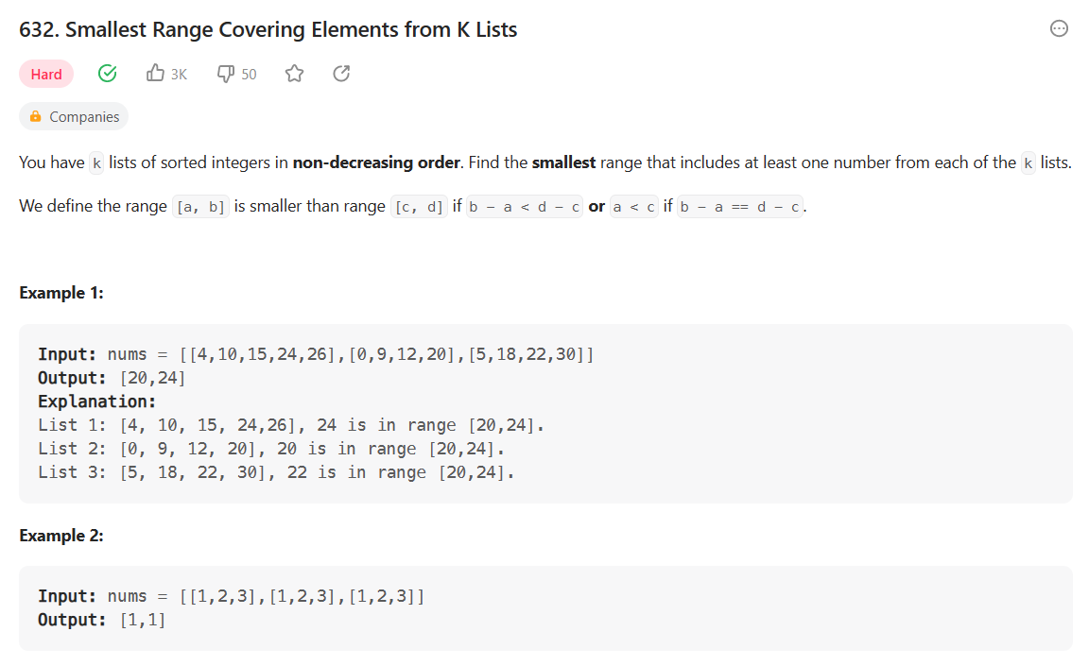

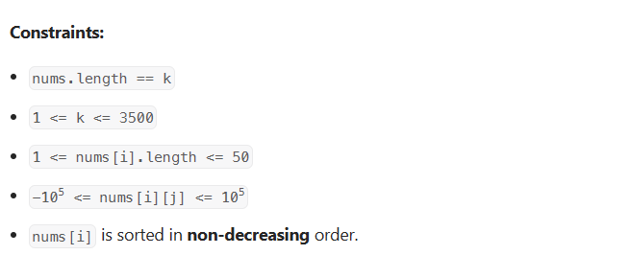

### Problem Statement

Given M sorted arrays, find the smallest range that includes at least one number from each of the M lists.

**Example 1**:

Input: L1=[1, 5, 8], L2=[4, 12], L3=[7, 8, 10]

Output: [4, 7]

Explanation: The range [4, 7] includes 5 from L1, 4 from L2 and 7 from L3.

**Example 2**:

Input: L1=[1, 9], L2=[4, 12], L3=[7, 10, 16]

Output: [9, 12]

Explanation: The range [9, 12] includes 9 from L1, 12 from L2 and 10 from L3

### Solution

This problem follows the [K-way merge pattern](https://github.com/maazshaikh007/DSA_Patterns/blob/main/%E2%9C%85%20Pattern%2014%3A%20K-way%20merge.md#pattern-14-k-way-merge) and we can follow a similar approach as discussed in [Merge K Sorted Lists](https://github.com/maazshaikh007/DSA_Patterns/blob/main/%E2%9C%85%20Pattern%2014%3A%20K-way%20merge.md#%F0%9F%91%A9%F0%9F%8F%BD%E2%80%8D%F0%9F%A6%AF-%F0%9F%8C%B4-merge-k-sorted-arrays).

We can start by inserting the first number from all the arrays in a min-heap(). We will keep track of the largest number that we have inserted in the heap (let’s call it maxNumber).

In a loop, we’ll take the smallest (top) element from the min-heap() and maxNumber has the largest element that we inserted in the heap. If these two numbers give us a smaller range, we’ll update our range. Finally, if the array of the top element has more elements, we’ll insert the next element to the heap.

We can finish searching the minimum range as soon as an array is completed or, in other terms, the **heap** has less than M elements.

### Code

|  |
| --- |
| import java.util.*;  class Node {  int elementIndex;  int arrayIndex;  Node(int elementIndex, int arrayIndex) {  this.elementIndex = elementIndex;  this.arrayIndex = arrayIndex;  }  }  class Solution {  public static int[] findSmallestRange(List<Integer[]> lists) {  PriorityQueue<Node> minHeap = new PriorityQueue<Node>(  (n1, n2) -> lists.get(n1.arrayIndex)[n1.elementIndex] -  lists.get(n2.arrayIndex)[n2.elementIndex]);  int rangeStart = 0, rangeEnd = Integer.MAX_VALUE,  currentMaxNumber = Integer.MIN_VALUE;  // put the 1st element of each array in the min heap  for (int i = 0; i < lists.size(); i++)  if (lists.get(i) != null) {  minHeap.add(new Node(0, i));  currentMaxNumber = Math.max(currentMaxNumber, lists.get(i)[0]);  }  // take the smallest (top) element form the min heap, if it gives us smaller range,  // update the ranges, if the array of the top element has more elements, insert the  // next element in the heap  while (minHeap.size() == lists.size()) {  Node node = minHeap.poll();  if (rangeEnd - rangeStart >  currentMaxNumber - lists.get(node.arrayIndex)[node.elementIndex]) {  rangeStart = lists.get(node.arrayIndex)[node.elementIndex];  rangeEnd = currentMaxNumber;  }  node.elementIndex++;  if (lists.get(node.arrayIndex).length > node.elementIndex) {  minHeap.add(node); // insert the next element in the heap  currentMaxNumber = Math.max(currentMaxNumber,  lists.get(node.arrayIndex)[node.elementIndex]);  }  }  return new int[] { rangeStart, rangeEnd };  }  public static void main(String[] args) {  Integer[] l1 = new Integer[] { 1, 5, 8 };  Integer[] l2 = new Integer[] { 4, 12 };  Integer[] l3 = new Integer[] { 7, 8, 10 };  List<Integer[]> lists = new ArrayList<Integer[]>();  lists.add(l1);  lists.add(l2);  lists.add(l3);  int[] result = Solution.findSmallestRange(lists);  System.out.print("Smallest range is: [" + result[0] + ", " + result[1] + "]");  }  } |

* Since, at most, we’ll be going through all the elements of all the arrays and will remove/add one element in the heap in each step, the time complexity of the above algorithm will be O(N*logM) where N is the total number of elements in all the M input arrays.
* The space complexity will be O(M) because, at any time, our min-heap() will be store one number from all the M input arrays.

### Java Solution

|  |
| --- |
| public static int[] smallestRange(List<List<Integer>> nums) {  PriorityQueue<int[]> minHeap = new PriorityQueue<>((a,b) -> a[0] - b[0]);  int max = Integer.MIN_VALUE;  int[] res = {-100000, 100000};  for(int i = 0; i< nums.size(); i++){  int value = nums.get(i).get(0);  max = Math.max(max, value);  minHeap.add(new int[]{value, 0, i});  }  while(true){  int[] min = minHeap.poll();  if(res[1] - res[0] > max - min[0]){  res[0] = min[0];  res[1] = max;  }  min[1]++;  List<Integer> list = nums.get(min[2]);  if(min[1] == list.size()) break;  min[0] = list.get(min[1]);  minHeap.add(min);  max = Math.max(max, min[0]);  }  return res;  } |

**🌟 K Pairs with Largest Sums (Hard)**

<https://leetcode.com/problems/find-k-pairs-with-smallest-sums/>

### Problem Statement

Given two sorted arrays in descending order, find K pairs with the largest sum where each pair consists of numbers from both the arrays.

**Example 1**:

Input: L1=[9, 8, 2], L2=[6, 3, 1], K=3

Output: [9, 3], [9, 6], [8, 6]

Explanation: These 3 pairs have the largest sum. No other pair has a sum larger than any of these.

**Example 2**:

Input: L1=[5, 2, 1], L2=[2, -1], K=3

Output: [5, 2], [5, -1], [2, 2]

### Solution

This problem follows the [K-way merge pattern](https://github.com/maazshaikh007/DSA_Patterns/blob/main/%E2%9C%85%20Pattern%2014%3A%20K-way%20merge.md#pattern-14-k-way-merge) and we can follow a similar approach as discussed in [Merge K Sorted Lists](https://github.com/maazshaikh007/DSA_Patterns/blob/main/%E2%9C%85%20Pattern%2014%3A%20K-way%20merge.md#%F0%9F%91%A9%F0%9F%8F%BD%E2%80%8D%F0%9F%A6%AF-%F0%9F%8C%B4-merge-k-sorted-arrays).

We can go through all the numbers of the two input arrays to create pairs and initially insert them all in the **heap** until we have K pairs in **Min Heap**. After that, if a pair is bigger than the top (smallest) pair in the **heap**, we can remove the smallest pair and insert this pair in the **heap**.

We can optimize our algorithms in two ways:

1. Instead of iterating over all the numbers of both arrays, we can iterate only the first K numbers from both arrays. Since the arrays are sorted in descending order, the pairs with the maximum sum will be constituted by the first K numbers from both the arrays.
2. As soon as we encounter a pair with a sum that is smaller than the smallest (top) element of the **heap**, we don’t need to process the next elements of the array. Since the arrays are sorted in descending order, we won’t be able to find a pair with a higher sum moving forward.

### Code

|  |
| --- |
| import java.util.*;  class Solution {  public static List<int[]> findKLargestPairs(int[] nums1, int[] nums2, int k) {  PriorityQueue<int[]> minHeap =  new PriorityQueue<int[]>((p1, p2) -> (p1[0] + p1[1]) - (p2[0] + p2[1]));  for (int i = 0; i < nums1.length && i < k; i++) {  for (int j = 0; j < nums2.length && j < k; j++) {  if (minHeap.size() < k) {  minHeap.add(new int[] { nums1[i], nums2[j] });  } else {  // if the sum of the two numbers from the two arrays is smaller than the  // smallest (top) element of the heap, we can 'break' here. Since the arrays  // are sorted in the descending order, we'll not be able to find a pair with a  // higher sum moving forward.  if (nums1[i] + nums2[j] < minHeap.peek()[0] + minHeap.peek()[1]) {  break;  }  //else: we've a pair with a larger sum, remove top and insert this pair in heap  else {  minHeap.poll();  minHeap.add(new int[] { nums1[i], nums2[j] });  }  }  }  }  return new ArrayList<>(minHeap);  }  public static void main(String[] args) {  int[] l1 = new int[] { 9, 8, 2 };  int[] l2 = new int[] { 6, 3, 1 };  List<int[]> result = Solution.findKLargestPairs(l1, l2, 3);  System.out.print("Pairs with largest sum are: ");  for (int[] pair : result)  System.out.print("[" + pair[0] + ", " + pair[1] + "] ");  }  } |

* Since, at most, we’ll be going through all the elements of both arrays and we will add/remove one element in the heap in each step, the time complexity of the above algorithm will be O(N∗M∗logK) where N and M are the total number of elements in both arrays, respectively. If we assume that both arrays have at least K elements then the time complexity can be simplified to O(K^2logK), because we are not iterating more than K elements in both arrays.
* The space complexity will be O(K) because, at any time, our **Min Heap** will be storing K largest pairs.

### Java Solution: Kth Pair with Smallest Sum

|  |
| --- |
| public List<List<Integer>> kSmallestPairs(int[] nums1, int[] nums2, int k) {  List<List<Integer>> ans = new ArrayList<>();  PriorityQueue<int[]> minHeap = new PriorityQueue<>((a,b) -> (a[0]+a[1]) - (b[0]+b[1]));  for(int i = 0; i< nums1.length && i < k ; i++){  minHeap.add(new int[]{nums1[i], nums2[0], 0});// 2nd index value denotes index of second array  }  while(!minHeap.isEmpty() && k-- >0){  int[] element = minHeap.poll();  ans.add(List.of(element[0], element[1]));  if(++element[2] < nums2.length){  minHeap.add(new int[]{element[0], nums2[element[2]],element[2] });  }  }  return ans;  } |

# Introduction to Backtracking Pattern

## Backtracking

Backtracking is an algorithmic technique that uses brute-force approach to solve a problem.

Brute-force approach states that for any problem, we should try out all possible solutions and pick up those solutions that satisfy the problem constraints.

In backtracking, we build a solution incrementally and follow the approach that if the current solution can’t lead to a valid solution, abandon it and backtrack (or go back) to try another solution. Because of this, recursion becomes a suitable technique for solving backtracking problems.

Dynamic Programming (DP) uses a similar approach where we try out all possible solutions (using Memoization) to pick up the most optimized solution. DP is used to solve optimization problems; backtracking, on the other hand, is mostly used when multiple valid solutions are possible for a problem.

### An Example

Let’s understand backtracking with an example.

Imagine we want to plant, in a straight line, three fruit trees Apple, Orange, and Mango. What are the possible ways these trees can be planted? The only restriction we have is that Apple and Orange trees can’t be placed next to each other.

Following a brute-force approach, we can find all possible combinations in which the three trees can be placed and pick those that fulfill the given constraint.

Let’s try finding all the possible arrangements.

The first tree can be of any kind, Apple, Orange, or Mango. If our first tree is Apple, the second tree can be Orange or Mango. If we place Orange as our second tree, then our constraint is not fulfilled (which was not to place Apple and Orange together). Hence it is not a valid arrangement; therefore, we go back (i.e., backtrack) and place Mango as our second tree.

Now, we can place Orange in the third place; this arrangement fulfills the problem constraint.

The following diagram shows all possible arrangements:

Backtracking example

From the above diagram, we can clearly see that the two valid arrangements are: [Apple, Mango, Orange] and [Orange, Mango, Apple].

This approach of evaluating all possible solutions, going back whenever we see that a certain constraint can’t be met, and trying out other possible solutions is called backtracking.

Let’s solve some more problems to develop a deeper understanding of backtracking.

## Combination Sum

### Problem Statement

Given an array of distinct positive integers candidates and a target integer target, return a list of all unique combinations of candidates where the chosen numbers sum to target. You may return the combinations in any order.

The same number may be chosen from candidates an unlimited number of times. Two combinations are unique if the frequency of at least one of the chosen numbers is different.

Example 1:

Input: candidates = [2, 3, 6, 7], target = 7

Output: [[2, 2, 3], [7]]

Explanation: The elements in these two combinations sum up to 7.

Example 2:

Input: candidates = [2, 4, 6, 8], target = 10

Output: [[2,2,2,2,2], [2,2,2,4], [2,2,6], [2,4,4], [2,8], [4,6]]

Explanation: The elements in these six combinations sum up to 10.

### Solution

This problem is quite similar to the example discussed in the previous lesson (placing apple, orange, and mango trees).

We can follow the brute-force approach to incrementally build the solution.

If, at any time, we find out that the current solution can’t lead to a valid combination, we will abandon it and backtrack to try the remaining solutions.

Let’s try this approach on the following input: Candidates: [3, 4, 5], Target: 9

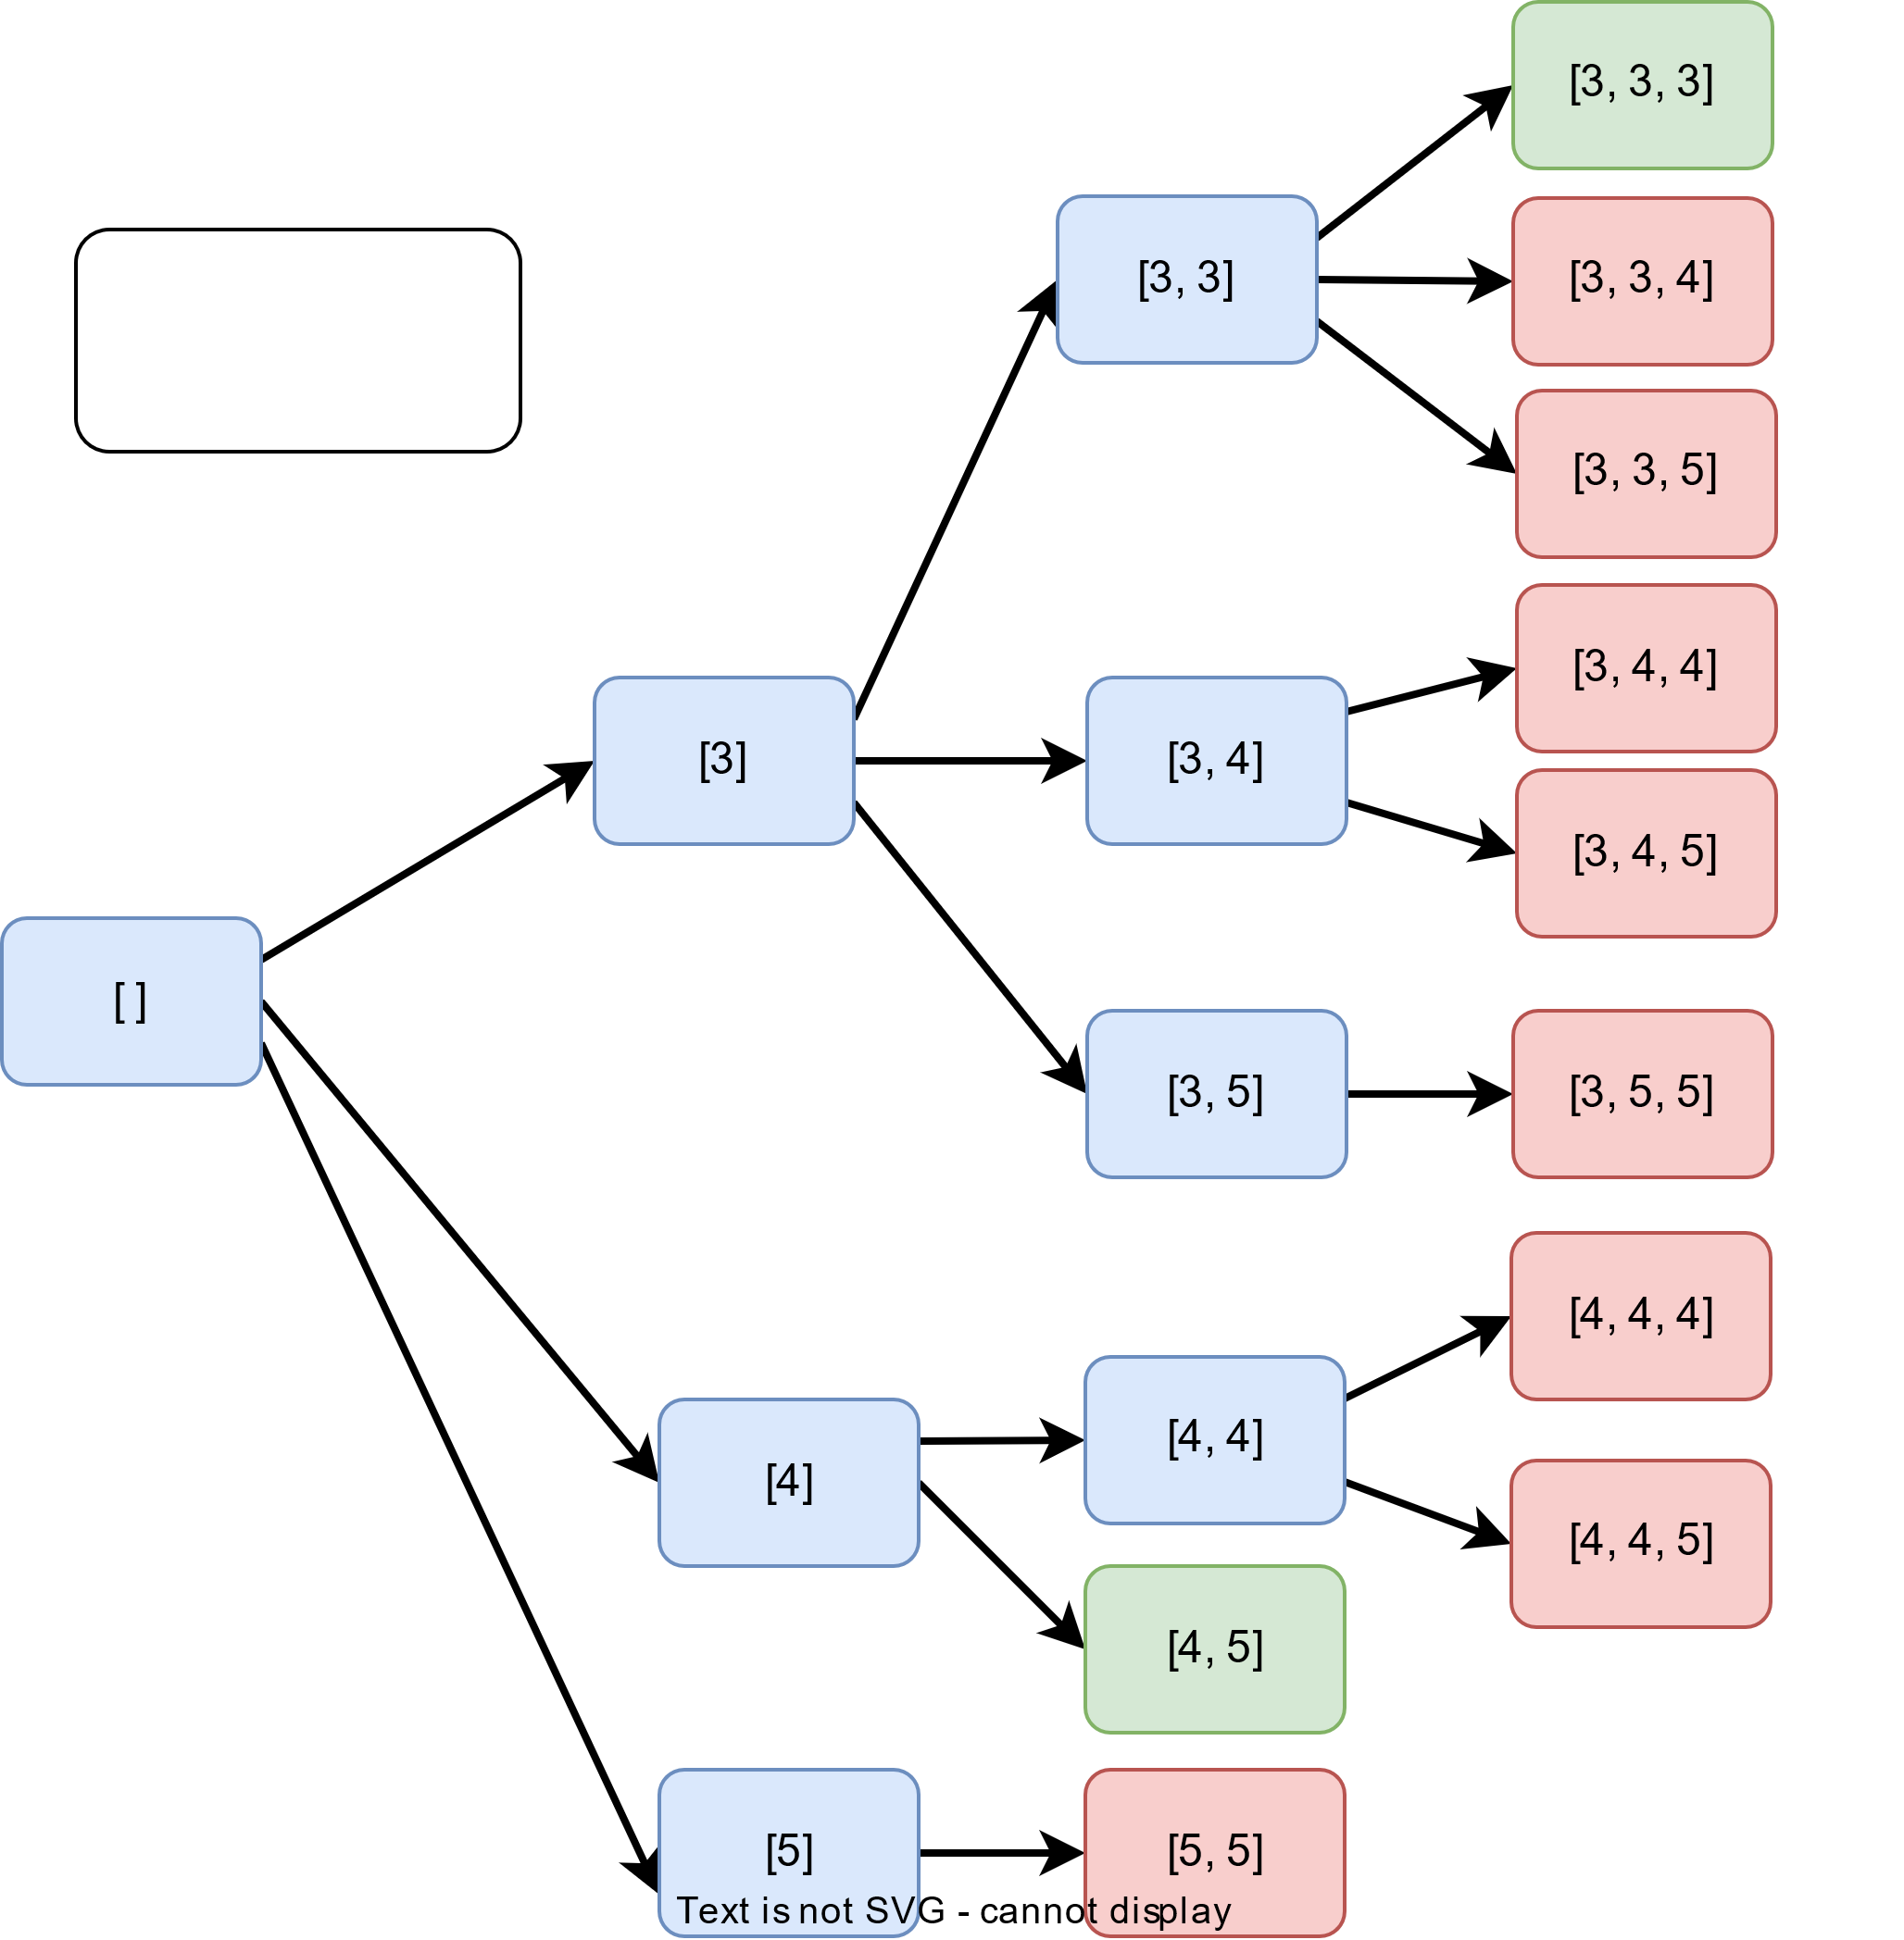

Here are the number of steps in our algorithm:

1. We will start with an empty set. This also means that the sum of the elements in the set is zero.
2. We can try adding all three numbers separately in the set. This will give us three sets: [3], [4], [5].
3. Let’s take set [3], since the sum of its elements is less than the Target (=9), we will try adding more numbers to it.
4. We can add all three numbers again to generate new sets. We can add ‘3’ again, as each number can be added multiple times.
5. After adding all numbers separately to the set [3], we will get the following sets: [3, 3], [3, 4], [3, 5]. We can see, each set has a sum less than the target.
6. We can now, repeat the same process as described in step-4.
   * For [3, 3]: Adding ‘3’ will give us a valid solution [3, 3, 3] having a sum equal to the target. Adding ‘4’ and ‘5’ will give us a sum which is greater than the target. Therefore, we can stop the search here for this set, as adding any additional number will not produce a correct solution.
   * For [3, 4]: We will add ‘4’ or ‘5’ to it, which will give us a sum greater than the target. We will stop our search here for this set.
   * For [3, 5]: We can only add ‘5’ to it, which does not produce a valid solution.
7. Similar approach can be applied to other sets.
8. In the end, we can see that the valid solutions are: [3, 3, 3] and [4, 5].

### Code

The basic idea is to start with an empty combination and iterate through the candidates array, adding each candidate to the current combination and recursively calling the function with the updated combination and the remaining target. If the target becomes 0, we add the current combination to the result list. If the target becomes negative, we backtrack and remove the last added candidate from the combination.

The function combinationSum takes in two parameters, an array of distinct integers candidates and a target integer target, and returns a list of all unique combinations of candidates where the chosen numbers sum to target. The function starts by defining the function backtrack(candidates, start, target, comb, res). This function takes five parameters, candidates, start, target, comb, and res:

* candidates is the array containing candidate elements.
* start is the starting index of the candidates array.
* target is the remaining target.
* comb is the current combination.
* res is the final result list.

The backtrack function uses recursion to find the combinations. The base case for the recursion is if the target is 0. When the target is 0, that means we have found a valid combination and we append a copy of the current combination to the result list. It then iterates through the candidates array starting from the given index. If the current candidate is greater than the remaining target, it skips the current candidate and move on to the next. If the current candidate is less than the remaining target, it adds the current candidate to the current combination, recursively calls the function with the updated combination and remaining target, and then backtracks by removing the last added candidate from the combination.

|  |
| --- |
| import java.util.ArrayList;  import java.util.List;  class Solution {  public List<List<Integer>> combinationSum(int[] candidates, int target) {  List<List<Integer>> res = new ArrayList<>();  backtrack(candidates, 0, target, new ArrayList<>(), res);  return res;  }  private void backtrack(int[] candidates, int start, int target, List<Integer> comb, List<List<Integer>> res) {  // If target is 0, we have found a valid combination  if (target == 0) {  // Append a copy of the current combination to the result list  res.add(new ArrayList<>(comb));  return;  }  // Iterate through the candidates array starting from the given index  for (int i = start; i < candidates.length; i++) {  // If the current candidate is greater than the remaining target, move on to the  // next  if (target < candidates[i]) {  continue;  }  // Add the current candidate to the current combination  comb.add(candidates[i]);  // Recursively call the function with the updated combination and remaining  // target  backtrack(candidates, i, target - candidates[i], comb, res);  // Backtrack by removing the last added candidate from the combination  comb.remove(comb.size() - 1);  }  }  public static void main(String[] args) {  Solution s = new Solution();  // Test case 1  int[] candidates = { 2, 3, 6, 7 };  int target = 7;  System.out.println(s.combinationSum(candidates, target)); // expected output: [[2, 2, 3], [7]]  // Test case 2  candidates = new int[] { 2, 3, 5 };  target = 8;  System.out.println(s.combinationSum(candidates, target)); // expected output: []  // Test case 3  candidates = new int[] {};  target = 8;  System.out.println(s.combinationSum(candidates, target)); // expected output: []  // Test case 4  candidates = new int[] { 5, 10, 15 };  target = 20;  System.out.println(s.combinationSum(candidates, target)); // expected output: [[5,5,5,5], [5,5,10], [5,15], [10,10]]  // Test case 5  candidates = new int[] { 2, 4, 6, 8 };  target = 10;  System.out.println(s.combinationSum(candidates, target)); // expected output: [[2,2,2,2,2], [2,2,2,4], [2,2,6],  // [2,4,4], [2,8], [4,6]]  // Test case 6  candidates = new int[] { 2, 3, 5 };  target = 0;  System.out.println(s.combinationSum(candidates, target)); // expected output: [[]]  }  } |

### Time Complexity

This algorithm has a time complexity of O(N^T/M+1) , where N is the total number of elements in the candidates array, T is the target value, and  M is the smallest value among the candidates. This is because the execution of the backtracking is similar to a DFS traversal of an n-ary tree. So, the time complexity would be the same as the number of nodes in the n-ary tree. This can be seen in the above diagram.

Each node can call the backtrack function a maximum of N times, i.e., the total number of candidates. The maximal depth of the n-ary tree would be T/M, where we keep on adding the smallest element to the combination. As we know, the maximal number of nodes in N-ary tree of  T/M height would be N^T/M+1, hence the time complexity is O(N^T/M+1) .

### Space Complexity

Ignoring the space needed for the output array, the space complexity will be O(T/M) because at any time, we can pile up to  T/M recursive calls of the backtrack function; this will happen when we keep on adding the smallest element to the combination. As a result, the space overhead of the recursion is O(T/M).

## Word Search

### Problem Statement

Given an m x n grid of characters board and a string word, return true if the word exists in the grid.

The word can be constructed from letters of sequentially adjacent cells, where adjacent cells are horizontally or vertically neighboring. The same letter cell may not be used more than once.

Example 1:  
Input: word="ABCCED", board:

{ 'A', 'B', 'C', 'E' },

{ 'S', 'F', 'C', 'S' },

{ 'A', 'D', 'E', 'E' }

Output: true Explanation: The word exists in the board:  
-> { '**A**', '**B**', '**C**', 'E' },  
-> { 'S', 'F', '**C**', 'S' },  
-> { 'A', '**D**', '**E**', 'E' }

Example 2:  
Input: word="SEE", board:

{ 'A', 'B', 'C', 'E' },

{ 'S', 'F', 'C', 'S' },

{ 'A', 'D', 'E', 'E' }

Output: true Explanation: The word exists in the board:  
-> { 'A', 'B', 'C', 'E' },  
-> { 'S', 'F', 'C', '**S**' },  
-> { 'A', 'D', '**E**', '**E**' }

### Solution

The basic approach to solving the word search problem using backtracking is to start at the first character of the word and check all 8 adjacent cells in the grid to see if any of them match the next character of the word. If a match is found, mark the cell as visited and recursively check the next character of the word in the adjacent cells of the newly visited cell. If the entire word is found, return true. If no match is found, backtrack to the previous cell and try a different path. Repeat this process until the entire grid has been searched or the word is found.

### Code

This function takes a 2D list board and a string word as input, and returns True if the word can be found in board and False otherwise. It uses a helper function dfs which takes 4 additional parameters: i and j are the current coordinates of the cell that is being visited, k is the index of the current character of the word being matched, and board and word are the inputs passed to the main function.

The dfs function uses a helper variable tmp to store the current value of the cell before it is marked as visited. This is done so that we can backtrack later. It then uses recursion to check if the next character of the word exists in the 4 adjacent cells, and it will mark the cell as visited and move to next index of the word by incrementing k by 1. If the next character is found, the function returns true, if not it backtracks to the previous cell, and continues the search in different path. If the entire word is found, the function returns True, otherwise it returns False after searching the entire grid.

|  |
| --- |
| public class Solution {  public static boolean dfs(char[][] board, String word, int i, int j, int k) {  // check if current coordinates are out of grid or the current cell doesn't  // match the current character of the word  if (i < 0 || i >= board.length || j < 0 || j >= board[0].length || board[i][j] != word.charAt(k)) {  return false;  }  // check if we have reached the end of the word  if (k == word.length() - 1) {  return true;  }  // mark the current cell as visited by replacing it with '/'  char tmp = board[i][j];  board[i][j] = '/';  // check all 4 adjacent cells recursively  boolean res = dfs(board, word, i + 1, j, k + 1) ||  dfs(board, word, i - 1, j, k + 1) ||  dfs(board, word, i, j + 1, k + 1) ||  dfs(board, word, i, j - 1, k + 1);  // backtrack by replacing the current cell with its original value  board[i][j] = tmp;  return res;  }  public static boolean exist(char[][] board, String word) {  for (int i = 0; i < board.length; i++) {  for (int j = 0; j < board[0].length; j++) {  // start the search from every cell  if (dfs(board, word, i, j, 0)) {  return true;  }  }  }  return false;  }  public static void main(String[] args) {  // Test Case 1  char[][] board1 = {  { 'A', 'B', 'C', 'E' },  { 'S', 'F', 'C', 'S' },  { 'A', 'D', 'E', 'E' }  };  String word1 = "ABCCED";  System.out.println(exist(board1, word1)); // expected output: true  // Test Case 2  char[][] board2 = {  { 'A', 'B', 'C', 'E' },  { 'S', 'F', 'C', 'S' },  { 'A', 'D', 'E', 'E' }  };  String word2 = "SEE";  System.out.println(exist(board2, word2)); // expected output: true  // Test Case 3  char[][] board3 = {  { 'A', 'B', 'C', 'E' },  { 'S', 'F', 'C', 'S' },  { 'A', 'D', 'E', 'E' }  };  String word3 = "ABCB";  System.out.println(exist(board3, word3)); // expected output: false  char[][] board4 = { { 'a', 'a' } };  String word4 = "aaa";  System.out.println(exist(board4, word4)); // expected output: false  char[][] board5 = { { 'a' } };  String word5 = "a";  System.out.println(exist(board5, word5)); // expected output: true  char[][] board6 = {  { 'a', 'b', 'c', 'd', 'e' },  { 'f', 'g', 'h', 'i', 'j' },  { 'k', 'l', 'm', 'n', 'o' },  { 'p', 'q', 'r', 's', 't' },  { 'u', 'v', 'w', 'x', 'y' },  { 'z', 'a', 'b', 'c', 'd' }  };  String word6 = "abcde";  System.out.println(exist(board6, word6)); // expected output: true  char[][] board7 = {  { 'a', 'b', 'c', 'd', 'e' },  { 'f', 'g', 'h', 'i', 'j' },  { 'k', 'l', 'm', 'n', 'o' },  { 'p', 'q', 'r', 's', 't' },  { 'u', 'v', 'w', 'x', 'y' },  { 'z', 'a', 'b', 'c', 'd' }  };  String word7 = "zabcd";  System.out.println(exist(board7, word7)); // expected output: true  }  } |

### Time Complexity

The time complexity of the 'exist' function is O(4^N) , where N  is the length of the word. This is because the function uses a depth-first search (DFS) algorithm to traverse the board, and for each cell in the board, it checks all 4 adjacent cells recursively. The worst-case scenario is when the word is found in the last cell of the board, and in that case, the function will have to check all possible paths from the starting cell to the last cell, which is 4^N possible paths.

### Space Complexity

The space complexity of the exist function is O(N), where N is the length of the word. This is because the function uses a DFS algorithm, and the maximum depth of the recursion tree is N . In other words, the maximum number of function calls that will be stored on the call stack at any point in time is N.

## Sudoku Solver

### Problem Statement

Write a program to solve a Sudoku puzzle by filling the empty cells.

A sudoku solution must satisfy all of the following rules:

* Each of the digits 1-9 must occur exactly once in each row.
* Each of the digits 1-9 must occur exactly once in each column.
* Each of the digits 1-9 must occur exactly once in each of the 9 3x3 sub-boxes of the grid.

The '.' character indicates empty cells.

Example 1:  
Input:

{'5', '3', '.', '.', '7', '.', '.', '.', '.'},

{'6', '.', '.', '1', '9', '5', '.', '.', '.'},

{'.', '9', '8', '.', '.', '.', '.', '6', '.'},

{'8', '.', '.', '.', '6', '.', '.', '.', '3'},

{'4', '.', '.', '8', '.', '3', '.', '.', '1'},

{'7', '.', '.', '.', '2', '.', '.', '.', '6'},

{'.', '6', '.', '.', '.', '.', '2', '8', '.'},

{'.', '.', '.', '4', '1', '9', '.', '.', '5'},

{'.', '.', '.', '.', '8', '.', '.', '7', '9'}

Output:

{'5'', '3'', '4'', '6'', '7'', '8'', '9'', '1'', '2''},

{'6'', '7'', '2'', '1'', '9'', '5'', '3'', '4'', '8''},

{'1'', '9'', '8'', '3'', '4'', '2'', '5'', '6'', '7''},

{'8'', '5'', '9'', '7'', '6'', '1'', '4'', '2'', '3''},

{'4'', '2'', '6'', '8'', '5'', '3'', '7'', '9'', '1''},

{'7'', '1'', '3'', '9'', '2'', '4'', '8'', '5'', '6''},

{'9'', '6'', '1'', '5'', '3'', '7'', '2'', '8'', '4''},

{'2'', '8'', '7'', '4'', '1'', '9'', '6'', '3'', '5''},

{'3'', '4'', '5'', '2'', '8'', '6'', '1'', '7'', '9''}

Explanation: The given output is the only valid Sudoku solution.

### Solution

Sudoku is a popular puzzle game that involves filling in a 9x9 grid with numbers such that each column, each row, and each of the nine 3x3 sub-grids that compose the grid contains all of the digits from 1 to 9. One way to solve a sudoku puzzle is by using backtracking, which is a form of brute-force search.

Here are the steps to solve a sudoku puzzle using backtracking:

1. Start with an empty 9x9 grid and fill in the numbers that are given in the puzzle.
2. From left to right and top to bottom, find the first empty cell (denoted by a .) in the grid.
3. Try out every number from 1 to 9 as a possible solution for the empty cell.
4. Before filling in a number, check if it is a valid solution by checking if the number is already present in the same row, column, or 3x3 sub-grid.
5. If the number is valid, fill it in the cell and recursively call the function to move to the next empty cell.
6. If the number is not valid, backtrack to the previous state and try a different number.
7. If a valid solution is found, return true. If no solution is found, return false.
8. If the function returns true, the grid is filled with a valid solution. Else, the puzzle is unsolvable.

### Code

The function solveSudoku starts by iterating through the board and checking for empty cells represented by '.' character. When an empty cell is found, the function tries every number from 1-9 by using a nested loop. Before filling the cell with a number, the function checks if the number is valid in the current cell by using the helper function isValid. The function isValid checks if the same number is already present in the same row, column or 3x3 box. If the number is valid, the cell is filled with the number and the function recursively calls itself to solve the rest of the board.

If the current number doesn't lead to a solution, the function backtracks by emptying the cell and trying the next number. If all the numbers have been tried and none of them lead to a solution, the function returns false. If the board is completely filled, the function returns true, indicating that a solution has been found.

|  |
| --- |
| public class Solution {      // Helper function to check if a given number is valid in the current cell    private static boolean isValid(char[][] board, int row, int col, char num) {      // Check if we already have the same number in the same row, col or box      for (int x = 0; x < 9; x++) {        if (board[row][x] == num) {          return false; // Check if the same number is in the same row        }        if (board[x][col] == num) {          return false; // Check if the same number is in the same col        }        if (board[(row / 3) * 3 + x / 3][(col / 3) * 3 + x % 3] == num) {          return false; // Check if the same number is in the same 3x3 box        }      }      return true;    }    public static boolean solveSudoku(char[][] board) {      for (int row = 0; row < 9; row++) {        for (int col = 0; col < 9; col++) {          if (board[row][col] == '.') { // If we find an empty cell            for (int num = 1; num <= 9; num++) { // Try every number from 1-9              if (isValid(board, row, col, (char) (num + '0'))) { // Check if the number is valid in the current cell                board[row][col] = (char) (num + '0'); // If it is valid, fill the cell with the number                if (solveSudoku(board)) { // Recursively call the function to solve the rest of the board                  return true;                } else { // If the current number doesn't lead to a solution, backtrack by emptying the cell                  board[row][col] = '.';                }              }            }            return false; // If we have tried every number and none of them lead to a solution, return false          }        }      }      return true; // If the board is completely filled, return true    }    public static void main(String[] args) {        // Test case 1      char[][] board = {              {'5', '3', '.', '.', '7', '.', '.', '.', '.'},              {'6', '.', '.', '1', '9', '5', '.', '.', '.'},              {'.', '9', '8', '.', '.', '.', '.', '6', '.'},              {'8', '.', '.', '.', '6', '.', '.', '.', '3'},              {'4', '.', '.', '8', '.', '3', '.', '.', '1'},              {'7', '.', '.', '.', '2', '.', '.', '.', '6'},              {'.', '6', '.', '.', '.', '.', '2', '8', '.'},              {'.', '.', '.', '4', '1', '9', '.', '.', '5'},              {'.', '.', '.', '.', '8', '.', '.', '7', '9'}      };      System.out.println(Solution.solveSudoku(board));      // expected output:  5 3 4 6 7 8 9 1 2      //                   6 7 2 1 9 5 3 4 8      //                   1 9 8 3 4 2 5 6 7      //                   8 5 9 7 6 1 4 2 3      //                   4 2 6 8 5 3 7 9 1      //                   7 1 3 9 2 4 8 5 6      //                   9 6 1 5 3 7 2 8 4      //                   2 8 7 4 1 9 6 3 5      //                   3 4 5 2 8 6 1 7 9      for (int i = 0; i < 9; i++) {        System.out.print("{");        for (int j = 0; j < 9; j++) {            System.out.print("'" + board[i][j] + "'', ");          }          System.out.print("},");          System.out.println();      }      // Test case 2      board = new char[][] {          {'8', '.', '.', '.', '.', '.', '.', '.', '.'},          {'.', '.', '3', '6', '.', '.', '.', '.', '.'},          {'.', '7', '.', '.', '9', '.', '2', '.', '.'},          {'.', '5', '.', '.', '.', '7', '.', '.', '.'},          {'.', '.', '.', '.', '4', '5', '7', '.', '.'},          {'.', '.', '.', '1', '.', '.', '.', '3', '.'},          {'.', '.', '1', '.', '.', '.', '.', '6', '8'},          {'.', '.', '8', '5', '.', '.', '.', '1', '.'},          {'.', '9', '.', '.', '.', '.', '4', '.', '.'}      };      System.out.println(solveSudoku(board));      // expected output:  8 1 2 7 5 3 6 4 9      //                   9 4 3 6 8 2 1 7 5      //                   6 7 5 4 9 1 2 8 3      //                   1 5 4 2 3 7 8 9 6      //                   3 6 9 8 4 5 7 2 1      //                   2 8 7 1 6 9 5 3 4      //                   5 2 1 9 7 4 3 6 8      //                   4 3 8 5 2 6 9 1 7      //                   7 9 6 3 1 8 4 5 2      for (int i = 0; i < 9; i++) {        for (int j = 0; j < 9; j++) {          System.out.print(board[i][j] + " ");        }        System.out.println();      }    }  } |

### Time Complexity

since the board size is fixed, the time complexity is O(1), as there is no variable input.

Though let's discuss the number of operations needed: (9!)^9

Let's consider one row where we have 9 cells to fill. There are not more than 9 possibilities for the first number to put, not more than 9×8 for the second one, not more than 9×8×7 for the third one, and so on. In total, that results in not more than  possibilities for just one row; this means not more than  operations in total.

If we compare the brutefore and backtracking algorithms:

* 9^81 = 1966270504755529136180759085269121162831034509442147669273154155379663911968099 for the brute force,
* and (9!)^9=109110688415571316480344899355894085582848000000000 for the standard backtracking, i.e. the number of operations is reduced in  times!

### Space Complexity

The board size is fixed, and the space is used to store the board containing 81 cells, hence the time complexity is o(1).

## Factor Combinations

### Problem Statement

Numbers can be regarded as the product of their factors.

For example, 8 = 2 x 2 x 2 = 2 x 4.

Given an integer n, return all possible combinations of its factors. You may return the answer in any order.

Example 1:

Input: n = 8

Output: [[2, 2, 2], [2, 4]]

Example 2:

Input: n = 20

Output: [[2, 2, 5], [2, 10], [4, 5]]

### Solution

We can use backtracking to find all the factors of a given number .

We will start by iterating through all integers from start (2 by default) to the square root of . If the current integer i divides n, we will add i to the list of current factors curr and appends this list along with the corresponding factor of  to the list of all factors (result). Then we can recursively call the function with  as the new input, i as the new start value, and curr and result as the current factors and results. After each recursive call, we have to pop the last element from curr to backtrack and find other factors.

### Code

Here is what our algorithm will look like:

|  |
| --- |
| import java.util.ArrayList;  import java.util.List;  class Solution {  public List<List<Integer>> getAllFactors(int n, int start, List<Integer> curr, List<List<Integer>> result) {  // This loop is used to find all the factors of the input number n  for (int i = start; i <= (int)Math.sqrt(n); i++) {  // If n is divisible by i, add i to the curr list of factors; curr is used to store the current factors being calculated  if (n % i == 0) {  curr.add(i); // Found a factor, append it to the list of factors  // Append the current factors and the corresponding factor of n // i to the result list  List<Integer> currCopy = new ArrayList<>(curr);  currCopy.add(n/i);  result.add(currCopy);  // Recursively call the function with n // i as the new input, i as the new start value, and curr and result as the current factors and results  getAllFactors(n / i, i, curr, result);  curr.remove(curr.size() - 1); // Remove last element from curr to backtrack and find other factors  }  }  return result;  }  public List<List<Integer>> getFactors(int n) {  // Call the helper function to get all the factor combinations and return the result  return getAllFactors(n, 2, new ArrayList<Integer>(), new ArrayList<List<Integer>>());  }  public static void main(String[] args) {  Solution s = new Solution();  // Test case 1  System.out.println(s.getFactors(8));  // Expected output: [[2, 2, 2], [2, 4]]  // Test case 2  System.out.println(s.getFactors(12));  // Expected output: [[2, 2, 3], [2, 6], [3, 4]]  // Test case 3  System.out.println(s.getFactors(16));  // Expected output: [[2, 2, 2, 2], [2, 2, 4], [2, 8], [4, 4]]  // Test case 4  System.out.println(s.getFactors(20));  // Expected output: [[2, 2, 5], [2, 10], [4, 5]]  // Test case 5  System.out.println(s.getFactors(1));  // Expected output: []  }  } |

### Time Complexity

We can't have [more than](https://en.wikipedia.org/wiki/Multiplicative_partition) O(n) factors of a number n. This means that getAllFactors can be called a maximum of  times recursively. The for loop iterates a maximum of O(sqrt(n)). This means that the overall time complexity is O(n*sqrt(n))  or O(n^1.5)

### Space Complexity

Ignoring the space needed for the output array, the space complexity will be  O(logn)as we need to save only one factor while in the recursion, and our recursion tree won't get bigger than O(logn) steps.

## Split a String Into the Max Number of Unique Substrings

### Problem Statement

Given a string s, return the maximum number of unique substrings that the given string can be split into.

You can split string s into any list of non-empty substrings, where the concatenation of the substrings forms the original string. However, you must split the substrings such that all of them are unique.

A substring is a contiguous sequence of characters within a string.

Example 1:

Input: s = "aab"

Output: 2

Explanation: Two possible ways to split the given string into maximum unique substrings are: ['a', 'ab'] & ['aa', 'b'], both have 2 substrings; hence the maximum number of unique substrings in which the given string can be split is 2.

Example 2:

Input: s = "abcabc"

Output: 4

Explanation: Four possible ways to split into maximum unique substrings are: ['a', 'b', 'c', 'abc'] & ['a', 'b', 'cab', 'c'] & ['a', 'bca', 'b', 'c'] & ['abc', 'a', 'b', 'c'], all have 4 substrings.

### Solution

We can use backtracking to solve this problem.

This solution uses a helper function splitAndCount which takes three arguments, the input string s, the current start position and a set set to keep track of the unique substrings that have been split so far. The maxUniqueSplit function calls the splitAndCount function to find the maximum number of unique substrings that the given string can be split into.

The splitAndCount function starts with a base case where it returns the size of the set when the current start position is equal to the length of the input string. This means that all substrings have been processed and the size of the set represents the maximum number of unique substrings.

The function then uses a for loop to iterate through all possible substrings starting from the current start position. For each substring, it checks if the substring is already in the set. If it is not, the substring is added to the set and the function is recursively called with the new start position being the end of the current substring. This continues until all possible substrings have been processed.

After the recursive call, the substring is removed from the set to backtrack. The function keeps track of the maximum number of unique substrings found so far and returns this maximum count when all substrings have been processed.

### Code

Here is the code of our algorithm:

|  |
| --- |
| import java.util.HashSet;  import java.util.Set;  class Solution {  public int maxUniqueSplit(String s) {  return splitAndCount(s, 0, new HashSet<>());  }  private int splitAndCount(String s, int start, Set<String> set) {  // base case, if we have reached the end of the input string, return the size of the set  if (start == s.length())  return set.size();  int count = 0;  // loop through all substrings starting from the current start position  for (int i = start + 1; i <= s.length(); i++) {  String string = s.substring(start, i);  // if the substring is not in the set, add it and recursively call the function with the new start position  if (set.add(string)) {  count = Math.max(count, splitAndCount(s, i, set));  set.remove(string); // remove the substring from the set and backtrack  }  }  return count; // return the maximum count of unique substrings found  }  public static void main(String[] args) {  Solution sol = new Solution();  // Test Case 1  String input1 = "abcabc";  int output1 = sol.maxUniqueSplit(input1);  System.out.println("maxUniqueSplit(" + input1 + ") = " + output1); //Expected: 4  // Test Case 2  String input2 = "aab";  int output2 = sol.maxUniqueSplit(input2);  System.out.println("maxUniqueSplit(" + input2 + ") = " + output2); //Expected: 2  // Test Case 3  String input3 = "ababab";  int output3 = sol.maxUniqueSplit(input3);  System.out.println("maxUniqueSplit(" + input3 + ") = " + output3); //Expected: 4  // Test Case 4  String input4 = "";  int output4 = sol.maxUniqueSplit(input4);  System.out.println("maxUniqueSplit(" + input4 + ") = " + output4); //Expected: 0  // Test Case 5  String input5 = "a";  int output5 = sol.maxUniqueSplit(input5);  System.out.println("maxUniqueSplit(" + input5 + ") = " + output5); //Expected: 1  }  } |

**Pattern 15: 0-1 Knapsack (Dynamic Programming)**

from this [course](https://www.educative.io/courses/grokking-dynamic-programming-patterns-for-coding-interviews)

|  |
| --- |
| [**Pattern 1: 0/1 Knapsack**](https://github.com/maazshaikh007/DSA_Patterns/blob/main/%E2%9C%85%20Pattern%2015:%200-1%20Knapsack%20(Dynamic%20Programming).md#pattern-1-01-knapsack) |
| [**Pattern 2: Unbounded Knapsack**](https://github.com/maazshaikh007/DSA_Patterns/blob/main/%E2%9C%85%20Pattern%2015:%200-1%20Knapsack%20(Dynamic%20Programming).md#pattern-2-unbounded-knapsack) |
| [**Pattern 3: Fibonacci Numbers**](https://github.com/maazshaikh007/DSA_Patterns/blob/main/%E2%9C%85%20Pattern%2015:%200-1%20Knapsack%20(Dynamic%20Programming).md#pattern-3-fibonacci-numbers) |
| [**Pattern 4: Palindromic Subsequence**](https://github.com/maazshaikh007/DSA_Patterns/blob/main/%E2%9C%85%20Pattern%2015:%200-1%20Knapsack%20(Dynamic%20Programming).md#pattern-4-palindromic-subsequence) |
| [**Pattern 5: Longest Common Substring**](https://github.com/maazshaikh007/DSA_Patterns/blob/main/%E2%9C%85%20Pattern%2015:%200-1%20Knapsack%20(Dynamic%20Programming).md#pattern-5-longest-common-substring) |

**Dynamic Programming (DP)** is an algorithmic technique for solving an optimization problem by breaking it down into simpler subproblems and utilizing the fact that the optimal solution to the overall problem depends upon the optimal solution to its subproblems.

Let’s take the example of the **Fibonacci numbers**. As we all know, *Fibonacci numbers* are a series of numbers in which each number is the sum of the two preceding numbers. The first few *Fibonacci numbers* are 0, 1, 1, 2, 3, 5, and 8, and they continue on from there.

If we are asked to calculate the nth Fibonacci number, we can do that with the following equation,

Fib(n) = Fib(n-1) + Fib(n-2), for n > 1

As we can clearly see here, to solve the overall problem (i.e. Fib(n)), we broke it down into two smaller subproblems (which are Fib(n-1) and Fib(n-2)). This shows that we can use **DP** to solve this problem.

**Characteristics of Dynamic Programming**

Before moving on to understand different methods of solving a **DP** problem, let’s first take a look at what are the characteristics of a problem that tells us that we can apply **DP** to solve it.

**Overlapping Subproblems**

Subproblems are smaller versions of the original problem. Any problem has overlapping sub-problems if finding its solution involves solving the same subproblem multiple times. Take the example of the Fibonacci numbers; to find the fib(4), we need to break it down into the following sub-problems:

[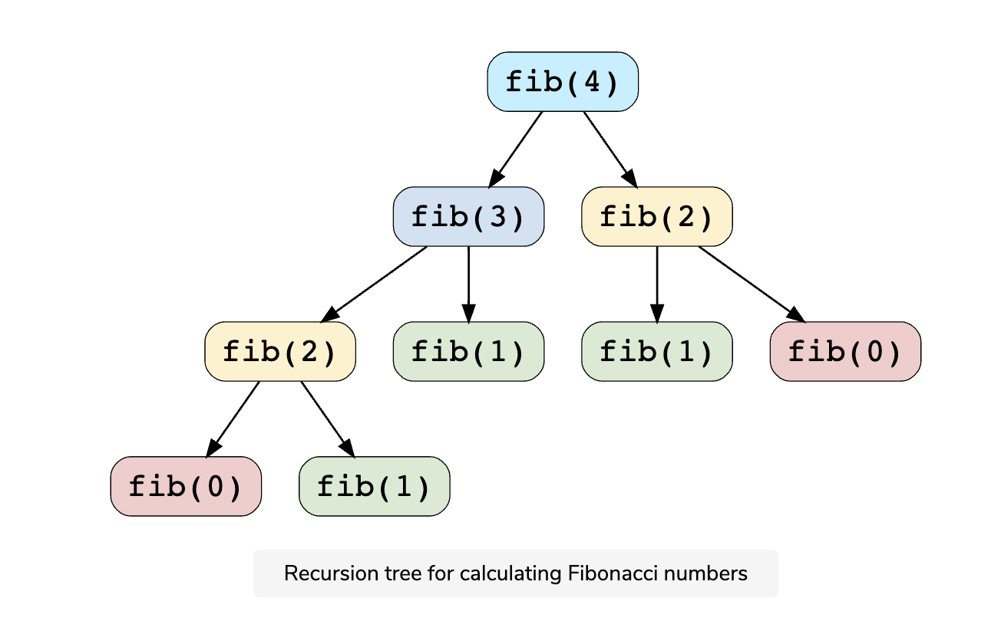](https://github.com/maazshaikh007/DSA_Patterns/blob/main/images/fib4.png)

We can clearly see the overlapping subproblem pattern here, as fib(2) has been evaluated twice and fib(1) has been evaluated three times.

**Optimal Substructure Property**

Any problem has optimal substructure property if its overall optimal solution can be constructed from the optimal solutions of its subproblems. For Fibonacci numbers, as we know,

Fib(n) = Fib(n-1) + Fib(n-2)

This clearly shows that a problem of size n has been reduced to subproblems of size n-1 and n-2. Therefore, Fibonacci numbers have optimal substructure property.

**Dynamic Programming Methods**

DP offers two methods to solve a problem.

**Top-down with Memoization**

In this approach, we try to solve the bigger problem by recursively finding the solution to smaller sub-problems. Whenever we solve a sub-problem, we cache its result so that we don’t end up solving it repeatedly if it’s called multiple times. Instead, we can just return the saved result. This technique of storing the results of already solved subproblems is called **Memoization**.

We’ll see this technique in our example of Fibonacci numbers. First, let’s see the non-DP recursive solution for finding the nth Fibonacci number:

function calculateFibonacci(n) {

if (n < 2) return n;

return calculateFibonacci(n - 1) + calculateFibonacci(n - 2);

}

console.log(`5th Fibonacci is ---> ${calculateFibonacci(5)}`);

console.log(`6th Fibonacci is ---> ${calculateFibonacci(6)}`);

console.log(`7th Fibonacci is ---> ${calculateFibonacci(7)}`);

### Java Solution: recursive

|  |
| --- |
| private static int calculateFibonacciRecursive(int n){  if(n <= 1) return n;  return calculateFibonacciRecursive(n-2) + calculateFibonacciRecursive(n-1);  } |

### Java Solution : Iterative

|  |
| --- |
| private static int calculateFibonacciIterative(int n){  int num1 = 0; int num2 = 1;int num3 = 0;  for(int i = 2; i<= n; i++){  num3 = num1+num2;  num1 = num2;  num2 = num3;  }  return num3;  } |

As we saw above, this problem shows the overlapping subproblems pattern, so let’s make use of **Memoization** here. We can use an array to store the already solved subproblems

function calculateFibonacci(n) {

const memoize = [];

function fib(n) {

if (n < 2) return n;

// if we have already solved this subproblem, simply return the result from the cache

if (memoize[n]) return memoize[n];

memoize[n] = fib(n - 1) + fib(n - 2);

return memoize[n];

}

return fib(n);

}

console.log(`5th Fibonacci is ---> ${calculateFibonacci(5)}`);

console.log(`6th Fibonacci is ---> ${calculateFibonacci(6)}`);

console.log(`7th Fibonacci is ---> ${calculateFibonacci(7)}`);

### Java Solution : Memoization

|  |
| --- |
| private static int calculateFibonacciMemoization(int n){  int[] memoize = new int[n+1];  return fib(n, memoize);  }  private static int fib(int n, int[] memoize){  if(n <= 1) return n;  if(memoize[n] != 0) return memoize[n];  memoize[n] = fib(n-1, memoize) + fib(n-2, memoize);  return memoize[n];  } |

**Bottom-up with Tabulation**

**Tabulation** is the opposite of the top-down approach and avoids recursion. In this approach, we solve the problem *“bottom-up”* (i.e. by solving all the related sub-problems first). This is typically done by filling up an n-dimensional table. Based on the results in the table, the solution to the top/original problem is then computed.

**Tabulation** is the opposite of **Memoization**, as in **Memoization** we solve the problem and maintain a map of already solved sub-problems. In other words, in **memoization** , we do it *top-down* in the sense that we solve the top problem first (which typically recurses down to solve the sub-problems).

Let’s apply **Tabulation** to our example of Fibonacci numbers. Since we know that every Fibonacci number is the sum of the two preceding numbers, we can use this fact to populate our table.

Here is the code for our **bottom-up dynamic programming** approach:

function calculateFibonacci(n) {

const dp = [0, 1];

for (let i = 2; i <= n; i++) {

dp[i] = dp[i - 1] + dp[i - 2];

}

return dp[n];

}

console.log(`5th Fibonacci is ---> ${calculateFibonacci(5)}`);

console.log(`6th Fibonacci is ---> ${calculateFibonacci(6)}`);

console.log(`7th Fibonacci is ---> ${calculateFibonacci(7)}`);

### Java Solution : Tabulation

|  |
| --- |
| private static int calculateFibonacciDP(int n){  int[] dp = new int[n+1];  dp[0] = 0;  dp[1] = 1;  for(int i = 2; i<= n; i++){  dp[i] = dp[i-1] +dp[i-2];  }  return dp[n];  } |

**In this course, we will always start with a brute-force recursive solution, which is the best way to start solving any DP problem!** Once we have a recursive solution then we will apply *memoization* and Tabulation techniques.

Let’s apply this knowledge to solve some of the frequently asked **DP** problems.

**Pattern 1: 0/1 Knapsack**

**Problem Set**

1. [🔎 0/1 Knapsack](https://github.com/maazshaikh007/DSA_Patterns/blob/main/%E2%9C%85%20Pattern%2015:%200-1%20Knapsack%20(Dynamic%20Programming).md#%F0%9F%94%8E-01-knapsack-medium)
2. [Equal Subset Sum Partition](https://github.com/maazshaikh007/DSA_Patterns/blob/main/%E2%9C%85%20Pattern%2015:%200-1%20Knapsack%20(Dynamic%20Programming).md#equal-subset-sum-partition-medium)
3. [Subset Sum](https://github.com/maazshaikh007/DSA_Patterns/blob/main/%E2%9C%85%20Pattern%2015:%200-1%20Knapsack%20(Dynamic%20Programming).md#%F0%9F%94%8E-subset-sum-medium)
4. [Minimum Subset Sum Difference](https://github.com/maazshaikh007/DSA_Patterns/blob/main/%E2%9C%85%20Pattern%2015:%200-1%20Knapsack%20(Dynamic%20Programming).md#minimum-subset-sum-difference-hard)
5. [🌟Count of Subset Sum](https://github.com/maazshaikh007/DSA_Patterns/blob/main/%E2%9C%85%20Pattern%2015:%200-1%20Knapsack%20(Dynamic%20Programming).md#%F0%9F%8C%9Fcount-of-subset-sum-hard)
6. [🌟 Target Sum](https://github.com/maazshaikh007/DSA_Patterns/blob/main/%E2%9C%85%20Pattern%2015:%200-1%20Knapsack%20(Dynamic%20Programming).md#%F0%9F%8C%9F-target-sum-hard)

**0/1 Knapsack pattern** is based on the famous problem with the same name which is efficiently solved using **Dynamic Programming (DP)**.

In this pattern, we will go through a set of problems to develop an understanding of **DP**. We will always start with a brute-force recursive solution to see the overlapping subproblems, i.e., realizing that we are solving the same problems repeatedly.

After the recursive solution, we will modify our algorithm Memoization to apply advanced techniques of **Memoization** and **Bottom-Up Dynamic Programming** to develop a complete understanding of this pattern.

Let’s jump onto our first problem.

**🔎 0/1 Knapsack (medium)**

<https://leetcode.com/problems/maximum-earnings-from-taxi/>

Given the weights and profits of N items, we are asked to put these items in a **knapsack** with a capacity C. The goal is to get the maximum profit out of the **knapsack** items. Each item can only be selected once, as we don’t have multiple quantities of any item.

Let’s take Merry’s example, who wants to carry some fruits in the **knapsack** to get maximum profit. Here are the weights and profits of the fruits:

* Items: { Apple, Orange, Banana, Melon }
* Weights: { 2, 3, 1, 4 }
* Profits: { 4, 5, 3, 7 }
* Knapsack capacity: 5

Let’s try to put various combinations of fruits in the knapsack, such that their total weight is not more than 5:

* Apple + Orange (total weight 5) => 9 profit
* Apple + Banana (total weight 3) => 7 profit
* Orange + Banana (total weight 4) => 8 profit
* Banana + Melon (total weight 5) => 10 profit

This shows that Banana + Melon is the best combination as it gives us the maximum profit, and the total weight does not exceed the capacity.

Given two integer arrays to represent weights and profits of N items, we need to find a subset of these items which will give us maximum profit such that their cumulative weight is not more than a given number C. Each item can only be selected once, which means either we put an item in the **knapsack** or we skip it.

**Basic Brute Force Soultion**

A basic **brute-force solution** could be to try all combinations of the given items (as we did above), allowing us to choose the one with maximum profit and a weight that doesn’t exceed C. Take the example of four items A, B, C, and D, as shown in the diagram below. To try all the combinations, our algorithm will look like:

|  |
| --- |
| for each item 'i'  create a new set which INCLUDES item 'i' if the total weight does not exceed the capacity, and  recursively process the remaining capacity and items  create a new set WITHOUT item 'i', and recursively process the remaining items  return the set from the above two sets with higher profit |

[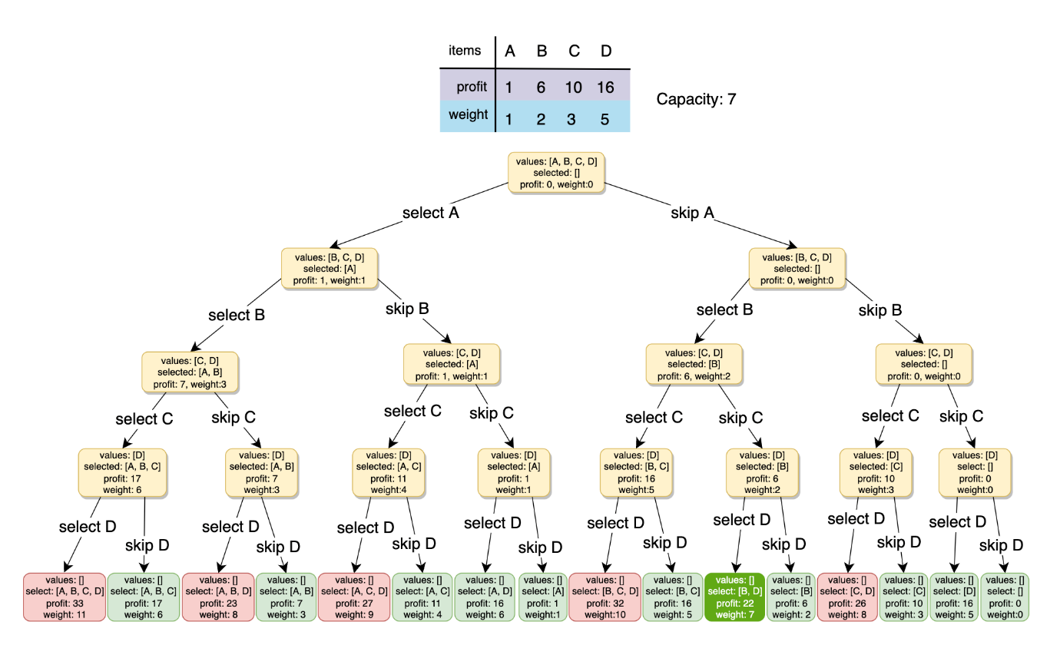](https://github.com/maazshaikh007/DSA_Patterns/blob/main/images/knapsack.png)

All **green boxes** have a total weight that is less than or equal to the capacity 7, and all the **red ones** have a weight that is more than 7. The best solution we have is with items [B, D] having a total profit of 22 and a total weight of 7.

**Brute-Force Solution**

### Code

|  |
| --- |
| public class Solution {  public int solveKnapsack(int[] profits, int[] weights, int capacity) {  return this.knapsackRecursive(profits, weights, capacity, 0);  }  private int knapsackRecursive(int[] profits, int[] weights, int capacity, int currentIndex) {  // base checks  if (capacity <= 0 || currentIndex >= profits.length)  return 0;  // recursive call after choosing the element at the currentIndex  // if the weight of the element at currentIndex exceeds the capacity, we shouldn't process this  int profit1 = 0;  if( weights[currentIndex] <= capacity )  profit1 = profits[currentIndex] + knapsackRecursive(profits, weights,  capacity - weights[currentIndex], currentIndex + 1);  // recursive call after excluding the element at the currentIndex  int profit2 = knapsackRecursive(profits, weights, capacity, currentIndex + 1);  return Math.max(profit1, profit2);  }  } |

### Time & Space Complexity

* The above algorithm’s **time complexity** is exponential O(2ⁿ), where n represents the total number of items. This can also be confirmed from the above recursion tree. As we can see, we will have a total of 31 😲 recursive calls – calculated through (2ⁿ) + (2ⁿ) - 1, which is *asymptotically* equivalent to O(2ⁿ).
* The **space complexity** is O(n). This space will be used to store the *recursion stack*. Since the recursive algorithm works in a depth-first fashion, which means that we can’t have more than n recursive calls on the call stack at any time.

### Java Solution : Brute Force

|  |
| --- |
| private static int solveKnapsack(int[] profits, int[] weights, int capacity){  return knapsack(profits, weights, capacity, 0);  }  private static int knapsack(int[] profits, int[] weights, int capacity, int currentIndex){  if(capacity == 0 || currentIndex >= profits.length) return 0;  int currentProfit = 0;  if(weights[currentIndex] <= capacity){  currentProfit = profits[currentIndex] + knapsack(profits, weights, capacity-weights[currentIndex], currentIndex+1);  }  int currentProfitWithoutCurrentItem = knapsack(profits, weights, capacity, currentIndex+1);  return Math.max(currentProfit, currentProfitWithoutCurrentItem);  } |

**Overlapping Sub-problems**

Let’s visually draw the recursive calls to see if there are any overlapping sub-problems. As we can see, in each recursive call, profits and weights arrays remain constant, and only capacity and currIndex change. For simplicity, let’s denote capacity with c and currIndex with i: [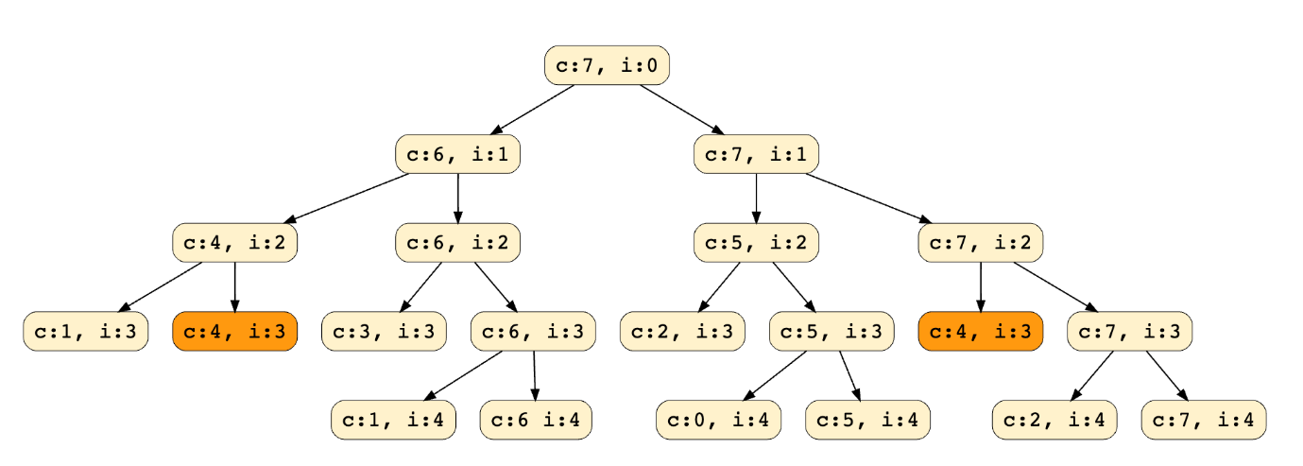](https://github.com/maazshaikh007/DSA_Patterns/blob/main/images/subproblems.png) We can clearly see that c:4, i=3 has been called twice. Hence we have an **overlapping sub-problems pattern**. We can use **[Memoization](https://en.wikipedia.org/wiki/Memoization)** to solve **overlapping sub-problems** efficiently.

**Top-down Dynamic Programming with Memoization**

We can use **memoization** to overcome the overlapping sub-problems. **[Memoization](https://en.wikipedia.org/wiki/Memoization)** is when we store the results of all the previously solved **sub-problems** and return the results from memory if we encounter a problem that has already been solved.

Since we have two changing values (capacity and currIndex) in our recursive function knapsackRecursive(), we can use a two-dimensional array to store the results of all the solved sub-problems. As mentioned above, we need to store results for every sub-array (i.e., for every possible index i) and every possible capacity c.

Here is the code with **memoization**

### Code

|  |
| --- |
| public class Solution {  public int solveKnapsack(int[] profits, int[] weights, int capacity) {  Integer[][] dp = new Integer[profits.length][capacity + 1];  return this.knapsackRecursive(dp, profits, weights, capacity, 0);  }  private int knapsackRecursive(Integer[][] dp, int[] profits, int[] weights, int capacity,  int currentIndex) {  // base checks  if (capacity <= 0 || currentIndex >= profits.length)  return 0;  // if we have already solved a similar problem, return the result from memory  if(dp[currentIndex][capacity] != null)  return dp[currentIndex][capacity];  // recursive call after choosing the element at the currentIndex  // if the weight of the element at currentIndex exceeds the capacity, we shouldn't process this  int profit1 = 0;  if( weights[currentIndex] <= capacity )  profit1 = profits[currentIndex] + knapsackRecursive(dp, profits, weights,  capacity - weights[currentIndex], currentIndex + 1);  // recursive call after excluding the element at the currentIndex  int profit2 = knapsackRecursive(dp, profits, weights, capacity, currentIndex + 1);  dp[currentIndex][capacity] = Math.max(profit1, profit2);  return dp[currentIndex][capacity];  }  } |

### Time & Space Complexity

* Since our **Memoization** array dp[profits.length][capacity+1] stores the results for all subproblems, we can conclude that we will not have more than N*C subproblems (where N is the number of items and C is the **knapsack** capacity). This means that our **time complexity** will be O(N*C).
* The above algorithm will use O(N*C) space for the **Memoization** array. Other than that, we will use O(N) space for the recursion call-stack. So the total **space complexity** will be O(N*C + N), which is *asymptotically* equivalent to O(N*C).

### Java Solution: Memoization

|  |
| --- |
| private static int solveKnapsack(int[] profits, int[] weights, int capacity){  int[][] memo = new int[profits.length + 1][capacity+1];  for(int i = 0; i<= profits.length; i++){  for(int j =0; j<=capacity; j++){  memo[i][j] = -1;  }  }  return knapsack(profits, weights, capacity, 0, memo);  }  private static int knapsack(int[] profits, int[] weights, int capacity, int currentIndex, int[][] memo){  if(capacity == 0 || currentIndex >= profits.length) return 0;  if(memo[currentIndex][capacity] != -1) return memo[currentIndex][capacity];  int currentProfit = 0;  if(weights[currentIndex] <= capacity){  currentProfit = profits[currentIndex] + knapsack(profits, weights, capacity-weights[currentIndex], currentIndex+1, memo);  }  int currentProfitWithoutCurrentItem = knapsack(profits, weights, capacity, currentIndex+1, memo);  return memo[currentIndex][capacity] = Math.max(currentProfit, currentProfitWithoutCurrentItem);  } |

**Bottom-up Dynamic Programming**

Let’s try to populate our memo[][] array from the above solution by working in a **bottom-up** fashion. Essentially, we want to find the maximum profit for every sub-array and every possible capacity. **This means that dp[i][c] will represent the maximum knapsack profit for capacity c calculated from the first i items**.

So, for each item at index i (0 <= i < items.length) and capacity c (0 <= c <= capacity), we have two options:

1. Exclude the item at index i. In this case, we will take whatever profit we get from the sub-array excluding this item => dp[i-1][c]
2. Include the item at index i if its weight is not more than the capacity. In this case, we include its profit plus whatever profit we get from the remaining capacity and from remaining items => profit[i] + dp[i-1][c-weight[i]]

Finally, our optimal solution will be maximum of the above two values:

dp[i][c] = max (dp[i-1][c], profit[i] + dp[i-1][c-weight[i]])

Let's visually draw this and start with our base case of zero capacity:

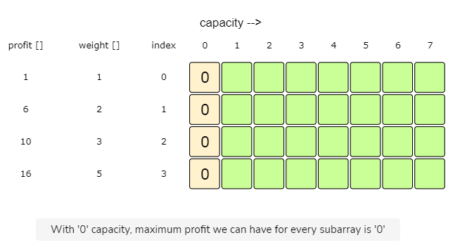

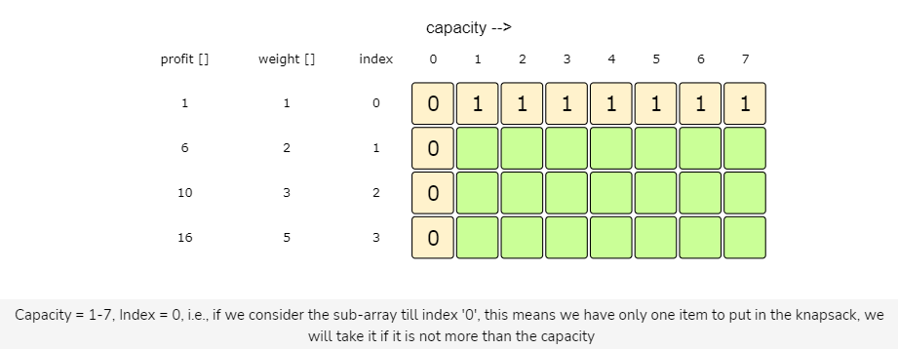

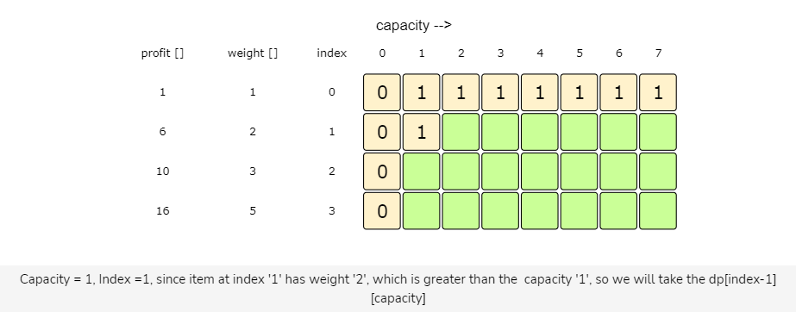

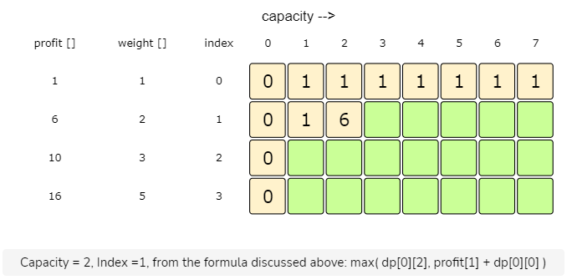

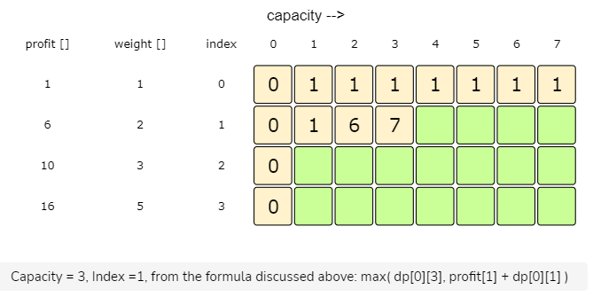

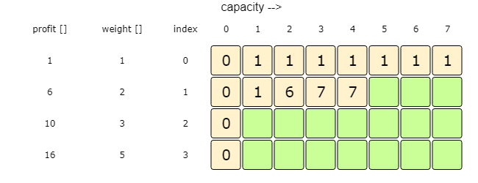

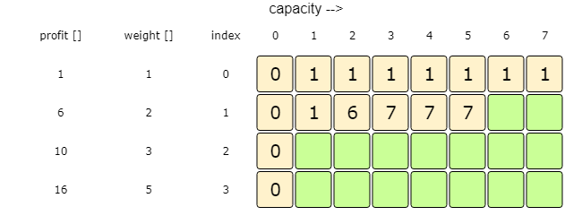

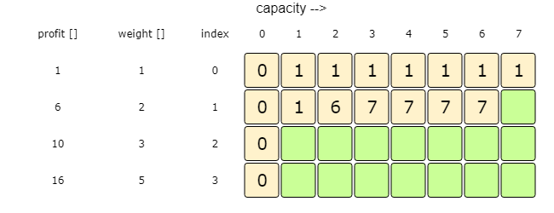

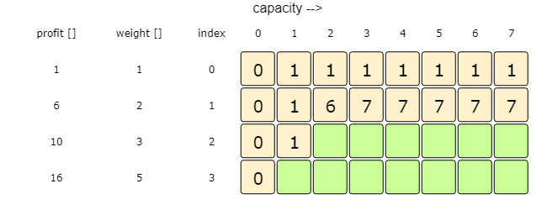

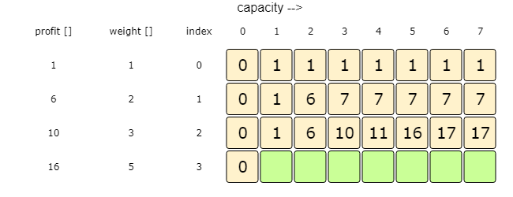

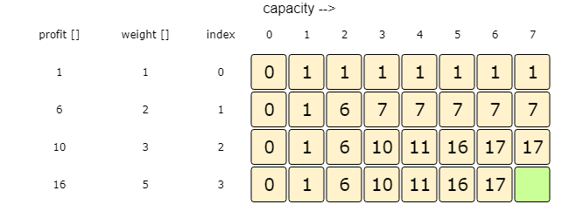

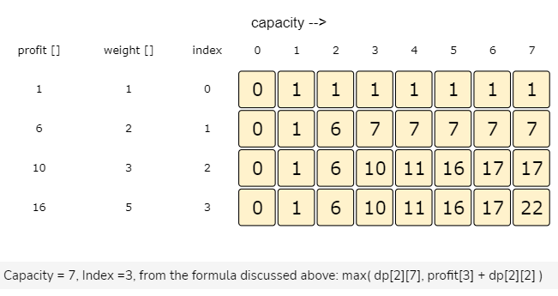

### Code

|  |
| --- |
| public class Solution {  public int solveKnapsack(int[] profits, int[] weights, int capacity) {  // basic checks  if (capacity <= 0 || profits.length == 0 || weights.length != profits.length)  return 0;  int n = profits.length;  int[][] dp = new int[n][capacity + 1];  // populate the capacity=0 columns, with '0' capacity we have '0' profit  for(int i=0; i < n; i++)  dp[i][0] = 0;  // if we have only one weight, we will take it if it is not more than the capacity  for(int c=0; c <= capacity; c++) {  if(weights[0] <= c)  dp[0][c] = profits[0];  }  // process all sub-arrays for all the capacities  for(int i=1; i < n; i++) {  for(int c=1; c <= capacity; c++) {  int profit1= 0, profit2 = 0;  // include the item, if it is not more than the capacity  if(weights[i] <= c)  profit1 = profits[i] + dp[i-1][c-weights[i]];  // exclude the item  profit2 = dp[i-1][c];  // take maximum  dp[i][c] = Math.max(profit1, profit2);  }  }  // maximum profit will be at the bottom-right corner.  return dp[n-1][capacity];  }  } |

### Time & Space Complexity

* The above solution has the time and **space complexity** of O(N*C), where N represents total items, and C is the maximum capacity.

### Java Solution

|  |
| --- |
| private static int solveKnapsack(int[] profits, int[] weights, int capacity){  int n = profits.length;  if(capacity <= 0 || n == 0 || n != weights.length) return 0;  int[][] dp = new int[n][capacity+1];  for (int c = 0; c <= capacity; c++) {  if (weights[0] <= c) {  dp[0][c] = profits[0];  }  }  for(int i = 1; i< n; i++){  for(int c = 1; c<= capacity; c++){  int profitWithCurIndex = 0;  int profitWithoutCurIndex = 0;  if(weights[i] <= c) profitWithCurIndex = profits[i]+dp[i-1][c-weights[i]];  profitWithoutCurIndex = dp[i-1][c];  dp[i][c] = Math.max(profitWithCurIndex, profitWithoutCurIndex);  }  }  return dp[n-1][capacity];  } |

### How can we find the selected items?

As we know, the final profit is at the bottom-right corner. Therefore, we will start from there to find the items that will be going into the **knapsack**.

As you remember, at every step, we had two options: include an item or skip it. If we skip an item, we take the profit from the remaining items (i.e., from the cell right above it); if we include the item, then we jump to the remaining profit to find more items.

Let’s understand this from the above example: [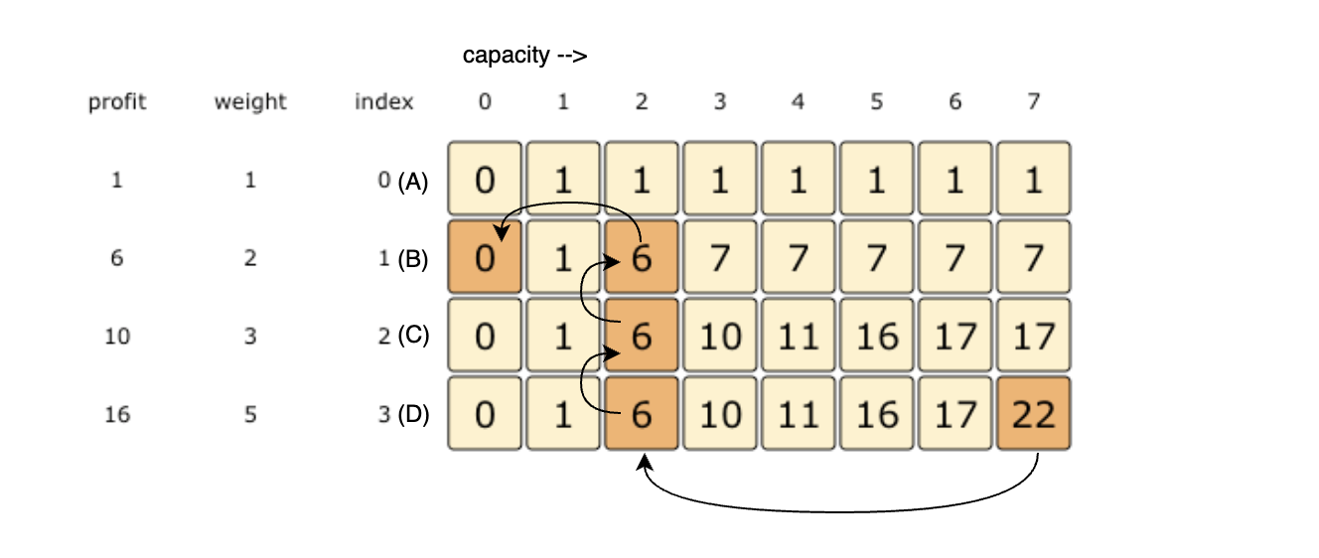](https://github.com/maazshaikh007/DSA_Patterns/blob/main/images/dpselected.png)

1. 22 did not come from the top cell (which is 17); hence we must include the item at index 3 (which is item D).
2. Subtract the profit of item D from 22 to get the remaining profit 6. We then jump to profit 6 on the same row.
3. 6 came from the top cell, so we jump to row 2.
4. Again, 6 came from the top cell, so we jump to row 1.
5. 6 is different from the top cell, so we must include this item (which is item B).
6. Subtract the profit of B from 6 to get profit 0. We then jump to profit 0 on the same row. As soon as we hit zero remaining profit, we can finish our item search.
7. Thus, the items going into the **knapsack** are {B, D}.

Let’s write a function to print the set of items included in the **knapsack**.

### Code

|  |
| --- |
| public class Solution {  public int solveKnapsack(int[] profits, int[] weights, int capacity) {  // base checks  if (capacity <= 0 || profits.length == 0 || weights.length != profits.length)  return 0;  int n = profits.length;  int[][] dp = new int[n][capacity + 1];  // populate the capacity=0 columns, with '0' capacity we have '0' profit  for(int i=0; i < n; i++)  dp[i][0] = 0;  // if we have only one weight, we will take it if it is not more than the capacity  for(int c=0; c <= capacity; c++) {  if(weights[0] <= c)  dp[0][c] = profits[0];  }  // process all sub-arrays for all the capacities  for(int i=1; i < n; i++) {  for(int c=1; c <= capacity; c++) {  int profit1= 0, profit2 = 0;  // include the item, if it is not more than the capacity  if(weights[i] <= c)  profit1 = profits[i] + dp[i-1][c-weights[i]];  // exclude the item  profit2 = dp[i-1][c];  // take maximum  dp[i][c] = Math.max(profit1, profit2);  }  }  printSelectedElements(dp, weights, profits, capacity);  // maximum profit will be at the bottom-right corner.  return dp[n-1][capacity];  }  private void printSelectedElements(int dp[][], int[] weights, int[] profits, int capacity){  System.out.print("Selected weights:");  int totalProfit = dp[weights.length-1][capacity];  for(int i=weights.length-1; i > 0; i--) {  if(totalProfit != dp[i-1][capacity]) {  System.out.print(" " + weights[i]);  capacity -= weights[i];  totalProfit -= profits[i];  }  }  if(totalProfit != 0)  System.out.print(" " + weights[0]);  System.out.println("");  }  } |

### Java Solution

|  |
| --- |
| private static int solveKnapsack(int[] profits, int[] weights, int capacity){  int n = profits.length;  if(capacity <= 0 || n == 0 || n != weights.length) return 0;  int[][] dp = new int[n][capacity+1];  for (int c = 0; c <= capacity; c++) {  if (weights[0] <= c) {  dp[0][c] = profits[0];  }  }  for(int i = 1; i< n; i++){  for(int c = 1; c<= capacity; c++){  int profitWithCurIndex = 0;  int profitWithoutCurIndex = 0;  if(weights[i] <= c) profitWithCurIndex = profits[i]+dp[i-1][c-weights[i]];  profitWithoutCurIndex = dp[i-1][c];  dp[i][c] = Math.max(profitWithCurIndex, profitWithoutCurIndex);  }  }  printSelectedItems(dp, weights, profits, capacity);  return dp[n-1][capacity];  }  private static void printSelectedItems(int[][] dp, int[] weights, int[] profits, int capacity){  int totalProfits = dp[weights.length - 1][capacity];  for(int i = weights.length - 1; i>0; i--){  if(dp[i-1][capacity] != totalProfits){  totalProfits -= profits[i];  System.out.print(weights[i]+" ");  capacity -= weights[i];  }  }  if(totalProfits != 0)  System.out.println(weights[0]);  System.out.println("");  } |

**Challenge**

Can we improve our **bottom-up DP** solution even further? Can you find an algorithm that has O(C) space complexity?

#### Code: Java Solution

|  |
| --- |
| public static int solveKnapsack1(int[] profits, int[] weights, int capacity) {  // basic checks  if (capacity <= 0 || profits.length == 0 || weights.length != profits.length)  return 0;  int n = profits.length;  // we only need one previous row to find the optimal solution, overall we need '2' rows  // the above solution is similar to the previous solution, the only difference is that  // we use `i%2` instead if `i` and `(i-1)%2` instead if `i-1`  int[][] dp = new int[2][capacity+1];  // if we have only one weight, we will take it if it is not more than the capacity  for(int c=0; c <= capacity; c++) {  if(weights[0] <= c)  dp[0][c] = dp[1][c] = profits[0];  }  // process all sub-arrays for all the capacities  for(int i=1; i < n; i++) {  for(int c=0; c <= capacity; c++) {  int profit1= 0, profit2 = 0;  // include the item, if it is not more than the capacity  if(weights[i] <= c)  profit1 = profits[i] + dp[(i-1)%2][c-weights[i]];  // exclude the item  profit2 = dp[(i-1)%2][c];  // take maximum  dp[i%2][c] = Math.max(profit1, profit2);  }  }  return dp[(n-1)%2][capacity];  } |

The solution above is similar to the previous solution; the only difference is that we use i%2 instead of i and (i-1)%2 instead of i-1. This solution has a **space complexity** of O(2*C) = O(C), where C is the knapsack’s maximum capacity.

This **space optimization solution** can also be implemented using a single array. It is a bit tricky, but the intuition is to use the same array for the previous and the next iteration!

If you see closely, we need two values from the previous iteration: dp[c] and dp[c-weight[i]]

Since our inner loop is iterating over c:0-->capacity, let’s see how this might affect our two required values:

1. When we access dp[c], it has not been overridden yet for the current iteration, so it should be fine.
2. dp[c-weight[i]] might be overridden if weight[i] > 0. Therefore we can’t use this value for the current iteration.

To solve the second case, we can change our inner loop to process in the reverse direction: c:capacity-->0. This will ensure that whenever we change a value in dp[], we will not need it again in the current iteration.

#### Code : Java Solution 2

|  |
| --- |
| public static int solveKnapsack2(int[] profits, int[] weights, int capacity) {  // basic checks  if (capacity <= 0 || profits.length == 0 || weights.length != profits.length)  return 0;  int n = profits.length;  int[] dp = new int[capacity + 1];  // if we have only one weight, we will take it if it is not more than the  // capacity  for (int c = 0; c <= capacity; c++) {  if (weights[0] <= c)  dp[c] = profits[0];  }  // process all sub-arrays for all the capacities  for (int i = 1; i < n; i++) {  for (int c = capacity; c >= 0; c--) {  int profit1 = 0, profit2 = 0;  // include the item, if it is not more than the capacity  if (weights[i] <= c)  profit1 = profits[i] + dp[c - weights[i]];  // exclude the item  profit2 = dp[c];  // take maximum  dp[c] = Math.max(profit1, profit2);  }  }  return dp[capacity];  } |

**Equal Subset Sum Partition (medium)**

<https://leetcode.com/problems/partition-equal-subset-sum/>

### Problem Statement

Given a set of positive numbers, find if we can partition it into two subsets such that the sum of elements in both subsets is equal.

**Example 1:**

Input: {1, 2, 3, 4}

Output: True

Explanation: The given set can be partitioned into two subsets with equal sum: {1, 4} & {2, 3}

**Example 2:**

Input: {1, 1, 3, 4, 7}

Output: True

Explanation: The given set can be partitioned into two subsets with equal sum: {1, 3, 4} & {1, 7}

**Example 3:**

Input: {2, 3, 4, 6}

Output: False

Explanation: The given set cannot be partitioned into two subsets with equal sum.

This problem follows the [**0/1 Knapsack pattern**](https://github.com/maazshaikh007/DSA_Patterns/blob/main/%E2%9C%85%20Pattern%2015:%200-1%20Knapsack%20(Dynamic%20Programming).md#pattern-1-01-knapsack). A basic **brute-force** solution could be to try all combinations of partitioning the given numbers into two sets to see if any pair of sets has an equal sum.

Assume that S represents the total sum of all the given numbers. Then the two equal subsets must have a sum equal to S/2. This essentially transforms our problem to: *"Find a subset of the given numbers that has a total sum of S/2"*.

So our **brute-force** algorithm will look like:

|  |
| --- |
| for each number 'i'  create a new set which INCLUDES number 'i' if it does not exceed 'S/2', and recursively  process the remaining numbers  create a new set WITHOUT number 'i', and recursively process the remaining items  return true if any of the above sets has a sum equal to 'S/2', otherwise return false |

### Code

|  |
| --- |
| public class Solution {  public boolean canPartition(int[] num) {  int sum = 0;  for (int i = 0; i < num.length; i++)  sum += num[i];  // if 'sum' is a an odd number, we can't have two subsets with equal sum  if(sum % 2 != 0)  return false;  return this.canPartitionRecursive(num, sum/2, 0);  }  private boolean canPartitionRecursive(int[] num, int sum, int currentIndex) {  // base check  if (sum == 0)  return true;  if(num.length == 0 || currentIndex >= num.length)  return false;  // recursive call after choosing the number at the currentIndex  // if the number at currentIndex exceeds the sum, we shouldn't process this  if( num[currentIndex] <= sum ) {  if(canPartitionRecursive(num, sum - num[currentIndex], currentIndex + 1))  return true;  }  // recursive call after excluding the number at the currentIndex  return canPartitionRecursive(num, sum, currentIndex + 1);  }  public static void main(String[] args) {  Solution ps = new Solution();  int[] num = {1, 2, 3, 4};  System.out.println(ps.canPartition(num));  num = new int[]{1, 1, 3, 4, 7};  System.out.println(ps.canPartition(num));  num = new int[]{2, 3, 4, 6};  System.out.println(ps.canPartition(num));  }  } |

* The **time complexity** of the above algorithm is exponential O(2ⁿ), where n represents the total number.
* The **space complexity** is O(n), which will be used to store the *recursion stack*.

**Top-down Dynamic Programming with Memoization**

We can use **Memoization** to overcome the overlapping sub-problems. As stated in previous lessons, **Memoization** is when we store the results of all the previously solved sub-problems so we can return the results from memory if we encounter a problem that has already been solved.

Since we need to store the results for every subset and for every possible sum, therefore we will be using a two-dimensional array to store the results of the solved sub-problems. The first dimension of the array will represent different subsets and the second dimension will represent different sums that we can calculate from each subset. These two dimensions of the array can also be inferred from the two changing values (sum and currIndex) in our recursive function canPartitionRecursive().

Here is the code for **Top-down Dynamic Programming with Memoization**:

### Code

|  |
| --- |
| public class Solution {  public boolean canPartition(int[] num) {  int sum = 0;  for (int i = 0; i < num.length; i++)  sum += num[i];  // if 'sum' is a an odd number, we can't have two subsets with equal sum  if (sum % 2 != 0)  return false;  Boolean[][] dp = new Boolean[num.length][sum / 2 + 1];  return this.canPartitionRecursive(dp, num, sum / 2, 0);  }  private boolean canPartitionRecursive(Boolean[][] dp, int[] num, int sum, int currentIndex) {  // base check  if (sum == 0)  return true;  if (num.length == 0 || currentIndex >= num.length)  return false;  // if we have not already processed a similar problem  if (dp[currentIndex][sum] == null) {  // recursive call after choosing the number at the currentIndex  // if the number at currentIndex exceeds the sum, we shouldn't process this  if (num[currentIndex] <= sum) {  if (canPartitionRecursive(dp, num, sum - num[currentIndex], currentIndex + 1)) {  dp[currentIndex][sum] = true;  return true;  }  }  // recursive call after excluding the number at the currentIndex  dp[currentIndex][sum] = canPartitionRecursive(dp, num, sum, currentIndex + 1);  }  return dp[currentIndex][sum];  }  public static void main(String[] args) {  Solution ps = new Solution();  int[] num = {1, 2, 3, 4};  System.out.println(ps.canPartition(num));  num = new int[]{1, 1, 3, 4, 7};  System.out.println(ps.canPartition(num));  num = new int[]{2, 3, 4, 6};  System.out.println(ps.canPartition(num));  }  } |

* The above algorithm has the time and **space complexity** of O(N*S), where N represents total numbers and S is the total sum of all the numbers.

**Bottom-up Dynamic Programming**

Let’s try to populate our dp[][] array from the above solution by working in a **bottom-up** fashion. Essentially, we want to find if we can make all possible sums with every subset. This means, dp[i][s] will be true if we can make the sum s from the first i numbers.

So, for each number at index i (0 <= i < num.length) and sum s (0 <= s <= S/2), we have two options:

1. Exclude the number. In this case, we will see if we can get s from the subset excluding this number: dp[i-1][s]
2. Include the number if its value is not more than s. In this case, we will see if we can find a subset to get the remaining sum: dp[i-1][s-num[i]] If either of the two above scenarios is true, we can find a subset of numbers with a sum equal to s.

Let’s start with our *base case of zero capacity*:

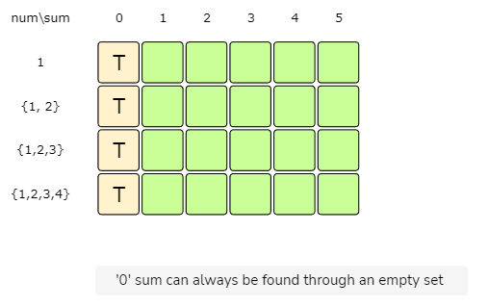

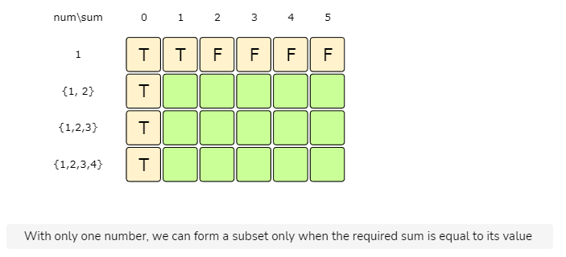

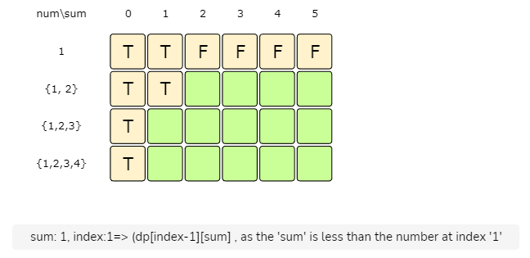

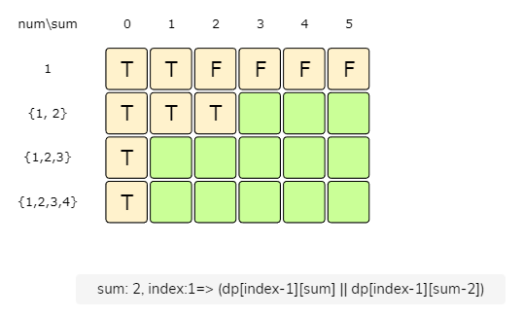

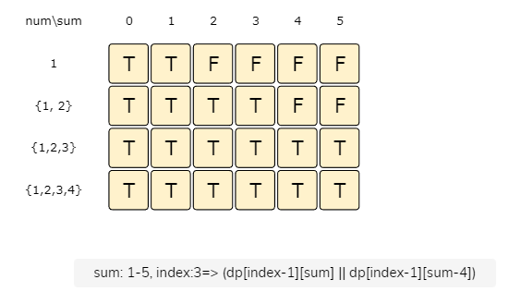

From the above visualization, we can clearly see that it is possible to partition the given set into two subsets with equal sums, as shown by bottom-right cell: dp[3][5] => T

### Code

|  |
| --- |
| public class Solution {  public boolean canPartition(int[] num) {  int n = num.length;  // find the total sum  int sum = 0;  for (int i = 0; i < n; i++)  sum += num[i];  // if 'sum' is a an odd number, we can't have two subsets with same total  if(sum % 2 != 0)  return false;  // we are trying to find a subset of given numbers that has a total sum of ‘sum/2’.  sum /= 2;  boolean[][] dp = new boolean[n][sum + 1];  // populate the sum=0 column, as we can always have '0' sum without including any element  for(int i=0; i < n; i++)  dp[i][0] = true;  // with only one number, we can form a subset only when the required sum is equal to its value  for(int s=1; s <= sum ; s++) {  dp[0][s] = (num[0] == s ? true : false);  }  // process all subsets for all sums  for(int i=1; i < n; i++) {  for(int s=1; s <= sum; s++) {  // if we can get the sum 's' without the number at index 'i'  if(dp[i-1][s]) {  dp[i][s] = dp[i-1][s];  } else if (s >= num[i]) { // else if we can find a subset to get the remaining sum  dp[i][s] = dp[i-1][s-num[i]];  }  }  }  // the bottom-right corner will have our answer.  return dp[n-1][sum];  }  } |

* The above solution the has time and **space complexity** of O(N*S), where N represents total numbers and S is the total sum of all the numbers.

#### Java Solution 2D Array

|  |
| --- |
| private static boolean canPartition(int[] nums) {  int n = nums.length;  int sum = 0;  for(int i=0; i< n; i++) sum += nums[i];  if(sum %2 != 0) return false;  sum /= 2;  boolean[][] dp = new boolean[n][sum + 1];  for (int i = 0; i < n; i++) {  dp[i][0] = true;  }  for (int s = 1; s <= sum; s++) {  dp[0][s] = nums[0] == s;  }  for (int i = 1; i < n; i++) {  for (int s = 1; s <= sum; s++) {  if (dp[i - 1][s])  dp[i][s] = dp[i - 1][s];  else if (nums[i] <= s)  dp[i][s] = dp[i - 1][s - nums[i]];  }  }  return dp[n - 1][sum];  } |

#### Java Solution 1D Array

|  |
| --- |
| private static boolean canPartitionOptimised(int[] nums) {  int n = nums.length;  int sum = 0;  for(int i=0; i< n; i++) sum += nums[i];  if(sum %2 != 0) return false;  sum /= 2;  boolean[] dp = new boolean[sum + 1];  dp[0] = true;  for (int s = 1; s <= sum; s++) {  dp[s] = nums[0] == s;  }  for (int i = 1; i < n; i++) {  for (int s = sum; s >= 0; s--) {  // if dp[s]==true, this means we can get the sum s without  //num[i], then move on to the next number else we can include num[i]  //and see if we can find a subset to get the remaining sum  if (!dp[s] && s >= nums[i]) {  //else include the number and see if we can find a subset to get the remaining sum  dp[s] = dp[s - nums[i]];  }  }  }  return dp[sum];  } |

#### Java optimised with 1 D Array

|  |
| --- |
| private static boolean canPartitionOptimised1(int[] nums) {  int n = nums.length;  int sum = 0;  for(int i=0; i< n; i++) sum += nums[i];  if(sum %2 != 0) return false;  sum /= 2;  boolean[] dp = new boolean[sum + 1];  dp[0] = true;  for (int i = 1; i < n; i++) {  for (int s = sum; s >= nums[i]; s--) {  if (dp[s - nums[i]]) {  dp[s] = true;  }  }  if(dp[sum]) return true;  }  return false;  } |

**🔎 Subset Sum (medium)**

<https://www.techiedelight.com/subset-sum-problem/>

Given a set of positive numbers, determine if a subset exists whose sum is equal to a given number S.

### Example 1:

Input: {1, 2, 3, 7}, S=6

Output: True

The given set has a subset whose sum is '6': {1, 2, 3}

### Example 2:

Input: {1, 2, 7, 1, 5}, S=10

Output: True

The given set has a subset whose sum is '10': {1, 2, 7}

### Example 3:

Input: {1, 3, 4, 8}, S=6

Output: False

The given set does not have any subset whose sum is equal to '6'.

This problem follows the [**0/1 Knapsack pattern**](https://github.com/maazshaikh007/DSA_Patterns/blob/main/%E2%9C%85%20Pattern%2015:%200-1%20Knapsack%20(Dynamic%20Programming).md#pattern-1-01-knapsack) and is quite similar to [**Equal Subset Sum Partition**](https://github.com/maazshaikh007/DSA_Patterns/blob/main/%E2%9C%85%20Pattern%2015:%200-1%20Knapsack%20(Dynamic%20Programming).md#equal-subset-sum-partition-medium). A basic **brute-force** solution could be to try all subsets of the given numbers to see if any set has a sum equal to S.

So our **brute-force** algorithm will look like:

for each number 'i'

create a new set which INCLUDES number 'i' if it does not exceed 'S', and recursively

process the remaining numbers

create a new set WITHOUT number 'i', and recursively process the remaining numbers

return true if any of the above two sets has a sum equal to 'S', otherwise return false

Since this problem is quite similar to [**Equal Subset Sum Partition**](https://github.com/maazshaikh007/DSA_Patterns/blob/main/%E2%9C%85%20Pattern%2015:%200-1%20Knapsack%20(Dynamic%20Programming).md#equal-subset-sum-partition-medium), let’s jump directly to the **bottom-up dynamic programming** solution.

### Java Brute force Solution

|  |
| --- |
| private static boolean subsetSum(int[] nums, int sum){  return subsetSumRecursive(nums, sum, 0);  }  private static boolean subsetSumRecursive(int[] nums, int sum, int currentIndex){  int n = nums.length;  if(sum == 0) return true;  if(n == 0 || currentIndex >= n) return false;  if(nums[currentIndex] <= sum){  if(subsetSumRecursive(nums, sum-nums[currentIndex], currentIndex+1)){  return true;  }  }  return subsetSumRecursive(nums, sum, currentIndex+1);  } |

### Java memoization Solution

|  |
| --- |
| private static boolean subsetSum1(int[] nums, int sum){  Boolean[][] dp = new Boolean[nums.length][sum+1];  return subsetSumRecursive1(nums, sum, 0, dp);  }  private static boolean subsetSumRecursive1(int[] nums, int sum, int currentIndex, Boolean[][] dp){  int n = nums.length;  if(sum == 0) return true;  if(n == 0 || currentIndex >= n) return false;  if(dp[currentIndex][sum] != null) return dp[currentIndex][sum];  if(nums[currentIndex] <= sum){  if(subsetSumRecursive1(nums, sum-nums[currentIndex], currentIndex+1, dp)){  dp[currentIndex][sum] = true;  return true;  }  }  return dp[currentIndex][sum] = subsetSumRecursive1(nums, sum, currentIndex+1, dp);  } |

**Bottom-up Dynamic Programming**

We’ll try to find if we can make all possible sums with every subset to populate the array dp[TotalNumbers][S+1].

For every possible sum s (where 0 <= s <= S), we have two options:

1. Exclude the number. In this case, we will see if we can get the sum s from the subset excluding this number => dp[index-1][s]
2. Include the number if its value is not more than s. In this case, we will see if we can find a subset to get the remaining sum => dp[index-1][s-num[index]]

If either of the above two scenarios returns true, we can find a subset with a sum equal to s.

Let's draw this visually, with the example input {1, 2, 3, 7}, and start with our base case of size zero:

Let's start with our base case of zero capacity:











Here is the code for our **bottom-up dynamic programming** approach:

### Code

|  |
| --- |
| class Solution {  public boolean canPartition(int[] num, int sum) {  int n = num.length;  boolean[][] dp = new boolean[n][sum + 1];  // populate the sum=0 columns, as we can always form '0' sum with an empty set  for (int i = 0; i < n; i++)  dp[i][0] = true;  // with only one number, we can form a subset only when the required sum is  // equal to its value  for (int s = 1; s <= sum; s++) {  dp[0][s] = (num[0] == s ? true : false);  }  // process all subsets for all sums  for (int i = 1; i < num.length; i++) {  for (int s = 1; s <= sum; s++) {  // if we can get the sum 's' without the number at index 'i'  if (dp[i - 1][s]) {  dp[i][s] = dp[i - 1][s];  } else if (s >= num[i]) {  // else include the number and see if we can find a subset to get the remaining  // sum  dp[i][s] = dp[i - 1][s - num[i]];  }  }  }  // the bottom-right corner will have our answer.  return dp[num.length - 1][sum];  }  public static void main(String[] args) {  Solution ss = new Solution();  int[] num = { 1, 2, 3, 7 };  System.out.println(ss.canPartition(num, 6));  num = new int[] { 1, 2, 7, 1, 5 };  System.out.println(ss.canPartition(num, 10));  num = new int[] { 1, 3, 4, 8 };  System.out.println(ss.canPartition(num, 6));  }  } |

* The above solution has the time and **space complexity** of O(N*S), where N represents total numbers and S is the required sum.

#### Java Solution

|  |
| --- |
| private static boolean subsetSum(int[] nums, int sum){  int n = nums.length;  boolean[][] dp = new boolean[n][sum+1];  for(int i=0; i< n; i++){  dp[i][0] = true;  }  for(int s = 1; s<=sum;s++){  dp[0][s] = nums[0] == sum? true:false;  }  for(int i = 1; i< n; i++){  for(int s=1; s<=sum;s++){  if(dp[i-1][s])  dp[i][s] = dp[i-1][s];  else if(nums[i] <= s)  dp[i][s] = dp[i-1][s-nums[i]];  }  }  return dp[n-1][sum];  } |

**Challenge**

*  Can we improve our **bottom-up DP** solution even further? Can you find an algorithm that has O(S) space complexity?

function canPartition(nums, sum) {

//O(S) space bottom-up dynamic programming approach

let n = nums.length;

const dp = Array(sum + 1).fill(false);

//sum=0, as we can always have 0 sum with an empty set

dp[0] = true;

//with only one number, we can form a subset only when the required sum is equal to its value

for (let s = 1; s <= sum; s++) dp[s] = nums[0] == s;

//process all subsets for all lsum

for (let i = 1; i < nums.length; i++) {

for (let s = sum; s >= 0; s--) {

// if dp[s]==true, this means we can get the sum s without

//num[i], then move on to the next number else we can include num[i]

//and see if e can find a subset to get the remaining sum

if (!dp[s] && s >= nums[i]) {

//else include the number and see if we can find a subset to get the remaining sum

dp[s] = dp[s - nums[i]];

}

}

}

return dp[sum];

}

console.log(`Can partitioning be done: ---> ${canPartition([1, 2, 3, 4], 6)}`);

//True

//The given set has a subset whose sum is '6': {1, 2, 3}

console.log(

`Can partitioning be done: ---> ${canPartition([1, 2, 7, 1, 5], 10)}`

);

//True

//The given set has a subset whose sum is '10': {1, 2, 7}

console.log(`Can partitioning be done: ---> ${canPartition([1, 3, 4, 8], 6)}`);

//False

//The given set does not have any subset whose sum is equal to '6'.

#### Java Solution

|  |
| --- |
| private static boolean subsetSumOptimised(int[] nums, int sum) {  int n = nums.length;  boolean[] dp = new boolean[sum + 1];  dp[0] = true;  for (int s = 1; s <= sum; s++) {  dp[s] = nums[0] == s;  }  for (int i = 1; i < n; i++) {  for (int s = sum; s >= 0; s--) {  // if dp[s]==true, this means we can get the sum s without  //num[i], then move on to the next number else we can include num[i]  //and see if we can find a subset to get the remaining sum  if (!dp[s] && s >= nums[i]) {  //else include the number and see if we can find a subset to get the remaining sum  dp[s] = dp[s - nums[i]];  }  }  }  return dp[sum];  } |

**Minimum Subset Sum Difference (hard)**

<https://leetcode.com/problems/partition-array-into-two-arrays-to-minimize-sum-difference/>

### Problem Statement

Given a set of positive numbers, partition the set into two subsets with minimum difference between their subset sums.

**Example 1:**

Input: {1, 2, 3, 9}

Output: 3

Explanation: We can partition the given set into two subsets where the minimum absolute difference

between the sum of numbers is '3'. Following are the two subsets: {1, 2, 3} & {9}.

**Example 2:**

Input: {1, 2, 7, 1, 5}

Output: 0

Explanation: We can partition the given set into two subsets where the minimum absolute difference

between the sum of numbers is '0'. Following are the two subsets: {1, 2, 5} & {7, 1}.

**Example 3:**

Input: {1, 3, 100, 4}

Output: 92

Explanation: We can partition the given set into two subsets where the minimum absolute difference

between the sum of numbers is '92'. Here are the two subsets: {1, 3, 4} & {100}.

### Solution

This problem follows the [**0/1 Knapsack pattern**](https://github.com/maazshaikh007/DSA_Patterns/blob/main/%E2%9C%85%20Pattern%2015:%200-1%20Knapsack%20(Dynamic%20Programming).md#pattern-1-01-knapsack) and can be converted into a [**Subset Sum**](https://github.com/maazshaikh007/DSA_Patterns/blob/main/%E2%9C%85%20Pattern%2015:%200-1%20Knapsack%20(Dynamic%20Programming).md#%F0%9F%94%8E-subset-sum-medium) problem.

Let’s assume str1 and str2 are the two desired subsets. A basic **brute-force** solution could be to try adding each element either in str1 or str2 in order to find the combination that gives the minimum sum difference between the two sets.

So our **brute-force** algorithm will look like:

for each number 'i'

add number 'i' to str1 and recursively process the remaining numbers

add number 'i' to str2 and recursively process the remaining numbers

return the minimum absolute difference of the above two sets

Here is the code for the **brute-force** solution:

### Code

|  |
| --- |
| class Solution {  public int canPartition(int[] num) {  return this.canPartitionRecursive(num, 0, 0, 0);  }  private int canPartitionRecursive(int[] num, int currentIndex, int sum1, int sum2) {  // base check  if (currentIndex == num.length)  return Math.abs(sum1 - sum2);  // recursive call after including the number at the currentIndex in the first set  int diff1 = canPartitionRecursive(num, currentIndex+1, sum1+num[currentIndex], sum2);  // recursive call after including the number at the currentIndex in the second set  int diff2 = canPartitionRecursive(num, currentIndex+1, sum1, sum2+num[currentIndex]);  return Math.min(diff1, diff2);  }  public static void main(String[] args) {  Solution ps = new Solution();  int[] num = {1, 2, 3, 9};  System.out.println(ps.canPartition(num));  num = new int[]{1, 2, 7, 1, 5};  System.out.println(ps.canPartition(num));  num = new int[]{1, 3, 100, 4};  System.out.println(ps.canPartition(num));  }  } |

* Because of the two recursive calls, the **time complexity** of the above algorithm is exponential O(2ⁿ), where n represents the total number.
* The **space complexity** is O(n) which is used to store the *recursion stack*.

### Java Solution

|  |
| --- |
| public static int minimumDifference(int[] nums) {  return minimumDifferenceRecursive(nums, 0, 0, 0);  }  public static int minimumDifferenceRecursive(int[] nums, int curIndex, int sum1, int sum2){  if(curIndex == nums.length){  return Math.abs(sum1 - sum2);  }  int diff1 = minimumDifferenceRecursive(nums, curIndex+1, sum1+nums[curIndex], sum2);  int diff2 = minimumDifferenceRecursive(nums, curIndex+1, sum1, sum2+nums[curIndex]);  return Math.min(diff1, diff2);  } |

**Top-down Dynamic Programming with Memoization**

We can use **memoization** to overcome the overlapping sub-problems.

We will be using a two-dimensional array to store the results of the solved sub-problems. We can uniquely identify a sub-problem from currIndex and sum1 as sum2 will always be the sum of the remaining numbers.

### Code

|  |
| --- |
| class Solution {  public int canPartition(int[] num) {  int sum = 0;  for (int i = 0; i < num.length; i++)  sum += num[i];  Integer[][] dp = new Integer[num.length][sum + 1];  return this.canPartitionRecursive(dp, num, 0, 0, 0);  }  private int canPartitionRecursive(Integer[][] dp, int[] num, int currentIndex, int sum1, int sum2) {  // base check  if(currentIndex == num.length)  return Math.abs(sum1 - sum2);  // check if we have not already processed similar problem  if(dp[currentIndex][sum1] == null) {  // recursive call after including the number at the currentIndex in the first set  int diff1 = canPartitionRecursive(dp, num, currentIndex + 1, sum1 + num[currentIndex], sum2);  // recursive call after including the number at the currentIndex in the second set  int diff2 = canPartitionRecursive(dp, num, currentIndex + 1, sum1, sum2 + num[currentIndex]);  dp[currentIndex][sum1] = Math.min(diff1, diff2);  }  return dp[currentIndex][sum1];  }  public static void main(String[] args) {  Solution ps = new Solution();  int[] num = {1, 2, 3, 9};  System.out.println(ps.canPartition(num));  num = new int[]{1, 2, 7, 1, 5};  System.out.println(ps.canPartition(num));  num = new int[]{1, 3, 100, 4};  System.out.println(ps.canPartition(num));  }  } |

#### Java Solution

|  |
| --- |
| public static int minimumDifferenceMemoization(int[] nums) {  int sum = 0;  for(int i =0; i<nums.length; i++){  sum += nums[i];  }  Integer[][] dp = new Integer[nums.length][sum+1];  return minimumDifferenceMemoization(nums, 0, 0, 0, dp);  }  public static int minimumDifferenceMemoization(int[] nums, int curIndex, int sum1, int sum2, Integer[][] dp){  if(curIndex == nums.length){  return Math.abs(sum1 - sum2);  }  if(dp[curIndex][sum1] == null) {  int diff1 = minimumDifferenceMemoization(nums, curIndex + 1, sum1 + nums[curIndex], sum2, dp);  int diff2 = minimumDifferenceMemoization(nums, curIndex + 1, sum1, sum2 + nums[curIndex], dp);  dp[curIndex][sum1] = Math.min(diff1, diff2);  }  return dp[curIndex][sum1];  } |

**Bottom-up Dynamic Programming**

Let’s assume S represents the total sum of all the numbers. So, in this problem, we are trying to find a subset whose sum is as close to S/2 as possible, because if we can partition the given set into two subsets of an equal sum, we get the minimum difference, i.e. zero. This transforms our problem to **Subset Sum**, where we try to find a subset whose sum is equal to a given number-- S/2 in our case. If we can’t find such a subset, then we will take the subset which has the sum closest to S/2. This is easily possible, as we will be calculating all possible sums with every subset.

Essentially, we need to calculate all the possible sums up to S/2 for all numbers. So how can we populate the array db[TotalNumbers][S/2+1] in the bottom-up fashion?

For every possible sum s (where 0 <= s <= S/2), we have two options:

1. Exclude the number. In this case, we will see if we can get the sum s from the subset excluding this number => dp[index-1][s]
2. Include the number if its value is not more than s. In this case, we will see if we can find a subset to get the remaining sum => dp[index-1][s-num[index]]

If either of the two above scenarios is true, we can find a subset with a sum equal to s. We should dig into this before we can learn how to find the closest subset.

Let’s draw this visually, with the example input {1, 2, 3, 9}. Since the total sum is 15, we will try to find a subset whose sum is equal to the half of it, i.e. 7.

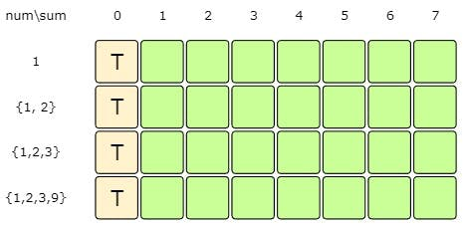

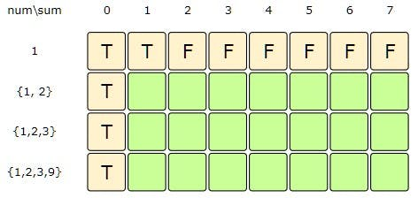

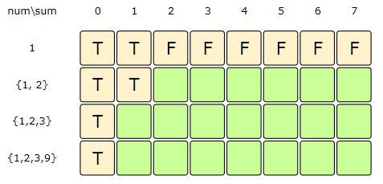

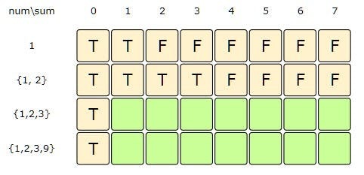

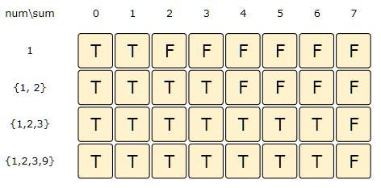

The above visualization tells us that it is not possible to find a subset whose sum is equal to 7. So what is the closest subset we can find? We can find the subset if we start moving backwards in the last row from the bottom right corner to find the first T. The first T in the diagram above is the sum 6, which means that we can find a subset whose sum is equal to 6. This means the other set will have a sum of 9 and the minimum difference will be 3.

Here is the code for our **bottom-up dynamic programming** approach:

function canPartition(nums) {

//bottom-up dynamic programming

let n = nums.length;

let sum = 0;

for (let i = 0; i < n; i++) sum += nums[i];

const requiredSum = Math.floor(sum / 2);

const dp = Array(n)

.fill(false)

.map(() => Array(requiredSum + 1).fill(false));

//populage the sum=0 columns, as we can always form 0 sum with empty set

for (let i = 0; i < n; i++) dp[i][0] = true;

//with only only number, we can form a subset only when the reuired sum is eual to that number

for (let s = 1; s <= requiredSum; s++) {

dp[0][s] = nums[0] == s;

}

//process all subsets for all sums

for (let i = 1; i < n; i++) {

for (let s = 1; s <= requiredSum; s++) {

// if we can get the sum 's' without the number at index 'i'

if (dp[i - 1][s]) {

dp[i][s] = dp[i - 1][s];

} else if (s >= nums[i]) {

// else include the number and see if we can find a subset to get the remaining sum

dp[i][s] = dp[i - 1][s - nums[i]];

}

}

}

let sum1 = 0;

// Find the largest index in the last row which is true

for (let i = requiredSum; i >= 0; i--) {

if (dp[n - 1][i] === true) {

sum1 = i;

break;

}

}

const sum2 = sum - sum1;

return Math.abs(sum2 - sum1);

}

console.log(`Can partitioning be done: ---> ${canPartition([1, 2, 3, 9])}`);

//3

//We can partition the given set into two subsets where minimum absolute difference between the sum of numbers is '3'. Following are the two subsets: {1, 2, 3} & {9}.

console.log(`Can partitioning be done: ---> ${canPartition([1, 2, 7, 1, 5])}`);

//0

//We can partition the given set into two subsets where minimum absolute difference between the sum of number is '0'. Following are the two subsets: {1, 2, 5} & {7, 1}.

console.log(`Can partitioning be done: ---> ${canPartition([1, 3, 100, 4])}`);

//92

//We can partition the given set into two subsets where minimum absolute difference between the sum of numbers is '92'. Here are the two subsets: {1, 3, 4} & {100}.

* The above solution has the time and **space complexity** of O(N*S), where N represents total numbers and S is the total sum of all the numbers.

#### Java Solution : 2d array

|  |
| --- |
| public static int minimumDifferenceTabulation(int[] num) {  int sum = 0;  for (int i = 0; i < num.length; i++)  sum += num[i];  int n = num.length;  boolean[][] dp = new boolean[n][sum/2 + 1];  // populate the sum=0 columns, as we can always form '0' sum with an empty set  for(int i=0; i < n; i++)  dp[i][0] = true;  // with only one number, we can form a subset only when the required sum is equal to that number  for(int s=1; s <= sum/2 ; s++) {  dp[0][s] = num[0] == s;  }  // process all subsets for all sums  for(int i=1; i < num.length; i++) {  for(int s=1; s <= sum/2; s++) {  // if we can get the sum 's' without the number at index 'i'  if(dp[i-1][s]) {  dp[i][s] = dp[i-1][s];  } else if (s >= num[i]) {  // else include the number and see if we can find a subset to get the remaining sum  dp[i][s] = dp[i-1][s-num[i]];  }  }  }  int sum1 = 0;  // Find the largest index in the last row which is true  for (int i = sum / 2; i >= 0; i--) {  if (dp[n-1][i] == true) {  sum1 = i;  break;  }  }  int sum2 = sum - sum1;  return Math.abs(sum2-sum1);  } |

#### Java solution : 1D array

|  |
| --- |
| public static int minimumDifferenceTabulationOptimised(int[] num) {  int sum = 0;  for (int i = 0; i < num.length; i++)  sum += num[i];  int n = num.length;  boolean[] dp = new boolean[sum/2 + 1];  dp[0] = true;  // with only one number, we can form a subset only when the required sum is equal to that number  for(int s=1; s <= sum/2 ; s++) {  dp[s] = num[0] == s;  }  // process all subsets for all sums  for(int i=1; i < num.length; i++) {  for(int s=sum/2; s >= num[i]; s--) {  // if we can get the sum 's' without the number at index 'i'  if (dp[s - num[i]]) {  dp[s] = true;  }  }  }  int sum1 = 0;  // Find the largest index in the last row which is true  for (int i = sum / 2; i >= 0; i--) {  if (dp[i] == true) {  sum1 = i;  break;  }  }  int sum2 = sum - sum1;  return Math.abs(sum2-sum1);  } |

## 🌟Count of Subset Sum (hard)

<https://leetcode.com/problems/combination-sum/>

### Problem Statement

Given a set of positive numbers, find the total number of subsets whose sum is equal to a given number 'S'.

**Example 1:**

Input: {1, 1, 2, 3}, S=4

Output: 3

The given set has '3' subsets whose sum is '4': {1, 1, 2}, {1, 3}, {1, 3}

Note that we have two similar sets {1, 3}, because we have two '1' in our input.

**Example 2:**

Input: {1, 2, 7, 1, 5}, S=9

Output: 3

The given set has '3' subsets whose sum is '9': {2, 7}, {1, 7, 1}, {1, 2, 1, 5}

Given a set of positive numbers, find the total number of subsets whose sum is equal to a given number S.

This problem follows the [**0/1 Knapsack pattern**](https://github.com/maazshaikh007/DSA_Patterns/blob/main/%E2%9C%85%20Pattern%2015:%200-1%20Knapsack%20(Dynamic%20Programming).md#pattern-1-01-knapsack) and is quite similar to [**Subset Sum**](https://github.com/maazshaikh007/DSA_Patterns/blob/main/%E2%9C%85%20Pattern%2015:%200-1%20Knapsack%20(Dynamic%20Programming).md#%F0%9F%94%8E-subset-sum-medium). The only difference in this problem is that we need to count the number of subsets, whereas in [**Subset Sum**](https://github.com/maazshaikh007/DSA_Patterns/blob/main/%E2%9C%85%20Pattern%2015:%200-1%20Knapsack%20(Dynamic%20Programming).md#%F0%9F%94%8E-subset-sum-medium) we only wanted to know if a subset with the given sum existed.

A basic **brute-force** solution could be to try all subsets of the given numbers to count the subsets that have a sum equal to S. So our **brute-force** algorithm will look like:

for each number 'i'

create a new set which includes number 'i' if it does not exceed 'S', and recursively

process the remaining numbers and sum

create a new set without number 'i', and recursively process the remaining numbers

return the count of subsets who has a sum equal to 'S'

Here is the code for the **brute-force** solution:

### Code

|  |
| --- |
| class Solution {  public int countSubsets(int[] num, int sum) {  return this.countSubsetsRecursive(num, sum, 0);  }  private int countSubsetsRecursive(int[] num, int sum, int currentIndex) {  // base checks  if (sum == 0)  return 1;  if(num.length == 0 || currentIndex >= num.length)  return 0;  // recursive call after selecting the number at the currentIndex  // if the number at currentIndex exceeds the sum, we shouldn't process this  int sum1 = 0;  if( num[currentIndex] <= sum )  sum1 = countSubsetsRecursive(num, sum - num[currentIndex], currentIndex + 1);  // recursive call after excluding the number at the currentIndex  int sum2 = countSubsetsRecursive(num, sum, currentIndex + 1);  return sum1 + sum2;  }  public static void main(String[] args) {  Solution ss = new Solution();  int[] num = {1, 1, 2, 3};  System.out.println(ss.countSubsets(num, 4));  num = new int[]{1, 2, 7, 1, 5};  System.out.println(ss.countSubsets(num, 9));  }  } |

* The **time complexity** of the above algorithm is exponential O(2ⁿ), where n represents the total number.
* The **space complexity** is O(n) which is used to store the *recursion stack*.

### Java Solution

|  |
| --- |
| public static int countSubsets(int[] num, int sum) {  return countSubsetsRecursive(num, sum, 0);  }  public static int countSubsetsRecursive(int[] num, int sum, int curIndex) {  if(sum == 0) return 1;  int n = num.length;  if(n == 0 || curIndex >= n) return 0;  int count1 = 0;  if (num[curIndex] <= sum) {  count1 = countSubsetsRecursive(num, sum-num[curIndex], curIndex+1);  }  int count2 = countSubsetsRecursive(num, sum, curIndex+1);  return count1+count2;  } |

**Top-down Dynamic Programming with Memoization**

We can use **memoization** to overcome the overlapping sub-problems. We will be using a two-dimensional array to store the results of solved sub-problems. As mentioned above, we need to store results for every subset and for every possible sum.

### Code

|  |
| --- |
| class Solution {  public int countSubsets(int[] num, int sum) {  Integer[][] dp = new Integer[num.length][sum + 1];  return this.countSubsetsRecursive(dp, num, sum, 0);  }  private int countSubsetsRecursive(Integer[][] dp, int[] num, int sum, int  currentIndex) {  // base checks  if (sum == 0)  return 1;  if(num.length == 0 || currentIndex >= num.length)  return 0;  // check if we have not already processed a similar problem  if(dp[currentIndex][sum] == null) {  // recursive call after choosing the number at the currentIndex  // if the number at currentIndex exceeds the sum, we shouldn't process this  int sum1 = 0;  if( num[currentIndex] <= sum )  sum1 = countSubsetsRecursive(dp, num, sum - num[currentIndex], currentIndex + 1);  // recursive call after excluding the number at the currentIndex  int sum2 = countSubsetsRecursive(dp, num, sum, currentIndex + 1);  dp[currentIndex][sum] = sum1 + sum2;  }  return dp[currentIndex][sum];  }  public static void main(String[] args) {  Solution ss = new Solution();  int[] num = {1, 1, 2, 3};  System.out.println(ss.countSubsets(num, 4));  num = new int[]{1, 2, 7, 1, 5};  System.out.println(ss.countSubsets(num, 9));  }  } |

#### Java Solution

|  |
| --- |
| public static int countSubsetsMemoization(int[] num, int sum) {  Integer[][] dp = new Integer[num.length][sum+1];  return countSubsetsMemoizationRecursive(num, sum, 0, dp);  }  public static int countSubsetsMemoizationRecursive(int[] num, int sum, int curIndex, Integer[][] dp) {  if(sum == 0) return 1;  int n = num.length;  if(n == 0 || curIndex >= n) return 0;  if(dp[curIndex][sum] == null) {  int count1 = 0;  if (num[curIndex] <= sum) {  count1 = countSubsetsMemoizationRecursive(num, sum - num[curIndex], curIndex + 1, dp);  }  int count2 = countSubsetsMemoizationRecursive(num, sum, curIndex + 1, dp);  dp[curIndex][sum] = count1 + count2;  }  return dp[curIndex][sum];  } |

**Bottom-up Dynamic Programming**

We will try to find if we can make all possible sums with every subset to populate the array db[TotalNumbers][S+1].

So, at every step we have two options:

1. Exclude the number. Count all the subsets without the given number up to the given sum => dp[index-1][sum]
2. Include the number if its value is not more than the sum. In this case, we will count all the subsets to get the remaining sum => dp[index-1][sum-num[index]]

To find the total sets, we will add both of the above two values:

dp[index][sum] = dp[index-1][sum] + dp[index-1][sum-num[index]])

Let's start with our base case of size zero:

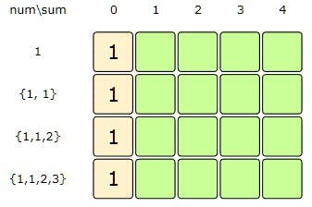

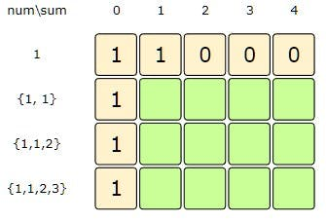

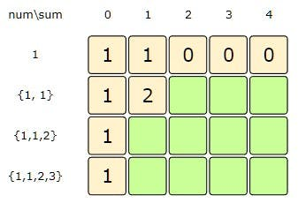

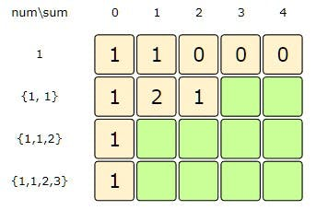

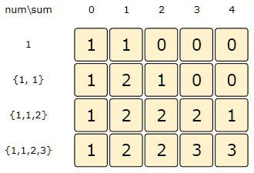

Here is the code for our **bottom-up dynamic programming** approach:

### Code

|  |
| --- |
| class Solution {  public int countSubsets(int[] num, int sum) {  int n = num.length;  int[][] dp = new int[n][sum + 1];  // populate the sum=0 columns, as we will always have an empty set for zero sum  for(int i=0; i < n; i++)  dp[i][0] = 1;  // with only one number, we can form a subset only when the required sum is equal to its value  for(int s=1; s <= sum ; s++) {  dp[0][s] = (num[0] == s ? 1 : 0);  }  // process all subsets for all sums  for(int i=1; i < num.length; i++) {  for(int s=1; s <= sum; s++) {  // exclude the number  dp[i][s] = dp[i-1][s];  // include the number, if it does not exceed the sum  if(s >= num[i])  dp[i][s] += dp[i-1][s-num[i]];  }  }  // the bottom-right corner will have our answer.  return dp[num.length-1][sum];  }  public static void main(String[] args) {  Solution ss = new Solution();  int[] num = {1, 1, 2, 3};  System.out.println(ss.countSubsets(num, 4));  num = new int[]{1, 2, 7, 1, 5};  System.out.println(ss.countSubsets(num, 9));  }  } |

* The above solution has the time and **space complexity** of O(N*S), where N represents total numbers and S is the desired sum.

#### Java Solution : 2D Array

|  |
| --- |
| public static int countSubsets(int[] num, int sum) {  int n = num.length;  int[][] dp = new int[n][sum+1];  for(int i = 0; i< n; i++) dp[i][0] = 1;  for(int s = 1; s<=sum; s++) dp[0][s] = num[0] == s ? 1 : 0;  for(int i = 1; i < n; i++){  for(int s = 1; s <= sum; s++){  dp[i][s] = dp[i-1][s];  if(s >= num[i]) dp[i][s] += dp[i-1][s-num[i]];  }  }  return dp[n-1][sum];  } |

**Challenge**

*  Can we improve our **bottom-up DP** solution even further? Can you find an algorithm that has O(S) space complexity?

### Code

|  |
| --- |
| class Solution {  static int countSubsets(int[] num, int sum) {  int n = num.length;  int[] dp = new int[sum + 1];  dp[0] = 1;  // with only one number, we can form a subset only when the required sum is equal to its value  for(int s=1; s <= sum ; s++) {  dp[s] = (num[0] == s ? 1 : 0);  }  // process all subsets for all sums  for(int i=1; i < num.length; i++) {  for(int s=sum; s >= 0; s--) {  if(s >= num[i])  dp[s] += dp[s-num[i]];  }  }  return dp[sum];  }  public static void main(String[] args) {  Solution ss = new Solution();  int[] num = {1, 1, 2, 3};  System.out.println(ss.countSubsets(num, 4));  num = new int[]{1, 2, 7, 1, 5};  System.out.println(ss.countSubsets(num, 9));  }  } |

#### Java Solution : 1D Array

|  |
| --- |
| public static int countSubsetsOptimised(int[] num, int sum) {  int n = num.length;  int[] dp = new int[sum+1];  dp[0] = 1;  for(int s = 1; s<=sum; s++) dp[s] = num[0] == s ? 1 : 0;  for(int i = 1; i < n; i++){  for(int s = sum; s >= num[i]; s--){  if(s >= num[i]) dp[s] += dp[s-num[i]];  }  }  return dp[sum];  } |

**🌟 Target Sum (hard)**

<https://leetcode.com/problems/target-sum/>

### Problem Statement

You are given a set of positive numbers and a target sum S. Each number should be assigned either a + or - sign. We need to find the total ways to assign symbols to make the sum of the numbers equal to the target S.

### Example 1:

Input: {1, 1, 2, 3}, S=1

Output: 3

Explanation: The given set has '3' ways to make a sum of '1': {+1-1-2+3} & {-1+1-2+3} & {+1+1+2-3}

### Example 2:

Input: {1, 2, 7, 1}, S=9

Output: 2

Explanation: The given set has '2' ways to make a sum of '9': {+1+2+7-1} & {-1+2+7+1}

### Solution

This problem follows the [**0/1 Knapsack pattern**](https://github.com/maazshaikh007/DSA_Patterns/blob/main/%E2%9C%85%20Pattern%2015:%200-1%20Knapsack%20(Dynamic%20Programming).md#01-knapsack-medium) and can be converted into [**Count of Subset Sum**](https://github.com/maazshaikh007/DSA_Patterns/blob/main/%E2%9C%85%20Pattern%2015:%200-1%20Knapsack%20(Dynamic%20Programming).md#count-of-subset-sum-hard). Let’s dig into this.

We are asked to find two subsets of the given numbers whose difference is equal to the given target S. Take the first example above. As we saw, one solution is {+1-1-2+3}. So, the two subsets we are asked to find are {1, 3} & {1, 2} because,

(1 + 3) - (1 + 2 ) = 1

Now, let’s say Sum(str1) denotes the total sum of set str1, and Sum(str2) denotes the total sum of set str2. So the required equation is:

Sum(str1) - Sum(str2) = S

This equation can be reduced to the [subset sum](https://github.com/maazshaikh007/DSA_Patterns/blob/main/%E2%9C%85%20Pattern%2015:%200-1%20Knapsack%20(Dynamic%20Programming).md#%F0%9F%94%8E-subset-sum-medium) problem. Let’s assume that Sum(num) denotes the total sum of all the numbers, therefore:

Sum(str1) + Sum(str2) = Sum(num)

Let’s add the above two equations:

=> Sum(str1) - Sum(str2) + Sum(str1) + Sum(str2) = S + Sum(num)

=> 2 * Sum(str1) = S + Sum(num)

=> Sum(str1) = (S + Sum(num)) / 2

Which means that one of the set str1 has a sum equal to (S + Sum(num)) / 2. This essentially converts our problem to: **"Find the count of subsets of the given numbers whose sum is equal to (S + Sum(num)) / 2"**

Let’s take the **dynamic programming** code of [**Count of Subset Sum**](https://github.com/maazshaikh007/DSA_Patterns/blob/main/%E2%9C%85%20Pattern%2015:%200-1%20Knapsack%20(Dynamic%20Programming).md#count-of-subset-sum-hard) and extend it to solve this problem:

### Code

|  |
| --- |
| class Solution {  public int findTargetSubsets(int[] num, int s) {  int totalSum = 0;  for (int n : num){  totalSum += n;  if(n < 1) return -1; //invalid input, the problem expects only positive numbers  }  // if 's + totalSum' is odd, we can't find a subset with sum equal to '(s + totalSum) / 2'  if(totalSum < s || (s + totalSum) % 2 == 1)  return 0;  return countSubsets(num, (s + totalSum) / 2);  }  // this function is exactly similar to what we have in 'Count of Subset Sum' problem.  private int countSubsets(int[] num, int sum) {  int n = num.length;  int[][] dp = new int[n][sum + 1];  // populate the sum=0 columns, as we will always have an empty set for zero sum  for(int i=0; i < n; i++)  dp[i][0] = 1;  // with only one number, we can form a subset only when the required sum is equal to the number  for(int s=1; s <= sum ; s++) {  dp[0][s] = (num[0] == s ? 1 : 0);  }  // process all subsets for all sums  for(int i=1; i < num.length; i++) {  for(int s=1; s <= sum; s++) {  dp[i][s] = dp[i-1][s];  if(s >= num[i])  dp[i][s] += dp[i-1][s-num[i]];  }  }  // the bottom-right corner will have our answer.  return dp[num.length-1][sum];  }  public static void main(String[] args) {  Solution ts = new Solution();  int[] num = {1, 1, 2, 3};  System.out.println(ts.findTargetSubsets(num, 1));  num = new int[]{1, 2, 7, 1};  System.out.println(ts.findTargetSubsets(num, 9));  }  } |

* The above solution has time and **space complexity** of O(N*S), where N represents total numbers and S is the desired sum.
* We can further improve the solution to use only O(S) space.

### Java solution : 2D Array

|  |
| --- |
| public static int findTargetSubsets(int[] num, int s) {  int totalSum = 0;  for(int val : num){  totalSum +=val;  if(val<0) return -1;  }  if(totalSum < s || (s+totalSum)%2 == 1) return 0;  return countSubsets(num, (s+totalSum)/2);  }    public static int countSubsets(int[] num, int sum) {  int n = num.length;  int[][] dp = new int[n][sum+1];  for(int i = 0; i< n; i++) dp[i][0] = 1;  for(int s = 1; s<=sum; s++) dp[0][s] = num[0] == s ? 1 : 0;  for(int i = 1; i < n; i++){  for(int s = 1; s <= sum; s++){  dp[i][s] = dp[i-1][s];  if(s >= num[i]) dp[i][s] += dp[i-1][s-num[i]];  }  }  return dp[n-1][sum];  } |

Here is the code for the **space-optimized solution**, using only a single array:

### Code

|  |
| --- |
| public int findTargetSubsets(int[] num, int s) {  int totalSum = 0;  for (int n : num){  totalSum += n;  if(n < 1) return -1; //invalid input, the problem expects only positive numbers  }  // if 's + totalSum' is odd, we can't find a subset with sum equal to '(s + totalSum) / 2'  if(totalSum < s || (s + totalSum) % 2 == 1)  return 0;  return countSubsets(num, (s + totalSum) / 2);  }  // this function is exactly similar to what we have in 'Count of Subset Sum' problem.  private int countSubsets(int[] num, int sum) {  int n = num.length;  int[] dp = new int[sum + 1];  dp[0] = 1;  // with only one number, we can form a subset only when the required sum is equal to the number  for(int s=1; s <= sum ; s++) {  dp[s] = (num[0] == s ? 1 : 0);  }  // process all subsets for all sums  for(int i=1; i < num.length; i++) {  for(int s=sum; s >= 0; s--) {  if(s >= num[i])  dp[s] += dp[s-num[i]];  }  }  return dp[sum];  } |

### Java Solution : 1D Array

|  |
| --- |
| public static int findTargetSubsetsOptimised(int[] num, int s) {  int totalSum = 0;  for(int val : num){  totalSum +=val;  if(val<0) return -1;  }  if(totalSum < s || (s+totalSum)%2 == 1) return 0;  return countSubsetsOptimised(num, (s+totalSum)/2);  }    public static int countSubsetsOptimised(int[] num, int sum) {  int n = num.length;  int[] dp = new int[sum+1];  dp[0] = 1;  for(int s = 1; s<=sum; s++) dp[s] = num[0] == s ? 1 : 0;  for(int i = 1; i < n; i++){  for(int s = sum; s >= num[i]; s--){  if(s >= num[i]) dp[s] += dp[s-num[i]];  }  }  return dp[sum];  } |

**Pattern 2: Unbounded Knapsack**

**Problem Set**

1. [Unbounded Knapsack](https://github.com/maazshaikh007/DSA_Patterns/blob/main/%E2%9C%85%20Pattern%2015:%200-1%20Knapsack%20(Dynamic%20Programming).md#unbounded-knapsack)
2. [Rod Cutting](https://github.com/maazshaikh007/DSA_Patterns/blob/main/%E2%9C%85%20Pattern%2015:%200-1%20Knapsack%20(Dynamic%20Programming).md#rod-cutting)
3. [🔎👩🏽‍🦯 Coin Change](https://github.com/maazshaikh007/DSA_Patterns/blob/main/%E2%9C%85%20Pattern%2015:%200-1%20Knapsack%20(Dynamic%20Programming).md#%F0%9F%94%8E%F0%9F%91%A9%F0%9F%8F%BD%E2%80%8D%F0%9F%A6%AF-coin-change)
4. [Minimum Coin Change](https://github.com/maazshaikh007/DSA_Patterns/blob/main/%E2%9C%85%20Pattern%2015:%200-1%20Knapsack%20(Dynamic%20Programming).md#minimum-coin-change)
5. [Maximum Ribbon Cut](https://github.com/maazshaikh007/DSA_Patterns/blob/main/%E2%9C%85%20Pattern%2015:%200-1%20Knapsack%20(Dynamic%20Programming).md#maximum-ribbon-cut)

Given the weights and profits of N items, we are asked to put these items in a **knapsack** with a capacity C. The goal is to get the maximum profit out of the **knapsack** items. The only difference between the [**0/1 Knapsack pattern**](https://github.com/maazshaikh007/DSA_Patterns/blob/main/%E2%9C%85%20Pattern%2015:%200-1%20Knapsack%20(Dynamic%20Programming).md#pattern-1-01-knapsack) problem and this problem is that we are allowed to use an unlimited quantity of an item.

Let’s take Merry’s example, who wants to carry some fruits in the **knapsack** to get maximum profit. Here are the weights and profits of the fruits:

* Items: { Apple, Orange, Banana, Melon }
* Weights: { 2, 3, 1, 4 }
* Profits: { 4, 5, 3, 7 }
* Knapsack capacity: 5

Let’s try to put various combinations of fruits in the knapsack, such that their total weight is not more than 5:

* Apple + Orange (total weight 5) => 9 profit
* Apple + Banana (total weight 3) => 7 profit
* Orange + Banana (total weight 4) => 8 profit
* Banana + Melon (total weight 5) => 10 profit

Items: { Apple, Orange, Melon }

Weights: { 1, 2, 3 }

Profits: { 15, 20, 50 }

Knapsack capacity: 5

Let's try to put different combinations of fruits in the knapsack, such that their total weight is not more than 5.

5 Apples (total weight 5) => 75 profit

1 Apple + 2 Oranges (total weight 5) => 55 profit

2 Apples + 1 Melon (total weight 5) => 80 profit

1 Orange + 1 Melon (total weight 5) => 70 profit

This shows that 2 apples + 1 melon is the best combination, as it gives us the maximum profit and the total weight does not exceed the capacity.

## Unbounded Knapsack

### Problem Statement

Given two integer arrays to represent weights and profits of N items, we need to find a subset of these items which will give us maximum profit such that their cumulative weight is not more than a given number ‘C’. We can assume an infinite supply of item quantities; therefore, each item can be selected multiple times.

**Basic Brute Force Solution**

A basic **brute-force solution** could be to try all combinations of the given items to choose the one with maximum profit and a weight that doesn’t exceed ‘C’. This is what our algorithm will look like:

for each item 'i'

create a new set which includes one quantity of item 'i' if it does not exceed the capacity, and

recursively call to process all items

create a new set without item 'i', and recursively process the remaining items

return the set from the above two sets with higher profit

The only difference between the [**0/1 Knapsack pattern**](https://github.com/maazshaikh007/DSA_Patterns/blob/main/%E2%9C%85%20Pattern%2015:%200-1%20Knapsack%20(Dynamic%20Programming).md#pattern-1-01-knapsack) problem and this one is that, after including the item, we recursively call to process all the items (including the current item). In [**0/1 Knapsack pattern**](https://github.com/maazshaikh007/DSA_Patterns/blob/main/%E2%9C%85%20Pattern%2015:%200-1%20Knapsack%20(Dynamic%20Programming).md#pattern-1-01-knapsack)., however, we recursively call to process the remaining items.

### Code

|  |
| --- |
| class Solution {  public int solveKnapsack(int[] profits, int[] weights, int capacity) {  return this.knapsackRecursive(profits, weights, capacity, 0);  }  private int knapsackRecursive(int[] profits, int[] weights, int capacity, int currentIndex) {  // base checks  if (capacity <= 0 || profits.length == 0 || weights.length != profits.length ||  currentIndex >= profits.length)  return 0;  // recursive call after choosing the items at the currentIndex, note that we recursive call on all  // items as we did not increment currentIndex  int profit1 = 0;  if (weights[currentIndex] <= capacity)  profit1 = profits[currentIndex]  + knapsackRecursive(profits, weights, capacity - weights[currentIndex], currentIndex);  // recursive call after excluding the element at the currentIndex  int profit2 = knapsackRecursive(profits, weights, capacity, currentIndex + 1);  return Math.max(profit1, profit2);  }  public static void main(String[] args) {  Solution ks = new Solution();  int[] profits = { 15, 50, 60, 90 };  int[] weights = { 1, 3, 4, 5 };  int maxProfit = ks.solveKnapsack(profits, weights, 8);  System.out.println(maxProfit);  }  } |

* The **time complexity** of the above algorithm is exponential O(2ᴺ⁺ᶜ), where N represents the total number of items.
* The **space complexity** will be O(N+C) to store the *recursion stack*.

Let’s try to find a better solution.

#### Java Solution

|  |
| --- |
| public int solveKnapsack(int[] profits, int[] weights, int capacity) {  return this.knapsackRecursive(profits, weights, capacity, 0);  }  private int knapsackRecursive(int[] profits, int[] weights, int capacity, int currentIndex) {  // base checks  if (capacity <= 0 || profits.length == 0 || weights.length != profits.length ||  currentIndex >= profits.length)  return 0;  // recursive call after choosing the items at the currentIndex, note that we recursive call on all  // items as we did not increment currentIndex  int profit1 = 0;  if (weights[currentIndex] <= capacity)  profit1 = profits[currentIndex]  + knapsackRecursive(profits, weights, capacity - weights[currentIndex], currentIndex);  // recursive call after excluding the element at the currentIndex  int profit2 = knapsackRecursive(profits, weights, capacity, currentIndex + 1);  return Math.max(profit1, profit2);  } |

**Top-down Dynamic Programming with Memoization**

Once again, we can use **memoization** to overcome the overlapping sub-problems.

We will be using a two-dimensional array to store the results of solved sub-problems. As mentioned above, we need to store results for every sub-array and for every possible capacity. Here is the code:

### Code

|  |
| --- |
| class Solution {  public int solveKnapsack(int[] profits, int[] weights, int capacity) {  Integer[][] dp = new Integer[profits.length][capacity + 1];  return this.knapsackRecursive(dp, profits, weights, capacity, 0);  }  private int knapsackRecursive(Integer[][] dp, int[] profits, int[] weights, int capacity,  int currentIndex) {  // base checks  if (capacity <= 0 || profits.length == 0 || weights.length != profits.length ||  currentIndex >= profits.length)  return 0;  // check if we have not already processed a similar sub-problem  if(dp[currentIndex][capacity] == null) {  // recursive call after choosing the items at the currentIndex, note that we recursive call on all  // items as we did not increment currentIndex  int profit1 = 0;  if( weights[currentIndex] <= capacity )  profit1 = profits[currentIndex] + knapsackRecursive(dp, profits, weights,  capacity - weights[currentIndex], currentIndex);  // recursive call after excluding the element at the currentIndex  int profit2 = knapsackRecursive(dp, profits, weights, capacity, currentIndex + 1);  dp[currentIndex][capacity] = Math.max(profit1, profit2);  }  return dp[currentIndex][capacity];  }  public static void main(String[] args) {  Solution ks = new Solution();  int[] profits = {15, 50, 60, 90};  int[] weights = {1, 3, 4, 5};  System.out.println(ks.solveKnapsack(profits, weights, 8));  System.out.println(ks.solveKnapsack(profits, weights, 6));  }  } |

**What is the time and space complexity of the above solution?**

* Since our *memoization* array dp[profits.length][capacity+1] stores the results for all the subproblems, we can conclude that we will not have more than N*C subproblems (where N is the number of items and C is the **knapsack** capacity). This means that our **time complexity** will be O(N∗C).
* The above algorithm will be using O(N*C) space for the *memoization* array. Other than that we will use O(N) space for the recursion call-stack. So the total **space complexity** will be O(N*C + N), which is *asymptotically* equivalent to O(N*C).

#### Java Solution

|  |
| --- |
| public int solveKnapsack(int[] profits, int[] weights, int capacity) {  Integer[][] dp = new Integer[profits.length][capacity + 1];  return this.knapsackRecursive(dp, profits, weights, capacity, 0);  }  private int knapsackRecursive(Integer[][] dp, int[] profits, int[] weights, int capacity,  int currentIndex) {  // base checks  if (capacity <= 0 || profits.length == 0 || weights.length != profits.length ||  currentIndex >= profits.length)  return 0;  // check if we have not already processed a similar sub-problem  if(dp[currentIndex][capacity] == null) {  // recursive call after choosing the items at the currentIndex, note that we recursive call on all  // items as we did not increment currentIndex  int profit1 = 0;  if( weights[currentIndex] <= capacity )  profit1 = profits[currentIndex] + knapsackRecursive(dp, profits, weights,  capacity - weights[currentIndex], currentIndex);  // recursive call after excluding the element at the currentIndex  int profit2 = knapsackRecursive(dp, profits, weights, capacity, currentIndex + 1);  dp[currentIndex][capacity] = Math.max(profit1, profit2);  }  return dp[currentIndex][capacity];  } |

**Bottom-up Dynamic Programming**

Let’s try to populate our dp[][] array from the above solution, working in a *bottom-up* fashion. Essentially, what we want to achieve is: *“Find the maximum profit for every sub-array and for every possible capacity”*.

So for every possible capacity c (0 <= c <= capacity), we have two options:

1. Exclude the item. In this case, we will take whatever profit we get from the sub-array excluding this item: dp[index-1][c]
2. Include the item if its weight is not more than the c. In this case, we include its profit plus whatever profit we get from the remaining capacity: profit[index] + dp[index][c-weight[index]]

Finally, we have to take the maximum of the above two values:

dp[index][c] = max (dp[index-1][c], profit[index] + dp[index][c-weight[index]])

Let's start with our base case of zero capacity:

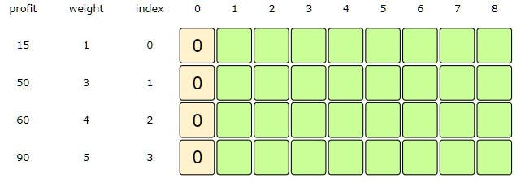

**With '0' capacity, maximum profit we can have for every subarray is '0'**

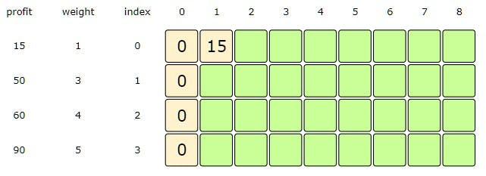

**Capacity = 1, Index = 0, i.e., if we consider the sub-array till index '0', maximum profit will be 15, as we can fit the item with weight '1' in the knapsack**

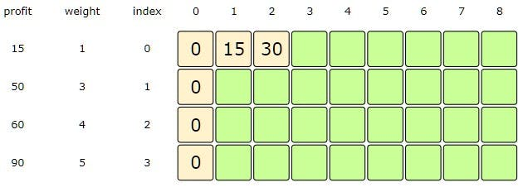

**Capacity = 2, Index = 0, => profits[Index] + dp[Index][1], we are not considering dp[index-1][Capacity] as Index is not bigger than '0'**

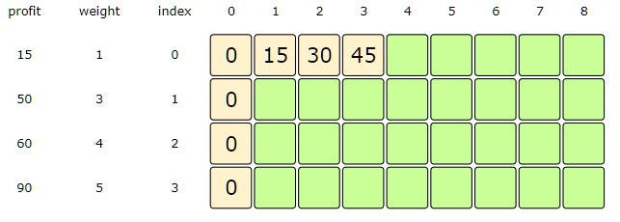

**Capacity = 3, Index = 0, => profits[Index] + dp[Index][1]**

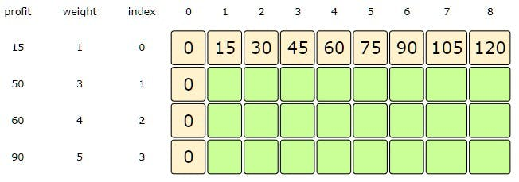

**Capacity = 4-8, Index = 0, => profits[Index] + dp[Index][1]**

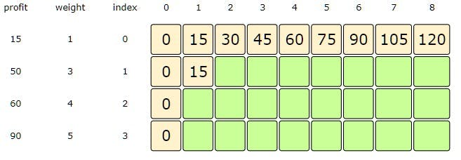

**Capacity = 1, Index =1, since item at index '1' has weight '3', which is greater than the capacity '1', so we will take the dp[index-1][capacity]**

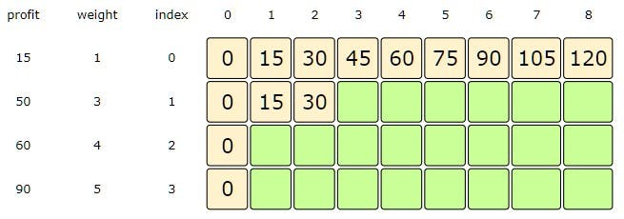

**Capacity = 2, Index =1, since item at index '1' has weight '3', which is greater than the capacity '2', so we will take the dp[index-1][capacity]**

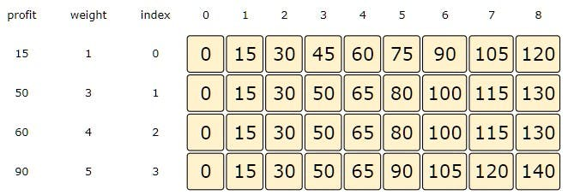

**Capacity = 8, Index =3, from the formula discussed above: max( dp[2][8], profit[3] + dp[3][3] )**

### Code

|  |
| --- |
| class Solution {  public int solveKnapsack(int[] profits, int[] weights, int capacity) {  // base checks  if (capacity <= 0 || profits.length == 0 || weights.length != profits.length)  return 0;  int n = profits.length;  int[][] dp = new int[n][capacity + 1];  // populate the capacity=0 columns  for(int i=0; i < n; i++)  dp[i][0] = 0;  // process all sub-arrays for all capacities  for(int i=0; i < n; i++) {  for(int c=1; c <= capacity; c++) {  int profit1=0, profit2=0;  if(weights[i] <= c)  profit1 = profits[i] + dp[i][c-weights[i]];  if( i > 0 )  profit2 = dp[i-1][c];  dp[i][c] = profit1 > profit2 ? profit1 : profit2;  }  }  // maximum profit will be in the bottom-right corner.  return dp[n-1][capacity];  }  public static void main(String[] args) {  Solution ks = new Solution();  int[] profits = {15, 50, 60, 90};  int[] weights = {1, 3, 4, 5};  System.out.println(ks.solveKnapsack(profits, weights, 8));  System.out.println(ks.solveKnapsack(profits, weights, 6));  }  } |

#### Java Solution

|  |
| --- |
| public int solveKnapsack(int[] profits, int[] weights, int capacity) {  // base checks  if (capacity <= 0 || profits.length == 0 || weights.length != profits.length)  return 0;  int n = profits.length;  int[][] dp = new int[n][capacity + 1];  // populate the capacity=0 columns  for(int i=0; i < n; i++)  dp[i][0] = 0;  // process all sub-arrays for all capacities  for(int i=0; i < n; i++) {  for(int c=1; c <= capacity; c++) {  int profit1=0, profit2=0;  if(weights[i] <= c)  profit1 = profits[i] + dp[i][c-weights[i]];  if( i > 0 )  profit2 = dp[i-1][c];  dp[i][c] = Math.max(profit1, profit2);  }  }  // maximum profit will be in the bottom-right corner.  return dp[n-1][capacity];  } |

### Find the selected items

As we know, the final profit is at the right-bottom corner; hence we will start from there to find the items that will be going to the **knapsack**.

As you remember, at every step we had two options: include an item or skip it. If we skip an item, then we take the profit from the cell right above it; if we include the item, then we jump to the remaining profit to find more items.

Let’s assume the four items are identified as {A, B, C, and D}, and use the above example to better understand this:

1. 140 did not come from the top cell (which is 130); hence we must include the item at index 3, which is D.
2. Subtract the profit of D from 140 to get the remaining profit 50. We then jump to profit 50 on the same row.
3. 50 came from the top cell, so we jump to row 2.
4. Again, 50 came from the top cell, so we jump to row 1.
5. 50 is different than the top cell, so we must include this item, which is B.
6. Subtract the profit of B from 50 to get the remaining profit 0. We then jump to profit 0 on the same row. As soon as we hit zero remaining profit, we can finish our item search.
7. So items going into the **knapsack** are {B, D}.

[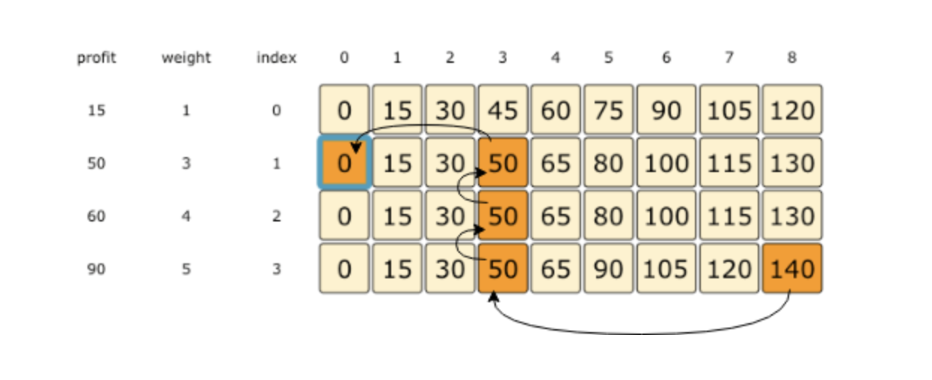](https://github.com/maazshaikh007/DSA_Patterns/blob/main/images/unbounded.png)

**Rod Cutting**

<https://leetcode.com/problems/minimum-cost-to-cut-a-stick/>

### Problem Statement

Given a rod of length n, we are asked to cut the rod and sell the pieces in a way that will maximize the profit. We are also given the price of every piece of length i where 1 <= i <= n.

Lengths: [1, 2, 3, 4, 5]

Prices: [2, 6, 7, 10, 13]

Rod Length: 5

Let’s try different combinations of cutting the rod:

* Five pieces of length 1 => 10 price
* Two pieces of length 2 and one piece of length 1 => 14 price
* One piece of length 3 and two pieces of length 1 => 11 price
* One piece of length 3 and one piece of length 2 => 13 price
* One piece of length 4 and one piece of length 1 => 12 price
* One piece of length 5 => 13 price

This shows that we get the maximum price (14) by cutting the rod into two pieces of length 2 and one piece of length 1.

This problem can be mapped to the [**Unbounded Knapsack pattern**](https://github.com/maazshaikh007/DSA_Patterns/blob/main/%E2%9C%85%20Pattern%2015:%200-1%20Knapsack%20(Dynamic%20Programming).md#unbounded-knapsack). The Weights array of the [**Unbounded Knapsack pattern**](https://github.com/maazshaikh007/DSA_Patterns/blob/main/%E2%9C%85%20Pattern%2015:%200-1%20Knapsack%20(Dynamic%20Programming).md#unbounded-knapsack) problem is equivalent to the Lengths array, and Profits is equivalent to Prices.

**Brute Force**

A **basic brute-force solution** could be to try all combinations of the given rod lengths to choose the one with the maximum sale price. This is what our algorithm will look like:

**for each rod length 'i'**

**create a new set which includes one quantity of length 'i', and recursively process**

**all rod lengths for the remaining length**

**create a new set without rod length 'i', and recursively process for remaining rod lengths**

**return the set from the above two sets with a higher sales price**

function solveRodCutting(lengths, prices, n) {

function solveRodCuttingRecursive(lengths, prices, n, currIndex) {

//recursive base case check

if (

n <= 0 ||

prices.length === 0 ||

lengths.length !== prices.length ||

currIndex >= prices.length

)

return 0;

//recursive call after choosing the items at the currIndex

//**recursive call on all items as we did not increment currIndex**

let currentProfit = 0;

if (lengths[currIndex] <= n) {

currentProfit =

prices[currIndex] +

solveRodCuttingRecursive(

prices,

lengths,

n - lengths[currIndex],

currIndex

);

}

//recursive call after excluding the element at the currIndex

const currentProfitMinusIndexItem = solveRodCuttingRecursive(

prices,

lengths,

n - lengths[currIndex],

currIndex + 1

);

return Math.max(currentProfit, currentProfitMinusIndexItem);

}

return solveRodCuttingRecursive(lengths, prices, n, 0);

}

console.log(

`Maximum profit: ---> ${solveRodCutting(

(lengths = [1, 2, 3, 4, 5]),

(prices = [2, 6, 7, 10, 13]),

5

)}`

);

Since this problem is quite similar to [**Unbounded Knapsack pattern**](https://github.com/maazshaikh007/DSA_Patterns/blob/main/%E2%9C%85%20Pattern%2015:%200-1%20Knapsack%20(Dynamic%20Programming).md#unbounded-knapsack), let’s jump directly to the **bottom-up dynamic solution**.

**Bottom-up Dynamic Programming**

Let’s try to populate our dp[][] array in a **bottom-up fashion**. Essentially, what we want to achieve is: *“Find the maximum sales price for every rod length and for every possible sales price”*.

So for every possible rod length len (0<= len <= n), we have two options:

1. Exclude the piece. In this case, we will take whatever price we get from the rod length excluding this piece => dp[index-1][len]
2. Include the piece if its length is not more than len. In this case, we include its price plus whatever price we get from the remaining rod length => prices[index] + dp[index][len-lengths[index]]

Finally, we have to take the maximum of the above two values:

**dp[index][len] = max(**

**dp[index - 1][len],**

**prices[index] + dp[index][len - lengths[index]]**

**);**

Let’s draw this visually, with the example:

Lengths: [1, 2, 3, 4, 5]

Prices: [2, 6, 7, 10, 13]

Rod Length: 5

Let’s start with our base case of zero size:

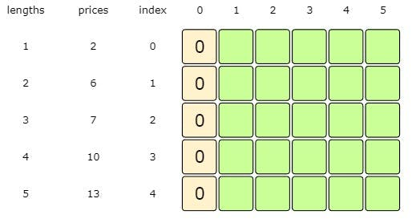

**With '0' capacity, maximum profit we can have for every subarray is '0'**

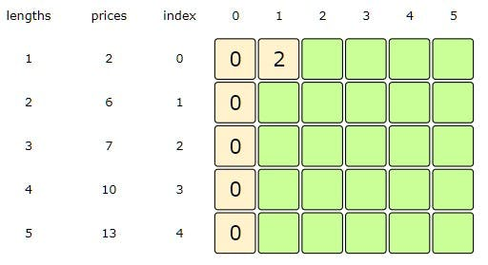

Length = 1, Index = 0, i.e., if we consider the sub-array till index '0', maximum price will be '2' from the rod of length '1'

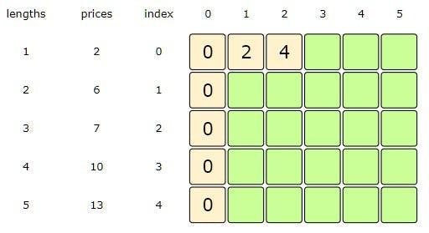

Length = 2, Index = 0, => prices[Index] + dp[Index][1], we are not considering dp[Index-1][Length] as Index is not bigger than '0'

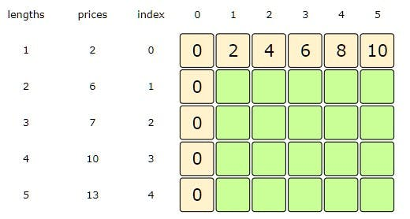

Length = 3-5, Index = 0, => prices[Index] + dp[Index][l]

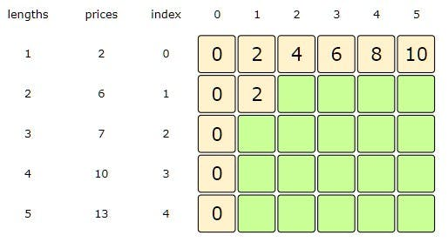

Length = 1, Index =1, since item at index '1' has length '2', which is greater than the maximum length '1', so we will take the dp[Index-1][Length]

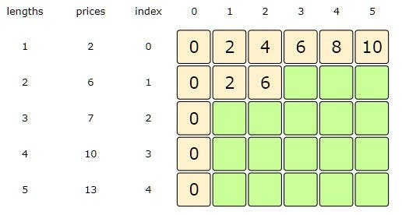

Length = 2, Index =1, from the formula discussed above: max( dp[Index-1][Length], prices[Index] + dp[Index][Length-lengths[index]] )

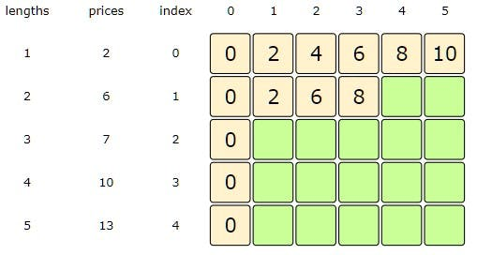

Length = 3, Index =1, from the formula discussed above: max( dp[Index-1][Length], prices[Index] + dp[Index][Length-lengths[index]] )

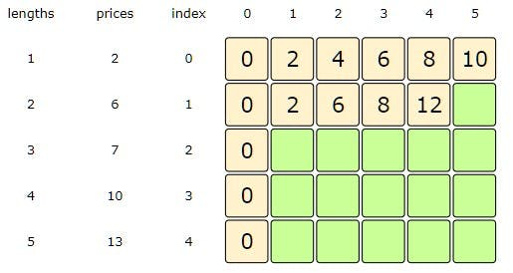

Length = 4, Index =1, from the formula discussed above: max( dp[Index-1][Length], prices[Index] + dp[Index][Length-lengths[index]] )

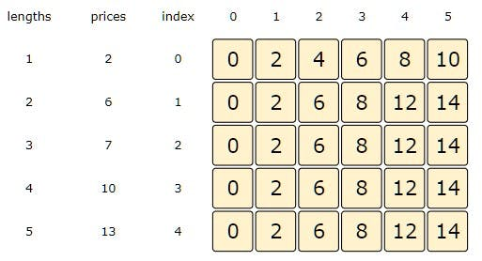

Length = 5, Index =4, from the formula discussed above: max( dp[Index-1][Length], prices[Index] + dp[Index][Length-lengths[index]] )

Here is the code for our **bottom-up dynamic programming** approach:

#### Java Solution

|  |
| --- |
| public int solveRodCutting(int[] lengths, int[] prices, int n) {  // base checks  if (n <= 0 || prices.length == 0 || prices.length != lengths.length)  return 0;  int lengthCount = lengths.length;  int[][] dp = new int[lengthCount][n + 1];  // process all rod lengths for all prices  for(int i=0; i < lengthCount; i++) {  for(int len=1; len <= n; len++) {  int p1=0, p2=0;  if(lengths[i] <= len)  p1 = prices[i] + dp[i][len-lengths[i]];  if( i > 0 )  p2 = dp[i-1][len];  dp[i][len] = Math.max(p1, p2);  }  }  // maximum price will be at the bottom-right corner.  return dp[lengthCount-1][n];  } |

* The above solution has time and **space complexity** of O(N*C), where N represents total items and C is the maximum capacity.

### Find the selected items

As we know, the final price is at the right-bottom corner; hence we will start from there to find the rod lengths.

As you remember, at every step we had two options: include a rod piece or skip it. If we skip it, then we take the price from the cell right above it; if we include it, then we jump to the remaining length to find more pieces.

Let’s understand this from the above example:

1. 14 did come from the top cell, so we jump to the fourth row.
2. 14 came from the top cell, so we jump to the third row.
3. Again, 14 came from the top cell, so we jump to the second row.
4. Now 14 is different from the top cell, so we must include rod of length 2. After this, we subtract the price of the rod of length 2 from 14 and jump to that cell.
5. 8 is different than the top cell, so we must include rod of length 2 again. After this, we subtract the price of the rod of length 2 from 8 and jump to that cell.
   1. 2 did come from the top cell, so we jump to the first row. Now we must include a piece of length 1. So the desired rod lengths are {2, 2, 1}.

[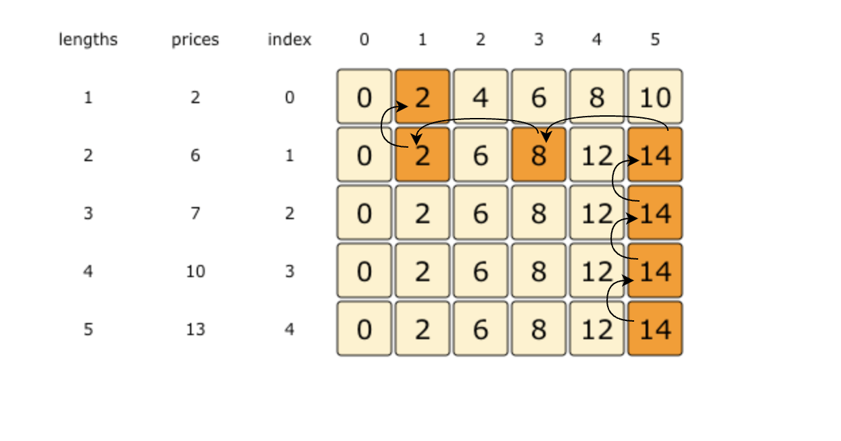](https://github.com/maazshaikh007/DSA_Patterns/blob/main/images/dpRodCutting.png)

## 🔎👩🏽‍🦯 Coin Change

<https://leetcode.com/problems/coin-change/>

### Introduction

Given an infinite supply of n coin denominations and a total money amount, we are asked to find the total number of distinct ways to make up that amount.

**Example:**

Denominations: {1,2,3}

Total amount: 5

Output: 5

**Explanation:** There are five ways to make the change for 5, here are those ways:

1. {1,1,1,1,1}
2. {1,1,1,2}
3. {1,2,2}
4. {1,1,3}
5. {2,3}

### Problem Statement

Given a number array to represent different coin denominations and a total amount T, we need to find all the different ways to make a change for T with the given coin denominations. We can assume an infinite supply of coins, therefore, each coin can be chosen multiple times.

This problem follows the [**Unbounded Knapsack**](https://github.com/maazshaikh007/DSA_Patterns/blob/main/%E2%9C%85%20Pattern%2015:%200-1%20Knapsack%20(Dynamic%20Programming).md#pattern-2-unbounded-knapsack) pattern.

### Basic Brute Force Solution

A basic **brute-force solution** could be to try all combinations of the given coins to select the ones that give a total sum of T. This is what our algorithm will look like:

**for each coin 'c'**

**create a new set which includes one quantity of coin 'c' if it does not exceed 'T', and**

**recursively call to process all coins**

**create a new set without coin 'c', and recursively call to process the remaining coins**

**return the count of sets who have a sum equal to 'T'**

This problem is quite similar to [**Count of Subset Sum**](https://github.com/maazshaikh007/DSA_Patterns/blob/main/%E2%9C%85%20Pattern%2015:%200-1%20Knapsack%20(Dynamic%20Programming).md#%F0%9F%94%8E-subset-sum-medium). The only difference here is that after including the item (i.e., coin), we recursively call to process all the items (including the current coin). In [**Count of Subset Sum**](https://github.com/maazshaikh007/DSA_Patterns/blob/main/%E2%9C%85%20Pattern%2015:%200-1%20Knapsack%20(Dynamic%20Programming).md#%F0%9F%94%8E-subset-sum-medium), however, we were recursively calling to process only the remaining items.

Here is the code for the **brute-force** solution:

### Code

|  |
| --- |
| class Solution {  public int countChange(int[] denominations, int total) {  return this.countChangeRecursive(denominations, total, 0);  }  private int countChangeRecursive(int[] denominations, int total, int currentIndex) {  // basic checks  if (total == 0)  return 1;  if(denominations.length == 0 || currentIndex >= denominations.length)  return 0;  // recursive call after selecting the coin at the currentIndex  // if the coin at currentIndex exceeds the total, we shouldn't process this  int sum1 = 0;  if( denominations[currentIndex] <= total )  sum1 = countChangeRecursive(denominations, total - denominations[currentIndex], currentIndex);  // recursive call after excluding the coin at the currentIndex  int sum2 = countChangeRecursive(denominations, total, currentIndex + 1);  return sum1 + sum2;  }  public static void main(String[] args) {  Solution cc = new Solution();  int[] denominations = {1, 2, 3};  System.out.println(cc.countChange(denominations, 5));  }  } |

* The **time complexity** of the above algorithm is exponential O(2ᶜ⁺ᵀ), where C represents total coin denominations and T is the total amount that we want to make change. The **space complexity** will be O(C+T).

Let’s try to find a better solution.

**Top-down Dynamic Programming with Memoization**

We can use **memoization** to overcome the *overlapping sub-problems*. We will be using a two-dimensional array to store the results of solved sub-problems. As mentioned above, we need to store results for every coin combination and for every possible sum:

function countChange(denominations, total) {

const dp = [];

function countChangeRecursive(denominations, total, currIndex) {

//base checks

if (total === 0) return 1;

if (denominations.length === 0 || currIndex >= denominations.length)

return 0;

dp[currIndex] = dp[currIndex] || [];

//if we have already processed a similar sub-problem, return the result

if (typeof dp[currIndex][total] !== 'undefined')

return dp[currIndex][total];

//recursive call after selecting the coin at currIndex

//if the coin at currIndex exceeds the total, we shouldn't process

let currSum = 0;

if (denominations[currIndex] <= total) {

currSum = countChangeRecursive(

denominations,

total - denominations[currIndex],

currIndex

);

}

//recursive call after excluding the coin at the currIndex

let sumAtNextIndex = countChangeRecursive(

denominations,

total,

currIndex + 1

);

dp[currIndex][total] = currSum + sumAtNextIndex;

return dp[currIndex][total];

}

return countChangeRecursive(denominations, total, 0);

}

console.log(

`Number of ways to make change: ---> ${countChange(

(denominations = [1, 2, 3]),

(total = 5)

)}`

);

#### Java Solution

|  |
| --- |
| public int countChange(int[] denominations, int total) {  Integer[][] dp = new Integer[denominations.length][total + 1];  return this.countChangeRecursive(denominations, total, 0, dp);  }  private int countChangeRecursive(int[] denominations, int total, int currentIndex, Integer[][] dp) {  // basic checks  if (total == 0)  return 1;  if(denominations.length == 0 || currentIndex >= denominations.length)  return 0;  if(dp[currentIndex][total] != null) return dp[currentIndex][total];  // recursive call after selecting the coin at the currentIndex  // if the coin at currentIndex exceeds the total, we shouldn't process this  int sum1 = 0;  if( denominations[currentIndex] <= total )  sum1 = countChangeRecursive(denominations, total - denominations[currentIndex], currentIndex, dp);  // recursive call after excluding the coin at the currentIndex  int sum2 = countChangeRecursive(denominations, total, currentIndex + 1, dp);  return dp[currentIndex][total] = sum1 + sum2;  } |

**Bottom-up Dynamic Programming**

We will try to find if we can make all possible sums, with every combination of coins, to populate the array dp[TotalDenominations][Total+1].

So for every possible total t (0<= t <= Total) and for every possible coin index (0 <= index < denominations.length), we have two options:

1. Exclude the coin. Count all the coin combinations without the given coin up to the total t => dp[index-1][t]
2. Include the coin if its value is not more than t. In this case, we will count all the coin combinations to get the remaining total: dp[index][t-denominations[index]]

Finally, to find the total combinations, we will add both the above two values:

**dp[index][t] = dp[index - 1][t] + dp[index][t - denominations[index]];**

Let’s draw this visually with the following example:

Denominations: [1, 2, 3]

Total: 5

Let’s start with our base case of zero total:

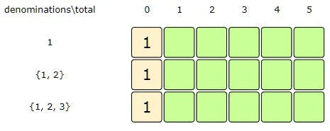

'0' total can always be found through an empty set

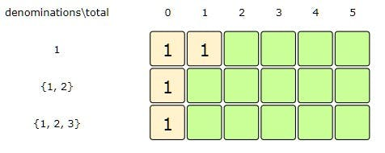

total: 1, index:0=> dp[index][total - denominations[index]], since index =0, we didn't consider dp[index-1][total]

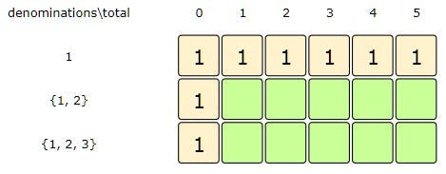

total: 2-5, index:0=> dp[index][total - denominations[index]], since index =0, we didn't consider dp[index-1][total]

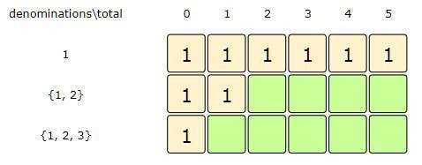

total: 1, index:1=> dp[index-1][total] , we didn't consider dp[index][total - denominations[index]], since 'total < denominations[index]'

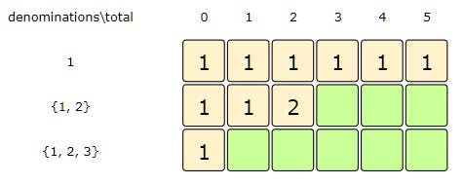

total: 2, index:1=> dp[index-1][total] + dp[index][total - denominations[index]]

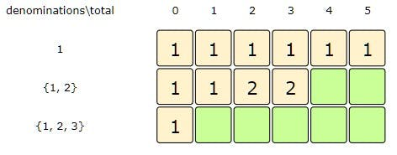

total: 3, index:1=> dp[index-1][total] + dp[index][total - denominations[index]]

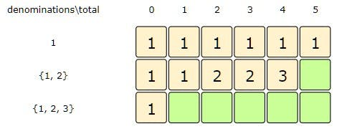

total: 4, index:1=> dp[index-1][total] + dp[index][total - denominations[index]]

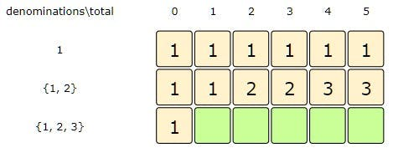

total: 5, index:1=> dp[index-1][total] + dp[index][total - denominations[index]]

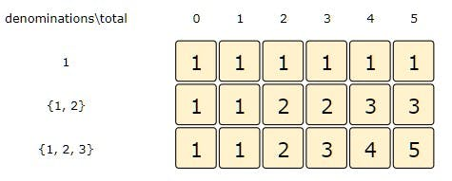

total: 5, index:2=> dp[index-1][total] + dp[index][total - denominations[index]]

Here is the code for our **bottom-up dynamic programming** approach:

function countChange(denominations, total) {

const n = denominations.length;

const dp = Array(n)

.fill(0)

.map(() => Array(total + 1).fill(0));

// populate the total=0 columns

//as we will always have an empty set for 0 total

for (let i = 0; i < n; i++) dp[i][0] = 1;

//process all sub-arrays for all capacities

for (let i = 0; i < n; i++) {

for (let t = 1; t <= total; t++) {

if (i > 0) dp[i][t] = dp[i - 1][t];

if (t >= denominations[i]) dp[i][t] += dp[i][t - denominations[i]];

}

}

//total combos will be at the bottom-right corner

console.log(dp);

return dp[n - 1][total];

}

console.log(

`Number of ways to make change: ---> ${countChange(

(denominations = [1, 2, 3]),

(total = 5)

)}`

);

* The above solution has time and **space complexity** of O(C*T), where C represents total coin denominations and T is the total amount that we want to make change.

#### Java Solution

|  |
| --- |
| public int countChange(int[] denominations, int total) {  int n = denominations.length;  int[][] dp = new int[n][total + 1];  // populate the total=0 columns, as we will always have an empty set for zero total  for(int i=0; i < n; i++)  dp[i][0] = 1;  // process all sub-arrays for all capacities  for(int i=0; i < n; i++) {  for(int t=1; t <= total; t++) {  if(i > 0)  dp[i][t] = dp[i-1][t];  if(t >= denominations[i])  dp[i][t] += dp[i][t-denominations[i]];  }  }  // total combinations will be at the bottom-right corner.  return dp[n-1][total];  } |

**Minimum Coin Change**

<https://leetcode.com/problems/coin-change-2/>

Given an infinite supply of n coin denominations and a total money amount, we are asked to find the minimum number of coins needed to make up that amount.

**Example 1:**

Denominations: {1,2,3}

Total amount: 5

Output: 2

Explanation: We need a minimum of two coins {2,3} to make a total of '5'

**Example 2:**

Denominations: {1,2,3}

Total amount: 11

Output: 4

Explanation: We need a minimum of four coins {2,3,3,3} to make a total of '11'

### Problem Statement

Given a number array to represent different coin denominations and a total amount T, we need to find the minimum number of coins needed to make a change for T. We can assume an infinite supply of coins, therefore, each coin can be chosen multiple times.

This problem follows the [**Unbounded Knapsack pattern**](https://github.com/maazshaikh007/DSA_Patterns/blob/main/%E2%9C%85%20Pattern%2015:%200-1%20Knapsack%20(Dynamic%20Programming).md#pattern-2-unbounded-knapsack).

**Basic Brute Force Solution**

A basic **brute-force solution** could be to try all combinations of the given coins to select the ones that give a total sum of T. This is what our algorithm will look like:

for each coin 'c'

**create a new set which includes one quantity of coin 'c' if it does not exceed 'T', and**

**recursively call to process all coins**

**create a new set without coin 'c', and recursively call to process the remaining coins**

**return the count of coins from the above two sets with a smaller number of coins**

Here is the code for the **brute-force solution:**

function countChange(denominations, total) {

function countChangeRecursive(denominations, total, currIndex) {

//base check

if (total === 0) return 0;

if (denominations.length === 0 || currIndex >= denominations.length)

return Infinity;

//recursive call after selecting the coin at currIndex

//if the coin at currIndex exceeds the total, we won't process

let currCoinCount = Infinity;

if (denominations[currIndex] <= total) {

const nextCoinCount = countChangeRecursive(

denominations,

total - denominations[currIndex],

currIndex

);

if (nextCoinCount !== Infinity) currCoinCount = nextCoinCount + 1;

}

//recursive call after excluding the coin at currIndex

const currCountMinusIndex = countChangeRecursive(

denominations,

total,

currIndex + 1

);

return Math.min(currCoinCount, currCountMinusIndex);

}

const result = countChangeRecursive(denominations, total, 0);

return result === Infinity ? -1 : result;

}

console.log(`Number of ways to make change: ---> ${countChange([1, 2, 3], 5)}`);

console.log(

`Number of ways to make change: ---> ${countChange([1, 2, 3], 11)}`

);

console.log(`Number of ways to make change: ---> ${countChange([1, 2, 3], 7)}`);

console.log(`Number of ways to make change: ---> ${countChange([3, 5], 7)}`);

* The **time complexity** of the above algorithm is exponential O(2ᶜ⁺ᵀ), where C represents total coin denominations and T is the total amount that we want to make change. The **space complexity** will be O(C+T).

#### Java Solution

|  |
| --- |
| public int countChange(int[] denominations, int total) {  int result = this.countChangeRecursive(denominations, total, 0);  return (result == Integer.MAX_VALUE - 1 ? -1 : result);  }  private int countChangeRecursive(int[] denominations, int total, int currentIndex) {  // base check  if (total == 0)  return 0;  if(denominations.length == 0 || currentIndex >= denominations.length)  return Integer.MAX_VALUE-1;  // recursive call after selecting the coin at the currentIndex  // if the coin at currentIndex exceeds the total, we shouldn't process this  int count1 = Integer.MAX_VALUE;  if( denominations[currentIndex] <= total ) {  count1 = 1 + countChangeRecursive(denominations, total - denominations[currentIndex], currentIndex);    }  // recursive call after excluding the coin at the currentIndex  int count2 = countChangeRecursive(denominations, total, currentIndex + 1);  return Math.min(count1, count2);  } |

Let’s try to find a better solution.

**Top-down Dynamic Programming with Memoization**

We can use **memoization** to overcome the **overlapping sub-problems**. We will be using a two-dimensional array to store the results of solved *sub-problems*. As mentioned above, we need to store results for every coin combination and for every possible sum:

function countChange(denominations, total) {

const dp = [];

function countChangeRecursive(denominations, total, currIndex) {

//base check

if (total === 0) return 0;

if (denominations.length === 0 || currIndex >= denominations.length)

return Infinity;

dp[currIndex] = dp[currIndex] || [];

//check if we. have not alreay processed a similar subproblem

if (typeof dp[currIndex][total] === 'undefined') {

//recursive call after selecting the coin at currIndex

//if the coin at currIndex exceeds the total, we won't process

let currCoinCount = Infinity;

if (denominations[currIndex] <= total) {

const nextCoinCount = countChangeRecursive(

denominations,

total - denominations[currIndex],

currIndex

);

if (nextCoinCount !== Infinity) currCoinCount = nextCoinCount + 1;

}

//recursive call after excluding the coin at currIndex

const currCountMinusIndex = countChangeRecursive(

denominations,

total,

currIndex + 1

);

dp[currIndex][total] = Math.min(currCoinCount, currCountMinusIndex);

}

return dp[currIndex][total];

}

const result = countChangeRecursive(denominations, total, 0);

return result === Infinity ? -1 : result;

}

console.log(`Number of ways to make change: ---> ${countChange([1, 2, 3], 5)}`);

console.log(

`Number of ways to make change: ---> ${countChange([1, 2, 3], 11)}`

);

console.log(`Number of ways to make change: ---> ${countChange([1, 2, 3], 7)}`);

console.log(`Number of ways to make change: ---> ${countChange([3, 5], 7)}`);

#### Java Solution

|  |
| --- |
| public int countChange(int[] denominations, int total) {  Integer[][] dp = new Integer[denominations.length][total + 1];  int result = this.countChangeRecursive(dp, denominations, total, 0);  return (result == Integer.MAX_VALUE - 1? -1 : result);  }  private int countChangeRecursive(Integer[][] dp, int[] denominations, int total, int currentIndex) {  // base check  if (total == 0)  return 0;  if(denominations.length == 0 || currentIndex >= denominations.length)  return Integer.MAX_VALUE - 1;  // check if we have not already processed a similar sub-problem  if(dp[currentIndex][total] == null) {  // recursive call after selecting the coin at the currentIndex  // if the coin at currentIndex exceeds the total, we shouldn't process this  int count1 = Integer.MAX_VALUE;  if( denominations[currentIndex] <= total ) {  count1 = 1 + countChangeRecursive(dp, denominations, total - denominations[currentIndex], currentIndex);  }  // recursive call after excluding the coin at the currentIndex  int count2 = countChangeRecursive(dp, denominations, total, currentIndex + 1);  dp[currentIndex][total] = Math.min(count1, count2);  }  return dp[currentIndex][total];  } |

**Bottom-up Dynamic Programming**

Let’s try to populate our array dp[TotalDenominations][Total+1] for every possible total with a minimum number of coins needed.

So for every possible total t (0<= t <= Total) and for every possible coin index (0 <= index < denominations.length), we have two options:

1. Exclude the coin: In this case, we will take the minimum coin count from the previous set => dp[index-1][t]
2. Include the coin if its value is not more than t: In this case, we will take the minimum count needed to get the remaining total, plus include 1 for the current coin => dp[index][t-denominations[index]] + 1

Finally, we will take the minimum of the above two values for our solution:

**dp[index][t] = min(dp[index - 1][t], dp[index][t - denominations[index]] + 1);**

Let’s draw this visually with the following example:

Denominations: [1, 2, 3]

Total: 7

Let’s start with our base case of zero total:

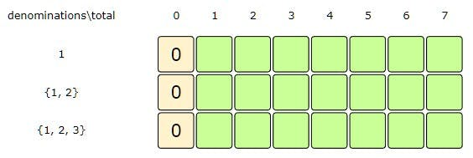

We don't need any coin to make zero total

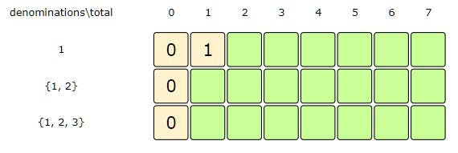

Total:1, Index:0 => dp[Index][Total-denominations[Index] + 1, we didn't consider dp[Index-1][Total] as Index = 0

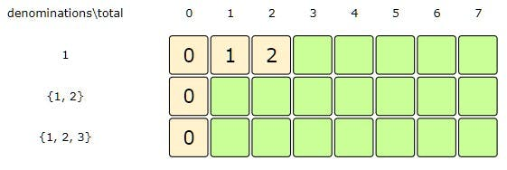

Total:2, Index:0 => dp[Index][Total-denominations[Index] + 1, we didn't consider dp[Index-1][Total] as Index = 0

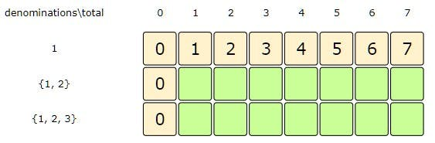

Total:3-7, Index:0 => dp[Index][Total-denominations[Index] + 1, we didn't consider dp[Index-1][Total] as Index = 0

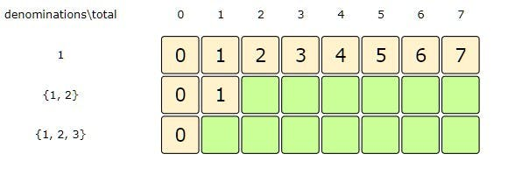

Total:1, Index:1 => dp[Index-1][t], we didn't consider dp[Index][Total-denominations[Index] as Total < denominations[Index]

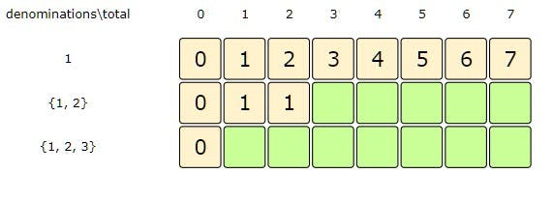

Total:2, Index:1 => min( dp[Index-1][Total], dp[Index][Total-denominations[Index] + 1)

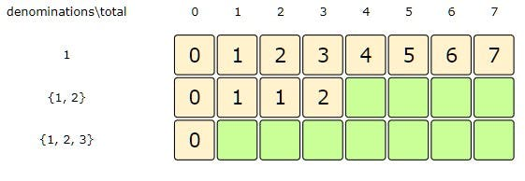

Total:3, Index:1 => min( dp[Index-1][Total], dp[Index][Total-denominations[Index] + 1)

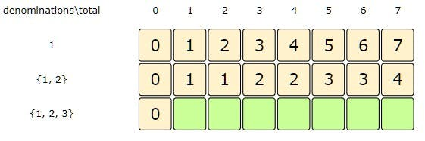

Total:4-7, Index:1 => min( dp[Index-1][Total], dp[Index][Total-denominations[Index] + 1)

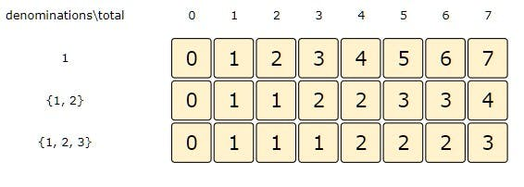

Total:7, Index:2 => min( dp[Index-1][Total], dp[Index][Total-denominations[Index] + 1)

Here is the code for our **bottom-up dynamic programming** approach:

function countChange(denominations, total) {

const n = denominations.length;

const dp = Array(n)

.fill(0)

.map(() => Array(total + 1).fill(0));

for (let i = 0; i < n; i++) {

for (let j = 0; j <= total; j++) {

dp[i][j] = Infinity;

}

}

//populate the total=0 columns, as we don't need any coin to make 0 total

for (let i = 0; i < n; i++) dp[i][0] = 0;

for (let i = 0; i < n; i++) {

for (let t = 1; t <= total; t++) {

if (i > 0) {

//exclude the coin

dp[i][t] = dp[i - 1][t];

}

if (t >= denominations[i]) {

//include the coin

dp[i][t] = Math.min(dp[i][t], dp[i][t - denominations[i]] + 1);

}

}

}

console.log(dp);

//total combos will be in the bottom-right corner

return dp[n - 1][total] === Infinity ? -1 : dp[n - 1][total];

}

console.log(`Number of ways to make change: ---> ${countChange([1, 2, 3], 5)}`);

console.log(

`Number of ways to make change: ---> ${countChange([1, 2, 3], 11)}`

);

console.log(`Number of ways to make change: ---> ${countChange([1, 2, 3], 7)}`);

console.log(`Number of ways to make change: ---> ${countChange([3, 5], 7)}`);

* The above solution has time and **space complexity** of O(C*T), where C represents total coin denominations and T is the total amount that we want to make change.

#### Java Solution

|  |
| --- |
| public int countChange(int[] denominations, int total) {  int n = denominations.length;  int[][] dp = new int[n][total + 1];   for(int i=0; i < n; i++)  for(int j=0; j <= total; j++)  dp[i][j] = Integer.*MAX_VALUE* - 1;   // populate the total=0 columns, as we don't need any coin to make zero total  for(int i=0; i < n; i++)  dp[i][0] = 0;   for(int i=0; i < n; i++) {  for(int t=1; t <= total; t++) {  if(i > 0)  dp[i][t] = dp[i-1][t]; //exclude the coin  if(t >= denominations[i]) {  dp[i][t] = Math.*min*(dp[i][t], dp[i][t-denominations[i]]+1); // include the coin  }  }  }   // total combinations will be at the bottom-right corner.  return (dp[n-1][total] == Integer.*MAX_VALUE* - 1 ? -1 : dp[n-1][total]); } |

**Maximum Ribbon Cut**

<https://leetcode.com/problems/cutting-ribbons/>

We are given a ribbon of length n and a set of possible ribbonLengths. We need to cut the ribbon into the maximum number of pieces that comply with the above-mentioned possible lengths. Write a method that will return the count of pieces.

Given a number array to represent possible ribbonLengths and a total ribbon length n, we need to find the maximum number of pieces that the ribbon can be cut into.

This problem follows the [**Unbounded Knapsack pattern**](https://github.com/maazshaikh007/DSA_Patterns/blob/main/%E2%9C%85%20Pattern%2015:%200-1%20Knapsack%20(Dynamic%20Programming).md#pattern-2-unbounded-knapsack) and is quite similar to [**Minimum Coin Change (MCC)**](https://github.com/maazshaikh007/DSA_Patterns/blob/main/%E2%9C%85%20Pattern%2015:%200-1%20Knapsack%20(Dynamic%20Programming).md#minimum-coin-change). The only difference is that in [**Minimum Coin Change (MCC)**](https://github.com/maazshaikh007/DSA_Patterns/blob/main/%E2%9C%85%20Pattern%2015:%200-1%20Knapsack%20(Dynamic%20Programming).md#minimum-coin-change), we were asked to find the **minimum** number of coin changes, whereas, in this problem, we need to find the **maximum** number of pieces.

**Example 1:**

n: 5

Ribbon Lengths: {2,3,5}

Output: 2

Explanation: Ribbon pieces will be {2,3}.

**Example 2:**

n: 7

Ribbon Lengths: {2,3}

Output: 3

Explanation: Ribbon pieces will be {2,2,3}.

**Example 3:**

n: 13

Ribbon Lengths: {3,5,7}

Output: 3

Explanation: Ribbon pieces will be {3,3,7}.

**Basic Brute Force Solution**

A **basic brute-force solution** could be to try all combinations of the given lengths to select the maximum one that gives the total length of n. This is what our algorithm will look like:

**for each length 'l'**

**create a new set which includes one quantity of length 'l' if it does not exceed 'n', and**

**recursively call to process all lengths**

**create a new set without length 'l', and recursively call to process the remaining lengths**

**return the number of pieces from the above two sets with a higher number of pieces**

Here is the code for the **brute-force solution:**

function countRibbonPieces(ribbonLengths, total) {

function countRibbonPiecesRecursive(ribbonLengths, total, currIndex) {

//base check

if (total === 0) return 0;

if (ribbonLengths.length === 0 || currIndex >= ribbonLengths.length)

return -Infinity;

//recursive call after selecting the ribbon length at currIndex

//if the ribbon length at the currIndex exceeds total, we shouldn't process

let currRibbon = -Infinity;

if (ribbonLengths[currIndex] <= total) {

let withoutIndexRibbon = countRibbonPiecesRecursive(

ribbonLengths,

total - ribbonLengths[currIndex],

currIndex

);

if (withoutIndexRibbon !== -Infinity) currRibbon = withoutIndexRibbon + 1;

}

//recursive call after excluding the ribbon at currIndex

const nextRibbon = countRibbonPiecesRecursive(

ribbonLengths,

total,

currIndex + 1

);

return Math.min(currRibbon, nextRibbon);

}

const result = countRibbonPiecesRecursive(ribbonLengths, total, 0);

return result === -Infinity ? -1 : result;

}

console.log(

`Maximum number of ribbons: ---> ${countRibbonPieces([2, 3, 5], 5)}`);

console.log(

`Maximum number of ribbons: ---> ${countRibbonPieces([2, 3], 7)}`);

console.log(

`Maximum number of ribbons: ---> ${countRibbonPieces([3, 5, 7], 13)}`;

console.log(

`Maximum number of ribbons: ---> ${countRibbonPieces([3, 5], 7)}`);

The above algorithm’s **time complexity** is exponential O(2 ᴸ⁺ᴺ), where L represents total ribbon lengths, and N is the total length that we want to cut. The **space complexity** will be O(L+N).

#### Java Solution

|  |
| --- |
| public int countRibbonPieces(int[] ribbonLengths, int total) {  int maxPieces = this.countRibbonPiecesRecursive(ribbonLengths, total, 0);  return maxPieces == Integer.MIN_VALUE ? -1 : maxPieces;  }  private int countRibbonPiecesRecursive(int[] ribbonLengths, int total, int currentIndex) {  // base check  if (total == 0)  return 0;  if(ribbonLengths.length == 0 || currentIndex >= ribbonLengths.length)  return Integer.MIN_VALUE;  // recursive call after selecting the ribbon length at the currentIndex  // if the ribbon length at the currentIndex exceeds the total, we shouldn't process this  int c1 = Integer.MIN_VALUE;  if( ribbonLengths[currentIndex] <= total ) {  int result = countRibbonPiecesRecursive(  ribbonLengths, total - ribbonLengths[currentIndex], currentIndex);  if(result != Integer.MIN_VALUE){  c1 = result + 1;  }  }  // recursive call after excluding the ribbon length at the currentIndex  int c2 = countRibbonPiecesRecursive(ribbonLengths, total, currentIndex + 1);  return Math.max(c1, c2);  } |

Since this problem is quite similar to [**Minimum Coin Change**](https://github.com/maazshaikh007/DSA_Patterns/blob/main/%E2%9C%85%20Pattern%2015:%200-1%20Knapsack%20(Dynamic%20Programming).md#minimum-coin-change), let’s jump on to the **bottom-up dynamic programming solution**.

**Bottom-up Dynamic Programming**

Let’s try to populate our array dp[ribbonLength][total+1] for every possible ribbon length with a maximum number of pieces.

So for every possible length len (0 <= len <= total) and for every possible ribbon length index (0 <= index < ribbonLengths.length), we have two options:

1. **Exclude the ribbon length:** In this case, we will take the maximum piece count from the previous set => dp[index-1][len]
2. **Include the ribbon length** if its value is not more than len: In this case, we will take the maximum pieces needed to get the remaining total, plus include 1 for the current ribbon length => 1 + dp[index][len-ribbonLengths[index]]

Finally, we will take the maximum of the above two values for our solution:

**dp[index][len] = max(**

**dp[index - 1][len],**

**1 + dp[index][len - ribbonLengths[index]]**

**);**

Here is the code for our **bottom-up dynamic programming approach**:

function countRibbonPieces(ribbonLengths, total) {

let n = ribbonLengths.length;

const dp = Array(n)

.fill(0)

.map(() => Array(total + 1).fill(0));

for (let i = 0; i < n; i++) {

for (let j = 0; j <= total; j++) {

dp[i][j] = -Infinity;

}

}

//populate the total=0 columns, as we don't need any ribbons to make 0 total

for (let i = 0; i < n; i++) dp[i][0] = 0;

for (let i = 0; i < n; i++) {

for (let t = 1; t <= total; t++) {

if (i > 0) {

//exclude the ribbon

dp[i][t] = dp[i - 1][t];

}

if (t >= ribbonLengths[i] && dp[i][t - ribbonLengths[i]] !== -Infinity) {

//include the ribbon and check if the remaining length can be cut into available lengths

dp[i][t] = Math.max(dp[i][t], dp[i][t - ribbonLengths[i]] + 1);

}

}

}

return dp[n - 1][total] === -Infinity ? -1 : dp[n - 1][total];

}

console.log(

`Maximum number of ribbons: ---> ${countRibbonPieces([2, 3, 5], 5)}`);

console.log(

`Maximum number of ribbons: ---> ${countRibbonPieces([2, 3], 7)}`);

console.log(

`Maximum number of ribbons: ---> ${countRibbonPieces([3, 5, 7], 13)}`;

console.log(

`Maximum number of ribbons: ---> ${countRibbonPieces([3, 5], 7)}`);

* The above solution has time and **space complexity** of O(L*N), where L represents total ribbon lengths and N is the total length that we want to cut.

#### Java Solution

|  |
| --- |
| public int countRibbonPieces(int[] ribbonLengths, int total)  {  int n = ribbonLengths.length;  int[][] dp = new int[n][total + 1];  for(int i=0; i < n; i++)  for(int j=0; j <= total; j++)  dp[i][j] = Integer.MIN_VALUE;  // populate the total=0 columns, as we don't need any ribbon to make zero total  for(int i=0; i < n; i++)  dp[i][0] = 0;  for(int i=0; i < n; i++) {  for(int t=1; t <= total; t++) {  if(i > 0) //exclude the ribbon  dp[i][t] = dp[i-1][t];  // include the ribbon and check if the remaining length can be cut into available lengths  if(t >= ribbonLengths[i] && dp[i][t-ribbonLengths[i]] != Integer.MIN_VALUE)  dp[i][t] = Math.max(dp[i][t], dp[i][t-ribbonLengths[i]]+1);  }  }  // total combinations will be at the bottom-right corner, return '-1' if cutting is not possible  return (dp[n-1][total] == Integer.MIN_VALUE ? -1 : dp[n-1][total]);  } |

**Pattern 3: Fibonacci Numbers**

**Problem Set**

1. [Fibonacci numbers](https://github.com/maazshaikh007/DSA_Patterns/blob/main/%E2%9C%85%20Pattern%2015:%200-1%20Knapsack%20(Dynamic%20Programming).md#fibonacci-numbers)
2. [🔎👩🏽‍🦯 Staircase](https://github.com/maazshaikh007/DSA_Patterns/blob/main/%E2%9C%85%20Pattern%2015:%200-1%20Knapsack%20(Dynamic%20Programming).md#%F0%9F%94%8E%F0%9F%91%A9%F0%9F%8F%BD%E2%80%8D%F0%9F%A6%AF-staircase)
3. [Number factors](https://github.com/maazshaikh007/DSA_Patterns/blob/main/%E2%9C%85%20Pattern%2015:%200-1%20Knapsack%20(Dynamic%20Programming).md#number-factors)
4. [🌴 Minimum jumps to reach the end](https://github.com/maazshaikh007/DSA_Patterns/blob/main/%E2%9C%85%20Pattern%2015:%200-1%20Knapsack%20(Dynamic%20Programming).md#%F0%9F%8C%B4-minimum-jumps-to-reach-the-end)
5. [Minimum jumps with fee](https://github.com/maazshaikh007/DSA_Patterns/blob/main/%E2%9C%85%20Pattern%2015:%200-1%20Knapsack%20(Dynamic%20Programming).md#minimum-jumps-with-fee)
6. [🌴 🔎 👩🏽‍🦯 House thief](https://github.com/maazshaikh007/DSA_Patterns/blob/main/%E2%9C%85%20Pattern%2015:%200-1%20Knapsack%20(Dynamic%20Programming).md#%F0%9F%8C%B4-%F0%9F%94%8E-%F0%9F%91%A9%F0%9F%8F%BD%E2%80%8D%F0%9F%A6%AF-house-thief)

**Fibonacci numbers**

<https://leetcode.com/problems/fibonacci-number/>

Write a function to calculate the nth **Fibonacci number**.

**Fibonacci numbers** are a series of numbers in which each number is the sum of the two preceding numbers. First few **Fibonacci numbers** are: 0, 1, 1, 2, 3, 5, 8, …

Mathematically we can define the **Fibonacci numbers** as:

**Fib(n) = Fib(n-1) + Fib(n-2), for n > 1**

**Given that: Fib(0) = 0, and Fib(1) = 1**

**Basic Brute Force Solution**

A *Basic Brute Force Solution* could be to have a recursive implementation of the mathematical formula discussed above:

function calculateFibonacci(n) {

if (n < 2) return n;

return calculateFibonacci(n - 1) + calculateFibonacci(n - 2);

}

console.log(`5th Fibonacci is ---> ${calculateFibonacci(5)}`);

console.log(`6th Fibonacci is ---> ${calculateFibonacci(6)}`);

console.log(`7th Fibonacci is ---> ${calculateFibonacci(7)}`);

#### Java Solution

|  |
| --- |
| public int CalculateFibonacci(int n) {  if(n < 2)  return n;  return CalculateFibonacci(n-1) + CalculateFibonacci(n-2);  } |

The **time complexity** of the above algorithm is exponential O(2ᴺ) as we are making two recursive calls in the same function. The **space complexity** is O(n) which is used to store the *recursion stack*.

Let’s visually draw the recursion for CalculateFibonacci(4) to see the overlapping subproblems:

[](https://github.com/maazshaikh007/DSA_Patterns/blob/main/images/fib4.png)

We can use an array to store the already solved subproblems. Here is the code:

function calculateFibonacci(n) {

const memoize = [];

function fib(n) {

if (n < 2) return n;

//if we have already solved this subproblem, simply return the result from the cache

if (memoize[n]) return memoize[n];

memoize[n] = calculateFibonacci(n - 1) + calculateFibonacci(n - 2);

return memoize[n];

}

return fib(n);

}

console.log(`5th Fibonacci is ---> ${calculateFibonacci(5)}`);

console.log(`6th Fibonacci is ---> ${calculateFibonacci(6)}`);

console.log(`7th Fibonacci is ---> ${calculateFibonacci(7)}`);

#### Java Solution

|  |
| --- |
| public int CalculateFibonacci(int n) {  int dp[] = new int[n + 1];  return CalculateFibonacciRecursive(dp, n);  }  public int CalculateFibonacciRecursive(int[] dp, int n) {  if (n < 2)  return n;  if (dp[n] == 0)  dp[n] = CalculateFibonacciRecursive(dp, n - 1) + CalculateFibonacciRecursive(dp, n - 2);  return dp[n];  } |

**Bottom-up Dynamic Programming**

Let’s try to populate our dp[] array from the above solution, working in a bottom-up fashion. Since every **Fibonacci number** is the sum of the previous two numbers, we can use this fact to populate our array.

Here is the code for the **bottom-up dynamic programming approach**:

function calculateFibonacci(n) {

if (n < 2) return n;

const dp = [0, 1];

for (let i = 2; i <= n; i++) {

dp[i] = dp[i - 1] + dp[i - 2];

}

return dp[n];

}

console.log(`5th Fibonacci is ---> ${calculateFibonacci(5)}`);

console.log(`6th Fibonacci is ---> ${calculateFibonacci(6)}`);

console.log(`7th Fibonacci is ---> ${calculateFibonacci(7)}`);

* The above solution has time and **space complexity** of O(n).

#### Java Solution

|  |
| --- |
| public int CalculateFibonacci(int n) {  if (n < 2)  return n;  int dp[] = new int[n + 1];  dp[0] = 0;  dp[1] = 1;  for (int i = 2; i <= n; i++)  dp[i] = dp[i - 1] + dp[i - 2];  return dp[n];  } |

**Memory optimization**

We can optimize the space used in our previous solution. We don’t need to store all the **Fibonacci numbers** up to n, as we only need two previous numbers to calculate the next **Fibonacci number**. We can use this fact to further improve our solution:

function calculateFibonacci(n) {

if (n < 2) return n;

let n1 = 0;

let n2 = 1;

for (let i = 2; i <= n; i++) {

[n1, n2] = [n2, n1 + n2];

}

return n2;

}

console.log(`5th Fibonacci is ---> ${calculateFibonacci(5)}`);

console.log(`6th Fibonacci is ---> ${calculateFibonacci(6)}`);

console.log(`7th Fibonacci is ---> ${calculateFibonacci(7)}`);

* The above solution has a **time complexity** of O(n) but a constant **space complexity** O(1).

##### Java solution:

|  |
| --- |
| public int CalculateFibonacci(int n) {  if (n < 2)  return n;  int n1 = 0, n2 = 1, temp;  for (int i = 2; i <= n; i++) {  temp = n1 + n2;  n1 = n2;  n2 = temp;  }  return n2;  } |

**🔎👩🏽‍🦯 Staircase**

<https://leetcode.com/problems/climbing-stairs/>

Given a stair with n steps, implement a method to count how many possible ways are there to reach the top of the staircase, given that, at every step you can either take 1 step, 2 steps, or 3 steps.

**Example 1:**

Number of stairs (n) : 3

Number of ways = 4

Explanation: Following are the four ways we can climb : {1,1,1}, {1,2}, {2,1}, {3}

**Example 2:**

Number of stairs (n) : 4

Number of ways = 7

Explanation: Following are the seven ways we can climb : {1,1,1,1}, {1,1,2}, {1,2,1}, {2,1,1},

{2,2}, {1,3}, {3,1}

Let’s first start with a **recursive brute-force solution**.

**Brute-Force Solution**

At every step, we have three options:

* either jump 1 step,
* 2 steps,
* or 3 steps.

So our algorithm will look like this:

function countWays(n) {

if (n === 0) {

return 1;

} // base case, we don't need to take any step, so there is only one way

if (n === 1) {

return 1;

} // we can take one step to reach the end, and that is the only way

if (n === 2) {

return 2;

} // we can take one step twice or jump two steps to reach at the top

// if we take 1 step, we are left with 'n-1' steps;

const take1Step = countWays(n - 1);

// similarly, if we took 2 steps, we are left with 'n-2' steps;

const take2Step = countWays(n - 2);

// if we took 3 steps, we are left with 'n-3' steps;

const take3Step = countWays(n - 3);

return take1Step + take2Step + take3Step;

}

console.log(`Number of ways: ---> ${countWays(3)}`);

console.log(`Number of ways: ---> ${countWays(4)}`);

console.log(`Number of ways: ---> ${countWays(5)}`);

* The **time complexity** of the above algorithm is exponential O(3ᴺ) as we are making three *recursive calls* in the same function. The **space complexity** is O(n) which is used to store the *recursion stack*.

#### Java Solution

|  |
| --- |
| public int CountWays(int n) {  if( n == 0)  return 1; // base case, we don't need to take any step, so there is only one way    if(n == 1)  return 1; // we can take one step to reach the end, and that is the only way  if(n == 2)  return 2; // we can take one step twice or jump two steps to reach at the top  // if we take 1 step, we are left with 'n-1' steps;  int take1Step = CountWays(n-1);  // similarly, if we took 2 steps, we are left with 'n-2' steps;  int take2Step = CountWays(n-2);  // if we took 3 steps, we are left with 'n-3' steps;  int take3Step = CountWays(n-3);  return take1Step + take2Step + take3Step;  } |

Let’s visually draw the recursion for countWays(4) to see the *overlapping subproblems*: [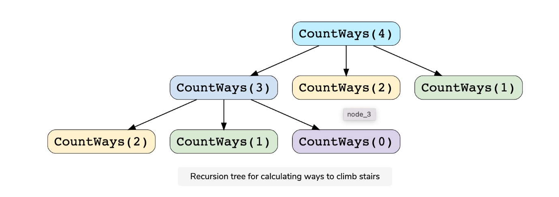](https://github.com/maazshaikh007/DSA_Patterns/blob/main/images/dpstairs.png)

We can clearly see the overlapping subproblem pattern: countWays(2) and countWays(1) have been called twice. We can optimize this using **memoization**.

**Top-down Dynamic Programming with Memoization**

We can use an array to store the already solved subproblems. Here is the code:

function countWays(n) {

const dp = [1, 1, 2];

function countWaysRecursive(n) {

// base case

if (n <= 2) {

return dp[n];

}

// if we take 1 step, we are left with 'n-1' steps;

const take1Step = countWaysRecursive(n - 1);

// similarly, if we took 2 steps, we are left with 'n-2' steps;

const take2Step = countWaysRecursive(n - 2);

// if we took 3 steps, we are left with 'n-3' steps;

const take3Step = countWaysRecursive(n - 3);

dp[n] = take1Step + take2Step + take3Step;

console.log(dp);

return dp[n];

}

return countWaysRecursive(n);

}

console.log(`Number of ways: ---> ${countWays(0)}`);

console.log(`Number of ways: ---> ${countWays(1)}`);

console.log(`Number of ways: ---> ${countWays(2)}`);

console.log(`Number of ways: ---> ${countWays(3)}`);

console.log(`Number of ways: ---> ${countWays(4)}`);

console.log(`Number of ways: ---> ${countWays(5)}`);

#### Java Soltuion

|  |
| --- |
| public int CountWays(int n) {  int dp[] = new int[n+1];  return CountWaysRecursive(dp, n);  }    public int CountWaysRecursive(int[] dp, int n) {  if( n == 0)  return 1; // base case, we don't need to take any step, so there is only one way  if(n == 1)  return 1; // we can take one step to reach the end, and that is the only way  if(n == 2)  return 2; // we can take one step twice or jump two steps to reach at the top  if(dp[n] == 0) {  // if we take 1 step, we are left with 'n-1' steps;  int take1Step = CountWaysRecursive(dp, n-1);  // similarly, if we took 2 steps, we are left with 'n-2' steps;  int take2Step = CountWaysRecursive(dp, n-2);  // if we took 3 steps, we are left with 'n-3' steps;  int take3Step = CountWaysRecursive(dp, n-3);  dp[n] = take1Step + take2Step + take3Step;  }    return dp[n];  } |

**What is the time and space complexity of the above solution?**

* Since our **memoization** array dp[n+1] stores the results for all the subproblems, we can conclude that we will not have more than n+1 subproblems (where n represents the total number of steps). This means that our **time complexity** will be O(N).
* The **space complexity** will also be O(n); this space will be used to store the *recursion-stack*.

**Bottom-up Dynamic Programming**

Let’s try to populate our dp[] array from the above solution, working in a *bottom-up fashion*. As we saw in the above code, every countWaysRecursive(n) is the sum of the previous three counts. We can use this fact to populate our array.

Here is the code for our **bottom-up dynamic programming approach**:

function countWays(n) {

const dp = Array(n + 1).fill(1);

dp[2] = 2;

for (let i = 3; i <= n; i++) {

// if we take 1 step, we are left with 'n-1' steps;

const take1Step = dp[n - 1];

// similarly, if we took 2 steps, we are left with 'n-2' steps;

const take2Step = dp[n - 2];

// if we took 3 steps, we are left with 'n-3' steps;

const take3Step = dp[n - 3];

dp[i] = take1Step + take2Step + take3Step;

}

return dp[n];

}

console.log(`Number of ways: ---> ${countWays(0)}`);

console.log(`Number of ways: ---> ${countWays(1)}`);

console.log(`Number of ways: ---> ${countWays(2)}`);

console.log(`Number of ways: ---> ${countWays(3)}`);

console.log(`Number of ways: ---> ${countWays(4)}`);

console.log(`Number of ways: ---> ${countWays(5)}`);

* The above solution has **time and space complexity** of O(n).

#### Java Solution

|  |
| --- |
| public int CountWays(int n) {  if (n < 2) return 1;  if (n == 2) return 2;  int dp[] = new int[n+1];  dp[0] = 1;  dp[1] = 1;  dp[2] = 2;  for(int i=3; i<=n; i++)  dp[i] = dp[i-1] + dp[i-2] + dp[i-3];  return dp[n];  } |

**Memory optimization**

We can optimize the space used in our previous solution. We don’t need to store all the counts up to n, as we only need three previous numbers to calculate the next count. We can use this fact to further improve our solution:

function countWays(n) {

const dp = [1, 1, 2];

for (let i = 3; i <= n; i++) {

dp[i] = dp[i - 1] + dp[i - 2] + dp[i - 3];

}

return dp[n];

}

console.log(`Number of ways: ---> ${countWays(0)}`);

console.log(`Number of ways: ---> ${countWays(1)}`);

console.log(`Number of ways: ---> ${countWays(2)}`);

console.log(`Number of ways: ---> ${countWays(3)}`);

console.log(`Number of ways: ---> ${countWays(4)}`);

console.log(`Number of ways: ---> ${countWays(5)}`);

* The above solution has a **time complexity** of O(n) and a constant **space complexity** O(1).

##### Java Solution

|  |
| --- |
| public int CountWays(int n) {  if (n < 2) return 1;  if (n == 2) return 2;    int n1=1, n2=1, n3=2, temp;  for(int i=3; i<=n; i++) {  temp = n1 + n2 + n3;  n1 = n2;  n2 = n3;  n3 = temp;  }  return n3;  } |

**Fibonacci number pattern**

We can clearly see that this problem follows the [**Fibonacci number pattern**](https://github.com/maazshaikh007/DSA_Patterns/blob/main/%E2%9C%85%20Pattern%2015:%200-1%20Knapsack%20(Dynamic%20Programming).md#fibonacci-number-pattern). The only difference is that in **Fibonacci numbers** every number is a sum of the two preceding numbers, whereas in this problem every count is a sum of three preceding counts. Here is the *recursive formula*for this problem:

countWays(n) = countWays(n-1) + countWays(n-2) + countWays(n-3),

for n >=3

This problem can be extended further. Instead of taking 1, 2, or 3 steps at any time, what if we can take up to k steps at any time? In that case, our *recursive formula*will look like:

countWays(n) = countWays(n-1) + countWays(n-2) + countWays(n-3) + ... + countWays(n-k),

for n >= k

**Number factors**

<https://www.geeksforgeeks.org/count-ofdifferent-ways-express-n-sum-1-3-4/>

Given a number n, implement a method to count how many possible ways there are to express n as the sum of 1, 3, or 4.

**Example 1:**

n : 4

Number of ways = 4

Explanation: Following are the four ways we can express 'n' : {1,1,1,1}, {1,3}, {3,1}, {4}

**Example 2:**

n : 5

Number of ways = 6

Explanation: Following are the six ways we can express 'n' : {1,1,1,1,1}, {1,1,3}, {1,3,1}, {3,1,1},

{1,4}, {4,1}

**Brute-Force Solution**

Let’s first start with a **recursive brute-force solution**.

For every number i, we have three option: subtract either 1, 3, or 4 from i and recursively process the remaining number. So our algorithm will look like:

function countWays(n) {

function countWaysRecursive(n) {

//base case

if (n <= 2) return 1;

if (n === 3) return 2;

// if we subtract 1, we are left with 'n-1'

const subtract1 = countWays(n - 1);

// if we subtract 3, we are left with 'n-3'

const subtract3 = countWays(n - 3);

// if we subtract 4, we are left with 'n-4'

const subtract4 = countWays(n - 4);

return subtract1 + subtract3 + subtract4;

}

return countWaysRecursive(n);

}

console.log(`Number of ways: ---> ${countWays(4)}`);

console.log(`Number of ways: ---> ${countWays(5)}`);

console.log(`Number of ways: ---> ${countWays(6)}`);

#### Java Solution

|  |
| --- |
| public int CountWays(int n) {  if( n == 0)  return 1; // base case, we don't need to subtract any thing, so there is only one way  if(n == 1)  return 1; // we can subtract 1 to be left with zero, and that is the only way  if(n == 2)  return 1; // we can subtract 1 twice to get zero and that is the only way  if(n == 3)  return 2; // '3' can be expressed as {1,1,1}, {3}  // if we subtract 1, we are left with 'n-1'  int subtract1 = CountWays(n-1);  // if we subtract 3, we are left with 'n-3'  int subtract3 = CountWays(n-3);  // if we subtract 4, we are left with 'n-4'  int subtract4 = CountWays(n-4);  return subtract1 + subtract3 + subtract4;  } |

The **time complexity** of the above algorithm is exponential O(3ᴺ). The **space complexity** is O(n) which is used to store the *recursion stack*.

Let’s visually draw the recursion for CountWays(5) to see the *overlapping subproblems*: [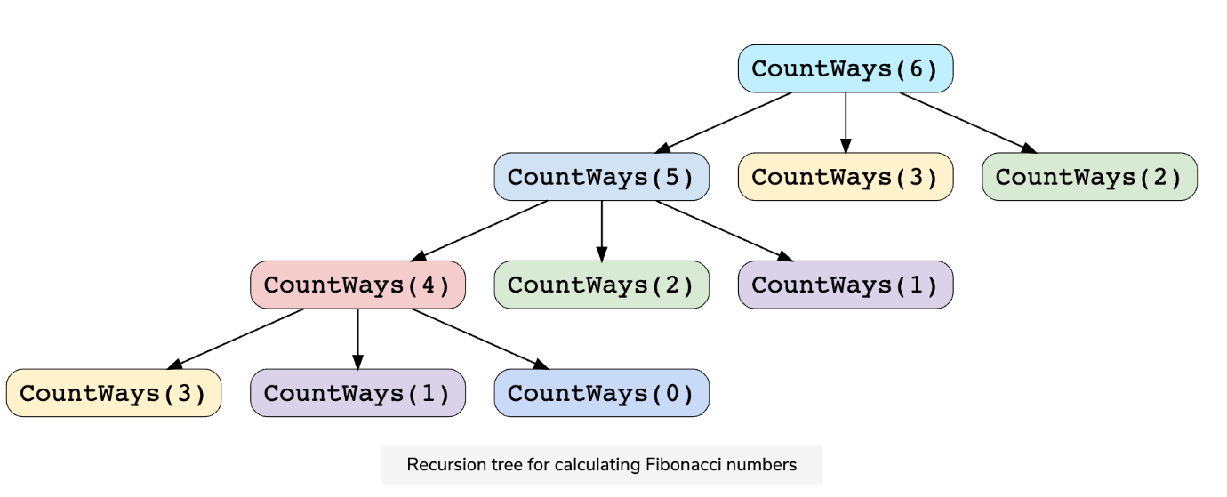](https://github.com/maazshaikh007/DSA_Patterns/blob/main/images/dpnumberfactors.png)

We can clearly see the *overlapping subproblems pattern*: CountWays(3), CountWays(2) and CountWays(1) have been called twice. We can optimize this using **memoization** to store the results for *subproblems*.

**Top-down Dynamic Programming with Memoization**

We can use an array to store the already solved *subproblems*. Here is the code:

function countWays(n) {

const dp = [];

function countWaysRecursive(n) {

//base case

if (n <= 2) return 1;

if (n === 3) return 2;

// if(typeod dp[n] === 'undefined'){

// if we subtract 1, we are left with 'n-1'

const subtract1 = countWaysRecursive(n - 1);

// if we subtract 3, we are left with 'n-3'

const subtract3 = countWaysRecursive(n - 3);

// if we subtract 4, we are left with 'n-4'

const subtract4 = countWaysRecursive(n - 4);

dp[n] = subtract1 + subtract3 + subtract4;

return dp[n];

}

return countWaysRecursive(n);

}

console.log(`Number of ways: ---> ${countWays(4)}`);

console.log(`Number of ways: ---> ${countWays(5)}`);

console.log(`Number of ways: ---> ${countWays(6)}`);

#### Java Solution

|  |
| --- |
| public int CountWaysMemoization(int n) {  int dp[] = new int[n + 1];  return CountWaysRecursive(dp, n);  }  public int CountWaysRecursive(int[] dp, int n) {  if (n == 0)  return 1; // base case, we don't need to subtract any thing, so there is only one way  if (n == 1)  return 1; // we can take subtract 1 to be left with zero, and that is the only way  if (n == 2)  return 1; // we can subtract 1 twice to get zero and that is the only way  if (n == 3)  return 2; // '3' can be expressed as {1,1,1}, {3}  if (dp[n] == 0) {  // if we subtract 1, we are left with 'n-1'  int subtract1 = CountWaysRecursive(dp, n - 1);  // if we subtract 3, we are left with 'n-3'  int subtract3 = CountWaysRecursive(dp, n - 3);  // if we subtract 4, we are left with 'n-4'  int subtract4 = CountWaysRecursive(dp, n - 4);  dp[n] = subtract1 + subtract3 + subtract4;  }  return dp[n];  } |

**Bottom-up Dynamic Programming**

Let’s try to populate our dp[] array from the above solution, working in a *bottom-up fashion*. As we saw in the above code, every CountWaysRecursive(n) is the sum of the three counts. We can use this fact to populate our array.

Here is the code for our **bottom-up dynamic programming approach**:

function countWays(n) {

const dp = [1, 1, 1, 2];

for (let i = 4; i <= n; i++) {

dp[i] = dp[i - 1] + dp[i - 3] + dp[i - 4];

}

return dp[n];

}

console.log(`Number of ways: ---> ${countWays(4)}`);

console.log(`Number of ways: ---> ${countWays(5)}`);

console.log(`Number of ways: ---> ${countWays(6)}`);

#### Java Solution

|  |
| --- |
| public int CountWays(int n) {  // bottom up  int n0 = 1, n1 = 1, n2 = 1, n3 = 2;  for(int i = 4; i <= n; i++){  int temp = n0 + n1 + n3;  n0 = n1;  n1 = n2;  n2 = n3;  n3 = temp;  }  return n3;  } |

The above solution has time and space complexity of O(n).

**Fibonacci number pattern**

We can clearly see that this problem follows the [**Fibonacci number pattern**](https://github.com/maazshaikh007/DSA_Patterns/blob/main/%E2%9C%85%20Pattern%2015:%200-1%20Knapsack%20(Dynamic%20Programming).md#fibonacci-number-pattern). However, every number in a **Fibonacci series** is the sum of the previous two numbers, whereas in this problem every count is a sum of previous three numbers: previous-1, previous-3, and previous-4. Here is the *recursive formula*for this problem:

countWays(n) = countWays(n-1) + countWays(n-3) + countWays(n-4),

for n >= 4

**🌴 Minimum jumps to reach the end**

<https://leetcode.com/problems/jump-game-ii/>

Given an array of positive numbers, where each element represents the max number of jumps that can be made forward from that element, write a program to find the minimum number of jumps needed to reach the end of the array (starting from the first element). If an element is 0, then we cannot move through that element.

**Example 1:**

Input = {2,1,1,1,4}

Output = 3

Explanation: Starting from index '0', we can reach the last index through: 0->2->3->4

**Example 2:**

Input = {1,1,3,6,9,3,0,1,3}

Output = 4

Explanation: Starting from index '0', we can reach the last index through: 0->1->2->3->8

Let’s first start with a **recursive brute-force solution**.

**Basic brute-force solution**

We will start with the 0th index and try all options. So, if the value at the current index is p, we will try every jump in the range (1 to p) from that index. After taking a jump, we *recursively* try all options from that index.

Here is the code:

#### Code

|  |
| --- |
| class Solution {  public int countMinJumps(int[] jumps) {  return this.countMinJumpsRecursive(jumps, 0);  }  private int countMinJumpsRecursive(int[] jumps, int currentIndex) {  // if we have reached the last index, we don't need any more jumps  if( currentIndex == jumps.length - 1)  return 0;  if (jumps[currentIndex] == 0)  return Integer.MAX_VALUE;  int totalJumps = Integer.MAX_VALUE;  int start = currentIndex + 1;  int end = currentIndex + jumps[currentIndex];  while(start < jumps.length && start <= end) {  // jump one step and recurse for the remaining array  int minJumps = countMinJumpsRecursive(jumps, start++);  if(minJumps != Integer.MAX_VALUE)  totalJumps = Math.min(totalJumps, minJumps + 1);  }  return totalJumps;  }  public static void main(String[] args) {  Solution aj = new Solution();  int[] jumps = {2, 1, 1, 1, 4};  System.out.println(aj.countMinJumps(jumps));  jumps = new int[]{1, 1, 3, 6, 9, 3, 0, 1, 3};  System.out.println(aj.countMinJumps(jumps));  }  } |

* The **time complexity** of the above algorithm is O(2ⁿ), where n is the size of the input array. The *while loop* can execute a maximum of n times (for the case where we can jump to all the steps ahead) and since in each iteration, the function *recursively calls* itself, therefore, the **time complexity** is O(2ⁿ). The **space complexity** is O(n) which is used to store the *recursion stack*.

We can clearly see the *overlapping subproblem pattern*. We can optimize this using **memoization** to store the results for *subproblems*.

**Top-down Dynamic Programming with Memoization**

We can use an array to store the already solved *subproblems*. Here is the code for this:

|  |
| --- |
| class Solution {  public int countMinJumps(int[] jumps) {  int dp[] = new int[jumps.length];  return this.countMinJumpsRecursive(dp, jumps, 0);  }  private int countMinJumpsRecursive(int[] dp, int[] jumps, int currentIndex) {  // if we have reached the last index, we don't need any more jumps  if( currentIndex == jumps.length - 1)  return 0;  // If an element is 0, then we cannot move through that element  if (jumps[currentIndex] == 0)  return Integer.MAX_VALUE;  // if we have already solved this problem, return the result  if(dp[currentIndex] != 0)  return dp[currentIndex];  int totalJumps = Integer.MAX_VALUE;  int start = currentIndex + 1;  int end = currentIndex + jumps[currentIndex];  while(start < jumps.length && start <= end) {  // jump one step and recurse for the remaining array  int minJumps = countMinJumpsRecursive(dp, jumps, start++);  if(minJumps != Integer.MAX_VALUE)  totalJumps = Math.min(totalJumps, minJumps + 1);  }  dp[currentIndex] = totalJumps;  return dp[currentIndex];  }  public static void main(String[] args) {  Solution aj = new Solution();  int[] jumps = {2, 1, 1, 1, 4};  System.out.println(aj.countMinJumps(jumps));  jumps = new int[]{1, 1, 3, 6, 9, 3, 0, 1, 3};  System.out.println(aj.countMinJumps(jumps));  }  } |

**Bottom-up Dynamic Programming**

Let’s try to populate our dp[] array from the above solution, working in the *bottom-up fashion*. As we saw in the above code, we were trying to find the minimum jumps needed to reach every index (if it is within the range) from the current index. We can use this fact to populate our array.

As we know, every index within the range of current index can be reached in one jump. Therefore, we can say that we can reach every index (within the range of current index) in:

'jumps to reach current index' + 1;

So, while going through all the indices, we will take the minimum value between the current jump-count and the jumps needed to reach the current index + 1.

Here is the code for our **bottom-up dynamic programming approach**:

function countMinJumps(jumps) {

const dp = Array(jumps.length).fill(Infinity);

dp[0] = 0;

for (let start = 0; start < jumps.length - 1; start++) {

for (

let end = start + 1;

end <= start + jumps[start] && end < jumps.length;

end++

) {

dp[end] = Math.min(dp[end], dp[start] + 1);

}

}

return dp[jumps.length - 1];

}

console.log(`Minimum jumps needed: ---> ${countMinJumps([2, 1, 1, 1, 4])}`);

console.log(

`Minimum jumps needed: ---> ${countMinJumps([1, 1, 3, 6, 9, 3, 0, 1, 3])}`

);

* The above solution has a **time complexity** of O(n²) (because of the two for loops) and **space complexity** of O(n) to store dp[].

#### Java Solution

|  |
| --- |
| class Solution {  public int countMinJumps(int[] jumps) {  int[] dp = new int[jumps.length];  //initialize with infinity, except the first index which should be zero as we start from there  for(int i=1; i<jumps.length; i++)  dp[i] = Integer.MAX_VALUE;  for(int start=0; start < jumps.length-1; start++) {  for(int end=start+1; end <= start+jumps[start] && end < jumps.length; end++)  dp[end] = Math.min(dp[end], dp[start]+1);  }  return dp[jumps.length-1];  }  public static void main(String[] args) {  Solution aj = new Solution();  int[] jumps = {2, 1, 1, 1, 4};  System.out.println(aj.countMinJumps(jumps));  jumps = new int[]{1, 1, 3, 6, 9, 3, 0, 1, 3};  System.out.println(aj.countMinJumps(jumps));  }  } |

#### Java Solution : O(n) SC

|  |
| --- |
| public int jump(int[] nums){  int jump = 0;  int pos = 0;  int des = 0;  for(int i =0; i< nums.length - 1; i++){  des = Math.max(des, nums[i]+i);  if(pos == i){  pos = des;  jump++;  }  }  return jump;  } |

**Fibonacci number pattern**

We can clearly see that this problem follows the [**Fibonacci number pattern**](https://github.com/maazshaikh007/DSA_Patterns/blob/main/%E2%9C%85%20Pattern%2015:%200-1%20Knapsack%20(Dynamic%20Programming).md#fibonacci-number-pattern). The only difference is that every **Fibonacci number** is a sum of the two preceding numbers, whereas in this problem every number is the minimum of two numbers (start and end):

dp[end] = Math.min(dp[end], dp[start] + 1);

## Minimum jumps with fee

<https://leetcode.com/problems/min-cost-climbing-stairs/>

### Problem Statement

Given a staircase with n steps and an array of n numbers representing the fee that you have to pay if you take the step. Implement a method to calculate the minimum fee required to reach the top of the staircase (beyond the top-most step). At every step, you have an option to take either 1 step, 2 steps, or 3 steps. You should assume that you are standing at the first step.

**Example 1:**

Number of stairs (n) : 6

Fee: {1,2,5,2,1,2}

Output: 3

Explanation: Starting from index '0', we can reach the top through: 0->3->top

The total fee we have to pay will be (1+2).

**Example 2:**

Number of stairs (n): 4

Fee: {2,3,4,5}

Output: 5

Explanation: Starting from index '0', we can reach the top through: 0->1->top

The total fee we have to pay will be (2+3).

Let’s first start with a **recursive brute-force solution**.

**Brute-Force Solution**

At every step, we have three options:

* either jump 1 step,
* 2 steps,
* or 3 steps.

So our algorithm will look like:

function findMinFee(fee) {

function findMinFeeRecursive(fee, currIndex) {

if (currIndex > fee.length - 1) return 0;

//if we take 1 step, we are left with n-1 steps

const take1Step = findMinFeeRecursive(fee, currIndex + 1);

//similarly, if we take 2 steps, we are left with n-2 steps

const take2Steps = findMinFeeRecursive(fee, currIndex + 2);

//if we take 3 steps, we are left with n-3 steps

const take3Steps = findMinFeeRecursive(fee, currIndex + 3);

const minCost = Math.min(take1Step, take2Steps, take3Steps);

return minCost + fee[currIndex];

}

return findMinFeeRecursive(fee, 0);

}

console.log(`Minimum fee needed: ---> ${findMinFee([1, 2, 5, 2, 1, 2])}`);

console.log(`Minimum fee needed: ---> ${findMinFee([2, 3, 4, 5])}`);

* The **time complexity** of the above algorithm is exponential O(3ⁿ). The **space complexity** is O(n) which is used to store the *recursion stack*.

#### Java Solution

|  |
| --- |
| private int findMinFeeRecursive(int[] fee, int currentIndex) {  if( currentIndex > fee.length - 1)  return 0;  // if we take 1 step, we are left with 'n-1' steps;  int take1Step = findMinFeeRecursive(fee, currentIndex + 1);  // similarly, if we took 2 steps, we are left with 'n-2' steps;  int take2Step = findMinFeeRecursive(fee, currentIndex + 2);  // if we took 3 steps, we are left with 'n-3' steps;  int take3Step = findMinFeeRecursive(fee, currentIndex + 3);  int min = Math.min(Math.min(take1Step, take2Step), take3Step);  return min + fee[currentIndex];  } |

**Top-down Dynamic Programming with Memoization**

To resolve *overlapping subproblems*, we can use an array to store the already solved subproblems. Here is the code:

function findMinFee(fee) {

const dp = [];

function findMinFeeRecursive(fee, currIndex) {

if (currIndex > fee.length - 1) return 0;

//if we take 1 step, we are left with n-1 steps

const take1Step = findMinFeeRecursive(fee, currIndex + 1);

//similarly, if we take 2 steps, we are left with n-2 steps

const take2Steps = findMinFeeRecursive(fee, currIndex + 2);

//if we take 3 steps, we are left with n-3 steps

const take3Steps = findMinFeeRecursive(fee, currIndex + 3);

dp[currIndex] =

Math.min(take1Step, take2Steps, take3Steps) + fee[currIndex];

return dp[currIndex];

}

return findMinFeeRecursive(fee, 0);

}

console.log(`Minimum fee needed: ---> ${findMinFee([1, 2, 5, 2, 1, 2])}`);

console.log(`Minimum fee needed: ---> ${findMinFee([2, 3, 4, 5])}`);

#### Java Solution

|  |
| --- |
| public int findMinFee(int[] fee) {  int dp[] = new int[fee.length];  return findMinFeeRecursive(dp, fee, 0);  }    private int findMinFeeRecursive(int[] dp, int[] fee, int currentIndex) {  if( currentIndex > fee.length - 1)  return 0;  if(dp[currentIndex] == 0) {  // if we take 1 step, we are left with 'n-1' steps;  int take1Step = findMinFeeRecursive(dp, fee, currentIndex + 1);  // similarly, if we took 2 steps, we are left with 'n-2' steps;  int take2Step = findMinFeeRecursive(dp, fee, currentIndex + 2);  // if we took 3 steps, we are left with 'n-3' steps;  int take3Step = findMinFeeRecursive(dp, fee, currentIndex + 3);    dp[currentIndex] = fee[currentIndex] + Math.min(Math.min(take1Step, take2Step), take3Step);  }  return dp[currentIndex];  } |

**Bottom-up Dynamic Programming**

Let’s try to populate our dp[] array from the above solution, working in a *bottom-up fashion*. As we saw in the above code, every findMinFeeRecursive(n) is the minimum of the three *recursive calls*; we can use this fact to populate our array.

Here is the code for our **bottom-up dynamic programming approach**:

function findMinFee(fee) {

const dp = Array(fee.length + 1).fill(0);

// if there are no steps, we dont have to pay any fee

// only one step, so we have to pay its fee

dp[1] = fee[0];

// for 2 steps, since we start from the first step, so we have to pay its fee

dp[2] = fee[0];

// and from the first step we can reach the top by taking two steps, so

// we dont have to pay any other fee.

//please note that dp[] has one extra element to handle the 0th step

for (let i = 2; i < fee.length; i++) {

dp[i + 1] = Math.min(

fee[i] + dp[i],

fee[i - 1] + dp[i - 1],

fee[i - 2] + dp[i - 2]

);

}

return dp[fee.length];

}

console.log(`Minimum fee needed: ---> ${findMinFee([1, 2, 5, 2, 1, 2])}`);

console.log(`Minimum fee needed: ---> ${findMinFee([2, 3, 4, 5])}`);

* The above solution has **time and space complexity** of O(n).

#### Java Solution

|  |
| --- |
| public int findMinFee(int[] fee) {  int dp[] = new int[fee.length + 1]; // +1 to handle the 0th step  dp[0] = 0; // if there are no steps, we dont have to pay any fee  dp[1] = fee[0]; // only one step, so we have to pay its fee  // for 2 or 3 steps staircase, since we start from the first step so we have to pay its fee  // and from the first step we can reach the top by taking two or three steps, so we don't  // have to pay any other fee.  dp[2] = dp[3] = fee[0];  for (int i = 3; i < fee.length; i++)  dp[i + 1] = Math.min(fee[i] + dp[i], Math.min(fee[i - 1] + dp[i - 1], fee[i - 2] + dp[i - 2]));  return dp[fee.length];  } |

**Fibonacci number pattern**

We can clearly see that this problem follows the [**Fibonacci number pattern**](https://github.com/maazshaikh007/DSA_Patterns/blob/main/%E2%9C%85%20Pattern%2015:%200-1%20Knapsack%20(Dynamic%20Programming).md#fibonacci-number-pattern). The only difference is that every **Fibonacci number** is a sum of the two preceding numbers, whereas in this problem every number (total fee) is the minimum of previous three numbers.

**🌴 🔎 👩🏽‍🦯 House thief**

<https://leetcode.com/problems/house-robber/>

There are n houses built in a line. A thief wants to steal the maximum possible money from these houses. The only restriction the thief has is that he can’t steal from two consecutive houses, as that would alert the security system. How should the thief maximize his stealing?

Given a number array representing the wealth of n houses, determine the maximum amount of money the thief can steal without alerting the security system.

**Example 1:**

Input: {2, 5, 1, 3, 6, 2, 4}

Output: 15

Explanation: The thief should steal from houses 5 + 6 + 4

**Example 2:**

Input: {2, 10, 14, 8, 1}

Output: 18

Explanation: The thief should steal from houses 10 + 8

Let’s first start with a **recursive brute-force solution**.

**Brute-Force Solution**

For every house i, we have two options:

1. Steal from the current house i, skip one and steal from i+2.
2. Skip the current house i, and steal from the adjacent house i+1.

The thief should choose the one with the maximum amount from the above two options. So our algorithm will look like this:

function findMaxSteal(wealth) {

function findMaxStealRecursive(wealth, currIndex) {

if (currIndex >= wealth.length) return 0;

//steal from the current house and skip one to steal from the next house

const stealCurr =

wealth[currIndex] + findMaxStealRecursive(wealth, currIndex + 2);

//skip current house to steal from the adjacent house

const skipCurr = findMaxStealRecursive(wealth, currIndex + 1);

return Math.max(stealCurr, skipCurr);

}

return findMaxStealRecursive(wealth, 0);

}

console.log(`Maximum stealing: ---> ${findMaxSteal([2, 5, 1, 3, 6, 2, 4])}`);

console.log(`Maximum stealing: ---> ${findMaxSteal([2, 10, 14, 8, 1])}`);

* The **time complexity** of the above algorithm is exponential O(2ⁿ). The **space complexity** is O(n) which is used to store the *recursion stack*.

#### Java solution

|  |
| --- |
| public int findMaxSteal(int[] wealth) {  return findMaxStealRecursive(wealth, 0);  }  private int findMaxStealRecursive(int[] wealth, int currentIndex) {  if( currentIndex >= wealth.length)  return 0;  // steal from current house and skip one to steal from the next house  int stealCurrent = wealth[currentIndex] + findMaxStealRecursive(wealth, currentIndex + 2);  // skip current house to steel from the adjacent house  int skipCurrent = findMaxStealRecursive(wealth, currentIndex + 1);  return Math.max(stealCurrent, skipCurrent);  } |

**Top-down Dynamic Programming with Memoization**

To resolve *overlapping subproblems*, we can use an array to store the already solved *subproblems*.

function findMaxSteal(wealth) {

const dp = [];

function findMaxStealRecursive(wealth, currIndex) {

if (currIndex >= wealth.length) return 0;

//steal from the current house and skip one to steal from the next house

const stealCurr =

wealth[currIndex] + findMaxStealRecursive(wealth, currIndex + 2);

//skip current house to steal from the adjacent house

const skipCurr = findMaxStealRecursive(wealth, currIndex + 1);

dp[currIndex] = Math.max(stealCurr, skipCurr);

return dp[currIndex];

}

return findMaxStealRecursive(wealth, 0);

}

console.log(`Maximum stealing: ---> ${findMaxSteal([2, 5, 1, 3, 6, 2, 4])}`);

console.log(`Maximum stealing: ---> ${findMaxSteal([2, 10, 14, 8, 1])}`);

#### Java Solution

|  |
| --- |
| public int findMaxSteal(int[] wealth) {  int dp[] = new int[wealth.length];  return findMaxStealRecursive(dp, wealth, 0);  }  private int findMaxStealRecursive(int[] dp, int[] wealth, int currentIndex) {  if( currentIndex >= wealth.length)  return 0;  if(dp[currentIndex] == 0) {  // steal from current house and skip one to steal next  int stealCurrent = wealth[currentIndex] + findMaxStealRecursive(dp, wealth, currentIndex + 2);  // skip current house to steel from the adjacent house  int skipCurrent = findMaxStealRecursive(dp, wealth, currentIndex + 1);  dp[currentIndex] = Math.max(stealCurrent, skipCurrent);  }  return dp[currentIndex];  } |

**Bottom-up Dynamic Programming**

Let’s try to populate our dp[] array from the above solution, working in a *bottom-up fashion*. As we saw in the above code, every findMaxStealRecursive() is the maximum of the two *recursive calls*; we can use this fact to populate our array.

Here is the code for our **bottom-up dynamic programming approach**:

function findMaxSteal(wealth) {

//+1 to handle the 0 index house

const dp = Array(wealth.length + 1).fill(0);

//if there are no houses, the thief can't steal anything

//only one house, so the thief will only be able to steal from that single house

dp[1] = wealth[1];

//please note that dp[] has one extra to handle house zero

for (let i = 1; i < wealth.length; i++) {

dp[i + 1] = Math.max(wealth[i] + dp[i - 1], dp[i]);

}

return dp[wealth.length];

}

console.log(`Maximum stealing: ---> ${findMaxSteal([2, 5, 1, 3, 6, 2, 4])}`);

console.log(`Maximum stealing: ---> ${findMaxSteal([2, 10, 14, 8, 1])}`);

* The above solution has **time and space complexity** of O(n).

#### Java solution

|  |
| --- |
| public int findMaxSteal(int[] wealth) {  if(wealth.length == 0) return 0;  int dp[] = new int[wealth.length+1]; // '+1' to handle the zero house  dp[0] = 0; // if there are no houses, the thief can't steal anything  dp[1] = wealth[0]; // only one house, so the thief have to steal from it  // please note that dp[] has one extra element to handle zero house  for(int i=1; i < wealth.length; i++)  dp[i+1] = Math.max(wealth[i] + dp[i-1], dp[i]);  return dp[wealth.length];  } |

**Memory optimization**

We can optimize the space used in our previous solution. We don’t need to store all the previous numbers up to n, as we only need two previous numbers to calculate the next number in the **sequence**. Let’s use this fact to further improve our solution:

function findMaxSteal(wealth) {

if (wealth.length === 0) return 0;

let house1 = 0;

let house2 = wealth[0];

for (let i = 1; i < wealth.length; i++) {

[house1, house2] = [house2, Math.max(house1 + wealth[i], house2)];

}

return house2;

}

console.log(`Maximum stealing: ---> ${findMaxSteal([2, 5, 1, 3, 6, 2, 4])}`);

console.log(`Maximum stealing: ---> ${findMaxSteal([2, 10, 14, 8, 1])}`);

* The above solution has a **time complexity** of O(n) and a constant **space complexity** O(1).

#### Java Solution

|  |
| --- |
| public int findMaxSteal(int[] wealth) {  if(wealth.length == 0) return 0;  int n1=0, n2=wealth[0], temp;  for(int i=1; i < wealth.length; i++) {  temp = Math.max(n1 + wealth[i], n2);  n1 = n2;  n2 = temp;  }  return n2;  } |

**Fibonacci number pattern**

We can clearly see that this problem follows the [**Fibonacci number pattern**](https://github.com/maazshaikh007/DSA_Patterns/blob/main/%E2%9C%85%20Pattern%2015:%200-1%20Knapsack%20(Dynamic%20Programming).md#fibonacci-number-pattern). The only difference is that every **Fibonacci number** is a sum of the two preceding numbers, whereas in this problem every number (total wealth) is the maximum of previous two numbers.

**Pattern 4: Palindromic Subsequence**

**Problem Set**

1. [Longest Palindromic Subsequence](https://github.com/maazshaikh007/DSA_Patterns/blob/main/%E2%9C%85%20Pattern%2015:%200-1%20Knapsack%20(Dynamic%20Programming).md#longest-palindromic-subsequence)
2. [👩🏽‍🦯 🌴 Longest Palindromic Substring](https://github.com/maazshaikh007/DSA_Patterns/blob/main/%E2%9C%85%20Pattern%2015:%200-1%20Knapsack%20(Dynamic%20Programming).md#%F0%9F%91%A9%F0%9F%8F%BD%E2%80%8D%F0%9F%A6%AF-%F0%9F%8C%B4-longest-palindromic-substring)
3. [👩🏽‍🦯 Count of Palindromic Substrings](https://github.com/maazshaikh007/DSA_Patterns/blob/main/%E2%9C%85%20Pattern%2015:%200-1%20Knapsack%20(Dynamic%20Programming).md#%F0%9F%91%A9%F0%9F%8F%BD%E2%80%8D%F0%9F%A6%AF-count-of-palindromic-substrings)
4. [🔎 Minimum Deletions in a String to make it a Palindrome](https://github.com/maazshaikh007/DSA_Patterns/blob/main/%E2%9C%85%20Pattern%2015:%200-1%20Knapsack%20(Dynamic%20Programming).md#%F0%9F%94%8E-minimum-deletions-in-a-string-to-make-it-a-palindrome)
5. [Minimum insertions in a string to make it a palindrome](https://github.com/maazshaikh007/DSA_Patterns/blob/main/%E2%9C%85%20Pattern%2015:%200-1%20Knapsack%20(Dynamic%20Programming).md#1-minimum-insertions-in-a-string-to-make-it-a-palindrome)
6. [Find if a string is K-Palindromic](https://github.com/maazshaikh007/DSA_Patterns/blob/main/%E2%9C%85%20Pattern%2015:%200-1%20Knapsack%20(Dynamic%20Programming).md#2-find-if-a-string-is-k-palindromic)
7. [Palindromic Partitioning](https://github.com/maazshaikh007/DSA_Patterns/blob/main/%E2%9C%85%20Pattern%2015:%200-1%20Knapsack%20(Dynamic%20Programming).md#palindromic-partitioning)

**Longest Palindromic Subsequence**

<https://leetcode.com/problems/longest-palindromic-subsequence/>

Given a **sequence**, find the length of its **Longest Palindromic Subsequence (LPS)**. In a **palindromic subsequence**, *elements read the same backward and forward*.

A **subsequence** is a *sequence* that can be derived from another *sequence* by *deleting some or no elements without changing the order of the remaining elements*.

**Example 1:**

Input: "abdbca"

Output: 5

Explanation: LPS is "abdba".

**Example 2:**

Input: = "cddpd"

Output: 3

Explanation: LPS is "ddd".

**Example 3:**

Input: = "pqr"

Output: 1

Explanation: LPS could be "p", "q" or "r".

**Basic Brute-Force Solution**

A **basic brute-force solution** could be to try all the **subsequences** of the given *sequence*. We can start processing from the beginning and the end of the *sequence*. So at any step, we have two options:

1. If the element at the beginning and the end are the same, we increment our count by two and make a recursive call for the remaining *sequence*.
2. We will skip the element either from the beginning or the end to make two recursive calls for the remaining **subsequence**.

If option one applies then it will give us the length of **LPS**; otherwise, the length of **LPS** will be the maximum number returned by the two recurse calls from the second option.

Here is the code:

function findLPSLength(str) {

function findLPSLengthRecursive(str, startIndex, endIndex) {

//base checks

if (startIndex > endIndex) return 0;

//every sequence with 1 element is a palindrome with length of 1

if (startIndex === endIndex) return 1;

//case 1: elements ar the start and end are the same

if (str[startIndex] === str[endIndex]) {

return 2 + findLPSLengthRecursive(str, startIndex + 1, endIndex - 1);

}

//case 2: skip one element either from the start or end

let startSkip = findLPSLengthRecursive(str, startIndex + 1, endIndex);

let endSkip = findLPSLengthRecursive(str, startIndex, endIndex - 1);

return Math.max(startSkip, endSkip);

}

return findLPSLengthRecursive(str, 0, str.length - 1);

}

findLPSLength('abdbca');

// Output: 5

// Explanation: LPS is "abdba".

findLPSLength('cddpd');

// Output: 3

// Explanation: LPS is "ddd".

findLPSLength('pqr');

// Output: 1

// Explanation: LPS could be "p", "q" or "r".

* In each function call, we are either having one *recursive call* or *two recursive calls* (we will never have *three recursive calls*); hence, the **time complexity** of the above algorithm is exponential O(2ⁿ), where n is the length of the input *sequence*. The **space complexity** is O(n), which is used to store the *recursion stack*.

#### Java Solution

|  |
| --- |
| public int findLPSLength(String st) {  return findLPSLengthRecursive(st, 0, st.length()-1);  }  private int findLPSLengthRecursive(String st, int startIndex, int endIndex) {  if(startIndex > endIndex)  return 0;  // every sequence with one element is a palindrome of length 1  if(startIndex == endIndex)  return 1;  // case 1: elements at the beginning and the end are the same  if(st.charAt(startIndex) == st.charAt(endIndex))  return 2 + findLPSLengthRecursive(st, startIndex+1, endIndex-1);  // case 2: skip one element either from the beginning or the end  int c1 = findLPSLengthRecursive(st, startIndex+1, endIndex);  int c2 = findLPSLengthRecursive(st, startIndex, endIndex-1);  return Math.max(c1, c2);  } |

**Top-down Dynamic Programming with Memoization**

We can use an array to store the already solved *subproblems*.

The two changing values to our recursive function are the two indices, startIndex and endIndex. Therefore, we can store the results of all the *subproblems* in a two-dimensional array. (Another alternative could be to use a *hash-table* whose key would be a string (startIndex + “|” + endIndex))

Here is the code for this:

function findLPSLength(str) {

const dp = [];

function findLPSLengthRecursive(str, startIndex, endIndex) {

//base checks

if (startIndex > endIndex) return 0;

//every sequence with 1 element is a palindrome with length of 1

if (startIndex === endIndex) return 1;

dp[startIndex] = dp[startIndex] || [];

//case 1: elements ar the start and end are the same

if (str[startIndex] === str[endIndex]) {

dp[startIndex][endIndex] =

2 + findLPSLengthRecursive(str, startIndex + 1, endIndex - 1);

} else {

//case 2: skip one element either from the start or end

let startSkip = findLPSLengthRecursive(str, startIndex + 1, endIndex);

let endSkip = findLPSLengthRecursive(str, startIndex, endIndex - 1);

dp[startIndex][endIndex] = Math.max(startSkip, endSkip);

}

// console.log(dp)

return dp[startIndex][endIndex];

}

return findLPSLengthRecursive(str, 0, str.length - 1);

}

findLPSLength('abdbca');

// Output: 5

// Explanation: LPS is "abdba".

findLPSLength('cddpd');

// Output: 3

// Explanation: LPS is "ddd".

findLPSLength('pqr');

// Output: 1

// Explanation: LPS could be "p", "q" or "r".

* Since our **memoization** array dp[str.length][str.length] stores the results for all the *subproblems*, we can conclude that we will not have more than N*N *subproblems*(where N is the length of the input *sequence*). This means that our time complexity will be O(N²).
* The above algorithm will be using O(N²) **space** for the **memoization** array. Other than that we will use O(N) **space** for the *recursion call-stack*. So the total **space complexity** will be O(N² + N), which is *asymptotically* equivalent to O(N²).

#### Java Solution

|  |
| --- |
| public int findLPSLength(String st) {  Integer[][] dp = new Integer[st.length()][st.length()];  return findLPSLengthRecursive(dp, st, 0, st.length()-1);  }  private int findLPSLengthRecursive(Integer[][] dp, String st, int startIndex, int endIndex) {  if(startIndex > endIndex)  return 0;  // every sequence with one element is a palindrome of length 1  if(startIndex == endIndex)  return 1;  if(dp[startIndex][endIndex] == null) {  // case 1: elements at the beginning and the end are the same  if(st.charAt(startIndex) == st.charAt(endIndex)) {  dp[startIndex][endIndex] = 2 + findLPSLengthRecursive(dp, st, startIndex+1, endIndex-1);  } else {  // case 2: skip one element either from the beginning or the end  int c1 = findLPSLengthRecursive(dp, st, startIndex+1, endIndex);  int c2 = findLPSLengthRecursive(dp, st, startIndex, endIndex-1);  dp[startIndex][endIndex] = Math.max(c1, c2);  }  }  return dp[startIndex][endIndex];  } |

**Bottom-up Dynamic Programming**

Since we want to try all the **subsequences** of the given *sequence*, we can use a two-dimensional array to store our results. We can start from the beginning of the *sequence* and keep adding one element at a time. At every step, we will try all of its **subsequences**. So for every startIndex and endIndex in the given string, we will choose one of the following two options:

1. If the element at the startIndex matches the element at the endIndex, the length of **LPS** would be two plus the length of **LPS** until startIndex+1 and endIndex-1.
2. If the element at the startIndex does not match the element at the endIndex, we will take the maximum **LPS** created by either skipping element at the startIndex or the endIndex.

So our *recursive formula*would be:

**if st[endIndex] == st[startIndex]**

**dp[startIndex][endIndex] = 2 + dp[startIndex + 1][endIndex - 1]**

**else**

**dp[startIndex][endIndex] = Math.max(dp[startIndex + 1][endIndex], dp[startInde[endIndex - 1])**

Let's draw this visually for "cddpd", starting with a subsequence of length '1'. As we know, every sequence with one element is a palindrome of length 1:

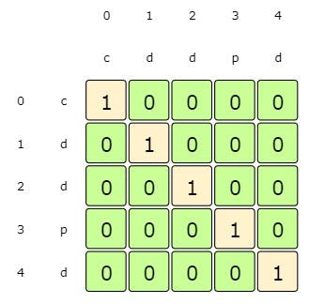

Every sequence with one element is a palindrome of length 1

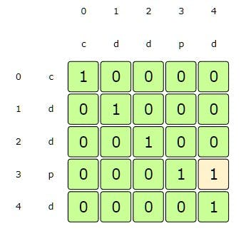

startIndex:3, endIndex:4 => st[startIndex] !=st[endIndex], so dp[startIndex][endIndex] = max(dp[startIndex + 1][endIndex], dp[startIndex][endIndex - 1])

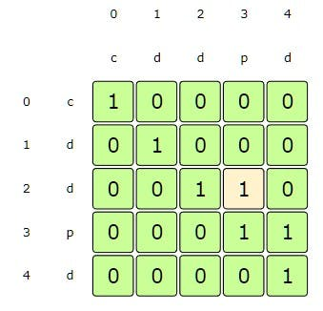

startIndex:2, endIndex:3 => st[startIndex] !=st[endIndex], so dp[startIndex][endIndex] = max(dp[startIndex + 1][endIndex], dp[startIndex][endIndex - 1])

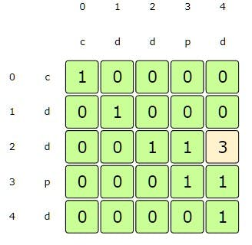

startIndex:2, endIndex:4 => st[startIndex] ==st[endIndex], so dp[startIndex][endIndex] = 2 + dp[startIndex + 1][endIndex - 1]

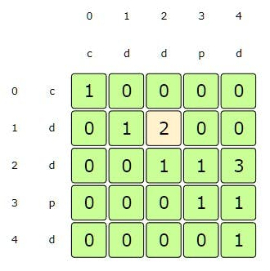

startIndex:1, endIndex:2 => st[startIndex] ==st[endIndex], so dp[startIndex][endIndex] = 2 + dp[startIndex + 1][endIndex - 1]

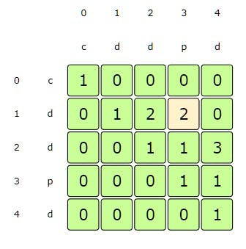

startIndex:1, endIndex:3 => st[startIndex] !=st[endIndex], so dp[startIndex][endIndex] = max(dp[startIndex + 1][endIndex], dp[startIndex][endIndex - 1])

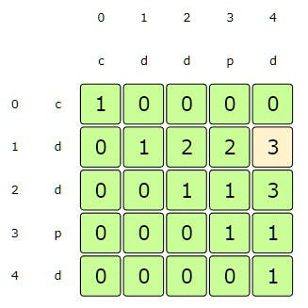

startIndex:1, endIndex:4 => st[startIndex] ==st[endIndex], so dp[startIndex][endIndex] = 2 + dp[startIndex + 1][endIndex - 1]

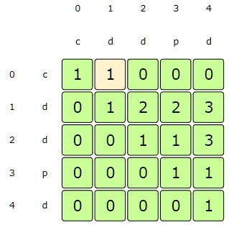

startIndex:0, endIndex:1 => st[startIndex] !=st[endIndex], so dp[startIndex][endIndex] = max(dp[startIndex + 1][endIndex], dp[startIndex][endIndex - 1])

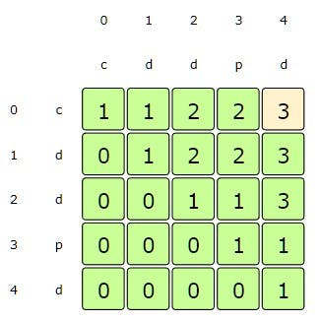

startIndex:0, endIndex:4 => st[startIndex] !=st[endIndex], so dp[startIndex][endIndex] = max(dp[startIndex + 1][endIndex], dp[startIndex][endIndex - 1])

From the above visualization, we can clearly see that the length of LPS is '3' as shown by dp[0][4].

Here is the code for our **bottom-up dynamic programming approach**:

function findLPSLength(str) {

//dp[i][j] stores the length of LPS from index start to end

const dp = Array(str.length)

.fill(0)

.map(() => Array(str.length).fill(0));

//every sequence with 1 element is a palindrome with length of 1

for (let start = 0; start < str.length; start++) {

dp[start][start] = 1;

}

for (let startIndex = str.length - 1; startIndex >= 0; startIndex--) {

for (let endIndex = startIndex + 1; endIndex < str.length; endIndex++) {

//case 1: elements ar the start and end are the same

if (str.charAt(startIndex) === str.charAt(endIndex)) {

dp[startIndex][endIndex] = 2 + dp[startIndex + 1][endIndex - 1];

} else {

//case 2: skip one element either from the start or end

dp[startIndex][endIndex] = Math.max(

dp[startIndex + 1][endIndex],

dp[startIndex][endIndex - 1]

);

}

}

}

return dp[0][str.length - 1];

}

console.log('Length of LPS ---> ' + findLPSLength('abdbca'));

// Output: 5

// Explanation: LPS is "abdba".

console.log('Length of LPS ---> ' + findLPSLength('cddpd'));

// Output: 3

// Explanation: LPS is "ddd".

console.log('Length of LPS ---> ' + findLPSLength('pqr'));

// Output: 1

// Explanation: LPS could be "p", "q" or "r".

#### Java Solution

|  |
| --- |
| public int findLPSLength(String st) {  // dp[i][j] stores the length of LPS from index 'i' to index 'j'  int[][] dp = new int[st.length()][st.length()];  // every sequence with one element is a palindrome of length 1  for (int i = 0; i < st.length(); i++)  dp[i][i] = 1;  for (int startIndex = st.length() - 1; startIndex >= 0; startIndex--) {  for (int endIndex = startIndex + 1; endIndex < st.length(); endIndex++) {  // case 1: elements at the beginning and the end are the same  if (st.charAt(startIndex) == st.charAt(endIndex)) {  dp[startIndex][endIndex] = 2 + dp[startIndex + 1][endIndex - 1];  } else { // case 2: skip one element either from the beginning or the end  dp[startIndex][endIndex] = Math.max(dp[startIndex + 1][endIndex], dp[startIndex][endIndex - 1]);  }  }  }  return dp[0][st.length() - 1];  } |

* The **time and space complexity** of the above algorithm is O(n²), where n is the length of the input *sequence*.

**👩🏽‍🦯 🌴 Longest Palindromic Substring**

<https://leetcode.com/problems/longest-palindromic-substring/>

Given a string, find the length of its **Longest Palindromic Substring (LPS)**. In a *palindromic* string, *elements read the same backward and forward*.

**Example 1:**

Input: "abdbca"

Output: 3

Explanation: LPS is "bdb".

**Example 2:**

Input: = "cddpd"

Output: 3

Explanation: LPS is "dpd".

**Example 3:**

Input: = "pqr"

Output: 1

Explanation: LPS could be "p", "q" or "r".

**Basic Brute-Force Solution**

This problem follows the [**Longest Palindromic Subsequence pattern**](https://github.com/maazshaikh007/DSA_Patterns/blob/main/%E2%9C%85%20Pattern%2015:%200-1%20Knapsack%20(Dynamic%20Programming).md#pattern-4-palindromic-subsequence). The only difference is that in a *palindromic subsequence* characters can be non-adjacent, whereas in a *substring* all characters should form a *palindrome*. We will follow a similar approach though.

The **basic brute-force solution** will be to try all the *substrings* of the given string. We can start processing from the beginning and the end of the string. So at any step, we will have two options:

1. If the element at the beginning and the end are the same, we make a *recursive call* to check if the remaining *substring* is also a *palindrome*. If so, the *substring* is a *palindrome* from beginning to end.
2. We will skip either the element from the beginning or the end to make two *recursive calls* for the remaining *substring*. The length of **LPS** would be the maximum of these two *recursive calls*.

Here is the code:

function findLPSLength(str) {

function findLPSLengthRecursive(str, startIndex, endIndex) {

//base check

if (startIndex > endIndex) return 0;

//every string with one character is a palindrome

if (startIndex === endIndex) return 1;

//case 1: elements at the start and the end are the same

if (str[startIndex] === str[endIndex]) {

const remainingLength = endIndex - startIndex - 1;

//check if the remaining string is also a palindrom

if (

remainingLength ===

findLPSLengthRecursive(str, startIndex + 1, endIndex - 1)

) {

return remainingLength + 2;

}

}

//case 2: skip one character either from the start or end

const skipStartChar = findLPSLengthRecursive(str, startIndex + 1, endIndex);

const skipEndChar = findLPSLengthRecursive(str, startIndex, endIndex - 1);

return Math.max(skipStartChar, skipEndChar);

}

return findLPSLengthRecursive(str, 0, str.length - 1);

}

console.log('Length of LPS ---> ' + findLPSLength('abdbca'));

// Output: 3

// Explanation: LPS is "bdb".

console.log('Length of LPS ---> ' + findLPSLength('cddpd'));

// Output: 3

// Explanation: LPS is "dpd".

console.log('Length of LPS ---> ' + findLPSLength('pqr'));

// Output: 1

// Explanation: LPS could be "p", "q" or "r".

#### Java Solution

|  |
| --- |
| public int findLPSLength(String st) {  return findLPSLengthRecursive(st, 0, st.length() - 1);  }  private int findLPSLengthRecursive(String st, int startIndex, int endIndex) {  if (startIndex > endIndex)  return 0;  // every string with one character is a palindrome  if (startIndex == endIndex)  return 1;  // case 1: elements at the beginning and the end are the same  if (st.charAt(startIndex) == st.charAt(endIndex)) {  int remainingLength = endIndex - startIndex - 1;  // check if the remaining string is also a palindrome  if (remainingLength == findLPSLengthRecursive(st, startIndex + 1, endIndex - 1))  return remainingLength + 2;  }  // case 2: skip one character either from the beginning or the end  int c1 = findLPSLengthRecursive(st, startIndex + 1, endIndex);  int c2 = findLPSLengthRecursive(st, startIndex, endIndex - 1);  return Math.max(c1, c2);  } |

* Due to the three **recursive calls**, the **time complexity** of the above algorithm is exponential O(3ⁿ), where n is the length of the input string.
* The **space complexity** is O(n) which is used to store the **recursion stack**.

**Top-down Dynamic Programming with Memoization**

We can use an array to store the already solved *subproblems*.

The two changing values to our **recursive function** are the two indices, startIndex and endIndex. Therefore, we can store the results of all the *subproblems* in a two-dimensional array. (Another alternative could be to use a *hash-table* whose key would be a string (startIndex + “|” + endIndex))

Here is the code for this:

function findLPSLength(str) {

const dp = [];

function findLPSLengthRecursive(str, startIndex, endIndex) {

//base check

if (startIndex > endIndex) return 0;

//every string with one character is a palindrome

if (startIndex === endIndex) return 1;

dp[startIndex] = dp[startIndex] || [];

//case 1: elements at the start and the end are the same

if (str[startIndex] === str[endIndex]) {

const remainingLength = endIndex - startIndex - 1;

//check if the remaining string is also a palindrom

if (

remainingLength ===

findLPSLengthRecursive(str, startIndex + 1, endIndex - 1)

) {

dp[startIndex][endIndex] = remainingLength + 2;

return dp[startIndex][endIndex];

}

}

//case 2: skip one character either from the start or end

const skipStartChar = findLPSLengthRecursive(str, startIndex + 1, endIndex);

const skipEndChar = findLPSLengthRecursive(str, startIndex, endIndex - 1);

dp[startIndex][endIndex] = Math.max(skipStartChar, skipEndChar);

return dp[startIndex][endIndex];

}

return findLPSLengthRecursive(str, 0, str.length - 1);

}

console.log('Length of LPS ---> ' + findLPSLength('abdbca'));

// Output: 3

// Explanation: LPS is "bdb".

console.log('Length of LPS ---> ' + findLPSLength('cddpd'));

// Output: 3

// Explanation: LPS is "dpd".

console.log('Length of LPS ---> ' + findLPSLength('pqr'));

// Output: 1

// Explanation: LPS could be "p", "q" or "r".

#### Java Solution

|  |
| --- |
| public int findLPSLength(String st) {  Integer[][] dp = new Integer[st.length()][st.length()];  return findLPSLengthRecursive(dp, st, 0, st.length() - 1);  }  private int findLPSLengthRecursive(Integer[][] dp, String st, int startIndex, int endIndex) {  if (startIndex > endIndex)  return 0;  // every string with one character is a palindrome  if (startIndex == endIndex)  return 1;  if (dp[startIndex][endIndex] == null) {  // case 1: elements at the beginning and the end are the same  if (st.charAt(startIndex) == st.charAt(endIndex)) {  int remainingLength = endIndex - startIndex - 1;  // check if the remaining string is also a palindrome  if (remainingLength == findLPSLengthRecursive(dp, st, startIndex + 1, endIndex - 1)) {  dp[startIndex][endIndex] = remainingLength + 2;  return dp[startIndex][endIndex];  }  }  // case 2: skip one character either from the beginning or the end  int c1 = findLPSLengthRecursive(dp, st, startIndex + 1, endIndex);  int c2 = findLPSLengthRecursive(dp, st, startIndex, endIndex - 1);  dp[startIndex][endIndex] = Math.max(c1, c2);  }  return dp[startIndex][endIndex];  } |

* The above algorithm has a **time and space complexity** of O(n²) because we will not have more than n∗n *subproblems*.

**Bottom-up Dynamic Programming**

Since we want to try all the *substrings* of the given string, we can use a two-dimensional array to store the *subproblems’* results. So dp[i][j] will be true if the *substring* from index i to index j is a *palindrome*.

We can start from the beginning of the string and keep adding one element at a time. At every step, we will try all of its *substrings*. So for every endIndex and startIndex in the given string, we need to check the following thing:

* If the element at the startIndex matches the element at the endIndex, we will further check if the remaining *substring* (from startIndex+1 to endIndex-1) is a *substring* too.

So our *recursive* formula will look like:

**if st[startIndex] == st[endIndex], and**

**if the remaing string is of zero length or dp[startIndex+1][endIndex-1] is a palindrome then**

**dp[startIndex][endIndex] = true**

Let's draw this visually for "cddpd", starting with a substring of length '1'. As we know, every substring with one element is a palindrome:

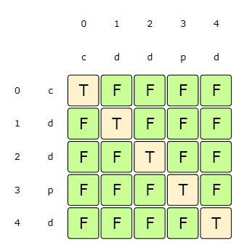

Every string with one element is a palindrome

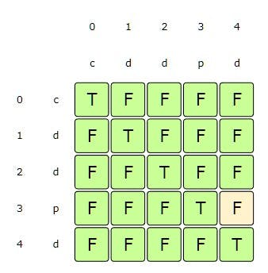

startIndex:3, endIndex:4 => since st[startIndex] != st[endIndex] => false

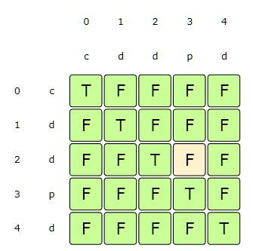

startIndex:2, endIndex:3 => since st[startIndex] != st[endIndex] => false

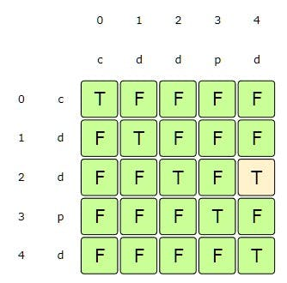

startIndex:2, endIndex:4 => since st[startIndex] == st[endIndex] and dp[startIndex+1][endIndex-1] is true => true

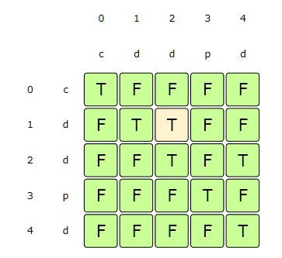

startIndex:1, endIndex:2 => since st[startIndex] == st[endIndex] and it is a two character string => true

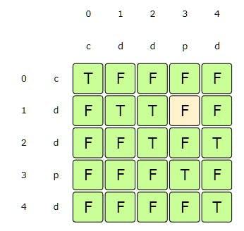

startIndex:1, endIndex:3 => since st[startIndex] != st[endIndex] => false

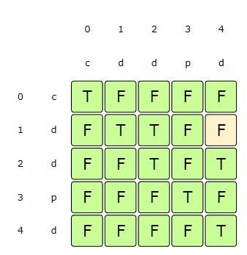

startIndex:1, endIndex:4 => since st[startIndex] == st[endIndex] but dp[startIndex+1][endIndex-1] is false => false

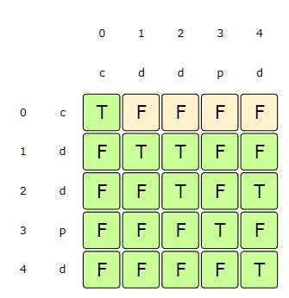

startIndex:0, endIndex:1-4 => since st[startIndex] != st[endIndex] => false

Here is the code for our **bottom-up dynamic programming approach**:

function findLPSLength(str) {

// dp[i][j] will be 'true' if the string from index 'start' to index 'end' is a palindrome

const dp = Array(str.length)

.fill(0)

.map(() => Array(str.length).fill(0));

//every string with one character is a palindrome

for (let start = 0; start < str.length; start++) {

dp[start][start] = true;

}

let maxLength = 1;

for (let startIndex = str.length - 1; startIndex >= 0; startIndex--) {

for (let endIndex = startIndex + 1; endIndex < str.length; endIndex++) {

if (str.charAt(startIndex) === str.charAt(endIndex)) {

//if it's a two character string or if the

//remain string is a palindrome too

if (endIndex - startIndex === 1 || dp[startIndex + 1][endIndex - 1]) {

dp[startIndex][endIndex] = true;

maxLength = Math.max(maxLength, endIndex - startIndex + 1);

}

}

}

}

return maxLength;

}

console.log('Length of LPS ---> ' + findLPSLength('abdbca'));

// Output: 3

// Explanation: LPS is "bdb".

console.log('Length of LPS ---> ' + findLPSLength('cddpd'));

// Output: 3

// Explanation: LPS is "dpd".

console.log('Length of LPS ---> ' + findLPSLength('pqr'));

// Output: 1

// Explanation: LPS could be "p", "q" or "r".

#### Java Solution

|  |
| --- |
| public int findLPSLength(String st) {  // dp[i][j] will be 'true' if the string from index 'i' to index 'j' is a  // palindrome  boolean[][] dp = new boolean[st.length()][st.length()];  // every string with one character is a palindrome  for (int i = 0; i < st.length(); i++)  dp[i][i] = true;  int maxLength = 1;  for (int startIndex = st.length() - 1; startIndex >= 0; startIndex--) {  for (int endIndex = startIndex + 1; endIndex < st.length(); endIndex++) {  if (st.charAt(startIndex) == st.charAt(endIndex)) {  // if it's a two character string or if the remaining string is a palindrome too  if (endIndex - startIndex == 1 || dp[startIndex + 1][endIndex - 1]) {  dp[startIndex][endIndex] = true;  maxLength = Math.max(maxLength, endIndex - startIndex + 1);  }  }  }  }  return maxLength;  } |

* The **time and space complexity** of the above algorithm is O(n²), where n is the length of the input string.

**Manacher’s Algorithm**

The best-known algorithm to find the [**longest palindromic substring**](https://github.com/maazshaikh007/DSA_Patterns/blob/main/%E2%9C%85%20Pattern%2015:%200-1%20Knapsack%20(Dynamic%20Programming).md#%F0%9F%91%A9%F0%9F%8F%BD%E2%80%8D%F0%9F%A6%AF-longest-palindromic-substring) which runs in linear time O(n) is **[Manacher’s Algorithm](https://en.wikipedia.org/wiki/Longest_palindromic_substring)**. However, it is a non-trivial algorithm that doesn’t use **DP**. Please take a look to familiarize yourself with this algorithm, however, no one expects you to come up with such an algorithm in a 45 minute coding interview.

**👩🏽‍🦯 Count of Palindromic Substrings**

<https://leetcode.com/problems/palindromic-substrings/>

Given a *string*, find the total number of *palindromic substrings* in it. Please note we need to find the total number of *substrings* and not *subsequences*.

**Example 1:**

Input: "abdbca"

Output: 7

Explanation: Here are the palindromic substrings, "a", "b", "d", "b", "c", "a", "bdb".

**Example 2:**

Input: = "cddpd"

Output: 7

Explanation: Here are the palindromic substrings, "c", "d", "d", "p", "d", "dd", "dpd".

**Example 3:**

Input: = "pqr"

Output: 3

Explanation: Here are the palindromic substrings,"p", "q", "r".

This problem follows the [**Longest Palindromic Subsequence pattern**](https://github.com/maazshaikh007/DSA_Patterns/blob/main/%E2%9C%85%20Pattern%2015:%200-1%20Knapsack%20(Dynamic%20Programming).md#pattern-4-palindromic-subsequence)and can be easily converted to [**Longest Palindromic Substring**](https://github.com/maazshaikh007/DSA_Patterns/blob/main/%E2%9C%85%20Pattern%2015:%200-1%20Knapsack%20(Dynamic%20Programming).md#%F0%9F%91%A9%F0%9F%8F%BD%E2%80%8D%F0%9F%A6%AF-%F0%9F%8C%B4-longest-palindromic-substring). The only difference is that instead of calculating the **longest palindromic substring**, we will instead count all the **palindromic substrings**.

**Bottom-up Dynamic Programming**

Let’s jump directly to the **bottom-up dynamic programming** solution:

function findCPS(str) {

// dp[i][j] will be 'true' if the string from index 'i' to index 'j' is a palindrome

const dp = Array(str.length)

.fill(false)

.map(() => Array(str.length).fill(false));

let count = 0;

//every string with one character is a palindrome

for (let i = 0; i < str.length; i++) {

dp[i][i] = true;

count++;

}

for (let startIndex = str.length - 1; startIndex >= 0; startIndex--) {

for (let endIndex = startIndex + 1; endIndex < str.length; endIndex++) {

if (str.charAt(startIndex) === str.charAt(endIndex)) {

//if it's a two character string or if the remaining string is palindrome too

if (endIndex - startIndex === 1 || dp[startIndex + 1][endIndex - 1]) {

dp[startIndex][endIndex] = true;

count++;

}

}

}

}

console.log(dp);

return count;

}

console.log('Length of LPS: ---> ' + findCPS('abdbca'));

// Output: 7

// Explanation: Here are the palindromic substrings, "a", "b", "d", "b", "c", "a", "bdb".

console.log('Length of LPS: ---> ' + findCPS('cddpd'));

// Output: 7

// Explanation: Here are the palindromic substrings, "c", "d", "d", "p", "d", "dd", "dpd".

console.log('Length of LPS: ---> ' + findCPS('pqr'));

// Output: 3

// Explanation: Here are the palindromic substrings,"p", "q", "r".

#### Java Solution

|  |
| --- |
| public int findCPS(String st) {  // dp[i][j] will be 'true' if the string from index 'i' to index 'j' is a  // palindrome  boolean[][] dp = new boolean[st.length()][st.length()];  int count = 0;  // every string with one character is a palindrome  for (int i = 0; i < st.length(); i++) {  dp[i][i] = true;  count++;  }  for (int startIndex = st.length() - 1; startIndex >= 0; startIndex--) {  for (int endIndex = startIndex + 1; endIndex < st.length(); endIndex++) {  if (st.charAt(startIndex) == st.charAt(endIndex)) {  // if it's a two character string or if the remaining string is a palindrome too  if (endIndex - startIndex == 1 || dp[startIndex + 1][endIndex - 1]) {  dp[startIndex][endIndex] = true;  count++;  }  }  }  }  return count;  } |

* The **time and space complexity** of the above algorithm is O(n²), where n is the length of the input string.

**🔎 Minimum Deletions in a String to make it a Palindrome**

<https://www.geeksforgeeks.org/minimum-number-deletions-make-string-palindrome/>

Given a string, find the minimum number of characters that we can remove to make it a *palindrome*.

**Example 1:**

Input: "abdbca"

Output: 1

Explanation: By removing "c", we get a palindrome "abdba".

**Example 2:**

Input: = "cddpd"

Output: 2

Explanation: Deleting "cp", we get a palindrome "ddd".

**Example 3:**

Input: = "pqr"

Output: 2

Explanation: We have to remove any two characters to get a palindrome,

e.g. if we remove "pq", we get palindrome "r".

This problem can be easily converted to the [**Longest Palindromic Subsequence (LPS)**](https://github.com/maazshaikh007/DSA_Patterns/blob/main/%E2%9C%85%20Pattern%2015:%200-1%20Knapsack%20(Dynamic%20Programming).md#longest-palindromic-subsequence) problem. We can use the fact that **LPS** is the best subsequence we can have, so any character that is not part of **LPS** must be removed. Please note that it is [‘Longest Palindromic SubSequence’](https://github.com/maazshaikh007/DSA_Patterns/blob/main/%E2%9C%85%20Pattern%2015:%200-1%20Knapsack%20(Dynamic%20Programming).md#longest-palindromic-subsequence) and not [‘Longest Palindrome Substring’](https://github.com/maazshaikh007/DSA_Patterns/blob/main/%E2%9C%85%20Pattern%2015:%200-1%20Knapsack%20(Dynamic%20Programming).md#%F0%9F%91%A9%F0%9F%8F%BD%E2%80%8D%F0%9F%A6%AF-%F0%9F%8C%B4-longest-palindromic-substring).

So, our solution for a given string str will be:

**Minimum_deletions_to_make_palindrome = Length(st) - LPS(st);**

**Bottom-up Dynamic Programming**

Let’s jump directly to **bottom-up dynamic programming**:

function findMinimumDeletions(str) {

function findLPSLength(str) {

// dp[i][j] stores the length of LPS from index 'i' to index 'j'

const dp = Array(str.length)

.fill(0)

.map(() => Array(str.length).fill(0));

//every sequence with one element is a palindrome of length 1

for (let i = 0; i < str.length; i++) dp[i][i] = 1;

for (let startIndex = str.length - 1; startIndex >= 0; startIndex--) {

for (let endIndex = startIndex + 1; endIndex < str.length; endIndex++) {

// case: 1 elements at the beggining and end are the same

if (str.charAt(startIndex) === str.charAt(endIndex)) {

dp[startIndex][endIndex] = 2 + dp[startIndex + 1][endIndex - 1];

} else {

// case: 2 skip one element either from the beginning or the end

dp[startIndex][endIndex] = Math.max(

dp[startIndex + 1][endIndex],

dp[startIndex][endIndex - 1]

);

}

}

}

// console.log(dp);

return dp[0][str.length - 1];

}

//subtracting the length of the LPS from the length

//of the input string to get minimum number of deletions

return str.length - findLPSLength(str);

}

console.log(

'Minimum number of deletions required ---> ' + findMinimumDeletions('abdbca')

);

// Output: 1

// Explanation: By removing "c", we get a palindrome "abdba".

console.log(

'Minimum number of deletions required ---> ' + findMinimumDeletions('cddpd')

);

// Output: 2

// Explanation: Deleting "cp", we get a palindrome "ddd".

console.log(

'Minimum number of deletions required ---> ' + findMinimumDeletions('pqr')

);

// 2

// Explanation: We have to remove any two characters to get a palindrome, e.g. if we

// remove "pq", we get palindrome "r".

#### Java Solution

|  |
| --- |
| public int findMinimumDeletions(String st) {  // subtracting the length of Longest Palindromic Subsequence from the length of  // the input string to get minimum number of deletions  return st.length() - findLPSLength(st);  }  public int findLPSLength(String st) {  // dp[i][j] stores the length of LPS from index 'i' to index 'j'  int[][] dp = new int[st.length()][st.length()];  // every sequence with one element is a palindrome of length 1  for (int i = 0; i < st.length(); i++)  dp[i][i] = 1;  for (int startIndex = st.length() - 1; startIndex >= 0; startIndex--) {  for (int endIndex = startIndex + 1; endIndex < st.length(); endIndex++) {  // case 1: elements at the beginning and the end are the same  if (st.charAt(startIndex) == st.charAt(endIndex)) {  dp[startIndex][endIndex] = 2 + dp[startIndex + 1][endIndex - 1];  } else { // case 2: skip one element either from the beginning or the end  dp[startIndex][endIndex] = Math.max(dp[startIndex + 1][endIndex], dp[startIndex][endIndex - 1]);  }  }  }  return dp[0][st.length() - 1];  } |

* The **time and space complexity** of the above algorithm is O(n²), where n is the length of the input string.

**Similar problems**

Here are a couple of similar problems:

**1. Minimum insertions in a string to make it a palindrome**

<https://leetcode.com/problems/minimum-insertion-steps-to-make-a-string-palindrome/>

Will the above approach work if we make insertions instead of deletions?

Yes, the length of the **Longest Palindromic Subsequence** is the best *palindromic subsequence* we can have. Let’s take a few examples:

**Example 1:**

Input: "abdbca"

Output: 1

Explanation: By inserting “c”, we get a palindrome “acbdbca”.

**Example 2:**

Input: = "cddpd"

Output: 2

Explanation: Inserting “cp”, we get a palindrome “cdpdpdc”. We can also get a palindrome by inserting “dc”: “cddpddc”

**Example 3:**

Input: = "pqr"

Output: 2

Explanation: We have to insert any two characters to get a palindrome (e.g. if we insert “pq”, we get a palindrome “pqrqp”).

function minInsertions(s) {

function findLPSLength(s) {

// dp[i][j] stores the length of LPS from index 'i' to index 'j'

const dp = Array(s.length)

.fill(0)

.map(() => Array(s.length).fill(0));

//every sequence with one element is a palindrome of length 1

for (let i = 0; i < s.length; i++) dp[i][i] = 1;

for (let startIndex = s.length - 1; startIndex >= 0; startIndex--) {

for (let endIndex = startIndex + 1; endIndex < s.length; endIndex++) {

// case: 1 elements at the beggining and end are the same

if (s.charAt(startIndex) === s.charAt(endIndex)) {

dp[startIndex][endIndex] = 2 + dp[startIndex + 1][endIndex - 1];

} else {

// case: 2 skip one element either from the beginning or the end

dp[startIndex][endIndex] = Math.max(

dp[startIndex + 1][endIndex],

dp[startIndex][endIndex - 1]

);

}

}

}

// console.log(dp);

return dp[0][s.length - 1];

}

//subtracting the length of the LPS from the length

//of the input string to get minimum number of deletions

return s.length - findLPSLength(s);

}

console.log(

'Minimum number of insertions required ---> ' + minInsertions('abdbca')

);

// Output: 1

// Explanation: Explanation: By inserting “c”, we get a palindrome “aCbdbca”.

console.log(

'Minimum number of insertions required ---> ' + minInsertions('cddpd')

);

// Output: 2

// Explanation: Inserting “cp”, we get a palindrome “cdPdpdC”. We can also get a palindrome by inserting “dc”: “cddpdDC”

console.log(

'Minimum number of insertions required ---> ' + minInsertions('pqr')

);

// 2

// Explanation: We have to insert any two characters to get a palindrome (e.g. if we insert “pq”, we get a palindrome “pqrQP”).

console.log(

'Minimum number of insertions required ---> ' + minInsertions('zzazz')

);

// Output: 0

// Explanation: The string "zzazz" is already palindrome we don't need any insertions.

console.log(

'Minimum number of insertions required ---> ' + minInsertions('mbadm')

);

// Output: 2

// Explanation: String can be "mbdadbm" or "mdbabdm".

console.log(

'Minimum number of insertions required ---> ' + minInsertions('leetcode')

);

// Output: 5

// Explanation: Inserting 5 characters the string becomes "leetcodocteel".

**2. Find if a string is K-Palindromic**

<https://leetcode.com/problems/valid-palindrome-iii/>

Any string will be called K**-palindromic** if it can be transformed into a *palindrome* by removing at most K characters from it.

This problem can easily be converted to our base problem of *finding the minimum deletions in a string to make it a palindrome*. If the *“minimum deletion count”* is not more than K, the string will be K**-palindromic**.

function isValidPalindrome(s, K) {

function findLPSLength(s) {

// dp[i][j] stores the length of LPS from index 'i' to index 'j'

const dp = Array(s.length)

.fill(0)

.map(() => Array(s.length).fill(0));

//every sequence with one element is a palindrome of length 1

for (let i = 0; i < s.length; i++) dp[i][i] = 1;

for (let startIndex = s.length - 1; startIndex >= 0; startIndex--) {

for (let endIndex = startIndex + 1; endIndex < s.length; endIndex++) {

// case: 1 elements at the beggining and end are the same

if (s.charAt(startIndex) === s.charAt(endIndex)) {

dp[startIndex][endIndex] = 2 + dp[startIndex + 1][endIndex - 1];

} else {

// case: 2 skip one element either from the beginning or the end

dp[startIndex][endIndex] = Math.max(

dp[startIndex + 1][endIndex],

dp[startIndex][endIndex - 1]

);

}

}

}

// console.log(dp[0]);

return dp[0][s.length - 1];

}

//subtracting the length of the LPS from the length

//of the input string to get minimum number of deletions < k

return s.length - findLPSLength(s) <= k;

}

console.log(

`Is ${(s = 'abcdeca')} a k-palindrome ---> ` + isValidPalindrome(s, 2)

);

// Output: true

// Explanation: Remove 'b' and 'e' characters.

console.log(

`Is ${(s = 'abbababa')} a k-palindrome ---> ` + isValidPalindrome(s, 1)

);

// Output: true

**Palindromic Partitioning**

<https://leetcode.com/problems/palindrome-partitioning-ii/>

Given a string, we want to cut it into pieces such that each piece is a **palindrome**. Write a function to return the minimum number of cuts needed.

**Example 1:**

Input: "abdbca"

Output: 3

Explanation: Palindrome pieces are "a", "bdb", "c", "a".

**Example 2:**

Input: = "cddpd"

Output: 2

Explanation: Palindrome pieces are "c", "d", "dpd".

**Example 3:**

Input: = "pqr"

Output: 2

Explanation: Palindrome pieces are "p", "q", "r".

**Example 4:**

Input: = "pp"

Output: 0

Explanation: We do not need to cut, as "pp" is a palindrome.

**Brute-Force Recursive Solution**

This problem follows the [**Longest Palindromic Subsequence pattern**](https://github.com/maazshaikh007/DSA_Patterns/blob/main/%E2%9C%85%20Pattern%2015:%200-1%20Knapsack%20(Dynamic%20Programming).md#pattern-4-palindromic-subsequence) and shares a similar approach as that of the [Longest Palindromic Substring](https://github.com/maazshaikh007/DSA_Patterns/blob/main/%E2%9C%85%20Pattern%2015:%200-1%20Knapsack%20(Dynamic%20Programming).md#longest-palindromic-subsequence).

The **brute-force solution** will be to try all the *substring combinations* of the given string. We can start processing from the beginning of the string and keep adding one character at a time. At any step, if we get a *palindrome*, we take it as one piece and *recursively* process the remaining length of the string to find the minimum cuts needed.

Here is the code:

function findMPPCuts(str) {

function findMPPCutsRecursive(str, startIndex, endIndex) {

//base case: we don't need to cut the str if it is a palindrom

if (startIndex >= endIndex || isPalindrome(str, startIndex, endIndex))

return 0;

//at most, we need to cut the str into it's length-1 pieces

let minimumCuts = endIndex - startIndex;

for (let i = startIndex; i <= endIndex; i++) {

if (isPalindrome(str, startIndex, i)) {

//we can cut here as we have a palindrome from

// startIndex to i

minimumCuts = Math.min(

minimumCuts,

1 + findMPPCutsRecursive(str, i + 1, endIndex)

);

}

}

return minimumCuts;

}

function isPalindrome(str, start, end) {

while (start <= end) {

if (str[start++] !== str[end--]) return false;

}

return true;

}

return findMPPCutsRecursive(str, 0, str.length - 1);

}

console.log(`Minimum palindrome partitions ---> ${findMPPCuts('abdbca')}`);

// Output: 3

// Explanation: Palindrome pieces are "a", "bdb", "c", "a".

console.log(`Minimum palindrome partitions ---> ${findMPPCuts('cdpdd')}`);

// Output: 2

// Explanation: Palindrome pieces are "c", "d", "dpd".

console.log(`Minimum palindrome partitions ---> ${findMPPCuts('pqr')}`);

// Output: 2

// Explanation: Palindrome pieces are "p", "q", "r".

console.log(`Minimum palindrome partitions ---> ${findMPPCuts('pp')}`);

// Output: 0

// Explanation: We do not need to cut, as "pp" is a palindrome.

#### Java Solution

|  |
| --- |
| public int findMPPCuts(String st) {  return this.findMPPCutsRecursive(st, 0, st.length()-1);  }  private int findMPPCutsRecursive(String st, int startIndex, int endIndex) {  // we don't need to cut the string if it is a palindrome  if(startIndex >= endIndex || isPalindrome(st, startIndex, endIndex))  return 0;  // at max, we need to cut the string into its 'length-1' pieces  int minimumCuts = endIndex-startIndex;  for (int i=startIndex; i <= endIndex; i++) {  if(isPalindrome(st, startIndex, i)){  // we can cut here as we have a palindrome from 'startIndex' to 'i'  minimumCuts = Math.min(minimumCuts, 1 + findMPPCutsRecursive(st, i+1, endIndex));  }  }  return minimumCuts;  }  private boolean isPalindrome(String st, int x, int y) {  while(x < y) {  if(st.charAt(x++) != st.charAt(y--))  return false;  }  return true;  } |

* The **time complexity** of the above algorithm is exponential O(2ⁿ), where n represents the total number.
* The **space complexity** is O(n), which will be used to store the *recursion stack*.

**Top-down Dynamic Programming with Memoization**

We can *memoize* both functions findMPPCutsRecursive() and isPalindrome(). The two changing values in both these functions are the two indices; therefore, we can store the results of all the *subproblems* in a two-dimensional array. (alternatively, we can use a *hash-table*).

Here is the code:

function findMPPCuts(str) {

const dp = [];

const dpIsPalindrome = [];

function findMPPCutsRecursive(str, startIndex, endIndex) {

//base case: we don't need to cut the str if it is a palindrom

if (startIndex >= endIndex || isPalindrome(str, startIndex, endIndex))

return 0;

//at most, we need to cut the str into it's length-1 pieces

let minimumCuts = endIndex - startIndex;

for (let i = startIndex; i <= endIndex; i++) {

if (isPalindrome(str, startIndex, i)) {

//we can cut here as we have a palindrome from

// startIndex to i

minimumCuts = Math.min(

minimumCuts,

1 + findMPPCutsRecursive(str, i + 1, endIndex)

);

}

}

return minimumCuts;

}

function isPalindrome(str, start, end) {

dpIsPalindrome[start] = dpIsPalindrome[start] || [];

if (typeof dpIsPalindrome[start][end] === 'undefined') {

dpIsPalindrome[start][end] = true;

let i = start;

let j = end;

while (i <= j) {

if (str[i++] !== str[j--]) {

dpIsPalindrome[start][end] = false;

break;

}

//use <i>memoization</i> to find if the remaining string is a palindrome

dpIsPalindrome[i] = dpIsPalindrome[i] || [];

if (i < j && typeof dpIsPalindrome[i][j] !== 'undefined') {

dpIsPalindrome[start][end] = dpIsPalindrome[i][j];

break;

}

}

}

return dpIsPalindrome[start][end];

}

return findMPPCutsRecursive(str, 0, str.length - 1);

}

console.log(`Minimum palindrome partitions ---> ${findMPPCuts('abdbca')}`);

// Output: 3

// Explanation: Palindrome pieces are "a", "bdb", "c", "a".

console.log(`Minimum palindrome partitions ---> ${findMPPCuts('cdpdd')}`);

// Output: 2

// Explanation: Palindrome pieces are "c", "d", "dpd".

console.log(`Minimum palindrome partitions ---> ${findMPPCuts('pqr')}`);

// Output: 2

// Explanation: Palindrome pieces are "p", "q", "r".

console.log(`Minimum palindrome partitions ---> ${findMPPCuts('pp')}`);

// Output: 0

// Explanation: We do not need to cut, as "pp" is a palindrome.

#### Java Solution

|  |
| --- |
| public int findMPPCuts(String st) {  Integer dp[][] = new Integer[st.length()][st.length()];  Boolean dpIsPalindrome[][] = new Boolean[st.length()][st.length()];  return this.findMPPCutsRecursive(dp, dpIsPalindrome, st, 0, st.length()-1);  }  private int findMPPCutsRecursive(Integer dp[][], Boolean dpIsPalindrome[][],  String st, int startIndex, int endIndex) {  if(startIndex >= endIndex || isPalindrome(dpIsPalindrome, st, startIndex, endIndex))  return 0;  if(dp[startIndex][endIndex] == null) {  // at max, we need to cut the string into its 'length-1' pieces  int minimumCuts = endIndex-startIndex;  for (int i=startIndex; i <= endIndex; i++) {  if(isPalindrome(dpIsPalindrome, st, startIndex, i)){  // we can cut here as we have a palindrome from 'startIndex' to 'i'  minimumCuts = Math.min(minimumCuts, 1+findMPPCutsRecursive(dp, dpIsPalindrome, st, i+1, endIndex));  }  }  dp[startIndex][endIndex] = minimumCuts;  }  return dp[startIndex][endIndex];  }  private boolean isPalindrome(Boolean dpIsPalindrome[][], String st, int x, int y) {  if(dpIsPalindrome[x][y] == null) {  dpIsPalindrome[x][y]=true;  int i=x, j=y;  while(i < j) {  if(st.charAt(i++) != st.charAt(j--)) {  dpIsPalindrome[x][y]=false;  break;  }  // use memoization to find if the remaining string is a palindrome  if(i < j && dpIsPalindrome[i][j] != null) {  dpIsPalindrome[x][y] = dpIsPalindrome[i][j];  break;  }  }  }  return dpIsPalindrome[x][y];  } |

**Bottom-up Dynamic Programming**

The above solution tells us that we need to build two tables, one for the isPalindrome() and one for findMPPCuts().

If you remember, we built a table in the [**Longest Palindromic Substring (LPS)**](https://github.com/maazshaikh007/DSA_Patterns/blob/main/%E2%9C%85%20Pattern%2015:%200-1%20Knapsack%20(Dynamic%20Programming).md#longest-palindromic-subsequence) chapter that can tell us what *substrings* (of the input *string*) are *palindrome*. We will use the same approach here to build the table required for isPalindrome().

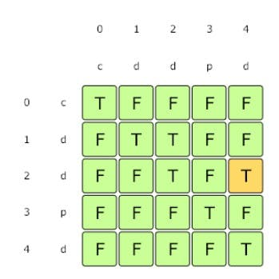

To build the second table for finding the minimum cuts, we can iterate through the first table built for isPalindrome(). At any step, if we get a *palindrome*, we can cut the *string* there. Which means minimum cuts will be one plus the cuts needed for the *remaining string*.

Here is the code for the **bottom-up approach**:

function findMPPCuts(str) {

// isPalindrome[i][j] will be 'true' if the string from index 'i' to index 'j' is a palindrome

const isPalindrome = Array(str.length)

.fill(false)

.map(() => Array(str.length).fill(false));

//every string with one character is a palindrome

for (let i = 0; i < str.length; i++) {

isPalindrome[i][i] = true;

}

//populate isPalindrome[][]

for (let startIndex = str.length - 1; startIndex >= 0; startIndex--) {

for (let endIndex = startIndex + 1; endIndex < str.length; endIndex++) {

if (str.charAt(startIndex) === str.charAt(endIndex)) {

//if it's a two cahracter strin or if the remaing

//string is a palindrome too

if (

endIndex - startIndex === 1 ||

isPalindrome[startIndex + 1][endIndex - 1]

) {

isPalindrome[startIndex][endIndex] = true;

}

}

}

}

//now lets populate the other [][], every index in cuts

//stores the min cuts needed for the substring

//from that index until the end

const cuts = Array(str.length).fill(0);

for (let startIndex = str.length - 1; startIndex >= 0; startIndex--) {

//maximum cuts

let minCuts = str.length;

for (let endIndex = str.length - 1; endIndex >= startIndex; endIndex--) {

if (isPalindrome[startIndex][endIndex]) {

//we can cut here as we got a palindrome

//also we dont need any cut if the whole substring is a palindrome

minCuts =

endIndex === str.length - 1

? 0

: Math.min(minCuts, 1 + cuts[endIndex + 1]);

}

}

cuts[startIndex] = minCuts;

}

return cuts[0];

}

console.log(`Minimum palindrome partitions ---> ${findMPPCuts('abdbca')}`);

// Output: 3

// Explanation: Palindrome pieces are "a", "bdb", "c", "a".

console.log(`Minimum palindrome partitions ---> ${findMPPCuts('cdpdd')}`);

// Output: 2

// Explanation: Palindrome pieces are "c", "d", "dpd".

console.log(`Minimum palindrome partitions ---> ${findMPPCuts('pqr')}`);

// Output: 2

// Explanation: Palindrome pieces are "p", "q", "r".

console.log(`Minimum palindrome partitions ---> ${findMPPCuts('pp')}`);

// Output: 0

// Explanation: We do not need to cut, as "pp" is a palindrome.

console.log(`Minimum palindrome partitions ---> ${findMPPCuts('madam')}`);

// Output: 0

// Explanation: We do not need to cut, as "madam" is a palindrome.

#### Java Solution

|  |
| --- |
| public int findMPPCuts(String st) {  // isPalindrome[i][j] will be 'true' if the string from index 'i' to index 'j' is a palindrome  boolean[][] isPalindrome = new boolean[st.length()][st.length()];  // every string with one character is a palindrome  for (int i = 0; i < st.length(); i++)  isPalindrome[i][i] = true;  // populate isPalindrome table  for (int startIndex = st.length() - 1; startIndex >= 0; startIndex--) {  for (int endIndex = startIndex + 1; endIndex < st.length(); endIndex++) {  if (st.charAt(startIndex) == st.charAt(endIndex)) {  // if it's a two character string or if the remaining string is a palindrome too  if (endIndex - startIndex == 1 || isPalindrome[startIndex + 1][endIndex - 1]) {  isPalindrome[startIndex][endIndex] = true;  }  }  }  }  // now lets populate the second table, every index in 'cuts' stores the minimum cuts needed  // for the substring from that index till the end  int[] cuts = new int[st.length()];  for (int startIndex = st.length() - 1; startIndex >= 0; startIndex--) {  int minCuts = st.length(); // maximum cuts  for (int endIndex = st.length() - 1; endIndex >= startIndex; endIndex--) {  if (isPalindrome[startIndex][endIndex]) {  // we can cut here as we got a palindrome  // also we dont need any cut if the whole substring is a palindrome  minCuts = (endIndex == st.length() - 1) ? 0 : Math.min(minCuts, 1 + cuts[endIndex + 1]);  }  }  cuts[startIndex] = minCuts;  }  return cuts[0];  } |

* The **time and space complexity** of the above algorithm is O(n²), where n is the length of the input string.

**Pattern 5: Longest Common Substring**

**Problem Set**

1. [Longest Common Substring](https://github.com/maazshaikh007/DSA_Patterns/blob/main/%E2%9C%85%20Pattern%2015:%200-1%20Knapsack%20(Dynamic%20Programming).md#longest-common-substring)
2. [🔎 Longest Common Subsequence](https://github.com/maazshaikh007/DSA_Patterns/blob/main/%E2%9C%85%20Pattern%2015:%200-1%20Knapsack%20(Dynamic%20Programming).md#%F0%9F%94%8E-longest-common-subsequence)
3. [Minimum Deletions & Insertions to Transform a String into another](https://github.com/maazshaikh007/DSA_Patterns/blob/main/%E2%9C%85%20Pattern%2015:%200-1%20Knapsack%20(Dynamic%20Programming).md#minimum-deletions--insertions-to-transform-a-string-into-another)
4. [👩🏽‍🦯 🔎 Longest Increasing Subsequence](https://github.com/maazshaikh007/DSA_Patterns/blob/main/%E2%9C%85%20Pattern%2015:%200-1%20Knapsack%20(Dynamic%20Programming).md#%F0%9F%91%A9%F0%9F%8F%BD%E2%80%8D%F0%9F%A6%AF-%F0%9F%94%8E-longest-increasing-subsequence)
5. [Maximum Sum Increasing Subsequence](https://github.com/maazshaikh007/DSA_Patterns/blob/main/%E2%9C%85%20Pattern%2015:%200-1%20Knapsack%20(Dynamic%20Programming).md#maximum-sum-increasing-subsequence)
6. [Shortest Common Super-sequence](https://github.com/maazshaikh007/DSA_Patterns/blob/main/%E2%9C%85%20Pattern%2015:%200-1%20Knapsack%20(Dynamic%20Programming).md#shortest-common-super-sequence)
7. [Minimum Deletions to Make a Sequence Sorted](https://github.com/maazshaikh007/DSA_Patterns/blob/main/%E2%9C%85%20Pattern%2015:%200-1%20Knapsack%20(Dynamic%20Programming).md#minimum-deletions-to-make-a-sequence-sorted)
8. [Longest Repeating Subsequence](https://github.com/maazshaikh007/DSA_Patterns/blob/main/%E2%9C%85%20Pattern%2015:%200-1%20Knapsack%20(Dynamic%20Programming).md#longest-repeating-subsequence)
9. [Subsequence Pattern Matching](https://github.com/maazshaikh007/DSA_Patterns/blob/main/%E2%9C%85%20Pattern%2015:%200-1%20Knapsack%20(Dynamic%20Programming).md#subsequence-pattern-matching)
10. [Longest Bitonic Subsequence](https://github.com/maazshaikh007/DSA_Patterns/blob/main/%E2%9C%85%20Pattern%2015:%200-1%20Knapsack%20(Dynamic%20Programming).md#longest-bitonic-subsequence)
11. [Longest Alternating Subsequence](https://github.com/maazshaikh007/DSA_Patterns/blob/main/%E2%9C%85%20Pattern%2015:%200-1%20Knapsack%20(Dynamic%20Programming).md#longest-alternating-subsequence)
12. [🔎 Edit Distance](https://github.com/maazshaikh007/DSA_Patterns/blob/main/%E2%9C%85%20Pattern%2015:%200-1%20Knapsack%20(Dynamic%20Programming).md#%F0%9F%94%8E-edit-distance)
13. [🔎 Strings Interleaving](https://github.com/maazshaikh007/DSA_Patterns/blob/main/%E2%9C%85%20Pattern%2015:%200-1%20Knapsack%20(Dynamic%20Programming).md#%F0%9F%94%8E-strings-interleaving)

**Longest Common Substring**

<https://www.geeksforgeeks.org/longest-common-substring-dp-29/>

Given two strings str1 and str2, find the length of the longest **substring** which is common in both the strings.

#### Example 1:

Input: str1 = "abdca"

str2 = "cbda"

Output: 2

Explanation: The longest common substring is "bd".

#### ****Example 2:****

Input: s1 = "passport"

s2 = "ppsspt"

Output: 3

Explanation: The longest common substring is "ssp".

### Basic Solution

A basic brute-force solution could be to try all substrings of 's1' and 's2' to find the longest common one. We can start matching both the strings one character at a time, so we have two options at any step:

1. If the strings have a matching character, we can recursively match for the remaining lengths and keep a track of the current matching length.
2. If the strings don't match, we start two new recursive calls by skipping one character separately from each string and reset the matching length.

The length of the Longest Common Substring (LCS) will be the maximum number returned by the three recurse calls in the above two options.

public int findLCSLength(String s1, String s2) {

return findLCSLengthRecursive(s1, s2, 0, 0, 0);

}

private int findLCSLengthRecursive(String s1, String s2, int i1, int i2, int count) {

if(i1 == s1.length() || i2 == s2.length())

return count;

if(s1.charAt(i1) == s2.charAt(i2))

count = findLCSLengthRecursive(s1, s2, i1+1, i2+1, count+1);

int c1 = findLCSLengthRecursive(s1, s2, i1, i2+1, 0);

int c2 = findLCSLengthRecursive(s1, s2, i1+1, i2, 0);

return Math.max(count, Math.max(c1, c2));

}

public static void main(String[] args) {

Solution lcs = new Solution();

System.out.println(lcs.findLCSLength("abdca", "cbda"));

System.out.println(lcs.findLCSLength("passport", "ppsspt"));

}

* Because of the three *recursive calls*, the **time complexity** of the above algorithm is exponential O(3ᵐ⁺ⁿ), where m and n are the lengths of the two input strings. The **space complexity** is O(m+n), this **space** will be used to store the *recursion stack*.

**Top-down Dynamic Programming with Memoization**

We can use an array to store the already solved *subproblems*.

The three changing values to our *recursive function* are the two indices (index1 and index2) and the count. Therefore, we can store the results of

all *subproblems*in a *three-dimensional array*. (Another alternative could be to use a *hash-table* whose key would be a string (index1 + “|” index2 + “|” + count)).

Here is the code:

function findLCSLength(str1, str2) {

const maxLength = Math.min(str1.length, str2.length);

const dp = [];

function findLCSLengthRecursive(str1, str2, index1, index2, count) {

//base case

if (index1 === str1.length || index2 === str2.length) return count;

dp[index1] = dp[index1] || [];

dp[index1][index2] = dp[index1][index2] || [];

if (typeof dp[index1][index2][count] === 'undefined') {

let checkFirstString = count;

if (str1[index1] === str2[index2]) {

checkFirstString = findLCSLengthRecursive(

str1,

str2,

index1 + 1,

index2 + 1,

count + 1

);

}

let checkSecondString = findLCSLengthRecursive(

str1,

str2,

index1,

index2 + 1,

0

);

let checkThirdString = findLCSLengthRecursive(

str1,

str2,

index1 + 1,

index2,

0

);

dp[index1][index2][count] = Math.max(

checkFirstString,

Math.max(checkSecondString, checkThirdString)

);

}

return dp[index1][index2][count];

}

return findLCSLengthRecursive(str1, str2, 0, 0, 0);

}

console.log(

`Length of Longest Common Substring: ---> ${findLCSLength('abdca', 'cbda')}`

);

// Output: 2

// Explanation: The longest common substring is "bd".

console.log(

`Length of Longest Common Substring: ---> ${findLCSLength(

'passport',

'ppsspt'

)}`

);

// Output: 3

// Explanation: The longest common substring is "ssp".

#### Java Solution

|  |
| --- |
| public int findLCSLength(String s1, String s2) {  int maxLength = Math.min(s1.length(), s2.length());  Integer[][][] dp = new Integer[s1.length()][s2.length()][maxLength];  return findLCSLengthRecursive(dp, s1, s2, 0, 0, 0);  }  private int findLCSLengthRecursive(Integer[][][] dp, String s1, String s2, int i1, int i2, int count) {  if(i1 == s1.length() || i2 == s2.length())  return count;  if(dp[i1][i2][count] == null) {  int c1 = count;  if(s1.charAt(i1) == s2.charAt(i2))  c1 = findLCSLengthRecursive(dp, s1, s2, i1+1, i2+1, count+1);  int c2 = findLCSLengthRecursive(dp, s1, s2, i1, i2+1, 0);  int c3 = findLCSLengthRecursive(dp, s1, s2, i1+1, i2, 0);  dp[i1][i2][count] = Math.max(c1, Math.max(c2, c3));  }  return dp[i1][i2][count];  } |

**Bottom-up Dynamic Programming**

Since we want to match all the *substrings* of the given two *strings*, we can use a two-dimensional array to store our results. The lengths of the two *strings* will define the size of the two dimensions of the array. So for every index index1 in string str1 and index2 in string str2, we have two options:

1. If the character at str1[index1] matches str2[index2], the length of the *common substring* would be one plus the length of the *common substring* until index1-1 and index2-1 indices in the two *strings*.
2. If the character at the str1[index1] does not match str2[index2], we don’t have any *common substring*. So our *recursive formula* would be:

**if str1[index1] == str2[index2]**

**dp[index1][index2] = 1 + dp[index1-1][index2-1]**

**else**

**dp[index1][index2] = 0**

Let's draw this visually for "abcda" and "cbda". Starting with a substring of zero lengths, if any one of the string has zero length, then the common substring will be of zero length:

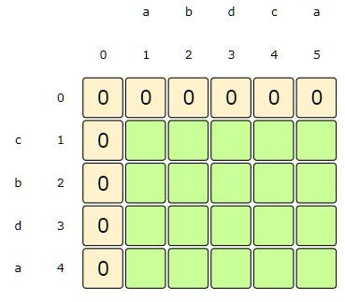

i:0, j:0-5 and i:0-4, j:0 => dp[i][j] = 0, as we don't have any common substring when one of the string is of zero length

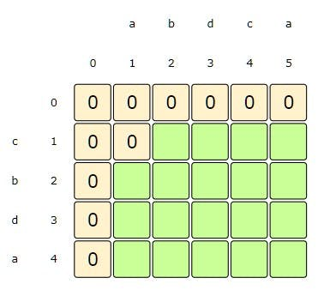

i:1, j:1 => dp[i][j] = 0, as s1[i] != s2[j]

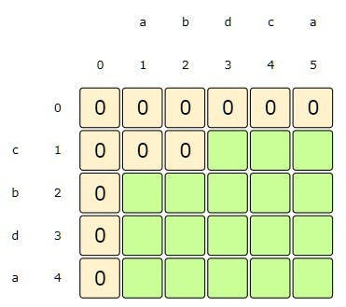

i:1, j:2 => dp[i][j] = 0, as s1[i] != s2[j]

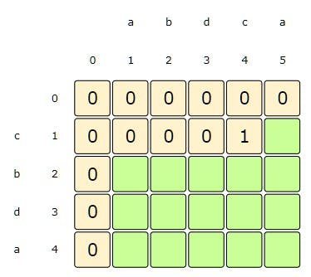

i:1, j:4 => dp[i][j] = 1 + dp[i-1][j-1], as s1[i] == s2[j]

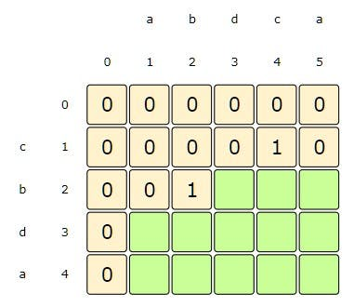

i:2, j:2=> dp[i][j] = 1 + dp[i-1][j-1], as s1[i] == s2[j]

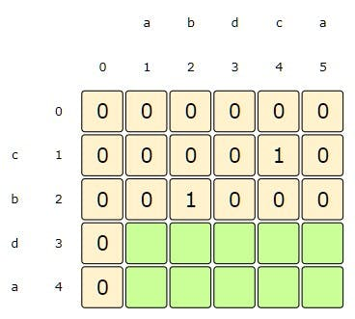

i:2, j:3-5 => dp[i][j] = 0, as s1[i] != s2[j]

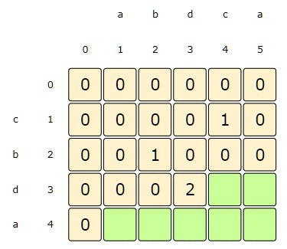

i:3, j:3=> dp[i][j] = 1 + dp[i-1][j-1], as s1[i] == s2[j]

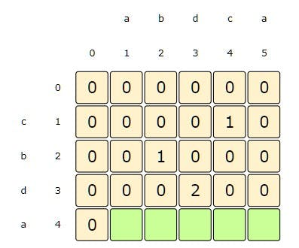

i:3, j:4-5=> dp[i][j] = 0, as s1[i] != s2[j]

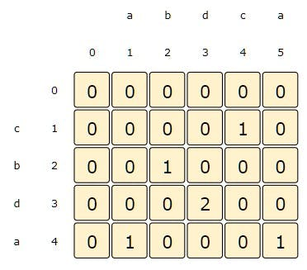

i:4, j:5=> dp[i][j] = 1 + dp[i-1][j-1], as s1[i] == s2[j]

From the above visualization, we can clearly see that the longest common substring is of length '2'-- as shown by dp[3][3]. Here is the code for our bottom-up dynamic programming approach:

Here is the code for our **bottom-up dynamic programming approach**:

function findLCSLength(str1, str2) {

const dp = Array(str1.length + 1)

.fill(0)

.map(() => Array(str2.length + 1).fill(0));

let maxLength = 0;

for (let i = 1; i <= str1.length; i++) {

for (let j = 1; j <= str2.length; j++) {

if (str1.charAt(i - 1) === str2.charAt(j - 1)) {

dp[i][j] = 1 + dp[i - 1][j - 1];

maxLength = Math.max(maxLength, dp[i][j]);

}

}

}

return maxLength;

}

console.log(

`Length of Longest Common Substring: ---> ${findLCSLength('abdca', 'cbda')}`

);

// Output: 2

// Explanation: The longest common substring is "bd".

console.log(

`Length of Longest Common Substring: ---> ${findLCSLength(

'passport',

'ppsspt'

)}`

);

// Output: 3

// Explanation: The longest common substring is "ssp".

#### Java solution

|  |
| --- |
| public int findLCSLength(String s1, String s2) {  int[][] dp = new int[s1.length()+1][s2.length()+1];  int maxLength = 0;  for(int i=1; i <= s1.length(); i++) {  for(int j=1; j <= s2.length(); j++) {  if(s1.charAt(i-1) == s2.charAt(j-1)) {  dp[i][j] = 1 + dp[i-1][j-1];  maxLength = Math.max(maxLength, dp[i][j]);  }  }  }  return maxLength;  } |

* The **time and space complexity** of the above algorithm is O(m∗n), where m and n are the lengths of the two input *strings*.

**Challenge**

Can we further improve our **bottom-up DP** solution? Can you find an algorithm that has O(n) **space complexity**

#### Hint

We only need one previous row to find the optimal solution!

#### Java Solution

|  |
| --- |
| static int findLCSLength(String s1, String s2) {  int[][] dp = new int[2][s2.length()+1];  int maxLength = 0;  for(int i=1; i <= s1.length(); i++) {  for(int j=1; j <= s2.length(); j++) {  dp[i%2][j] = 0;  if(s1.charAt(i-1) == s2.charAt(j-1)) {  dp[i%2][j] = 1 + dp[(i-1)%2][j-1];  maxLength = Math.max(maxLength, dp[i%2][j]);  }  }  }  return maxLength;  } |

**🔎 Longest Common Subsequence**

<https://leetcode.com/problems/longest-common-subsequence/>

Given two strings str1 and str2, find the length of the *longest subsequence* which is common in both the strings.

A **subsequence** is a *sequence that can be derived from another sequence by deleting some or no elements without changing the order of the remaining elements*.

**Example :**

Input: str1 = "abdca"

str2 = "cbda"

Output: 3

Explanation: The longest common subsequence is "bda".

**Example 2:**

Input: str1 = "passport"

str2 = "ppsspt"

Output: 5

Explanation: The longest common subsequence is "psspt".

**Basic Brute-Force Solution**

A **basic brute-force solution** could be to try all *subsequences* of str1 and str2 to find the longest one. We can match both the strings one character at a time. So for every index index1 in str1 and index2 in str2 we must choose between:

1. If the character str1[index1] matches str2[index2, we can *recursively* match for the remaining lengths.
2. If the character str1[index1] does not match str2[index2], we will start two new *recursive calls* by skipping one character separately from each string.

Here is the code:

function findLCSLength(str1, str2) {

function findLCSLengthRecursive(str1, str2, index1, index2) {

// base check

if (index1 === str1.length || index2 === str2.length) return 0;

if (str1[index1] === str2[index2])

return 1 + findLCSLengthRecursive(str1, str2, index1 + 1, index2 + 1);

let checkFirstString = findLCSLengthRecursive(

str1,

str2,

index1,

index2 + 1

);

let checkSecondString = findLCSLengthRecursive(

str1,

str2,

index1 + 1,

index2

);

return Math.max(checkFirstString, checkSecondString);

}

return findLCSLengthRecursive(str1, str2, 0, 0);

}

console.log(

`Length of Longest Common Subsequence: ---> ${findLCSLength('abdca', 'cbda')}`

);

// Output: 3

// Explanation: The longest common subsequence is "bda".

console.log(

`Length of Longest Common Subsequence: ---> ${findLCSLength(

'passport',

'ppsspt'

)}`

);

// Output: 5

// Explanation: The longest common subsequence is "psspt".

#### Java Solution

|  |
| --- |
| public int findLCSLength(String s1, String s2) {  return findLCSLengthRecursive(s1, s2, 0, 0);  }  private int findLCSLengthRecursive(String s1, String s2, int i1, int i2) {  if(i1 == s1.length() || i2 == s2.length())  return 0;  if(s1.charAt(i1) == s2.charAt(i2))  return 1 + findLCSLengthRecursive(s1, s2, i1+1, i2+1);  int c1 = findLCSLengthRecursive(s1, s2, i1, i2+1);  int c2 = findLCSLengthRecursive(s1, s2, i1+1, i2);  return Math.max(c1, c2);  } |

* The **time complexity** of the above algorithm is exponential O(2ᵐ⁺ⁿ), where m and n are the lengths of the two input strings.
* The **space complexity** is O(m+n), this **space** will be used to store the *recursion stack*.

**Top-down Dynamic Programming with Memoization**

We can use an array to store the already solved *subproblems*.

The two changing values to our *recursive function* are the two indices, index1 and index2. Therefore, we can store the results of all the *subproblems* in a two-dimensional array. (Another alternative could be to use a *hash-table* whose key would be a *string* (index1 + “|” + index2)).

Here is the code:

function findLCSLength(str1, str2) {

const dp = [];

function findLCSLengthRecursive(str1, str2, index1, index2) {

// base check

if (index1 === str1.length || index2 === str2.length) return 0;

dp[index1] = dp[index1] || [];

if (typeof dp[index1][index2] === 'undefined') {

if (str1[index1] === str2[index2]) {

dp[index1][index2] =

1 + findLCSLengthRecursive(str1, str2, index1 + 1, index2 + 1);

} else {

let checkFirstString = findLCSLengthRecursive(

str1,

str2,

index1,

index2 + 1

);

let checkSecondString = findLCSLengthRecursive(

str1,

str2,

index1 + 1,

index2

);

dp[index1][index2] = Math.max(checkFirstString, checkSecondString);

}

}

// console.log(dp);

return dp[index1][index2];

}

return findLCSLengthRecursive(str1, str2, 0, 0);

}

console.log(

`Length of Longest Common Subsequence: ---> ${findLCSLength('abdca', 'cbda')}`

);

// Output: 3

// Explanation: The longest common subsequence is "bda".

console.log(

`Length of Longest Common Subsequence: ---> ${findLCSLength(

'passport',

'ppsspt'

)}`

);

// Output: 5

// Explanation: The longest common subsequence is "psspt".

#### Java solution

|  |
| --- |
| public int findLCSLength(String s1, String s2) {  Integer[][] dp = new Integer[s1.length()][s2.length()];  return findLCSLengthRecursive(dp, s1, s2, 0, 0);  }  private int findLCSLengthRecursive(Integer[][] dp, String s1, String s2, int i1, int i2) {  if (i1 == s1.length() || i2 == s2.length())  return 0;  if (dp[i1][i2] == null) {  if (s1.charAt(i1) == s2.charAt(i2))  dp[i1][i2] = 1 + findLCSLengthRecursive(dp, s1, s2, i1 + 1, i2 + 1);  else {  int c1 = findLCSLengthRecursive(dp, s1, s2, i1, i2 + 1);  int c2 = findLCSLengthRecursive(dp, s1, s2, i1 + 1, i2);  dp[i1][i2] = Math.max(c1, c2);  }  }  return dp[i1][i2];  } |

**Bottom-up Dynamic Programming**

Since we want to match all the **subsequences** of the given two strings, we can use a two-dimensional array to store our results. The lengths of the two strings will define the size of the array’s two dimensions. So for every index index1 in string str1 and index2 in string str2, we will choose one of the following two options:

1. If the character str1[index1] matches str2[index2], the length of the **common subsequence** would be one plus the length of the **common subsequence** until the index1-1 and index2-1 indices in the two respective strings.
2. If the character str1[index1]does not match str2[index2], we will take the *longest subsequence* by either skipping [index1]th or [index2]th character from the respective strings.

So our **recursive formula** would be:

**if str1[index1] == str2[index2]**

**dp[index1][index2] = 1 + dp[index1-1][index2-1]**

**else**

**dp[index1][index2] = Math.max(dp[index1-1][index2], dp[index1][index2-1])**

Let's draw this visually for "abcda" and "cbda". Starting with a subsequence of zero lengths, if any string has zero length then the common subsequence will be of zero length:

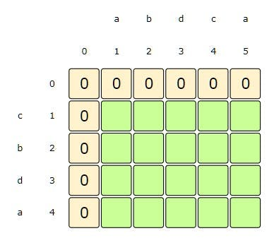

i:0, j:0-5 and i:0-4, j:0 => dp[i][j] = 0, as we don't have any common subsequence when one of the string is of zero length

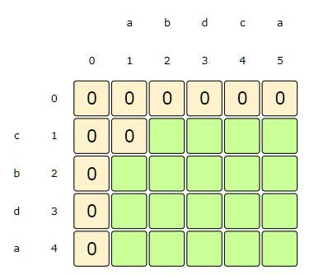

i:1, j:1 => dp[i][j] = max(dp[i-1][j], dp[i][j-1]), as s1[i] != s2[j]

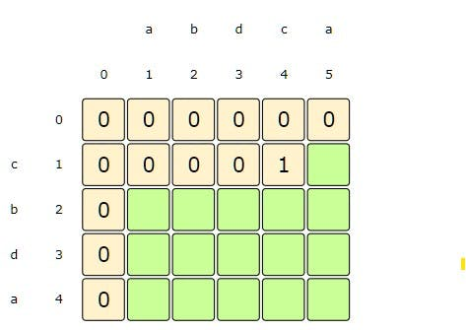

i:1, j:4 => dp[i][j] = 1 + dp[i-1][j-1], as s1[i] == s2[j]

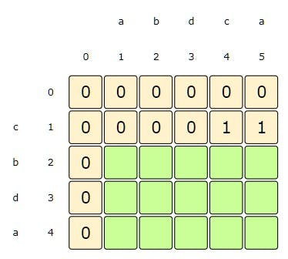

i:1, j:5 => dp[i][j] = max(dp[i-1][j], dp[i][j-1]), as s1[i] != s2[j]

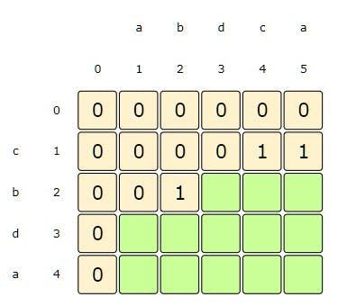

i:2, j:2=> dp[i][j] = 1 + dp[i-1][j-1], as s1[i] == s2[j]

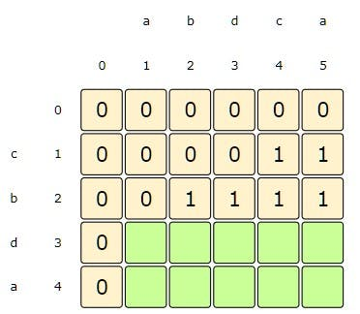

i:2, j:3-5 => dp[i][j] = max(dp[i-1][j], dp[i][j-1]), as s1[i] != s2[j]

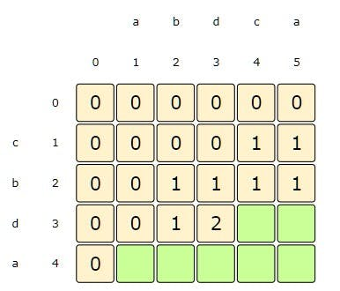

i:3, j:3=> dp[i][j] = 1 + dp[i-1][j-1], as s1[i] == s2[j]

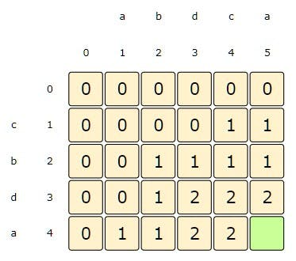

i:4, j:5=> dp[i][j] = 1 + dp[i-1][j-1], as s1[i] == s2[j]

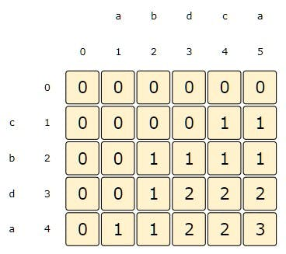

i:4, j:5=> dp[i][j] = 1 + dp[i-1][j-1], as s1[i] == s2[j]

From the above visualization, we can clearly see that the **longest common subsequence** is of length 3 – as shown by dp[4][5].

Here is the code for our **bottom-up dynamic programming approach**:

function findLCSLength(str1, str2) {

const dp = Array(str1.length + 1)

.fill(0)

.map(() => Array(str2.length + 1).fill(0));

let maxLength = 0;

for (let index1 = 1; index1 <= str1.length; index1++) {

for (let index2 = 1; index2 <= str2.length; index2++) {

if (str1[index1 - 1] === str2[index2 - 1]) {

dp[index1][index2] = 1 + dp[index1 - 1][index2 - 1];

} else {

dp[index1][index2] = Math.max(

dp[index1 - 1][index2],

dp[index1][index2 - 1]

);

}

// console.log(dp)

maxLength = Math.max(maxLength, dp[index1][index2]);

}

}

return maxLength;

}

console.log(

`Length of Longest Common Subsequence: ---> ${findLCSLength('abdca', 'cbda')}`

);

// Output: 3

// Explanation: The longest common subsequence is "bda".

console.log(

`Length of Longest Common Subsequence: ---> ${findLCSLength(

'passport',

'ppsspt'

)}`

);

// Output: 5

// Explanation: The longest common subsequence is "psspt".

#### Java Solution

|  |
| --- |
| public int findLCSLength(String s1, String s2) {  int[][] dp = new int[s1.length()+1][s2.length()+1];  int maxLength = 0;  for(int i=1; i <= s1.length(); i++) {  for(int j=1; j <= s2.length(); j++) {  if(s1.charAt(i-1) == s2.charAt(j-1))  dp[i][j] = 1 + dp[i-1][j-1];  else  dp[i][j] = Math.max(dp[i-1][j], dp[i][j-1]);    maxLength = Math.max(maxLength, dp[i][j]);  }  }  return maxLength;  } |

* The **time and space complexity** of the above algorithm is O(m*n), where m and n are the lengths of the two input strings.

**Challenge**

Can we further improve our **bottom-up DP solution**? Can you find an algorithm that has O(n) **space complexity**?

#### Hint

We only need one previous row to find the optimal solution!

#### Java Solution

|  |
| --- |
| static int findLCSLength(String s1, String s2) {  int[][] dp = new int[2][s2.length()+1];  int maxLength = 0;  for(int i=1; i <= s1.length(); i++) {  for(int j=1; j <= s2.length(); j++) {  if(s1.charAt(i-1) == s2.charAt(j-1))  dp[i%2][j] = 1 + dp[(i-1)%2][j-1];  else  dp[i%2][j] = Math.max(dp[(i-1)%2][j], dp[i%2][j-1]);  maxLength = Math.max(maxLength, dp[i%2][j]);  }  }  return maxLength;  } |

**Minimum Deletions & Insertions to Transform a String into another**

<https://practice.geeksforgeeks.org/problems/minimum-number-of-deletions-and-insertions0209/1/>

Given strings str1 and str2, we need to transform str1 into str2 by deleting and inserting characters. Write a function to calculate the count of the minimum number of deletion and insertion operations.

**Example 1:**

Input: str1 = "abc"

str2 = "fbc"

Output: 1 deletion and 1 insertion.

Explanation: We need to delete {'a'} and insert {'f'} to str1 to transform it into str2.

**Example 2:**

Input: str1 = "abdca"

str2 = "cbda"

Output: 2 deletions and 1 insertion.

Explanation: We need to delete {'a', 'c'} and insert {'c'} to str1 to transform it into str2.

**Example 3:**

Input: str1 = "passport"

str2 = "ppsspt"

Output: 3 deletions and 1 insertion

Explanation: We need to delete {'a', 'o', 'r'} and insert {'p'} to str1 to transform it into str2.

### Solution

This problem can easily be converted to the [**Longest Common Subsequence (LCS)**](https://github.com/maazshaikh007/DSA_Patterns/blob/main/%E2%9C%85%20Pattern%2015:%200-1%20Knapsack%20(Dynamic%20Programming).md#%F0%9F%94%8E-longest-common-subsequence). If we can find the **LCS** of the two input strings, we can easily find how many characters we need to insert and delete from str1. Here is how we can do this:

1. Let’s assume length1 is the length of str1 and length2 is the length of str2.
2. Now let’s assume c1 is the length of **LCS** of the two strings str1 and str2.
3. To transform str1 into str2, we need to delete everything from str1 which is not part of **LCS**, so minimum deletions we need to perform from str1 => length1 - c1
4. Similarly, we need to insert everything in str1 which is present in str2 but not part of **LCS**, so minimum insertions we need to perform in str1 => length2 - c1

**Bottom-up Dynamic Programming Solution**

Let’s jump directly to the **bottom-up dynamic programming solution**:

function findMDI(str1, str2) {

const c1 = findLCSLength(str1, str2);

function findLCSLength(str1, str2) {

const dp = Array(str1.length + 1)

.fill(0)

.map(() => Array(str2.length + 1).fill(0));

let maxLength = 0;

for (let i = 1; i <= str1.length; i++) {

for (let j = 1; j <= str2.length; j++) {

if (str1[i - 1] === str2[j - 1]) {

dp[i][j] = 1 + dp[i - 1][j - 1];

} else {

dp[i][j] = Math.max(dp[i - 1][j], dp[i][j - 1]);

}

maxLength = Math.max(maxLength, dp[i][j]);

}

}

// console.log(dp);

return maxLength;

}

console.log(

`We need ${str1.length - c1} deletions and ${

str2.length - c1

} insertions to transform "${str1}" into "${str2}"`

);

}

findMDI('abc', 'fbc');

// Output: 1 deletion and 1 insertion.

// Explanation: We need to delete {'a'} and insert {'f'} to s1 to transform it into s2.

findMDI('abdca', 'cbda');

// Output: 2 deletions and 1 insertion.

// Explanation: We need to delete {'a', 'c'} and insert {'c'} to s1 to transform it into s2.

findMDI('passport', 'ppsspt');

// Output: 3 deletions and 1 insertion

// Explanation: We need to delete {'a', 'o', 'r'} and insert {'p'} to s1 to transform it into s2.

#### Java Solution

|  |
| --- |
| public void findMDI(String s1, String s2) {  int c1 = findLCSLength(s1, s2);  System.out.println("Minimum deletions needed: " + (s1.length() - c1));  System.out.println("Minimum insertions needed: " + (s2.length() - c1));  }    private int findLCSLength(String s1, String s2) {  int[][] dp = new int[s1.length()+1][s2.length()+1];  int maxLength = 0;  for(int i=1; i <= s1.length(); i++) {  for(int j=1; j <= s2.length(); j++) {  if(s1.charAt(i-1) == s2.charAt(j-1))  dp[i][j] = 1 + dp[i-1][j-1];  else  dp[i][j] = Math.max(dp[i-1][j], dp[i][j-1]);    maxLength = Math.max(maxLength, dp[i][j]);  }  }  return maxLength;  } |

* The **time and space complexity** of the above algorithm is O(m*n), where m and n are the lengths of the two input strings.

**👩🏽‍🦯 🔎 Longest Increasing Subsequence**

<https://leetcode.com/problems/longest-increasing-subsequence/>

Given a number sequence, find the length of its **Longest Increasing Subsequence (LIS)**. In an **increasing subsequence**, *all the elements are in increasing order (from lowest to highest)*.

**Example 1:**

Input: {4,2,3,6,10,1,12}

Output: 5

Explanation: The LIS is {2,3,6,10,12}.

**Example 2:**

Input: {-4,10,3,7,15}

Output: 4

Explanation: The LIS is {-4,3,7,15}.

**Basic Brute-Force Solution**

A **basic brute-force solution** could be to try all the *subsequences* of the given number sequence. We can process one number at a time, so we have two options at any step:

1. If the current number is greater than the previous number that we included, we can *increment our count* and make a *recursive call* for the remaining array.
2. We can skip the current number to make a *recursive call* for the remaining array.

The length of the **longest increasing subsequence** will be the maximum number returned by the two recurse calls from the above two options.

Here is the code:

function findLISLength(nums) {

function findLISLengthRecursive(nums, currIndex, prevIndex) {

// base check

if (currIndex === nums.length) return 0;

//include nums[currIndex] if if is larger than the last included number

let count1 = 0;

if (prevIndex === -1 || nums[currIndex] > nums[prevIndex]) {

count1 = 1 + findLISLengthRecursive(nums, currIndex + 1, currIndex);

}

//exluding number at currIndex

let count2 = findLISLengthRecursive(nums, currIndex + 1, prevIndex);

return Math.max(count1, count2);

}

return findLISLengthRecursive(nums, 0, -1);

}

console.log(

`Length of Longest Increasing Subsequence: ---> ${findLISLength([

4, 2, 3, 6, 10, 1, 12,

])}`

);

// Output: 5

// Explanation: The LIS is {2,3,6,10,12}.

console.log(

`Length of Longest Increasing Subsequence: ---> ${findLISLength([

-4, 10, 3, 7, 15,

])}`

);

// Output: 4

// Explanation: The LIS is {-4,3,7,15}.

#### Java Solution

|  |
| --- |
| public int findLISLength(int[] nums) {  return findLISLengthRecursive(nums, 0, -1);  }  private int findLISLengthRecursive(int[] nums, int currentIndex, int previousIndex) {  if(currentIndex == nums.length)  return 0;  // include nums[currentIndex] if it is larger than the last included number  int c1 = 0;  if(previousIndex == -1 || nums[currentIndex] > nums[previousIndex])  c1 = 1 + findLISLengthRecursive(nums, currentIndex+1, currentIndex);  // excluding the number at currentIndex  int c2 = findLISLengthRecursive(nums, currentIndex+1, previousIndex);  return Math.max(c1, c2);  } |

* The **time complexity** of the above algorithm is exponential O(2ⁿ), where n is the lengths of the input array.
* The **space complexity** is O(n) which is used to store the *recursion stack*.

**Top-down Dynamic Programming with Memoization**

To overcome the *overlapping subproblems*, we can use an array to store the already solved *subproblems*.

The two changing values for our *recursive function* are the currIndex and the prevIndex. Therefore, we can store the results of all *subproblems* in a two-dimensional array. (Another alternative could be to use a *hash-table* whose key would be a string (currIndex + “|” + prevIndex)).

Here is the code:

function findLISLength(nums) {

const dp = [];

function findLISLengthRecursive(nums, currIndex, prevIndex) {

// base check

if (currIndex === nums.length) return 0;

dp[currIndex] = dp[currIndex] || [];

if (typeof dp[currIndex][prevIndex + 1] === 'undefined') {

//include nums[currIndex] if if is larger than the last included number

let count1 = 0;

if (prevIndex === -1 || nums[currIndex] > nums[prevIndex]) {

count1 = 1 + findLISLengthRecursive(nums, currIndex + 1, currIndex);

}

//exluding number at currIndex

let count2 = findLISLengthRecursive(nums, currIndex + 1, prevIndex);

dp[currIndex][prevIndex + 1] = Math.max(count1, count2);

}

return dp[currIndex][prevIndex + 1];

}

return findLISLengthRecursive(nums, 0, -1);

}

console.log(

`Length of Longest Increasing Subsequence: ---> ${findLISLength([

4, 2, 3, 6, 10, 1, 12,

])}`

);

// Output: 5

// Explanation: The LIS is {2,3,6,10,12}.

console.log(

`Length of Longest Increasing Subsequence: ---> ${findLISLength([

-4, 10, 3, 7, 15,

])}`

);

// Output: 4

// Explanation: The LIS is {-4,3,7,15}.

#### Java Solution

|  |
| --- |
| public int findLISLength(int[] nums) {  Integer[][] dp = new Integer[nums.length][nums.length+1];  return findLISLengthRecursive(dp, nums, 0, -1);  }  private int findLISLengthRecursive(Integer[][] dp, int[] nums, int currentIndex, int previousIndex) {  if(currentIndex == nums.length)  return 0;  if(dp[currentIndex][previousIndex+1] == null) {  // include nums[currentIndex] if it is larger than the last included number  int c1 = 0;  if(previousIndex == -1 || nums[currentIndex] > nums[previousIndex])  c1 = 1 + findLISLengthRecursive(dp, nums, currentIndex+1, currentIndex);  int c2 = findLISLengthRecursive(dp, nums, currentIndex+1, previousIndex);  dp[currentIndex][previousIndex+1] = Math.max(c1, c2);  }  return dp[currentIndex][previousIndex+1];  } |

* Since our *memoization* array dp[nums.length()][nums.length()] stores the results for all the *subproblems*, we can conclude that we will not have more than N*N *subproblems* (where N is the length of the input sequence). This means that our **time complexity** will be O(N²).
* The above algorithm will be using O(N²) **space** for the *memoization array*. Other than that we will use O(N) **space** for the *recursion call-stack*. So the total **space complexity** will be O(N² + N), which is *asymptotically* equivalent to O(N²).

**Bottom-up Dynamic Programming**

The above algorithm tells us two things:

1. If the number at the currIndex is bigger than the number at the prevIndex, we increment the count for **LIS** up to the currIndex.
2. But if there is a bigger **LIS** without including the number at the currIndex, we take that. So we need to find all the *increasing subsequences* for the number at index i, from all the previous numbers (i.e. number until index i-1), to eventually find the *longest increasing subsequence.*

If i represents the currIndex and j represents the prevIndex, our *recursive formula* would look like:

**if num[i] > num[j] => dp[i] = dp[j] + 1 if there is no bigger LIS for 'i'**

Let's draw this visually for {-4,10,3,7,15}. Start with a subsequence of length '1', as every number will be a LIS of length '1':

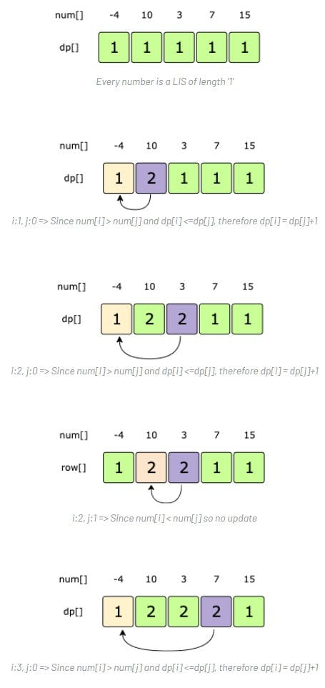

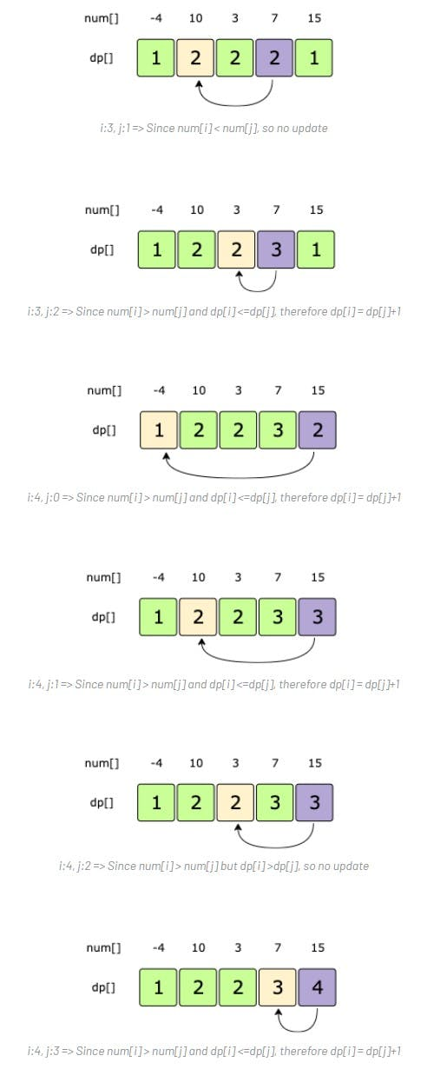

From the above visualization, we can clearly see that the longest increasing subsequence is of length '4' -- as shown by dp[4].

Here is the code for our **bottom-up dynamic programming approach**:

function findLISLength(nums) {

const dp = [1];

let maxLength = 1;

for (let i = 0; i < nums.length; i++) {

dp[i] = 1;

for (let j = 0; j < i; j++) {

if (nums[i] > nums[j] && dp[i] <= dp[j]) {

dp[i] = dp[j] + 1;

maxLength = Math.max(maxLength, dp[i]);

}

}

}

return maxLength;

}

console.log(

`Length of Longest Increasing Subsequence: ---> ${findLISLength([

4, 2, 3, 6, 10, 1, 12,

])}`

);

// Output: 5

// Explanation: The LIS is {2,3,6,10,12}.

console.log(

`Length of Longest Increasing Subsequence: ---> ${findLISLength([

-4, 10, 3, 7, 15,

])}`

);

// Output: 4

// Explanation: The LIS is {-4,3,7,15}.

#### Java Solution

|  |
| --- |
| public int findLISLength(int[] nums) {  int[] dp = new int[nums.length];  dp[0] = 1;  int maxLength = 1;  for (int i=1; i<nums.length; i++) {  dp[i] = 1;  for (int j=0; j<i; j++)  if (nums[i] > nums[j] && dp[i] <= dp[j] ) {  dp[i] = dp[j]+1;  maxLength = Math.max(maxLength, dp[i]);  }  }  return maxLength;  } |

* The **time complexity** of the above algorithm is O(N²) and the **space complexity** is O(n).

**Maximum Sum Increasing Subsequence**

<https://www.geeksforgeeks.org/maximum-sum-increasing-subsequence-dp-14/>

Given a number sequence, find the increasing subsequence with the highest sum. Write a method that returns the highest sum.

**Example 1:**

Input: {4,1,2,6,10,1,12}

Output: 32

Explanation: The increasing sequence is {4,6,10,12}.

Please note the difference, as the LIS is {1,2,6,10,12} which has a sum of '31'.

**Example 2:**

Input: {-4,10,3,7,15}

Output: 25

Explanation: The increasing sequences are {10, 15} and {3,7,15}.

**Basic Brute Force Solution**

The problem is quite similar to the [**Longest Increasing Subsequence**](https://github.com/maazshaikh007/DSA_Patterns/blob/main/%E2%9C%85%20Pattern%2015:%200-1%20Knapsack%20(Dynamic%20Programming).md#%F0%9F%91%A9%F0%9F%8F%BD%E2%80%8D%F0%9F%A6%AF-%F0%9F%94%8E-longest-increasing-subsequence). The only difference is that, instead of finding the increasing subsequence with the maximum length, we need to find an increasing sequence with the maximum sum.

A **basic brute-force solution** could be to try all the *subsequences* of the given array. We can process one number at a time, so we have two options at any step:

1. If the current number is greater than the previous number that we included, we include that number in a running sum and make a *recursive call* for the remaining array.
2. We can skip the current number to make a *recursive call* for the remaining array.

The highest sum of any *increasing subsequence* would be the max value returned by the two *recurse calls* from the above two options.

Here is the code:

function findMSIS(nums) {

function findMSISRecursive(nums, currIndex, prevIndex, sum) {

//base check

if (currIndex === nums.length) return sum;

//include nums[currIndex] if it is larger than the last include number

let sumIncludingCurrIndex = sum;

if (prevIndex === -1 || nums[currIndex] > nums[prevIndex]) {

sumIncludingCurrIndex = findMSISRecursive(

nums,

currIndex + 1,

currIndex,

sum + nums[currIndex]

);

}

//exclude the number at currIndex

let sumWithoutCurrIndex = findMSISRecursive(

nums,

currIndex + 1,

prevIndex,

sum

);

return Math.max(sumIncludingCurrIndex, sumWithoutCurrIndex);

}

return findMSISRecursive(nums, 0, -1, 0);

}

console.log(

`Maximum Sum Increasing Subsequence is: ---> ${findMSIS([

4, 1, 2, 6, 10, 1, 12,

])}`

);

// Output: 32

// Explanation: The increaseing sequence is {4,6,10,12}.

// Please note the difference, as the LIS is {1,2,6,10,12} which has a sum of '31'.

console.log(

`Maximum Sum Increasing Subsequence is: ---> ${findMSIS([-4, 10, 3, 7, 15])}`

);

// Output: 25

// Explanation: The increaseing sequences are {10, 15} and {3,7,15}.

#### Java Solution

|  |
| --- |
| public int findMSIS(int[] nums) {  return findMSISRecursive(nums, 0, -1, 0);  }  private int findMSISRecursive(int[] nums, int currentIndex, int previousIndex, int sum) {  if(currentIndex == nums.length)  return sum;  // include nums[currentIndex] if it is larger than the last included number  int s1 = sum;  if(previousIndex == -1 || nums[currentIndex] > nums[previousIndex])  s1 = findMSISRecursive(nums, currentIndex+1, currentIndex, sum + nums[currentIndex]);  // excluding the number at currentIndex  int s2 = findMSISRecursive(nums, currentIndex+1, previousIndex, sum);  return Math.max(s1, s2);  } |

* The **time complexity** of the above algorithm is exponential O(2ⁿ), where n is the lengths of the input array.
* The **space complexity** is O(n) which is used to store the *recursion stack*.

**Top-down Dynamic Programming with Memoization**

We can use **memoization** to overcome the *overlapping subproblems*.

The three changing values for our *recursive function* are the currIndex, the prevIndex, and the sum. An efficient way of storing the results of the *subproblems* could be a *hash-table* whose *key* would be a string (currIndex + “|” + prevIndex + “|” + sum).

Here is the code:

function findMSIS(nums) {

const dp = [];

function findMSISRecursive(nums, currIndex, prevIndex, sum) {

//base check

if (currIndex === nums.length) return sum;

const subProbKey = `${currIndex}-${prevIndex}-${sum}`;

if (typeof dp[subProbKey] === 'undefined') {

//include nums[currIndex] if it is larger than the last include number

let sumIncludingCurrIndex = sum;

if (prevIndex == -1 || nums[currIndex] > nums[prevIndex]) {

sumIncludingCurrIndex = findMSISRecursive(

nums,

currIndex + 1,

currIndex,

sum + nums[currIndex]

);

}

//exclude the number at currIndex

let sumWithoutCurrIndex = findMSISRecursive(

nums,

currIndex + 1,

prevIndex,

sum

);

// console.log(dp)

dp[subProbKey] = Math.max(sumIncludingCurrIndex, sumWithoutCurrIndex);

return dp[subProbKey];

}

}

return findMSISRecursive(nums, 0, -1, 0);

}

console.log(

`Maximum Sum Increasing Subsequence is: ---> ${findMSIS([

4, 1, 2, 6, 10, 1, 12,

])}`

);

// Output: 32

// Explanation: The increaseing sequence is {4,6,10,12}.

// Please note the difference, as the LIS is {1,2,6,10,12} which has a sum of '31'.

console.log(

`Maximum Sum Increasing Subsequence is: ---> ${findMSIS([-4, 10, 3, 7, 15])}`

);

// Output: 25

// Explanation: The increaseing sequences are {10, 15} and {3,7,15}.

#### Java solution

|  |
| --- |
| public int findMSIS(int[] nums) {  Map<String, Integer> dp = new HashMap<>();  return findMSISRecursive(dp, nums, 0, -1, 0);  }  private int findMSISRecursive(Map<String, Integer> dp, int[] nums, int currentIndex, int previousIndex, int sum) {  if(currentIndex == nums.length)  return sum;  String subProblemKey = currentIndex + "-" + previousIndex + "-" + sum;  if(!dp.containsKey(subProblemKey)) {  // include nums[currentIndex] if it is larger than the last included number  int s1 = sum;  if(previousIndex == -1 || nums[currentIndex] > nums[previousIndex])  s1 = findMSISRecursive(dp, nums, currentIndex+1, currentIndex, sum + nums[currentIndex]);  // excluding the number at currentIndex  int s2 = findMSISRecursive(dp, nums, currentIndex+1, previousIndex, sum);  dp.put(subProblemKey, Math.max(s1, s2));  }  return dp.get(subProblemKey);  } |

**Bottom-up Dynamic Programming**

The above algorithm tells us two things:

1. If the number at the currIndex is bigger than the number at the prevIndex, we include that number in the sum for an increasing sequence up to the currIndex.
2. But if there is a **maximum sum increasing subsequence (MSIS)**, without including the number at the currIndex, we take that.

So we need to find all the *increasing subsequences* for a number at index i, from all the previous numbers (i.e. numbers until index i-1), to find **MSIS**.

If i represents the currIndex and j represents the prevIndex, our *recursive formula* would look like:

**if num[i] > num[j] => dp[i] = dp[j] + num[i] if there is no bigger MSIS for 'i'**

Let's draw this visually for {-4,10,3,7,15}. Start with a subsequence of length '1', as every number can represent an MSIS:

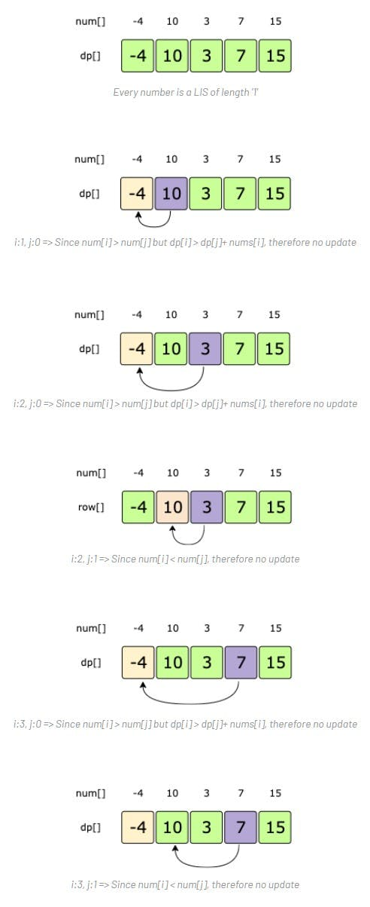

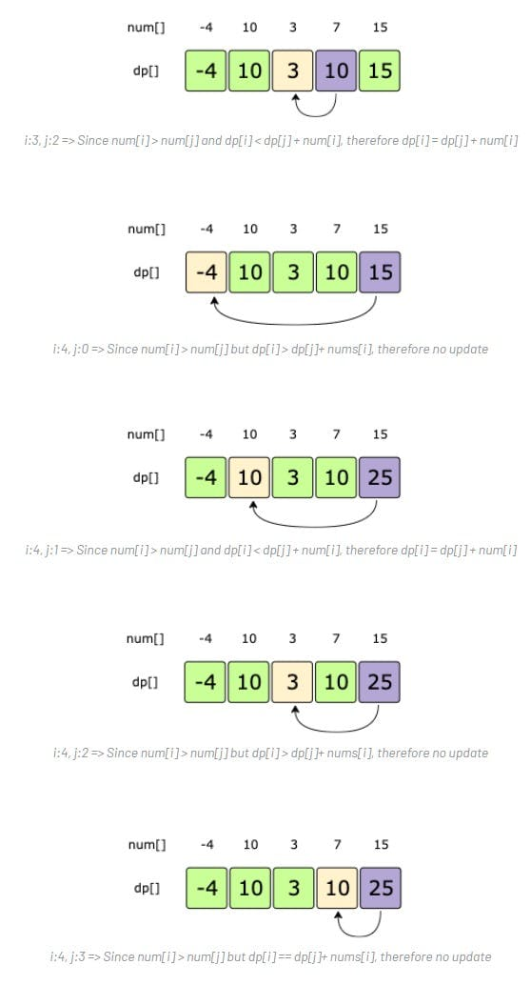

From the above visualization, we can clearly see that the maximum sum of any increasing subsequence is '25' -- as shown by dp[4].

Here is the code for our **bottom-up dynamic programming approach**:

function findMSIS(nums) {

const dp = [nums[0]];

let maxSum = nums[0];

for (let i = 1; i < nums.length; i++) {

dp[i] = nums[i];

for (let j = 0; j < i; j++) {

if (nums[i] > nums[j] && dp[i] < dp[j] + nums[i]) dp[i] = dp[j] + nums[i];

}

// console.log(dp);

maxSum = Math.max(maxSum, dp[i]);

}

return maxSum;

}

console.log(

`Maximum Sum Increasing Subsequence is: ---> ${findMSIS([

4, 1, 2, 6, 10, 1, 12,

])}`

);

// Output: 32

// Explanation: The increaseing sequence is {4,6,10,12}.

// Please note the difference, as the LIS is {1,2,6,10,12} which has a sum of '31'.

console.log(

`Maximum Sum Increasing Subsequence is: ---> ${findMSIS([-4, 10, 3, 7, 15])}`

);

// Output: 25

// Explanation: The increaseing sequences are {10, 15} and {3,7,15}.

console.log(

'Maximum Sum Increasing Subsequence is: ---> ' +

findMSIS([1, 3, 8, 4, 14, 6, 14, 1, 9, 4, 13, 3, 11, 17, 29])

);

#### Java Solution

|  |
| --- |
| public int findMSIS(int[] nums) {  int[] dp = new int[nums.length];  dp[0] = nums[0];  int maxSum = nums[0];  for (int i=1; i<nums.length; i++) {  dp[i] = nums[i];  for (int j=0; j<i; j++) {  if (nums[i] > nums[j] && dp[i] < dp[j] + nums[i])  dp[i] = dp[j] + nums[i];  }  maxSum = Math.max(maxSum, dp[i]);  }  return maxSum;  } |

* The **time complexity** of the above algorithm is is O(n²) and the **space complexity** is O(n).

**Shortest Common Super-sequence**

<https://leetcode.com/problems/shortest-common-supersequence/>

Given two **sequences** s1 and s2, write a method to find the length of the shortest sequence which has s1 and s2 as **subsequences**.

**Example 1:**

Input: s1: "abcf" s2:"bdcf"

Output: 5

Explanation: The shortest common super-sequence (SCS) is "abdcf".

**Example 2:**

Input: s1: "dynamic" s2:"programming"

Output: 15

Explanation: The SCS is "dynprogrammicng".

**Basic Brute-Force Solution**

The problem is quite similar to the [**Longest Common Subsequence**](https://github.com/maazshaikh007/DSA_Patterns/blob/main/%E2%9C%85%20Pattern%2015:%200-1%20Knapsack%20(Dynamic%20Programming).md#%F0%9F%94%8E-longest-common-subsequence).

A **basic brute-force solution** could be to try all the **super-sequences** of the given **sequences**. We can process both of the **sequences** one character at a time, so at any step, we must choose between:

1. If the **sequences** have a matching character, we can skip one character from both the **sequences** and make a *recursive call* for the remaining lengths to get **SCS**.
2. If the strings don’t match, we start two new *recursive calls* by skipping one character separately from each string. The minimum of these two *recursive calls* will have our answer.

Here is the code:

function findSCSLength(s1, s2) {

// **MY THOUGHT PROCESS**

//1 => traverse each string until you find the first common shared char at i

//2 => push s1.substring(0,i) + s2.substring(0,i) onto output string (dyn + progr)

//3 => then check s1[i] against s2[j] push entire length of common char onto output(A)n

//4 => if one is longer push longer length onto output(MM)

//5 => if next char is not shared, find next common shared char and push whateve was not shared onto output(step 1 & 2 again)

//6 => when we reach end of either string push whatever is left from the longer string to output and

//7 => return output

function findSCSLengthRecursive(s1, s2, index1, index2) {

//if we have reached the end of a string

//return the remaining length of the other string

//as in this case we have to take all of the remaining other string

if (index1 === s1.length) return s2.length - index2;

if (index2 === s2.length) return s1.length - index1;

if (s1[index1] === s2[index2])

return 1 + findSCSLengthRecursive(s1, s2, index1 + 1, index2 + 1);

let length1 = 1 + findSCSLengthRecursive(s1, s2, index1, index2 + 1);

let length2 = 1 + findSCSLengthRecursive(s1, s2, index1 + 1, index2);

return Math.min(length1, length2);

}

return findSCSLengthRecursive(s1, s2, 0, 0);

}

console.log(

`Length of Shortest Common Subsequence: Substring: ---> ${findSCSLength(

'dynamic',

'programming'

)}`

);

//Output: 15

// Explanation: The SCS is "dynprogrammicng".

// 'dyn AMI c',

// 'progr AMMI ng'

console.log(

`Length of Shortest Common Subsequence: Substring: ---> ${findSCSLength(

'abcf',

'bdcf'

)}`

);

// Output: 5

// Explanation: The shortest common super-sequence (SCS) is "abdcf".

// aBCF

// 'BdCF'

#### Java Solution

|  |
| --- |
| public int findSCSLength(String s1, String s2) {  return findSCSLengthRecursive(s1, s2, 0, 0);  }  private int findSCSLengthRecursive(String s1, String s2, int i1, int i2) {  // if we have reached the end of a string, return the remaining length of the other string,  // as in this case we have to take all of the remaining other string  if(i1 == s1.length())  return s2.length()-i2;  if(i2 == s2.length())  return s1.length()-i1;  if(s1.charAt(i1) == s2.charAt(i2))  return 1 + findSCSLengthRecursive(s1, s2, i1+1, i2+1);  int length1 = 1 + findSCSLengthRecursive(s1, s2, i1, i2+1);  int length2 = 1 + findSCSLengthRecursive(s1, s2, i1+1, i2);  return Math.min(length1, length2);  } |

* The **time complexity** of the above algorithm is exponential O(2ᵐ⁺ⁿ), where m and n are the lengths of the input **sequences**.
* The **space complexity** is O(m+n) which is used to store the *recursion stack*.

**Top-down Dynamic Programming with Memoization**

Let's use **memoization** to overcome the *overlapping subproblems*.

The two changing values to our **recursive function** are the two indices, index1 and index2. Therefore, we can store the results of all the *subproblems* in a two-dimensional array. (Another alternative could be to use a *hash-table* whose key would be a string (index1 + | + index2)).

Here is the code:

function findSCSLength(s1, s2) {

const dp = [];

function findSCSLengthRecursive(s1, s2, index1, index2) {

//if we have reached the end of a string

//return the remaining length of the other string

//as in this case we have to take all of the remaining other string

if (index1 === s1.length) return s2.length - index2;

if (index2 === s2.length) return s1.length - index1;

dp[index1] = dp[index1] || [];

if (typeof dp[index1][index2] === 'undefined') {

if (s1[index1] === s2[index2]) {

dp[index1][index2] =

1 + findSCSLengthRecursive(s1, s2, index1 + 1, index2 + 1);

} else {

let length1 = 1 + findSCSLengthRecursive(s1, s2, index1, index2 + 1);

let length2 = 1 + findSCSLengthRecursive(s1, s2, index1 + 1, index2);

dp[index1][index2] = Math.min(length1, length2);

}

}

return dp[index1][index2];

}

return findSCSLengthRecursive(s1, s2, 0, 0);

}

console.log(

`Length of Shortest Common Subsequence: Substring: ---> ${findSCSLength(

'dynamic',

'programming'

)}`

);

//Output: 15

// Explanation: The SCS is "dynprogrammicng".

console.log(

`Length of Shortest Common Subsequence: Substring: ---> ${findSCSLength(

'abcf',

'bdcf'

)}`

);

// Output: 5

// Explanation: The shortest common super-sequence (SCS) is "abdcf".

#### Java solution

|  |
| --- |
| public int findSCSLength(String s1, String s2) {  Integer[][] dp = new Integer[s1.length()][s2.length()];  return findSCSLengthRecursive(dp, s1, s2, 0, 0);  }  private int findSCSLengthRecursive(Integer[][] dp, String s1, String s2, int i1, int i2) {  // if we have reached the end of a string, return the remaining length of the other string,  // as in this case we have to take all of the remaining other string  if(i1 == s1.length())  return s2.length()-i2;  if(i2 == s2.length())  return s1.length()-i1;  if(dp[i1][i2] == null) {  if(s1.charAt(i1) == s2.charAt(i2))  dp[i1][i2] = 1 + findSCSLengthRecursive(dp, s1, s2, i1+1, i2+1);  else {  int length1 = 1 + findSCSLengthRecursive(dp, s1, s2, i1, i2+1);  int length2 = 1 + findSCSLengthRecursive(dp, s1, s2, i1+1, i2);  dp[i1][i2] = Math.min(length1, length2);  }  }  return dp[i1][i2];  } |

**Bottom-up Dynamic Programming**

Since we want to match all the **subsequences** of the given **sequences**, we can use a two-dimensional array to store our results. The lengths of the two strings will define the size of the array’s dimensions. So for every index i in sequence s1 and j in sequence s2, we will choose one of the following two options:

1. If the character s1[i] matches s2[j], the length of the **SCS** would be the one plus the length of the **SCS** until i-1 and j-1 indices in the two strings.
2. If the character s1[i] does not match s2[j], we will consider two **SCS**:

* one without s1[i] and one without s2[j].
* Our required **SCS** length will be the shortest of these two super-sequences plus one.

So our **recursive formula** would be:

**if s1[i] == s2[j]**

**dp[i][j] = 1 + dp[i-1][j-1]**

**else**

**dp[i][j] = 1 + min(dp[i-1][j], dp[i][j-1])**

Let’s draw this visually for “abcf” and “bdcf”. Starting with a subsequence of zero length. As we can see, if any strings have zero length, then the shortest super-sequence would be equal to the length of the other string:

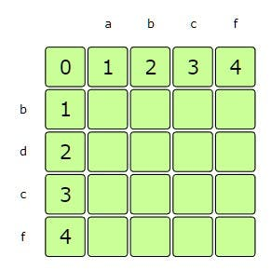

if one of the strings is of zero length, SCS would be equal to the length of the other string

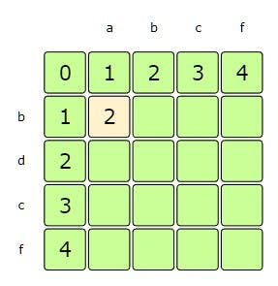

i=1, j=1 => since s1[i-1] != s2[j-1], therefore dp[i][j] = 1 + min(dp[i-1][j], dp[i][j-1])

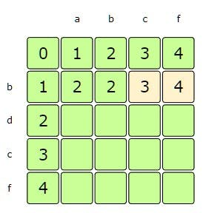

i=1, j=3-4 => since s1[i] != s2[j], therefore dp[i][j] = 1 + min(dp[i-1][j], dp[i][j-1])

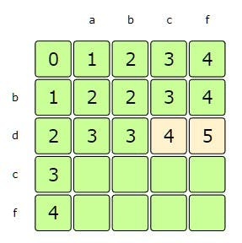

i=2, j=3-4 => since s1[i] != s2[j], therefore dp[i][j] = 1 + min(dp[i-1][j], dp[i][j-1])

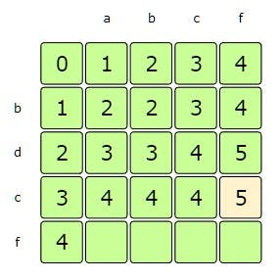

i=3, j=4 => since s1[i-1] == s2[j-1], therefore dp[i][j] = 1 + dp[i-1][j-1]

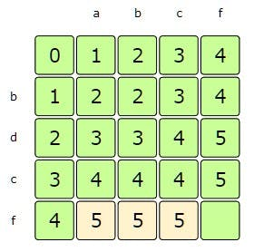

i=4, j=1-3 => since s1[i] != s2[j], therefore dp[i][j] = 1 + min(dp[i-1][j], dp[i][j-1])

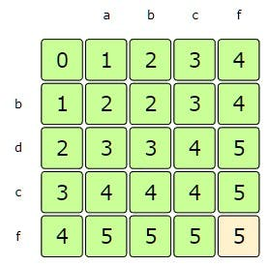

i=4, j=4 => since s1[i-1] == s2[j-1], therefore dp[i][j] = 1 + dp[i-1][j-1]

From the above visualization, we can clearly see that the longest increasing subsequence is of length '5' -- as shown by dp[4][4].

Here is the code for our **bottom-up dynamic programming** approach:

function findSCSLength(s1, s2) {

const dp = Array(s1.length + 1)

.fill(0)

.map(() => Array(s2.length + 1).fill(0));

// if one of the strings is of zero length

// SCS would be equl to the length of the other string

for (let i = 0; i <= s1.length; i++) {

dp[i][0] = i;

for (let j = 0; j <= s2.length; j++) {

dp[0][j] = j;

}

}

for (let i = 1; i <= s1.length; i++) {

for (let j = 1; j <= s2.length; j++) {

if (s1.charAt(i - 1) === s2.charAt(j - 1)) {

dp[i][j] = 1 + dp[i - 1][j - 1];

} else {

dp[i][j] = 1 + Math.min(dp[i - 1][j], dp[i][j - 1]);

}

}

}

console.log(dp);

return dp[s1.length][s2.length];

}

console.log(

`Length of Shortest Common Subsequence: Substring: ---> ${findSCSLength(

'dynamic',

'programming'

)}`

);

//Output: 15

// Explanation: The SCS is "dynprogrammicng".

console.log(

`Length of Shortest Common Subsequence: Substring: ---> ${findSCSLength(

'abcf',

'bdcf'

)}`

);

// Output: 5

// Explanation: The shortest common super-sequence (SCS) is "abdcf".

#### Java Solution

|  |
| --- |
| public int findSCSLength(String s1, String s2) {  int[][] dp = new int[s1.length()+1][s2.length()+1];    // if one of the strings is of zero length, SCS would be equal to the length of the other string  for(int i=0; i<=s1.length(); i++)  dp[i][0] = i;  for(int j=0; j<=s2.length(); j++)  dp[0][j] = j;  for(int i=1; i <= s1.length(); i++) {  for(int j=1; j <= s2.length(); j++) {  if(s1.charAt(i-1) == s2.charAt(j-1))  dp[i][j] = 1 + dp[i-1][j-1];  else  dp[i][j] = 1 + Math.min(dp[i-1][j], dp[i][j-1]);  }  }  return dp[s1.length()][s2.length()];  } |

* The **time and space complexity** of the above algorithm is O(n*m).

**Minimum Deletions to Make a Sequence Sorted**

<https://www.geeksforgeeks.org/minimum-number-deletions-make-sorted-sequence/>

Given a number **sequence**, find the minimum number of elements that should be deleted to make the remaining **sequence** sorted.

**Example 1:**

Input: {4,2,3,6,10,1,12}

Output: 2

Explanation: We need to delete {4,1} to make the remaing sequence sorted {2,3,6,10,12}.

**Example 2:**

Input: {-4,10,3,7,15}

Output: 1

Explanation: We need to delete {10} to make the remaing sequence sorted {-4,3,7,15}.

**Example 3:**

Input: {3,2,1,0}

Output: 3

Explanation: Since the elements are in reverse order, we have to delete all except one to get a

sorted sequence. Sorted sequences are {3}, {2}, {1}, and {0}

**Basic Brute-force Solution**

A **basic brute-force solution** could be to try deleting all combinations of elements, one by one, and checking if that makes the **subsequence** sorted.

Alternately, we can convert this problem into a [**Longest Increasing Subsequence (LIS)**](https://github.com/maazshaikh007/DSA_Patterns/blob/main/%E2%9C%85%20Pattern%2015:%200-1%20Knapsack%20(Dynamic%20Programming).md#%F0%9F%91%A9%F0%9F%8F%BD%E2%80%8D%F0%9F%A6%AF-%F0%9F%94%8E-longest-increasing-subsequence) problem. As we know that **LIS** will give us the length of the **longest increasing subsequence** (in the sorted order!), which means that the elements which are not part of the **LIS** should be removed to make the **sequence** sorted. This is exactly what we need. So we’ll get our solution by subtracting the length of **LIS** from the length of the input array: Length-of-input-array - LIS()

Let’s jump directly to the **bottom-up dynamic programming** solution.

**Bottom-up Dynamic Programming**

Here is the code for our **bottom-up dynamic programming** approach:

function findMinimumDeletions(nums) {

/* Given a number sequence, find the minimum number of elements

that should be deleted to make the remaining sequence sorted. */

/*MY THOUGHT PROCESS*/

// check currIndex and prevIndex,

// case 1 => if currIndex and prevIndex are sorted increase currIndex and prevIndex and try to extend subsequence

// case 2 => if currIndex and prevIndex are not sorted,

// SKIP currIndex and check prevIndex is sorted in comparison to currIndex + 1, increment deletions counter

/**/

// substracting the length of the LIS from the length of the input array to

// get the minimum number of deletions

return nums.length - findLISLength(nums);

function findLISLength(nums) {

const dp = Array(nums.length).fill(0);

dp[0] = 1;

let maxLength = 1;

for (let i = 1; i < nums.length; i++) {

dp[i] = 1;

for (let j = 0; j < i; j++) {

// console.log(dp[i], i, dp[j], j)

if (nums[i] > nums[j] && dp[i] <= dp[j]) {

dp[i] = dp[j] + 1;

maxLength = Math.max(maxLength, dp[i]);

// console.log(dp)

}

}

}

return maxLength;

}

}

console.log(

`Minimum deletion needed: ---> ${findMinimumDeletions([

4, 2, 3, 6, 10, 1, 12,

])}`

);

// Output: 2

// Explanation: We need to delete {4,1} to make the remaing sequence sorted {2,3,6,10,12}.

console.log(

`Minimum deletion needed: ---> ${findMinimumDeletions([-4, 10, 3, 7, 15])}`

);

// Output: 1

// Explanation: We need to delete {10} to make the remaing sequence sorted {-4,3,7,15}.

console.log(

`Minimum deletion needed: ---> ${findMinimumDeletions([3, 2, 1, 0])}`

);

// Output: 3

// Explanation: Since the elements are in reverse order, we have to delete all except one to get a sorted sequence. Sorted sequences are {3}, {2}, {1}, and {0}

#### Java Solution

|  |
| --- |
| public int findMinimumDeletions(int[] nums){  // subtracting the length of LIS from the length of the input array to get minimum number of deletions  return nums.length - findLISLength(nums);  }  private int findLISLength(int[] nums) {  int[] dp = new int[nums.length];  dp[0] = 1;  int maxLength = 1;  for (int i=1; i<nums.length; i++) {  dp[i] = 1;  for (int j=0; j<i; j++)  if (nums[i] > nums[j] && dp[i] <= dp[j] ) {  dp[i] = dp[j]+1;  maxLength = Math.max(maxLength, dp[i]);  }  }  return maxLength;  } |

* The **time complexity** of the above algorithm is is O(n²) and the **space complexity** is O(n).

**Longest Repeating Subsequence**

<https://www.geeksforgeeks.org/longest-repeating-subsequence/>

Given a **sequence**, find the length of its **longest repeating subsequence (LRS)**. A **repeating subsequence** will be *the one that appears at least twice in the original****sequence****and is not overlapping (i.e. none of the corresponding characters in the repeating subsequences have the same index)*.

**Example 1:**

Input: “t o m o r r o w”

Output: 2

Explanation: The longest repeating subsequence is “or” {tomorrow}.

**Example 2:**

Input: “a a b d b c e c”

Output: 3

Explanation: The longest repeating subsequence is “a b c” {a a b d b c e c}.

**Example 3:**

Input: “f m f f”

Output: 2

Explanation: The longest repeating subsequence is “f f” {f m f f, f m f f}.

Please note the second last character is shared in LRS.

**Basic Brute-Force Solution**

The problem is quite similar to the [**Longest Common Subsequence (LCS)**](https://github.com/maazshaikh007/DSA_Patterns/blob/main/%E2%9C%85%20Pattern%2015:%200-1%20Knapsack%20(Dynamic%20Programming).md#%F0%9F%94%8E-longest-common-subsequence), with two differences:

1. In **LCS**, we were trying to find the **longest common subsequence** between the *two strings*, whereas in **LRS** we are trying to find the **two longest common subsequences** within *one string*.
2. In **LRS**, every corresponding character in the **subsequences** should not have the same *index*.

A **basic brute-force solution** could be to try all **subsequences** of the given **sequence** to find *the longest repeating one*, but the problem is how to ensure that the **LRS**’s characters do not have the *same index*. For this, we can start with two *indices* in the given **sequence**, so at any step we have two choices:

1. If the *two indices* are not the same and the characters at both the *indices* are same, we can **recursively** match for the remaining length (i.e. by incrementing both the *indices*).
2. If the characters at both the *indices* don’t match, we start two new **recursive calls** by incrementing each *index* separately. The **LRS** would be the one with the highest length from the two **recursive calls**.

Here is the code:

function findLRSLength(str) {

/*Given a sequence, find the length of its longest repeating subsequence (LRS). A repeating subsequence will be the one that appears at least twice in the original sequence and is not overlapping (i.e. none of the corresponding characters in the repeating subsequences have the same index). */

/*MY THOUGHT PROCESS*/

// 1 => start with initial index, go through string and check if that char repeats

// 2 => if it does repeat it could potentially be part of the LRS

// 3 => repeat step one for each char

/**/

function findLRSLengthRecursive(str, index1, index2) {

//base case => 0 length or end of str

if (index1 === str.length || index2 === str.length) return 0;

if (index1 !== index2 && str[index1] === str[index2])

return 1 + findLRSLengthRecursive(str, index1 + 1, index2 + 1);

const call1 = findLRSLengthRecursive(str, index1 + 1, index2);

const call2 = findLRSLengthRecursive(str, index1, index2 + 1);

return Math.max(call1, call2);

}

return findLRSLengthRecursive(str, 0, 0);

}

console.log(

`Length of Longest Repeating Subsequence: ---> ${findLRSLength('tomorrow')}`

);

// Output: 2

// Explanation: The longest repeating subsequence is “or” {tomorrow}.

// tOmORROw

console.log(

`Length of Longest Repeating Subsequence: ---> ${findLRSLength('aabdbcec')}`

);

// Output: 3

// Explanation: The longest repeating subsequence is “a b c” {a a b d b c e c}.

// A A B d B C e C

console.log(

`Length of Longest Repeating Subsequence: ---> ${findLRSLength('fmff')}`

);

// Output: 2

// Explanation: The longest repeating subsequence is “f f” {f m f f, f m f f}. Please note the second last character is shared in LRS.

// FmFF

#### Java Solution

|  |
| --- |
| public int findLRSLength(String str) {  return findLRSLengthRecursive(str, 0, 0);  }  private int findLRSLengthRecursive(String str, int i1, int i2) {  if(i1 == str.length() || i2 == str.length())  return 0;  if(i1 != i2 && str.charAt(i1) == str.charAt(i2))  return 1 + findLRSLengthRecursive(str, i1+1, i2+1);  int c1 = findLRSLengthRecursive(str, i1, i2+1);  int c2 = findLRSLengthRecursive(str, i1+1, i2);  return Math.max(c1, c2);  } |

* The **time complexity** of the above algorithm is exponential O(2ⁿ), where n is the lengths of the input **sequence**.
* The **space complexity** is O(n) which is used to store the *recursion stack*.

**Top-down Dynamic Programming with Memoization**

We can use an array to store the already solved **subproblems**.

The two changing values to our **recursive** function are the two *indices*, index1 and index2. Therefore, we can store the results of all the **subproblems** in a two-dimensional array. (Another alternative could be to use a **hash-table** whose key would be a string (index1 + “|” + index2)).

Here is the code:

function findLRSLength(str) {

const dp = [];

function findLRSLengthRecursive(str, index1, index2) {

//base case => 0 length or end of str

if (index1 === str.length || index2 === str.length) return 0;

dp[index1] = dp[index1] || [];

if (index1 !== index2 && str[index1] === str[index2])

dp[index1][index2] =

1 + findLRSLengthRecursive(str, index1 + 1, index2 + 1);

else {

let call1 = findLRSLengthRecursive(str, index1 + 1, index2);

let call2 = findLRSLengthRecursive(str, index1, index2 + 1);

dp[index1][index2] = Math.max(call1, call2);

}

return dp[index1][index2];

}

return findLRSLengthRecursive(str, 0, 0);

}

console.log(

`Length of Longest Repeating Subsequence: ---> ${findLRSLength('tomorrow')}`

);

// Output: 2

// Explanation: The longest repeating subsequence is “or” {tomorrow}.

console.log(

`Length of Longest Repeating Subsequence: ---> ${findLRSLength('aabdbcec')}`

);

// Output: 3

// Explanation: The longest repeating subsequence is “a b c” {a a b d b c e c}.

console.log(

`Length of Longest Repeating Subsequence: ---> ${findLRSLength('fmff')}`

);

// Output: 2

// Explanation: The longest repeating subsequence is “f f” {f m f f, f m f f}. Please note the second last character is shared in LRS.

#### Java Solution

|  |
| --- |
| public int findLRSLength(String str) {  Integer[][] dp = new Integer[str.length()][str.length()];  return findLRSLengthRecursive(dp, str, 0, 0);  }  private int findLRSLengthRecursive(Integer[][] dp, String str, int i1, int i2) {  if(i1 == str.length() || i2 == str.length())  return 0;  if(dp[i1][i2] == null) {  if(i1 != i2 && str.charAt(i1) == str.charAt(i2))  dp[i1][i2] = 1 + findLRSLengthRecursive(dp, str, i1+1, i2+1);  else {  int c1 = findLRSLengthRecursive(dp, str, i1, i2+1);  int c2 = findLRSLengthRecursive(dp, str, i1+1, i2);  dp[i1][i2] = Math.max(c1, c2);  }  }  return dp[i1][i2];  } |

**Bottom-up Dynamic Programming**

Since we want to match all the **subsequences** of the given string, we can use a two-dimensional array to store our results. As mentioned above, we will be tracking two *indices* to overcome the overlapping problem. So for each of the two *indices*, index1 and index2, we will choose one of the following options:

1. If index1 and index2 are different and the character str[index1] matches the character str[index2], then the length of the **LRS** would be one plus the length of **LRS** up to index1-1 and index2-1 *indices*.
2. If the character at str[index1] does not match str[index2], we will take the **LRS** by either skipping index1th or index2th character.

So our **recursive formula** would be:

**if index1 != index2 && str[index1] == str[index2]**

**dp[index1][index2] = 1 + dp[index1-1][index2-1]**

**else**

**dp[index1][index2] = max(dp[index1-1][index2], dp[index1][index2-1])**

Here is the code for our **bottom-up dynamic programming** approach:

function findLRSLength(str) {

const dp = Array(str.length + 1)

.fill(0)

.map(() => Array(str.length + 1).fill(0));

let maxLength = 0;

// dp[index1][index2] will be storing the LRS up to str[0... index1-1][0... index2-1]

// this also means that subsequences of length 0(first row and column of dp[][])

// will always have a LRS of size 0

for (let index1 = 1; index1 <= str.length; index1++) {

for (let index2 = 1; index2 <= str.length; index2++) {

if (index1 !== index2 && str[index1 - 1] === str[index2 - 1]) {

dp[index1][index2] = 1 + dp[index1 - 1][index2 - 1];

} else {

dp[index1][index2] = Math.max(

dp[index1 - 1][index2],

dp[index1][index2 - 1]

);

}

maxLength = Math.max(maxLength, dp[index1][index2]);

}

}

return maxLength;

}

console.log(

`Length of Longest Repeating Subsequence: ---> ${findLRSLength('tomorrow')}`

);

// Output: 2

// Explanation: The longest repeating subsequence is “or” {tomorrow}.

console.log(

`Length of Longest Repeating Subsequence: ---> ${findLRSLength('aabdbcec')}`

);

// Output: 3

// Explanation: The longest repeating subsequence is “a b c” {a a b d b c e c}.

console.log(

`Length of Longest Repeating Subsequence: ---> ${findLRSLength('fmff')}`

);

// Output: 2

// Explanation: The longest repeating subsequence is “f f” {f m f f, f m f f}. Please note the second last character is shared in LRS.

#### Java Solution

|  |
| --- |
| public int findLRSLength(String str) {  int[][] dp = new int[str.length()+1][str.length()+1];  int maxLength = 0;  // dp[i1][i2] will be storing the LRS up to str[0..i1-1][0..i2-1]  // this also means that subsequences of length zero (first row and column of dp[][]),  // will always have LRS of size zero.  for(int i1=1; i1 <= str.length(); i1++) {  for(int i2=1; i2 <= str.length(); i2++) {  if(i1 != i2 && str.charAt(i1-1) == str.charAt(i2-1))  dp[i1][i2] = 1 + dp[i1-1][i2-1];  else  dp[i1][i2] = Math.max(dp[i1-1][i2], dp[i1][i2-1]);    maxLength = Math.max(maxLength, dp[i1][i2]);  }  }  return maxLength;  } |

* The **time complexity and space complexity** of the above algorithm is is O(n²).

**Subsequence Pattern Matching**

<https://www.geeksforgeeks.org/find-number-times-string-occurs-given-string/>

Given a string and a pattern, write a method to count the number of times the pattern appears in the string as a **subsequence**.

**Example 1:**

Input: string: “baxmx”, pattern: “ax”

Output: 2

Explanation: {baxmx, baxmx}.

**Example 2:**

Input: string: “tomorrow”, pattern: “tor”

Output: 4

Explanation: Following are the four occurrences: {tomorrow, tomorrow, tomorrow, tomorrow}.

**Basic Brute-force Solution**

This problem follows the [**Longest Common Subsequence (LCS) pattern**](https://github.com/maazshaikh007/DSA_Patterns/blob/main/%E2%9C%85%20Pattern%2015:%200-1%20Knapsack%20(Dynamic%20Programming).md#pattern-5-longest-common-substring) and is quite similar to the [**Longest Repeating Subsequence**](https://github.com/maazshaikh007/DSA_Patterns/blob/main/%E2%9C%85%20Pattern%2015:%200-1%20Knapsack%20(Dynamic%20Programming).md#longest-repeating-subsequence); the difference is that we need to count the total occurrences of the **subsequence**.

A **basic brute-force solution** could be to try all the **subsequences** of the given string to count all that match the given pattern. We can match the pattern with the given string one character at a time, so we can do two things at any step:

1. If the pattern has a matching character with the string, we can **recursively** match for the remaining lengths of the pattern and the string.
2. At every step, we can always skip a character from the string to try to match the remaining string with the pattern. So we can start a **recursive call** by skipping one character from the string.

Our total count will be the sum of the counts returned by the above two options.

Here is the code:

function findSPMCount(str, pattern) {

function findSPMCountRecursive(str, pattern, strIndex, patternIndex) {

// base case => if we have reached the end of the pattern

if (patternIndex === pattern.length) return 1;

// base case => if we have reached the end of the str

// but pattern has some chars left

if (strIndex === str.length) return 0;

let count1 = 0;

if (str[strIndex] === pattern[patternIndex]) {

count1 = findSPMCountRecursive(

str,

pattern,

strIndex + 1,

patternIndex + 1

);

}

let count2 = findSPMCountRecursive(

str,

pattern,

strIndex + 1,

patternIndex

);

return count1 + count2;

}

return findSPMCountRecursive(str, pattern, 0, 0);

}

console.log(

`Count of pattern in the string: ---> ${findSPMCount('baxmx', 'ax')}`

);

// Output: 2

// Explanation: {baxmx, baxmx}.

console.log(

`Count of pattern in the string: ---> ${findSPMCount('tomorrow', 'tor')}`

);

// Output: 4

// Explanation: Following are the four occurences: {tomorrow, tomorrow, tomorrow, tomorrow}.

#### Java Solution

|  |
| --- |
| public int findSPMCount(String str, String pat) {  return findSPMCountRecursive(str, pat, 0, 0);  }  private int findSPMCountRecursive(String str, String pat, int strIndex, int patIndex) {  // if we have reached the end of the pattern  if(patIndex == pat.length())  return 1;  // if we have reached the end of the string but pattern has still some characters left  if(strIndex == str.length())  return 0;  int c1 = 0;  if(str.charAt(strIndex) == pat.charAt(patIndex))  c1 = findSPMCountRecursive(str, pat, strIndex+1, patIndex+1);  int c2 = findSPMCountRecursive(str, pat, strIndex+1, patIndex);  return c1 + c2;  } |

* The **time complexity** of the above algorithm is exponential O(2ᵐ), where m is the length of the string, as our *recursion stack* will not be deeper than m. The **space complexity** is O(m) which is used to store the *recursion stack*.

**Top-down Dynamic Programming with Memoization**

We can use an array to store the already solved *subproblems*.

The two changing values to our **recursive function** are the two *indices* strIndex and patternIndex. Therefore, we can store the results of all the *subproblems* in a two-dimensional array. (Another alternative could be to use a **hash-table** whose key would be a string (strIndex + “|” + patternIndex)).

Here is the code:

function findSPMCount(str, pattern) {

const dp = [];

function findSPMCountRecursive(str, pattern, strIndex, patternIndex) {

// base case => if we have reached the end of the pattern

if (patternIndex === pattern.length) return 1;

// base case => if we have reached the end of the str

// but pattern has some chars left

if (strIndex === str.length) return 0;

dp[strIndex] = dp[strIndex] || [];

let count1 = 0;

if (str.charAt(strIndex) === pattern.charAt(patternIndex)) {

count1 = findSPMCountRecursive(

str,

pattern,

strIndex + 1,

patternIndex + 1

);

}

let count2 = findSPMCountRecursive(

str,

pattern,

strIndex + 1,

patternIndex

);

dp[strIndex][patternIndex] = count1 + count2;

return dp[strIndex][patternIndex];

}

return findSPMCountRecursive(str, pattern, 0, 0);

}

console.log(

`Count of pattern in the string: ---> ${findSPMCount('baxmx', 'ax')}`

);

// Output: 2

// Explanation: {baxmx, baxmx}.

console.log(

`Count of pattern in the string: ---> ${findSPMCount('tomorrow', 'tor')}`

);

// Output: 4

// Explanation: Following are the four occurences: {tomorrow, tomorrow, tomorrow, tomorrow}.

#### Java Solution

|  |
| --- |
| public int findSPMCount(String str, String pat) {  Integer[][] dp = new Integer[str.length()][pat.length()];  return findSPMCountRecursive(dp, str, pat, 0, 0);  }  private int findSPMCountRecursive(Integer[][] dp, String str, String pat, int strIndex, int patIndex) {  // if we have reached the end of the pattern  if(patIndex == pat.length())  return 1;  // if we have reached the end of the string but pattern has still some characters left  if(strIndex == str.length())  return 0;  if(dp[strIndex][patIndex] == null) {  int c1 = 0;  if(str.charAt(strIndex) == pat.charAt(patIndex))  c1 = findSPMCountRecursive(dp, str, pat, strIndex+1, patIndex+1);  int c2 = findSPMCountRecursive(dp, str, pat, strIndex+1, patIndex);  dp[strIndex][patIndex] = c1 + c2;  }  return dp[strIndex][patIndex];  } |

**Bottom-up Dynamic Programming**

Since we want to match all the **subsequences** of the given string, we can use a two-dimensional array to store our results. As mentioned above, we will be tracking separate *indices* for the string and the pattern, so we will be doing two things for every value of strIndex and patternIndex:

1. If the character at the strIndex (in the string) matches the character at patIndex (in the pattern), the count of the **SPM** would be equal to the count of **SPM** up to strIndex-1 and patternIndex-1.
2. At every step, we can always skip a character from the string to try matching the remaining string with the pattern; therefore, we can add the **SPM** count from the *indices* strIndex-1 and patternIndex.

So our **recursive formula** would be:

**if str[strIndex] == pat[patIndex] {**

**dp[strIndex][patIndex] = dp[strIndex-1][patIndex-1]**

**}**

**dp[strIndex][patIndex] += dp[strIndex-1][patIndex]**

Here is the code for our **bottom-up dynamic programming** approach:

function findSPMCount(str, pattern) {

//every empty pattern has one match

if (pattern.length === 0) return 1;

if (str.length === 0 || pattern.length > str.length) return 0;

// dp[strIndex][patIndex] will be storing the count of SPM up to str[0..strIndex-1][0..patIndex-1]

const dp = Array(str.length + 1)

.fill(0)

.map(() => Array(pattern.length + 1).fill(0));

// for the empty pattern, we have one matching

for (let i = 0; i <= str.length; i++) dp[i][0] = 1;

for (let strIndex = 1; strIndex <= str.length; strIndex++) {

for (let patternIndex = 1; patternIndex <= pattern.length; patternIndex++) {

if (str[strIndex - 1] === pattern[patternIndex - 1]) {

dp[strIndex][patternIndex] = dp[strIndex - 1][patternIndex - 1];

}

dp[strIndex][patternIndex] += dp[strIndex - 1][patternIndex];

}

}

return dp[str.length][pattern.length];

}

console.log(

`Count of pattern in the string: ---> ${findSPMCount('baxmx', 'ax')}`

);

// Output: 2

// Explanation: {baxmx, baxmx}.

console.log(

`Count of pattern in the string: ---> ${findSPMCount('tomorrow', 'tor')}`

);

// Output: 4

// Explanation: Following are the four occurences: {tomorrow, tomorrow, tomorrow, tomorrow}.

#### Java Solution

|  |
| --- |
| public int findSPMCount(String str, String pat) {  // every empty pattern has one match  if(pat.length() == 0)  return 1;    if(str.length() == 0 || pat.length() > str.length())  return 0;  // dp[strIndex][patIndex] will be storing the count of SPM up to str[0..strIndex-1][0..patIndex-1]  int[][] dp = new int[str.length()+1][pat.length()+1];  // for the empty pattern, we have one matching  for(int i=0; i<=str.length(); i++)  dp[i][0] = 1;  for(int strIndex=1; strIndex<=str.length(); strIndex++) {  for(int patIndex=1; patIndex<=pat.length(); patIndex++) {  if(str.charAt(strIndex-1) == pat.charAt(patIndex-1))  dp[strIndex][patIndex] = dp[strIndex-1][patIndex-1];  dp[strIndex][patIndex] += dp[strIndex-1][patIndex];  }  }  return dp[str.length()][pat.length()];  } |

* The **time and space complexity** of the above algorithm is O(m*n), where m and n are the lengths of the string and the pattern respectively.

**Longest Bitonic Subsequence**

<https://www.geeksforgeeks.org/longest-bitonic-subsequence-dp-15/>

Given a number sequence, find the length of its **Longest Bitonic Subsequence (LBS)**. *A****subsequence****is considered****bitonic****if it is monotonically increasing and then monotonically decreasing*.

**Example 1:**

Input: {4,2,3,6,10,1,12}

Output: 5

Explanation: The LBS is {2,3,6,10,1}.

**Example 2:**

Input: {4,2,5,9,7,6,10,3,1}

Output: 7

Explanation: The LBS is {4,5,9,7,6,3,1}.

**Basic Solution**

A **basic brute-force solution** could be to try finding the **Longest Decreasing Subsequences (LDS)**, starting from every number in both directions. So for every index i in the given array, we will do two things:

1. Find **LDS** starting from i to the end of the array.
2. Find **LDS** starting from i to the beginning of the array.

**Longest Bitonic Subsequence (LBS)** would be the maximum sum of the above two *subsequences*.

Here is the code:

function findLBSLength(nums) {

let maxLength = 0;

for (let i = 0; i < nums.length; i++) {

const checkIndexToEnd = findLDSLength(nums, i, -1);

const checkIndexToStart = findLDSLengthReverse(nums, i, -1);

// console.log(checkIndexToEnd, checkIndexToStart, checkIndexToEnd + checkIndexToStart - 1)

maxLength = Math.max(maxLength, checkIndexToEnd + checkIndexToStart - 1);

}

return maxLength;

}

function findLDSLength(nums, currIndex, prevIndex) {

//find the longest decreasing subsequence from

//currIndex to the end of the array

if (currIndex === nums.length) return 0;

//include nums[currIndex] if it is smaller than previous number

let checkWithCurrIndex = 0;

if (prevIndex == -1 || nums[currIndex] < nums[prevIndex]) {

checkWithCurrIndex = 1 + findLDSLength(nums, currIndex + 1, currIndex);

}

//excluding the number at currIndex

let checkExcludingCurrIndex = findLDSLength(nums, currIndex + 1, prevIndex);

return Math.max(checkWithCurrIndex, checkExcludingCurrIndex);

}

function findLDSLengthReverse(nums, currIndex, prevIndex) {

//find the longest decreasing subsequence from

//currIndex to the beginning of the array

if (currIndex < 0) return 0;

// include nums[currIndex] if it is smaller than the prev number

let checkWithCurrIndex = 0;

if (prevIndex == -1 || nums[currIndex] < nums[prevIndex]) {

checkWithCurrIndex =

1 + findLDSLengthReverse(nums, currIndex - 1, currIndex);

}

//excluding the number at currIndex

let checkExcludingCurrIndex = findLDSLengthReverse(

nums,

currIndex - 1,

prevIndex

);

return Math.max(checkWithCurrIndex, checkExcludingCurrIndex);

}

console.log(

`Length of Longest Bitonic Subsequence: ---> ${findLBSLength([

4, 2, 3, 6, 10, 1, 12,

])}`

);

// Output: 5

// Explanation: The LBS is {2,3,6,10,1}.

console.log(

`Length of Longest Bitonic Subsequence: ---> ${findLBSLength([

4, 2, 5, 9, 7, 6, 10, 3, 1,

])}`

);

// Output: 7

// Explanation: The LBS is {4,5,9,7,6,3,1}.

#### Java Solution

|  |
| --- |
| private int findLBSLength(int[] nums) {  int maxLength = 0;  for(int i=0; i<nums.length; i++) {  int c1 = findLDSLength(nums, i, -1);  int c2 = findLDSLengthRev(nums, i, -1);  maxLength = Math.max(maxLength, c1+c2-1);  }  return maxLength;  }  // find the longest decreasing subsequence from currentIndex till the end of the array  private int findLDSLength(int[] nums, int currentIndex, int previousIndex) {  if(currentIndex == nums.length)  return 0;  // include nums[currentIndex] if it is smaller than the previous number  int c1 = 0;  if(previousIndex == -1 || nums[currentIndex] < nums[previousIndex])  c1 = 1 + findLDSLength(nums, currentIndex+1, currentIndex);  // excluding the number at currentIndex  int c2 = findLDSLength(nums, currentIndex+1, previousIndex);  return Math.max(c1, c2);  }  // find the longest decreasing subsequence from currentIndex till the beginning of the array  private int findLDSLengthRev(int[] nums, int currentIndex, int previousIndex) {  if(currentIndex < 0)  return 0;  // include nums[currentIndex] if it is smaller than the previous number  int c1 = 0;  if(previousIndex == -1 || nums[currentIndex] < nums[previousIndex])  c1 = 1 + findLDSLengthRev(nums, currentIndex-1, currentIndex);  // excluding the number at currentIndex  int c2 = findLDSLengthRev(nums, currentIndex-1, previousIndex);  return Math.max(c1, c2);  } |

* The **time complexity** of the above algorithm is exponential O(2ⁿ), where n is the lengths of the input array.
* The **space complexity** is O(n) which is used to store the *recursion stack*.

**Top-down Dynamic Programming with Memoization**

To overcome the **overlapping subproblems**, we can use an array to store the already solved **subproblems**.

We need to **memoize** the *recursive functions* that calculate the **longest decreasing subsequence**. The two changing values for our *recursive function* are the current and the previous index. Therefore, we can store the results of all **subproblems** in a two-dimensional array. (Another alternative could be to use a *hash-table* whose key would be a string (currIndex + “|” + prevIndex)).

Here is the code:

### Code

|  |
| --- |
| private int findLBSLengthMemoization(int[] nums) {  Integer[][] lds = new Integer[nums.length][nums.length+1];  Integer[][] ldsRev = new Integer[nums.length][nums.length+1];  int maxLength = 0;  for(int i=0; i<nums.length; i++) {  int c1 = findLDSLength(lds, nums, i, -1);  int c2 = findLDSLengthReverse(ldsRev, nums, i, -1);  maxLength = Math.max(maxLength, c1+c2-1);  }  return maxLength;  }  // find the longest decreasing subsequence from currentIndex till the end of the array  private int findLDSLength(Integer[][] dp, int[] nums, int currentIndex, int previousIndex) {  if(currentIndex == nums.length)  return 0;  if(dp[currentIndex][previousIndex+1] == null) {  // include nums[currentIndex] if it is smaller than the previous number  int c1 = 0;  if(previousIndex == -1 || nums[currentIndex] < nums[previousIndex])  c1 = 1 + findLDSLength(dp, nums, currentIndex+1, currentIndex);  // excluding the number at currentIndex  int c2 = findLDSLength(dp, nums, currentIndex+1, previousIndex);  dp[currentIndex][previousIndex+1] = Math.max(c1, c2);  }  return dp[currentIndex][previousIndex+1];  }  // find the longest decreasing subsequence from currentIndex till the beginning of the array  private int findLDSLengthReverse(Integer[][] dp, int[] nums, int currentIndex, int previousIndex) {  if(currentIndex < 0)  return 0;  if(dp[currentIndex][previousIndex+1] == null) {  // include nums[currentIndex] if it is smaller than the previous number  int c1 = 0;  if(previousIndex == -1 || nums[currentIndex] < nums[previousIndex])  c1 = 1 + findLDSLengthReverse(dp, nums, currentIndex-1, currentIndex);  // excluding the number at currentIndex  int c2 = findLDSLengthReverse(dp, nums, currentIndex-1, previousIndex);  dp[currentIndex][previousIndex+1] = Math.max(c1, c2);  }  return dp[currentIndex][previousIndex+1];  } |

**Bottom-up Dynamic Programming**

The above algorithm shows us a clear **bottom-up approach**. We can separately calculate **LDS** for every index i.e., from the beginning to the end of the array and vice versa. The required length of **LBS** would be the one that has the maximum sum of **LDS** for a given index (from both ends).

Here is the code for our **bottom-up dynamic programming approach**:

### Code

|  |
| --- |
| private int findLBSLengthTabulation(int[] nums) {  int[] lds = new int[nums.length];  int[] ldsReverse = new int[nums.length];  // find LDS for every index up to the beginning of the array  for (int i = 0; i < nums.length; i++) {  lds[i] = 1; // every element is an LDS of length 1  for (int j = i - 1; j >= 0; j--)  if (nums[j] < nums[i]) {  lds[i] = Math.max(lds[i], lds[j] + 1);  }  }  // find LDS for every index up to the end of the array  for (int i = nums.length - 1; i >= 0; i--) {  ldsReverse[i] = 1; // every element is an LDS of length 1  for (int j = i + 1; j < nums.length; j++)  if (nums[j] < nums[i]) {  ldsReverse[i] = Math.max(ldsReverse[i], ldsReverse[j] + 1);  }  }  int maxLength = 0;  for (int i = 0; i < nums.length; i++) {  maxLength = Math.max(maxLength, lds[i] + ldsReverse[i] - 1);  }  return maxLength;  }  public static void main(String[] args) {  LongestBitonicSubsequence lbs = new LongestBitonicSubsequence();  int[] nums = {4,2,3,6,10,1,12};  System.out.println(lbs.findLBSLength(nums));  System.out.println(lbs.findLBSLengthTabulation(nums));  nums = new int[]{4,2,5,9,7,6,10,3,1};  System.out.println(lbs.findLBSLength(nums));  System.out.println(lbs.findLBSLengthTabulation(nums));  } |

* The **time omplexity** of the above algorithm is O(n²) and the **space complexity** is O(n).

**Longest Alternating Subsequence**

<https://www.geeksforgeeks.org/longest-alternating-subsequence/>

Given a number sequence, find the length of its **Longest Alternating Subsequence (LAS)**. A **subsequence** is considered **alternating** if its elements are in **alternating** order.

A three element sequence (a1, a2, a3) will be an **alternating sequence** if its elements hold one of the following conditions:

{a1 > a2 < a3 } or { a1 < a2 > a3}.

**Example 1:**

Input: {1,2,3,4}

Output: 2

Explanation: There are many LAS: {1,2}, {3,4}, {1,3}, {1,4}

**Example 2:**

Input: {3,2,1,4}

Output: 3

Explanation: The LAS are {3,2,4} and {2,1,4}.

**Example 3:**

Input: {1,3,2,4}

Output: 4

Explanation: The LAS is {1,3,2,4}.

**Basic Solution**

A **basic brute-force solution** could be to try finding the **LAS** starting from every number in both *ascending* and *descending* order. So for every index i in the given array, we will have three options:

1. If the element at i is bigger than the last element we considered, we include the element at i and recursively process the remaining array to find the next element in *descending* order.
2. If the element at i is smaller than the last element we considered, we include the element at i and recursively process the remaining array to find the next element in *ascending* order.
3. In addition to the above two cases, we can always skip the element i to recurse for the remaining array. This will ensure that we try all subsequences.

**LAS** would be the maximum of the above three subsequences.

Here is the code:

function findLASLength(nums) {

function findLASLengthRecursive(nums, prevIndex, currIndex, isAscending) {

if (currIndex === nums.length) return 0;

let condition1 = 0;

//if ascending, the next element should be bigger

if (isAscending) {

if (prevIndex === -1 || nums[prevIndex] < nums[currIndex]) {

condition1 =

1 +

findLASLengthRecursive(nums, currIndex, currIndex + 1, !isAscending);

}

} else {

//if descending, the next element should be smaller

if (prevIndex === -1 || nums[prevIndex] > nums[currIndex]) {

condition1 =

1 +

findLASLengthRecursive(nums, currIndex, currIndex + 1, !isAscending);

}

}

//OR skip the current element

let condition2 = findLASLengthRecursive(

nums,

prevIndex,

currIndex + 1,

isAscending

);

return Math.max(condition1, condition2);

}

//we start with two recursive calls,

//one where we will consider that the first elemnt is bigger than the second element

//and one where the first element is smaller than the second element

return Math.max(

findLASLengthRecursive(nums, -1, 0, true),

findLASLengthRecursive(nums, -1, 0, false)

);

}

console.log(`Length of Longest Alternating Subsequence: --->

${findLASLength([1, 2, 3, 4])}`);

//Output: 2

// Explanation: There are many LAS: {1,2}, {3,4}, {1,3}, {1,4}

console.log(`Length of Longest Alternating Subsequence: --->

${findLASLength([3, 2, 1, 4])}`);

//Output: 3

// Explanation: The LAS are {3,2,4} and {2,1,4}.

console.log(`Length of Longest Alternating Subsequence: --->

${findLASLength([1, 3, 2, 4])}`);

//Output: 4

// Explanation: The LAS is {1,3,2,4}.

* The **time complexity** of the above algorithm is exponential O(2ᴺ), where n is the lengths' of the input array.
* The **space complexity** is O(n) which is used to store the *recursion stack*.

**Top-down Dynamic Programming with Memoization**

To overcome the **overlapping subproblems**, we can use an array to store the already solved **subproblems**.

The three changing values for our *recursive function* are the currIndex and prevIndex and the isAscending flag. Therefore, we can store the results of all **subproblems** in a three-dimensional array, where the third dimension will be of size two, to store the *boolean* flag isAscending. (Another alternative could be to use a *hash-table* whose key would be a string (currIndex + “|” + prevIndex+ “|” + isAscending)).

Here is the code:

function findLASLength(nums) {

const dp = [];

function findLASLengthRecursive(nums, prevIndex, currIndex, isAscending) {

if (currIndex === nums.length) return 0;

dp[prevIndex + 1] = dp[prevIndex + 1] || [];

dp[prevIndex + 1][currIndex] = dp[prevIndex + 1][currIndex] || [];

if (

typeof dp[prevIndex + 1][currIndex][isAscending ? 1 : 0] === 'undefined'

) {

let condition1 = 0;

//if ascending, the next element should be bigger

if (isAscending) {

if (prevIndex === -1 || nums[prevIndex] < nums[currIndex]) {

condition1 =

1 +

findLASLengthRecursive(

nums,

currIndex,

currIndex + 1,

!isAscending

);

}

} else {

//if descending, the next element should be smaller

if (prevIndex === -1 || nums[prevIndex] > nums[currIndex]) {

condition1 =

1 +

findLASLengthRecursive(

nums,

currIndex,

currIndex + 1,

!isAscending

);

}

}

//OR skip the current element

const condition2 = findLASLengthRecursive(

nums,

prevIndex,

currIndex + 1,

isAscending

);

dp[prevIndex + 1][currIndex][isAscending ? 1 : 0] = Math.max(

condition1,

condition2

);

}

return dp[prevIndex + 1][currIndex][isAscending ? 1 : 0];

}

//we start with two recursive calls,

//one where we will consider that the first elemnt is bigger than the second element

//and one where the first element is smaller than the second element

return Math.max(

findLASLengthRecursive(nums, -1, 0, true),

findLASLengthRecursive(nums, -1, 0, false)

);

}

console.log(`Length of Longest Alternating Subsequence: --->

${findLASLength([1, 2, 3, 4])}`);

// Output: 2

// Explanation: There are many LAS: {1,2}, {3,4}, {1,3}, {1,4}

console.log(`Length of Longest Alternating Subsequence: --->

${findLASLength([3, 2, 1, 4])}`);

// Output: 3

// Explanation: The LAS are {3,2,4} and {2,1,4}.

console.log(`Length of Longest Alternating Subsequence: --->

${findLASLength([1, 3, 2, 4])}`);

// Output: 4

// Explanation: The LAS is {1,3,2,4}.

**Bottom-up Dynamic Programming**

The above algorithm tells us three things:

1. We need to find an *ascending* and *descending* *subsequence* at every index.
2. While finding the next element in the *ascending* order, if the number at the currIndex is bigger than the number at the prevIndex, we increment the count for a **LAS** up to the currIndex. But if there is a bigger **LAS** without including the number at the currIndex, we take that.
3. Similarly for the *descending* order, if the number at the currIndex is smaller than the number at the prevndex, we increment the count for a **LAS** up to the currIndex. But if there is a bigger **LAS** without including the number at the currIndex, we take that.

To find the largest **LAS**, we need to find all of the **LAS** for a number at index i from all the previous numbers (i.e. number until index i-1).

We can use two arrays to store the length of **LAS**, one for *ascending* order and one for *descending* order. (Actually, we will use a two-dimensional array, where the second dimension will be of size two).

If i represents the currIndex and j represents the prevIndex, our recursive formula would look like:

* If nums[i] is bigger than nums[j] then we will consider the **LAS** ending at j where the last two elements were in *descending* order =>

if num[i] > num[j] => dp[i][0] = 1 + dp[j][1], if there is no bigger LAS for 'i'

* If nums[i] is smaller than nums[j] then we will consider the **LAS** ending at j where the last two elements were in *ascending* order =>

if num[i] < num[j] => dp[i][1] = 1 + dp[j][0], if there is no bigger LAS for 'i'

Here is the code for our **bottom-up dynamic programming** approach:

function findLASLength(nums) {

if (nums.length == 0) return 0;

// dp[i][0] = stores the LAS ending at 'i' such that the last two elements are in ascending order

// dp[i][1] = stores the LAS ending at 'i' such that the last two elements are in descending order

const dp = Array(nums.length)

.fill(0)

.map(() => Array(2).fill(0));

let maxLength = 1;

for (let i = 0; i < nums.length; i++) {

// every single element can be considered as a LAS of length 1

dp[i][0] = dp[i][1] = 1;

for (let j = 0; j < i; j++) {

if (nums[i] > nums[j]) {

// if nums[i] is BIGGER than nums[j] then we will consider the LAS ending at 'j' where the

// last two elements were in DESCENDING order

dp[i][0] = Math.max(dp[i][0], 1 + dp[j][1]);

maxLength = Math.max(maxLength, dp[i][0]);

} else if (nums[i] !== nums[j]) {

// if the numbers are equal, don't do anything

// if nums[i] is SMALLER than nums[j] then we will consider the LAS ending at 'j' where the

// last two elements were in ASCENDING order

dp[i][1] = Math.max(dp[i][1], 1 + dp[j][0]);

maxLength = Math.max(maxLength, dp[i][1]);

}

}

}

return maxLength;

}

console.log(`Length of Longest Alternating Subsequence: --->

${findLASLength([1, 2, 3, 4])}`);

// Output: 2

// Explanation: There are many LAS: {1,2}, {3,4}, {1,3}, {1,4}

console.log(`Length of Longest Alternating Subsequence: --->

${findLASLength([3, 2, 1, 4])}`);

// Output: 3

// Explanation: The LAS are {3,2,4} and {2,1,4}.

console.log(`Length of Longest Alternating Subsequence: --->

${findLASLength([1, 3, 2, 4])}`);

// Output: 4

// Explanation: The LAS is {1,3,2,4}.

* The **time complexity** of the above algorithm is O(n²) and the **space complexity** is O(n).

**🔎 Edit Distance**

<https://leetcode.com/problems/edit-distance/>

Given strings s1 and s2, we need to transform s1 into s2 by *deleting*, *inserting*, or *replacing* characters. Write a function to calculate the count of the minimum number of edit operations.

**Example 1:**

Input: s1 = "bat"

s2 = "but"

Output: 1

Explanation: We just need to replace 'a' with 'u' to transform s1 to s2.

**Example 2:**

Input: s1 = "abdca"

s2 = "cbda"

Output: 2

Explanation: We can replace first 'a' with 'c' and delete second 'c'.

**Example 3:**

Input: s1 = "passpot"

s2 = "ppsspqrt"

Output: 3

Explanation: Replace 'a' with 'p', 'o' with 'q', and insert 'r'.

**Basic Solution**

A **basic brute-force solution** could be to try all operations (one by one) on each character of s1. We can iterate through s1 and s2 together. Let’s assume index1 and index2 point to the current indexes of s1 and s2 respectively, so we have two options at every step:

1. If the strings have a matching character, we can recursively match for the remaining lengths.
2. If the strings don’t match, we start three new recursive calls representing the three edit operations. Whichever recursive call returns the minimum count of operations will be our answer.

Here is the recursive implementation:

function findMinOperations(s1, s2) {

function findMinOperationsRecursive(s1, s2, index1, index2) {

// if we have reached the end of s1, then we have to insert all the remaining characters of s2

if (index1 == s1.length) return s2.length - index2;

// if we have reached the end of s2, then we have to delete all the remaining characters of s1

if (index2 == s2.length) return s1.length - index1;

// If the strings have a matching character, we can recursively match for the remaining lengths.

if (s1.charAt(index1) == s2.charAt(index2)) {

return findMinOperationsRecursive(s1, s2, index1 + 1, index2 + 1);

}

//perform deletion

let onDeletion = 1 + findMinOperationsRecursive(s1, s2, index1 + 1, index2);

//perform insertion

let onInsertion =

1 + findMinOperationsRecursive(s1, s2, index1, index2 + 1);

// perform replacement

let onReplacement =

1 + findMinOperationsRecursive(s1, s2, index1 + 1, index2 + 1);

return Math.min(onDeletion, Math.min(onInsertion, onReplacement));

}

return findMinOperationsRecursive(s1, s2, 0, 0);

}

console.log(`Minimum Edit Distance: ---> ${findMinOperations('bat', 'but')}`);

// Output: 1

// Explanation: We just need to replace 'a' with 'u' to transform s1 to s2.

console.log(

`Minimum Edit Distance: ---> ${findMinOperations('abdca', 'cbda')}`

);

// Output: 2

// Explanation: We can replace first 'a' with 'c' and delete second 'c'.

console.log(

`Minimum Edit Distance: ---> ${findMinOperations('passpot', 'ppsspqrt')}`

);

// Output: 3

// Explanation: Replace 'a' with 'p', 'o' with 'q', and insert 'r'.

### Code

|  |
| --- |
| static int findMinOperations(String s1, String s2) {  return findMinOperationsRecursive(s1, s2, 0, 0);  }  static int findMinOperationsRecursive(String s1, String s2, int index1, int index2) {  // if we have reached the end of s1, then we have to insert all the remaining characters of s2  if (index1 == s1.length()) return s2.length() - index2;  // if we have reached the end of s2, then we have to delete all the remaining characters of s1  if (index2 == s2.length()) return s1.length() - index1;  // If the strings have a matching character, we can recursively match for the remaining lengths.  if (s1.charAt(index1) == s2.charAt(index2)) {  return findMinOperationsRecursive(s1, s2, index1 + 1, index2 + 1);  }  //perform deletion  int onDeletion = 1 + findMinOperationsRecursive(s1, s2, index1 + 1, index2);  //perform insertion  int onInsertion =  1 + findMinOperationsRecursive(s1, s2, index1, index2 + 1);  // perform replacement  int onReplacement =  1 + findMinOperationsRecursive(s1, s2, index1 + 1, index2 + 1);  return Math.min(onDeletion, Math.min(onInsertion, onReplacement));  } |

* Because of the three recursive calls, the **time complexity** of the above algorithm is exponential O(3ᵐ⁺ⁿ), where m and n are the lengths of the two input strings.
* The **space complexity** is O(m+n) which is used to store the *recursion stack*.

**Top-down Dynamic Programming with Memoization**

We can use an array to store the already solved **subproblems**.

The two changing values in our recursive function are the two indexes, index1 and index2. Therefore, we can store the results of all the subproblems in a two-dimensional array. (Another alternative could be to use a hash-table whose key would be a string (index1 + “|” + index2)).

Here is the code for the **Top-down Dynamic Programming**approach:

function findMinOperations(s1, s2) {

const dp = [];

function findMinOperationsRecursive(s1, s2, index1, index2) {

dp[index1] = dp[index1] || [];

if (typeof dp[index1][index2] === 'undefined') {

// if we have reached the end of s1, then we have to insert all the remaining characters of s2

if (index1 === s1.length) dp[index1][index2] = s2.length - index2;

// if we have reached the end of s2, then we have to delete all the remaining characters of s1

else if (index2 == s2.length) dp[index1][index2] = s1.length - index1;

// If the strings have a matching character, we can recursively match for the remaining lengths.

else if (s1[index1] === s2[index2])

dp[index1][index2] = findMinOperationsRecursive(

s1,

s2,

index1 + 1,

index2 + 1

);

else {

//perform deletion

const onDeletion = findMinOperationsRecursive(

s1,

s2,

index1 + 1,

index2

);

//perform insertion

const onInsertion = findMinOperationsRecursive(

s1,

s2,

index1,

index2 + 1

);

// perform replacement

const onReplacement = findMinOperationsRecursive(

s1,

s2,

index1 + 1,

index2 + 1

);

dp[index1][index2] =

1 + Math.min(onDeletion, Math.min(onInsertion, onReplacement));

}

}

return dp[index1][index2];

}

return findMinOperationsRecursive(s1, s2, 0, 0);

}

console.log(`Minimum Edit Distance: ---> ${findMinOperations('bat', 'but')}`);

// Output: 1

// Explanation: We just need to replace 'a' with 'u' to transform s1 to s2.

console.log(

`Minimum Edit Distance: ---> ${findMinOperations('abdca', 'cbda')}`

);

// Output: 2

// Explanation: We can replace first 'a' with 'c' and delete second 'c'.

console.log(

`Minimum Edit Distance: ---> ${findMinOperations('passpot', 'ppsspqrt')}`

);

// Output: 3

// Explanation: Replace 'a' with 'p', 'o' with 'q', and insert 'r'.

### Code

|  |
| --- |
| static int findMinOperationsMemoized(String s1, String s2) {  Integer[][] dp = new Integer[s1.length()][s2.length()];  return findMinOperationsRecursive(dp,s1, s2, 0, 0);  }  static int findMinOperationsRecursive(Integer[][] dp, String s1, String s2, int index1, int index2) {  // if we have reached the end of s1, then we have to insert all the remaining characters of s2  if (index1 == s1.length()) return s2.length() - index2;  // if we have reached the end of s2, then we have to delete all the remaining characters of s1  if (index2 == s2.length()) return s1.length() - index1;  if(dp[index1][index2] != null) return dp[index1][index2];  // If the strings have a matching character, we can recursively match for the remaining lengths.  if (s1.charAt(index1) == s2.charAt(index2)) {  return dp[index1][index2] = findMinOperationsRecursive(dp, s1, s2, index1 + 1, index2 + 1);  }  //perform deletion  int onDeletion = 1 + findMinOperationsRecursive(dp, s1, s2, index1 + 1, index2);  //perform insertion  int onInsertion =  1 + findMinOperationsRecursive(dp, s1, s2, index1, index2 + 1);  // perform replacement  int onReplacement =  1 + findMinOperationsRecursive(dp, s1, s2, index1 + 1, index2 + 1);  return dp[index1][index2] = Math.min(onDeletion, Math.min(onInsertion, onReplacement));  } |

* Since our *memoization* array dp[s1.length()][s2.length()] stores the results for all the **subproblems**, we can conclude that we will not have more than m*n **subproblems** (where m and n are the lengths of the two input strings.). This means that our **time complexity** will be O(m*n).
* The above algorithm will be using O(m*n)space for the*memoization* array. Other than that we will use O(m+n)space for the **recursion call-stack**. So the total **space complexity** will be O(m*n + (m+n)), which is asymptotically equivalent to O(m*n).

**Bottom-up Dynamic Programming**

Since we want to match all the characters of the given two strings, we can use a two-dimensional array to store our results. The lengths of the two strings will define the size of the two dimensions of the array. So for every index index1 in string s1 and index2 in string s2, we will choose one of the following options:

1. If the character s1[index1] matches s2[index2], the count of the edit operations will be equal to the count of the edit operations for the remaining strings.
2. If the character s1[index1] does not match s2[index2], we will take the minimum count from the remaining strings after performing any of the three edit operations.

So our **recursive formula** would be:

if s1[index1] == s2[index2]

dp[index1][index2] = dp[index1-1][index2-1]

else

dp[index1][index2] = 1 + min(dp[index1-1][index2], // delete

dp[index1][index2-1], // insert

dp[index1-1][index2-1]) // replace

Here is the code for our **bottom-up dynamic programming** approach:

function findMinOperations(s1, s2) {

const dp = Array(s1.length + 1)

.fill(0)

.map(() => Array(s2.length + 1).fill(0));

// if s2 is empty, we can remove all the characters of s1 to make it empty too

for (let index1 = 0; index1 <= s1.length; index1++) dp[index1][0] = index1;

// if s1 is empty, we have to insert all the characters of s2

for (let index2 = 0; index2 <= s2.length; index2++) dp[0][index2] = index2;

for (let index1 = 1; index1 <= s1.length; index1++) {

for (let index2 = 1; index2 <= s2.length; index2++) {

// If the strings have a matching character, we can recursively match for the remaining lengths

if (s1[index1 - 1] === s2[index2 - 1]) {

dp[index1][index2] = dp[index1 - 1][index2 - 1];

} else {

dp[index1][index2] =

1 +

Math.min(

dp[index1 - 1][index2],

Math.min(dp[index1][index2 - 1], dp[index1 - 1][index2 - 1])

);

}

}

}

return dp[s1.length][s2.length];

}

console.log(`Minimum Edit Distance: ---> ${findMinOperations('bat', 'but')}`);

// Output: 1

// Explanation: We just need to replace 'a' with 'u' to transform s1 to s2.

console.log(

`Minimum Edit Distance: ---> ${findMinOperations('abdca', 'cbda')}`

);

// Output: 2

// Explanation: We can replace first 'a' with 'c' and delete second 'c'.

console.log(

`Minimum Edit Distance: ---> ${findMinOperations('passpot', 'ppsspqrt')}`

);

// Output: 3

// Explanation: Replace 'a' with 'p', 'o' with 'q', and insert 'r'.

### Code

|  |
| --- |
| static int findMinOperationsTabulation(String s1, String s2){  int[][] dp = new int[s1.length()+1][s2.length()+1];  // if s2 is empty, we can remove all the characters of s1 to make it empty too  for (int index1 = 0; index1 <= s1.length(); index1++) dp[index1][0] = index1;  // if s1 is empty, we have to insert all the characters of s2  for (int index2 = 0; index2 <= s2.length(); index2++) dp[0][index2] = index2;  for (int index1 = 1; index1 <= s1.length(); index1++) {  for (int index2 = 1; index2 <= s2.length(); index2++) {  // If the strings have a matching character, we can recursively match for the remaining lengths  if (s1.charAt(index1 - 1) == s2.charAt(index2 - 1)) {  dp[index1][index2] = dp[index1 - 1][index2 - 1];  } else {  dp[index1][index2] =  1 +Math.min(dp[index1 - 1][index2],//delete  Math.min(dp[index1][index2 - 1], //insert  dp[index1 - 1][index2 - 1])); //replace  }  }  }  return dp[s1.length()][s2.length()];  } |

* The **time complexity and space complexity** of the above algorithm is O(n*m), where m and n are the lengths of the two input strings.

**🔎 Strings Interleaving**

<https://leetcode.com/problems/interleaving-string/>

Given three strings m, n, and p, write a method to find out if p has been formed by interleaving m and n. p would be considered interleaving m and n if it contains all the letters from m and n and the order of letters is preserved too.

**Example 1:**

Input: m="abd", n="cef", p="abcdef"

Output: true

Explanation: 'p' contains all the letters from 'm' and 'n' and preserves their order too.

**Example 2:**

Input: m="abd", n="cef", p="adcbef"

Output: false

Explanation: 'p' contains all the letters from 'm' and 'n' but does not preserve the order.

**Example 3:**

Input: m="abc", n="def", p="abdccf"

Output: false

Explanation: 'p' does not contain all the letters from 'm' and 'n'.

**Example 3:**

Input: m="abcdef", n="mnop", p="mnaobcdepf"

Output: true

Explanation: 'p' contains all the letters from 'm' and 'n' and preserves their order too.

**Basic Solution**

The problem follows the [**Longest Common Subsequence (LCS) pattern**](https://github.com/maazshaikh007/DSA_Patterns/blob/main/%E2%9C%85%20Pattern%2015:%200-1%20Knapsack%20(Dynamic%20Programming).md#pattern-5-longest-common-substring) and has some similarities with [**Subsequence Pattern Matching**](https://github.com/maazshaikh007/DSA_Patterns/blob/main/%E2%9C%85%20Pattern%2015:%200-1%20Knapsack%20(Dynamic%20Programming).md#subsequence-pattern-matching).

A **basic brute-force solution**could be to try matching m and n with p one letter at a time. Let’s assume mIndex, nIndex, and pIndex represent the current indexes of m, n, and p strings respectively. Therefore, we have two options at any step:

1. If the letter at mIndex matches with the letter at pIndex, we can recursively match for the remaining lengths of m and p.
2. If the letter at nIndex matches with the letter at pIndex, we can recursively match for the remaining lengths of n and p.

**LAS** would be the maximum of the above three subsequences.

Here is the code:

function findSI(m, n, p) {

function findSIRecursive(m, n, p, mIndex, nIndex, pIndex) {

// if we have reached the end of the all the strings

if (mIndex === m.length && nIndex === n.length && pIndex === p.length)

return true;

// if we have reached the end of 'p' but 'm' or 'n' still have some characters left

if (pIndex === p.length) return false;

let mMatchesP = false;

let nMatchesP = false;

if (mIndex < m.length && m[mIndex] === p[pIndex])

mMatchesP = findSIRecursive(m, n, p, mIndex + 1, nIndex, pIndex + 1);

if (nIndex < n.length && n[nIndex] === p[pIndex])

nMatchesP = findSIRecursive(m, n, p, mIndex, nIndex + 1, pIndex + 1);

return mMatchesP || nMatchesP;

}

return findSIRecursive(m, n, p, 0, 0, 0);

}

console.log(`String leterleaving: ---> ${findSI('abd', 'cef', 'abcdef')}`);

// Output: true

// Explanation: 'p' contains all the letters from 'm' and 'n' and preserves their order too.

console.log(`String leterleaving: ---> ${findSI('abd', 'cef', 'adcbef')}`);

// Output: false

// Explanation: 'p' contains all the letters from 'm' and 'n' but does not preserve the order.

console.log(`String leterleaving: ---> ${findSI('abc', 'def', 'abdccf')}`);

// Output: false

// Explanation: 'p' does not contain all the letters from 'm' and 'n'.

console.log(

`String leterleaving: ---> ${findSI('abcdef', 'mnop', 'mnaobcdepf')}`

);

// Output: true

// Explanation: 'p' contains all the letters from 'm' and 'n' and preserves their order too.

* The **time complexity**of the above algorithm is exponential O(2ᵐ⁺ⁿ) , where m and n are the lengths of the two interleaving strings.
* The **space complexity** is O(m+n), the value that is used to store the *recursion stack*.

**Top-down Dynamic Programming with Memoization**

This problem can have **overlapping subproblems** only when there are some common letters between m and n at the same index. Because whenever we hit such a scenario, we get an option to match with any one of them.

The three changing values in our recursive function are the three indexes mIndex, nIndex, and pIndex. Therefore, we can store the results of all the **subproblems** in a three-dimensional array. Alternately, we can use a hash-table whose key would be a string (mIndex + “|” +nIndex + “|” + pIndex).

Here is the code:

function findSI(m, n, p) {

const dp = [];

function findSIRecursive(m, n, p, mIndex, nIndex, pIndex) {

// if we have reached the end of the all the strings

if (mIndex === m.length && nIndex === n.length && pIndex === p.length)

return true;

// if we have reached the end of 'p' but 'm' or 'n' still have some characters left

if (pIndex === p.length) return false;

let subProblemKey = `${mIndex}-${nIndex}-${pIndex}`;

if (typeof dp[subProblemKey] === 'undefined') {

let mMatchesP = false;

let nMatchesP = false;

if (mIndex < m.length && m[mIndex] === p[pIndex])

mMatchesP = findSIRecursive(m, n, p, mIndex + 1, nIndex, pIndex + 1);

if (nIndex < n.length && n[nIndex] === p[pIndex])

nMatchesP = findSIRecursive(m, n, p, mIndex, nIndex + 1, pIndex + 1);

dp[subProblemKey] = mMatchesP || nMatchesP;

}

return dp[subProblemKey];

}

return findSIRecursive(m, n, p, 0, 0, 0);

}

console.log(`String leterleaving: ---> ${findSI('abd', 'cef', 'abcdef')}`);

// Output: true

// Explanation: 'p' contains all the letters from 'm' and 'n' and preserves their order too.

console.log(`String leterleaving: ---> ${findSI('abd', 'cef', 'adcbef')}`);

// Output: false

// Explanation: 'p' contains all the letters from 'm' and 'n' but does not preserve the order.

console.log(`String leterleaving: ---> ${findSI('abc', 'def', 'abdccf')}`);

// Output: false

// Explanation: 'p' does not contain all the letters from 'm' and 'n'.

console.log(

`String leterleaving: ---> ${findSI('abcdef', 'mnop', 'mnaobcdepf')}`

);

// Output: true

// Explanation: 'p' contains all the letters from 'm' and 'n' and preserves their order too.

**Bottom-up Dynamic Programming**

Since we want to completely match m and n (the two interleaving strings) with p, we can use a two-dimensional array to store our results. The lengths of m and n will define the dimensions of the result array.

As mentioned above, we will be tracking separate indexes for m, n and p, so we will have the following options for every value of mIndex, nIndex, and pIndex:

1. If the character m[mIndex] matches the character p[pIndex], we will take the matching result up to mIndex-1 and nIndex.
2. If the character n[nIndex] matches the character p[pIndex], we will take the matching result up to mIndex and nIndex-1.

String p will be interleaving strings m and n if any of the above two options is true. This is also required as there could be some common letters between m and n.

So our recursive formula would look like:

dp[mIndex][nIndex] = false

if m[mIndex] == p[pIndex]

dp[mIndex][nIndex] = dp[mIndex-1][nIndex]

if n[nIndex] == p[pIndex]

dp[mIndex][nIndex] |= dp[mIndex][nIndex-1]

Here is the code for our **bottom-up dynamic programming** approach:

function findSI(m, n, p) {

// dp[mIndex][nIndex] will be storing the result of string leterleaving

// up to p[0..mIndex+nIndex-1]

const dp = Array(m.length + 1)

.fill(false)

.map(() => Array(n.length + 1).fill(false));

// make sure if lengths of the strings add up

if (m.length + n.length != p.length) return false;

for (let mIndex = 0; mIndex <= m.length; mIndex++) {

for (let nIndex = 0; nIndex <= n.length; nIndex++) {

// if 'm' and 'n' are empty, then 'p' must have been empty too.

if (mIndex === 0 && nIndex === 0) {

dp[mIndex][nIndex] = true;

}

// if 'm' is empty, we need to check the leterleaving with 'n' only

else if (mIndex === 0 && n[nIndex - 1] === p[mIndex + nIndex - 1]) {

dp[mIndex][nIndex] = dp[mIndex][nIndex - 1];

}

// if 'n' is empty, we need to check the leterleaving with 'm' only

else if (nIndex === 0 && m[mIndex - 1] === p[mIndex + nIndex - 1]) {

dp[mIndex][nIndex] = dp[mIndex - 1][nIndex];

} else {

// if the letter of 'm' and 'p' match, we take whatever is matched till mIndex-1

if (mIndex > 0 && m[mIndex - 1] === p[mIndex + nIndex - 1]) {

dp[mIndex][nIndex] = dp[mIndex - 1][nIndex];

}

// if the letter of 'n' and 'p' match, we take whatever is matched till nIndex-1 too

// note the '||', this is required when we have common letters

if (nIndex > 0 && n[nIndex - 1] === p[mIndex + nIndex - 1]) {

dp[mIndex][nIndex] = dp[mIndex][nIndex] || dp[mIndex][nIndex - 1];

}

}

}

}

return dp[m.length][n.length];

}

console.log(`String leterleaving: ---> ${findSI('abd', 'cef', 'abcdef')}`);

// Output: true

// Explanation: 'p' contains all the letters from 'm' and 'n' and preserves their order too.

console.log(`String leterleaving: ---> ${findSI('abd', 'cef', 'adcbef')}`);

// Output: false

// Explanation: 'p' contains all the letters from 'm' and 'n' but does not preserve the order.

console.log(`String leterleaving: ---> ${findSI('abc', 'def', 'abdccf')}`);

// Output: false

// Explanation: 'p' does not contain all the letters from 'm' and 'n'.

console.log(

`String leterleaving: ---> ${findSI('abcdef', 'mnop', 'mnaobcdepf')}`

);

// Output: true

// Explanation: 'p' contains all the letters from 'm' and 'n' and preserves their order too.

* The **time and space complexity** of the above algorithm is O(m*n), where m and n are the lengths of the two interleaving strings.

# Miscellaneous: Matrix Chain Multiplication

## Matrix Chain Multiplication | (DP-48)

**Problem Statement:**

**Matrix Chain Multiplication | Partition DP Starts**

In the coming articles, we will discuss problems related to a new pattern called “**Partition DP”**.Before proceeding further, let us understand how to identify whether a problem can be solved using this pattern.

**Pattern Identification:**

Whenever we need to find the answer to a large problem such that the problem can be broken into subproblems and the final answer varies due to the **order** in which the subproblems are solved, we can think in terms of partition DP.

**For example:**

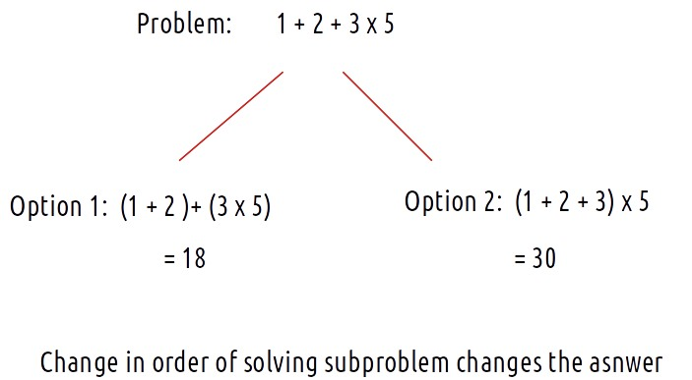

**Matrix Chain Multiplication:**

**Problem Link:**[**Matrix Chain Multiplication**](https://www.codingninjas.com/codestudio/problems/matrix-chain-multiplication_975344?source=youtube&campaign=striver_dp_videos&utm_source=youtube&utm_medium=affiliate&utm_campaign=striver_dp_videos)

Let us first understand the problem of matrix chain multiplication. In order to understand the problem we need to first understand the rules of matrix multiplication:

* Two matrices A1 and A2 of dimensions [p x q] and [r x s] can only be multiplied if and only if q=r.

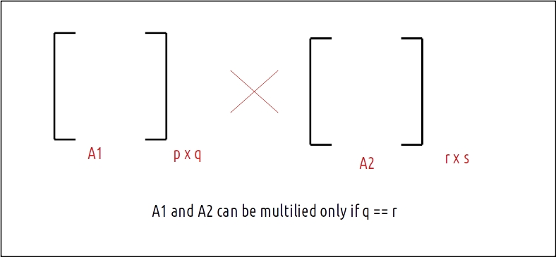

* The total number of multiplications required to multiply A1 and A2 are: p*q*s

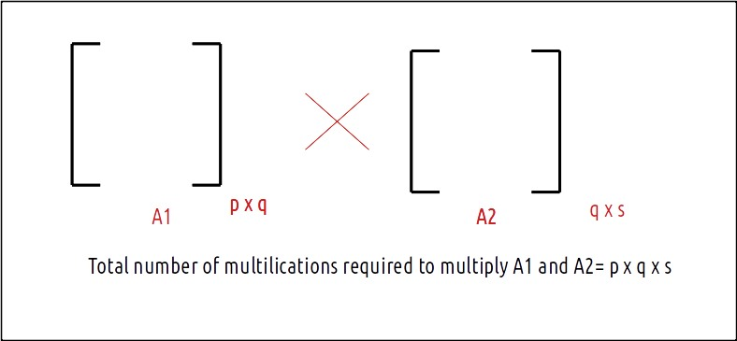

**Problem statement:**

Given a chain of matrices A1,…, An denoted by an array of size n+1, find out the minimum number of operations to multiply these n matrices.

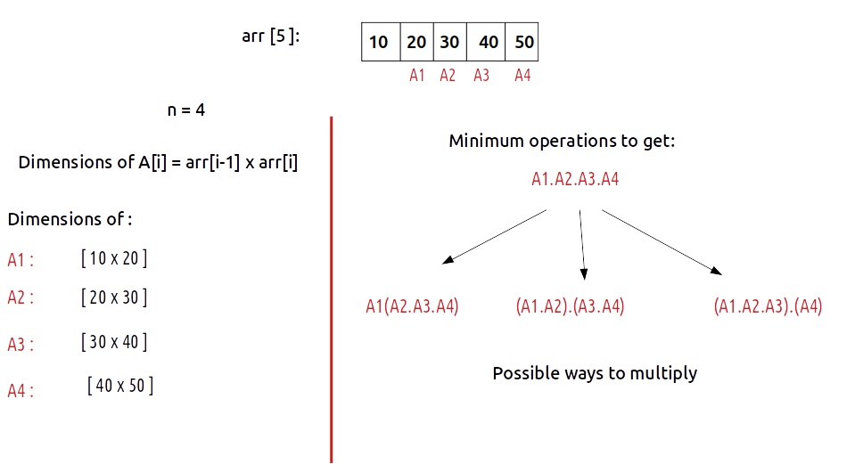

**Approach:**

As this problem of matrix multiplication solves one big problem ( minimum operations to get A1.A2….An) and the answer varies in the order the subproblems are being solved, we can identify this problem of pattern partition DP.

**Rules to solve the problem of partition DP:**

1. Start with the entire block/array and mark it with i,j. We need to find the value of f(i,j).
2. Try all partitions.
3. Run the best possible answer of the two partitions ( answer that comes after dividing the problem into two subproblems and solving them recursively).

Now let us go through these rules and apply them one by one to the MCM problem.

* **Start with the entire block/array and mark it with i,j**

We are given the following array, which can be represented by i and j as shown:

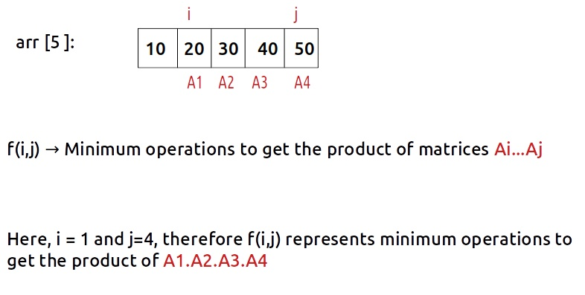

* **Try all partitions:**

Let us first see all the partitions that can be made with respect to the indexing:

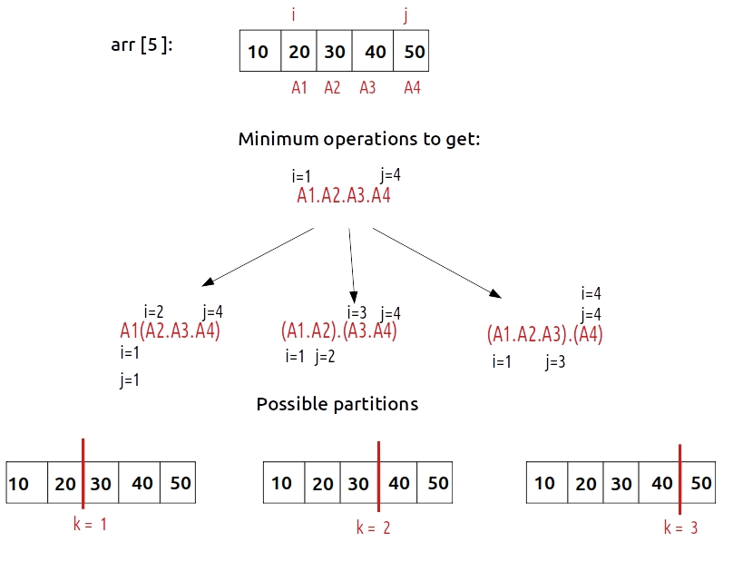

As we can see 3 partitions are possible, to try all three partitions, we can write a for loop starting from i and ending at j-1, (1 to 3). The two partitions will be **f(i,k) and f(k+1,j).**

* **Run the best possible answer of the two partitions:**

Before understanding the approach, let us first understand the base condition:

**If (i ==j), we return 0.**

If i==j, it means we are interested in a single matrix and no operation is required to multiply it so we return 0.

Now let us understand how to find the answer in a generic case, we will take a smaller example with only two matrices in order to illustrate:

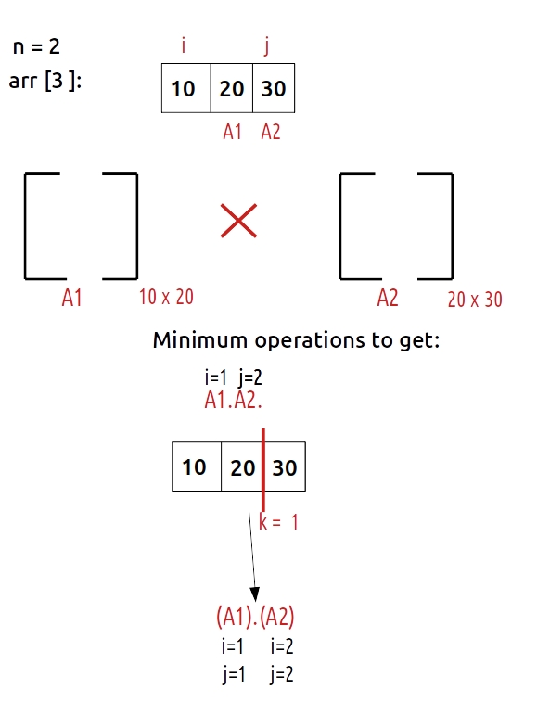

As there are only two matrices, we can say that only one partition is possible at k=1, when we do this partition, we see that the two partitions made are f(1,1) and f(2,2) (by f(i,k) and f(k+1,j) therefore we hit the base condition in both of these subcases which return 0.

Now, we know that the subproblems/partitions give us 0 operations, but we still have some work to do. The partition f(i,k) gives us a resultant matrix of dimensions [i -1 x k] and the partition f(k+1,j) gives us a resultant matrix of dimensions [k,j]. Therefore we need to count the number of operations for our two partitions (k=1) as shown:

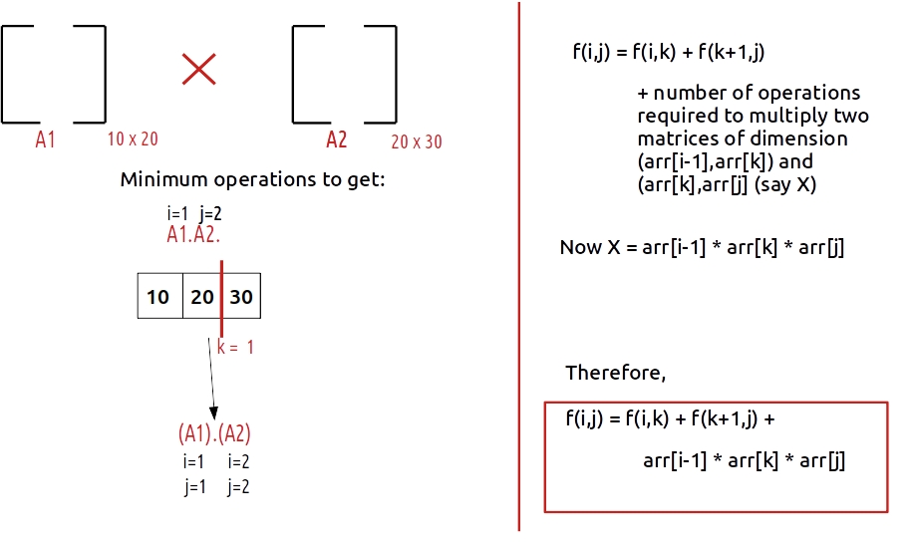

Now, this is at one partition, in general, we need to calculate this answer of every partition and return the minimum as the answer.

To summarize:

* Represent the entire array by two indexes i and j. In this question i =1 and j = n. We need to find f(i,j).
* Maintain a mini variable to get the minimum answer.
* Set a for loop to find the answer( variable k) from i to j-1,
* In every iteration find the answer, with the formula discussed above and compare it with the mini value.
* Return mini as the answer.

**Code:**

import java.util.*;

class TUF{

static int f(int[] arr, int i, int j){

// base condition

if(i == j)

return 0;

int mini = Integer.MAX_VALUE;

// partioning loop

for(int k = i; k<= j-1; k++){

int ans = f(arr,i,k) + f(arr, k+1,j) + arr[i-1]*arr[k]*arr[j];

mini = Math.min(mini,ans);

}

return mini;

}

static int matrixMultiplication(int[] arr, int N){

int i =1;

int j = N-1;

return f(arr,i,j);

}

public static void main(String args[]) {

int arr[] = {10, 20, 30, 40, 50};

int n = arr.length;

System.out.println("The minimum number of operations are "+

matrixMultiplication(arr,n));

}

}

**Output:**

The minimum number of operations is 38000

**Steps to memoize a recursive solution:**

As there are overlapping subproblems in the recursive tree, we can memoize the recursive code to reduce the time complexity.

1. Create a dp array of size [n][n]. I and j can range from 0 to n-1 so we take the size n X n.
2. We initialize the dp array to -1.
3. Whenever we want to find the answer to particular parameters (say f(i,j)), we first check whether the answer is already calculated using the dp array(i.e dp[i][j]!= -1 ). If yes, simply return the value from the dp array.
4. If not, then we are finding the answer for the given value for the first time, we will use the recursive relation as usual but before returning from the function, we will set dp[i][j] to the solution we get.

**Code:**

import java.util.*;

class TUF{

static int f(int arr[], int i, int j, int[][] dp){

// base condition

if(i == j)

return 0;

if(dp[i][j]!=-1)

return dp[i][j];

int mini = Integer.MAX_VALUE;

// partioning loop

for(int k = i; k<= j-1; k++){

int ans = f(arr,i,k,dp) + f(arr, k+1,j,dp) + arr[i-1]*arr[k]*arr[j];

mini = Math.min(mini,ans);

}

return mini;

}

static int matrixMultiplication(int[] arr, int N){

int dp[][]= new int[N][N];

for(int row[]:dp)

Arrays.fill(row,-1);

int i =1;

int j = N-1;

return f(arr,i,j,dp);

}

public static void main(String args[]) {

int arr[] = {10, 20, 30, 40, 50};

int n = arr.length;

System.out.println("The minimum number of operations are "+

matrixMultiplication(arr,n));

}

}

**Output:**

The minimum number of operations is 38000

**Time Complexity: O(N*N*N)**

Reason: There are N*N states and we explicitly run a loop inside the function which will run for N times, therefore at max ‘N*N*N’ new problems will be solved.

**Space Complexity: O(N*N) + O(N)**

Reason: We are using an auxiliary recursion stack space(O(N))and a 2D array ( O(N*N)).

## Matrix Chain Multiplication | Tabulation Method | (DP-49)

In the previous article, we learned the solution for the problem of “**Matrix chain multiplication”**. We had discussed the recursive and memoization solution. In this article, we will learn about the tabulation solution.

**Problem Link:**[**Matrix Chain Multiplication**](https://www.codingninjas.com/codestudio/problems/matrix-chain-multiplication_975344?source=youtube&campaign=striver_dp_videos&utm_source=youtube&utm_medium=affiliate&utm_campaign=striver_dp_videos)

**Understanding the dp array**

In the memoization approach, we have taken a dp[N][N]. Let us revise it and understand what dp[i][j] means.

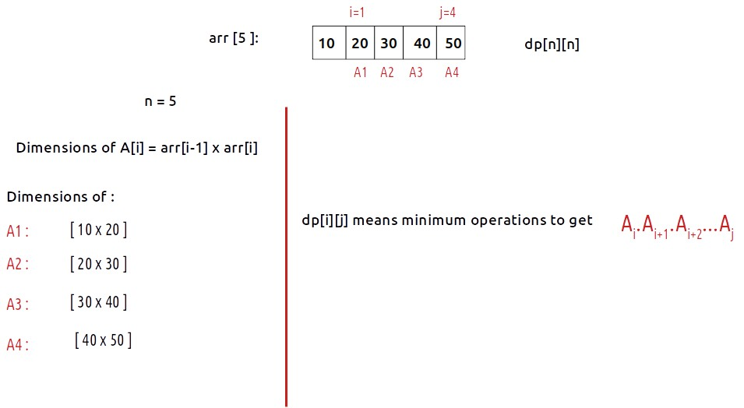

**As we have to find A1.A2.A3.A4, we will return dp[1][4] as our final answer.**

**Rules to write tabulation solution from the memoization solution**

1. Write the base case.
2. Write down the changing parameters in terms of loops.
3. Write the recursive logic inside the loops.

**Base Case**

Let us discuss the base case first, in the memoization approach the base case was:

if (i==j) return 0  
Now dp[i][i] means minimum operations to get the multiplication of Ai which means a single array which doesn’t mean anything in the context of this problem so we return 0. Therefore we write a loop to set the base case in our dp array as follows:

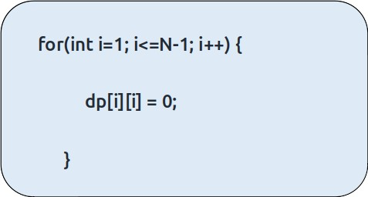

**Changing Parameters**

In tabulation, we follow a bottom-up approach that is we start from a smaller problem to the bigger problem, so here we start from (n-1)th matrix and move towards the first matrix i.e

A4_ -> A3_ -> A2_ -> A1_ .

These dashes are the matrix represented by the j pointer.

As j>i, we will start j from i+1 to N-1, thus the pattern of problem-solving becomes:

A4 -> A3.A4 -> A2.A3.A4 -> A1.A2.A3.A4.

This pattern can be achieved by writing the loops in the following way:

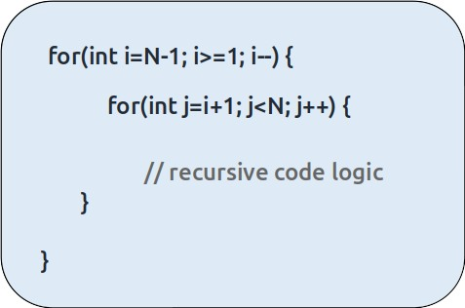

**Recursive Logic:**

Next, we just copy down the recursive logic and modify it as required.

**Code:**

import java.util.*;

class TUF{

static int f(int[] arr, int i, int j,int[][] dp){

// base condition

if(i == j)

return 0;

if(dp[i][j]!=-1)

return dp[i][j];

int mini = Integer.MAX_VALUE;

// partioning loop

for(int k = i; k<= j-1; k++){

int ans = f(arr,i,k,dp) + f(arr, k+1,j,dp) + arr[i-1]*arr[k]*arr[j];

mini = Math.min(mini,ans);

}

return mini;

}

static int matrixMultiplication(int[] arr, int N){

int [][] dp=new int[N][N];

for(int row[]: dp)

Arrays.fill(row,-1);

for(int i=1; i<N; i++){

dp[i][i] = 0;

}

for(int i=N-1; i>=1; i--){

for(int j=i+1; j<N; j++){

int mini = Integer.MAX_VALUE;

// partioning loop

for(int k = i; k<= j-1; k++){

int ans = dp[i][k]+ dp[k+1][j] + arr[i-1]*arr[k]*arr[j];

mini = Math.min(mini,ans);

}

dp[i][j] = mini;

}

}

return dp[1][N-1];

}

public static void main(String args[]) {

int[] arr = {10, 20, 30, 40, 50};

int n = arr.length;

System.out.println("The minimum number of operations are "+

matrixMultiplication(arr,n));

}

}

**Output:**

The minimum number of operations are 38000

**Time Complexity: O(N*N*N)**

Reason: There are N*N states and we explicitly run a loop inside the function which will run for N times, therefore at max ‘N*N*N’ new problems will be solved.

**Space Complexity: O(N*N)**

Reason: We are using a 2D array ( O(N*N)) space.

### Matrix Chain multiplication Tabulation

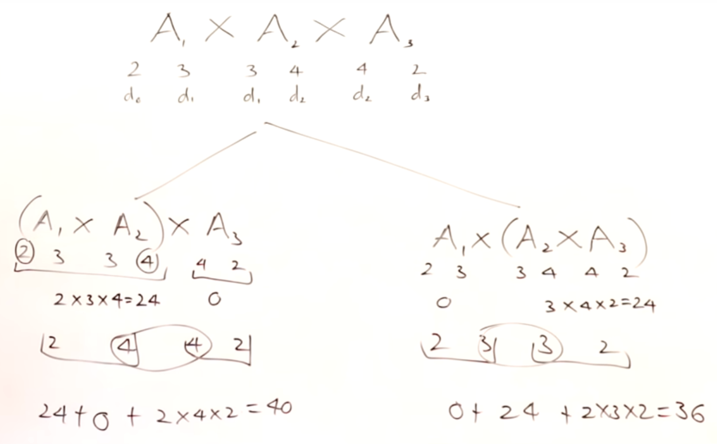

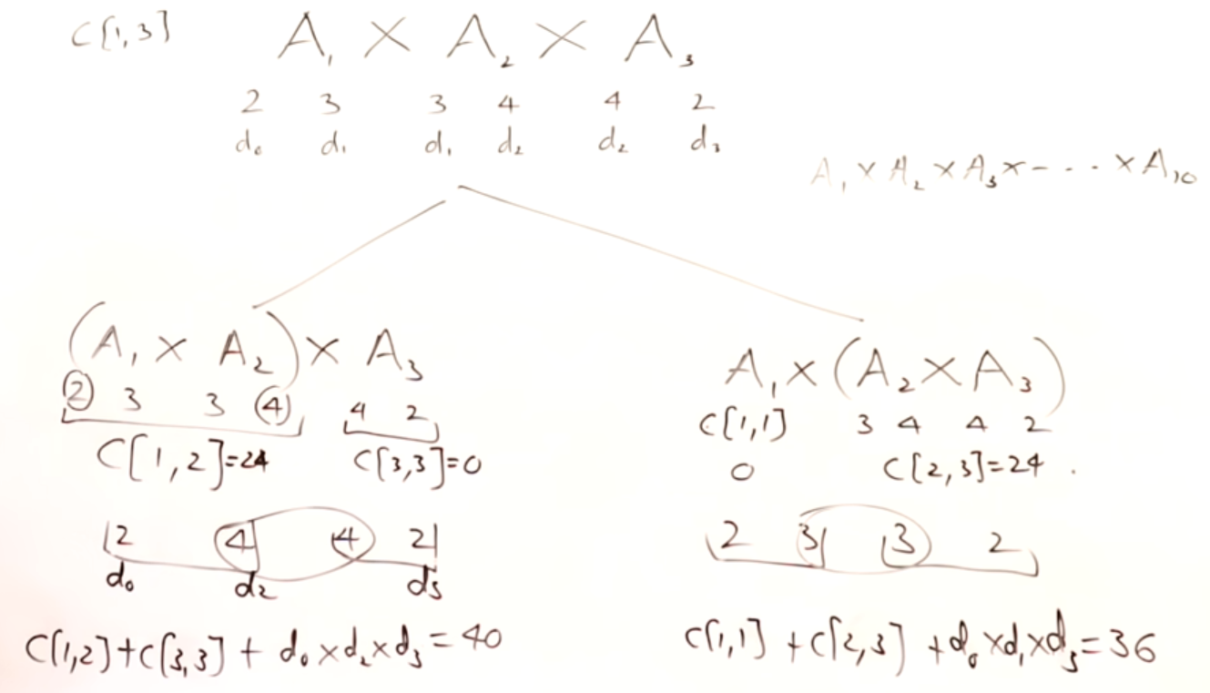

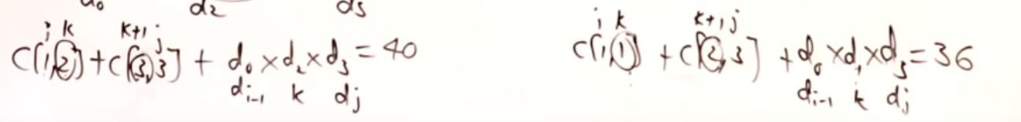

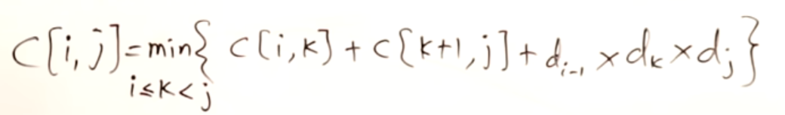

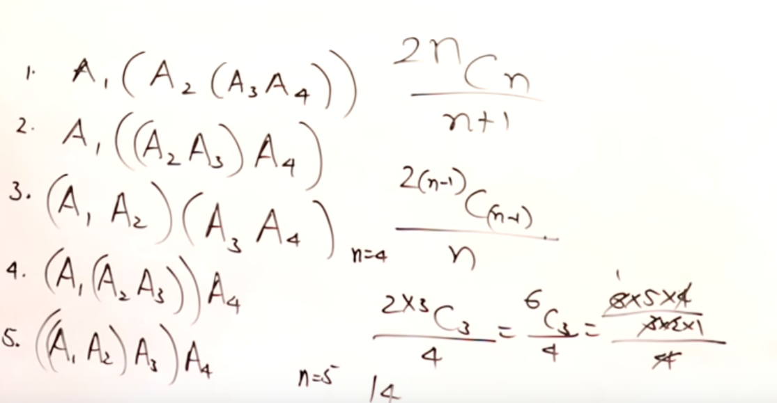

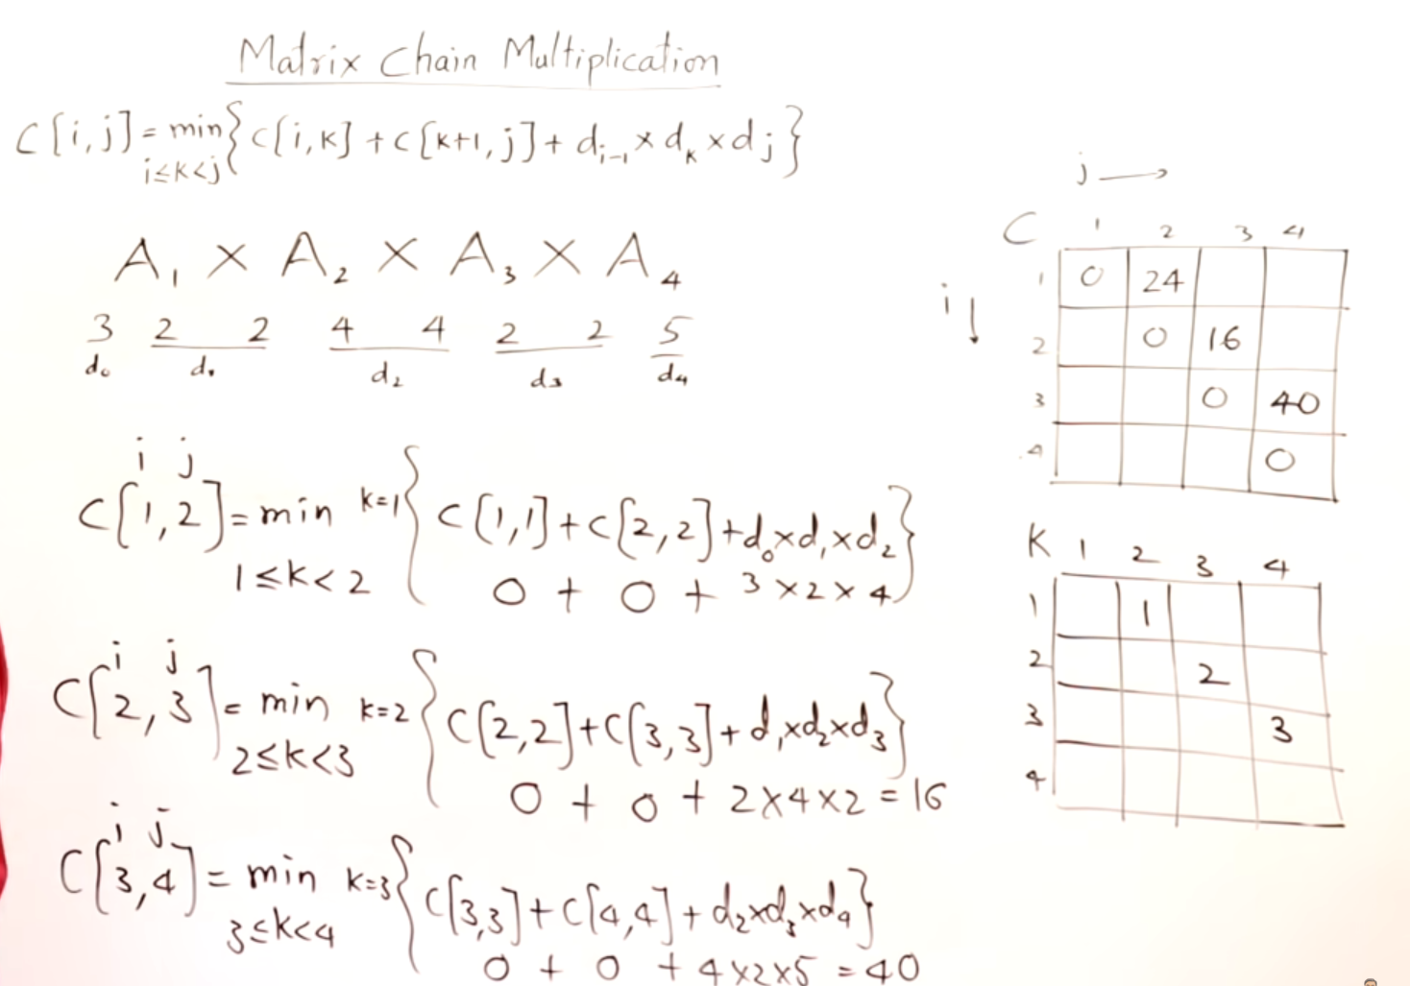

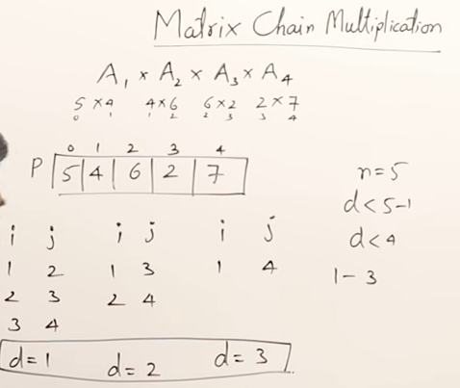

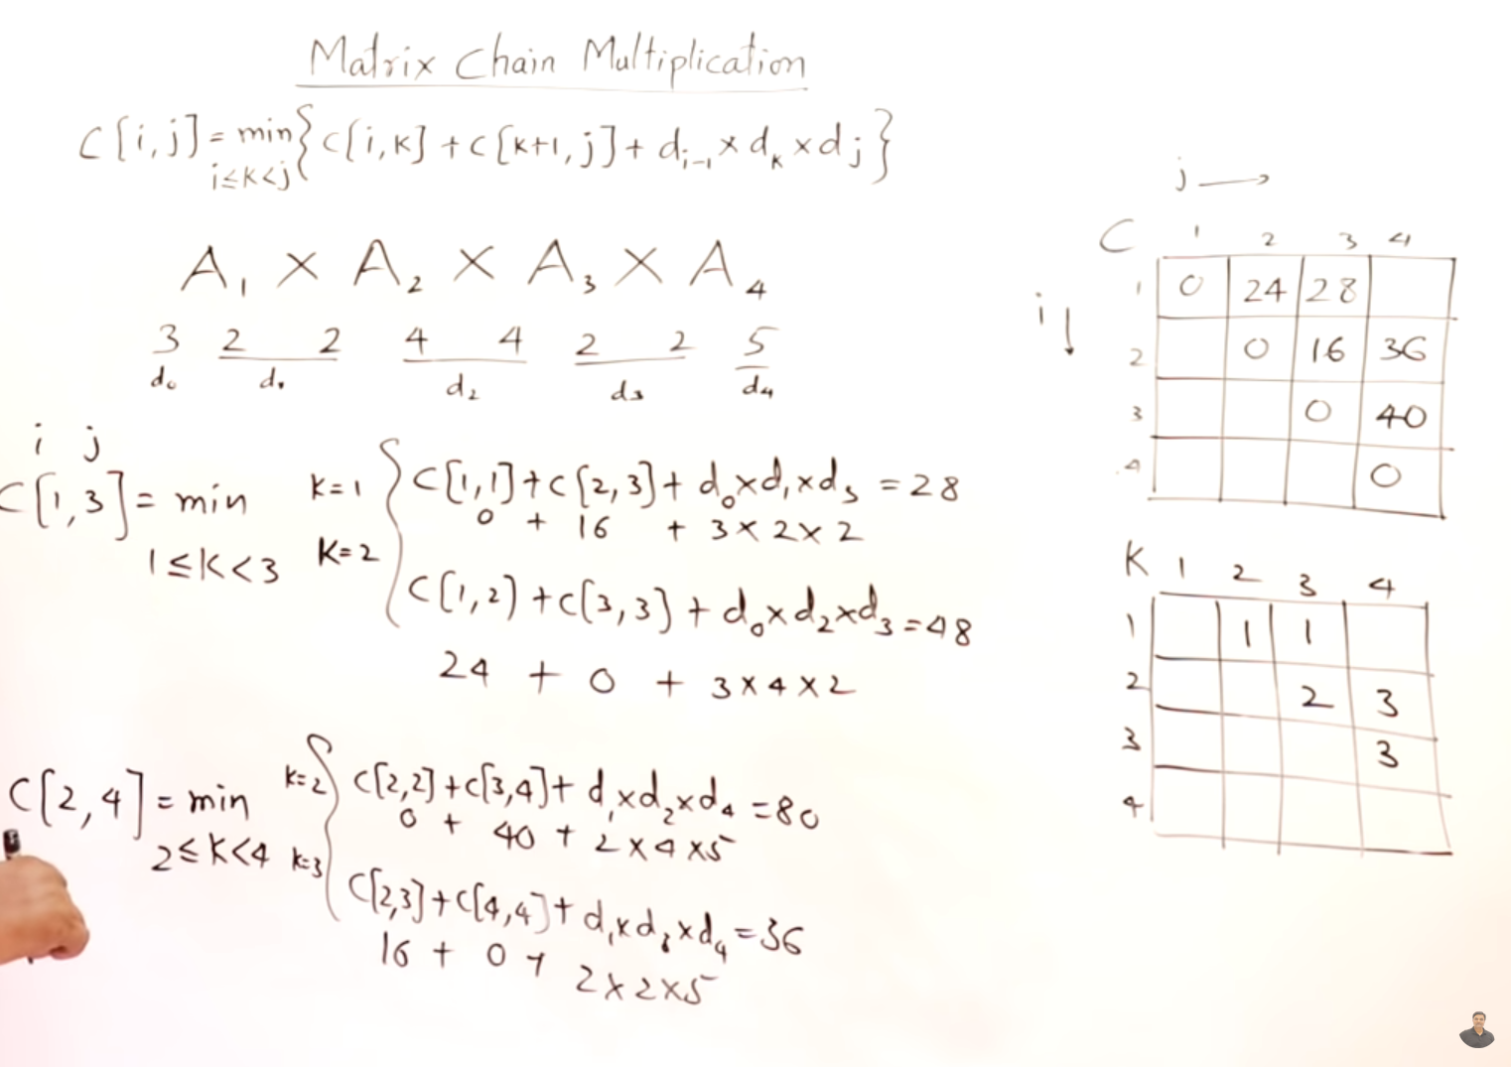

Then we need to find out C[1,4]

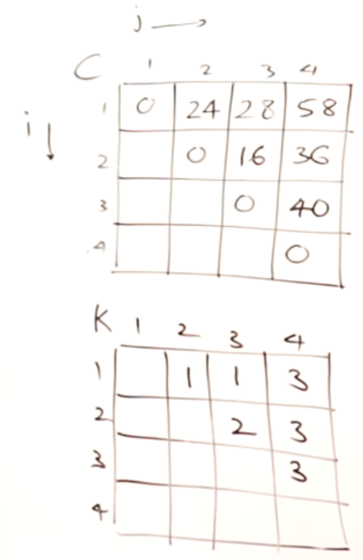 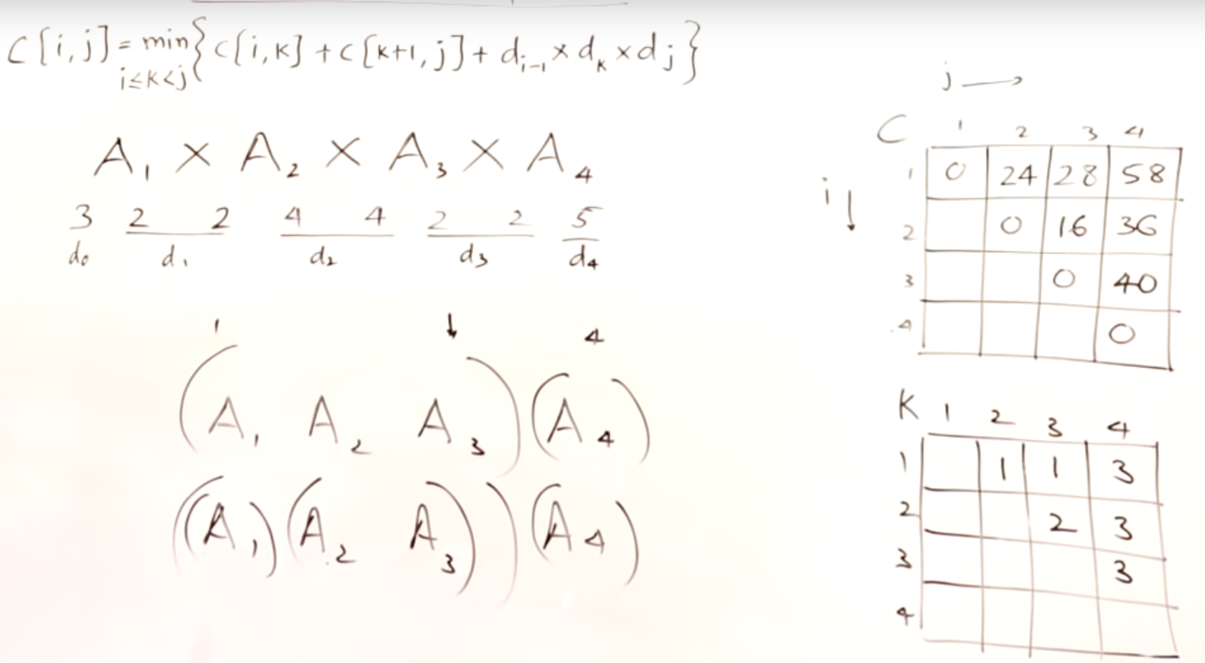

Time Complexity

From the table we can see we have calculated 1+2+3+4 values

Which is 1+2+3+4 = 4*5/2

n(n+1)/2 = n^2

For getting each value we used k ways/times which is equivalent to n. So total time is n*n^2 i.e. n^3.

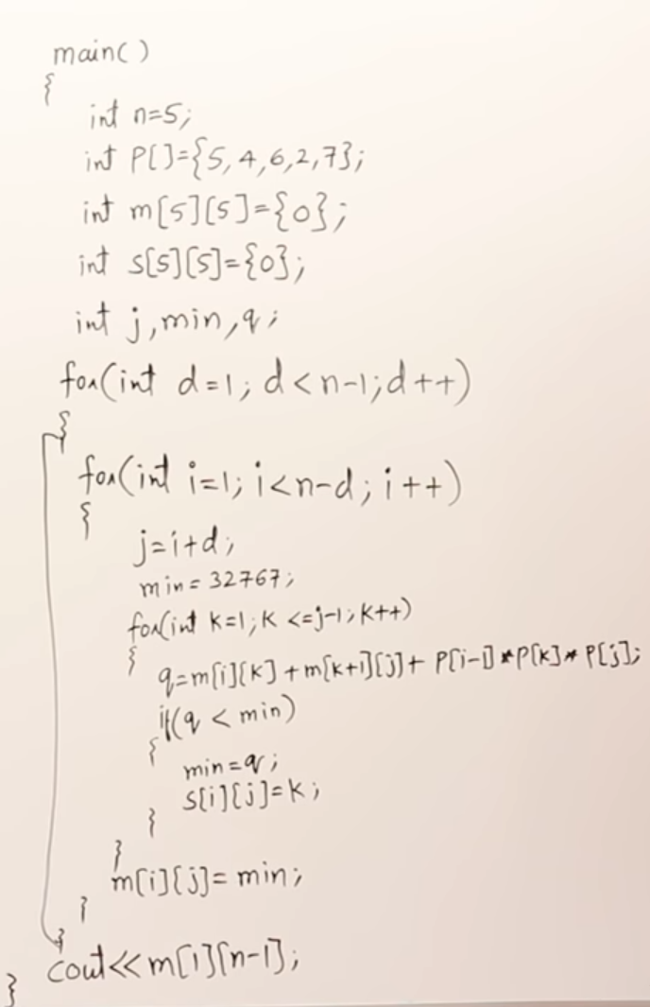

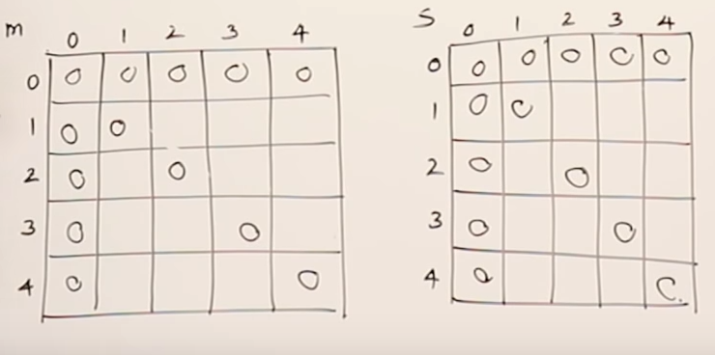

#### Code

|  |
| --- |
| **package** dp;  **import** java.util.Arrays;  //Dynamic Programming Java implementation of Matrix  //Chain Multiplication.  //See the Cormen book for details of the following  //algorithm  **class** MatrixChainMultiplication  {  **static** **int** matrixMultiplication(**int** N, **int** arr[])  {  // code here  **int**[][] m = **new** **int**[N][N];  **int** temp,j;  **for** (**int** i = 1; i < N; i++)  m[i][i] = 0;  **for**(**int** d=1; d<N-1;d++){// difference is just 1 and 2 when N is 4  **for**(**int** i=1; i<N-d; i++){//In difference 1, 2 times and in difference 2, 1 time  j=i+d;// j is i plus difference  m[i][j] = Integer.***MAX_VALUE***;  **for**(**int** k=i;k<=j-1;k++){  temp = m[i][k]+m[k+1][j]+arr[i-1]*arr[k]*arr[j];  **if**(temp < m[i][j]){  m[i][j] = temp;  }  }  }  }    System.***out***.println(Arrays.*deepToString*(m));  **return** m[1][N-1];  }      // Driver code  **public** **static** **void** main(String args[])  {  **int** arr[] = **new** **int**[] { 10, 30, 5, 60 };  **int** size = arr.length;  System.***out***.println(  "Minimum number of multiplications is "  + *matrixMultiplication*(size, arr));    }  } |
|  |

#### Print parenthesis

|  |
| --- |
| static void printParenthesis(int i, int j,                                 int n, int[][] bracket)    {        // If only one matrix left in current segment      if (i == j)      {        System.out.print(name++);        return;      }      System.out.print("(");        // Recursively put brackets around subexpression      // from i to bracket[i][j].      // Note that "*((bracket+i*n)+j)" is similar to      // bracket[i][j]      printParenthesis(i, bracket[i][j], n, bracket);        // Recursively put brackets around subexpression      // from bracket[i][j] + 1 to j.      printParenthesis(bracket[i][j] + 1, j, n, bracket);      System.out.print(")");    } |

## Burst Balloons | Partition DP | DP 51

**Problem Statement:** You are given n balloons, indexed from 0 to n – 1. Each balloon is painted with a number on it represented by an array. You are asked to burst all the balloons.

If you burst the ith balloon, you will get arr[i – 1] * arr[i] * arr[i + 1] coins. If i – 1 or i + 1 goes out of the array’s bounds, then treat it as if there is a balloon with a 1 painted on it.

Return the maximum coins you can collect by bursting the balloons wisely.

**Pre-requisite:**[**MCM**](https://takeuforward.org/dynamic-programming/matrix-chain-multiplication-dp-48/)**&**[**DP 50**](https://takeuforward.org/data-structure/minimum-cost-to-cut-the-stick-dp-50/)

**Example 1:**

**Input:** N = 4, array[] = {3, 1, 5, 8

**Output**: 167

**Explanation:**

First, we will burst the second balloon with

the value 1. Coins = 3*1*5 = 15.

Second, we will burst the balloon with the

value 5. Coins = 3*5*8 = 120.

Third, we will burst the balloon with the

value 3. Coins = 1*3*8 = 24.

Fourth, we will burst the balloon with the

value 8. Coins = 1*8*1 = 8.

So, the total number of coins we can collect

is 167. This is the maximum number of coins we

can collect.

**Example 2:**

**Input**: N = 2, array[] = {1, 5}

**Output**: 10

**Explanation**:

First, we will burst the second balloon with the

value 1. Coins = 1*1*5 = 5.

Second, we will burst the balloon with the

value 5. Coins = 1*5*1 = 5.

So, the total number of coins we can collect is 10.

This is the maximum number of coins we can collect.

### ****Solution****

**Disclaimer**: Don’t jump directly to the solution, try it out yourself first.[Problem Link 1](https://www.codingninjas.com/codestudio/problems/mining-diamonds_4244494?source=youtube&campaign=striver_dp_videos&utm_source=youtube&utm_medium=affiliate&utm_campaign=striver_dp_videos).

[Problem Link 2](https://leetcode.com/problems/burst-balloons/).

**Solution:**

From the question, we can easily understand that we must burst the balloons in a particular order to collect the maximum number of coins. For example, in the first case, we followed the order: 1, 5, 3, 8 to collect the maximum number of coins i.e. 167. So, the order of bursting the balloons will change the number of coins we can collect. There may be several orders that we can follow.

So, in order to find a valid order, can figure out the first balloon we will burst. Apparently, the entire array(i.e. given) is the range of the elements(i.e. the balloons) and anyone among the elements can be the first.

First, we will try to solve the problem using the technique we have learned in [MCM](https://takeuforward.org/data-structure/matrix-chain-multiplication-tabulation-method-dp-49/). In the MCM, we selected the matrices sequentially so that the number of scalar multiplication is minimized. Similarly, here we can maintain an order where we will first try to choose the first element, then we can try to find the second one, and so on.

**Now, let’s understand if we can really solve the problem using the above approach:**

Let’s consider the following example:

We are given an array: {b1, b2, b3, b4, b5, b6}. Each element of the given array is representing a balloon. Now, if we burst the b4, we will get a total of (b3*b4*b5) coins. After bursting b4, we are left with the left sub-problem {b1, b2, b3} and the right sub-problem {b5, b6} to solve.

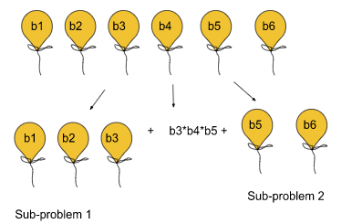

**Now, the question is, if we can say that the final answer will be the summation of the current number of coins and the answers from the left and right subproblems**. The answer is **No**.

Let’s understand the reason behind this. Imagine, at first we burst the balloon b4. Then, we are left with the array:  {b1, b2, b3, b5, b6}. Now, if we try to burst b3, it will be dependent on b5. Similarly, if we try to burst b5, it will be dependent on b3. Similarly, we can observe the same dependency in the case of other elements as well. So, we cannot solve the subproblems {b1, b2, b3} and {b4, b5} independently as they are dependent on each other.

##### **Intuition:**

Until now, we have clearly understood that we cannot solve this problem using this approach. So, we will just try to think in the opposite way. First, we tried to find out a balloon that we will burst first. But now, we will first try to find that balloon which we will burst last.

**Note:**The intuition is to first find the last balloon, then the second last, and so on. This is the sequence we need to follow to solve this problem.

**Now, let’s understand how the subproblems are independent in this approach:**

Let’s consider the following example:

We are given an array: {b1, b2, b3, b4, b5, b6}. Assume, b4 be the last balloon we will burst. Then we can surely say, the total no. of coins we can get by bursting the balloon b4 is (1*b4*1). Now, we get two subproblems as usual: {b1, b2, b3} and {b5, b6}, and while choosing the second last balloon, we can ensure that b4 exists while bursting the second last balloon. If the second last balloon belongs to the 1st sub-problem i.e. {b1, b2, b3}, it will be only dependent on the last balloon i.e. b4 as the rightmost element will be b4. Similarly,  if the second last balloon belongs to the 2nd sub-problem i.e. {b5, b6}, it will also be dependent only on the last balloon i.e. b4 as the leftmost element will be b4. The following illustration will clarify the concept:

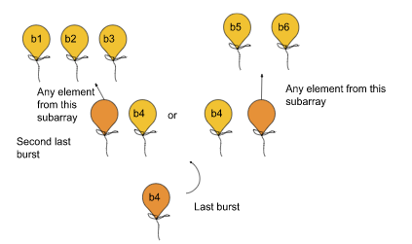

Now, we can clearly observe the subproblems are no anymore dependent on each other.

We have found the right approach until now. Now, let us quickly revise the rules to solve a problem on partition dp.

1. Start with the entire block/array and mark it with i, j.
2. Try all partitions.
3. Return the best possible answer of the two partitions (the answer that comes after dividing the problem into two subproblems and solving them recursively).

Now let us go through these rules and apply them to this problem.

**Marking the array with i, j:**

We are given an array of balloons of size N. The entire array basically represents the range of the balloons. So, we will place i and j at both ends of the array.

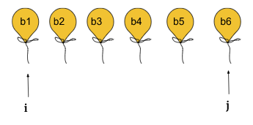

**Try all partitions:**

As we have figured out the logic for marking the i, and j pointers, we will move to the partitioning loop. We can simply write a for loop(say ind) starting from i to j, The problem is being broken in the following manner:

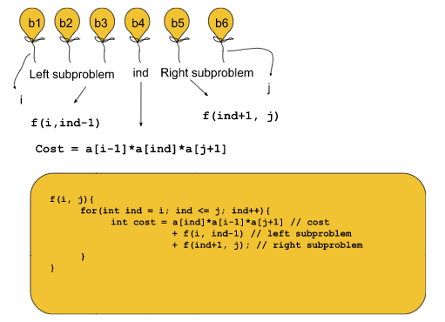

**Note:**Here f(i, ind-1) is the left sub-problem, and f(ind+1, j) is the right sub-problem.

**Base Case:**We can say that when i > j this is not a valid partition and so we will return 0.

**Return the best possible answer:**

Here, in this problem, we are trying to achieve the maximum possible answer i.e. the maximum number of coins. So, among all the costs calculated, we will just store the maximum one. And finally, the maximum cost will be our answer.

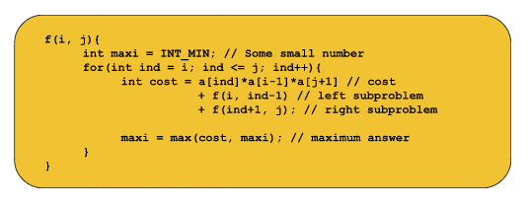

**Note**: If you wish to see the dry run of the above approach, you can watch the video attached to this article.

**Approach**:

**The recursive algorithm steps are as follows:**

1. Append 1 to both ends of the given array.
2. Convert the problem to a recursive function marked by two pointers i and j.
3. Use a loop to check all possible combinations of balloons and get all possible total numbers of coins.
4. Return the maximum number of coins we can get.
5. **Base case:**If i > j, we will return 0.

**Code**:

* C++ Code

#include <bits/stdc++.h>

using namespace std;

int f(int i, int j, vector<int> &a) {

if (i > j) return 0;

int maxi = INT_MIN;

for (int ind = i; ind <= j; ind++) {

int cost = a[i - 1] * a[ind] * a[j + 1] +

f(i, ind - 1, a) + f(ind + 1, j, a);

maxi = max(maxi, cost);

}

return maxi;

}

int maxCoins(vector<int> &a) {

int n = a.size();

a.push_back(1);

a.insert(a.begin(), 1);

return f(1, n, a);

}

int main() {

vector<int> a = {3, 1, 5, 8};

int ans = maxCoins(a);

cout << ans << "\n";

}

**Output: The maximum coins we can get: 167(For example 1)**

**Time Complexity:**Exponential

**Steps to memoize the recursive solution:**

1. Create a dp array of size [n+1][n+1]. i and j can range from 1 to n so we take the size n+1 X n+1.
2. We initialize the dp array to -1.
3. Whenever we want to find the answer to particular parameters (say f(i,j)), we first check whether the answer is already calculated using the dp array(i.e dp[i][j]!= -1 ). If yes, simply return the value from the dp array.
4. If not, then we are finding the answer for the given value for the first time, we will use the recursive relation as usual but before returning from the function, we will set dp[i][j] to the solution we get.

**Code**:

* C++ Code

#include <bits/stdc++.h>

using namespace std;

int f(int i, int j, vector<int> &a, vector<vector<int>> &dp) {

if (i > j) return 0;

if (dp[i][j] != -1) return dp[i][j];

int maxi = INT_MIN;

for (int ind = i; ind <= j; ind++) {

int cost = a[i - 1] * a[ind] * a[j + 1] +

f(i, ind - 1, a, dp) + f(ind + 1, j, a, dp);

maxi = max(maxi, cost);

}

return dp[i][j] = maxi;

}

int maxCoins(vector<int> &a) {

int n = a.size();

a.push_back(1);

a.insert(a.begin(), 1);

vector<vector<int>> dp(n + 1, vector<int>(n + 1, -1));

return f(1, n, a, dp);

}

int main() {

vector<int> a = {3, 1, 5, 8};

int ans = maxCoins(a);

cout << ans << "\n";

}

**Output: The maximum coins we can get: 167(For example 1)**

**Time Complexity:**O(N3), There are total N2 no. of states. And for each state, we are running a partitioning loop roughly for N times.

**Space Complexity:**O(N2) + Auxiliary stack space of O(N), N2 for the dp array we are using.

**Tabulation:**

1. First of all, we handle the base case. If (i > j) we return 0. To cover this case we can initialize the entire dp array with 0.  
   **Here, we need the dp of size n+2 X n+2 as the highest value of j can be n and in that case, it will search for the value a[j+1] i.e. a[n+1]. So, to handle this case, we need the size to be n+2.**
2. Next, memoization is a top-down approach, whereas tabulation is bottom-up. Our changing parameters i and j will change in opposite directions, i.e i will change from n→1 and j will change from 1→ n.
3. Next, we copy down the recursive logic(recurrence) inside the nested loops.

**Code**:

* C++ Code

#include <bits/stdc++.h>

using namespace std;

int maxCoins(vector<int> &a) {

int n = a.size();

a.push_back(1);

a.insert(a.begin(), 1);

vector<vector<int>> dp(n + 2, vector<int>(n + 2, 0));

for (int i = n; i >= 1; i--) {

for (int j = 1; j <= n; j++) {

if (i > j) continue;

int maxi = INT_MIN;

for (int ind = i; ind <= j; ind++) {

int cost = a[i - 1] * a[ind] * a[j + 1] +

dp[i][ind - 1] + dp[ind + 1][j];

maxi = max(maxi, cost);

}

dp[i][j] = maxi;

}

}

return dp[1][n];

}

int main() {

vector<int> a = {3, 1, 5, 8};

int ans = maxCoins(a);

cout << ans << "\n";

}

**Output: The maximum coins we can get: 167(For example 1)**

**Time Complexity:**O(N3), There are total N2 no. of states. And for each state, we are running a partitioning loop roughly for N times.

**Space Complexity:**O(N2), N2 for the dp array we are using.

# DP on Stocks

## Stock Buy and Sell | (DP-35)

**Best time to buy and sell stock**

We are given an array Arr[] of length n. It represents the price of a stock on ‘n’ days. The following guidelines need to be followed:

1. We can [buy and sell a stock](https://takeuforward.org/data-structure/stock-buy-and-sell/) only once.
2. We can buy and sell the stock on any day but to sell the stock, we need to first buy it on the same or any previous day.

We need to tell the maximum profit one can get by buying and selling this stock.

**Problem Link:**[**Best Time to Buy and Sell Stock**](https://www.codingninjas.com/codestudio/problems/stocks-are-profitable_893405?source=youtube&campaign=striver_dp_videos&utm_source=youtube&utm_medium=affiliate&utm_campaign=striver_dp_videos)

**Disclaimer**: Don’t jump directly to the solution, try it out yourself first.

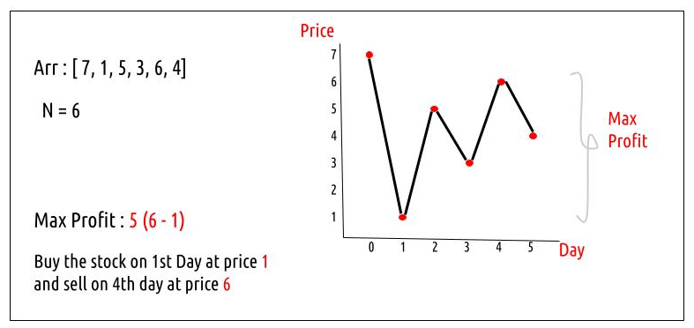

### ****Solution :****

### ****Intuition:****

We need to find the maximum profit. In order to maximize the profit, we need to buy the stock at its lowest price and sell it when the price is highest. In the given example the lowest price(1) is on Day 1 and the highest price is (7) is on Day 0. But we need to buy the stock before selling it therefore we need to modify this approach.

We can try to sell the stock every day and try to find the maximum profit that can be generated by selling the stock on that day. At last, we can return the maximum of these individual maximum profits as our answer.

To find the individual maximum profit on a day ‘i’, we know the selling price, i.e the price of the stock on day i, we need to find the buying price. To maximize the profit on day ‘i’, the buying price should be the lowest price of the stock from day 0 to day i (see the graph above). This way we can keep track of the correct buying price for any day.

### ****Approach:****

The algorithm approach can be stated as:

1. Initialize a variable ‘maxProfit’ to 0 and declare another variable ‘mini’ which we will use to keep track of the buying price (minimum price from day 0 to day i) for selling the stock.
2. Traverse the array from index 1 to n-1. We started at index 1 because buying and selling the stock on the 0th day will give us a profit of 0, which we have initialized our maxProfit as already.
3. In each iteration, try to find the curProfit. The selling price will be Arr[i] and ‘mini’ will give us the buying price. We calculate the curProfit. If it is more than the existing profit value (maxProfit), we update the maxProfit value.
4. Before going to the next iteration, we check if the current price (Arr[i]) is less than the mini value, and we assign it as the new mini value. In this way, we keep track of the buying price in a single iteration itself.

**Code:**

class TUF{

static int maximumProfit(int []Arr){

// Write your code here.

int maxProfit = 0;

int mini = Arr[0];

for(int i=1;i<Arr.length;i++){

int curProfit = Arr[i] - mini;

maxProfit = Math.max(maxProfit,curProfit);

mini = Math.min(mini,Arr[i]);

}

return maxProfit;

}

public static void main(String args[]) {

int[] Arr ={7,1,5,3,6,4};

System.out.println("The maximum profit by selling the stock is "+

maximumProfit(Arr));

}

}

**Output:**

The maximum profit by selling the stock is 5

**Time Complexity: O(N)**

Reason: We are performing a single iteration

**Space Complexity: O(1)**

Reason: No extra space is used.

## Buy and Sell Stock – II | (DP -36)

**Problem Statement:**

**Buy and Sell Stock – II**

**Problem Link:**[Best Time to Buy and Sell Stock II](https://www.codingninjas.com/codestudio/problems/selling-stock_630282?source=youtube&campaign=striver_dp_videos&utm_source=youtube&utm_medium=affiliate&utm_campaign=striver_dp_videos)

We are given an array Arr[] of length n. It represents the price of a stock on ‘n’ days. The following guidelines need to be followed:

1. We can buy and sell the stock any number of times.
2. In order to sell the stock, we need to first buy it on the same or any previous day.
3. We can’t buy a stock again after buying it once. In other words, we first buy a stock and then sell it. After selling we can buy and sell again. But we can’t sell before buying and can’t buy before selling any previously bought stock.

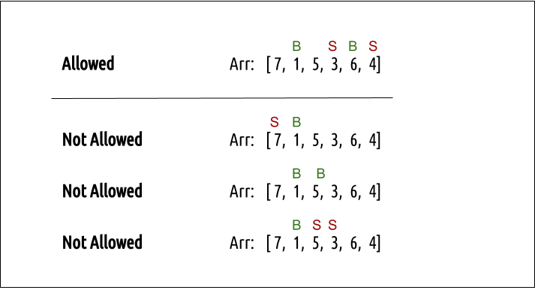

**Example:**

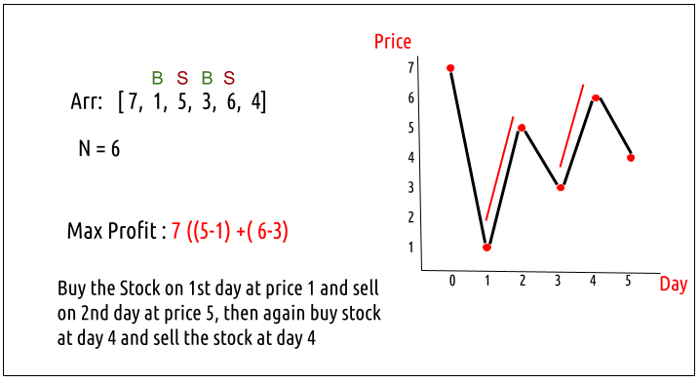

**Disclaimer**: Don’t jump directly to the solution, try it out yourself first.

### ****Solution :****

**Intuition:**

Every day, we will have two choices, either to do nothing and move to the next day or to buy/sell (based on the last transaction) and find out the profit. Therefore we need to generate all the choices in order to compare the profit. As we need to try out all the possible choices, we will use **recursion**.

**Steps to form the recursive solution:**

We will first form the recursive solution by the three points mentioned in the[Dynamic Programming Introduction](https://takeuforward.org/data-structure/dynamic-programming-introduction/).

**Step 1:**Express the problem in terms of indexes.

We need to think in the terms of the number of days, therefore one variable will be the array index( say ind). Next, we need to respect the condition that we can’t buy a stock again, that is we need to first sell a stock, and then we can buy that again. Therefore we need a second variable ‘buy’ which tells us on a particular day whether we can buy or sell the stock. We can generalize the function as :

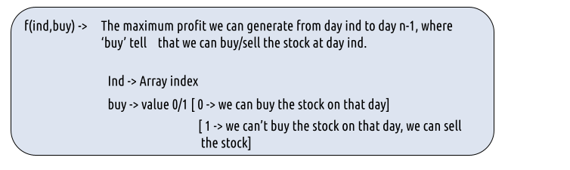

**Step 2:**Try out all possible choices at a given index.

Every day, we have two choices:

* To either buy/sell the stock(based on the buy variable’s value).
* To do nothing and move on to the next day.

We need to generate all the choices. We will use the pick/non-pick technique as discussed in this video “[Recursion on Subsequences](https://www.youtube.com/watch?v=AxNNVECce8c)”.

**Case 1:**When buy == 0, we can buy the stock.

If we can buy the stock on a particular day, we have two options:

* **Option 1:**To do no transaction and move to the next day. In this case, the net profit earned will be **0** from the current transaction, and to calculate the maximum profit starting from the next day, we will recursively call f(ind+1,0). As we have not bought the stock, the ‘buy’ variable value will still remain 0, indicating that we can buy the stock the next day.
* **Option 2:**The other option is to buy the stock on the current day. In this case, the net profit earned from the current transaction will be **-Arr[i]**. As we are buying the stock, we are giving money out of our pocket, therefore the profit we earn **is negative**. To calculate the maximum profit starting from the next day, we will recursively call f(ind+1,1). As we have bought the stock, the ‘buy’ variable value will change to 1, indicating that we can’t buy and only sell the stock the next day.

**Case 2:**When buy == 1, we can sell the stock.

If we can buy the stock on a particular day, we have two options:

* **Option 1:**To do no transaction and move to the next day. In this case, the net profit earned will be **0** from the current transaction, and to calculate the maximum profit starting from the next day, we will recursively call **f(ind+1,1)**. As we have not bought the stock, the ‘buy’ variable value will still remain at 1, indicating that we can’t buy and only sell the stock the next day.
* **Option 2:**The other option is to sell the stock on the current day. In this case, the net profit earned from the current transaction will be +**Arr[i]**. As we are selling the stock, we are putting the money into our pocket, therefore the profit we earn **is positive**. To calculate the maximum profit starting from the next day, we will recursively call **f(ind+1,0)**. As we have sold the stock, the ‘buy’ variable value will change to 0, indicating that we can buy the stock the next day.

The figure below gives us the summary:

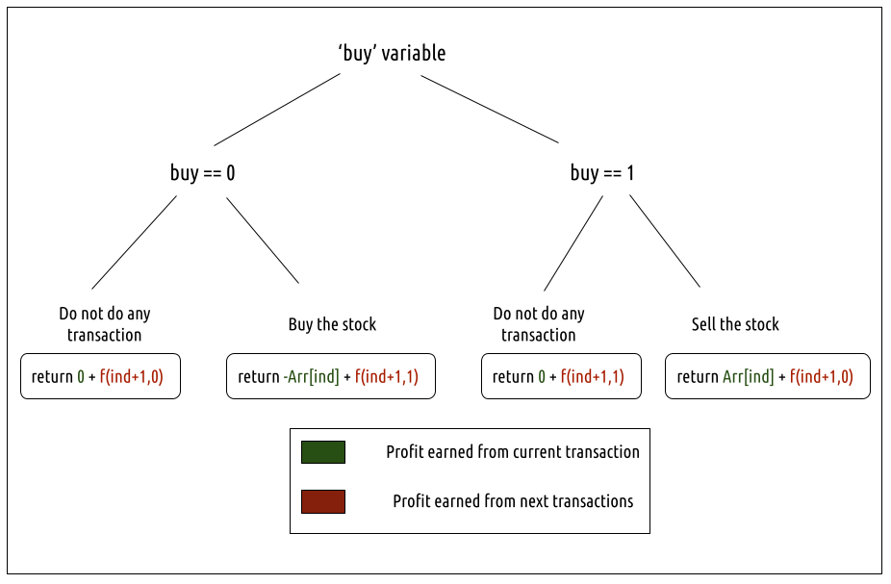

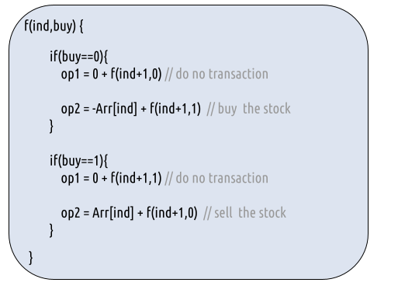

**Step 3:  Return the maximum**

As we are looking to maximize the profit earned, we will return the maximum value in both cases.

The final pseudocode after steps 1, 2, and 3:

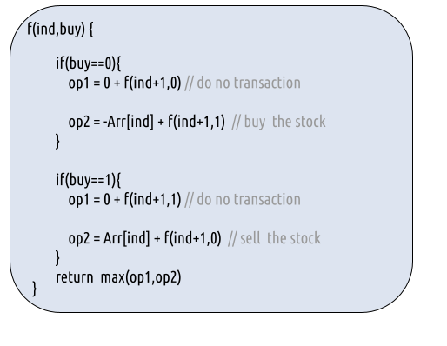

**Base Cases:**

* If ind==n, it means we have finished trading on all days, and there is no more money that we can get, therefore we simply return 0.

**Steps to memoize a recursive solution:**

If we draw the recursion tree, we will see that there are overlapping subproblems. In order to convert a recursive solution the following steps will be taken:

1. Create a dp array of size [n][2]. The size of the input array is ‘n’, so the index will always lie between ‘0’ and ‘n-1’. The ‘buy’  variable can take only two values: 0 and 1. Therefore we take the dp array as dp[n][2]
2. We initialize the dp array to -1.
3. Whenever we want to find the answer to particular parameters (say f(ind, buy)), we first check whether the answer is already calculated using the dp array(i.e dp[ind][buy]!= -1 ). If yes, simply return the value from the dp array.
4. If not, then we are finding the answer for the given value for the first time, we will use the recursive relation as usual but before returning from the function, we will set dp[ind][buy] to the solution we get.

**Code:**

#include <bits/stdc++.h>

using namespace std;

long getAns(long *Arr, int ind, int buy, int n, vector<vector<long>> &dp ){

if(ind==n) return 0; //base case

if(dp[ind][buy]!=-1)

return dp[ind][buy];

long profit;

if(buy==0){// We can buy the stock

profit = max(0+getAns(Arr,ind+1,0,n,dp), -Arr[ind] + getAns(Arr,ind+1,1,n,dp));

}

if(buy==1){// We can sell the stock

profit = max(0+getAns(Arr,ind+1,1,n,dp), Arr[ind] + getAns(Arr,ind+1,0,n,dp));

}

return dp[ind][buy] = profit;

}

long getMaximumProfit(long *Arr, int n)

{

//Write your code here

vector<vector<long>> dp(n,vector<long>(2,-1));

if(n==0) return 0;

long ans = getAns(Arr,0,0,n,dp);

return ans;

}

int main() {

int n =6;

long Arr[n] = {7,1,5,3,6,4};

cout<<"The maximum profit that can be generated is "<<getMaximumProfit(Arr, n);

}

**Output:**

The maximum profit that can be generated is 7

**Time Complexity: O(N*2)**

Reason: There are N*2 states therefore at max ‘N*2’ new problems will be solved and we are running a for loop for ‘N’ times to calculate the total sum

**Space Complexity: O(N*2) + O(N)**

Reason: We are using a recursion stack space(O(N)) and a 2D array ( O(N*2)).

**Steps to convert Recursive Solution to Tabulation one.**

To convert the memoization approach to a tabulation one, create a dp array with the same size as done in memoization. We can set its type as bool and initialize it as false.

* First, we declare the dp array of size [n+1][2] as zero.
* Next, we set the base condition, we set dp[n][0] = dp[n][1] = 0(the case when we had exhausted the number of days of the stock market).

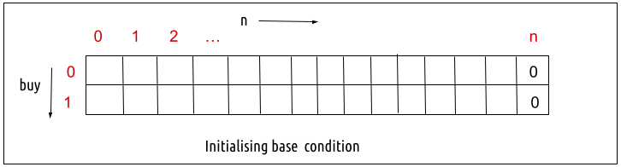

* Next, we set two nested for loops, the outer loop (for variable ind) moves from  n-1 to 0 and the inner loop (for variable buy) moves from 0 to 1.

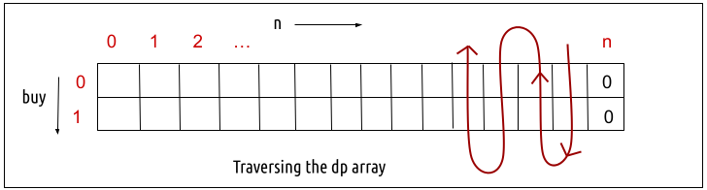

* In every iteration, we calculate the value according to the memoization logic.
* At last, we will print dp[0][0] as our answer.

**Code:**

import java.util.*;

class TUF{

static long getMaximumProfit(long Arr[], int n)

{

//Write your code here

long dp[][]=new long[n+1][2];

for(long row[]: dp)

Arrays.fill(row,-1);

//base condition

dp[n][0] = dp[n][1] = 0;

long profit=0;

for(int ind= n-1; ind>=0; ind--){

for(int buy=0; buy<=1; buy++){

if(buy==0){// We can buy the stock

profit = Math.max(0+dp[ind+1][0], -Arr[ind] + dp[ind+1][1]);

}

if(buy==1){// We can sell the stock

profit = Math.max(0+dp[ind+1][1], Arr[ind] + dp[ind+1][0]);

}

dp[ind][buy] = profit;

}

}

return dp[0][0];

}

public static void main(String args[]) {

int n =6;

long Arr[] = {7,1,5,3,6,4};

System.out.println("The maximum profit that can be generated is "+getMaximumProfit(Arr, n));

}

}

**Output:**

The maximum profit that can be generated is 7

**Time Complexity: O(N*2)**

Reason: There are two nested loops that account for O(N*2) complexity.

**Space Complexity: O(N*2)**

Reason: We are using an external array of size ‘N*2’. Stack Space is eliminated.

**Part 3: Space Optimization**

If we closely look the relation,

**dp[ind][buy] = max( dp[ind+1][buy] , max( dp[ind+1][!buy])**

We see that to calculate a value of a cell of the dp array, we need only the next column values(say ahead). So, we don’t need to store an entire 2-D array. Hence we can space optimize it.

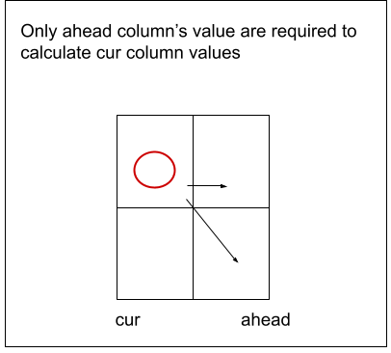

* We set the ahead column as 0 (base condition)
* Then we set the nested loops to calculate the cur column values.
* We replace dp[ind] with cur and dp[ind+1] with ahead in our memoization code.
* After the inner loop execution, we set ahead as cur for the next outer loop iteration.
* At last, we return cur[0] as our answer.

**Code:**

import java.util.*;

class TUF{

static long getMaximumProfit(long Arr[], int n)

{

//Write your code here

long ahead[]=new long[2];

long cur[] =new long[2];

//base condition

ahead[0] = ahead[1] = 0;

long profit=0;

for(int ind= n-1; ind>=0; ind--){

for(int buy=0; buy<=1; buy++){

if(buy==0){// We can buy the stock

profit = Math.max(0+ahead[0], -Arr[ind] + ahead[1]);

}

if(buy==1){// We can sell the stock

profit = Math.max(0+ahead[1], Arr[ind] + ahead[0]);

}

cur[buy] = profit;

}

ahead = (long[])(cur.clone());

}

return cur[0];

}

public static void main(String args[]) {

int n =6;

long Arr[] = {7,1,5,3,6,4};

System.out.println("The maximum profit that can be generated is "+

getMaximumProfit(Arr, n));

}

}

**Output:**

The maximum profit that can be generated is 7

**Time Complexity: O(N*2)**

Reason: There are two nested loops that account for O(N*2) complexity

**Space Complexity: O(1)**

Reason: We are using an external array of size ‘2’.

## Buy and Sell Stock – III | (DP – 37)

**Problem Link:**[Best Time to Buy and Sell Stock III](https://www.codingninjas.com/codestudio/problems/buy-and-sell-stock_1071012?source=youtube&campaign=striver_dp_videos&utm_source=youtube&utm_medium=affiliate&utm_campaign=striver_dp_videos&leftPanelTab=0)

We are given an array Arr[] of length n. It represents the price of a stock on ‘n’ days. The following guidelines need to be followed:

1. We can buy and sell the stock any number of times.
2. In order to sell the stock, we need to first buy it on the same or any previous day.
3. We can’t buy a stock again after buying it once. In other words, we first buy a stock and then sell it. After selling we can buy and sell again. But we can’t sell before buying and can’t buy before selling any previously bought stock.
4. We can do at most 2 transactions.



**Example:**

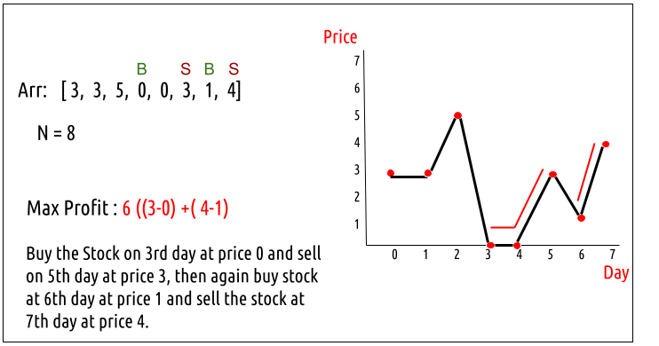

**Disclaimer**: Don’t jump directly to the solution, try it out yourself first.

### ****Solution :****

Every day, we will have two choices, either to do nothing and move to the next day or to buy/sell (based on the last transaction and the number of transactions left) and find out the profit. Therefore we need to generate all the choices in order to compare the profit. As we need to try out all the possible choices, we will use **recursion**.

**Steps to form the recursive solution:**

We will first form the recursive solution by the three points mentioned in the [Dynamic Programming Introduction](https://takeuforward.org/data-structure/dynamic-programming-introduction/).

**Step 1:**Express the problem in terms of indexes.

We need to think in the terms of the number of days, therefore one variable will be the array index( say ind). Next, we need to respect the condition that we can’t buy a stock again, that is we need to first sell a stock, and then we can buy that again. Therefore we need a second variable ‘buy’ which tells us on a particular day whether we can buy or sell the stock. Next, we have a cap on the number of transactions that we can make. Here the initial cap is 2. We need to always keep in mind this constraint. We can generalize the function as :

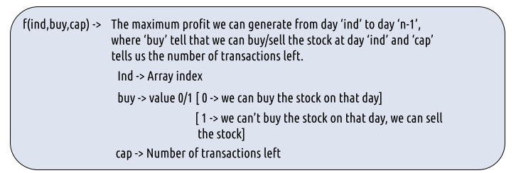

**Step 2:**Try out all possible choices at a given index.

Every day, we have two choices:

* To either buy/sell the stock(based on the buy variable’s value and if ‘cap’ > 0).
* To do nothing and move on to the next day.

We need to generate all the choices. We will use the pick/non-pick technique as discussed in this video “[Recursion on Subsequences](https://www.youtube.com/watch?v=AxNNVECce8c)”.

**Case 1:**When buy == 0, we can buy the stock.

If we can buy the stock on a particular day, we have two options:

* **Option 1:**To do no transaction and move to the next day. In this case, the net profit earned will be **0** from the current transaction, and to calculate the maximum profit starting from the next day, we will recursively call f(ind+1,0, cap). As we have not bought the stock, the ‘buy’ variable value will still remain 0, indicating that we can buy the stock the next day. And the ‘cap’ variable will remain the same as if no transaction took place.
* **Option 2:**The other option is to buy the stock on the current day. In this case, the net profit earned from the current transaction will be **-Arr[i]**. As we are buying the stock, we are giving money out of our pocket, therefore the profit we earn **is negative**. To calculate the maximum profit starting from the next day, we will recursively call **f(ind+1,1, cap)**. As we have bought the stock, the ‘buy’ variable value will change to 1, indicating that we can’t buy and only sell the stock the next day. As we have **only** bought the stock and not sold it the transaction remains incomplete and the ‘cap’ variable value remains unchanged.

**Case 2:**When buy == 1, we can sell the stock.

If we can buy the stock on a particular day, we have two options:

* **Option 1:**To do no transaction and move to the next day. In this case, the net profit earned will be **0** from the current transaction, and to calculate the maximum profit starting from the next day, we will recursively call **f(ind+1,1, cap)**. As we have not bought the stock, the ‘buy’ variable value will still remain at 1, indicating that we can’t buy and only sell the stock the next day. And the ‘cap’ variable will remain the same as if no transaction took place.
* **Option 2:**The other option is to sell the stock on the current day. In this case, the net profit earned from the current transaction will be +**Arr[i]**. As we are selling the stock, we are putting the money into our pocket, therefore the profit we earn **is positive**. To calculate the maximum profit starting from the next day, we will recursively call f(ind+1,0,cap-1). As we have sold the stock, the ‘buy’ variable value will change to 0, indicating that we can buy the stock the next day. As we have sold the earlier bought stock, we make one complete transaction, therefore now we update the ‘cap’ variable’s value to cap-1.

**Note:**Buying and selling a stock together counts as one complete transaction.

The figure below gives us the summary:

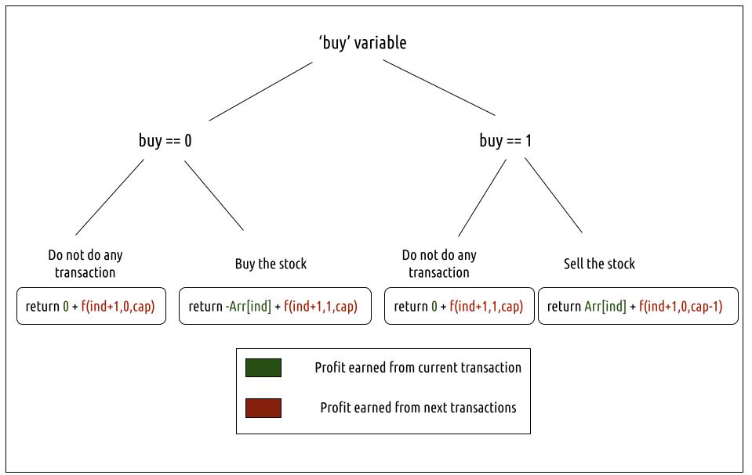

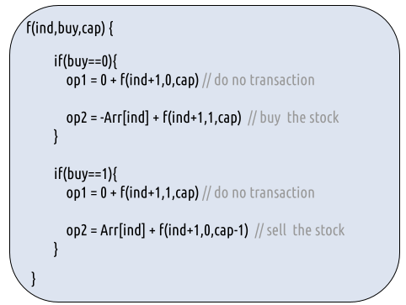

**Step 3:  Return the maximum**

As we are looking to maximize the profit earned, we will return the maximum value in both cases.

**Base Cases:**

* If ind==n, it means we have finished trading on all days, and there is no more money that we can get, therefore we simply return 0.
* If cap==0, it means that we cannot make any more transactions. Therefore we return 0.

The final pseudocode after steps 1, 2, and 3:

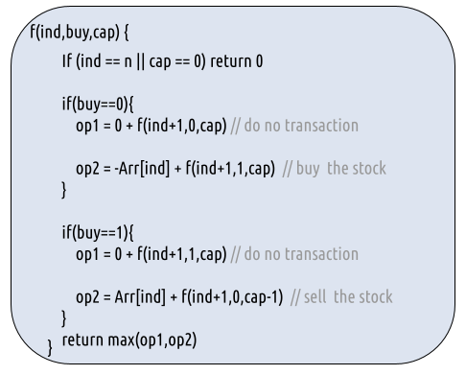

**Steps to memoize a recursive solution:**

If we draw the recursion tree, we will see that there are overlapping subproblems. In order to convert a recursive solution the following steps will be taken:

1. Create a dp array of size [n][2][3]. The size of the input array is ‘n’, so the index will always lie between ‘0’ and ‘n-1’. The ‘buy’  variable can take only two values: 0 and 1 and the ‘cap’ variable can only take three variables 0, 1, and 2. Therefore we take the dp array as dp[n][2][3].
2. We initialize the dp array to -1.
3. Whenever we want to find the answer of particular parameters (say f(ind,buy,cap)), we first check whether the answer is already calculated using the dp array(i.e dp[ind][buy][cap]!= -1 ). If yes, simply return the value from the dp array.
4. If not, then we are finding the answer for the given value for the first time, we will use the recursive relation as usual but before returning from the function, we will set dp[ind][buy][cap] to the solution we get.

**Code:**

#include <bits/stdc++.h>

using namespace std;

int getAns(vector<int>& Arr, int n, int ind, int buy, int cap, vector<vector<vector<int>>>& dp ){

if(ind==n || cap==0) return 0; //base case

if(dp[ind][buy][cap]!=-1)

return dp[ind][buy][cap];

int profit;

if(buy==0){// We can buy the stock

profit = max(0+getAns(Arr,n,ind+1,0,cap,dp),

-Arr[ind] + getAns(Arr,n,ind+1,1,cap,dp));

}

if(buy==1){// We can sell the stock

profit = max(0+getAns(Arr,n,ind+1,1,cap,dp),

Arr[ind] + getAns(Arr,n,ind+1,0,cap-1,dp));

}

return dp[ind][buy][cap] = profit;

}

int maxProfit(vector<int>& prices, int n)

{

// Creating a 3d - dp of size [n][2][3]

vector<vector<vector<int>>> dp(n,

vector<vector<int>>

(2,vector<int>(3,-1)));

return getAns(prices,n,0,0,2,dp);

}

int main() {

vector<int> prices = {3,3,5,0,0,3,1,4};

int n = prices.size();

cout<<"The maximum profit that can be generated is "<<maxProfit(prices, n);

}

**Output:**

The maximum profit that can be generated is 6

**Time Complexity: O(N*2*3)**

Reason: There are N*2*3 states therefore at max ‘N*2*3’ new problems will be solved.

**Space Complexity: O(N*2*3) + O(N)**

Reason: We are using a recursion stack space(O(N)) and a 3D array ( O(N*2*3)).

**Steps to convert Recursive Solution to Tabulation one.**

To convert the memoization approach to a tabulation one, create a dp array with the size [N+1][2][3].

**Handling the base case:**

Now, what the base condition in the recursive relation is:

**if( ind == n || cap == 0) return 0**

We handle this in the following way:

* **ind == n**

When ind == n, the other two variables: cap and buy can take any value, therefore we can set the following two loops and set dp[n][buy][cap] = 0

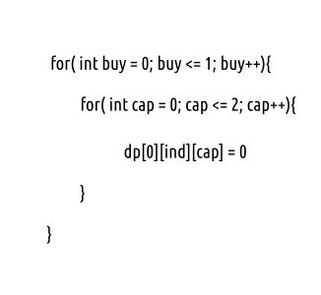

* **cap == 0**

When cap == 0, the other two variables: ind and cap can take any value, therefore we can set the following two loops and set dp[ind][buy][0] = 0.

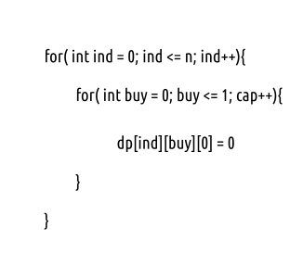

Another hack is to initialize the entire 3D DP Array as 0. In this case, we need not worry about explicitly setting the base cases.

* First, we declare the dp array of size [n+1][2][3] as zero.
* As we have initialized the array as 0, we have automatically set the base condition as explained above.
* Now, traverse the array in the opposite direction of that of the memoization technique. We will start from ind = n-1 -> ind =0.
* In every iteration copy the recursive code logic.
* At last dp[0][0][2] ( maximum profit generated on ith day, when we can buy the stock on 0th day and can have a total 2 transactions) gives us the final answer.

**Code:**

#include <bits/stdc++.h>

using namespace std;

int maxProfit(vector<int>& Arr, int n)

{

// Creating a 3d - dp of size [n+1][2][3] initialized to 0

vector<vector<vector<int>>> dp(n+1,

vector<vector<int>>

(2,vector<int>(3,0)));

// As dp array is intialized to 0, we have already covered the base case

for(int ind = n-1; ind>=0; ind--){

for(int buy = 0; buy<=1; buy++){

for(int cap=1; cap<=2; cap++){

if(buy==0){// We can buy the stock

dp[ind][buy][cap] = max(0+dp[ind+1][0][cap],

-Arr[ind] + dp[ind+1][1][cap]);

}

if(buy==1){// We can sell the stock

dp[ind][buy][cap] = max(0+dp[ind+1][1][cap],

Arr[ind] + dp[ind+1][0][cap-1]);

}

}

}

}

return dp[0][0][2];

}

int main() {

vector<int> prices = {3,3,5,0,0,3,1,4};

int n = prices.size();

cout<<"The maximum profit that can be generated is "<<maxProfit(prices, n);

}

**Output:**

The maximum profit that can be generated is 6

**Time Complexity: O(N*2*3)**

Reason: There are three nested loops that account for O(N*2*3) complexity.

**Space Complexity: O(N*2*3)**

Reason: We are using an external array of size ‘N*2*3’. Stack Space is eliminated.

**Part 3: Space Optimization**

If we closely look at the relation,

**dp[ind][buy][cap] = max( dp[ind+1][buy][cap] , max( dp[ind+1][!buy][cap])**

We see that to calculate a value of a cell of the dp array, we need only the next row values(say ahead of ind+1). So, we don’t need to store an entire 2-D array. Hence we can space optimize it.



* We set a 2D vector ahead initialized to 0 (base condition) and another 2D
* Then we set three nested loops to calculate the cur array’s values.
* We replace dp[ind] with cur and dp[ind+1] with ahead in our tabulation code.
* After the inner loop execution, we set ahead as cur for the next outer loop iteration.
* At last, we return ahead[0][2] as our answer.

**Code:**

#include <bits/stdc++.h>

using namespace std;

int maxProfit(vector<int>& Arr, int n)

{

vector<vector<int>> ahead(2,vector<int> (3,0));

vector<vector<int>> cur(2,vector<int> (3,0));

for(int ind = n-1; ind>=0; ind--){

for(int buy = 0; buy<=1; buy++){

for(int cap=1; cap<=2; cap++){

if(buy==0){// We can buy the stock

cur[buy][cap] = max(0+ahead[0][cap],

-Arr[ind] + ahead[1][cap]);

}

if(buy==1){// We can sell the stock

cur[buy][cap] = max(0+ahead[1][cap],

Arr[ind] + ahead[0][cap-1]);

}

}

}

ahead = cur;

}

return ahead[0][2];

}

int main() {

vector<int> prices = {3,3,5,0,0,3,1,4};

int n = prices.size();

cout<<"The maximum profit that can be generated is "<<maxProfit(prices, n);

}

**Output:**

The maximum profit that can be generated is 6

**Time Complexity: O(N*2*3)**

Reason: There are three nested loops that account for O(N*2*3) complexity

**Space Complexity: O(1)**

Reason: We are using two external arrays of size ‘2*3’.

## Buy and Sell Stock – IV | (DP – 38)

**Problem Link:**[**Best Time to Buy and Sell Stock IV**](https://www.codingninjas.com/codestudio/problems/best-time-to-buy-and-sell-stock_1080698?source=youtube&campaign=striver_dp_videos&utm_source=youtube&utm_medium=affiliate&utm_campaign=striver_dp_videos)

We are given an array Arr[] of length n. It represents the price of a stock on ‘n’ days. The following guidelines need to be followed:

1. We can buy and sell the stock any number of times.
2. In order to sell the stock, we need to first buy it on the same or any previous day.
3. We can’t buy a stock again after buying it once. In other words, we first buy a stock and then sell it. After selling we can buy and sell again. But we can’t sell before buying and can’t buy before selling any previously bought stock.
4. We can do at-most **K** transactions.



**Example:**



**K = 2**

**Disclaimer**: Don’t jump directly to the solution, try it out yourself first.

Pre- Requisite: [Buy and Sell Stock III](https://takeuforward.org/data-structure/buy-and-sell-stock-iii-dp-37/)

### ****Solution :****

This question is quite similar to the question discussed in [Buy and Sell Stock III](https://takeuforward.org/data-structure/buy-and-sell-stock-iii-dp-37/). There we can do at most two transactions whereas here we can do at most K transactions. Therefore, we will modify that approach according to our needs in this section. Readers are highly advised to go through [**Buy and Sell Stock III**](https://takeuforward.org/data-structure/buy-and-sell-stock-iii-dp-37/)first.

### ****Intuition:****

Every day, we will have two choices, either to do nothing and move to the next day or to buy/sell (based on the last transaction and the number of transactions left) and find out the profit. Therefore we need to generate all the choices in order to compare the profit. As we need to try out all the possible choices, we will use **recursion**.

**Steps to form the recursive solution:**

We will first form the recursive solution by the three points mentioned in the [Dynamic Programming Introduction](https://takeuforward.org/data-structure/dynamic-programming-introduction/).

**Step 1:**Express the problem in terms of indexes.

We need to think in the terms of the number of days, therefore one variable will be the array index( say ind). Next, we need to respect the condition that we can’t buy a stock again, that is we need to first sell a stock, and then we can buy that again. Therefore we need a second variable ‘buy’ which tells us on a particular day whether we can buy or sell the stock. Next, we have a cap on the number of transactions that we can make. Here the initial cap is K.We need to always keep in mind this constraint. We can generalize the function as :



**Step 2:**Try out all possible choices at a given index.

Every day, we have two choices:

* To either buy/sell the stock(based on the buy variable’s value and if ‘cap’ > 0).
* To do nothing and move on to the next day.

We need to generate all the choices. We will use the pick/non-pick technique as discussed in this video “[Recursion on Subsequences](https://www.youtube.com/watch?v=AxNNVECce8c)”.

**Case 1:**When buy == 0, we can buy the stock.

If we can buy the stock on a particular day, we have two options:

* **Option 1:**To do no transaction and move to the next day. In this case, the net profit earned will be **0** from the current transaction, and to calculate the maximum profit starting from the next day, we will recursively call **f(ind+1,0, cap)**. As we have not bought the stock, the ‘buy’ variable value will still remain 0, indicating that we can buy the stock the next day. And the ‘cap’ variable will remain the same as if no transaction took place.
* **Option 2:**The other option is to buy the stock on the current day. In this case, the net profit earned from the current transaction will be **-Arr[i]**. As we are buying the stock, we are giving money out of our pocket, therefore the profit we earn **is negative**. To calculate the maximum profit starting from the next day, we will recursively call **f(ind+1,1, cap)**. As we have bought the stock, the ‘buy’ variable value will change to 1, indicating that we can’t buy and only sell the stock the next day. As we have **only** bought the stock and not sold it the transaction remains incomplete and the ‘cap’ variable value remains unchanged.

**Case 2:**When buy == 1, we can sell the stock.

If we can buy the stock on a particular day, we have two options:

* **Option 1:**To do no transaction and move to the next day. In this case, the net profit earned will be **0** from the current transaction, and to calculate the maximum profit starting from the next day, we will recursively call **f(ind+1,1, cap)**. As we have not bought the stock, the ‘buy’ variable value will still remain at 1, indicating that we can’t buy and only sell the stock the next day. And the ‘cap’ variable will remain the same as if no transaction took place.
* **Option 2:**The other option is to sell the stock on the current day. In this case, the net profit earned from the current transaction will be +**Arr[i]**. As we are selling the stock, we are putting the money into our pocket, therefore the profit we earn **is positive**. To calculate the maximum profit starting from the next day, we will recursively call **f(ind+1,0,cap-1)**. As we have sold the stock, the ‘buy’ variable value will change to 0, indicating that we can buy the stock the next day. As we have sold the earlier bought stock, we make one complete transaction, therefore now we update the ‘cap’ variable’s value to cap-1.

**Note:**Buying and selling a stock together counts as one complete transaction.

The figure below gives us the summary:





**Step 3:  Return the maximum**

As we are looking to maximize the profit earned, we will return the maximum value in both cases.

**Base Cases:**

* If ind==n, it means we have finished trading on all days, and there is no more money that we can get, therefore we simply return 0.
* If cap==0, it means that we cannot make any more transactions. Therefore we return 0.

The final pseudocode after steps 1, 2, and 3:



**Steps to memoize a recursive solution:**

If we draw the recursion tree, we will see that there are overlapping subproblems. In order to convert a recursive solution the following steps will be taken:

1. Create a dp array of size [n][2][3]. The size of the input array is ‘n’, so the index will always lie between ‘0’ and ‘n-1’. The ‘buy’  variable can take only two values: 0 and 1 and the ‘cap’ variable can only take three variables 0, 1, and 2. Therefore we take the dp array as dp[n][2][3].
2. We initialize the dp array to -1.
3. Whenever we want to find the answer of particular parameters (say f(ind,buy,cap)), we first check whether the answer is already calculated using the dp array(i.e dp[ind][buy][cap]!= -1 ). If yes, simply return the value from the dp array.
4. If not, then we are finding the answer for the given value for the first time, we will use the recursive relation as usual but before returning from the function, we will set dp[ind][buy][cap] to the solution we get.

**Code:**

#include <bits/stdc++.h>

using namespace std;

int getAns(vector<int>& Arr, int n, int ind, int buy, int cap, vector<vector<vector<int>>>& dp ){

if(ind==n || cap==0) return 0; //base case

if(dp[ind][buy][cap]!=-1)

return dp[ind][buy][cap];

int profit;

if(buy==0){// We can buy the stock

profit = max(0+getAns(Arr,n,ind+1,0,cap,dp),

-Arr[ind] + getAns(Arr,n,ind+1,1,cap,dp));

}

if(buy==1){// We can sell the stock

profit = max(0+getAns(Arr,n,ind+1,1,cap,dp),

Arr[ind] + getAns(Arr,n,ind+1,0,cap-1,dp));

}

return dp[ind][buy][cap] = profit;

}

int maximumProfit(vector<int>& prices, int n, int k)

{

// Creating a 3d - dp of size [n][2][k+1]

vector<vector<vector<int>>> dp(n,

vector<vector<int>>

(2,vector<int>(k+1,-1)));

return getAns(prices,n,0,0,k,dp);

}

int main() {

vector<int> prices = {3,3,5,0,0,3,1,4};

int n = prices.size();

int k = 2;

cout<<"The maximum profit that can be generated is "<<maximumProfit(prices, n,k);

}

**Output:**

The maximum profit that can be generated is 6

**Time Complexity: O(N*2*3)**

Reason: There are N*2*K states therefore at max ‘N*2*K’ new problems will be solved.

**Space Complexity: O(N*2*K) + O(N)**

Reason: We are using a recursion stack space(O(N)) and a 3D array ( O(N*2*K)).

**Steps to convert Recursive Solution to Tabulation one.**

To convert the memoization approach to a tabulation one, create a dp array with the size [N+1][2][K+1].

**Handling the base case:**

Now, what the base condition in the recursive relation is:

**if( ind == n || cap == 0) return 0**

We handle this in the following way:

1. **ind == n**

When ind == n, the other two variables: cap and buy can take any value, therefore we can set the following two loops and set dp[n][buy][cap] = 0

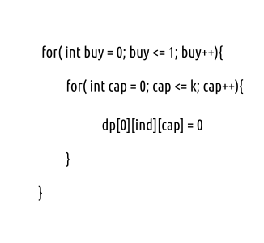

1. **cap == 0**

When cap == 0, the other two variables: ind and cap can take any value, therefore we can set the following two loops and set dp[ind][buy][0] = 0.

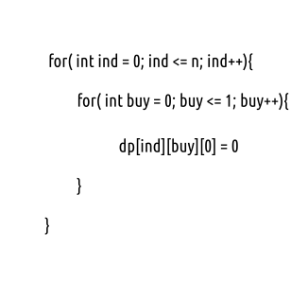

Another hack is to initialize the entire 3D DP Array as 0. In this case, we need not worry about explicitly setting the base cases.

* First we declare the dp array of size [n+1][2][k+1] as zero.
* As we have initialized the array as 0, we have automatically set the base condition as explained above.
* Now, traverse the array in the opposite direction of that of the memoization technique. We will start from ind = n-1 -> ind =0.
* In every iteration copy the recursive code logic.
* At last dp[0][0][2] ( maximum profit generated on ith day, when we can buy the stock on 0th day and can have a total 2 transactions) gives us the final answer.

**Code:**

#include <bits/stdc++.h>

using namespace std;

int maximumProfit(vector<int>& Arr, int n, int k)

{

// Creating a 3d - dp of size [n+1][2][k+1] initialized to 0

vector<vector<vector<int>>> dp(n+1,

vector<vector<int>>

(2,vector<int>(k+1,0)));

// As dp array is initialized to 0, we have already covered the base case

for(int ind = n-1; ind>=0; ind--){

for(int buy = 0; buy<=1; buy++){

for(int cap=1; cap<=k; cap++){

if(buy==0){// We can buy the stock

dp[ind][buy][cap] = max(0+dp[ind+1][0][cap],

-Arr[ind] + dp[ind+1][1][cap]);

}

if(buy==1){// We can sell the stock

dp[ind][buy][cap] = max(0+dp[ind+1][1][cap],

Arr[ind] + dp[ind+1][0][cap-1]);

}

}

}

}

return dp[0][0][k];

}

int main() {

vector<int> prices = {3,3,5,0,0,3,1,4};

int n = prices.size();

int k =2;

cout<<"The maximum profit that can be generated is "<<maximumProfit(prices, n, k);

}

**Output:**

The maximum profit that can be generated is 6

**Time Complexity: O(N*2*k)**

Reason: There are three nested loops that account for O(N*2*K) complexity.

**Space Complexity: O(N*2*k)**

Reason: We are using an external array of size ‘N*2*K’. Stack Space is eliminated.

**Part 3: Space Optimization**

If we closely look the relation,

**dp[ind][buy][cap] = max( dp[ind+1][buy][cap] , max( dp[ind+1][!buy][cap])**

We see that to calculate a value of a cell of the dp array, we need only the next row values(say ahead of ind+1). So, we don’t need to store an entire 2-D array. Hence we can space optimize it.



* We set a 2D vector ahead initialized to 0 (base condition) and another 2D
* Then we set three nested loops to calculate the cur array’s values.
* We replace dp[ind] with cur and dp[ind+1] with ahead in our tabulation code.
* After the inner loop execution, we set ahead as cur for the next outer loop iteration.
* At last, we return ahead[0][k] as our answer.

**Code:**

#include <bits/stdc++.h>

using namespace std;

int maxProfit(vector<int>& Arr, int n, int k)

{

vector<vector<int>> ahead(2,vector<int> (k+1,0));

vector<vector<int>> cur(2,vector<int> (k+1,0));

for(int ind = n-1; ind>=0; ind--){

for(int buy = 0; buy<=1; buy++){

for(int cap=1; cap<=k; cap++){

if(buy==0){// We can buy the stock

cur[buy][cap] = max(0+ahead[0][cap],

-Arr[ind] + ahead[1][cap]);

}

if(buy==1){// We can sell the stock

cur[buy][cap] = max(0+ahead[1][cap],

Arr[ind] + ahead[0][cap-1]);

}

}

}

ahead = cur;

}

return ahead[0][k];

}

int main() {

vector<int> prices = {3,3,5,0,0,3,1,4};

int n = prices.size();

int k=2;

cout<<"The maximum profit that can be generated is "<<maxProfit(prices, n,k);

}

**Output:**

The maximum profit that can be generated is 6

**Time Complexity: O(N*2*K)**

Reason: There are three nested loops that account for O(N*2*K) complexity

**Space Complexity: O(K)**

Reason: We are using two external arrays of size ‘2*K’.

**Pattern 16: Topological Sort (Graph)**

**Topological Sort** is used to find a linear ordering of elements that have dependencies on each other. For example, if event B is dependent on event A, A comes before B in topological ordering.

This pattern defines an easy way to understand the technique for performing topological sorting of a set of elements and then solves a few problems using it.

Let’s see this pattern in action.

**Topological Sort (medium)**

Topological Sort of a directed graph (a graph with unidirectional edges) is a linear ordering of its vertices such that for every directed edge (U, V) from vertex U to vertex V, U comes before V in the ordering.

Given a directed graph, find the topological ordering of its vertices.

**Example 1:**

Input: Vertices=4, Edges=[3, 2], [3, 0], [2, 0], [2, 1]

Output: Following are the two valid topological sorts for the given graph:

1) 3, 2, 0, 1

2) 3, 2, 1, 0

[](https://github.com/maazshaikh007/DSA_Patterns/blob/main/images/topsort.png)

**Example 2:**

Input: Vertices=5, Edges=[4, 2], [4, 3], [2, 0], [2, 1], [3, 1]

Output: Following are all valid topological sorts for the given graph:

1) 4, 2, 3, 0, 1

2) 4, 3, 2, 0, 1

3) 4, 3, 2, 1, 0

4) 4, 2, 3, 1, 0

5) 4, 2, 0, 3, 1

[](https://github.com/maazshaikh007/DSA_Patterns/blob/main/images/topsort2.png)

**Example 3:**

Input: Vertices=7, Edges=[6, 4], [6, 2], [5, 3], [5, 4], [3, 0], [3, 1], [3, 2], [4, 1]

Output: Following are all valid topological sorts for the given graph:

1) 5, 6, 3, 4, 0, 1, 2

2) 6, 5, 3, 4, 0, 1, 2

3) 5, 6, 4, 3, 0, 2, 1

4) 6, 5, 4, 3, 0, 1, 2

5) 5, 6, 3, 4, 0, 2, 1

6) 5, 6, 3, 4, 1, 2, 0

There are other valid topological ordering of the graph too.

[](https://github.com/maazshaikh007/DSA_Patterns/blob/main/images/topsort3.png)

### Solution

The basic idea behind the topological sort is to provide a partial ordering among the vertices of the graph such that if there is an edge from U to V then U≤V i.e., U comes before V in the ordering.

Here are a few fundamental concepts related to **topological sort**:

* **Source:** Any node that has no incoming edge and has only outgoing edges is called a **source**.
* **Sink:** Any node that has only incoming edges and no outgoing edge is called a **sink**.
* So, we can say that a topological ordering starts with one of the **sources** and ends at one of the **sinks**.
* A topological ordering is possible only when the graph has no directed *cycles*, i.e. if the graph is a **Directed Acyclic Graph (DAG)**. If the graph has a cycle, some vertices will have cyclic dependencies which makes it impossible to find a linear ordering among vertices.

To find the *topological sort* of a graph we can traverse the graph in a **Breadth First Search (BFS)** way. We will start with all the *sources*, and in a stepwise fashion, save all sources to a sorted list. We will then remove all sources and their edges from the graph. After the removal of the edges, we will have new sources, so we will repeat the above process until all vertices are visited.

Here is the visual representation of this algorithm for Example-3:

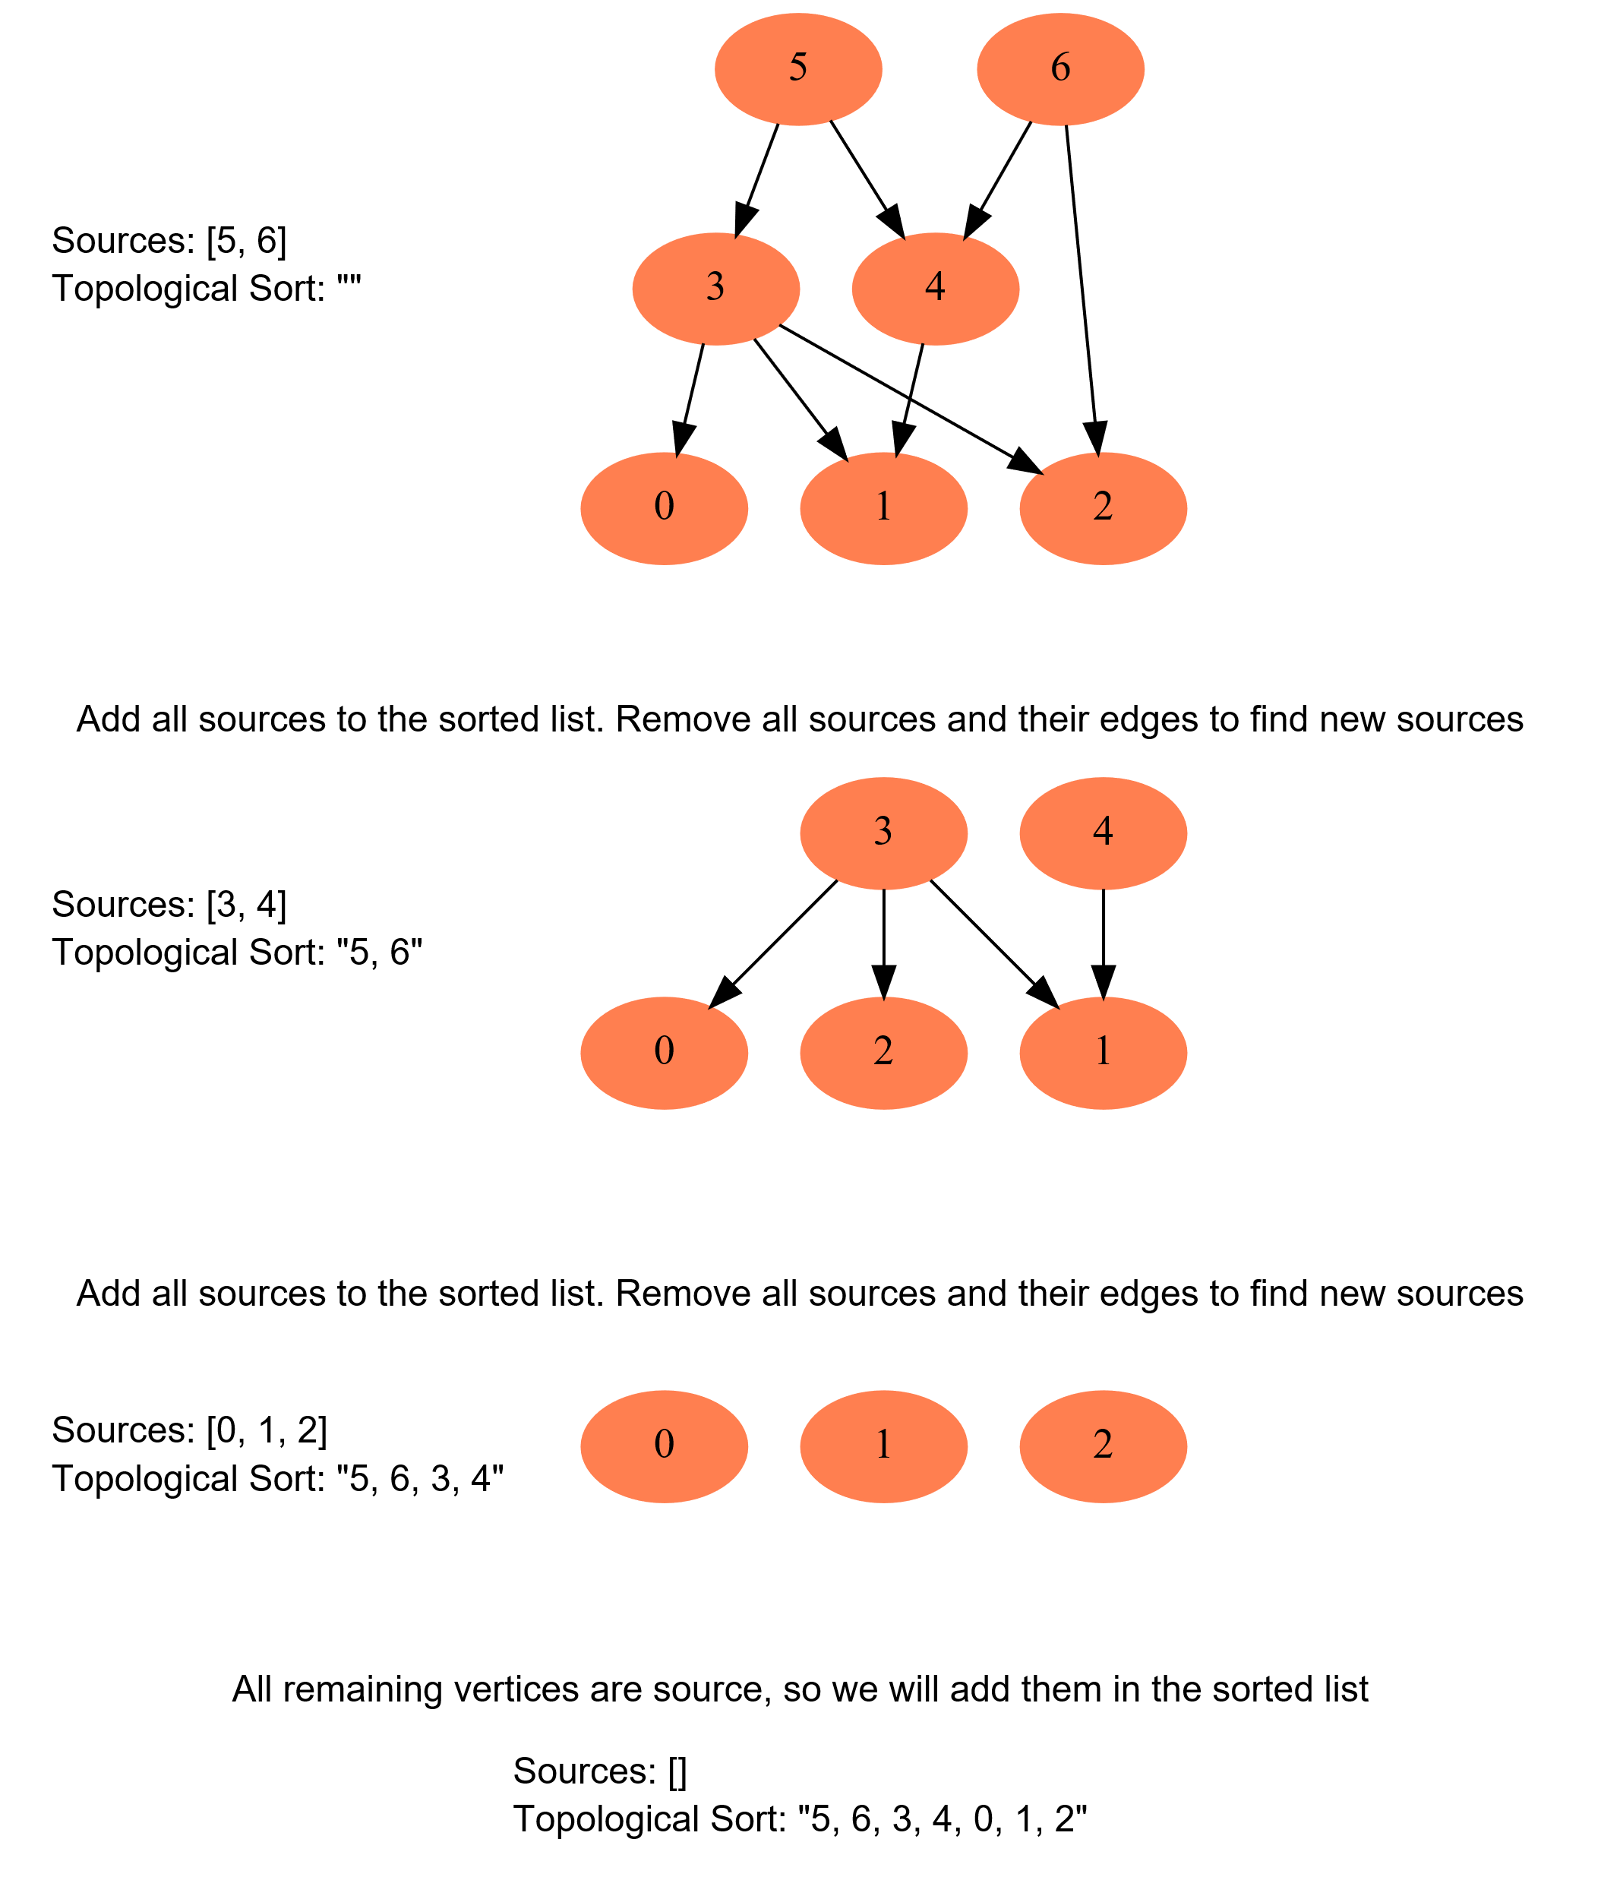

This is how we can implement this algorithm:

**1. Initialization**

* We will store the graph in **Adjacency Lists**, which means each parent vertex will have a list containing all of its children.
* We will do this using a **HashMap** where the key will be the parent vertex number and the value will be a List containing children vertices.
* To find the sources, we will keep a **HashMap** to count the in-degrees i.e., count of incoming edges of each vertex. Any vertex with 0 in-degree will be a source.

**2. Build the graph and find in-degrees of all vertices**

* We will build the graph from the input and populate the in-degrees **HashMap**.

**3. Find all sources**

* All vertices with 0 in-degrees will be our sources and we will store them in a **Queue**.

**4. Sort**

* For each source, do the following things:
  + Add it to the sorted list.
  + Get all of its children from the graph.
  + Decrement the in-degree of each child by 1.
  + If a child’s in-degree becomes 0, add it to the sources **Queue**.
* Repeat for each source, until the source **Queue** is empty.

Here is the visual representation of this algorithm for **Example 3**: [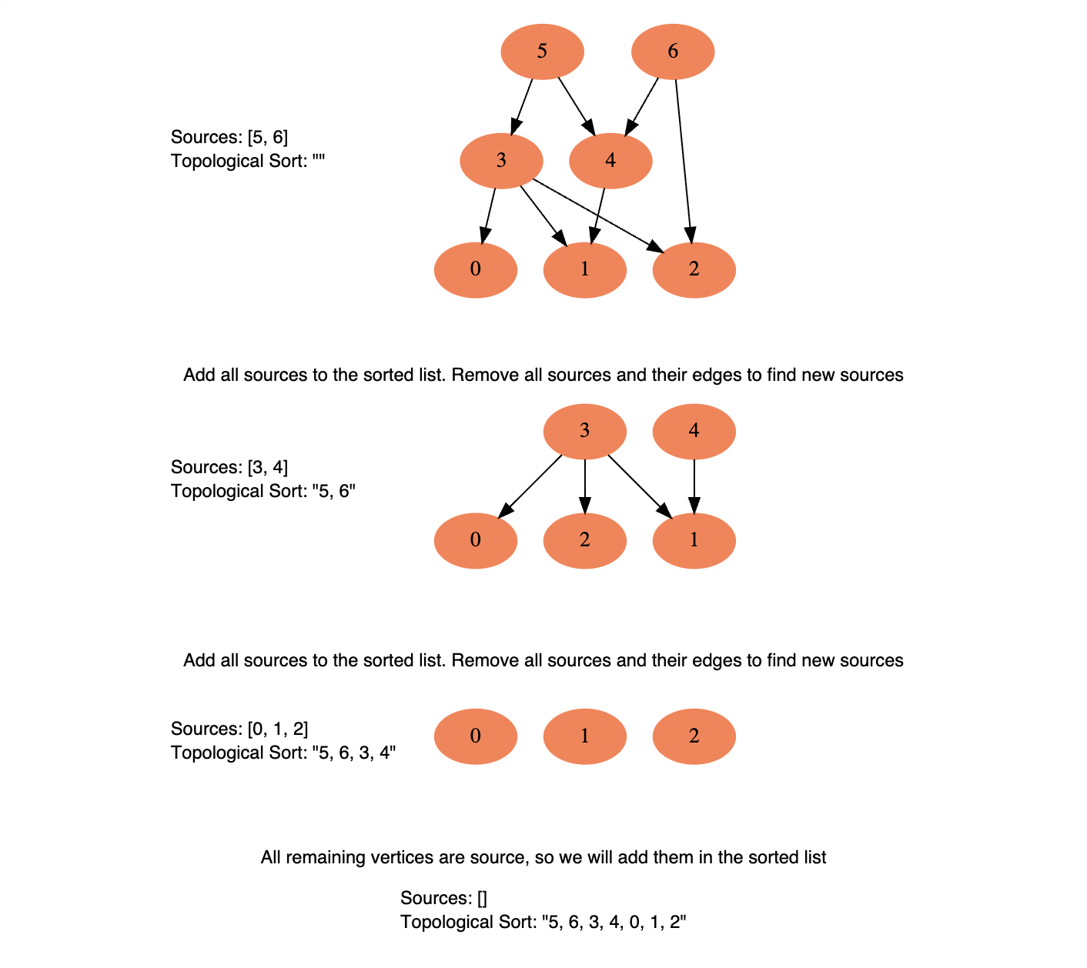](https://github.com/maazshaikh007/DSA_Patterns/blob/main/images/topsort4.png)

This is how we can implement this algorithm:

### Code

|  |
| --- |
| import java.util.*;  class Solution {  public static List<Integer> sort(int vertices, int[][] edges) {  List<Integer> sortedOrder = new ArrayList<>();  if (vertices <= 0)  return sortedOrder;  // a. Initialize the graph  HashMap<Integer, Integer> inDegree =  new HashMap<>(); // count of incoming edges for every vertex  HashMap<Integer, List<Integer>> graph = new HashMap<>(); // adjacency list graph  for (int i = 0; i < vertices; i++) {  inDegree.put(i, 0);  graph.put(i, new ArrayList<Integer>());  }  // b. Build the graph  for (int i = 0; i < edges.length; i++) {  int parent = edges[i][0], child = edges[i][1];  graph.get(parent).add(child); // put the child into it's parent's list  inDegree.put(child, inDegree.get(child) + 1); // increment child's inDegree  }  // c. Find all sources i.e., all vertices with 0 in-degrees  Queue<Integer> sources = new LinkedList<>();  for (Map.Entry<Integer, Integer> entry : inDegree.entrySet()) {  if (entry.getValue() == 0)  sources.add(entry.getKey());  }  // d. For each source, add it to the sortedOrder and subtract one from all of its  // children's in-degrees if a child's in-degree becomes zero, add it to sources queue  while (!sources.isEmpty()) {  int vertex = sources.poll();  sortedOrder.add(vertex);  // get the node's children to decrement their in-degrees  List<Integer> children = graph.get(vertex);  for (int child : children) {  inDegree.put(child, inDegree.get(child) - 1);  if (inDegree.get(child) == 0)  sources.add(child);  }  }  // if topological sort is not possible as the graph has a cycle  if (sortedOrder.size() != vertices)  return new ArrayList<>();  return sortedOrder;  }  public static void main(String[] args) {  List<Integer> result = Solution.sort(4, new int[][] { new int[] { 3, 2 },  new int[] { 3, 0 }, new int[] { 2, 0 }, new int[] { 2, 1 } });  System.out.println(result);  result = Solution.sort(5, new int[][] { new int[] { 4, 2 },  new int[] { 4, 3 }, new int[] { 2, 0 }, new int[] { 2, 1 }, new int[] { 3, 1 } });  System.out.println(result);  result = Solution.sort(7, new int[][] { new int[] { 6, 4 },  new int[] { 6, 2 }, new int[] { 5, 3 }, new int[] { 5, 4 },  new int[] { 3, 0 }, new int[] { 3, 1 }, new int[] { 3, 2 }, new int[] { 4, 1 } });  System.out.println(result);  }  } |

* In step 4, each vertex will become a source only once and each edge will be accessed and removed once. Therefore, the time complexity of the above algorithm will be O(V+E), where V is the total number of vertices and ‘E’ is the total number of edges in the graph.
* The space complexity will be O(V+E), since we are storing all of the edges for each vertex in an adjacency list.

**Similar Problems**

Find if a given Directed Graph has a cycle in it or not.

**Solution:** If we can’t determine the topological ordering of all the vertices of a directed graph, the graph has a cycle in it. This was also referred to in the above code:

if (sortedOrder.size() != vertices) // topological sort is not possible as the graph has a cycle

return new ArrayList<>();

## 👩🏽‍🦯 Tasks Scheduling (medium)

<https://leetcode.com/problems/course-schedule/>

### Problem Statement

There are ‘N’ tasks, labeled from ‘0’ to ‘N-1’. Each task can have some prerequisite tasks which need to be completed before it can be scheduled. Given the number of tasks and a list of prerequisite pairs, find out if it is possible to schedule all the tasks.

**Example 1**:

Input: Tasks=3, Prerequisites=[0, 1], [1, 2]

Output: true

Explanation: To execute task '1', task '0' needs to finish first. Similarly, task '1' needs

to finish before '2' can be scheduled. One possible scheduling of tasks is: [0, 1, 2]

**Example 2**:

Input: Tasks=3, Prerequisites=[0, 1], [1, 2], [2, 0]

Output: false

Explanation: The tasks have a cyclic dependency, therefore they cannot be scheduled.

**Example 3**:

Input: Tasks=6, Prerequisites=[2, 5], [0, 5], [0, 4], [1, 4], [3, 2], [1, 3]

Output: true

Explanation: A possible scheduling of tasks is: [0 1 4 3 2 5]

### Solution

There are N tasks, labeled from 0 to N-1. Each task can have some prerequisite tasks which need to be completed before it can be scheduled. Given the number of tasks and a list of prerequisite pairs, find out if it is possible to schedule all the tasks.

This problem is asking us to find out if it is possible to find a **topological ordering** of the given tasks. The tasks are equivalent to the vertices and the prerequisites are the edges.

We can use a similar algorithm as described in [**Topological Sort**](https://github.com/maazshaikh007/DSA_Patterns/blob/main/%E2%9C%85%20Pattern%2016%3A%20%F0%9F%94%8E%20Topological%20Sort%20(Graph).md#topological-sort-medium) to find the topological ordering of the tasks. If the ordering does not include all the tasks, we will conclude that some tasks have *cyclic dependencies*.

### Code

|  |
| --- |
| import java.util.*;  class Solution {  public static boolean isSchedulingPossible(int tasks, int[][] prerequisites) {  List<Integer> sortedOrder = new ArrayList<>();  if (tasks <= 0)  return false;  // a. Initialize the graph  HashMap<Integer, Integer> inDegree =  new HashMap<>(); // count of incoming edges for every vertex  HashMap<Integer, List<Integer>> graph = new HashMap<>(); // adjacency list graph  for (int i = 0; i < tasks; i++) {  inDegree.put(i, 0);  graph.put(i, new ArrayList<Integer>());  }  // b. Build the graph  for (int i = 0; i < prerequisites.length; i++) {  int parent = prerequisites[i][0], child = prerequisites[i][1];  graph.get(parent).add(child); // put the child into it's parent's list  inDegree.put(child, inDegree.get(child) + 1); // increment child's inDegree  }  // c. Find all sources i.e., all vertices with 0 in-degrees  Queue<Integer> sources = new LinkedList<>();  for (Map.Entry<Integer, Integer> entry : inDegree.entrySet()) {  if (entry.getValue() == 0)  sources.add(entry.getKey());  }  // d. For each source, add it to the sortedOrder and subtract one from all of its  // children's in-degrees if a child's in-degree becomes zero, add it to sources queue  while (!sources.isEmpty()) {  int vertex = sources.poll();  sortedOrder.add(vertex);  // get the node's children to decrement their in-degrees  List<Integer> children = graph.get(vertex);  for (int child : children) {  inDegree.put(child, inDegree.get(child) - 1);  if (inDegree.get(child) == 0)  sources.add(child);  }  }  // if sortedOrder doesn't contain all tasks, there is a cyclic dependency between  // tasks, therefore, we will not be able to schedule all tasks  return sortedOrder.size() == tasks;  }  public static void main(String[] args) {  boolean result = Solution.isSchedulingPossible(3,  new int[][] { new int[] { 0, 1 }, new int[] { 1, 2 } });  System.out.println("Tasks execution possible: " + result);  result = Solution.isSchedulingPossible(3,  new int[][] { new int[] { 0, 1 }, new int[] { 1, 2 }, new int[] { 2, 0 } });  System.out.println("Tasks execution possible: " + result);  result = Solution.isSchedulingPossible(6, new int[][] { new int[] { 2, 5 },  new int[] { 0, 5 }, new int[] { 0, 4 }, new int[] { 1, 4 },  new int[] { 3, 2 }, new int[] { 1, 3 } });  System.out.println("Tasks execution possible: " + result);  }  } |

* In step 4, each task can become a source only once, and each edge (i.e., prereq) will be accessed and removed once. Therefore, the time complexity of the above algorithm will be O(V+E), where V is the total number of tasks and E is the total number of prerequisites.
* The space complexity will be O(V+E), since we are storing all of the prerequisites for each task in an adjacency list.

**Similar Problems**

**Course Schedule:** There are N courses, labeled from 0 to N-1. Each course can have some prerequisite courses which need to be completed before it can be taken. Given the number of courses and a list of prerequisite pairs, find if it is possible for a student to take all the courses.

**Solution:** This problem is exactly similar to our parent problem. In this problem, we have courses instead of tasks.

**🔎 Tasks Scheduling Order (medium)**

<https://leetcode.com/problems/course-schedule-ii/>

### Problem Statement

There are N tasks, labeled from 0 to N-1. Each task can have some prerequisite tasks which need to be completed before it can be scheduled. Given the number of tasks and a list of prerequisite pairs, write a method to find the ordering of tasks we should pick to finish all tasks.

**Example 1**:

Input: Tasks=3, Prerequisites=[0, 1], [1, 2]

Output: [0, 1, 2]

Explanation: To execute task '1', task '0' needs to finish first. Similarly, task '1' needs

to finish before '2' can be scheduled. A possible scheduling of tasks is: [0, 1, 2]

**Example 2**:

Input: Tasks=3, Prerequisites=[0, 1], [1, 2], [2, 0]

Output: []

Explanation: The tasks have a cyclic dependency, therefore they cannot be scheduled.

**Example 3**:

Input: Tasks=6, Prerequisites=[2, 5], [0, 5], [0, 4], [1, 4], [3, 2], [1, 3]

Output: [0 1 4 3 2 5]

Explanation: A possible scheduling of tasks is: [0 1 4 3 2 5]

### Solution

This problem is similar to [**Tasks Scheduling**](https://github.com/maazshaikh007/DSA_Patterns/blob/main/%E2%9C%85%20Pattern%2016%3A%20%F0%9F%94%8E%20Topological%20Sort%20(Graph).md#-tasks-scheduling-medium), the only difference being that we need to find the best ordering of tasks so that it is possible to schedule them all.

### Code

|  |
| --- |
| import java.util.*;  class Solution {  public static List<Integer> findOrder(int tasks, int[][] prerequisites) {  List<Integer> sortedOrder = new ArrayList<>();  if (tasks <= 0)  return sortedOrder;  // a. Initialize the graph  HashMap<Integer, Integer> inDegree =  new HashMap<>(); // count of incoming edges for every vertex  HashMap<Integer, List<Integer>> graph = new HashMap<>(); // adjacency list graph  for (int i = 0; i < tasks; i++) {  inDegree.put(i, 0);  graph.put(i, new ArrayList<Integer>());  }  // b. Build the graph  for (int i = 0; i < prerequisites.length; i++) {  int parent = prerequisites[i][0], child = prerequisites[i][1];  graph.get(parent).add(child); // put the child into it's parent's list  inDegree.put(child, inDegree.get(child) + 1); // increment child's inDegree  }  // c. Find all sources i.e., all vertices with 0 in-degrees  Queue<Integer> sources = new LinkedList<>();  for (Map.Entry<Integer, Integer> entry : inDegree.entrySet()) {  if (entry.getValue() == 0)  sources.add(entry.getKey());  }  // d. For each source, add it to the sortedOrder and subtract one from all of its  // children's in-degrees if a child's in-degree becomes zero, add it to sources queue  while (!sources.isEmpty()) {  int vertex = sources.poll();  sortedOrder.add(vertex);  // get the node's children to decrement their in-degrees  List<Integer> children = graph.get(vertex);  for (int child : children) {  inDegree.put(child, inDegree.get(child) - 1);  if (inDegree.get(child) == 0)  sources.add(child);  }  }  // if sortedOrder doesn't contain all tasks, there is a cyclic dependency between  // tasks, therefore, we will not be able to schedule all tasks  if (sortedOrder.size() != tasks)  return new ArrayList<>();  return sortedOrder;  }  public static void main(String[] args) {  List<Integer> result = Solution.findOrder(3, new int[][] {  new int[] { 0, 1 }, new int[] { 1, 2 } });  System.out.println(result);  result = Solution.findOrder(3,  new int[][] { new int[] { 0, 1 }, new int[] { 1, 2 }, new int[] { 2, 0 } });  System.out.println(result);  result = Solution.findOrder(6, new int[][] { new int[] { 2, 5 },  new int[] { 0, 5 }, new int[] { 0, 4 }, new int[] { 1, 4 }, new int[] { 3, 2 },  new int[] { 1, 3 } });  System.out.println(result);  }  } |

* In step 4, each task can become a source only once, and each edge (i.e., prereq) will be accessed and removed once. Therefore, the time complexity of the above algorithm will be O(V+E), where V is the total number of tasks and E is the total number of prerequisites.
* The space complexity will be O(V+E), since we are storing all of the prerequisites for each task in an adjacency list.

**Similar Problems**

**Course Schedule:**

There are N courses, labeled from 0 to N-1. Each course has some prerequisite courses which need to be completed before it can be taken. Given the number of courses and a list of prerequisite pairs, write a method to find the best ordering of the courses that a student can take in order to finish all courses.

**Solution:** This problem is exactly similar to our parent problem. In this problem, we have courses instead of tasks.

**All Tasks Scheduling Orders (hard)**

### Problem Statement

There are N tasks, labeled from 0 to N-1. Each task can have some prerequisite tasks which need to be completed before it can be scheduled. Given the number of tasks and a list of prerequisite pairs, write a method to print all possible ordering of tasks meeting all prerequisites.

**Example 1**:

Input: Tasks=3, Prerequisites=[0, 1], [1, 2]

Output: [0, 1, 2]

Explanation: There is only possible ordering of the tasks.

**Example 2**:

Input: Tasks=4, Prerequisites=[3, 2], [3, 0], [2, 0], [2, 1]

Output:

1) [3, 2, 0, 1]

2) [3, 2, 1, 0]

Explanation: There are two possible orderings of the tasks meeting all prerequisites.

**Example 3**:

Input: Tasks=6, Prerequisites=[2, 5], [0, 5], [0, 4], [1, 4], [3, 2], [1, 3]

Output:

1) [0, 1, 4, 3, 2, 5]

2) [0, 1, 3, 4, 2, 5]

3) [0, 1, 3, 2, 4, 5]

4) [0, 1, 3, 2, 5, 4]

5) [1, 0, 3, 4, 2, 5]

6) [1, 0, 3, 2, 4, 5]

7) [1, 0, 3, 2, 5, 4]

8) [1, 0, 4, 3, 2, 5]

9) [1, 3, 0, 2, 4, 5]

10) [1, 3, 0, 2, 5, 4]

11) [1, 3, 0, 4, 2, 5]

12) [1, 3, 2, 0, 5, 4]

13) [1, 3, 2, 0, 4, 5]

### Solution

This problem is similar to [**Tasks Scheduling Order**](https://github.com/maazshaikh007/DSA_Patterns/blob/main/%E2%9C%85%20Pattern%2016%3A%20%F0%9F%94%8E%20Topological%20Sort%20(Graph).md#-tasks-scheduling-order-medium), the only difference is that we need to find **all** of the *topological orderings* of the tasks.

At any stage, if we have more than one source available and since we can choose any source, therefore, in this case, we will have multiple orderings of the tasks. We can use a recursive approach with **Backtracking** to consider all sources at any step.

### Code

|  |
| --- |
| import java.util.*;  class Solution {  public static void printOrders(int tasks, int[][] prerequisites) {  List<Integer> sortedOrder = new ArrayList<>();  if (tasks <= 0)  return;  // a. Initialize the graph  HashMap<Integer, Integer> inDegree = n  ew HashMap<>(); // count of incoming edges for every vertex  HashMap<Integer, List<Integer>> graph = new HashMap<>(); // adjacency list graph  for (int i = 0; i < tasks; i++) {  inDegree.put(i, 0);  graph.put(i, new ArrayList<Integer>());  }  // b. Build the graph  for (int i = 0; i < prerequisites.length; i++) {  int parent = prerequisites[i][0], child = prerequisites[i][1];  graph.get(parent).add(child); // put the child into it's parent's list  inDegree.put(child, inDegree.get(child) + 1); // increment child's inDegree  }  // c. Find all sources i.e., all vertices with 0 in-degrees  Queue<Integer> sources = new LinkedList<>();  for (Map.Entry<Integer, Integer> entry : inDegree.entrySet()) {  if (entry.getValue() == 0)  sources.add(entry.getKey());  }  printAllTopologicalSorts(graph, inDegree, sources, sortedOrder);  }  private static void printAllTopologicalSorts(HashMap<Integer, List<Integer>> graph,  HashMap<Integer, Integer> inDegree, Queue<Integer> sources,  List<Integer> sortedOrder) {  if (!sources.isEmpty()) {  for (Integer vertex : sources) {  sortedOrder.add(vertex);  Queue<Integer> sourcesForNextCall = cloneQueue(sources);  // only remove the current source, all other sources should remain in the queue  // for the next call  sourcesForNextCall.remove(vertex);  // get the node's children to decrement their in-degrees  List<Integer> children = graph.get(vertex);  for (int child : children) {  inDegree.put(child, inDegree.get(child) - 1);  if (inDegree.get(child) == 0)  sourcesForNextCall.add(child); // save the new source for the next call  }  // recursive call to print other orderings from the remaining (and new) sources  printAllTopologicalSorts(graph, inDegree, sourcesForNextCall, sortedOrder);  // backtrack, remove the vertex from the sorted order and put all of its  // children back to consider the next source instead of the current vertex  sortedOrder.remove(vertex);  for (int child : children)  inDegree.put(child, inDegree.get(child) + 1);  }  }  // if sortedOrder doesn't contain all tasks, either we've a cyclic dependency  // between tasks, or we have not processed all the tasks in this recursive call  if (sortedOrder.size() == inDegree.size())  System.out.println(sortedOrder);  }  // makes a deep copy of the queue  private static Queue<Integer> cloneQueue(Queue<Integer> queue) {  Queue<Integer> clone = new LinkedList<>();  for (Integer num : queue)  clone.add(num);  return clone;  }  public static void main(String[] args) {  Solution.printOrders(3,  new int[][] { new int[] { 0, 1 }, new int[] { 1, 2 } });  System.out.println();  Solution.printOrders(4, new int[][] { new int[] { 3, 2 },  new int[] { 3, 0 }, new int[] { 2, 0 }, new int[] { 2, 1 } });  System.out.println();  Solution.printOrders(6,  new int[][] { new int[] { 2, 5 }, new int[] { 0, 5 }, new int[] { 0, 4 },  new int[] { 1, 4 }, new int[] { 3, 2 }, new int[] { 1, 3 } });  System.out.println();  }  } |

* If we don’t have any prerequisites, all combinations of the tasks can represent a *topological ordering*. As we know, that there can be N combinations for N numbers, therefore the **time and space complexity** of our algorithm will be O(V! * E) where V is the total number of tasks and E is the total prerequisites. We need the E part because in each recursive call, at max, we remove (and add back) all the edges.

**👩🏽‍🦯 Alien Dictionary (hard)**

<https://leetcode.com/problems/alien-dictionary/>

### Problem Statement

There is a dictionary containing words from an alien language for which we don’t know the ordering of the letters. Write a method to find the correct order of the letters in the alien language. It is given that the input is a valid dictionary and there exists an ordering among its letters.

**Example 1**:

Input: Words: ["ba", "bc", "ac", "cab"]

Output: bac

Explanation: Given that the words are sorted lexicographically by the rules of the alien language, so

from the given words we can conclude the following ordering among its characters:

1. From "ba" and "bc", we can conclude that 'a' comes before 'c'.

2. From "bc" and "ac", we can conclude that 'b' comes before 'a'

From the above two points, we can conclude that the correct character order is: "bac"

**Example 2**:

Input: Words: ["cab", "aaa", "aab"]

Output: cab

Explanation: From the given words we can conclude the following ordering among its characters:

1. From "cab" and "aaa", we can conclude that 'c' comes before 'a'.

2. From "aaa" and "aab", we can conclude that 'a' comes before 'b'

From the above two points, we can conclude that the correct character order is: "cab"

**Example 3**:

Input: Words: ["ywx", "wz", "xww", "xz", "zyy", "zwz"]

Output: ywxz

Explanation: From the given words we can conclude the following ordering among its characters:

1. From "ywx" and "wz", we can conclude that 'y' comes before 'w'.

2. From "wz" and "xww", we can conclude that 'w' comes before 'x'.

3. From "xww" and "xz", we can conclude that 'w' comes before 'z'

4. From "xz" and "zyy", we can conclude that 'x' comes before 'z'

5. From "zyy" and "zwz", we can conclude that 'y' comes before 'w'

From the above five points, we can conclude that the correct character order is: "ywxz"

There is a dictionary containing words from an alien language for which we don’t know the ordering of the alphabets. Write a method to find the correct order of the alphabets in the alien language. It is given that the input is a valid dictionary and there exists an ordering among its alphabets.

### Solution

Since the given words are sorted lexicographically by the rules of the alien language, we can always compare two adjacent words to determine the ordering of the characters. Take **Example 1** below: [“ba”, “bc”, “ac”, “cab”]

Take the first two words “ba” and “bc”. Starting from the beginning of the words, find the first character that is different in both words: it would be a from “ba” and c from “bc”. Because of the sorted order of words (i.e. the *dictionary!*), we can conclude that a comes before c in the alien language. Similarly, from “bc” and “ac”, we can conclude that b comes before a. These two points tell us that we are actually asked to find the **topological ordering** of the characters, and that the ordering rules should be inferred from adjacent words from the alien dictionary.

This makes the current problem similar to [**Tasks Scheduling Order**](https://github.com/maazshaikh007/DSA_Patterns/blob/main/%E2%9C%85%20Pattern%2016%3A%20%F0%9F%94%8E%20Topological%20Sort%20(Graph).md#-tasks-scheduling-order-medium), the only difference being that we need to build the graph of the characters by comparing adjacent words first, and then perform the *topological sort* for the graph to determine the order of the characters.

### Code

|  |
| --- |
| import java.util.*;  class Solution {  public static String findOrder(String[] words) {  if (words == null || words.length == 0)  return "";  // a. Initialize the graph  HashMap<Character, Integer> inDegree =  new HashMap<>(); // count of incoming edges for every vertex  HashMap<Character, List<Character>> graph = new HashMap<>(); // adjacency list graph  for (String word : words) {  for (char character : word.toCharArray()) {  inDegree.put(character, 0);  graph.put(character, new ArrayList<Character>());  }  }  // b. Build the graph  for (int i = 0; i < words.length - 1; i++) {  // find ordering of characters from adjacent words  String w1 = words[i], w2 = words[i + 1];  for (int j = 0; j < Math.min(w1.length(), w2.length()); j++) {  char parent = w1.charAt(j), child = w2.charAt(j);  if (parent != child) { // if the two characters are different  graph.get(parent).add(child); // put the child into it's parent's list  inDegree.put(child, inDegree.get(child) + 1); // increment child's inDegree  break; // only the first different character between the two words will help  // us find the order  }  }  }  // c. Find all sources i.e., all vertices with 0 in-degrees  Queue<Character> sources = new LinkedList<>();  for (Map.Entry<Character, Integer> entry : inDegree.entrySet()) {  if (entry.getValue() == 0)  sources.add(entry.getKey());  }  // d. For each source, add it to the sortedOrder and subtract one from all of its  // children's in-degrees if a child's in-degree becomes zero, add it to sources queue  StringBuilder sortedOrder = new StringBuilder();  while (!sources.isEmpty()) {  Character vertex = sources.poll();  sortedOrder.append(vertex);  // get the node's children to decrement their in-degrees  List<Character> children = graph.get(vertex);  for (Character child : children) {  inDegree.put(child, inDegree.get(child) - 1);  if (inDegree.get(child) == 0)  sources.add(child);  }  }  // if sortedOrder doesn't contain all characters, there is a cyclic dependency  // between characters, therefore, we will not be able to find the correct ordering  // of the characters  if (sortedOrder.length() != inDegree.size())  return "";  return sortedOrder.toString();  }  public static void main(String[] args) {  String result = Solution.findOrder(new String[] { "ba", "bc", "ac", "cab" });  System.out.println("Character order: " + result);  result = Solution.findOrder(new String[] { "cab", "aaa", "aab" });  System.out.println("Character order: " + result);  result = Solution.findOrder(new String[] { "ywx", "wz", "xww", "xz", "zyy", "zwz" });  System.out.println("Character order: " + result);  }  } |

* In step **4**, each task can become a source only once and each edge (a rule) will be accessed and removed once. Therefore, the time complexity of the above algorithm will be O(V+E), where V is the total number of different characters and E is the total number of the rules in the alien language. Since, at most, each pair of words can give us one rule, therefore, we can conclude that the upper bound for the rules is O(N)where N is the number of words in the input. So, we can say that the time complexity of our algorithm is O(V+N).
* The space complexity will be O(V+N), since we are storing all of the rules for each character in an *adjacency list*.

**🌟 🔎 Reconstructing a Sequence (hard)**

<https://leetcode.com/problems/sequence-reconstruction/>

### Problem Statement

Given a sequence originalSeq and an array of sequences, write a method to find if originalSeq can be uniquely reconstructed from the array of sequences.

Unique reconstruction means that we need to find if originalSeq is the only sequence such that all sequences in the array are subsequences of it.

**Example 1**:

Input: originalSeq: [1, 2, 3, 4], seqs: [[1, 2], [2, 3], [3, 4]]

Output: true

Explanation: The sequences [1, 2], [2, 3], and [3, 4] can uniquely reconstruct

[1, 2, 3, 4], in other words, all the given sequences uniquely define the order of numbers

in the 'originalSeq'.

**Example 2**:

Input: originalSeq: [1, 2, 3, 4], seqs: [[1, 2], [2, 3], [2, 4]]

Output: false

Explanation: The sequences [1, 2], [2, 3], and [2, 4] cannot uniquely reconstruct

[1, 2, 3, 4]. There are two possible sequences we can construct from the given sequences:

1) [1, 2, 3, 4]

2) [1, 2, 4, 3]

**Example 3**:

Input: originalSeq: [3, 1, 4, 2, 5], seqs: [[3, 1, 5], [1, 4, 2, 5]]

Output: true

Explanation: The sequences [3, 1, 5] and [1, 4, 2, 5] can uniquely reconstruct

[3, 1, 4, 2, 5].

### Solution

Since each sequence in the given array defines the ordering of some numbers, we need to combine all these ordering rules to find two things:

1. Is it possible to construct the originalSeq from all these rules?
2. Are these ordering rules not sufficient enough to define the unique ordering of all the numbers in the originalSeq? In other words, can these rules result in more than one sequence? Take **Example 1**:

originalSeq: [1, 2, 3, 4], seqs:[[1, 2], [2, 3], [3, 4]]

The first sequence tells us that 1 comes before 2; the second sequence tells us that 2 comes before 3; the third sequence tells us that 3 comes before 4. Combining all these sequences will result in a unique sequence: [1, 2, 3, 4].

The above explanation tells us that we are actually asked to find the *topological ordering* of all the numbers and also to verify that there is only one *topological ordering* of the numbers possible from the given array of the sequences.

This makes the current problem similar to [**Tasks Scheduling Order**](https://github.com/maazshaikh007/DSA_Patterns/blob/main/%E2%9C%85%20Pattern%2016%3A%20%F0%9F%94%8E%20Topological%20Sort%20(Graph).md#-tasks-scheduling-order-medium) with two differences:

1. We need to build the graph of the numbers by comparing each pair of numbers in the given array of sequences.
2. We must perform the **topological sort** for the graph to determine two things:

* Can the topological **ordering construct** the originalSeq?
* That there is only one **topological ordering** of the numbers possible. This can be confirmed if we do not have more than one **source** at any time while finding the **topological ordering** of numbers.

### Code

|  |
| --- |
| import java.util.*;  class Solution {  public static boolean canConstruct(int[] originalSeq, int[][] sequences) {  List<Integer> sortedOrder = new ArrayList<>();  if (originalSeq.length <= 0)  return false;  // a. Initialize the graph  HashMap<Integer, Integer> inDegree = n  ew HashMap<>(); // count of incoming edges for every vertex  HashMap<Integer, List<Integer>> graph = new HashMap<>(); // adjacency list graph  for (int[] seq : sequences) {  for (int i = 0; i < seq.length; i++) {  inDegree.putIfAbsent(seq[i], 0);  graph.putIfAbsent(seq[i], new ArrayList<Integer>());  }  }  // b. Build the graph  for (int[] seq : sequences) {  for (int i = 1; i < seq.length; i++) {  int parent = seq[i - 1], child = seq[i];  graph.get(parent).add(child);  inDegree.put(child, inDegree.get(child) + 1);  }  }  // if we don't have ordering rules for all the numbers we'll not able to uniquely  // construct the sequence  if (inDegree.size() != originalSeq.length)  return false;  // c. Find all sources i.e., all vertices with 0 in-degrees  Queue<Integer> sources = new LinkedList<>();  for (Map.Entry<Integer, Integer> entry : inDegree.entrySet()) {  if (entry.getValue() == 0)  sources.add(entry.getKey());  }  // d. For each source, add it to the sortedOrder and subtract one from all of its  // children's in-degrees if a child's in-degree becomes zero, add it to sources queue  while (!sources.isEmpty()) {  if (sources.size() > 1)  return false; // more than one sources mean, there is more than one way to  // reconstruct the sequence  if (originalSeq[sortedOrder.size()] != sources.peek())  return false; // the next source (or number) is different from original sequence  int vertex = sources.poll();  sortedOrder.add(vertex);  // get the node's children to decrement their in-degrees  List<Integer> children = graph.get(vertex);  for (int child : children) {  inDegree.put(child, inDegree.get(child) - 1);  if (inDegree.get(child) == 0)  sources.add(child);  }  }  // if sortedOrder's size is not equal to original sequence's size, there is no  // unique way to construct  return sortedOrder.size() == originalSeq.length;  }  public static void main(String[] args) {  boolean result = Solution.canConstruct(new int[] { 1, 2, 3, 4 },  new int[][] { new int[] { 1, 2 }, new int[] { 2, 3 }, new int[] { 3, 4 } });  System.out.println("Can we uniquely construct the sequence: " + result);  result = Solution.canConstruct(new int[] { 1, 2, 3, 4 },  new int[][] { new int[] { 1, 2 }, new int[] { 2, 3 }, new int[] { 2, 4 } });  System.out.println("Can we uniquely construct the sequence: " + result);  result = Solution.canConstruct(new int[] { 3, 1, 4, 2, 5 },  new int[][] { new int[] { 3, 1, 5 }, new int[] { 1, 4, 2, 5 } });  System.out.println("Can we uniquely construct the sequence: " + result);  }  } |

* In step **4**, each task can become a source only once and each edge (a rule) will be accessed and removed once. Therefore, the time complexity of the above algorithm will be O(V+E), where V is the total number of different characters and E is the total number of the rules in the alien language. Since, at most, each pair of words can give us one rule, therefore, we can conclude that the upper bound for the rules is O(N)where N is the number of words in the input. So, we can say that the time complexity of our algorithm is O(V+N).
* The space complexity will be O(V+N), since we are storing all of the rules for each character in an *adjacency list*.

**🌟 Minimum Height Trees (hard)**

<https://leetcode.com/problems/minimum-height-trees/>

### Problem Statement

We are given an undirected graph that has characteristics of a [**k-ary tree**](https://en.wikipedia.org/wiki/M-ary_tree). In such a graph, we can choose any node as the root to make a **k-ary tree**. The *root (or the tree)* with the minimum height will be called **Minimum Height Tree (MHT)**. There can be multiple **MHTs** for a graph. In this problem, we need to find all those roots which give us **MHTs**. Write a method to find all **MHTs** of the given graph and return a list of their roots.

**Example 1:**

Input: vertices: 5, Edges: [[0, 1], [1, 2], [1, 3], [2, 4]]

Output:[1, 2]

Explanation: Choosing '1' or '2' as roots give us MHTs. In the below diagram, we can see that the

height of the trees with roots '1' or '2' is three which is minimum.

[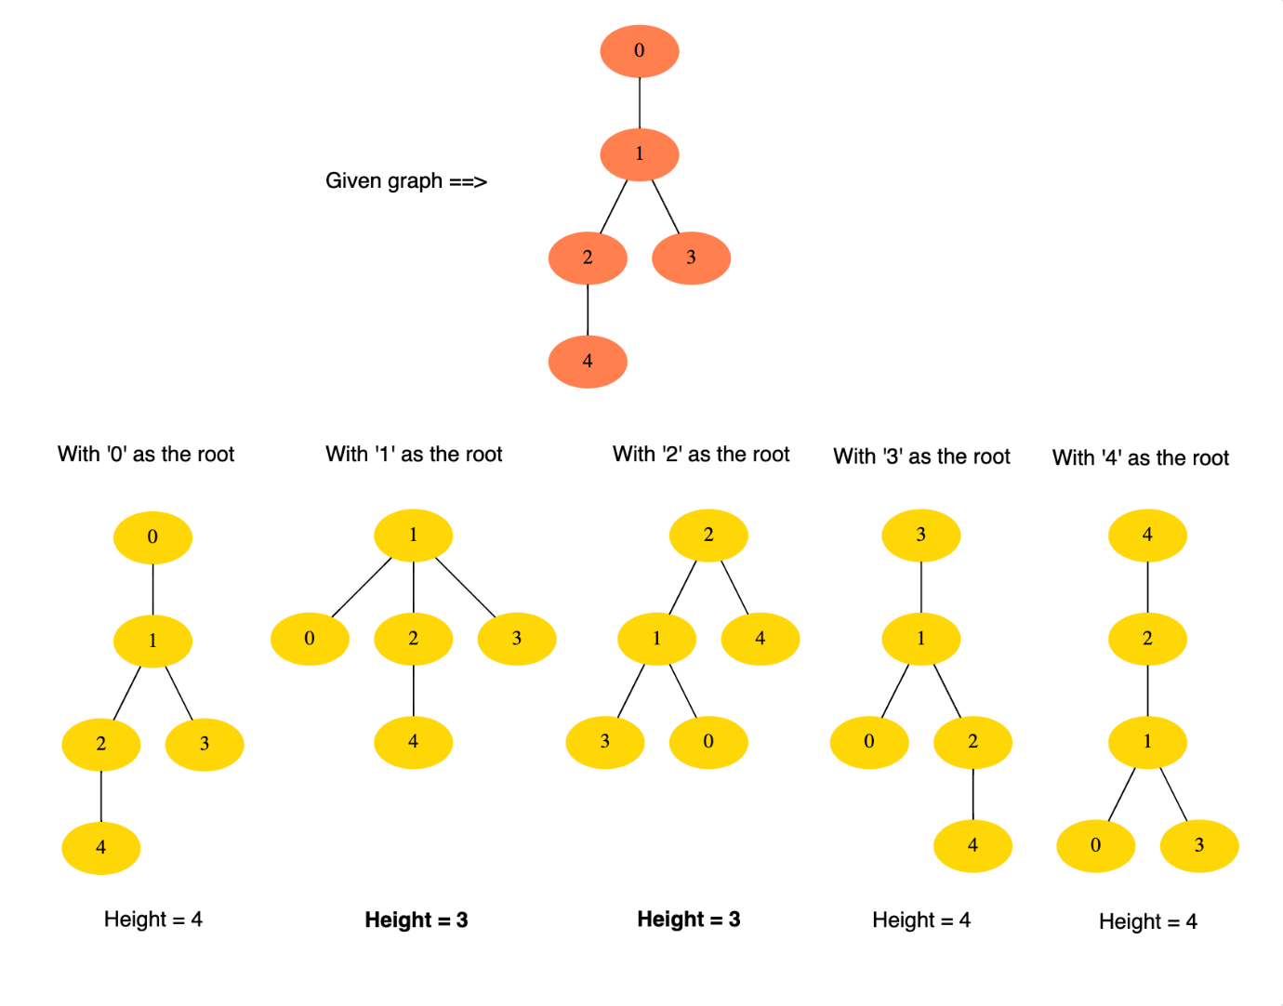](https://github.com/maazshaikh007/DSA_Patterns/blob/main/images/MHT1.png)

**Example 2:**

Input: vertices: 4, Edges: [[0, 1], [0, 2], [2, 3]]

Output:[0, 2]

Explanation: Choosing '0' or '2' as roots give us MHTs. In the below diagram, we can see that the

height of the trees with roots '0' or '2' is three which is minimum.

[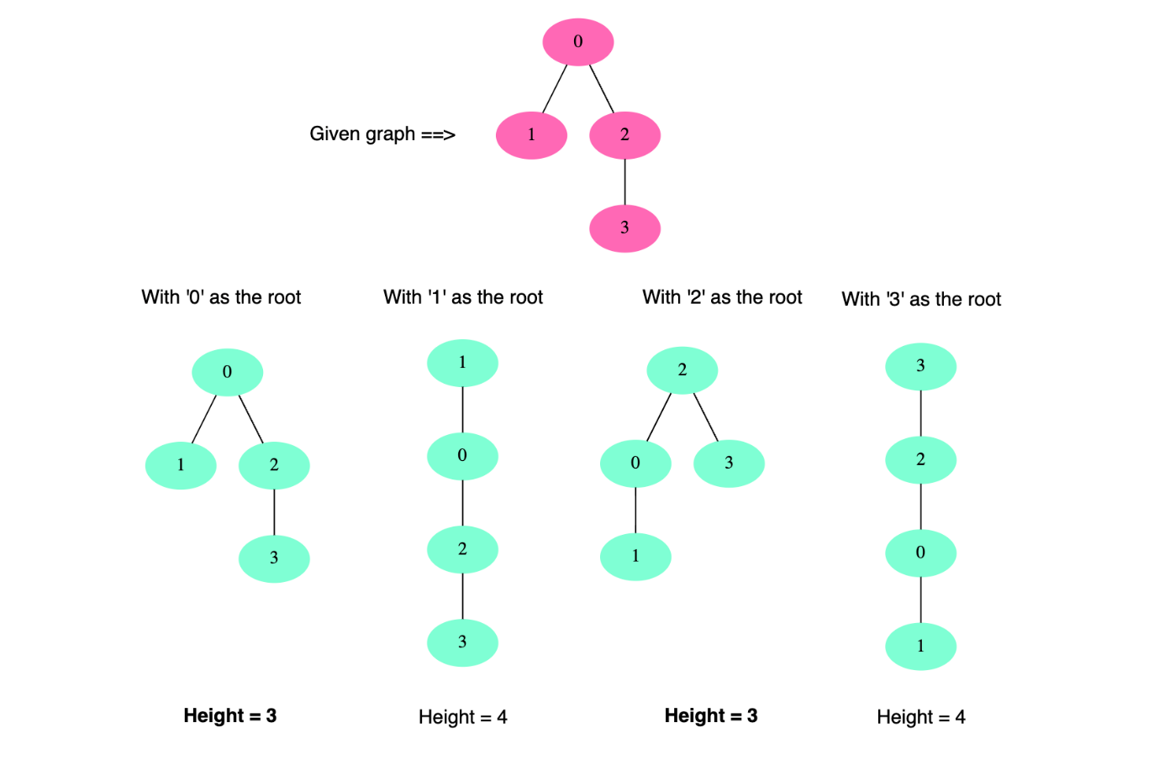](https://github.com/maazshaikh007/DSA_Patterns/blob/main/images/MHT2.png)

**Example 3:**

Input: vertices: 4, Edges: [[0, 1], [1, 2], [1, 3]]

Output:[1]

### Solution

From the above-mentioned examples, we can clearly see that any *leaf node (i.e., node with only one edge)* can never give us an **MHT** because its adjacent *non-leaf nodes* will always give an **MHT** with a smaller height. All the adjacent *non-leaf nodes* will consider the *leaf node* as a *subtree*.

Let’s understand this with another example. Suppose we have a tree with *root* M and *height* 5. Now, if we take another *node*, say P, and make the M tree as its subtree, then the height of the overall tree with root P will be 6 (=5+1). Now, this whole tree can be considered a graph, where P is a leaf as it has only one edge (connection with M). This clearly shows that the leaf node P gives us a tree of height 6 whereas its adjacent non-leaf node M gives us a tree with smaller height 5 - since P will be a child of M.

This gives us a strategy to find **MHTs**. Since leaves can’t give us **MHT**, we can remove them from the graph and remove their edges too. Once we remove the leaves, we will have new leaves. Since these new leaves can’t give us **MHT**, we will repeat the process and remove them from the graph too. We will prune the leaves until we are left with one or two nodes which will be our answer and the roots for **MHTs**.

We can implement the above process using the **topological sort**. Any node with only one edge (i.e., a leaf) can be our source and, in a stepwise fashion, we can remove all sources from the graph to find new sources. We will repeat this process until we are left with one or two nodes in the graph, which will be our answer.

### Code

|  |
| --- |
| import java.util.*;  class Solution {  public static List<Integer> findTrees(int nodes, int[][] edges) {  List<Integer> minHeightTrees = new ArrayList<>();  if (nodes <= 0)  return minHeightTrees;  // with only one node, since its in-degree will be 0, therefore, we need to handle  // it separately  if (nodes == 1) {  minHeightTrees.add(0);  return minHeightTrees;  }  // a. Initialize the graph  HashMap<Integer, Integer> inDegree =  new HashMap<>(); // count of incoming edges for every vertex  HashMap<Integer, List<Integer>> graph = new HashMap<>(); // adjacency list graph  for (int i = 0; i < nodes; i++) {  inDegree.put(i, 0);  graph.put(i, new ArrayList<Integer>());  }  // b. Build the graph  for (int i = 0; i < edges.length; i++) {  int n1 = edges[i][0], n2 = edges[i][1];  // since this is an undirected graph, therefore, add a link for both the nodes  graph.get(n1).add(n2);  graph.get(n2).add(n1);  // increment the in-degrees of both the nodes  inDegree.put(n1, inDegree.get(n1) + 1);  inDegree.put(n2, inDegree.get(n2) + 1);  }  // c. Find all leaves i.e., all nodes with only 1 in-degree  Queue<Integer> leaves = new LinkedList<>();  for (Map.Entry<Integer, Integer> entry : inDegree.entrySet()) {  if (entry.getValue() == 1)  leaves.add(entry.getKey());  }  // d. Remove leaves level by level and subtract each leave's children's in-degrees.  // Repeat this until we are left with 1 or 2 nodes, which will be our answer.  // Any node that has already been a leaf cannot be the root of a minimum height tree,  // because its adjacent non-leaf node will always be a better candidate.  int totalNodes = nodes;  while (totalNodes > 2) {  int leavesSize = leaves.size();  totalNodes -= leavesSize;  for (int i = 0; i < leavesSize; i++) {  int vertex = leaves.poll();  List<Integer> children = graph.get(vertex);  for (int child : children) {  inDegree.put(child, inDegree.get(child) - 1);  if (inDegree.get(child) == 1) // if the child has become a leaf  leaves.add(child);  }  }  }  minHeightTrees.addAll(leaves);  return minHeightTrees;  }  public static void main(String[] args) {  List<Integer> result = Solution.findTrees(5, new int[][] {  new int[] { 0, 1 }, new int[] { 1, 2 }, new int[] { 1, 3 }, new int[] { 2, 4 } });  System.out.println("Roots of MHTs: " + result);  result = Solution.findTrees(4,  new int[][] { new int[] { 0, 1 }, new int[] { 0, 2 }, new int[] { 2, 3 } });  System.out.println("Roots of MHTs: " + result);  result = Solution.findTrees(4,  new int[][] { new int[] { 0, 1 }, new int[] { 1, 2 }, new int[] { 1, 3 } });  System.out.println("Roots of MHTs: " + result);  }  } |

* In step **4**, each task can become a source only once and each edge (a rule) will be accessed and removed once. Therefore, the time complexity of the above algorithm will be O(V+E), where V is the total number of different characters and E is the total number of the rules in the alien language. Since, at most, each pair of words can give us one rule, therefore, we can conclude that the upper bound for the rules is O(N)where N is the number of words in the input. So, we can say that the time complexity of our algorithm is O(V+N).
* The space complexity will be O(V+N), since we are storing all of the rules for each character in an *adjacency list*.

Famous algorithmic patterns and their everyday usage.  
  
✦ Sliding Window: Maintains a "window" of elements in a data structure (usually an array or a string) to optimize the solution of a problem.  
✦ Two Heaps: Uses two heaps (min-heap and max-heap) to maintain a specific order of elements to efficiently solve problems  
✦ Two Pointers: Uses two pointers that move through the data structure (often an array) in a coordinated manner to solve problems.  
✦ Breadth-First Search (BFS): Traverses a tree or a graph using a breadth-first approach, visiting all nodes at the current level before moving to the next level.  
✦ Depth-First Search (DFS): Traverses a tree or a graph using a depth-first approach, visiting a node and exploring as far as possible along a branch before backtracking.  
✦ Topological Sort: Used for linear ordering of the vertices of a directed acyclic graph (DAG) such that for every directed edge (u, v), vertex u comes before vertex v in the ordering.  
✦ Merge Intervals: Involves merging of overlapping or continuous intervals in a given data structure (usually an array or a list) to optimize solutions for a specific problem.  
✦ Backtracking: Tries out different possibilities, undoing them, and then trying out new paths until a solution is found.  
✦ Trie (Prefix Tree): Uses a tree-like data structure to efficiently store and retrieve strings based on their prefixes.  
✦ Flood Fill: Traverses a 2D grid (matrix) and replacing connected elements of a specific value with a new value.  
✦ Segment Tree: Uses a tree-like data structure to efficiently perform range queries and updates on an array or a list.  
  
See the below picture for the usages of each algorithm.  
  
👉 Did I miss any other usage of these algorithms? What other algorithmic patterns have you used?  
  
Ref:  
✨ 𝗚𝗿𝗼𝗸𝗸𝗶𝗻𝗴 𝘁𝗵𝗲 𝗦𝘆𝘀𝘁𝗲𝗺 𝗗𝗲𝘀𝗶𝗴𝗻 𝗜𝗻𝘁𝗲𝗿𝘃𝗶𝗲𝘄: <https://lnkd.in/giwyzfkT>

✨ 𝗚𝗿𝗼𝗸𝗸𝗶𝗻𝗴 𝘁𝗵𝗲 𝗖𝗼𝗱𝗶𝗻𝗴 𝗜𝗻𝘁𝗲𝗿𝘃𝗶𝗲𝘄: <https://lnkd.in/gUNnQuPm>

[#systemdesign](https://www.linkedin.com/feed/hashtag/?keywords=systemdesign&highlightedUpdateUrns=urn%3Ali%3Aactivity%3A7054087374888177664) [#softwarearchitecture](https://www.linkedin.com/feed/hashtag/?keywords=softwarearchitecture&highlightedUpdateUrns=urn%3Ali%3Aactivity%3A7054087374888177664) [#softwaredevelopment](https://www.linkedin.com/feed/hashtag/?keywords=softwaredevelopment&highlightedUpdateUrns=urn%3Ali%3Aactivity%3A7054087374888177664)

Activate to view larger image,



# Introduction to Island Pattern

Many coding interview problems involve traversing 2D arrays (aka matrix or grid). The **Island pattern** describes all the efficient ways to traverse a matrix. This pattern will go through many problems to explain matrix traversal using **Depth First Search (DFS)** and **Breadth First Search (BFS)** approaches and their variants.

Let’s jump onto our first problem to develop an understanding of this pattern.

## Number of Islands (easy)

### Problem Statement

Given a 2D array (i.e., a matrix) containing only 1s (land) and 0s (water), count the number of islands in it.

An island is a connected set of 1s (land) and is surrounded by either an edge or 0s (water). Each cell is considered connected to other cells horizontally or vertically (not diagonally).

Example 1

Input: matrix =

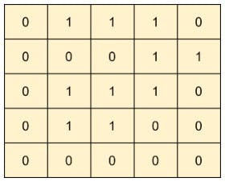

Output: 1  
Explanation: The matrix has only one island. See the highlighted cells below.

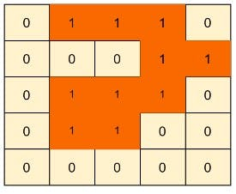

Example 2

Input: matrix =

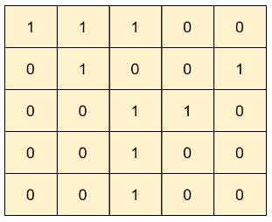

Output: 3  
Explanation: The matrix has three islands. See the highlighted cells below.

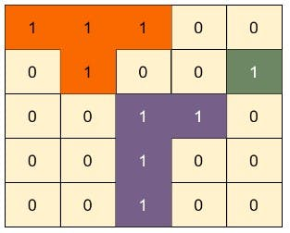

### Solution

We can traverse the matrix linearly to find islands.

Whenever we find a cell with the value '1' (i.e., land), we have found an island. Using that cell as the root node, we will perform a Depth First Search (DFS) or Breadth First Search (BFS) to find all of its connected land cells. During our DFS or BFS traversal, we will find and mark all the horizontally and vertically connected land cells.

We need to have a mechanism to mark each land cell to ensure that each land cell is visited only once. To mark a cell visited, we have two options:

1. We can update the given input matrix. Whenever we see a '1', we will make it '0'.
2. A separate boolean matrix can be used to record whether or not each cell has been visited.

Following is the DFS or BFS traversal of the example-2 mentioned above:

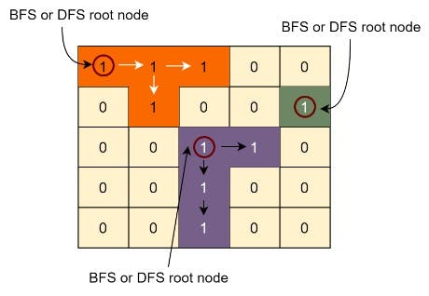

By following the above algorithm, every time DFS or BFS is triggered, we are sure that we have found an island. We will keep a running count to calculate the total number of islands.

Below, we will see three solutions based on:

1. DFS
2. BFS
3. BFS with visited matrix

### Code  (DFS)

Here is what our DFS algorithm will look like. We will update the input matrix to mark cells visited.

#### Java Solution

|  |
| --- |
| import java.util.*;  class Solution {  public static int countIslands(int[][] matrix) {  int rows = matrix.length;  int cols = matrix[0].length;  int totalIslands = 0;  for (int i = 0; i < rows; i++) {  for (int j = 0; j < cols; j++) {  if (matrix[i][j] == 1) { // only if the cell is a land  // we have found an island  totalIslands++;  visitIslandDFS(matrix, i, j);  }  }  }  return totalIslands;  }  private static void visitIslandDFS(int[][] matrix, int x, int y) {  if (x < 0 || x >= matrix.length || y < 0 || y >= matrix[0].length)  return; // return, if it is not a valid cell  if (matrix[x][y] == 0)  return; // return, if it is a water cell  matrix[x][y] = 0; // mark the cell visited by making it a water cell  // recursively visit all neighboring cells (horizontally & vertically)  visitIslandDFS(matrix, x + 1, y); // lower cell  visitIslandDFS(matrix, x - 1, y); // upper cell  visitIslandDFS(matrix, x, y + 1); // right cell  visitIslandDFS(matrix, x, y - 1); // left cell  }  public static void main(String[] args) {  System.out.println(Solution.countIslands(  new int[][] {  { 0, 1, 1, 1, 0 },  { 0, 0, 0, 1, 1 },  { 0, 1, 1, 1, 0 },  { 0, 1, 1, 0, 0 },  { 0, 0, 0, 0, 0 }  }));  System.out.println(Solution.countIslands(  new int[][] {  { 1, 1, 1, 0, 0 },  { 0, 1, 0, 0, 1 },  { 0, 0, 1, 1, 0 },  { 0, 0, 1, 0, 0 },  { 0, 0, 1, 0, 0 }  }));  }  } |

**Time Complexity**Time complexity of the above algorithm will be O(M*N) , where ‘M’ is the number of rows and 'N' is the number of columns of the input matrix. This is due to the fact that we have to traverse the whole matrix to find the islands.

**Space Complexity**  
DFS recursion stack can go  M*N deep when the whole matrix is filled with '1's. Hence, the space complexity will be O(M*N), where ‘M’ is the number of rows and 'N' is the number of columns of the input matrix.

### Code  (BFS)

Here is what our BFS algorithm will look like. We will update the input matrix to mark cells visited.

#### Java Solution

|  |
| --- |
| import java.util.*;  class Solution {  public static int countIslands(int[][] matrix) {  int rows = matrix.length;  int cols = matrix[0].length;  int totalIslands = 0;  for (int i = 0; i < rows; i++) {  for (int j = 0; j < cols; j++) {  if (matrix[i][j] == 1) { // only if the cell is a land  // we have found an island  totalIslands++;  visitIslandBFS(matrix, i, j);  }  }  }  return totalIslands;  }  private static void visitIslandBFS(int[][] matrix, int x, int y) {  Queue<int[]> neighbors = new LinkedList<>();  neighbors.add(new int[] { x, y });  while (!neighbors.isEmpty()) {  int row = neighbors.peek()[0];  int col = neighbors.peek()[1];  neighbors.remove();  if (row < 0 || row >= matrix.length || col < 0 || col >= matrix[0].length)  continue; // continue, if it is not a valid cell  if (matrix[row][col] == 0)  continue; // continue if it is a water cell  matrix[row][col] = 0; // mark the cell visited by making it a water cell  // insert all neighboring cells to the queue for BFS  neighbors.add(new int[] { row + 1, col }); // lower cell  neighbors.add(new int[] { row - 1, col }); // upper cell  neighbors.add(new int[] { row, col + 1 }); // right cell  neighbors.add(new int[] { row, col - 1 }); // left cell  }  }  public static void main(String[] args) {  System.out.println(Solution.countIslands(  new int[][] {  { 0, 1, 1, 1, 0 },  { 0, 0, 0, 1, 1 },  { 0, 1, 1, 1, 0 },  { 0, 1, 1, 0, 0 },  { 0, 0, 0, 0, 0 }  }));  System.out.println(Solution.countIslands(  new int[][] {  { 1, 1, 1, 0, 0 },  { 0, 1, 0, 0, 1 },  { 0, 0, 1, 1, 0 },  { 0, 0, 1, 0, 0 },  { 0, 0, 1, 0, 0 }  }));  }  } |

**Time Complexity**  
Time complexity of the above algorithm will be O(M*N), where ‘M’ is the number of rows and 'N' is the number of columns.

O(M*N),  
Space complexity of the above algorithm will be O(min(M,N)),. In the worst case, when the matrix is completely filled with land cells, the size of the queue can grow up to .

### Code  (BFS with visited matrix)

Here is what our BFS algorithm will look like. We will keep a separate boolean matrix to record whether or not each cell has been visited.

#### Java Solution

|  |
| --- |
| import java.util.*;  class Solution {  public static int countIslands(int[][] matrix) {  int rows = matrix.length;  int cols = matrix[0].length;  boolean[][] visited = new boolean[rows][cols];  int totalIsland = 0;  for (int i = 0; i < rows; i++) {  for (int j = 0; j < cols; j++) {  // if the cell has not been visited before and is a land  if (!visited[i][j] && matrix[i][j] == 1) {  // we have found an island  totalIsland++;  visitIslandBFS(matrix, visited, i, j);  }  }  }  return totalIsland;  }  private static void visitIslandBFS(int[][] matrix, boolean[][] visited, int x, int y) {  Queue<int[]> neighbors = new LinkedList<>();  neighbors.add(new int[] { x, y });  while (!neighbors.isEmpty()) {  int row = neighbors.peek()[0];  int col = neighbors.peek()[1];  neighbors.remove();  if (row < 0 || col < 0 || row >= matrix.length || col >= matrix[0].length)  continue; // continue, if it is not a valid cell  if (matrix[row][col] == 0 || visited[row][col])  continue; // continue if the cell is water or visited  visited[row][col] = true; // mark the visited array  // insert all neighboring cells to the queue for BFS  neighbors.add(new int[] { row + 1, col }); // lower cell  neighbors.add(new int[] { row - 1, col }); // upper cell  neighbors.add(new int[] { row, col + 1 }); // right cell  neighbors.add(new int[] { row, col - 1 }); // left cell  }  }  public static void main(String[] args) {  System.out.println(Solution.countIslands(  new int[][] {  { 0, 1, 1, 1, 0 },  { 0, 0, 0, 1, 1 },  { 0, 1, 1, 1, 0 },  { 0, 1, 1, 0, 0 },  { 0, 0, 0, 0, 0 }  }));  System.out.println(Solution.countIslands(  new int[][] {  { 1, 1, 1, 0, 0 },  { 0, 1, 0, 0, 1 },  { 0, 0, 1, 1, 0 },  { 0, 0, 1, 0, 0 },  { 0, 0, 1, 0, 0 }  }));  }  } |

**Time Complexity**  
Time complexity of the above algorithm will be O(M*N), where ‘M’ is the number of rows and 'N' is the number of columns.

**Space Complexity**  
Because of the visited array and max size of the queue, the space complexity will be O(M*N) , where ‘M’ is the number of rows and 'N' is the number of columns of the input matrix.

## Biggest Island (easy)

### Problem Statement

Given a 2D array (i.e., a matrix) containing only 1s (land) and 0s (water), find the biggest island in it. Write a function to return the area of the biggest island.

An island is a connected set of 1s (land) and is surrounded by either an edge or 0s (water). Each cell is considered connected to other cells horizontally or vertically (not diagonally).

Example 1

Input: matrix =

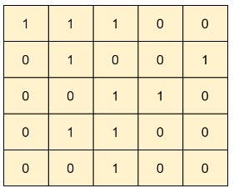

Output: 5  
Explanation: The matrix has three islands. The biggest island has 5 cells .

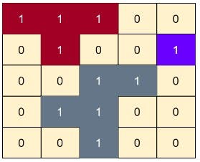

### **Solution**

The question follows the Island pattern and is quite similar to Number of Islands problem.

We will traverse the matrix linearly to find islands.

Whenever we find a cell with the value '1' (i.e., land), we have found an island. Using that cell as the root node, we will perform a **Depth First Search (DFS)** or **Breadth First Search (BFS)** to find all of its connected land cells. During our DFS or BFS traversal, we will find and mark all the horizontally and vertically connected land cells.

We will keep a variable to remember the max area of any island.

### **Code  (DFS)**

Here is what our DFS algorithm will look like. We will update the input matrix to mark nodes visited.

#### Java Solution

|  |
| --- |
| import java.util.*;  class Solution {  public static int maxAreaOfIsland(int[][] matrix) {  int rows = matrix.length;  int cols = matrix[0].length;  int biggestIslandArea = 0;  for (int i = 0; i < rows; i++) {  for (int j = 0; j < cols; j++) {  if (matrix[i][j] == 1) { // only if the cell is a land  // we have found an island  biggestIslandArea = Math.max(biggestIslandArea, visitIslandDFS(matrix, i, j));  }  }  }  return biggestIslandArea;  }  private static int visitIslandDFS(int[][] matrix, int x, int y) {  if (x < 0 || x >= matrix.length || y < 0 || y >= matrix[0].length)  return 0; // return, if it is not a valid cell  if (matrix[x][y] == 0)  return 0; // return, if it is a water cell  matrix[x][y] = 0; // mark the cell visited by making it a water cell  int area = 1; // counting the current cell  // recursively visit all neighboring cells (horizontally & vertically)  area += visitIslandDFS(matrix, x + 1, y); // lower cell  area += visitIslandDFS(matrix, x - 1, y); // upper cell  area += visitIslandDFS(matrix, x, y + 1); // right cell  area += visitIslandDFS(matrix, x, y - 1); // left cell  return area;  }  public static void main(String[] args) {  System.out.println(Solution.maxAreaOfIsland(  new int[][] {  { 1, 1, 1, 0, 0 },  { 0, 1, 0, 0, 1 },  { 0, 0, 1, 1, 0 },  { 0, 1, 1, 0, 0 },  { 0, 0, 1, 0, 0 }  }));  }  } |

**Time Complexity**  
Time complexity of the above algorithm will be O(M*N), where ‘M’ is the number of rows and 'N' is the number of columns of the input matrix. This is due to the fact that we have to traverse the whole matrix to find islands.

**Space Complexity**  
DFS recursion stack can go M*N deep when the whole matrix is filled with '1's. Hence, the space complexity will be O(M*N), where ‘M’ is the number of rows and 'N' is the number of columns of the input matrix.

## Flood Fill (easy)

### Problem Statement

Any image can be represented by a 2D integer array (i.e., a matrix) where each cell represents the pixel value of the image.

Flood fill algorithm takes a starting cell (i.e., a pixel) and a color. The given color is applied to all horizontally and vertically connected cells with the same color as that of the starting cell. Recursively, the algorithm fills cells with the new color until it encounters a cell with a different color than the starting cell.

Given a matrix, a starting cell, and a color, flood fill the matrix.

Example 1:

Input: matrix =

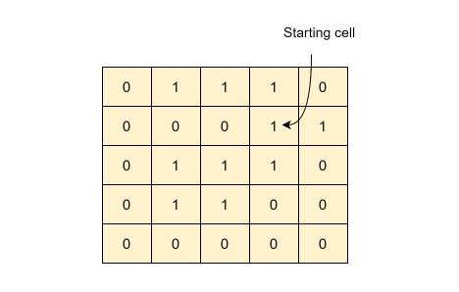

starting cell = (1, 3)  
new color = 2

Output:

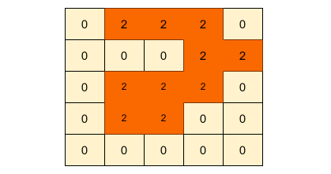

Example 2:

Input: matrix =

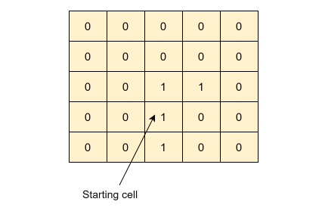

starting cell = (3, 2)

new color = 5

Output:

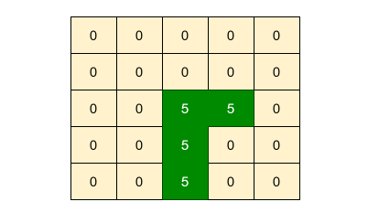

### Solution

The question follows the Island pattern and is quite similar to Number of Islands problem.

From the given starting cell, we can perform a Depth First Search (DFS) or Breadth First Search (BFS) to find all of its connected cells with the same color. During our DFS or BFS traversal, we will update the cells with the new color.

Following is the DFS or BFS traversal of the example-2 mentioned above:

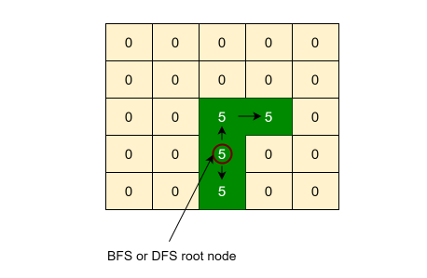

### Code (DFS)

Here is what our DFS algorithm will look like:

### Java Solution

|  |
| --- |
| import java.util.*;  class Solution {  public static int[][] floodFill(int[][] matrix, int x, int y, int newColor) {  if (matrix[x][y] != newColor)  fillDFS(matrix, x, y, matrix[x][y], newColor);  return matrix;  }  private static void fillDFS(int[][] matrix, int x, int y, int oldColor, int newColor) {  if (x < 0 || x >= matrix.length || y < 0 || y >= matrix[0].length)  return; // return, if it is not a valid cell  if (matrix[x][y] != oldColor)  return; // return, if it is not the required color  matrix[x][y] = newColor; // update the cell to the new color  // recursively visit all neighboring cells (horizontally & vertically)  fillDFS(matrix, x + 1, y, oldColor, newColor); // lower cell  fillDFS(matrix, x - 1, y, oldColor, newColor); // upper cell  fillDFS(matrix, x, y + 1, oldColor, newColor); // right cell  fillDFS(matrix, x, y - 1, oldColor, newColor); // left cell  }  public static void main(String[] args) {  System.out.println(Arrays.deepToString(Solution.floodFill(  new int[][] {  { 0, 1, 1, 1, 0 },  { 0, 0, 0, 1, 1 },  { 0, 1, 1, 1, 0 },  { 0, 1, 1, 0, 0 },  { 0, 0, 0, 0, 0 }  }, 1, 3, 2)));  System.out.println(Arrays.deepToString(Solution.floodFill(  new int[][] {  { 0, 0, 0, 0, 0 },  { 0, 0, 0, 0, 0 },  { 0, 0, 1, 1, 0 },  { 0, 0, 1, 0, 0 },  { 0, 0, 1, 0, 0 }  }, 3, 2, 5)));  }  } |

### Time Complexity

Time complexity the above algorithm will be O(M*N) , where ‘M’ is the number of rows and 'N' is the number of columns of the input matrix. This is due to the fact that, in the worst case, we might have to fill the whole matrix.

### Space Complexity

DFS recursion stack can go M*N deep when we have to fill the whole matrix. Hence, the space complexity will be O(M*N) , where ‘M’ is the number of rows and 'N' is the number of columns of the input matrix.

## Number of Closed Islands (easy)

### Problem Statement

You are given a 2D matrix containing only 1s (land) and 0s (water).

An island is a connected set of 1s (land) and is surrounded by either an edge or 0s (water). Each cell is considered connected to other cells horizontally or vertically (not diagonally).

A closed island is an island that is totally surrounded by 0s (i.e., water). This means all horizontally and vertically connected cells of a closed island are water. This also means that, by definition, a closed island can't touch an edge (as then the edge cells are not connected to any water cell).

Write a function to find the number of closed islands in the given matrix.

Example 1

Input: matrix =

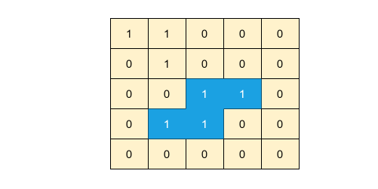

Output: 1 Explanation: The given matrix has two islands, but only the highlighted island is a closed island. The other island is touching the boundary that's why is is not considered a closed island.

Example 2

Input: matrix =

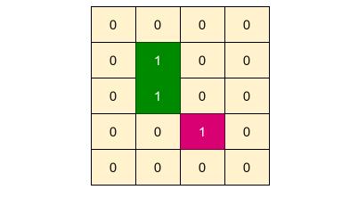

Output: 2

Explanation: The given matrix has two islands and both of them are closed islands.

### **Solution**

The question follows the Island pattern and is quite similar to Number of Islands problem.

We will traverse the matrix linearly to find islands. We can use the Depth First Search (DFS) or Breadth First Search (BFS) to traverse an island i.e., to find all of its connected land cells.

How do we decide if an island is a closed island?

To find that out, while traversing an island we need to ensure two things:

1. The island does not touch an edge.
2. Outside boundary of the island are water cells.

For the first condition, whenever we go outside the boundary of the matrix during DFS or BFS, it means that one of the cells of the island is touching an edge; so, the island is not closed. Following code will cover this condition:

if (x < 0 || x >= matrix.length || y < 0 || y >= matrix[0].length)

return false; // returning false since the island is touching an edge

For the second condition, we need to ensure that all the boundary cells of the island are water. Following code will take care of that:

if (matrix[x][y] == 0 || visited[x][y])

return true; // returning true as the island is surrounded by water

### **Code (DFS)**

Here is what our DFS algorithm will look like. We will use a separate array to mark nodes visited.

#### Java Solution

|  |
| --- |
| import java.util.*;  class Solution {  public static int countClosedIslands(int[][] matrix) {  int rows = matrix.length;  int cols = matrix[0].length;  int countClosedIslands = 0;  boolean[][] visited = new boolean[rows][cols];  for (int i = 0; i < rows; i++) {  for (int j = 0; j < cols; j++) {  if (matrix[i][j] == 1 && !visited[i][j]) { // only if the cell is a land and not visited  if (isClosedIslandDFS(matrix, visited, i, j))  countClosedIslands++;  }  }  }  return countClosedIslands;  }  private static boolean isClosedIslandDFS(int[][] matrix, boolean[][] visited, int x, int y) {  if (x < 0 || x >= matrix.length || y < 0 || y >= matrix[0].length)  return false; // returning false since the island is touching an edge  if (matrix[x][y] == 0 || visited[x][y])  return true; // returning true as the island is surrounded by water  visited[x][y] = true; // mark the cell visited  Boolean isClosed = true;  // recursively visit all neighboring cells (horizontally & vertically)  isClosed &= isClosedIslandDFS(matrix, visited, x + 1, y); // lower cell  isClosed &= isClosedIslandDFS(matrix, visited, x - 1, y); // upper cell  isClosed &= isClosedIslandDFS(matrix, visited, x, y + 1); // right cell  isClosed &= isClosedIslandDFS(matrix, visited, x, y - 1); // left cell  return isClosed;  }  public static void main(String[] args) {  System.out.println(Solution.countClosedIslands(  new int[][] {  { 1, 1, 0, 0, 0 },  { 0, 1, 0, 0, 0 },  { 0, 0, 1, 1, 0 },  { 0, 1, 1, 0, 0 },  { 0, 0, 0, 0, 0 }  }));  System.out.println(Solution.countClosedIslands(  new int[][] {  { 0, 0, 0, 0 },  { 0, 1, 0, 0 },  { 0, 1, 0, 0 },  { 0, 0, 1, 0 },  { 0, 0, 0, 0 }  }));  }  } |

**Time Complexity**

Time complexity of the above algorithm will be O(M*N), where ‘M’ is the number of rows and 'N' is the number of columns of the input matrix. This is due to the fact that we have to traverse the whole matrix to find islands.

**Space Complexity**

DFS recursion stack can go M*N deep when the whole matrix is filled with '1's. Hence, the space complexity will be O(M*N), where ‘M’ is the number of rows and 'N' is the number of columns of the input matrix.

## Problem Challenge 1(Perimeter)

### Problem Statement

You are given a 2D matrix containing only 1s (land) and 0s (water).

An island is a connected set of 1s (land) and is surrounded by either an edge or 0s (water). Each cell is considered connected to other cells horizontally or vertically (not diagonally).

There are no lakes on the island, so the water inside the island is not connected to the water around it. A cell is a square with a side length of 1..

The given matrix has only one island, write a function to find the perimeter of that island.

Example 1

Input: matrix =

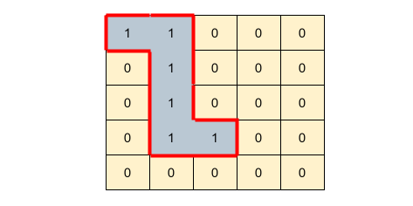

Output: 14

Explanation: The boundary of the island constitutes 14 sides.

Example 2

Input: matrix =

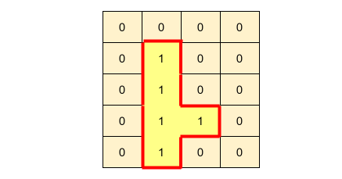

Output: 12

Explanation: The boundary of the island constitute 12 sides.

### Solution

The question follows the Island pattern and is quite similar to Number of Islands problem.

We will traverse the matrix linearly to find the island. We can use the Depth First Search (DFS) or Breadth First Search (BFS) to traverse the island i.e., to find all of its connected land cells.

How do we calculate the boundary if the island?

Each cell has four sides. Each side of an island cell can be shared with another cell; we can include the side in the island perimeter only if the other cell is a water.

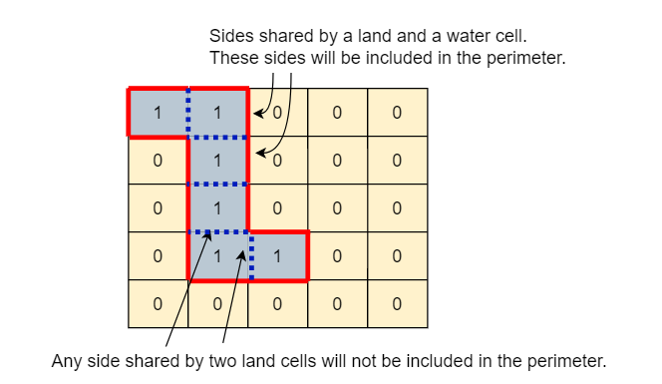

If a cell side is on boundary, we should include that side in the perimeter.

Following piece of code will cover these two conditions:

if (x < 0 || x >= matrix.length || y < 0 || y >= matrix[0].length)

return 1; // returning 1, since this a boundary cell initiated this DFS call

if (matrix[x][y] == 0)

return 1; // returning 1, because of the shared side b/w a water and a land cell

### Code (DFS)

Here is what our DFS algorithm will look like. We will use a separate matrix to mark nodes visited.

### Java Solution

|  |
| --- |
| import java.util.*;  class Solution {  public static int findIslandPerimeter(int[][] matrix) {  int rows = matrix.length;  int cols = matrix[0].length;  boolean[][] visited = new boolean[rows][cols];  for (int i = 0; i < rows; i++) {  for (int j = 0; j < cols; j++) {  if (matrix[i][j] == 1 && !visited[i][j]) // only if the cell is a land and not visited  return Solution(matrix, visited, i, j);  }  }  return 0;  }  private static int Solution(int[][] matrix, boolean[][] visited, int x, int y) {  if (x < 0 || x >= matrix.length || y < 0 || y >= matrix[0].length)  return 1; // returning 1, since this a boundary cell initiated this DFS call  if (matrix[x][y] == 0)  return 1; // returning 1, because of the shared side b/w a water and a land cell  if (visited[x][y])  return 0; // we have already taken care of this cell  visited[x][y] = true; // mark the cell visited  int edgeCount = 0;  // recursively visit all neighboring cells (horizontally & vertically)  edgeCount += Solution(matrix, visited, x + 1, y); // lower cell  edgeCount += Solution(matrix, visited, x - 1, y); // upper cell  edgeCount += Solution(matrix, visited, x, y + 1); // right cell  edgeCount += Solution(matrix, visited, x, y - 1); // left cell  return edgeCount;  }  public static void main(String[] args) {  System.out.println(Solution.findIslandPerimeter(  new int[][] {  { 1, 1, 0, 0, 0 },  { 0, 1, 0, 0, 0 },  { 0, 1, 0, 0, 0 },  { 0, 1, 1, 0, 0 },  { 0, 0, 0, 0, 0 }  }));  System.out.println(Solution.findIslandPerimeter(  new int[][] {  { 0, 0, 0, 0 },  { 0, 1, 0, 0 },  { 0, 1, 0, 0 },  { 0, 1, 1, 0 },  { 0, 1, 0, 0 }  }));  }  } |

### Time Complexity

Time complexity of the above algorithm will be O(M*N), where ‘M’ is the number of rows and 'N' is the number of columns of the input matrix. This is due to the fact that we have to traverse the whole matrix to find the island.

### Space Complexity

DFS recursion stack can go M*N deep when the whole matrix is filled with '1's. Hence, the space complexity will be O(M*N), where ‘M’ is the number of rows and 'N' is the number of columns of the input matrix.

## Problem Challenge 2(Distinct Islands)

### Problem Statement

You are given a 2D matrix containing only 1s (land) and 0s (water).

An island is a connected set of 1s (land) and is surrounded by either an edge or 0s (water). Each cell is considered connected to other cells horizontally or vertically (not diagonally).

Two islands are considered the same if and only if they can be translated (not rotated or reflected) to equal each other.

Write a function to find the number of distinct islands in the given matrix.

Example 1

Input: matrix =

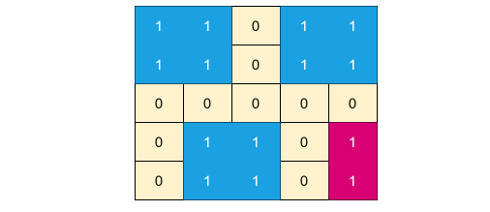

Output: 2

Explanation: There are four islands in the given matrix, but three of them are the same; hence, there are only two distinct islands.

Example 2

Input: matrix =

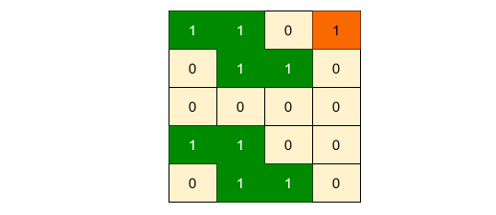

Output: 2

Explanation: There are three islands in the given matrix, but two of them are the same; hence, there are only two distinct islands.

### Solution

The question follows the Island pattern and is quite similar to Number of Islands problem.

We will traverse the matrix linearly to find islands. We can use the Depth First Search (DFS) or Breadth First Search (BFS) to traverse an island i.e., to find all of its connected land cells.

How do we decide if two islands are same?

If two islands are same, their traversal path should be same too. This means, if we perform a DFS or BFS on two equal islands starting from their top-left cell, the traversal pattern should be exactly same for both the islands. For example, here is the DFS traversal of the example-2 mentioned above:

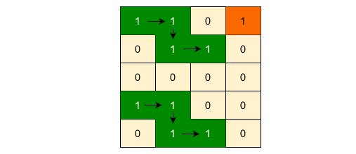

We can clearly see that the two equal islands have same traversal pattern.

We can utilize this fact to develop an algorithm.

While traversing an island, we can construct a string that maps the traversal path of the island. For example, here is the DFS traversal of the two same islands mentioned in Example-2 ( 'R' for right move, 'D' for down move, 'O' for origin denoting the start): ORDR

We can start inserting these traversal strings of each island in a HashSet. This will ensure that we will not have any duplicate traversal string in the HashSet, thus giving us distinct islands. When we finish traversing the matrix, the HashSet will contain the distinct traversal path of all islands. Hence, the total number of elements in the HashSet will be equal to distinct number of islands.

#### Java Solution

|  |
| --- |
| import java.util.*;  class Solution {  public static int findDistinctIslandsDFS(int[][] matrix) {  int rows = matrix.length;  int cols = matrix[0].length;  boolean[][] visited = new boolean[rows][cols];  Set<String> islandsSet = new HashSet<>();  for (int i = 0; i < rows; i++) {  for (int j = 0; j < cols; j++) {  if (matrix[i][j] == 1 && !visited[i][j]) { // only if the cell is a land and not visited  StringBuilder islandTraversal = new StringBuilder();  traverseIslandDFS(matrix, visited, i, j, islandTraversal, "O"); // origin  islandsSet.add(islandTraversal.toString());  }  }  }  return islandsSet.size();  }  private static void traverseIslandDFS(int[][] matrix, boolean[][] visited, int x, int y,  StringBuilder islandTraversal, String direction) {  if (x < 0 || x >= matrix.length || y < 0 || y >= matrix[0].length)  return; // return if it is not a valid cell  if (matrix[x][y] == 0 || visited[x][y])  return; // return if it is a water cell or is visited  visited[x][y] = true; // mark the cell visited  islandTraversal.append(direction);  // recursively visit all neighboring cells (horizontally & vertically)  traverseIslandDFS(matrix, visited, x + 1, y, islandTraversal, "D"); // down  traverseIslandDFS(matrix, visited, x - 1, y, islandTraversal, "U"); // up  traverseIslandDFS(matrix, visited, x, y + 1, islandTraversal, "R"); // right  traverseIslandDFS(matrix, visited, x, y - 1, islandTraversal, "L"); // left  islandTraversal.append("B"); // back  }  public static void main(String[] args) {  System.out.println(Solution.findDistinctIslandsDFS(  new int[][] {  { 1, 1, 0, 1, 1 },  { 1, 1, 0, 1, 1 },  { 0, 0, 0, 0, 0 },  { 0, 1, 1, 0, 1 },  { 0, 1, 1, 0, 1 }  }));  System.out.println(Solution.findDistinctIslandsDFS(  new int[][] {  { 1, 1, 0, 1 },  { 0, 1, 1, 0 },  { 0, 0, 0, 0 },  { 1, 1, 0, 0 },  { 0, 1, 1, 0 }  }));  }  } |

**Time Complexity**

Time complexity of the above algorithm will be O(M*N), where ‘M’ is the number of rows and 'N' is the number of columns of the input matrix. This is due to the fact that we have to traverse the whole matrix to find islands.

**Space Complexity**

DFS recursion stack can go M*N deep when the whole matrix is filled with '1's. Hence, the space complexity will be O(M*N), where ‘M’ is the number of rows and 'N' is the number of columns of the input matrix.

## Problem Challenge 3(Contains Cycle)

### Problem Statement

You are given a 2D matrix containing different characters, you need to find if there exists any cycle consisting of the same character in the matrix.

A cycle is a path in the matrix that starts and ends at the same cell and has four or more cells. From a given cell, you can move to one of the cells adjacent to it - in one of the four directions (up, down, left, or right), if it has the same character value of the current cell.

Write a function to find if the matrix has a cycle.

Example 1

Input: matrix =

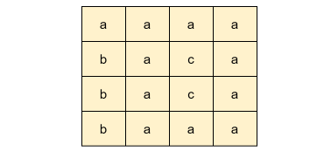

Output: true

Explanation: The given matrix has a cycle as shown below:

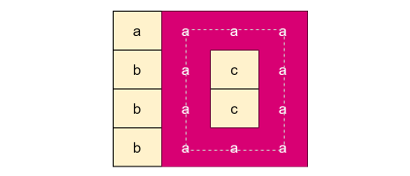

Example 2

Input: matrix =

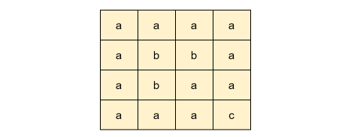

Output: true

Explanation: The given matrix has one cycle as shown below:

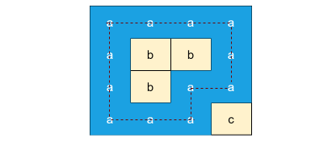

Example 3

Input: matrix =

Output: false

Explanation: The given matrix has no cycle.

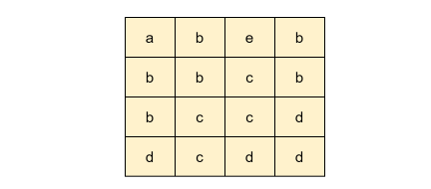

### Solution

The question follows the Island pattern and is quite similar to Number of Islands problem.

We will traverse the matrix linearly to find any cycle. Each cycle is like an island having cells containing same values. Hence, we can use the Depth First Search (DFS) or Breadth First Search (BFS) to traverse a cycle i.e., to find all of its connected cells with the same value.

Our approach for traversing the matrix will be similar to the one we used when searching for islands. We will keep another matrix to remember the cells that we have visited. From any given cell, we can perform DFS to traverse all the neighboring cells having the same character value.

Whenever we reach a cell that have already been visited, we can conclude that we have found a cycle. This also means that we need to be careful to not start traversing the parent cell and wrongly finding a cycle. That is, while traversing, when initiating DFS recursive calls to all the neighbouring cell, we should not start a DFS call to the pervious cell, for example:

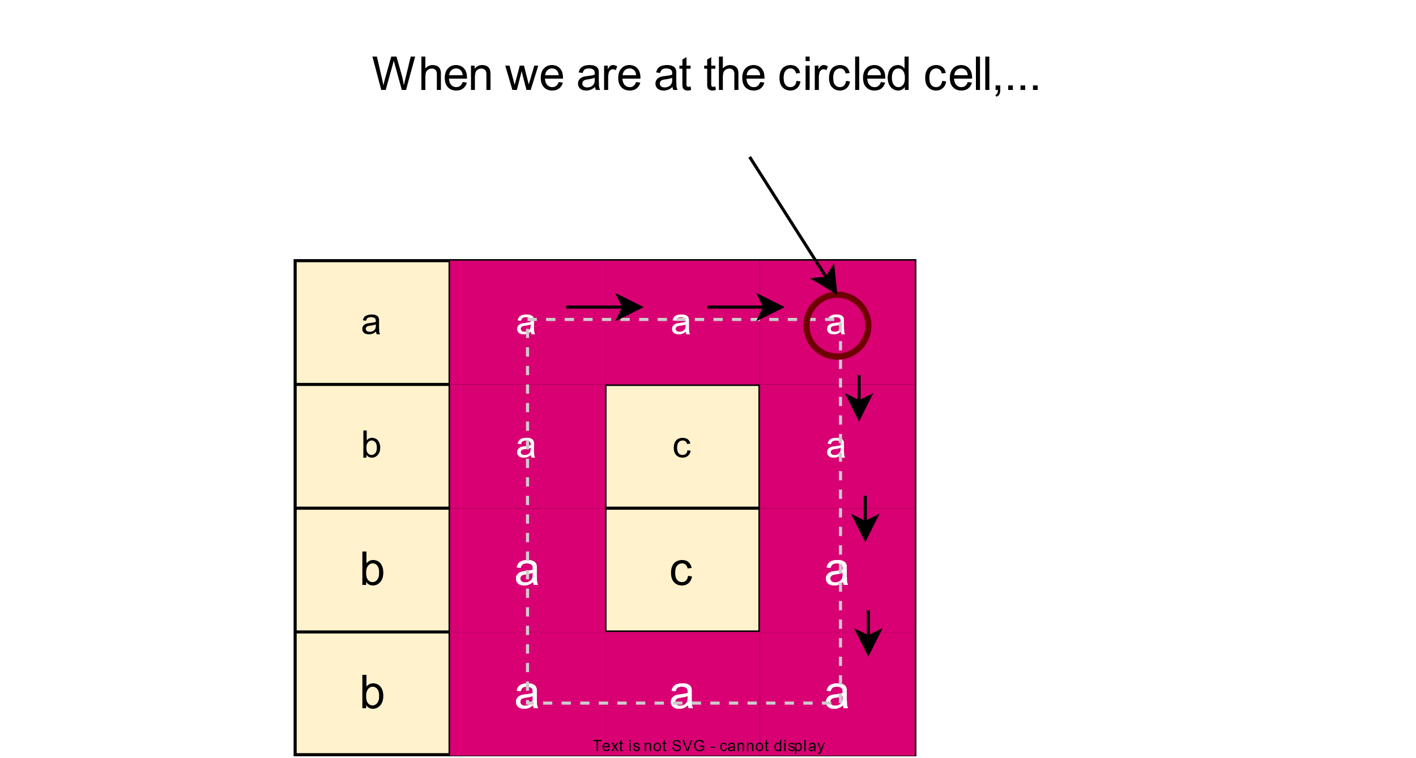

### Java Solution

|  |
| --- |
| import java.util.*;  class Solution {  public static boolean hasCycle(char[][] matrix) {  int rows = matrix.length;  int cols = matrix[0].length;  boolean[][] visited = new boolean[rows][cols];  for (int i = 0; i < rows; i++) {  for (int j = 0; j < cols; j++) {  if (!visited[i][j]) // only if the cell is not visited  if (containsCycleDFS(matrix, visited, matrix[i][j], i, j, -1, -1))  return true;  }  }  return false;  }  private static boolean containsCycleDFS(char[][] matrix, boolean[][] visited,  char startChar, int x, int y, int prevX, int prevY) {  if (x < 0 || x >= matrix.length || y < 0 || y >= matrix[0].length)  return false; // not a valid cell  if (matrix[x][y] != startChar)  return false; // different character which means a different island  if (visited[x][y])  return true; // found a cycle, as we are visiting an already visited valid cell  visited[x][y] = true; // mark the cell visited  // recursively visit all neighboring cells (horizontally & vertically)  if (x + 1 != prevX && containsCycleDFS(matrix, visited, startChar, x + 1, y, x, y)) // down  return true;  if (x - 1 != prevX && containsCycleDFS(matrix, visited, startChar, x - 1, y, x, y)) // up  return true;  if (y + 1 != prevY && containsCycleDFS(matrix, visited, startChar, x, y + 1, x, y)) // right  return true;  if (y - 1 != prevY && containsCycleDFS(matrix, visited, startChar, x, y - 1, x, y)) // left  return true;  return false;  }  public static void main(String[] args) {  System.out.println(Solution.hasCycle(  new char[][] {  { 'a', 'a', 'a', 'a' },  { 'b', 'a', 'c', 'a' },  { 'b', 'a', 'c', 'a' },  { 'b', 'a', 'a', 'a' }  }));  System.out.println(Solution.hasCycle(  new char[][] {  { 'a', 'a', 'a', 'a' },  { 'a', 'b', 'b', 'a' },  { 'a', 'b', 'a', 'a' },  { 'a', 'a', 'a', 'c' }  }));  System.out.println(Solution.hasCycle(  new char[][] {  { 'a', 'b', 'e', 'b' },  { 'b', 'b', 'b', 'b' },  { 'b', 'c', 'c', 'd' },  { 'c', 'c', 'd', 'd' }  }));  }  } |

**Time Complexity**

Time complexity of the above algorithm will be O(M*N), where ‘M’ is the number of rows and 'N' is the number of columns of the input matrix. This is due to the fact that we have to traverse the whole matrix to find cycles.

**Space Complexity**

DFS recursion stack can go M*N deep when the whole matrix is filled with the same character. Hence, the space complexity will be O(M*N), where ‘M’ is the number of rows and 'N' is the number of columns of the input matrix.

# Introduction to Multi-threaded Pattern

In many algorithms, concurrency and thread safety are very important. With technical interviews in mind, we can easily apply these concepts to most coding problems and stand out from the crowd.

Thread safety can be easily added to any algorithm that uses multiple threads.

Algorithms can be made multi-threaded to perform multiple concurrent tasks or to perform pre-fetching or post-processing functions to speed things up.

Let’s see this pattern in action

## Same Tree

### Problem Statement

Given the roots of two binary trees 'p' and 'q', write a function to check if they are the same or not.

Two binary trees are considered the same if they met following two conditions:

1. Both tree are structurally identical.
2. Each corresponding node on both the trees have the same value.

Example 1:

Given the following two binary trees:

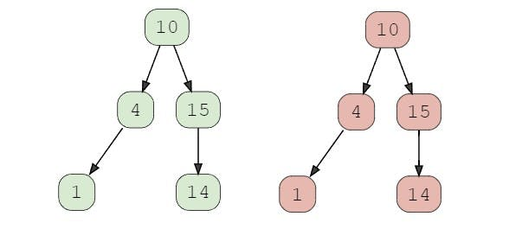

Output: true

Explanation: Both trees are structurally identical and have same values.

Example 2:

Given the following two binary trees:

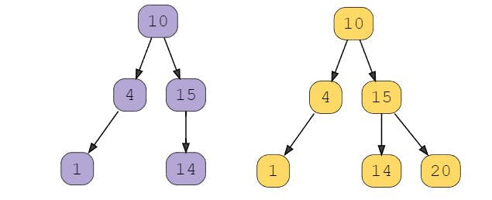

Output: false

Explanation: Trees are structurally different.

Example 3:

Given the following two binary trees:

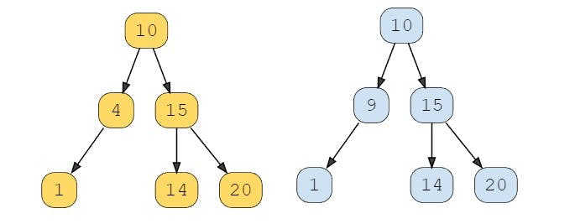

Output: false

Explanation: Corresponding nodes have different value ( 4 & 9 ).

### Solution

A simple solution would be to recursively check each corresponding node of the two trees. If one of the trees do not have a corresponding node or their values differ, we can conclude that the trees are not the same.

### Code

Here is what our algorithm will look like:

|  |
| --- |
| /** definition for a binary tree node */  class TreeNode {  int val;  TreeNode left;  TreeNode right;  public TreeNode(int val) {  this.val = val;  this.left = null;  this.right = null;  }  }  public class Solution {  public boolean isSameTree(TreeNode p, TreeNode q) {  // p and q are both null  if (p == null && q == null) return true;  // one of p and q is null  if (q == null || p == null) return false;  // one of p and q has different value  if (p.val != q.val) return false;    // check left and right subtree recursively  return isSameTree(p.right, q.right) &&  isSameTree(p.left, q.left);  }  public static void main(String[] args) {  TreeNode p = new TreeNode(10);  p.left = new TreeNode(4);  p.left.left = new TreeNode(1);  p.right = new TreeNode(15);  p.right.left = new TreeNode(14);  TreeNode q = new TreeNode(10);  q.left = new TreeNode(4);  q.left.left = new TreeNode(1);  q.right = new TreeNode(15);  q.right.left = new TreeNode(14);  Solution sameTree = new Solution();  System.out.println(sameTree.isSameTree(p, q));  q.right.right = new TreeNode(20);  System.out.println(sameTree.isSameTree(p, q));  q.right.right = new TreeNode(20);  p.left.val = 9;  System.out.println(sameTree.isSameTree(p, q));  }  } |

**Time Complexity**

The solution will take O(min(M, N)) time, where 'M' and 'N' are the number of nodes in the given trees respectively. We are taking minimum of 'M' and 'N', since as soon as we see a difference in value or structure, we do not check the remaining trees.

**Space Complexity**

We will need O(N) space for the recursion stack in the worst case (when the binary tree is a list). Overall, we will need to store nodes equal to the height of the tree, hence, O(H) space complexity, where H is the height of the given tree.

### Making the Algorithm Multi-threaded

To further improve the algorithm, we can make **isSameTree()** multi-threaded to check the left and right subtrees in separate threads.

We can find how many processors the machine has on which our algorithm is running. We will, then, start multiple threads so that each core can run one thread.

We will use a Volatile Boolean variable **isSame** so that multiple threads can update its value concurrently.

Here is the code that takes care of this scenario:

|  |
| --- |
| /** definition for a binary tree node */  class TreeNode {  int val;  TreeNode left;  TreeNode right;  public TreeNode(int val) {  this.val = val;  this.left = null;  this.right = null;  }  }  public class Solution {  private volatile boolean isSame;  public boolean isSameTree(TreeNode p, TreeNode q) {  isSame = true;  int numThreads = Runtime.getRuntime().availableProcessors();  return isSameTreeMultiThreaded(p, q, numThreads);  }    private boolean isSameTreeMultiThreaded(TreeNode p, TreeNode q, int numThreads) {  // p and q are both null  if (p == null && q == null) return true;  // one of p and q is null  if (q == null || p == null) return false;  // one of p and q has different value  if (p.val != q.val) return false;  // if we can start more threads, we will spawn a new thread to check the  // right subtree, otherwise we will do everything in the current thread  if (numThreads > 0) {  // spawn a separate thread for checking the right sub-tree  Thread t1 = new Thread(new Runnable() {  @Override  public void run() {  isSame &= isSameTreeMultiThreaded(p.right, q.right, numThreads/2);  }  });  t1.start();  // check the left sub-tree in the current thread  isSame &= isSameTreeMultiThreaded(p.left, q.left, numThreads/2);    try {  t1.join(); // wait for the thread checking the right sub-tree  } catch(InterruptedException e){ System.out.println(e); }  } else { // do everything in the current thread  isSame &= isSameTreeMultiThreaded(p.right, q.right, 0) &&  isSameTreeMultiThreaded(p.left, q.left, 0);  }  return isSame;  }    public static void main(String[] args) {  TreeNode p = new TreeNode(10);  p.left = new TreeNode(4);  p.left.left = new TreeNode(1);  p.right = new TreeNode(15);  p.right.left = new TreeNode(14);  TreeNode q = new TreeNode(10);  q.left = new TreeNode(4);  q.left.left = new TreeNode(1);  q.right = new TreeNode(15);  q.right.left = new TreeNode(14);  Solution sameTree = new Solution();  System.out.println(sameTree.isSameTree(p, q));  q.right.right = new TreeNode(20);  System.out.println(sameTree.isSameTree(p, q));  q.right.right = new TreeNode(20);  p.left.val = 9;  System.out.println(sameTree.isSameTree(p, q));  }  } |

### Time and Space Complexities

Everything has the same complexity as the previous solution.

## Invert Binary Tree

### Problem Statement

Given the root of a binary tree, invert it.

Example:

Given the following two binary trees:

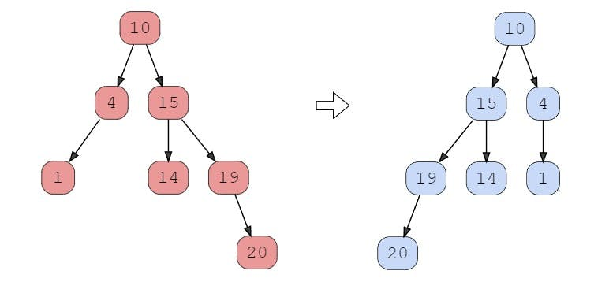

### Solution

This problem is quite similar to Same Tree. We can follow the same approach. After swapping left and right child of a node, we will recursively invert its left and right subtrees.

### Code

Here is what our algorithm will look like:

|  |
| --- |
| import java.io.Console;  /** definition for a binary search tree node */  class TreeNode {  int val;  TreeNode left;  TreeNode right;  public TreeNode(int val) {  this.val = val;  this.left = null;  this.right = null;  }  }  public class Solution {  public static TreeNode invertTree(TreeNode root) {  if (root == null) return null;    // invert children of the current node  TreeNode temp = root.left;  root.left = root.right;  root.right = temp;  // invert left and right subtrees  invertTree(root.left);  invertTree(root.right);  return root;  }  public static void main(String[] args) {  TreeNode root = new TreeNode(10);  root.left = new TreeNode(4);  root.left.left = new TreeNode(1);  root.right = new TreeNode(15);  root.right.left = new TreeNode(14);  root.right.right = new TreeNode(19);  root.right.right.right = new TreeNode(20);  Solution.invertTree(root);  System.out.println(root.right.val == 4);  System.out.println(root.left.val == 15);  System.out.println(root.left.right.val == 14);  System.out.println(root.left.left.val == 19);  System.out.println(root.left.left.left.val == 20);  }  } |

### Time Complexity

Since we traverse each node once, the solution will take O(N) time where 'N' is the total number of nodes in the tree.

### Space Complexity

We will need O(N) space for the recursion stack in the worst case (when the binary tree is a list). Overall, we will need to store nodes equal to the height of the tree, hence, O(H) space complexity, where H is the height of the given tree.

### Making the Algorithm Multi-threaded

To further improve the algorithm, we can make **invertTree()** multi-threaded to invert left and right subtrees in separate threads.

We can find how many cores the machine has on which our algorithm is running. We will, then, start multiple threads so that each core can run one thread.

Here is the code that takes care of this scenario:

|  |
| --- |
| import java.io.Console;  /** definition for a binary search tree node */  class TreeNode {  int val;  TreeNode left;  TreeNode right;  public TreeNode(int val) {  this.val = val;  this.left = null;  this.right = null;  }  }  public class Solution {  public static TreeNode invertTree(TreeNode root) {  int numThreads = Runtime.getRuntime().availableProcessors();  return invertTreeMultiThreaded(root, numThreads);  }  private static TreeNode invertTreeMultiThreaded(TreeNode root, int numThreads) {  if (root == null) return null;    // invert the current node  TreeNode temp = root.left;  root.left = root.right;  root.right = temp;    if (numThreads > 0) {  // spawn a separate thread to invert the left sub-tree  Thread t1 = new Thread(new Runnable() {  @Override  public void run() {  invertTreeMultiThreaded(root.left, numThreads/2);  }  });  t1.start();    // invert the right sub-tree in the same thread  invertTreeMultiThreaded(root.right, numThreads/2);    try {  t1.join(); // wait for the thread inverting the left subtree  } catch(InterruptedException e){ System.out.println(e); }    } else {  invertTreeMultiThreaded(root.left, 0);  invertTreeMultiThreaded(root.right, 0);  }    return root;  }  public static void main(String[] args) {  TreeNode root = new TreeNode(10);  root.left = new TreeNode(4);  root.left.left = new TreeNode(1);  root.right = new TreeNode(15);  root.right.left = new TreeNode(14);  root.right.right = new TreeNode(19);  root.right.right.right = new TreeNode(20);  Solution.invertTree(root);  System.out.println(root.right.val == 4);  System.out.println(root.left.val == 15);  System.out.println(root.left.right.val == 14);  System.out.println(root.left.left.val == 19);  System.out.println(root.left.left.left.val == 20);  }  } |

### Time and Space Complexities

Everything has the same complexity as the previous solution.

## Binary Search Tree Iterator

### Problem Statement

Implement an iterator for the in-order traversal of a binary search tree (BST). That is, given a BST, we need to implement two functions:

bool hasNext(): Returns true if at least one element is left in the in-order traversal of the BST. int next(): Return the next element in the in-order traversal of the BST.

Example:

Given the following BST:

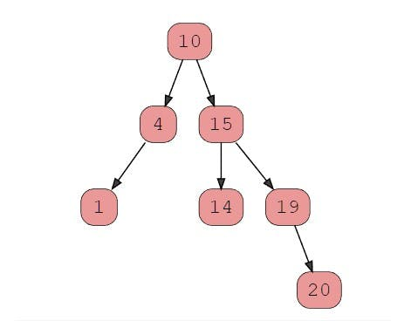

Here is the in-order traversal of this tree: [1, 4, 10, 14, 15, 19, 20]

Here is the expected output from the algorithm based on different calls:

hasNext() -> true

next() -> 1

next() -> 4

hasNext() -> true

next() -> 10

next() -> 14

next() -> 15

next() -> 19

next() -> 20

hasNext() -> false

### Solution

A brute force solution could be to store the in-order traversal of the BST in an array and used that array to process the two functions next() and hasNext(). We can maintain a pointer in the array, which points to the next element to be returned to the caller. This algorithm will take O(N) space for storing all elements in the array, and O(N) time to traverse the tree. Both the operations will take O(1) time complexity, as we have pre-processed all the data to store the in-order traversal of the BST in the array.

### Transforming a Recursive Algorithm to an Iterative one

We know that we can perform the in-order traversal of a BST recursively. But for the iterator, we can’t use recursion as we can’t stop recursion in the middle to return the required element; this way, we will lose the recursive state of the traversal. Also, we didn’t want to perform the in-order traversal every time next() or hasNext() is called; this will make these function O(N) operations.

We know that we can transform a recursive solution to make it iterative using a stack. This was exactly what we need! This way, we can control the recursion by saving the state of the in-order traversal of the BST in the stack, and later we can resume the tree traversal when next() is called again.

### Code

Here is what our algorithm will look like:

|  |
| --- |
| import java.util.Stack;  /** definition for a binary search tree node */  class TreeNode {  int val;  TreeNode left;  TreeNode right;  public TreeNode(int val) {  this.val = val;  this.left = null;  this.right = null;  }  }  public class Solution {  private Stack<TreeNode> stack = new Stack<TreeNode>();  public BSTIterator(TreeNode root) {  traverseLeft(root);  }  /** @return whether we have a next smallest number */  public boolean hasNext() {  return !stack.isEmpty();  }  /** @return the next smallest number */  public int next() {  TreeNode tmpNode = stack.pop();  traverseLeft(tmpNode.right);  return tmpNode.val;  }    /** traverse the left sub-tree to push all nodes on the stack */  private void traverseLeft(TreeNode node) {  while(node != null){  stack.push(node);  node = node.left;  }  }  public static void main(String[] args) {  TreeNode root = new TreeNode(10);  root.left = new TreeNode(4);  root.left.left = new TreeNode(1);  root.right = new TreeNode(15);  root.right.left = new TreeNode(14);  root.right.right = new TreeNode(19);  root.right.right.right = new TreeNode(20);  Solution itr = new Solution(root);  System.out.println("hasNext() -> " + itr.hasNext());  System.out.println("next() -> " + itr.next());  System.out.println("next() -> " + itr.next());  System.out.println("hasNext() -> " + itr.hasNext());  System.out.println("next() -> " + itr.next());  System.out.println("next() -> " + itr.next());  System.out.println("next() -> " + itr.next());  System.out.println("next() -> " + itr.next());  System.out.println("next() -> " + itr.next());  System.out.println("hasNext() -> " + itr.hasNext());  }  } |

### Time Complexity

* The **hasNext()** will take O(1) time.
* Since **next()** calls the **traverseLeft()** function which traverses the left subtree and in the worst case the left subtree could contain all elements (practically it would be a list), hence, **next()** can take O(N) time in the worst case. One thing to note there though, **traverseLeft()** processes each element only once. This means, amortized cost of **traverseLeft()** will be O(1) for 'n' calls of next(), therefore, next() has O(1) amortized cost.

### Space Complexity

We will need O(N) space for the stack in the worst case (when the BST is a list). Overall, we will need to store nodes equal to the height of the tree, hence,  
O(H) space complexity, where H is the height of the given tree.

### Making the Algorithm Thread Safe

Our algorithm does not have thread-safety. The algorithm would fail if multiple threads access the same **BSTIterator** object. We could get a synchronization issue in the next() function for the following two lines:

TreeNode tmpNode = stack.pop();

traverseLeft(tmpNode.right);

If two threads access the function concurrently, the stack could end up in a bad state.

Here is what can happen. Suppose one thread executes the first line to pop an element from the stack. Before it executes the next line (to traverse the left subtree), another thread which is also processing these lines, can also pop another element from the stack, thus, making the stack invalid.

This means we need to synchronize this function so that only one thread is allowed to process next() at any time.

Here is the new synchronized version of the algorithm.

|  |
| --- |
| /** We only need to synchronize the following function.  @return the next smallest number */  synchronized public int next() {  TreeNode tmpNode = stack.pop();  traverseLeft(tmpNode.right);  return tmpNode.val;  } |

### Making the Algorithm Multi-threaded

To further improve the algorithm, we can make **next()** multi-threaded so that I can return the element to the caller immediately and spawn a separate thread to perform the post-processing required to traverse the left subtree.

In the **next()** function, we do have the required node available right away, but we could not return to the caller before we traverse the left subtree of the right child of the current node:

traverseLeft(tmpNode.right);

we can spawn a new thread to process this traversal and return the element to the caller. This way, the caller is unblocked as it has the data quickly, and all the post-processing is done in a separate thread.

This made the algorithm a bit complex. Now, whenever we are starting a new execution of **next()** or **hasNext()**, we need to ensure any previous thread doing the post-processing has finished. This means we have to add a check before processing **next()** or **hasNext()** to wait and call **join()** on the previous thread if it has not already finished. Here is the code that takes care of this scenario:

|  |
| --- |
| import java.util.Stack;  /** definition for a binary search tree node */  class TreeNode {  int val;  TreeNode left;  TreeNode right;  public TreeNode(int val) {  this.val = val;  this.left = null;  this.right = null;  }  }  public class Solution {  private Stack<TreeNode> stack = new Stack<TreeNode>();  private Thread t1 = null;  public BSTIterator(TreeNode root) {  traverseLeft(root);  }  /** @return whether we have a next smallest number */  synchronized public boolean hasNext() {  checkThread();  return !stack.isEmpty();  }  /** @return the next smallest number */  synchronized public int next() {  checkThread();  TreeNode tmpNode = stack.pop();  traverseLeft(tmpNode.right);  return tmpNode.val;  }    /** traverse the left sub-tree to push all nodes on the stack */  private void traverseLeft(TreeNode node) {  // spawn a new thread to process the left sub-tree  t1 = new Thread(new Runnable() {  @Override  public void run() {  TreeNode tmp = node;  while(tmp != null){  stack.push(tmp);  tmp = tmp.left;  }  }  });    t1.start();  }    /** if the previous thread is active, wait before it finishes */  private void checkThread() {  if( t1 != null && t1.isAlive()) {  try  {  t1.join(); // wait for the thread traversing the left subtree  } catch(InterruptedException e){ System.out.println(e); }  }  }  public static void main(String[] args) {  TreeNode root = new TreeNode(10);  root.left = new TreeNode(4);  root.left.left = new TreeNode(1);  root.right = new TreeNode(15);  root.right.left = new TreeNode(14);  root.right.right = new TreeNode(19);  root.right.right.right = new TreeNode(20);  Solution itr = new Solution(root);  System.out.println("hasNext() -> " + itr.hasNext());  System.out.println("next() -> " + itr.next());  System.out.println("next() -> " + itr.next());  System.out.println("hasNext() -> " + itr.hasNext());  System.out.println("next() -> " + itr.next());  System.out.println("next() -> " + itr.next());  System.out.println("next() -> " + itr.next());  System.out.println("next() -> " + itr.next());  System.out.println("next() -> " + itr.next());  System.out.println("hasNext() -> " + itr.hasNext());  }  } |

### Time and Space Complexities

Everything has the same complexity as the previous solution.

# Sorting

## Selection Sort Algorithm

### Problem Statement:

Given an array of **N integers**, write a program to implement the Selection sorting algorithm.

**Examples:**

**Example 1:**

**Input:** N = 6, array[] = {13,46,24,52,20,9}

**Output:** 9,13,20,24,46,52

**Explanation:** After sorting the array is: 9, 13, 20, 24, 46, 52

**Example 2:**

**Input:** N=5, array[] = {5,4,3,2,1}

**Output:** 1,2,3,4,5

**Explanation:** After sorting the array is: 1, 2, 3, 4, 5

**Solution**

***Disclaimer***: *Don’t jump directly to the solution, try it out yourself first.*

**Approach:**

The algorithm steps are as follows:

1. First, we will select the range of the unsorted array using a loop (say i) that indicates the starting index of the range.  
   The loop will run forward from 0 to n-1. The value i = 0 means the range is from 0 to n-1, and similarly, i = 1 means the range is from 1 to n-1, and so on.  
   (*Initially, the range will be the whole array starting from the first index.*)
2. Now, in each iteration, we will select the minimum element from the range of the unsorted array using an inner loop.
3. After that, we will swap the minimum element with the first element of the selected range(*in step 1*).
4. Finally, after each iteration, we will find that the array is sorted up to the first index of the range.

**Note:***Here, after each iteration, the array becomes sorted up to the first index of the range. That is why the starting index of the range increases by 1 after each iteration. This increment is achieved by the outer loop and the starting index is represented by variable****i****in the following code. And the inner loop(****i.e. j****) helps to find the minimum element of the range***[i…..n-1].**

**Dry run:**

The following dry run will clarify the concepts:

Assume the given array is: {7, 5, 9, 2, 8}

**Outer loop iteration 1:**The range will be the whole array starting from the 1st index as this is the first iteration. The minimum element of this range is 2(**found using the inner loop**).

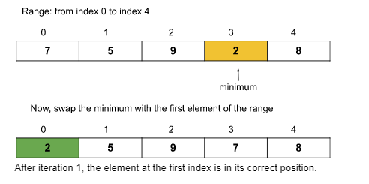

**Outer loop iteration 2:**The range will be from the **[2nd index to the last index]** as the array is sorted up to the first index. The minimum element of this range is 5(**found using the inner loop**).

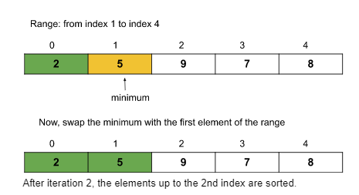

**Outer loop iteration 3:**The range will be from the **[3rd index to the last index]**. The minimum element of this range is 7(**found using the inner loop**).

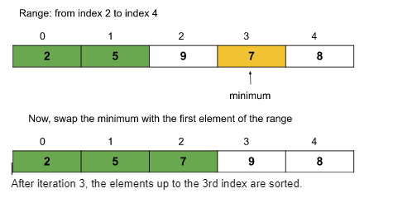

**Outer loop iteration 4:**The range will be from the **[4th index to the last index]**. The minimum element of this range is 8(**found using the inner loop**).

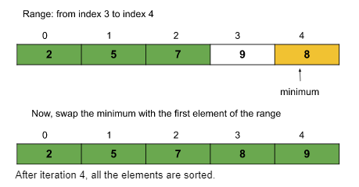

So, after 4 iterations(i.e. n-1 iterations where n = size of the array), the given array is sorted.

### Code:

import java.util.*;

public class tUf {

static void selection_sort(int arr[], int n) {

for (int i = 0; i < n - 1; i++) {

int mini = i;

for (int j = i + 1; j < n; j++) {

if (arr[j] < arr[mini]) {

mini = j;

}

}

//swap

int temp = arr[mini];

arr[mini] = arr[i];

arr[i] = temp;

}

System.out.println("After selection sort:");

for (int i = 0; i < n; i++) {

System.out.print(arr[i] + " ");

}

System.out.println();

}

public static void main(String args[]) {

int arr[] = {13, 46, 24, 52, 20, 9};

int n = arr.length;

System.out.println("Before selection sort:");

for (int i = 0; i < n; i++) {

System.out.print(arr[i] + " ");

}

System.out.println();

selection_sort(arr, n);

}

}

**Output:**

Before selection sort:  
13 46 24 52 20 9  
After selection sort:  
9 13 20 24 46 52

**Time complexity:**O(N2), (where N = size of the array), for the best, worst, and average cases.  
Reason: If we carefully observe, we can notice that the outer loop, say i, is running from 0 to n-2 i.e. n-1 times, and for each i, the inner loop j runs from i to n-1. For, i = 0, the inner loop runs n-1 times, for i = 1, the inner loop runs n-2 times, and so on. So, the total steps will be approximately the following: (n-1) + (n-2) + (n-3) + ……..+ 3 + 2 + 1. The summation is approximately the sum of the first n natural numbers i.e. (n*(n+1))/2. The precise time complexity will be O(n2/2 + n/2). Previously, we have learned that we can ignore the lower values as well as the constant coefficients. So, the time complexity is O(n2). Here the value of n is N i.e. the size of the array.

**Space Complexity: O(1)**

## Bubble Sort Algorithm

### Problem Statement:

Given an array of **N integers**, write a program to implement the Bubble Sorting algorithm.

**Examples:**

**Example 1:**

**Input:** N = 6, array[] = {13,46,24,52,20,9}

**Output:** 9,13,20,24,46,52

**Explanation:** After sorting we get 9,13,20,24,46,52

**Input:** N = 5, array[] = {5,4,3,2,1}

**Output:** 1,2,3,4,5

**Explanation:** After sorting we get 1,2,3,4,5

### Solution

***Disclaimer***: *Don’t jump directly to the solution, try it out yourself first.*

**Approach:**

The algorithm steps are as follows:

1. First, we will select the range of the unsorted array. For that, we will run a loop(say i) that will signify the last index of the selected range. The loop will run backward from index n-1 to 0(where n = size of the array). The value i = n-1 means the range is from 0 to n-1, and similarly, i = n-2 means the range is from 0 to n-2, and so on.
2. Within the loop, we will run another loop(say j, runs from 0 to i-1 though the range is from 0 to i) to push the maximum element to the last index of the selected range, by repeatedly swapping adjacent elements.  
   Basically, we will swap adjacent elements(**if arr[j] > arr[j+1]**) until the maximum element of the range reaches the end.
3. Thus, after each iteration, the last part of the array will become sorted. Like: after the first iteration, the array up to the last index will be sorted, and after the second iteration, the array up to the second last index will be sorted, and so on.
4. After (n-1) iteration, the whole array will be sorted.

**Note:***Here, after each iteration, the array becomes sorted up to the last index of the range. That is why the last index of the range decreases by 1 after each iteration. This decrement is achieved by the outer loop and the last index is represented by variable****i****in the following code. And the inner loop(****i.e. j****) helps to push the maximum element of range [0….i] to the last index(i.e. index i)***.**

**Dry Run:**

**Iteration 1:**

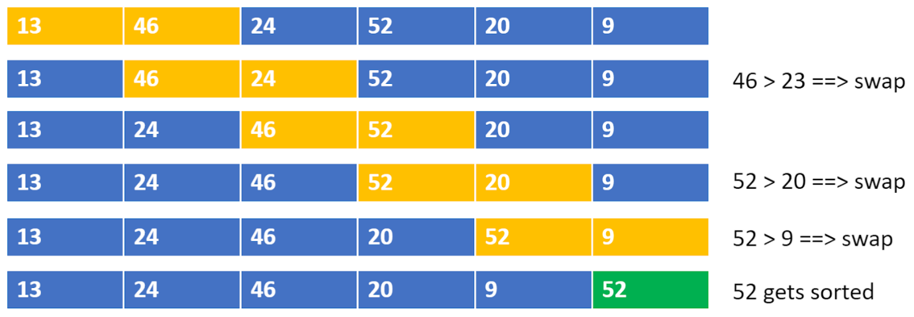

**Iteration 2:**

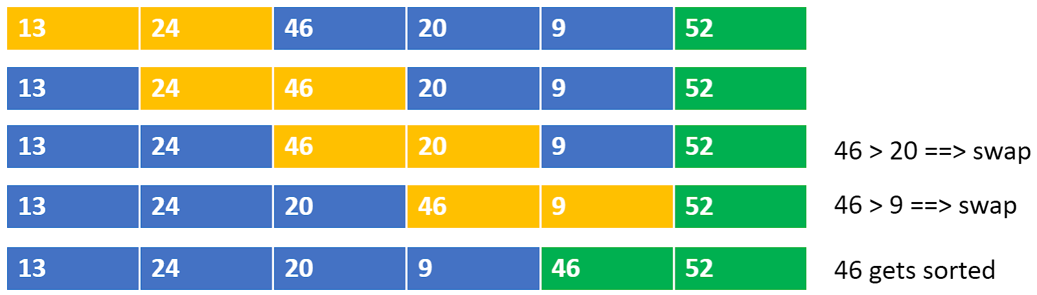

**Iteration 3:**

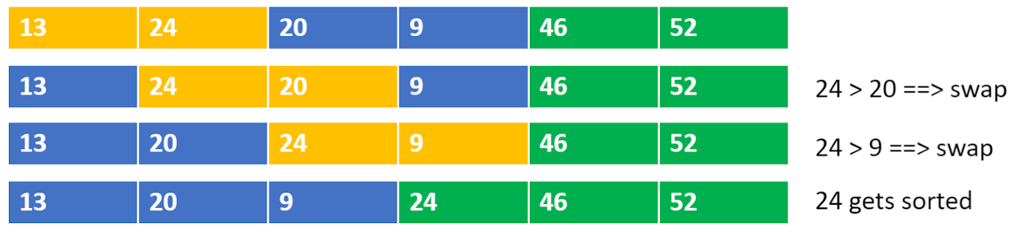

**Iteration 4:**

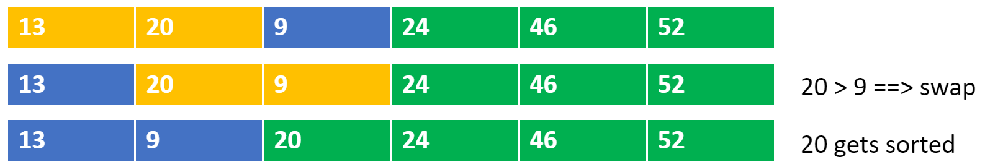

**Iteration 5:**

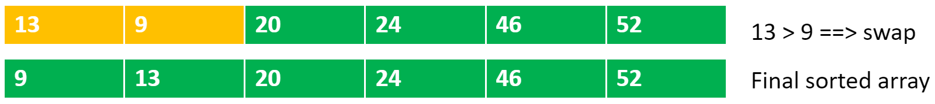

### Code:

import java.util.*;

public class tUf {

static void bubble_sort(int[] arr, int n) {

for (int i = n - 1; i >= 0; i--) {

for (int j = 0; j <= i - 1; j++) {

if (arr[j] > arr[j + 1]) {

int temp = arr[j];

arr[j] = arr[j + 1];

arr[j + 1] = temp;

}

}

}

System.out.println("After bubble sort: ");

for (int i = 0; i < n; i++) {

System.out.print(arr[i] + " ");

}

System.out.println();

}

public static void main(String args[]) {

int arr[] = {13, 46, 24, 52, 20, 9};

int n = arr.length;

System.out.println("Before Using Bubble Sort: ");

for (int i = 0; i < n; i++) {

System.out.print(arr[i] + " ");

}

System.out.println();

bubble_sort(arr, n);

}

}

**Output:**

Before Using Bubble Sort:  
13 46 24 52 20 9  
After Using bubble sort:  
9 13 20 24 46 52

**Time complexity:**O(N2), (where N = size of the array), for the worst, and average cases.  
Reason: If we carefully observe, we can notice that the outer loop, say i, is running from n-1 to 0 i.e. n times, and for each i, the inner loop j runs from 0 to i-1. For, i = n-1, the inner loop runs n-1 times, for i = n-2, the inner loop runs n-2 times, and so on. So, the total steps will be approximately the following: (n-1) + (n-2) + (n-3) + ……..+ 3 + 2 + 1. The summation is approximately the sum of the first n natural numbers i.e. (n*(n+1))/2. The precise time complexity will be O(n2/2 + n/2). Previously, we have learned that we can ignore the lower values as well as the constant coefficients. So, the time complexity is O(n2). Here the value of n is N i.e. the size of the array.

**Space Complexity: O(1)**

### Optimized approach (Reducing time complexity for the best case):

The best case occurs if the given array is already sorted. We can reduce the time complexity to O(N) by just adding a small check inside the loops.

* We will check in the first iteration if any swap is taking place. If the array is already sorted no swap will occur and we will break out from the loops.
* Thus the iteration of the outer loop will be just 1. And our overall time complexity will be O(N).

### Code:

import java.util.*;

public class tUf {

static void bubble_sort(int[] arr, int n) {

for (int i = n - 1; i >= 0; i--) {

int didSwap = 0;

for (int j = 0; j <= i - 1; j++) {

if (arr[j] > arr[j + 1]) {

int temp = arr[j];

arr[j] = arr[j + 1];

arr[j + 1] = temp;

didSwap = 1;

}

}

if (didSwap == 0) {

break;

}

}

System.out.println("After bubble sort: ");

for (int i = 0; i < n; i++) {

System.out.print(arr[i] + " ");

}

System.out.println();

}

public static void main(String args[]) {

int arr[] = {13, 46, 24, 52, 20, 9};

int n = arr.length;

System.out.println("Before Using Bubble Sort: ");

for (int i = 0; i < n; i++) {

System.out.print(arr[i] + " ");

}

System.out.println();

bubble_sort(arr, n);

}

}

**Output:**

Before Using Bubble Sort:

13 46 24 52 20 9

After Using bubble sort:

9 13 20 24 46 52

**Time Complexity:**O(N2) for the worst and average cases and O(N) for the best case. Here, N = size of the array.

**Space Complexity:**O(1)

## Insertion Sort Algorithm

### Problem Statement:

Given an array of **N integers**, write a program to implement the Insertion sorting algorithm.

**Examples:**

**Example 1:**

**Input:** N = 6, array[] = {13,46,24,52,20,9}

**Output:** 9,13,20,24,46,52

**Explanation:**

After sorting the array is: 9,13,20,24,46,52

**Example 2:**

**Input:** N=5, array[] = {5,4,3,2,1}

**Output:** 1,2,3,4,5

**Explanation:** After sorting the array is: 1,2,3,4,5

### Solution

***Disclaimer***: *Don’t jump directly to the solution, try it out yourself first.*

**Approach:**

1. Select an element in each iteration from the unsorted array(using a loop).
2. Place it in its corresponding position in the sorted part and shift the remaining elements accordingly (using an inner loop and swapping).
3. The “inner while loop” basically shifts the elements using swapping.

**Dry Run:**

* The purple color represents the unsorted array.
* The yellow color represents the current element that needs to be placed in the appropriate position.
* The green color represents the sorted array.

**Outer loop iteration 1(selected index i = 0):** The element at index i=0 is 13 and there is no other element on the left of 13. So, currently, the subarray up to the first index is sorted as it contains only element 13.

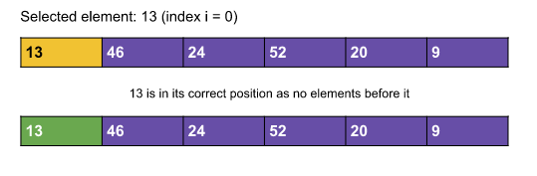

**Outer loop iteration 2(selected index i = 1):**

The selected element at index i=1 is 46. Now, we will try to move leftwards and put 46 in its correct position. Here, 46 > 13 and so 46 is already in its correct position. Now, the subarray up to the second index is sorted.

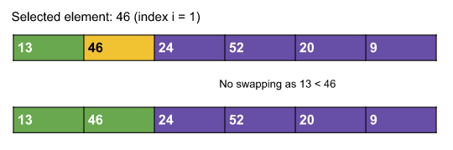

**Outer loop iteration 3(selected index i = 2):**

The selected element at index i=2 is 24. Now, we will try to move leftwards and put 24 in its correct position. Here, the correct position for 24 will be index 1. So, we will insert 24 in between 13 and 46. We will do it by swapping 24 and 46. Now, the subarray up to the third index is sorted.

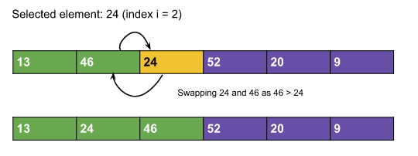

**Outer loop iteration 4(selected index i = 3):**

The selected element at index i=3 is 52. Now, we will try to move leftwards and put 52 in its correct position. Here, the correct position for 52 will be index 3. So, we need not swap anything. Now, the subarray up to the fourth index is sorted.

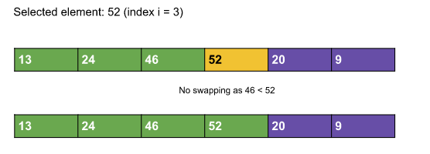

**Outer loop iteration 5(selected index i = 4):**

The selected element at index i=4 is 20. Now, we will try to move leftwards and put 20 in its correct position. Here, the correct position for 20 will be index 1. So, we need to swap adjacent elements until 20 reaches index 1. Now, the subarray up to the fifth index is sorted.

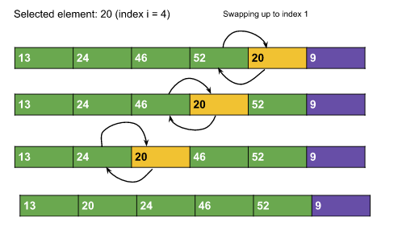

**Outer loop iteration 6(selected index i = 5):**

The selected element at index i=5 is 9. Now, we will try to move leftwards and put 9 in its correct position. Here, the correct position for 9 will be index 0. So, we need to swap adjacent elements until 9 reaches index 0. Now, the whole array is sorted.

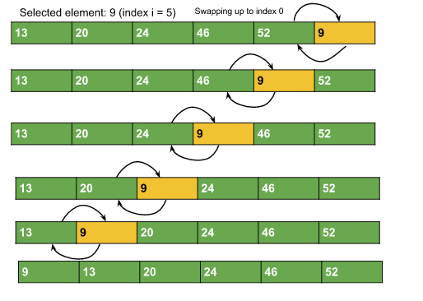

### Code:

import java.util.*;

public class Main {

static void insertion_sort(int[] arr, int n) {

for (int i = 0; i <= n - 1; i++) {

int j = i;

while (j > 0 && arr[j - 1] > arr[j]) {

int temp = arr[j - 1];

arr[j - 1] = arr[j];

arr[j] = temp;

j--;

}

}

System.out.println("After insertion sort: ");

for (int i = 0; i < n; i++) {

System.out.print(arr[i] + " ");

}

System.out.println();

}

public static void main(String args[]) {

int arr[] = {13, 46, 24, 52, 20, 9};

int n = arr.length;

System.out.println("Before Using insertion Sort: ");

for (int i = 0; i < n; i++) {

System.out.print(arr[i] + " ");

}

System.out.println();

insertion_sort(arr, n);

}

}

**Output:**

Before insertion sort:  
13 46 24 52 20 9  
After insertion sort:  
9 13 20 24 46 52

**Time complexity:**O(N2), (where N = size of the array), for the worst, and average cases.  
**Reason:** If we carefully observe, we can notice that the outer loop, say i, is running from 0 to n-1 i.e. n times, and for each i, the inner loop j runs from i to 1 i.e. i times. For, i = 1, the inner loop runs 1 time, for i = 2, the inner loop runs 2 times, and so on. So, the total steps will be approximately the following: 1 + 2 + 3 +……+ (n-2) + (n-1). The summation is approximately the sum of the first n natural numbers i.e. (n*(n+1))/2. The precise time complexity will be O(n2/2 + n/2). Previously, we have learned that we can ignore the lower values as well as the constant coefficients. So, the time complexity is O(n2). Here the value of n is N i.e. the size of the array.

**Space Complexity: O(1)**

## Merge Sort Algorithm

### **Problem**:

Given an array of size n, sort the array using **Merge Sort**.

**Examples:**

**Example 1:**

**Input:** N=5, arr[]={4,2,1,6,7}

**Output:** 1,2,4,6,7,

**Example 2:**

**Input:** N=7,arr[]={3,2,8,5,1,4,23}

**Output:** 1,2,3,4,5,8,23

**Disclaimer**: Don’t jump directly to the solution, try it out yourself first.

### **Solution :**

**Intuition:**

1. Merge Sort is a **divide and conquers algorithm**, it divides the given array into equal parts and then merges the 2 sorted parts.
2. There are 2 main functions :  
   **merge():**This function is used to merge the 2 halves of the array. It assumes that both parts of the array are sorted and merges both of them.  
   **mergeSort():** This function divides the array into 2 parts. low to mid and mid+1 to high where,

low = leftmost index of the array

high = rightmost index of the array

mid = Middle index of the array

1. We recursively split the array, and go from top-down until all sub-arrays size becomes 1.

**Approach :**

**Approach:**

* We will be creating 2 functions mergeSort() and merge().
* **mergeSort(arr[], low, high):**
  1. In order to implement merge sort we need to first divide the given array into two halves. Now, if we carefully observe, we need not divide the array and create a separate array, but we will divide the array’s range into halves every time. For example, the given range of the array is 0 to 4(0-based indexing). Now on the first go, we will divide the range into half like (0+4)/2 = 2. So, the range of the left half will be 0 to 2 and for the right half, the range will be 3 to 4. Similarly, if the given range is low to high, the range for the two halves will be low to mid and mid+1 to high, where mid = (low+high)/2. This process will continue until the range size becomes.
  2. So, in mergeSort(), we will divide the array around the middle index(rather than creating a separate array) by making the recursive call :  
     1. mergeSort(arr,low,mid)   [Left half of the array]  
     2. mergeSort(arr,mid+1,high)[Right half of the array]  
     where low = leftmost index of the array, high = rightmost index of the array, and mid = middle index of the array.
  3. Now, in order to complete the recursive function, we need to write the base case as well. We know from step 2.1, that our recursion ends when the array has only 1 element left. So, the leftmost index, low, and the rightmost index high become the same as they are pointing to a single element.  
     **Base Case:**if(low >= high) return;
* **Pseudocode:**

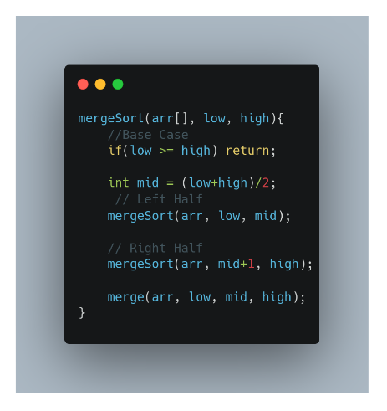

* **merge(arr[], low, mid, high):**
  1. In the merge function, we will use a temp array to store the elements of the two sorted arrays after merging. Here, the range of the left array is low to mid and the range for the right half is mid+1 to high.
  2. Now we will take two pointers left and right, where left starts from low and right starts from mid+1.
  3. Using a while loop( while(left <= mid && right <= high)), we will select two elements, one from each half, and will consider the smallest one among the two. Then, we will insert the smallest element in the temp array.
  4. After that, the left-out elements in both halves will be copied as it is into the temp array.
  5. Now, we will just transfer the elements of the temp array to the range low to high in the original array. The pseudo code will look like the following:

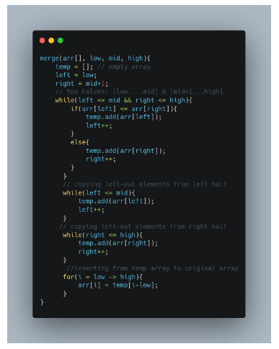

**The red number shows the order of the steps in recursion calls.**

### **Code:**

import java.util.*;

class Solution {

private static void merge(int[] arr, int low, int mid, int high) {

ArrayList<Integer> temp = new ArrayList<>(); // temporary array

int left = low; // starting index of left half of arr

int right = mid + 1; // starting index of right half of arr

//storing elements in the temporary array in a sorted manner//

while (left <= mid && right <= high) {

if (arr[left] <= arr[right]) {

temp.add(arr[left]);

left++;

} else {

temp.add(arr[right]);

right++;

}

}

// if elements on the left half are still left //

while (left <= mid) {

temp.add(arr[left]);

left++;

}

// if elements on the right half are still left //

while (right <= high) {

temp.add(arr[right]);

right++;

}

// transfering all elements from temporary to arr //

for (int i = low; i <= high; i++) {

arr[i] = temp.get(i - low);

}

}

public static void mergeSort(int[] arr, int low, int high) {

if (low >= high) return;

int mid = (low + high) / 2 ;

mergeSort(arr, low, mid); // left half

mergeSort(arr, mid + 1, high); // right half

merge(arr, low, mid, high); // merging sorted halves

}

}

public class tUf {

public static void main(String args[]) {

Scanner sc = new Scanner(System.in);

int n = 7;

int arr[] = { 9, 4, 7, 6, 3, 1, 5 };

System.out.println("Before sorting array: ");

for (int i = 0; i < n; i++) {

System.out.print(arr[i] + " ");

}

System.out.println();

Solution.mergeSort(arr, 0, n - 1);

System.out.println("After sorting array: ");

for (int i = 0; i < n; i++) {

System.out.print(arr[i] + " ");

}

System.out.println();

}

}

**Output:**

Before Sorting Array:  
9 4 7 6 3 1 5  
After Sorting Array:  
1 3 4 5 6 7 9

**Time complexity:**O(nlogn)

Reason: At each step, we divide the whole array, for that logn and we assume n steps are taken to get a sorted array, so overall time complexity will be nlogn

**Space complexity:** O(n)

Reason: We are using a temporary array to store elements in sorted order.

## Quick Sort Algorithm

### **Problem Statement:**

Given an array of n integers, sort the array using the **Quicksort** method.

**Examples:**

**Example 1:**

**Input:** N = 5 , Arr[] = {4,1,7,9,3}

**Output:** 1 3 4 7 9

**Explanation:** After sorting the array becomes 1, 3, 4, 7, 9

**Example 2:**

**Input:** N = 8 , Arr[] = {4,6,2,5,7,9,1,3}

**Output:** 1 2 3 4 5 6 7 9

**Explanation:** After sorting the array becomes 1, 3, 4, 7, 9

### **Solution**

**Disclaimer**: Don’t jump directly to the solution, try it out yourself first.

[Problem Link](https://www.codingninjas.com/codestudio/problems/quick-sort_983625?utm_source=youtube&utm_medium=affiliate&utm_campaign=striver_Arrayproblems).

**Intuition:**

Quick Sort is a divide-and-conquer algorithm like [the Merge Sort](https://takeuforward.org/data-structure/merge-sort-algorithm/). But unlike Merge sort, this algorithm does not use any extra array for sorting(though it uses an auxiliary stack space). So, from that perspective, Quick sort is slightly better than Merge sort.

This algorithm is basically a repetition of two simple steps that are the following:

* Pick a pivot and place it in its correct place in the sorted array.
* Shift smaller elements(i.e. Smaller than the pivot) on the left of the pivot and larger ones to the right.

Now, let’s discuss the steps in detail considering the array {4,6,2,5,7,9,1,3}:

**Step 1:**The first thing is to choose the pivot. **A pivot is basically a chosen element of the given array.** The element or the pivot can be chosen by our choice. So, in an array a pivot can be any of the following:

* The first element of the array
* The last element of the array
* Median of array
* Any Random element of the array

After choosing the pivot(i.e. the element), we should place it in its correct position(i.e. The place it should be after the array gets sorted) in the array. For example, if the given array is {4,6,2,5,7,9,1,3}, the correct position of 4 will be the 4th position.

**Note:** Here in this tutorial, we have chosen the first element as our pivot. You can choose any element as per your choice.

**Step 2:**In step 2, we will shift the smaller elements(i.e. Smaller than the pivot) to the left of the pivot and the larger ones to the right of the pivot. In the example, if the chosen pivot is 4, after performing step 2 the array will look like: {3, 2, 1, 4, 6, 5, 7, 9}.

From the explanation, we can see that after completing the steps, pivot 4 is in its correct position with the left and right subarray unsorted. Now **we will apply these two steps on the left subarray and the right subarray recursively**. And we will continue this process until the size of the unsorted part becomes 1(as an array with a single element is always sorted).

So, from the above intuition, we can get a clear idea that we are going to use recursion in this algorithm.

To summarize, the main intention of this process is to place the pivot, after each recursion call, at its final position, where the pivot should be in the final sorted array.

**Approach**:

Now, let’s understand how we are going to implement the logic of the above steps. In the intuition, we have seen that the given array should be broken down into subarrays. But while implementing, we are not going to break down and create any new arrays. Instead, we will specify the range of the subarrays using two indices or pointers(i.e. **low**pointer and **high**pointer) each time while breaking down the array.

The algorithm steps are the following for the **quickSort()** function:

1. Initially, the **low** points to the first index and the **high** points to the last index(as the range is n i.e. the size of the array).
2. After that, we will get the index(where the pivot should be placed after sorting) while shifting the smaller elements on the left and the larger ones on the right using a partition() function discussed later.  
   Now, this index can be called the **partition index** as it creates a partition between the left and the right unsorted subarrays.
3. After placing the pivot in the partition index(within the partition() function specified), we need to call the function quickSort() for the left and the right subarray recursively. So, **the range of the left subarray will be [low to (partition index – 1)]** and **the range of the right subarray will be [(partition index + 1) to high].**
4. This is how the recursion will continue until the range becomes 1.

**Pseudocode:**

So, the pseudocode will look like the following:

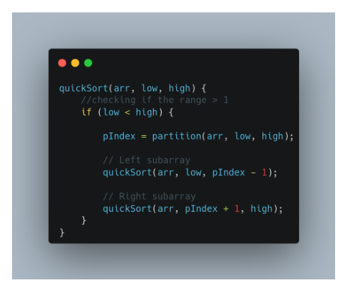

Now, let’s understand how to implement the partition() function to get the partition index.

1. Inside the function, we will first select the pivot(i.e. arr[low] in our case).
2. Now, we will again take two-pointers i and j. The i pointer points to low and the j points to high.
3. Now, the pointer i will move forward and find the first element that is greater than the pivot. Similarly, the pointer j will move backward and find the first element that is smaller than the pivot.  
   Here, we need to add some checks like i <= high-1 and j >= low+1. Because it might happen that i is standing at high and trying to proceed or j is standing at low and trying to exceed.
4. Once we find such elements i.e. arr[i] > pivot and arr[j] < pivot, and i < j, we will swap arr[i] and arr[j].
5. We will continue step 3 and step 4, until j becomes smaller than i.
6. Finally, we will swap the pivot element(i.e. arr[low]) with arr[j] and will return the index j i.e. the partition index.

**Pseudocode:**

So, the pseudocode will look like the following:

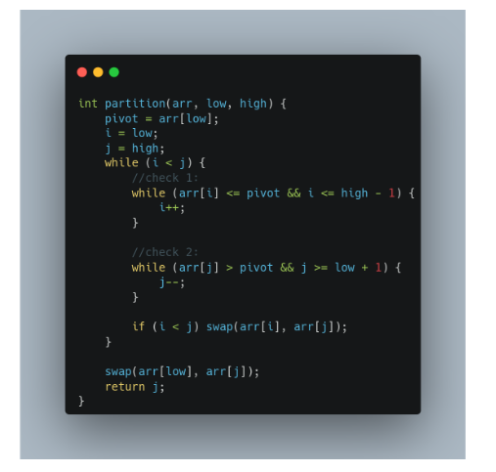

**Note:**In the function, we have kept the elements equal to the pivot on the left side. If you choose to place them on the right, check 1 will be arr[i] < pivot and check 2 will be arr[j] >= pivot.

**Note:**If you wish to see the dry run, refer to the video attached below.

### **Code:**

import java.util.*;

class Solution {

static int partition(List<Integer> arr, int low, int high) {

int pivot = arr.get(low);

int i = low;

int j = high;

while (i < j) {

while (arr.get(i) <= pivot && i <= high - 1) {

i++;

}

while (arr.get(j) > pivot && j >= low + 1) {

j--;

}

if (i < j) {

int temp = arr.get(i);

arr.set(i, arr.get(j));

arr.set(j, temp);

}

}

int temp = arr.get(low);

arr.set(low, arr.get(j));

arr.set(j, temp);

return j;

}

static void qs(List<Integer> arr, int low, int high) {

if (low < high) {

int pIndex = partition(arr, low, high);

qs(arr, low, pIndex - 1);

qs(arr, pIndex + 1, high);

}

}

public static List<Integer> quickSort(List<Integer> arr) {

// Write your code here.

qs(arr, 0, arr.size() - 1);

return arr;

}

}

public class tUf {

public static void main(String args[]) {

List<Integer> arr = new ArrayList<>();

arr = Arrays.asList(new Integer[] {4, 6, 2, 5, 7, 9, 1, 3});

int n = arr.size();

System.out.println("Before Using insertion Sort: ");

for (int i = 0; i < n; i++) {

System.out.print(arr.get(i) + " ");

}

System.out.println();

arr = Solution.quickSort(arr);

System.out.println("After insertion sort: ");

for (int i = 0; i < n; i++) {

System.out.print(arr.get(i) + " ");

}

System.out.println();

}

}

**Output:**Before Using quick Sort:  
4 6 2 5 7 9 1 3  
After Using quick sort:  
1 2 3 4 5 6 7 9

**Time Complexity:**O(N*logN), where N = size of the array.

**Reason:** At each step, we divide the whole array, for that logN and n steps are taken for partition() function, so overall time complexity will be N*logN.

The following recurrence relation can be written for Quick sort :

F(n) = F(k) + F(n-1-k)

Here k is the number of elements smaller or equal to the pivot and n-1-k denotes elements greater than the pivot.

There can be 2 cases :

**Worst Case** – This case occurs when the pivot is the greatest or smallest element of the array. If the partition is done and the last element is the pivot, then the worst case would be either in the increasing order of the array or in the decreasing order of the array.

**Recurrence:**  
**F(n) = F(0)+F(n-1)  or  F(n) = F(n-1) + F(0)**

**Worst Case Time complexity: O(n2)**

Best Case – This case occurs when the pivot is the middle element or near to middle element of the array.  
Recurrence :  
F(n) = 2F(n/2)  
  
Time Complexity for the best and average case: O(N*logN)

**Space Complexity:**O(1) + O(N) auxiliary stack space.